Social Media and EPSS Analysis

Executive Overview
This report follows the original social-media records through the temporal EPSS study, comparison with similar CVEs, and final interpretation. Telegram posts were excluded because their recorded dates represent message-crafting dates rather than original publication dates. For each CVE, the earliest post captured in this dataset was used as the event date, and historical EPSS scores were examined before and after it. Similar comparison CVEs were selected using CVE year, CVSS severity and score, source, and starting EPSS percentile. Original post text was used only for basic quality checks and simple, explainable features, while LLM-generated summaries were evaluated separately and did not determine the primary temporal results.
The main result is modest but useful. CVEs often moved upward in EPSS percentile during the first seven days after their first captured post. After comparison with similar CVEs, the average seven-day difference remained positive, although the median difference was close to zero. By day 30, the difference from similar CVEs was no longer convincing. This pattern is better understood as a short-term warning signal than as evidence that social media caused exploitation.

1. Purpose and Key Terms
The project asks whether social-media attention can add useful information about the future exploitation risk of software vulnerabilities. A vulnerability is identified by a CVE, which is a public identifier such as CVE-2025-3600.
The following terms are used throughout the report:
- EPSS is the Exploit Prediction Scoring System. Its score ranges from 0 to 1 and estimates the probability of exploitation in the following 30 days.
- CVSS is the Common Vulnerability Scoring System. It measures technical severity, not the probability of real-world exploitation.
- CISA KEV is the Known Exploited Vulnerabilities catalog. A CVE in this catalog has evidence of exploitation in the wild.
- Post-CVE row is one connection between one collected post and one CVE. A post that mentions three CVEs can therefore create three rows, and one CVE mentioned in five posts can appear in five rows.
- Event date (`t`) is the earliest post date captured for a canonical CVE in this dataset.
- Posted CVE is the CVE whose first captured post defines the event being studied.
- Comparison CVE is a different, similar CVE used as a reference. Its own first captured post occurs after the posted CVE's 30-day study window. If the posted and comparison CVEs change similarly, their movement may reflect a wider trend rather than something unique to the captured post.
- Similarity selection means choosing comparison CVEs with close measured characteristics. This method is technically called matching, but the report uses the clearer term “comparison CVE.”
- Event window is the period examined around the post. For example, +/-7 days means seven days before and seven days after it.
- Required pre-history means that EPSS data already existed far enough before the post to calculate the chosen before-and-after window.
- CVE-specific text means the exact post text was connected to only one CVE in this dataset. General articles or copied pages linked to several CVEs are not CVE-specific.
- Baseline anchor is the starting EPSS value. It uses the event day when available, otherwise the next available value at day 1 or day 3.
- Horizon is how many days after the event are checked, such as 7 or 30 days.
- EPSS percentile is the CVE's daily position compared with other scored CVEs. A percentile of 0.90 means it ranks above roughly 90% of them.
- Mean is the arithmetic average. Median is the middle value and is less affected by unusually large changes.
- p-value shows how unusual the measured difference would be if there were really no consistent change. A small value supports evidence of a difference, but it does not prove that the post caused it.

2. Dataset Structure
The three input files are gemma_combined_summ.csv, gpt_combined_summ.csv, and mistral_combined_summ.csv. They contain the same post and vulnerability records, but each file contains summaries generated by a different LLM.
Item | Verified value
Rows in each original model file | 9,218
Columns in each file | 28
Canonical CVEs in the original files | 5,692
Rows used in this analysis | 6,628
Canonical CVEs used in this analysis | 4,187
First-post events | 4,187

“Rows” are post-CVE links, so the same CVE can appear in more than one row. “Canonical CVEs” are unique vulnerability identifiers after removing the row suffix. “First-post events” retain the earliest captured date for each canonical CVE.
Model file | Parsed rows | Independent CSV rows | Columns | Complete columns | Columns with missing values | Ragged rows
gemma_combined_summ.csv | 9218 | 9218 | 28 | 21 | 7 | 0
gpt_combined_summ.csv | 9218 | 9218 | 28 | 21 | 7 | 0
mistral_combined_summ.csv | 9218 | 9218 | 28 | 20 | 8 | 0

Table notes: The same files were counted in two independent ways. Both methods found 9,218 rows and 28 columns in every file. “Complete columns” have a value in every row. “Columns with missing values” counts the fields that contain at least one blank. A “ragged row” would contain too many or too few columns; no such rows were found.

3. Online Data Sources and Analysis Tools
Historical scores were not inferred from the social-media files. They were retrieved from public vulnerability-data services:
- FIRST EPSS API: https://api.first.org/data/v1/epss. The API was queried by CVE and historical date to obtain the EPSS score and same-day percentile.
- FIRST EPSS data documentation: https://www.first.org/epss/data.html. This was used to confirm daily publication, historical availability, and EPSS model-version changes.
- Historical daily EPSS archive: https://epss.empiricalsecurity.com/epss_scores-YYYY-MM-DD.csv.gz. Daily snapshots were used in the feasibility audit and to check historical coverage.
- CISA KEV catalog: https://www.cisa.gov/known-exploited-vulnerabilities-catalog, using CISA's public JSON feed. This supplied the external known-exploitation label and catalog-addition date.
The local analysis used Python with pandas for data preparation, SciPy for statistical tests, scikit-learn for predictive models and cross-validation, Matplotlib for figures, and ReportLab for this PDF. Cached copies of downloaded EPSS and KEV data were retained so the results could be reproduced without changing values during report generation.
FIRST supplied historical EPSS scores for CVEs and dates. It did not supply the identities of the comparison CVEs. Both the posted CVEs and comparison CVEs came from the social-media dataset; the local selection algorithm decided which CVEs were similar enough to compare.

4. Important Dataset Attributes
Field | Plain-language meaning | Main caution
cve | CVE plus a row suffix | Remove the suffix before CVE-level analysis
source | Source of the collected post | Sources cover different dates and CVE populations
date_posted | Recorded publication date | Used to define event order and time windows
time_posted | Recorded publication time | 00:00 is a placeholder on several sources
social_media_post | Original collected text | Some rows are page dumps or reuse identical text
epss_score | Predicted 30-day exploitation probability | Highly skewed and changes over time
epss_status | Whether the score was original or enriched | Strongly related to collection source, so it is unsafe as a predictor
cvss_score | Technical severity from 0 to 10 | High severity does not automatically mean high exploitation probability
CVSS submetrics | Attack vector, complexity, privileges, interaction, scope, and impacts | These components largely determine the CVSS score
occurrence_count | Supplied count of CVE appearances | Can reflect collection behavior rather than real-world attention
source_links, github_urls | External references and GitHub evidence | GitHub information is missing for many rows
summ_all_sources | LLM summary of external references | Coverage and wording differ by model
summ_github_urls | LLM summary of GitHub evidence | Sparse and model-dependent
summ_cvss_metrics | LLM explanation of CVSS metrics | Often restates information already present in structured columns

5. Source Profile
Source | Post-CVE rows | Unique CVEs | Mean EPSS | Median EPSS | Mean CVSS | Enriched EPSS rows (%) | First date | Last date
Mastodon | 3136 | 2860 | 0.0085929 | 0.00043 | 8.8121 | 58.578 | 2024-09-04 | 2025-05-20
Reddit | 1333 | 616 | 0.1495 | 0.00174 | 7.9374 | 5.7764 | 2021-11-23 | 2025-06-01
HackerNews | 816 | 483 | 0.25256 | 0.00738 | 7.7561 | 4.6569 | 2025-04-07 | 2025-05-28
BleepingComputer | 755 | 276 | 0.19062 | 0.00228 | 8.1415 | 20.132 | 2025-01-04 | 2025-05-30
ExploitDB | 588 | 362 | 0.1804 | 0.00146 | 7.7721 | 12.585 | 2023-05-02 | 2025-05-29

Table notes: A “post-CVE row” is one link between a collected post and one CVE. If one post mentions three CVEs, it can create three rows. “Unique CVEs” counts each vulnerability once even if it appears in several posts. Mean EPSS and CVSS are averages; median EPSS is the middle score. “Enriched EPSS rows” shows how often EPSS was added later instead of being present in the original record. The first and last dates show when each source appears in the dataset.

6. Figures
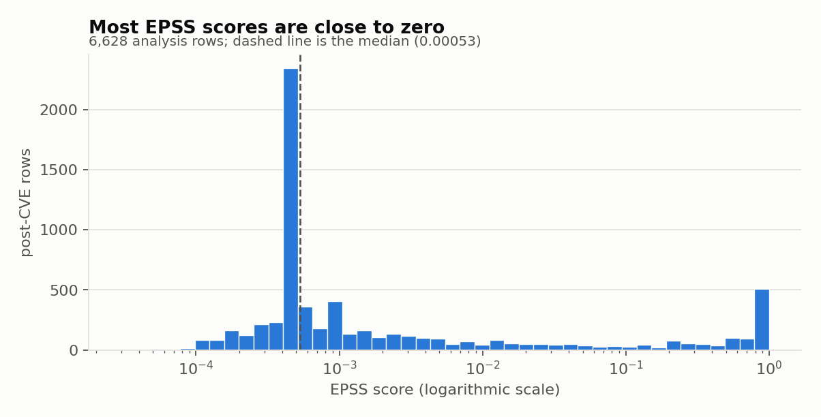
Figure 1. Distribution of EPSS scores. This figure shows how common low and high EPSS scores are. The horizontal axis is EPSS: values near 0 mean very low predicted exploitation probability, while values near 1 mean very high probability. The scale is compressed so very small scores remain visible. The vertical axis counts post-CVE rows, where one row is one link between a collected post and a CVE. The dashed line is the middle score. Most rows have very low EPSS, while a smaller group has much higher scores.
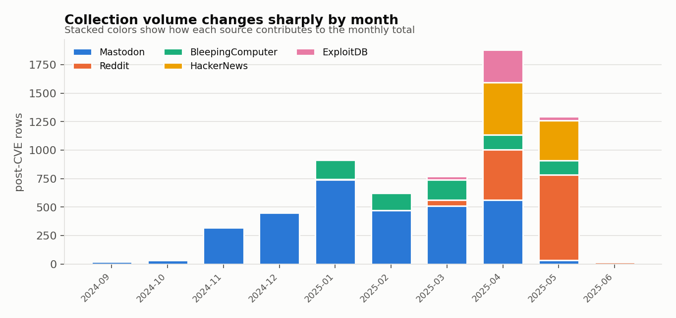
Figure 2. Monthly post volume by source. Each bar represents one month. Its full height is the number of post-to-CVE links collected in that month, and each color shows how many came from one source. A taller bar means more records were collected. Changes in the colors show that the mix of sources also changed over time, so differences between months may partly reflect collection coverage.
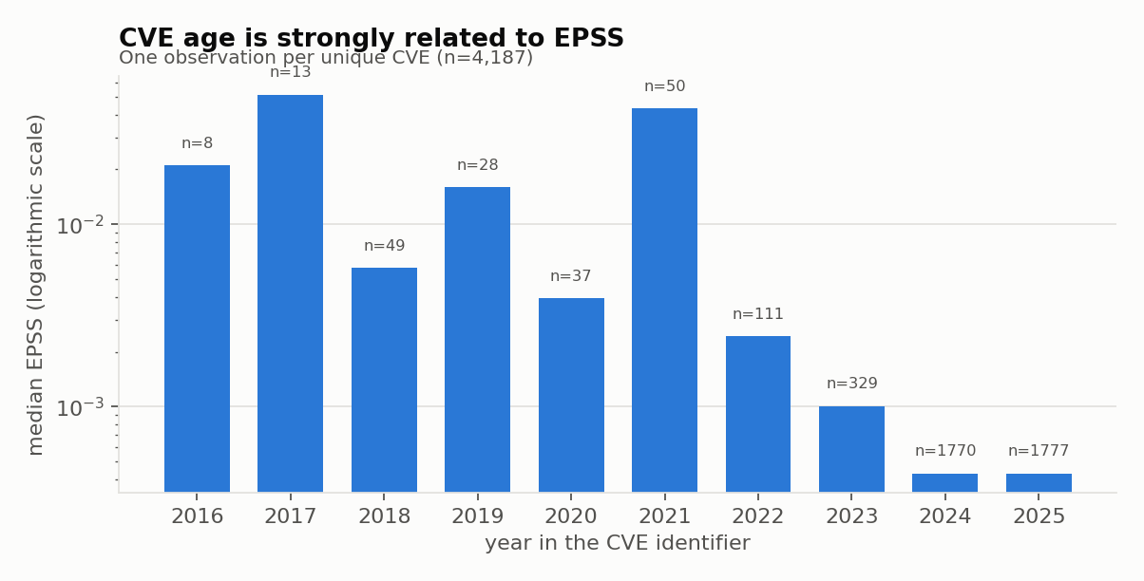
Figure 3. EPSS by CVE year. The horizontal axis is the year written in the CVE identifier, not the year of the social-media post. The vertical axis shows the middle EPSS score for each CVE-year group. The scale is compressed so small values remain visible. Each n label is the number of unique CVEs in that group. Older CVE groups often have higher EPSS, which means CVE age must be considered when groups are compared.
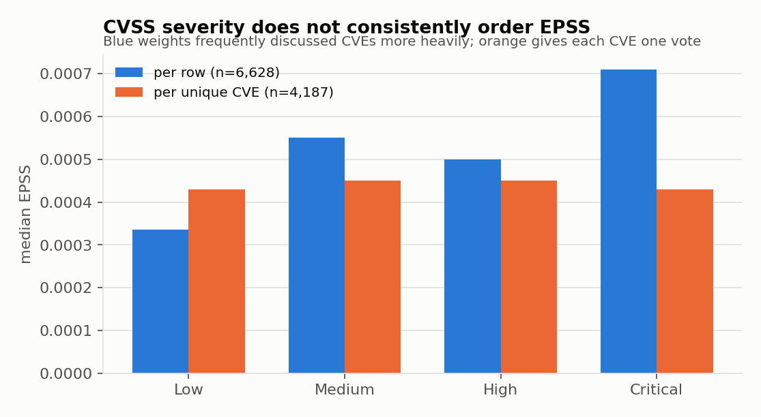
Figure 4. CVSS severity compared with EPSS. The groups along the bottom are the CVSS severity levels Low, Medium, High, and Critical. Bar height is the middle EPSS score. Blue bars count every post-to-CVE link, so a CVE mentioned many times can influence the result repeatedly. Orange bars count each CVE once. The different patterns show that CVSS severity and predicted exploitation probability are related but are not the same thing.
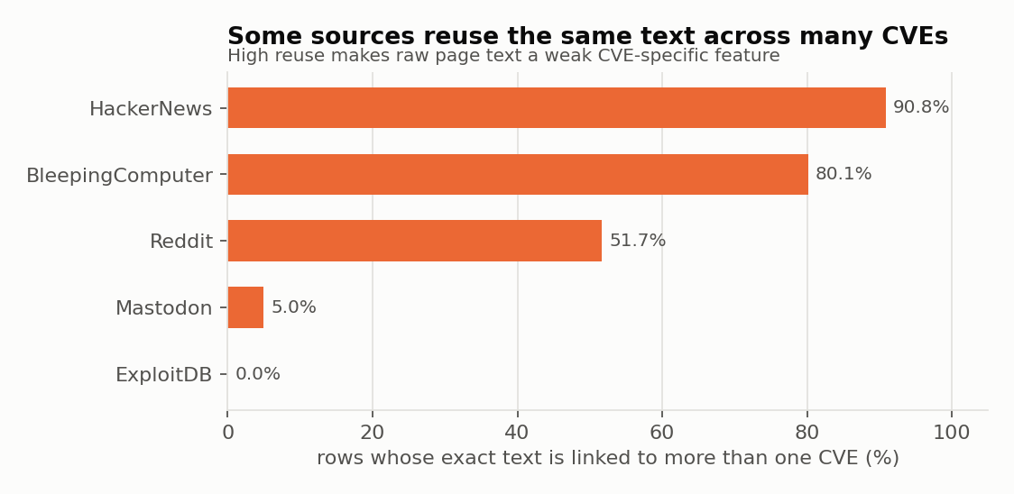
Figure 5. Reuse of post text across CVEs. Each bar represents one source. Bar length is the percentage of its rows where the exact same post text was connected to more than one CVE. Such text is not CVE-specific because it may be a general article or copied page about several vulnerabilities. A high percentage means a text model could learn repeated page content instead of information about one particular CVE.
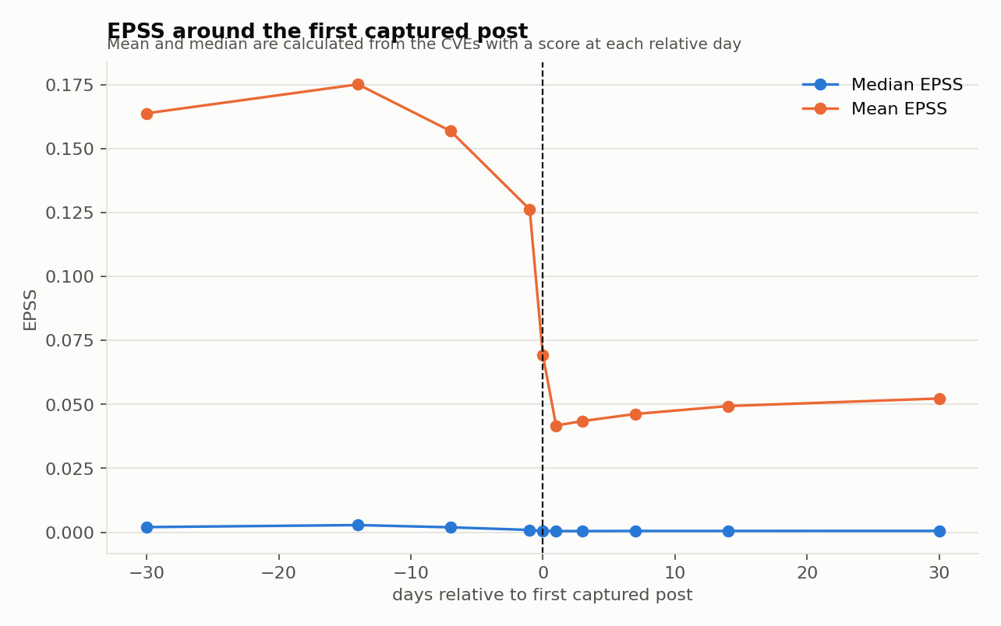
Figure 6. EPSS around the first captured post. Day 0 is the earliest post for a CVE captured in this dataset. Negative day numbers are before that captured post and positive numbers are after it. The blue line is the middle EPSS score, and the orange line is the average among CVEs with data on that day. The average is much higher than the middle value because a small number of high-EPSS CVEs pull it upward.
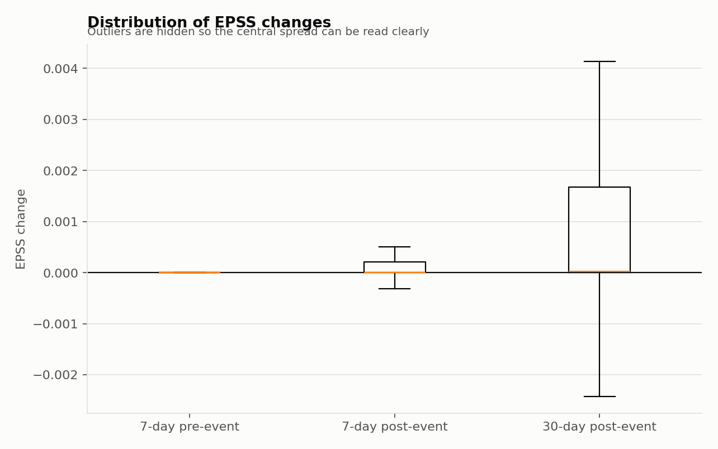
Figure 7. Distribution of EPSS changes. This figure shows how much EPSS changed in several time windows. A value above 0 means EPSS increased; a value below 0 means it decreased. The line inside each box is the middle change, and the box contains the middle half of CVEs. The longer lines show the wider range. Most changes are small, but a smaller number of CVEs change much more.

7. Data-Quality Findings
Scope | Field or field group | Rows checked | Rows with missing value | Missing (%) | Meaning
Each model file | social_media_post | 9218 | 5 | 0.05 | Five absent posts occur outside the analysis population; all analyzed rows contain post text.
Each model file | days_since_latest_git_source | 9218 | 7323 | 79.44 | Present only when dated Git evidence is available.
Each model file | days_since_oldest_git_source | 9218 | 7323 | 79.44 | Present only when dated Git evidence is available.
Each model file | source_links | 9218 | 1582 | 17.16 | Absence exactly agrees with sources_available=False.
Each model file | github_urls | 9218 | 6879 | 74.63 | Optional evidence; most rows do not contain a GitHub URL.
Analysis population | 21 required core fields | 6628 | 0 | 0 | No analyzed row is missing its CVE, date, post text, EPSS, CVSS, or core metadata.

Table notes: “Rows checked” is the number examined, and “rows with missing value” is how many have a blank in that field. Some blanks are expected because a post may have no external link or GitHub evidence. The final row checks the 21 fields required for the analysis together. None of the 6,628 analyzed rows is missing its CVE, date, original post text, EPSS, CVSS, or other required metadata.
The most important issue for text modeling is repeated content. In the analysis population, 387 exact texts are linked to more than one CVE, affecting 2,191 rows, or 33.1% of the analyzed rows. HackerNews is particularly unusual because many records are full-page captures rather than individual comments. These patterns can make a model learn templates or page structure instead of CVE-specific evidence.
CVE age is another major concern. Older vulnerabilities have had more time to accumulate exploit evidence and often have higher EPSS. This can make a source appear more predictive simply because it discusses older CVEs. CVSS and EPSS also answer different questions: CVSS describes technical impact, while EPSS estimates exploitation likelihood.

8. LLM Summary Variants
Model | Summary field | Available summaries | Missing (%) | Median words | 90th-percentile words | Maximum words
gemma | External-source summary | 7636 | 17.16 | 81 | 136.5 | 343
gpt | External-source summary | 7606 | 17.49 | 111 | 180 | 561
mistral | External-source summary | 7317 | 20.62 | 122 | 205 | 504
gemma | CVSS explanation | 9218 | 0 | 66 | 82 | 117
gpt | CVSS explanation | 9218 | 0 | 85 | 136 | 249
mistral | CVSS explanation | 9016 | 2.19 | 108 | 150 | 259
gemma | GitHub summary | 2381 | 74.17 | 81 | 118 | 424
gpt | GitHub summary | 2246 | 75.63 | 210 | 298.5 | 1208
mistral | GitHub summary | 2388 | 74.09 | 113 | 190 | 830

Table notes: “Available summaries” counts generated summaries that are not blank. “Missing (%)” is the percentage missing from the 9,218 rows. “Median words” is the middle summary length. “90th-percentile words” means 90% of summaries are no longer than that value. “Maximum words” is the longest summary produced.
Model | External-source summary gaps | GitHub summary gaps | CVSS explanation gaps
Gemma | 0 | 7 | 0
GPT | 30 | 141 | 0
Mistral | 319 | 0 | 202

Table notes: A “gap” means the LLM received the needed input but no summary was saved. For example, a GitHub summary gap means a GitHub URL existed but the summary was blank. This table separates expected blanks caused by missing source material from possible model or processing failures. It checks only whether a summary exists, not whether its content is correct.
Gemma had the strongest overall coverage and the best parsed CVSS-score agreement in the independent audit. GPT was generally accurate but had more truncated source summaries. Mistral was more verbose and structured, but it had more missing summaries and more false statements that a recent CVE was not real. Because an LLM may also carry prior knowledge of public CVEs, generated summaries were not used as the primary evidence for temporal direction.

9. EPSS by CVE Year
CVE year | Unique CVEs | Mean EPSS | Median EPSS
2008 | 1 | 0.04015 | 0.04015
2009 | 1 | 0.93821 | 0.93821
2010 | 2 | 0.70186 | 0.70186
2012 | 1 | 0.0138 | 0.0138
2013 | 3 | 0.54307 | 0.61542
2014 | 3 | 0.8851 | 0.94237
2015 | 4 | 0.011168 | 0.007235
2016 | 8 | 0.21509 | 0.021025
2017 | 13 | 0.3966 | 0.05142
2018 | 49 | 0.17916 | 0.00578
2019 | 28 | 0.25618 | 0.015925
2020 | 37 | 0.23817 | 0.00392
2021 | 50 | 0.35679 | 0.04318
2022 | 111 | 0.13996 | 0.00244
2023 | 329 | 0.11496 | 0.00101
2024 | 1770 | 0.028388 | 0.00043
2025 | 1777 | 0.0019859 | 0.00043

Table notes: “CVE year” is the year written inside the CVE identifier, not the year of the social-media post. Each CVE is counted once. Mean EPSS is the average for that year group, while median EPSS is the middle score. Results based on only a few CVEs are less dependable and should not be treated as a general pattern.

10. Monthly Collection Pattern
Month | BleepingComputer rows | ExploitDB rows | HackerNews rows | Mastodon rows | Reddit rows
2021-11 | 0 | 0 | 0 | 0 | 1
2021-12 | 0 | 0 | 0 | 0 | 6
2022-01 | 0 | 0 | 0 | 0 | 2
2022-11 | 0 | 0 | 0 | 0 | 2
2023-01 | 0 | 0 | 0 | 0 | 6
2023-02 | 0 | 0 | 0 | 0 | 6
2023-03 | 0 | 0 | 0 | 0 | 5
2023-04 | 0 | 0 | 0 | 0 | 5
2023-05 | 0 | 41 | 0 | 0 | 13
2023-06 | 0 | 23 | 0 | 0 | 0
2023-07 | 0 | 30 | 0 | 0 | 3
2023-08 | 0 | 25 | 0 | 0 | 0
2023-09 | 0 | 11 | 0 | 0 | 0
2023-10 | 0 | 8 | 0 | 0 | 0
2023-11 | 0 | 0 | 0 | 0 | 1
2024-02 | 0 | 10 | 0 | 0 | 0
2024-03 | 0 | 42 | 0 | 0 | 2
2024-04 | 0 | 36 | 0 | 0 | 3
2024-05 | 0 | 8 | 0 | 0 | 0
2024-06 | 0 | 4 | 0 | 0 | 2
2024-07 | 0 | 0 | 0 | 0 | 1
2024-08 | 0 | 2 | 0 | 0 | 1
2024-09 | 0 | 0 | 0 | 21 | 1
2024-10 | 0 | 2 | 0 | 32 | 1
2024-11 | 0 | 0 | 0 | 320 | 5
2024-12 | 0 | 0 | 0 | 450 | 5
2025-01 | 168 | 0 | 0 | 741 | 3
2025-02 | 154 | 0 | 0 | 469 | 1
2025-03 | 178 | 30 | 0 | 510 | 51
2025-04 | 130 | 284 | 462 | 560 | 443
2025-05 | 125 | 32 | 354 | 33 | 750
2025-06 | 0 | 0 | 0 | 0 | 14

Table notes: The month is written as year-month. Each number is the count of post-to-CVE links collected from that source during that month. A zero means no such row was collected. Because the available sources change over time, a difference between months may reflect collection coverage as well as a real change in social-media activity.

11. Why Simple Correlation Was Not Enough
A direct correlation would mix together information in the original post, prior knowledge inside the LLM, CVE age, technical severity, source-specific collection windows, repeated records, and public signals that may already influence EPSS. The analysis therefore moved from description to an event timeline and then to a comparison with selected similar CVEs.
The workflow was:
1. verify the row structure, missing values, and agreement among the three model files;
2. examine distributions, correlations, source differences, CVE age, and text reuse;
3. audit LLM coverage and faithfulness;
4. align historical EPSS scores around the first-post event;
5. check whether enough pre-event EPSS history existed;
6. compare posted CVEs with selected similar CVEs over the same calendar window; and
7. add CISA KEV as an external outcome and run exploratory predictive models.

12. Temporal Event Study
For every canonical CVE, the earliest post date captured in this dataset is t. EPSS was examined at t-30, t-14, t-7, t-1, t, t+1, t+3, t+7, t+14, and t+30 when data existed. A negative offset means days before the event and a positive offset means days after it.
When a score was unavailable exactly at t, the baseline anchor used t+1 and then t+3. A “change” or “delta” is the later score minus the earlier score. Positive values mean EPSS rose; negative values mean it fell.

13. Feasibility Audit
Event window | Has required pre-history | Also has CVE-specific text | Also stays within one EPSS version
+/-7d | 852 | 384 | 372
+/-14d | 810 | 346 | 321
+/-30d | 773 | 321 | 213

Table notes: This table asks whether a fair before-and-after comparison is possible. An event window of +/-7d means seven days before and seven days after the first post. “Has required pre-history” means EPSS data already existed far enough before the post. “CVE-specific text” keeps posts whose exact text is connected to only one CVE, removing general articles or copied pages linked to several CVEs. “One EPSS version” means the window does not cross a change in the EPSS calculation method. The columns are step-by-step filters, so each number is a smaller subset of the number to its left.
For example, in the +/-30d row, 773 CVEs had enough earlier EPSS data. After keeping only CVE-specific first-post text, 321 remained. After also requiring the full window to stay inside one EPSS version, 213 remained.
The audit shows that a full before-and-after study would rely on a small, selected group of older CVEs. The audit's broader text rule retained 3,523 forward events, while the implemented clean-first-post rule retained 3,507; they are different filters and should not be read as contradictory counts.

14. Temporal Results

Understanding the Two p-values
- t-test p-value: This test asks whether the average change across the CVEs is different from zero. It uses the actual numerical changes, so a few unusually large increases or decreases can strongly affect it.
- Wilcoxon p-value: This test asks whether the non-zero changes generally point in one direction. It ranks changes by size instead of relying directly on their raw values, so it is less affected by a few extreme CVEs. Exact zero changes are excluded from this Wilcoxon calculation.
- How to interpret them: A small value, commonly below 0.05, means the observed pattern would be unusual if there were no consistent change. It does not show how large or useful the change is, and it does not prove that the social-media post caused it. When both p-values are small, both the average and ranked direction support a change. When they disagree, the result may be affected by extreme values, many zero changes, or an uneven distribution.
Small example: Suppose the changes for four CVEs are +0.10, +0.02, -0.01, and 0.00. The t-test uses their average. The Wilcoxon test removes the zero, ranks the other three changes by size, and compares the positive ranks with the negative rank. The real report applies these tests to hundreds or thousands of CVEs, not only four.
EPSS change definition | CVEs | Mean change | Median change | 25th percentile | 75th percentile | Increased | Decreased | No change | Increased (%) | Decreased (%) | t-test p-value | Wilcoxon p-value
Change from t-7 to t-1 | 924 | 0.0059892 | 0 | 0 | 0 | 198 | 83 | 643 | 21.43 | 8.98 | 0.025298 | 3.1442e-06
Change from t-7 to event anchor | 935 | 0.010968 | 0 | 0 | 1e-05 | 235 | 89 | 611 | 25.13 | 9.52 | 0.00055532 | 1.7022e-09
Change from anchor to t+7 | 4092 | 0.0066415 | 0 | 0 | 0.0001 | 1492 | 351 | 2249 | 36.46 | 8.58 | 8.76e-12 | 1.4583e-123
Change from anchor to t+30 | 4088 | 0.013006 | 0 | 0 | 0.00027 | 2033 | 550 | 1505 | 49.73 | 13.45 | 6.4286e-20 | 4.6796e-154
7-day post change minus 7-day pre-change | 916 | 0.0057785 | 0 | -5e-05 | 0.0005725 | 302 | 266 | 348 | 32.97 | 29.04 | 0.13543 | 2.7067e-05
30-day post change minus 30-day pre-change | 778 | -0.0096739 | 2.5e-05 | -0.001355 | 0.0022675 | 396 | 292 | 90 | 50.9 | 37.53 | 0.16756 | 0.027486

Table notes: t is the first post date, so t-7 means seven days before it and t+30 means 30 days after it. The “anchor” is the starting EPSS value on day 0, or the next available value on day 1 or day 3. “CVEs” is the number for which both scores needed for that comparison exist. Positive changes mean EPSS rose; negative changes mean it fell. Increased, decreased, and no change are simple counts. The two p-values test whether the pattern is likely to be more than random variation, but even a small p-value does not prove that the post caused the change.
Many CVEs moved upward after the event, but many were unchanged and the average was influenced by a smaller group with larger movements. The limited pre-event sample also prevents a broad claim about reverse causality across the entire corpus.

15. Forward Comparison with Similar CVEs
“Forward” means that we start at the posted CVE's first captured post and look 7 or 30 days ahead. We then compare its EPSS movement with selected similar CVEs. Statistical studies call this selection process matching, but this report uses the simpler term comparison CVE.

How the Comparison CVEs Were Selected
Both the posted CVE and every comparison CVE come from the original social-media dataset. For a posted CVE with event date t, we look for other CVEs whose earliest captured posts occur after t+30. Those other CVEs form the comparison group during the posted CVE's study window. Their later post dates are used only to confirm that they had no captured post in this dataset from t through t+30.
The selection was performed separately for every posted CVE:
1. Start with the posted CVE and its first captured post date, called the event date.
2. Exclude the same CVE and any candidate whose own first captured post was not more than 30 days later. This keeps the candidate without a captured post in this dataset throughout the outcome window.
3. Keep candidates from the same CVE year. Prefer the same CVSS severity level; if fewer than 12 are available, allow other severity levels from the same year.
4. Rank candidates using the absolute CVSS-score difference, plus a penalty of 0.25 for a different severity level and 0.05 for a different source. The source penalty is deliberately small and acts mainly as a tie-breaker. Retain the closest 12 candidates at this stage.
5. Compare historical EPSS percentiles at the posted CVE's event date. If day 0 is unavailable, use day 1 and then day 3. Remove candidates more than 0.10, or 10 percentile points, from the posted CVE's starting percentile.
6. Rank the remaining candidates first by starting-percentile distance and then by the earlier technical/source distance. Select up to three comparison CVEs.
The same comparison CVE can be reused for different posted CVEs. “No captured post during this window” refers only to this dataset and does not prove that the CVE was absent from every social platform.
Coverage measure | Value
CVEs with a baseline EPSS anchor | 4,116
Posted-CVE/comparison-CVE pair rows | 1,668
Posted CVEs with at least one comparison CVE | 884

One posted CVE can have more than one comparison CVE, so pair rows are more numerous than posted CVEs. This design makes the groups more similar on measured features, but it does not make different vulnerabilities identical. The result is an adjusted comparison, not a causal experiment.

Real Comparison CVE Examples from the Dataset
The following examples were read directly from the original GPT dataset, the saved event and pair tables, and the cached FIRST daily EPSS files. Example A shows a positive difference from similar CVEs, while Example B shows a negative difference. Including both avoids giving the impression that posted CVEs always rise more.
Example | Role | CVE | First captured post | Days after event | Source | Year / severity / CVSS | Starting EPSS percentile
A | Posted CVE | CVE-2024-42733 | 2025-03-10 | 0 | Mastodon | 2024 / Critical / 9.8 | 0.1187
A | Comparison 1 | CVE-2024-48573 | 2025-04-10 | 31 | ExploitDB | 2024 / Critical / 9.8 | 0.1187
A | Comparison 2 | CVE-2024-35056 | 2025-04-11 | 32 | HackerNews | 2024 / Critical / 9.8 | 0.1187
A | Comparison 3 | CVE-2024-50672 | 2025-04-15 | 36 | ExploitDB | 2024 / Critical / 9.8 | 0.1187
B | Posted CVE | CVE-2023-28461 | 2025-01-09 | 0 | BleepingComputer | 2023 / Critical / 9.8 | 0.97173
B | Comparison 1 | CVE-2023-34048 | 2025-03-04 | 54 | BleepingComputer | 2023 / Critical / 9.8 | 0.97409
B | Comparison 2 | CVE-2023-26602 | 2025-04-16 | 97 | ExploitDB | 2023 / Critical / 9.8 | 0.97588
B | Comparison 3 | CVE-2023-30258 | 2025-04-11 | 92 | ExploitDB | 2023 / Critical / 9.8 | 0.98104

Table notes: “Posted CVE” is the vulnerability whose first captured post defines the event date. “Comparison 1–3” are the three selected similar CVEs. “Days after event” is the number of days between the posted CVE's event and the comparison CVE's own first captured post. Every value is greater than 30. “Year / severity / CVSS” lists the CVE identifier year, severity level, and CVSS score. “Starting EPSS percentile” is measured on the posted CVE's event date. A value of 0.11870 means the CVE ranked above about 11.87% of scored CVEs that day.
In Example A, CVE-2024-42733 had its first captured post on 10 March 2025. Its comparison CVEs first appeared 31, 32, and 36 days later. All four CVEs are from 2024, have Critical severity and CVSS 9.8, and had the same starting EPSS percentile of 0.11870. In Example B, CVE-2023-28461 and its comparison CVEs are 2023 Critical CVEs with CVSS 9.8. Their starting percentiles differ by no more than 0.00931, or 0.931 percentile points, and the comparison CVEs first appeared 54, 92, and 97 days later. In both examples, the complete CVSS submetric profiles also happen to agree, although the general selection rule explicitly requires only CVE year and uses severity and CVSS score in candidate selection.
Example | Posted CVE | Horizon (days) | Posted CVE change | Average comparison-CVE change | Difference from similar CVEs
A | CVE-2024-42733 | 7 | 0.39616 | 0.22199 | 0.17417
A | CVE-2024-42733 | 30 | 0.41281 | 0.27477 | 0.13804
B | CVE-2023-28461 | 7 | 0.00013 | 0.0017533 | -0.0016233
B | CVE-2023-28461 | 30 | 0.00033 | 0.00187 | -0.00154

Table notes: “Posted CVE change” is its later EPSS percentile minus its starting percentile. “Average comparison-CVE change” is the average of the same calculation for the three comparison CVEs over exactly the same calendar dates. “Difference from similar CVEs” is the posted-CVE change minus that average. Positive means the posted CVE rose more; negative means the comparison CVEs rose more on average.
For Example A at seven days, the posted CVE changed by +0.39616 and its comparison CVEs changed by +0.22199 on average. The difference is +0.17417, or 17.417 percentile points. For Example B, the posted CVE changed by only +0.00013, while its comparison CVEs changed by +0.00175 on average. Its difference is -0.00162, meaning the comparison CVEs rose slightly more. These are worked examples, not the final evidence. The reported study result combines all 869 posted CVEs with valid seven-day comparison outcomes.

How to Read the Two Comparisons
The first comparison, Change in Posted CVEs Alone, measures how the EPSS percentile of each posted CVE changed after its first captured social-media post. It answers: Did the posted CVE's EPSS percentile increase or decrease after the captured post?
Example: A posted CVE starts at EPSS percentile 0.60 and reaches 0.70 after seven days. Its change is 0.70 - 0.60 = +0.10, an increase of 10 percentile points. This shows that the CVE moved upward, but it does not show whether the increase was unusual because similar CVEs may also have risen during the same seven days.
The second comparison, Change Compared with Similar CVEs, subtracts the average change of the selected comparison CVEs from the change of the posted CVE. It answers: Did the posted CVE change more or less than similar CVEs during the same period?
Example: The posted CVE increases by +0.10. Its comparison CVEs increase by an average of +0.03. The difference is +0.10 - (+0.03) = +0.07. The posted CVE therefore rose by 7 percentile points more than the similar CVEs. This shows a larger relative change, but it does not prove that the social-media post caused the increase. The post and the EPSS change may both reflect the same developing security threat.

Change in Posted CVEs Alone
Horizon (days) | Posted CVEs included | Mean change in posted CVEs | Median change in posted CVEs | Posted CVEs increased (%) | Posted CVEs decreased (%) | Posted CVEs unchanged (%)
7 | 4092 | 0.04299 | 0.00125 | 81.92 | 17.38 | 0.71
30 | 4088 | 0.060727 | 0.00612 | 83.93 | 15.85 | 0.22

Table notes: “Horizon” is the number of days after the first post. “Posted CVEs included” is the number with both a starting EPSS percentile and a later percentile at that horizon. “Mean change” is the average change across those CVEs, while “median change” is the middle change after ordering all changes. Each change is the later percentile minus the starting percentile. A positive value means the CVE moved upward relative to other CVEs, and a negative value means it moved downward. The final three columns show the percentages that increased, decreased, or remained unchanged.

Change Compared with Similar CVEs
All posted CVEs with selected comparison CVEs:
Horizon (days) | Posted CVEs compared | Mean difference from similar CVEs | Median difference from similar CVEs | 25th percentile | 75th percentile | Posted CVE rose more (%) | Posted CVE rose less (%) | t-test p-value | Wilcoxon p-value
7 | 869 | 0.045343 | 4.6667e-05 | -0.00033 | 0.0321 | 53.51 | 43.84 | 4.9826e-13 | 4.0691e-09
30 | 868 | 0.0017783 | 2e-05 | -0.031222 | 0.04571 | 50.58 | 48.04 | 0.83248 | 0.4811

More strictly cleaned first-post group:
Horizon (days) | Posted CVEs compared | Mean difference from similar CVEs | Median difference from similar CVEs | Posted CVE rose more (%) | Posted CVE rose less (%)
7 | 642 | 0.054634 | 0.0001075 | 56.386 | 41.121
30 | 641 | -0.0025662 | 9e-05 | 51.014 | 48.05

Table notes: “Posted CVEs compared” is the number of posted CVEs with the scores and similar CVEs needed for the comparison. For each posted CVE, we subtract the comparison CVEs' average EPSS-percentile change from the posted CVE's change. “Mean difference from similar CVEs” is the average of these differences, and “median difference from similar CVEs” is the middle difference. A positive value means the posted CVE rose more than its comparison CVEs; a negative value means it rose less or fell more. “Posted CVE rose more” and “Posted CVE rose less” show how often each result occurred. They may not add to 100% because some posted CVEs changed by the same amount as their comparison CVEs. The more strictly cleaned group keeps first-post text connected to only one CVE and removes general or copied text associated with several CVEs. The 25th and 75th percentiles contain the middle half of the differences. The p-values test whether the differences consistently move away from zero; they do not prove that a post caused an EPSS change.
At seven days, the mean difference from similar CVEs was positive, but the median difference was only 0.000047 and posted CVEs rose more than their comparison CVEs in 53.51% of comparisons. The more strictly cleaned group was somewhat stronger at 56.39%. At 30 days, the all-event tests were not significant and the mean for the more strictly cleaned group was slightly negative. The clearest evidence is therefore a small, short-term association found in part of the sample.

16. CISA KEV Outcome
KEV measure | CVE count | Share of events (%)
All CVE events | 4187 | 100
Ever listed in CISA KEV | 284 | 6.78
Added to KEV on or after the event | 119 | 2.84
Added to KEV within 90 days | 102 | 2.44

Table notes: CISA KEV is the US Cybersecurity and Infrastructure Security Agency's catalog of vulnerabilities with evidence of real-world exploitation. It is used here as an external confirmation that exploitation was known, rather than as another EPSS score. The table starts with all 4,187 first-post events and then shows smaller groups:
- All CVE events (4,187; 100%): Every unique CVE event included in this study.
- Ever listed in CISA KEV (284; 6.78%): CVEs found in the downloaded KEV catalog, whether CISA added them before or after the first captured post.
- Added to KEV on or after the event (119; 2.84%): CVEs whose CISA catalog date was the same as or later than the first captured post. This removes CVEs already listed before the event.
- Added to KEV within 90 days (102; 2.44%): CVEs added from the event date through day 90. These 102 are part of the 119 above, which are themselves part of the 284 ever listed.
“CVE count” is the number in each group. “Share of events” divides that count by 4,187 and converts it to a percentage. For example, if 5 out of 100 study CVEs were added to KEV within 90 days, the CVE count would be 5 and the share would be 5%. The CISA dateAdded value is the catalog-entry date, not necessarily the first day attackers exploited the vulnerability; exploitation may have started earlier.
KEV provides an outcome outside EPSS, but only 102 events were added within 90 days. That small positive class makes precision-recall performance and uncertainty especially important.

17. Exploratory Predictive Results
Prediction target | Predictor set | CVEs | Positive outcome share | Mean ROC-AUC | ROC-AUC standard deviation | Mean PR-AUC | PR-AUC standard deviation
EPSS percentile increased by day 7 | CVSS only | 4116 | 0.81438 | 0.57703 | 0.018383 | 0.84318 | 0.010889
EPSS percentile increased by day 7 | CVSS plus baseline EPSS | 4116 | 0.81438 | 0.66141 | 0.014423 | 0.889 | 0.0084572
EPSS percentile increased by day 7 | Plus source and attention features | 4116 | 0.81438 | 0.71239 | 0.0089329 | 0.90468 | 0.0058811
EPSS percentile increased by day 30 | CVSS only | 4116 | 0.83358 | 0.60981 | 0.010586 | 0.87213 | 0.0010864
EPSS percentile increased by day 30 | CVSS plus baseline EPSS | 4116 | 0.83358 | 0.71257 | 0.014979 | 0.92001 | 0.0062109
EPSS percentile increased by day 30 | Plus source and attention features | 4116 | 0.83358 | 0.74662 | 0.021445 | 0.9329 | 0.0091467
Added to CISA KEV within 90 days | CVSS only | 4116 | 0.023567 | 0.62114 | 0.056396 | 0.041009 | 0.0063279
Added to CISA KEV within 90 days | CVSS plus baseline EPSS | 4116 | 0.023567 | 0.67369 | 0.061344 | 0.07912 | 0.019098
Added to CISA KEV within 90 days | Plus source and attention features | 4116 | 0.023567 | 0.92554 | 0.035879 | 0.5236 | 0.073085

Table notes: “Prediction target” is the result the model tries to predict. “Predictor set” is the information given to it. “Positive outcome share” is how often the result actually occurred. ROC-AUC shows how well the model ranks positive cases above negative ones: 0.5 is similar to chance and 1.0 is perfect. PR-AUC focuses more strongly on correctly finding the uncommon positive cases. Standard deviation shows how much performance changed across repeated validation groups.
The larger AUC values are exploratory, not a clean deployment estimate. The source-and-attention predictor set includes post totals and source counts calculated across the full corpus, so some information may occur after the event. It also includes epss_status, which is related to how scores were collected. In addition, the validation folds were random rather than chronological. The 0.9255 KEV ROC-AUC should therefore not be presented as proven real-time performance.

18. Final Interpretation
The analysis found a small, short-term relationship between social-media attention and changes in EPSS. During the seven days after the first captured post, the posted CVEs showed a slightly greater increase in EPSS percentile, on average, than their selected comparison CVEs. However, the difference for a typical CVE was very small, and only a modest majority of posted CVEs increased more than the similar CVEs. After 30 days, there was no clear evidence that this difference continued.
These findings do not prove that social-media posts caused EPSS to increase or caused vulnerabilities to be exploited. A vulnerability may have been discussed because its risk was already increasing, while the same developing threat information may also have influenced EPSS. Social-media attention should therefore be treated as a possible early-warning signal, not as a cause of exploitation. It is most useful when considered together with baseline EPSS, CVSS severity, the source of the post, and confirmed evidence of real-world exploitation.

19. Verification Appendix
Verification check | Passed | Local source file
Three input files have 9,218 rows and 28 columns | True | model_inventory.csv
Independent CSV row counts agree | True | model_inventory.csv
Every parsed source record has exactly 28 columns | True | source_file_structure_audit.csv
Static post/CVE fields match across LLM variants | True | static_feature_consistency.csv
The analysis population has 6,628 rows and valid dates | True | gpt_combined_summ.csv
All 21 core fields are complete in the analysis population | True | source_missingness_audit.csv
The input contains 5,692 canonical CVEs | True | gpt_combined_summ.csv
The analysis population and first-event table contain 4,187 CVEs | True | forward_events_base.csv
Platform and monthly totals reconcile to 6,628 rows | True | platform profile and saved monthly volume table
CVE-year totals reconcile to 4,187 unique CVEs | True | epss_by_cve_year.csv
All summary tables used in the report have complete cells | True | saved report-input CSV tables
Shared-text result is 387 texts and 2,191 analysis rows | True | gpt_combined_summ.csv
Forward EPSS summaries match expected event counts | True | forward_event_outcome_summary.csv
Comparison summary contains 869 (+7d) and 868 (+30d) posted-CVE events | True | comparison_summary.csv
KEV counts are internally consistent | True | kev_summary.csv
Worked comparison CVEs and captured-post dates agree with the original dataset | True | gpt_combined_summ.csv and forward_events_base.csv
Worked comparison CVEs first appear more than 30 days after their posted-CVE events | True | comparison_pair_outcomes.csv
Worked comparison CVEs reproduce the year, CVSS, source-distance, and starting-EPSS selection rules | True | forward_events_base.csv and comparison_pair_outcomes.csv
Worked EPSS values agree with cached FIRST daily scores | True | Forward_EPSS_Study/epss_cache
Worked posted-minus-comparison calculations reproduce the saved results | True | comparison_pair_outcomes.csv

Table notes: Each row is a fact calculated again directly from a saved data file. True means the recalculated value agrees with the value reported in this document. Report generation stops if any check is false. The last column identifies the local data used for the check.
The verification also confirmed that all summary tables printed in this report contain complete cells and that platform, monthly, and CVE-year totals reconcile with the analysis population. Missing EPSS values in the intermediate event panels were not filled in: each temporal result uses only CVEs with the required dates, and its CVEs column reports that available sample. The largest allowed starting-percentile distance is 10 percentile points, and the strongest predictive feature set carries future-information and provenance risks.

20. Reproducibility Record
The report was built from the verified dataset inventory, the correlation report, the temporal feasibility audit, the historical EPSS event panel, the forward comparison outputs, the CISA KEV enrichment, the generated figures, and the saved result tables. The online sources listed in Section 3 were used to retrieve or validate external EPSS and KEV information; the final PDF itself was generated from cached local copies and the saved CSV outputs.

