PRODUCT REQUIREMENTS DOCUMENT · ROADMAP
NextStep
A First-90-Days Money Coach for New Students
Prepared by Affan Ameer
July 2026

92%
of Canadian post-secondary students say they feel stressed about money, versus 65% of the general population.
This project is my attempt at closing that gap.
An independent, self-directed product case study for a Canadian retail bank. Not affiliated with or commissioned by any institution.

1. Executive Summary
NextStep is an idea for a new feature inside a Canadian bank's app. It's meant to help new students handle money on their own for the first time, during their first 90 days away from home. Basically, it's built around one moment: you open your first bank account with no parent checking in on it, and you have to figure out a budget by yourself.
The goal is really two things. First, actually lower how stressed and overdrawn new students get. Second, give the bank a reason to keep these students as customers, since first year is when people are most likely to switch banks if nothing's helping them.

2. Problem Statement
The data backs this up, and it's not a small problem. In a national survey of Canadian post-secondary students, 92% said they feel stressed about money, compared to 65% of the general population. Only 11% of students said they feel financially stable, and only 64% said they feel like they actually know how to budget, compared to 84% of everyone else.
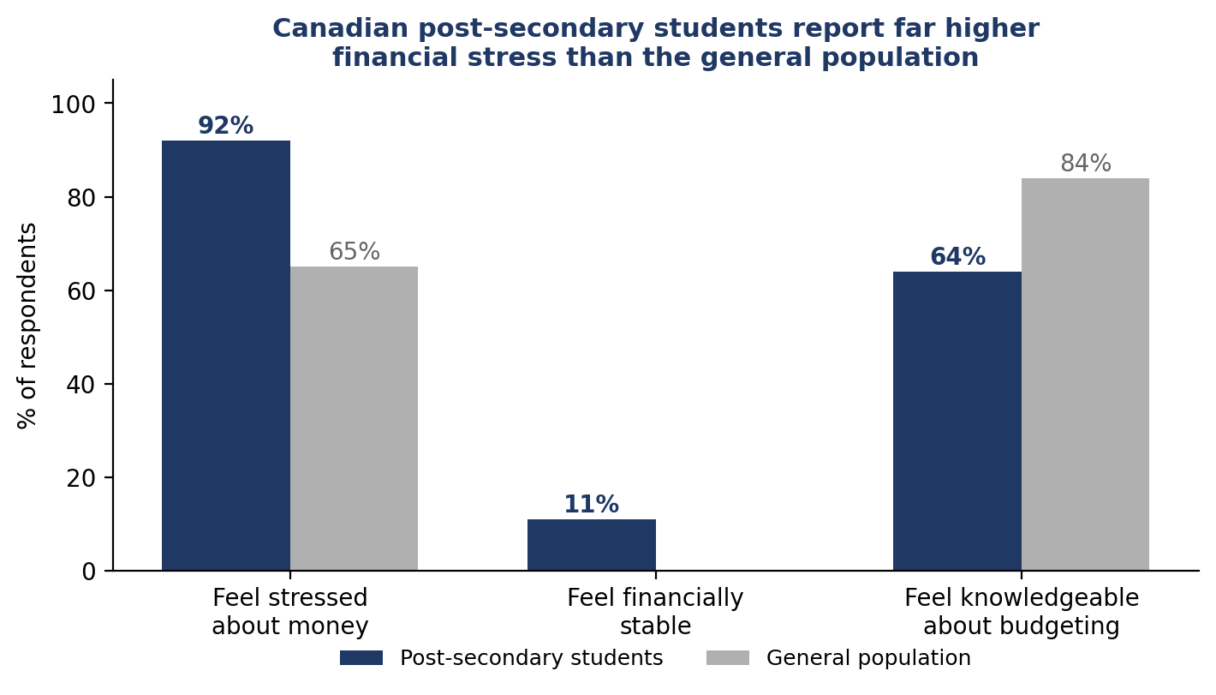
Source: The Harris Poll Canada, national bank-commissioned survey of Canadian post-secondary students and parents, August 2025.
And the cost side keeps going up. The national average tuition for Canadian undergrads is $7,734 for 2025/2026, and in some provinces it's getting close to $10,000, before you even add rent, food, and regular spending. About one in four Canadian students say they've actually thought about dropping out because of money. That's not a small stat.
Meanwhile, almost everyone my age already banks through an app instead of a branch. Close to half of Gen Z does most of their banking on mobile. So the app is already where people are. What's missing isn't the channel, it's the actual help inside it.

The gap
A few Canadian banks already have money apps for kids and teens, usually ages 6 to 17, where a parent funds the account and can see everything. They're actually pretty well designed. But they're built around a parent watching, and that watching stops the second the teen leaves for university. Nobody's really built something for that specific gap, the moment a student moves out and has to build a budget completely alone for the first time.

Why this matters to a bank
- The bank already has these kids as customers through the youth app. In a few years they age into needing a real account anyway, so this is a pretty natural next step if the bank actually builds it.
- If a student opens their first real account somewhere else, they probably won't switch banks again for years. So first year is basically the one shot a bank gets to either win them or lose them.
- With 92% of students stressed about money and only 11% feeling stable, it's a safe bet that overdraft fees and missed payments are a big reason people get frustrated and leave early. I can't confirm that without the bank's actual account data, but it's a strong assumption worth checking (see Section 8).

3. Goals & Success Metrics
Goal | Metric | Target (12 months post-launch)
Smooth the youth-account → adult account transition | % of youth-app users (17–18) who activate an independent chequing account within 6 months of aging out | ≥ 55%
Reduce early financial stress | Overdraft incidents per active first-year user in first 90 days | ↓ 25% vs. cohort baseline
Build a lasting budgeting habit | % of NextStep users with a budget still active at day 90 | ≥ 40%
Prove retention value | 12-month account retention rate, NextStep users vs. non-users | +10 pts higher
Validate satisfaction | In-app NPS from first-year NextStep users | ≥ 45

4. Target Users & Personas

Persona 1: “First-Time Freshman”
Who: 18-year-old, first year away from home at university (e.g., Waterloo, Toronto, Western)
Financial history: Used a youth banking app growing up, or had a parent-supervised account. Never paid rent, a phone bill, or a tuition instalment on their own before
Goals: Avoid embarrassing declines, get a feel for what a “normal” month of spending actually looks like, and stop having to ask parents for help with everything
Frustrations: No idea how to budget for stuff like textbooks or meal plan top-ups. Anxious about overdraft fees. Too proud to keep asking parents for money

Persona 2: “The Long-Distance Parent”
Who: Parent of a first-year student, used to being a co-user on their kid's youth banking app
Goals: Just wants peace of mind their kid won't overdraw or miss a payment, and some visibility without being overbearing about it
Frustrations: Loses all visibility the day their kid turns 18 and opens an adult account. Only finds out about problems after the fact
Quick note: these personas come from research and my own experience going into first year, not from formal interviews yet. Section 9 has the actual testing results.

What I heard early on
Before doing any formal interviews, I just asked three people I know who are about to start first year how they handle money right now. None of them track spending in an app. One writes it down after the fact, and one just uses an AI assistant to track it for them, which tells me people already want automated tracking, their bank just isn't giving it to them. All three said the thing that surprises them most isn't big one-time costs like textbooks, it's small recurring stuff like food delivery and groceries. And all three said they'd actually use a starter budget if it was already built for them, instead of making one from scratch.
I want to be upfront that this is just an early signal, not real proof of anything. It was three casual conversations with people I know, not actual research. But it lines up with the Must-Have features in Section 5 (the starter budget and the weekly summary), and it's exactly the kind of thing the testing in Section 9 is meant to check at a bigger scale.

5. User Stories

Must Have
- As a first-year student, I want a simple starter budget built from my known income (OSAP, job, parental support) and fixed costs (rent, meal plan) so I don't have to build one from scratch.
- As a first-year student, I want a low-balance alert before I actually overdraw, so I can move money or delay a purchase.
- As a first-year student, I want to see a plain-language breakdown of where my money went each week, grouped in terms I understand (food, textbooks, going out).

Should Have
- As a first-year student, I want to set a savings goal (e.g., spring break trip, laptop) and see weekly progress.
- As a former youth-app user, I want my saving habits and goals to carry over automatically instead of starting over in a new app.
- As a first-year student, I want to mark part of my balance as a protected buffer (like an emergency fund) so low-balance alerts reflect what I can actually afford to spend, not my raw balance. (I added this after testing my prototype, see Section 9.)

Could Have
- As a student, I want the option to share a read-only spending summary with a parent, on my terms, so they stay reassured without seeing every transaction.
- As a student, I want short, campus-relevant tips (e.g., cheapest meal plan add-ons, textbook buyback timing) inside the app.

Won't Have (v1)
- Investing or credit-building products. That's a later-phase idea, not something I think belongs in the first release.

6. Feature Requirements (MVP)
Feature | Description | Priority
Guided starter budget | 3-question setup (income sources, fixed costs, campus city) auto-generates a first budget | Must
Low-balance alerts | Push notification when balance is projected to go negative within 3 days | Must
Plain-language spend summary | Weekly digest grouped into student-relevant categories, not generic bank categories | Must
Savings goal tracker | Named goal with a target date and simple progress bar | Should
Youth-app history carryover | Prior savings goals/habits from the bank's youth product pre-populate the new account | Should
Protected buffer for alerts | Lets a student mark an emergency-fund amount as off-limits so low-balance alerts calculate against spendable balance, not raw balance | Should
Optional parent digest | Student-controlled, opt-in, read-only monthly summary sent to a linked parent | Could
Campus cost tips | Short, localized tips tied to the student's school and city | Could

7. Product Roadmap
I lined this up with the school year. Basically, build it through winter and spring so it's ready before the fall move-in rush, since that's when most new students open their first account on their own.
Phase | Timeline | Focus | Key Deliverables
Phase 0: Discovery | Jan – Feb | Validate the problem | Interviews with 15–20 recent youth-app-graduate students; overdraft & churn data review; competitive scan
Phase 1: MVP Build | Mar – May | Build the must-have features | Guided budget, low-balance alerts, weekly spend summary; internal alpha
Phase 2: Campus Pilot | Jun – Aug | Test with a real cohort before move-in | Closed pilot with incoming students at 2–3 partner campuses (e.g., Waterloo, Toronto Metropolitan, Western); iterate on feedback
Phase 3: Fall Launch | Sept | Launch for move-in week | Full rollout to all new youth-app graduates and first-year account openers nationally
Phase 4: Iterate & Expand | Oct – Dec | Add Should/Could features | Savings goals, history carryover, optional parent digest; measure against 12-month KPIs

8. Risks & Assumptions
- Assumption: I'm assuming most incoming students already have, or will open, an account with the bank. I can't actually check this since I don't have access to real account data as an outside project, so this needs to be validated.
- Risk: if the budgeting prompts don't feel clearly optional and student-controlled, they might come off as intrusive, especially the parent-digest feature.
- Risk: the campus pilot only works if partner schools' orientation or residence teams actually help recruit students for it.
- Dependency: the low-balance alerts and spend categories only work if a new feature team can actually access the bank's existing transaction systems.

9. Prototype Testing: Round 1 Results
I actually built a clickable prototype, the starter budget, low-balance alert, weekly summary, and savings goal, and tested it with real incoming first-year students. Round 1 got 7 submissions from 6 different people (one person did it twice and gave the same answers both times).
Tester | Likelihood to use (1–5) | Most useful feature
Kofi Kayden | 4 | Starter budget
Ayaan Vali | 4 | Weekly summary
Grace Green | 4 | Starter budget
M.M. | 4 | Weekly summary
Tim | 4 | Savings goal
Jordan Kessler | 3 | Low-balance alert
The average score for how likely people were to use it was 3.9 out of 5. The weekly spend summary got picked as the favourite feature the most (3 out of 7), then the starter budget (2 out of 7), and the savings goal and low-balance alert each got picked once. That backs up why I made those first two Must-Haves in Section 5.

Where this round falls short
- Small sample, and not random. Everyone who tested it was someone I know, not a real cross-section of incoming students.
- I didn't ask any open-ended questions in this round, just the quick rating and multiple choice. So this tells me people are interested, but not really why.
- One person (M.M.) submitted it twice, so I'm only counting one of their responses to avoid double-counting.
- The lowest score came from Jordan Kessler (3/5), who was most interested in the low-balance alert, so I followed up with them directly. Honestly, figuring out why a skeptical person wasn't fully sold felt more useful than just hearing from people who already liked it.

Something worth changing
When I followed up with them, they told me something pretty specific. The alert, the way I designed it, treats your whole balance as money you can spend. But in real life, people mentally set some of that aside for stuff like emergencies, and that money shouldn't count as “available to spend.” So an alert that ignores that is going to feel annoying or just wrong, even if the math checks out. That's probably why they rated it lower.
That's a fair criticism, not just a personal preference. It points to a real fix for the MVP: let a student set aside part of their balance as a protected buffer, like an emergency fund, and have the low-balance alert ignore that amount when it calculates what's “available to spend.” That way the alert actually reflects real risk instead of just a raw balance. I added this to Section 6 as a new Should-Have feature.

Next step
For round 2, I want to do 8 to 10 real conversations, 10 to 15 minutes each, with a wider group of people, not just people I already know. I'll actually write down quotes this time and ask the lower scorers more questions. The goal is to go from “people rated it okay” to actually understanding why, since that's what Sections 4 and 5 should really be built on.

10. Appendix: Competitive Landscape (Brief)
Bank-owned youth apps: Strong products for ages 6–17, but they're built around a parent supervising. Not made for someone managing money on their own at 18+
Other student account offerings: Mostly just fee waivers and basic chequing accounts. Almost none of them actually help with budgeting for the first-year transition specifically
Gamified financial-literacy apps: This category is growing fast, projected to grow roughly 5x by 2034, but it's focused on general financial education, not connected to a student's actual bank account or their specific campus situation
The opportunity here is that no major Canadian bank has actually built something for that specific first-90-days-away-from-home moment yet.
Sources: The Harris Poll Canada / national bank survey of post-secondary students (Aug. 2025); Statistics Canada, Tuition and Living Accommodation Costs Survey (Sept. 2025); Embark student survey via Leger (2024); Canadian Bankers Association, How Canadians Bank (2026); Intel Market Research, Financial Literacy Gamification App for Gen Z Market Outlook (2026).

