**COMP 3005  
Assignment #5   
Due: March 25**

**Instruction**

1. You should do the assignment independently. Copying is not allowed.
2. The assignment must be typed, completed on an individual basis, and submitted as a single Word/PDF file with your name as the filename to **brightspace**. Scanned handwritten documents *won’t* be accepted. Make sure your uploaded file can be opened and contain everything required.

I don’t know any other way to write this on docx other than writing it using hand. I hope you can accept this submission, next time I will find a better way of doing it.

1. You should directly do your assignment on this document and name the document with your last name followed by your first name so that it is easy for TAs to mark.

**Part 1 ER (10 marks)**Map the generated ER diagram in A4 Part 2 into a relational database schema. (15)

**Part 2 EER (40 marks)**  
Extend the ER Diagram created in A4 Part 2 with the following additional information.

1. A person is either a student or an employee.
2. A student is either an undergraduate student or a graduate student. A graduate student is either a Masters student or Ph.D student.
3. An employee is either a chair, an instructor or a TA who is also a student,
4. A course is either an undergraduate course or a graduate course.
5. An undergraduate course section can have up to 3 TAs who are graduate students and is taken only by undergraduate students.
6. A graduate student takes graduate course sections.
7. Draw the EER diagram for this information system that can represent the constraints specified above. (30)
8. Map the EER diagram into a relational database schema. (15)

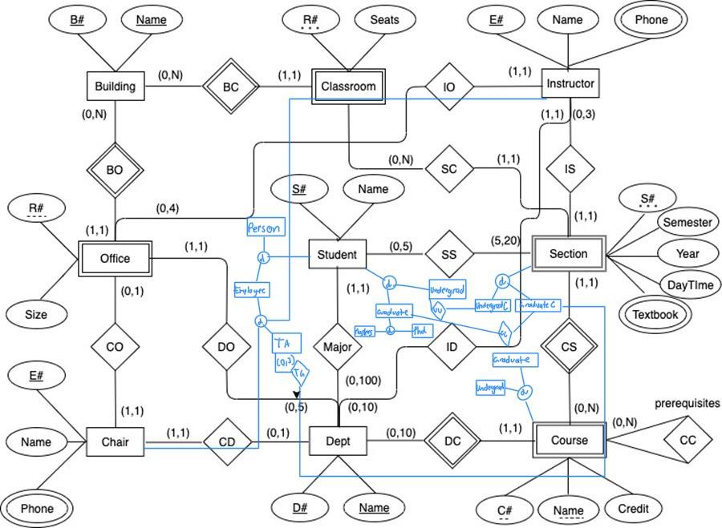

**Part 3. FD (10 marks)**  
Consider the following relation. Which of the following functional dependencies may hold in this relation? If the dependency cannot hold, explain why by specifying the tuples that cause the violation.

|  |  |  |
| --- | --- | --- |
| A | B | C |
| 10 | b1 | c1 |
| 10 | b2 | c2 |
| 11 | b4 | c1 |
| 12 | b3 | c4 |
| 13 | b1 | c1 |

1. A → B
2. B → C
3. C → B
4. B → A
5. C → A

**Part 4 (10 marks)**

|  |  |  |  |  |  |  |  |  |  |  |
| --- | --- | --- | --- | --- | --- | --- | --- | --- | --- | --- |
| **FIRST** | A | B | C | D | E | F | G | H | I | J |

Given a first normal form relation **FIRST** with attributes {A, B, C, D, E, F, G, H, I, J} and the functional dependencies as well as the dependency diagram as follows:

**Functional Dependencies {AB → C, A → DE, B → F, E→D, F → GH, D → IJ}**

**Dependency Diagram**

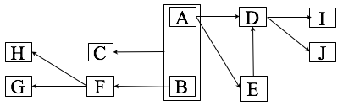

1. What is the key in FIRST? (2 marks)

A and B

1. Normalize FIRST into second normal form by giving the relation names, their attributes with primary keys underscored and foreign keys pointing to the corresponding attributes properly and its dependency diagrams as shown above. (4 marks)

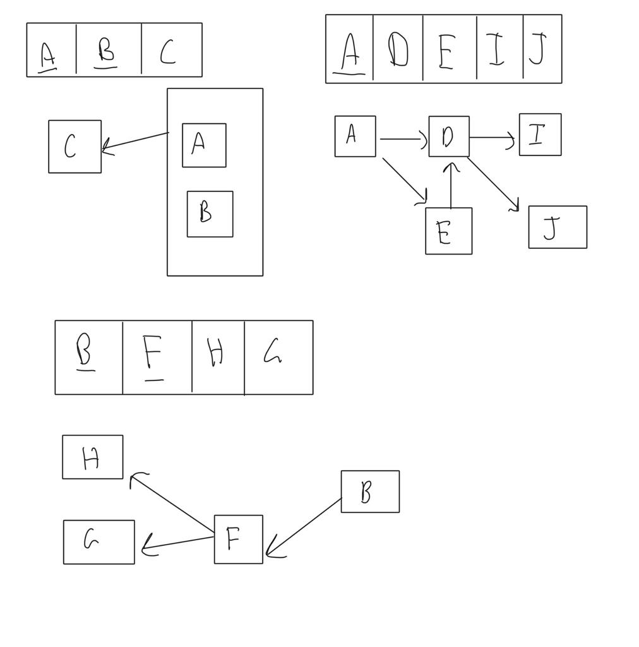

1. Normalize the result in 2 into the third normal form by giving the relation names, their attributes with primary keys underscored and foreign keys pointing to the corresponding attributes properly and its dependency diagrams. (4 marks)

**Part 5 (10 marks)**

Repeat the questions in Part 4 with the following different set of functional dependencies: **{AB → C, BD → EF, AD → GH, A→I, H → J}.**

**Part 6. (10 marks)**

Given a first normal form relation **SECOND** with attributes A, B, C, D, E, and the functional and multi-valued dependencies as well as the functional and the multi-valued dependency diagram as follows:

|  |  |  |  |  |  |
| --- | --- | --- | --- | --- | --- |
| **SECOND** | A | B | C | D | E |

**Functional Dependencies {AB → C, C → B}**

**Multivalued Dependencies {C →→ D, C→→ E}**

**Dependency Diagram**

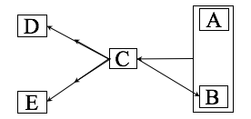

1. What is the key in SECOND? (2 marks)

A and B

1. What is the highest normal form this relation is in? (2 marks)

3rd normal form

1. Normalize SECOND into BCNF by giving its relation names, their attributes with primary keys underscored and foreign keys pointing to the corresponding attributes properly and its dependency diagrams as showing above. (4 marks)

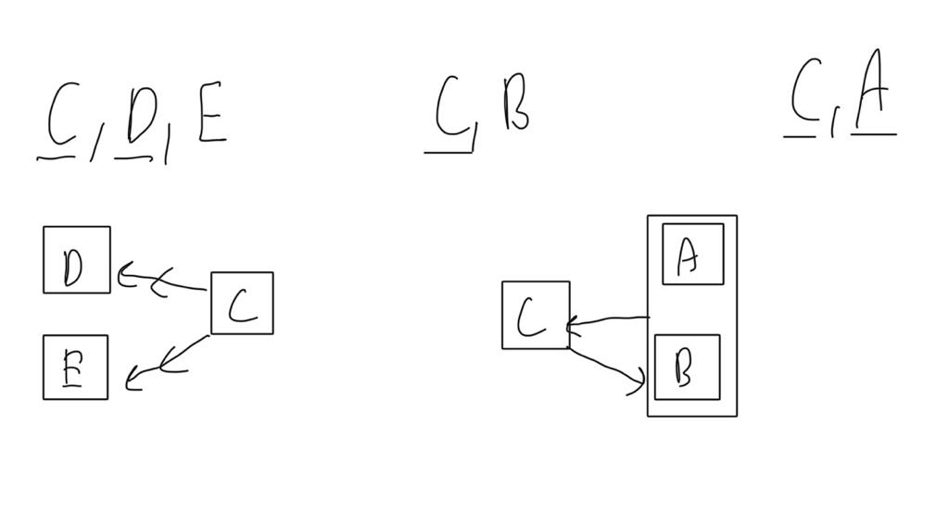

1. Normalize the result in question 3 into the fourth normal form by giving its relation names, their attributes with primary keys underscored and foreign keys pointing to the corresponding attributes properly and its dependency diagrams. (4 marks)

**Part 6. FD/MVD (10 marks)**

Given the following inference rules:

(R0) X → XX

(R1) if X ⊇ Y, then X → Y

(R2) X → Y ⊨XZ → YZ

(R3) X → Y, Y → Z ⊨ X → Z

Prove or disprove the following inference rules for functional/multi-valued dependencies.

1. X → Y and Z ⊆ Y and W ⊆ Z ⊨X → W

2. X → Y, Z → Y ⊨X → Z

3. X → Y, XY → Z ⊨ X → Z

4. X →→ Y ⊨X → Y

5. X → Y, Z → W ⊨ XZ → YW