# Department of Computing

# 

**CS260: Human-Computer Interaction**

**Class: BESE 12AB**

**Lab 01: Introduction to HCI**

**Date: 29th Feb 2024**

**Time: 10:00am -12:50pm /02:00pm-05:00pm**

**Instructor: Dr. Mehvish Rashid**

**Dr. Hasan Tahir Butt**

## Lab 1: Introduction to HCI

**Introduction:**

Human-Computer Interaction (HCI) Lab, where students will embark on an exploration of Qalam operations and Learning Management Systems (LMS). This lab aims to provide hands-on experience in understanding, quantifying, and optimizing user interactions through innovative technologies.

**Objectives:**

Explore end-to-end usage scenarios for both Qalam and LMS.

Analyze and compare the number of clicks required for tasks using Qalam and LMS

Identify areas for optimizing user experiences, particularly in educational contexts facilitated by LMS.

**Tools and Techniques**

Qalam Operations: Students will engage with Qalam, and understand its features and capabilities.

Learning Management Systems (LMS): Explore user interactions within an LMS environment.

**Click Tracking:**

Utilize click tracking methodologies to quantify and compare the number of clicks for various tasks.

**Description:**

Students will first delve into the intricacies of Qalam operations, gaining insights into its unique functionalities. Subsequently, they will explore Learning Management Systems, focusing on the HCI aspects of educational interactions. The lab will employ click tracking to measure the efficiency of user interactions.

**Tasks:**

**Qalam Exploration:**

Familiarize students with Qalam's design and functionalities.

Explore practical applications and scenarios for Qalam operations.

**LMS Integration:**

Understand the integration of Learning Management Systems in the HCI landscape.

Engage with educational content and navigate LMS interfaces.

**Student-Selected Process:**

Students will select a specific process within the LMS for completion.

Measure and document the number of clicks required to accomplish the selected process.

Some of the processes are as under for Qalam and LMS.

**Qalam:**

**Results**

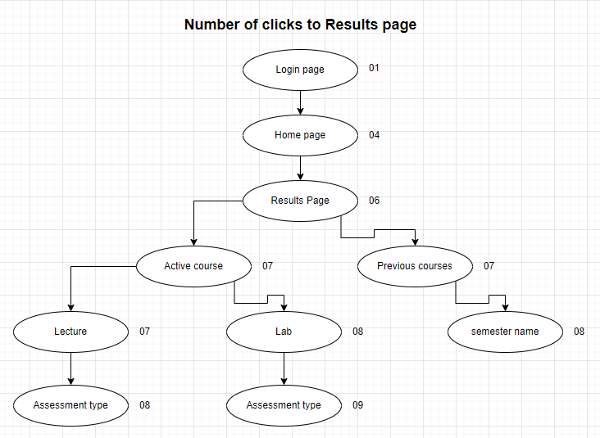

**How to improve:**

We can improve this by showing active course names on home page and also showing a button along with the active course name to show it results.

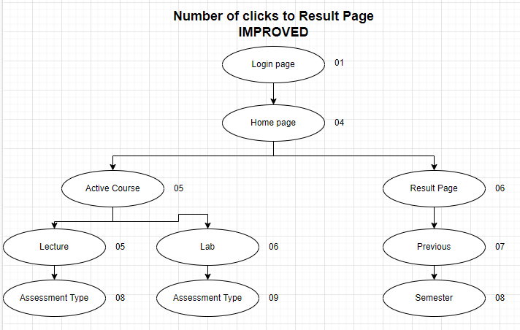

**Attendence**

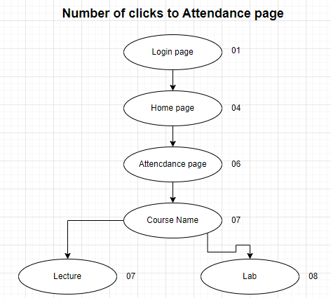

**How to improve:**

We can improve this by showing active course names on home page and also showing a button along with the active course name to show its attendance.

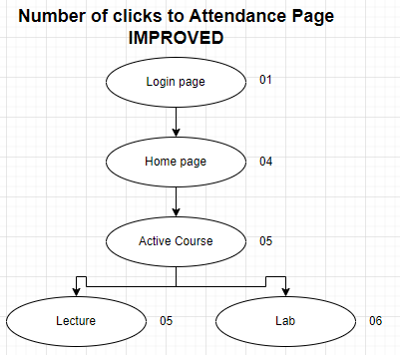

**Mess Invoices**

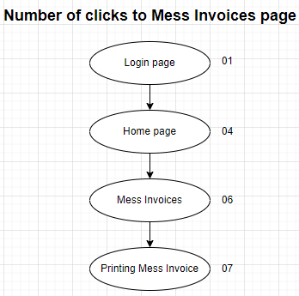

**Remark:**

In my opinion, No improvement is required.

**Fee Invoices**

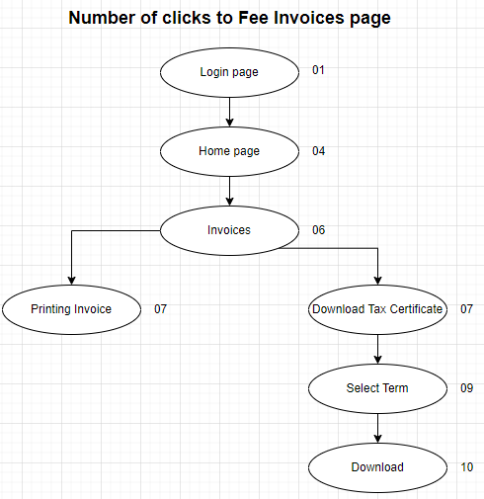

**Remark:**

In my opinion, No improvement is required.

**Transcript Request**

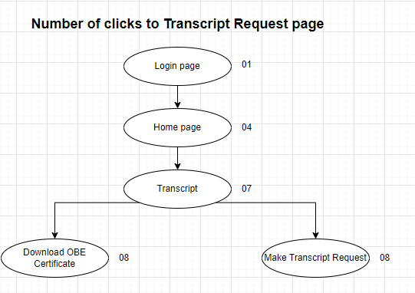

**Remark:**

In my opinion, No improvement is required.

**Class Schedule**

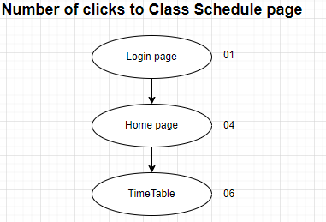

**How to improve:**

It can be improved by showing a simplified version of time table on Home Page.

**Lms:**

**Course Enrollment**

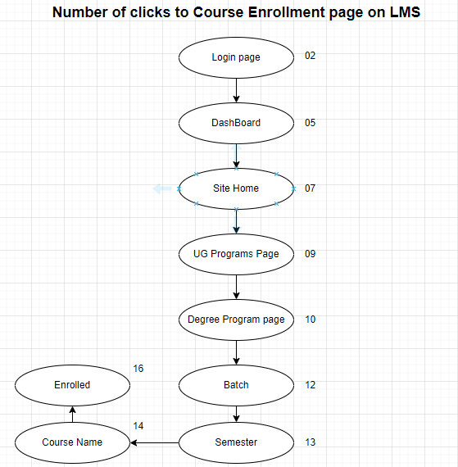

**How it is improved:**

We can improve our experience such that when a new semester starts we should see our new courses on the Dash Board which we can enroll by clicking on the them directly. Once enrolled they should become enrolled links.

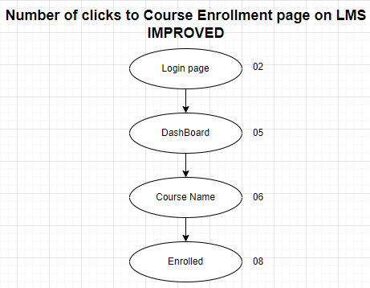

**Course content**

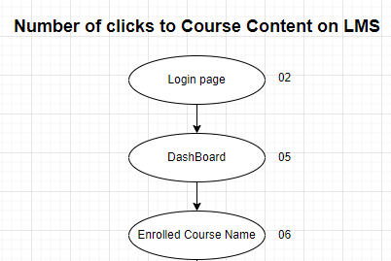

**Remark:**

In my opinion, No improvement is required.

**Assignment**

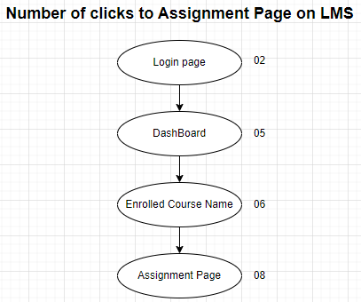

**Remark:**

In my opinion, No improvement is required.

**Online Quiz**

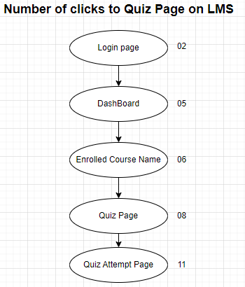

**How to Improve:**

The only improvement I can think of is that when we open the quiz page the cursor should be focused on input box to enter password. This way we just need to click “Start quiz” button only after we type password.



09

**IMPROVED**

**Deliverables**

Compile a single Word document by filling in the solution/answer part (as directed) along with the snapshots. Name your submission file as given below and submit this Word file on LMS before the deadline.

**Lab Rubrics**

|  |  |  |  |  |  |
| --- | --- | --- | --- | --- | --- |
|  | **Assessment** | **Does not meet**  **expectation**  **(0.5 marks)** | **Meets expectation**  **(1 marks)** | **Exceeds**  **expectation**  **(2 marks)** | **Obtained Marks** |
| **1** | **Software**  **Problem**  **Realization** | The student is unable to understand the given problem and does not select the relevant method to solve it. Moreover, program flow diagrams and pseudo codes are missing or incomprehensible. | The student requires some guidance to understand the problem, to select relevant method, and to develop appropriate program flow diagrams and pseudo codes. | The student fully understands the given problem, is able to select the relevant method to solve it, and develops detailed program flow diagrams and pseudo codes |  |
| **2** | **Coding Style & Documentation** | The student has not followed naming conventions and has randomly assigned variable/function names. Program description in the form of comments is not provided. Inputs/ outputs of program/ functions are not documented. Codes are non-modular and cannot be reused. | The student assigned generic but appropriate variable/function names. He/she has provided some code description in the form of comments. Inputs/outputs of program/functions are sufficiently documented. Codes are semi-modular and semi-reusable. | The student uses correct naming conventions for variable/function names and provides detailed descriptions in the form of comments. Inputs/ outputs of program/ functions are documented in detail. Codes are modular, reusable, and easily readable. |  |
| **3** | **Software Tool**  **Usage** | The student has no idea on how to use the basic tools of the software. The codes have syntax errors, and parts of the coding are missing. | The student has a limited command on the basic tools of the software. The codes are correct in terms of their syntax; however, the program output is not always correct. | The student has full command on various tools available in the software. Furthermore, his/her coding is complete and functional, and the program output is correct. |  |
|  |  |  |  |  |  |
| **4** | **Ethics and**  **Adherence**  **to Laboratory Safety Rules** | Disturbs the lab environment, doesn’t take care of safety measures, and/or isn’t punctual | does not disturb the lab environment, takes care of safety measures, and is punctual | Encourages others to maintain lab decorum, and alerts them to follow safety measures. |  |
| **5** | **Individual and Team work** | Distracts or discourages other group members from conducting the experiment. Can’t perform well both  individually and as part of a team | Cooperates with other group members in a reasonable manner. Performs well individually and in a team | In addition to performing well individually and in team, also provided leadership in the team. Actively engages  and cooperates with other group members in an effective manner |  |

# Department of Computing

# 

**CS260: Human-Computer Interaction**

**Class: BESE 12AB**

**Lab 01: Introduction to HCI**

**Date: 29th Feb 2024**

**Time: 10:00am -12:50pm /02:00pm-05:00pm**

**Instructor: Dr. Mehvish Rashid**