Semester Project Report





**Submitted By:**

Affan Hameed. 22i-2582

Shoaib Mehmood, 22i-2448

Bilal Mehmood, 22i-2452

**CS 2009 Design and Analysis of Algorithms**

**Semester Project**

**Algorithm Analysis Report**

Submitted to Sir Bilal Khalid Dar

Date: May 9th, 2025

# Introduction

The following is the work division for this project:

1. Member 1 - Affan Hameed, 22i-2582
2. Member 2 - Bilal Mehmood, 22i-2452
3. Member 3 - Shoaib Mehmood, 22i-2448

# Machine Specifications

The machine that was used for this project for the purpose of testing all the member’s algorithms against the selected dataset has the following specifications:

* Processor: Core i7 11th Generation
* Memory: 16 GB DDR4 at 3200 Mhz
* Graphics: Intel Iris Xe Graphics

# Complete Algorithms with Time Complexity Analysis

## Member 1 Code and TC Analysis:

| Algorithm Name | Best Case TC | Worst Case TC | Average Case TC |
| --- | --- | --- | --- |
| Dijkstra | O((nodes+edges) log ⁡nodes) | O((nodes+edges) log⁡ nodes) | O((nodes²)log ⁡nodes) |
| Bellman Ford | O(edges+nodes²) | O(edges*nodes) | O(edges*nodes) |
| Diameter of Graph | O(nodes) | O(nodes) | O(nodes) |

## Member 2 Code and TC Analysis:

| Algorithm Name | Best Case TC | Worst Case TC | Average Case TC |
| --- | --- | --- | --- |
| Prims | O(nodes²) | O(nodes²) | O(nodes²) |
| Kruskals | O(edges* log(⁡edges)) | O(edges* log(⁡edges)) | O(edges* log(⁡edges)) |
| Avg Degree | O(nodes) | O(nodes) | O(nodes) |

## Member 3 Code and TC Analysis:

| Algorithm Name | Best Case TC | Worst Case TC | Average Case TC |
| --- | --- | --- | --- |
| BFS | O(nodes) | O(nodes+edges) | O(nodes+edges) |
| DFS | O(nodes) | O(nodes+edges) | O(nodes+edges) |
| Cycle Detection | O(nodes+E) | O(nodes+edges*log(edges)) | O(nodes³) |

# Dataset Details

This is who-trusts-whom network of people who trade using Bitcoin on a platform called Bitcoin Alpha. Since Bitcoin users are anonymous, there is a need to maintain a record of users' reputation to prevent transactions with fraudulent and risky users. The details for the dataset are as follows:

* Total Nodes = 7605
* Total Edges = 24,186
* Weight Range = +1 to +10

# Comparison of Algorithms Using Plots of Results

## Member 1

### Directed Graph

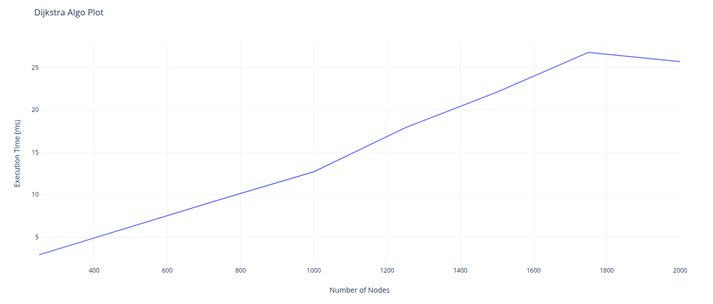

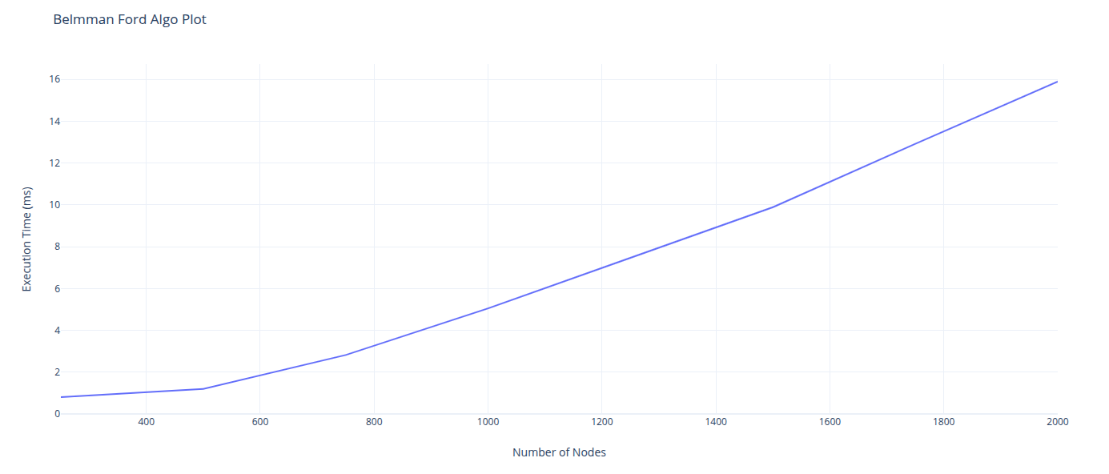

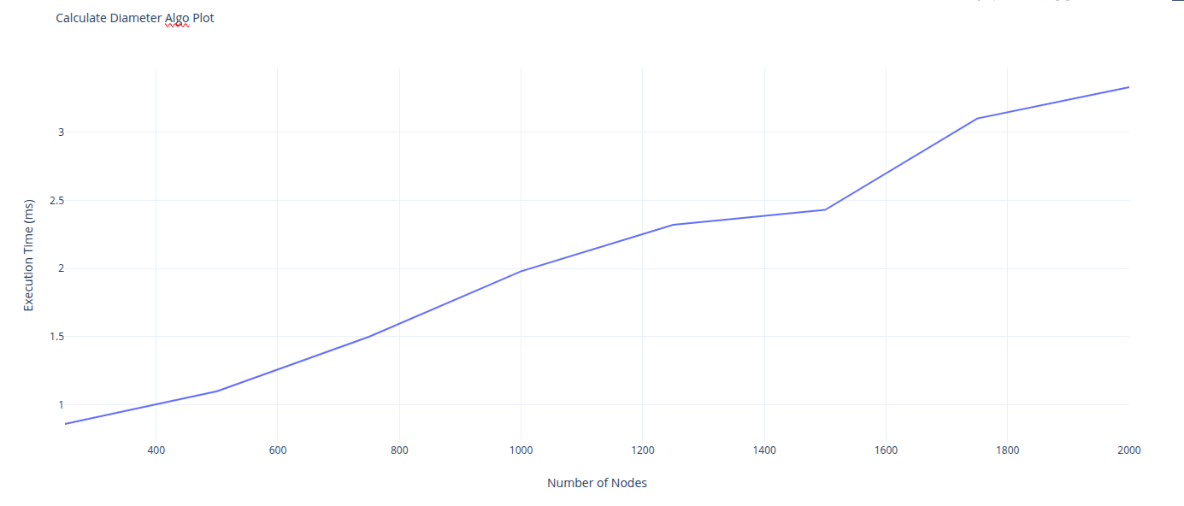

## Member 2

### Undirected Graph (except for average degree)

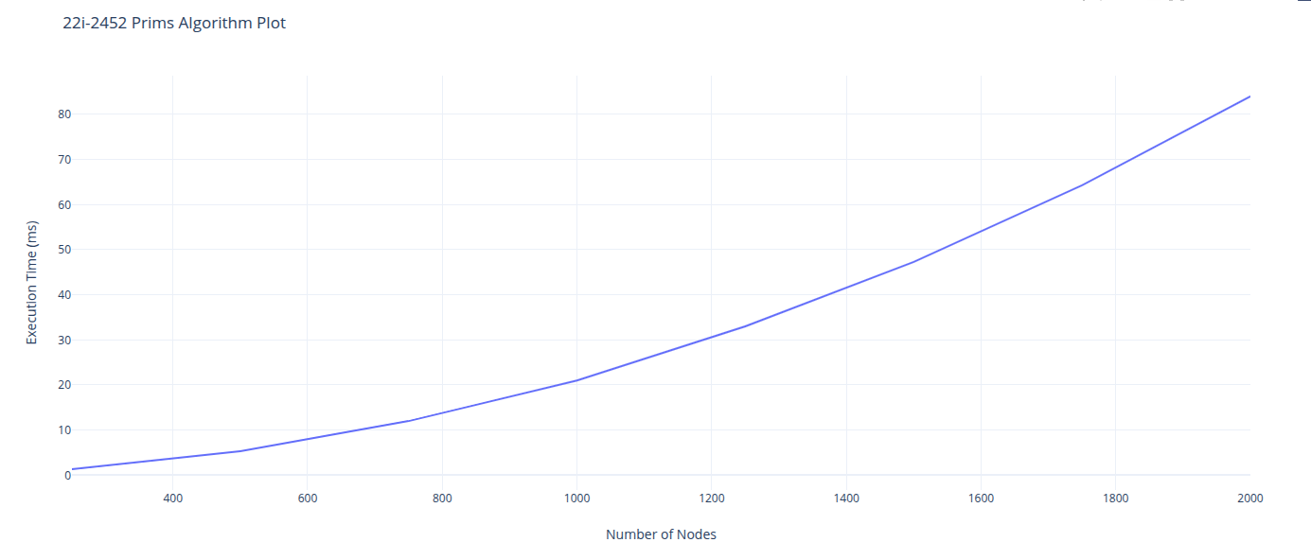

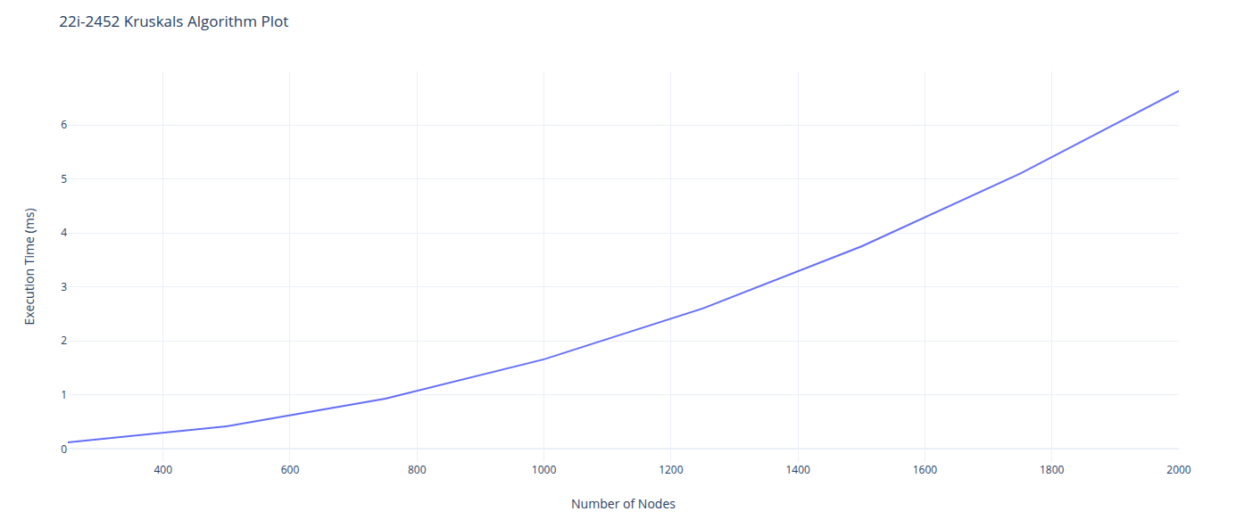

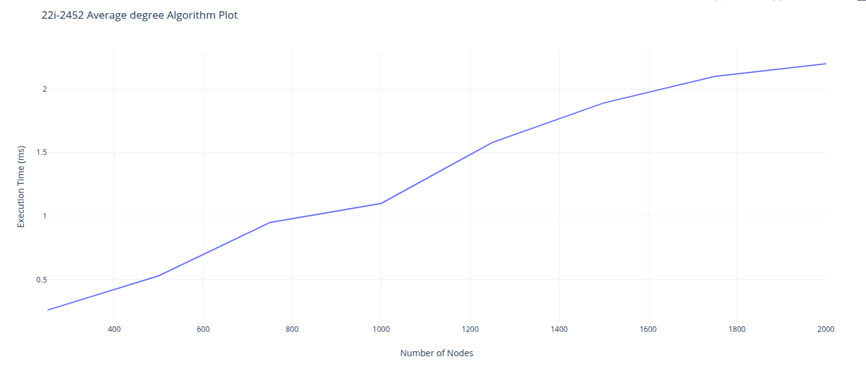

## Member 3

### Undirected Graph (except for cycle detection)

