# **Introduction**

# dual-tone mutifrequency (DTMF) signaling , increasingly being employed worldwide with push-button telephone sets, offers a high dialing speed over the dial-pulse signaling used in conventional rotatary telephone sets. in recent years, dtmf signaling has also found applications requiring interactive control such as in voice main, electronic mail (e-mail), telephone banking , and ATM machines.

# **DTMF**

* A dual tone mutifrequency signal consists sum of two tones with frequencies taken from two mutually exclusive groups of preassigned frequencies.
* Each pair of such tones represents a unique number or a symbol.
* Decoding of a DTMF signal thus involves identifying the two tones in that signal and determining their corresponding number or symbol.
* Frequencies allocated to the various digits and symbols of a push-button keypad are internationally accepted standards.

# **WORKING**

When you press the buttons on the keypad, a connection is made that generates two tones at the same time. A “Row” tone and a “Column” tone. These two tones identify the key you pressed to any equipment you are controlling. If the keypad is on your phone, the telephone company’s “Central Office” equipment knows what numbers you are dialing by these tones, and will switch your call accordingly. If you are using a DTMF keypad to remotely control equipment, the tones can identify what unit you want to control, as well as which unique function you want it to perform. When you press the digit 1 on the keypad, you generate the tones 1209 Hz and 697 Hz. Pressing the digit 2 will generate the tones 1336 Hz and 697 Hz. Sure, the tone 697 is the same for both digits, but it take two tones to make a digit and the decoding equipment knows the difference between the 1209 Hz that would complete the digit 1, and a 1336 Hz that completes a digit 2.

|  |  |  |  |
| --- | --- | --- | --- |
| 1 | 2 | 3 | **697 Hz** |
| 4 | 5 | 6 | **770 Hz** |
| 7 | 8 | 9 | **852 Hz** |
| * | 0 | # | **941 Hz** |
| **1209 Hz** | **1336 Hz** | **1477 Hz** |  |

Mark and Space refer to the duration a DTMF tone is produced, as well as the duration of the silence between individual digits. 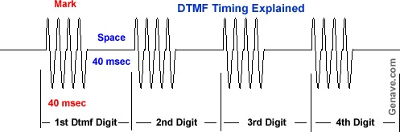

# **simulation and discussion on results**

There is two different frequencies for eeach button one is higher and one is lower for example followind is for button 4. First we take input from user, convert it into closley likely integer (K). There is pre defined sets one for lower frequincuws set one is higher frequencies set.

