Business Report: Regulation Chatbot API Project
Prepared by: AI Team
Date: October 2025

1. Introduction
The Regulation Chat-bot API Project is designed to simplify the process of interacting with Anti-Money Laundering (AML) regulatory documents. It enables organizations to upload, analyze, and query regulations efficiently using advanced AI models integrated through RAG (Retrieval-Augmented Generation). The system also extracts compliance requirements and converts them into actionable tasks to support compliance departments.

2. Project Objective
The primary objective of this project is to automate regulatory compliance processing through natural language interactions. By leveraging AI-driven document understanding, the chat-bot minimizes human effort in searching, interpreting, and implementing financial compliance regulations.

3. System Overview
The Regulation Chat-bot API back-end provides REST-based endpoints that allow users to:
- Upload and vectorize regulatory documents (PDF/JSON).
- Ask questions about AML regulations using context retrieval.
- Extract regulatory requirements and generate actionable compliance tasks.
- List all vectorized document chunks.
Each endpoint operates in JSON format and follows standard REST principles.

4. Key Features
1. Upload & Vectorization: Handles document upload and chunk-level vectorization.
2. Question Answering: Allows users to ask regulatory questions through RAG.
3. Requirement Extraction: Automatically extracts obligations and compliance statements.
4. Task Generation: Converts requirements into detailed actionable tasks.
5. Guardrails Integration: Protects the LLM from unsafe or irrelevant prompts.

5. Technical Implementation
The back-end is implemented using Python and Fast-API. The system includes Guardrails AI integration for prompt safety and validation. Each function corresponds to a REST endpoint that performs a specific role in the data processing workflow.

6. API Endpoints Summary
Endpoint | Method | Purpose
/upload_and_vector | POST | Uploads and vectorizes regulatory documents
/ask | POST | Answers queries using RAG
/requirements | POST | Extracts regulatory requirements from LLM response
/actions | POST | Generates actionable tasks from requirements
/ | GET | Lists all vectorized document chunks

7. System Demonstration
Below are the screenshots of API responses demonstrating system functionality:
Question Answering Output
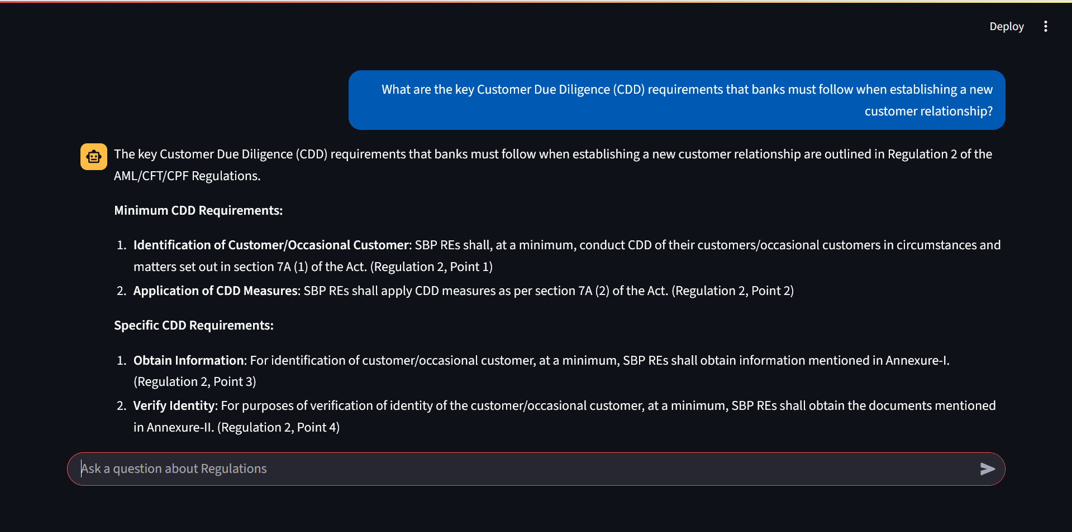
Requirements Extraction Output
- 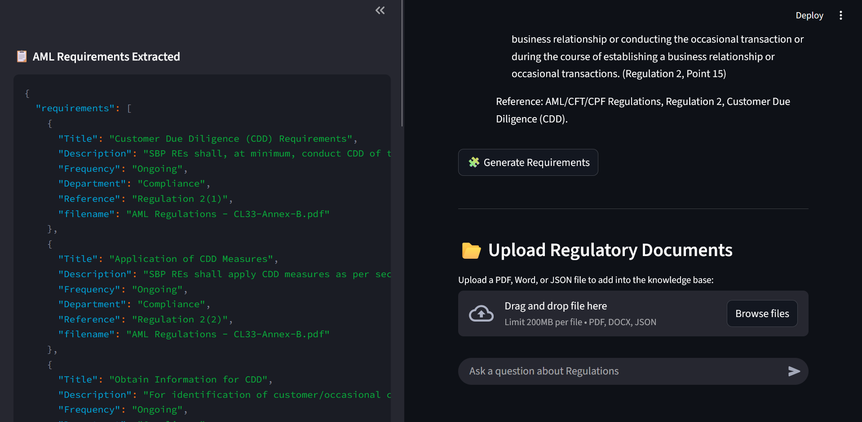
Action Generation Output

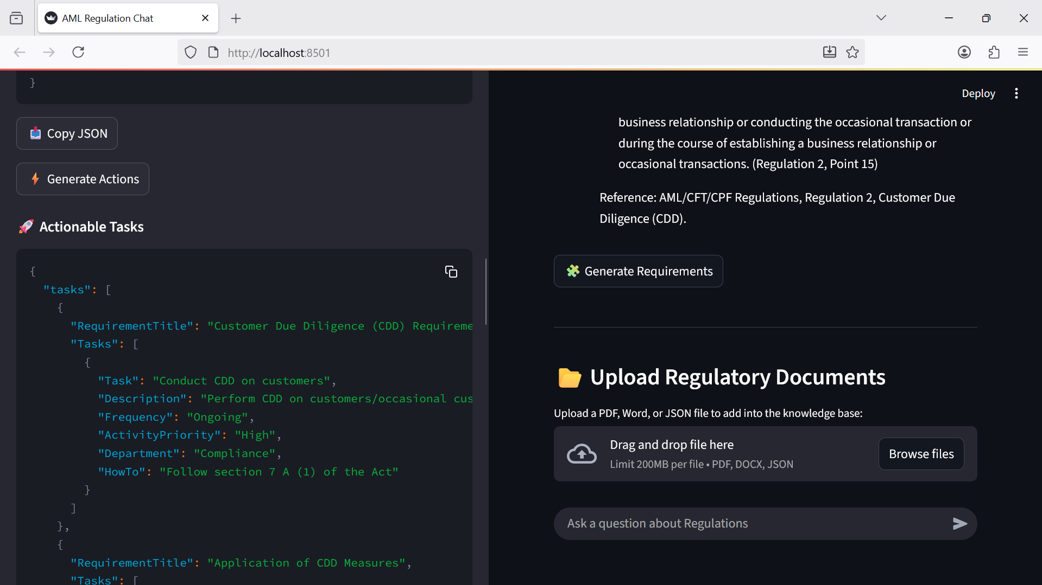

8. Business Impact
The chat-bot streamlines compliance management by reducing manual interpretation time of regulations. Financial institutions can now:
- Ensure consistent application of AML regulations.
- Enhance accuracy of compliance task tracking.
- Improve productivity of regulatory teams.
- Reduce risk of non-compliance penalties.

9. Conclusion
The Regulation Chat-bot API is a robust AI-powered back-end solution that leverages RAG for intelligent regulatory document processing. Its modular design allows easy expansion to other domains like tax compliance or policy review. The integration of Guardrails ensures reliability and safety across user interactions.

