# Attendee Interfaces

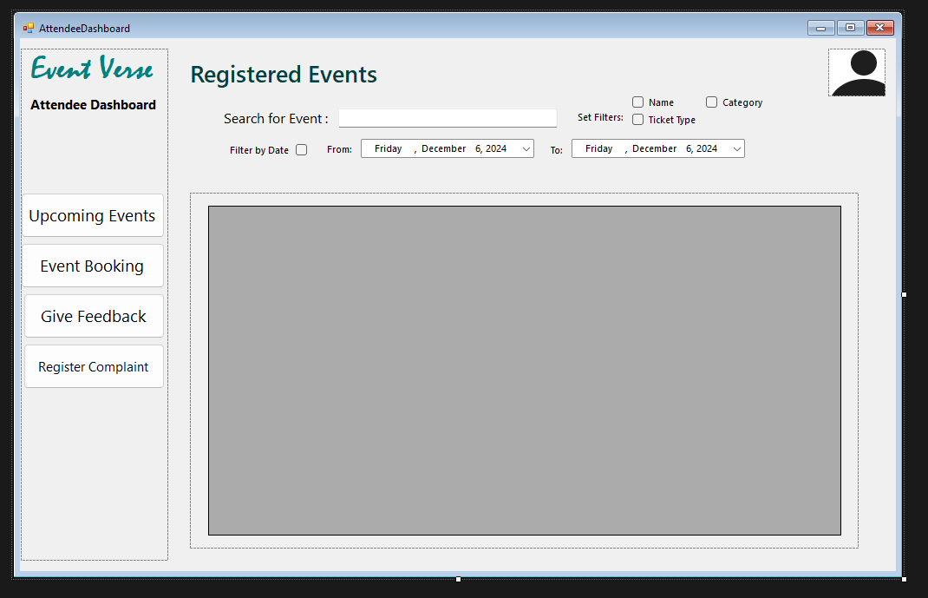

# Organizer Interface:

# User Interfaces:

