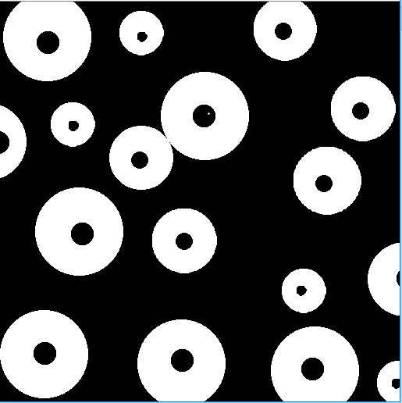

Figure : INPUT IMAGE



Figure : OUTPUT of fig01.tif



Figure : OUTPUT of fig02.tif