Muhammad Affan Khan

19P-0045

BS(CS) 5-A

Client to Server Messages

Server

import socket

import threading

s=socket.socket()

print(“Soceket has been created”)

s.bind((‘’,12345))

s.listen(5)

print (“socket is listening”)

c,addr=s.accept()

print (‘Got connection from’, addr )

c.send(‘Thank you for connecting’.encode())

def received():

while(True):

data=c.recv(1024).decode()

print(data)

def send():

while(True):

msg=input(“Enter your Message”)

c.send(msg.encode())

# a=input(“For exit press 0”)

if __name__==”__main__”:

t1=threading.Thread(target=received,args=””)

t2=threading.Thread(target=send,args=””)

t1.start()

t2.start()

t1.join()

t2.join()

c.close()

**Client**

import socket

# Create a socket object

s = socket.socket()

import threading

port = 12345

# connect to the server on local computer

s.connect(('127.0.0.1', port))

# receive data from the server and decoding to get the string.

def recived():

while(True):

print (s.recv(1024).decode())

def send():

while(True):

msg=input("Enter your Message")

s.send(msg.encode())

if __name__=="__main__":

t1=threading.Thread(target=recived,args="")

t2=threading.Thread(target=send,args="")

t1.start()

t2.start()

t1.join()

t2.join()

s.close()

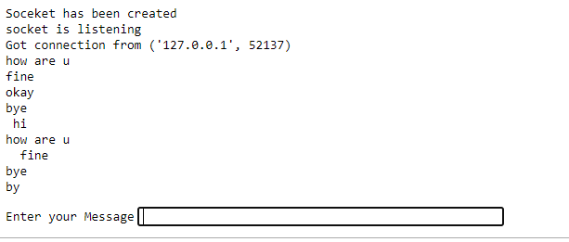

**Q#2**

**FTP Protocol**

**Server**

import socket

import threading

import os

class Server:

def __init__(self):

self.s = socket.socket(socket.AF_INET,socket.SOCK_STREAM)

self.accept_connections()

def accept_connections(self):

ip = socket.gethostbyname(socket.gethostname())

port = int(input('Enter desired port --> '))

self.s.bind((ip,port))

self.s.listen(100)

print('Running on IP: '+ip)

print('Running on port: '+str(port))

while 1:

c, addr = self.s.accept()

print(c)

threading.Thread(target=self.handle_client,args=(c,addr,)).start()

def handle_client(self,c,addr):

data = c.recv(1024).decode()

if not os.path.exists(data):

c.send("file-doesn't-exist".encode())

else:

c.send("file-exists".encode())

print('Sending',data)

if data != '':

file = open(data,'rb')

data = file.read(1024)

while data:

c.send(data)

data = file.read(1024)

c.shutdown(socket.SHUT_RDWR)

c.close()

server = Server()

**Client**

import socket

import os

class Client:

def __init__(self):

self.s = socket.socket(socket.AF_INET,socket.SOCK_STREAM)

self.connect_to_server()

def connect_to_server(self):

self.target_ip = input('Enter ip --> ')

self.target_port = input('Enter port --> ')

self.s.connect((self.target_ip,int(self.target_port)))

self.main()

def reconnect(self):

self.s = socket.socket(socket.AF_INET,socket.SOCK_STREAM)

self.s.connect((self.target_ip,int(self.target_port)))

def main(self):

while 1:

file_name = input('Enter file name on server --> ')

self.s.send(file_name.encode())

confirmation = self.s.recv(1024)

if confirmation.decode() == "file-doesn't-exist":

print("File doesn't exist on server.")

self.s.shutdown(socket.SHUT_RDWR)

self.s.close()

self.reconnect()

else:

write_name = 'from_server '+file_name

if os.path.exists(write_name): os.remove(write_name)

with open(write_name,'wb') as file:

while 1:

data = self.s.recv(1024)

if not data:

break

file.write(data)

print(file_name,'successfully downloaded.')

self.s.shutdown(socket.SHUT_RDWR)

self.s.close()

self.reconnect()

client = Client()

