MUHAMMAD AFFAN KHAN  
19P-0045

BS(CS)

Section:3B

Code 1:

[org 0x0100]

xor ax, ax ; check effect on ZF

mov bx, num1

add ax, [bx]

add bx, 2

add ax, [bx]

add bx, 2

add ax, [bx]

add bx, 2

mov [result], ax

mov ax, 0x4c00

int 0x21

; to turn this into an iteration, we need a couple of things:

; - branching instruction

; - checking constraints -- e.g. c > 0 ; Intel Sotware Developer Manual - Figure 3-8 (Page 80)

num1: dw 5, 10, 15

result: dw 0

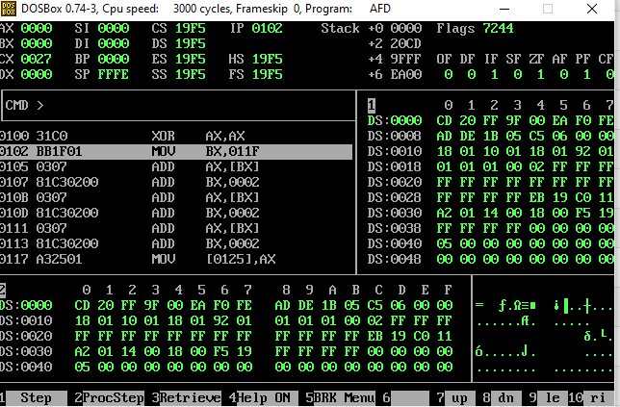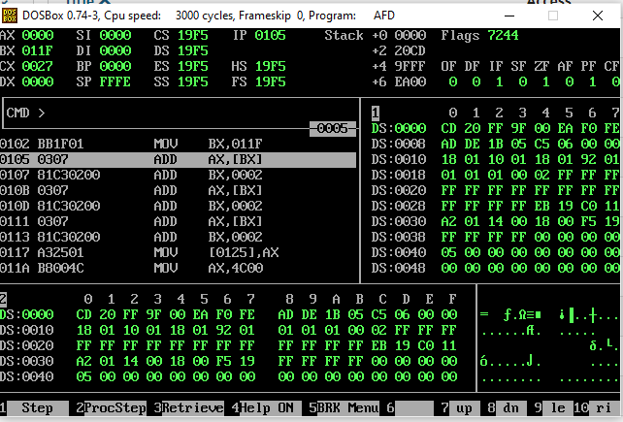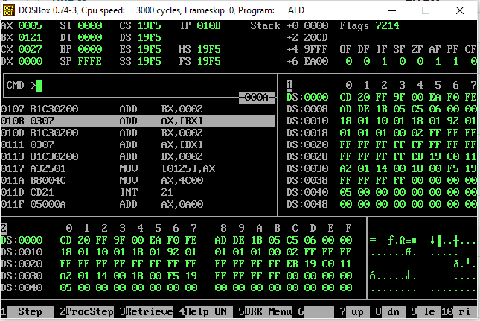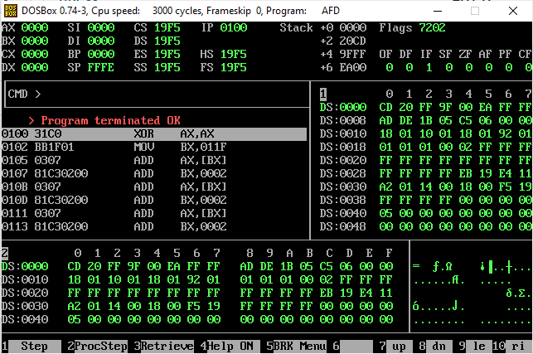

Code 2:

org 0x100

mov ax,0

mov cx,6

l:

add ax,6

sub cx,1

jnz l

mov ax, 0x4c00

int 0x21

