Section: B

Members: Affaq Ahmed (18L-1141) 🡪 GUI

Muhammad Hassan (18L-1102) 🡪 Console

Muhammad Qasim (18L-1101) 🡪 Database

Khizer Amjad (18L-1007) 🡪 Plaintext

Combined 🡪 BL

DB interface

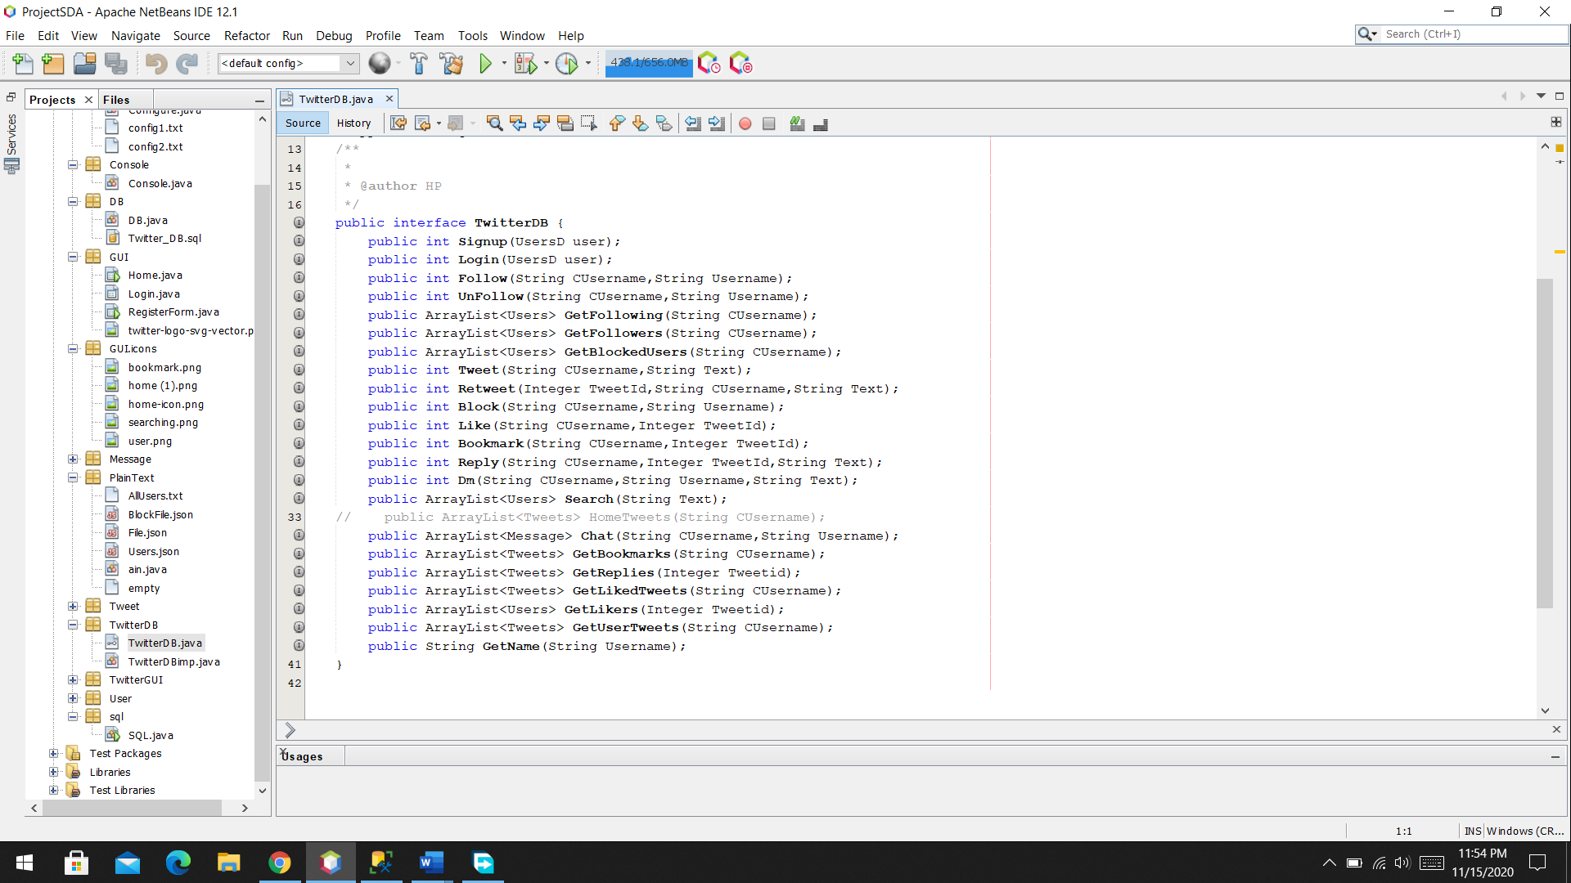

GUI interface

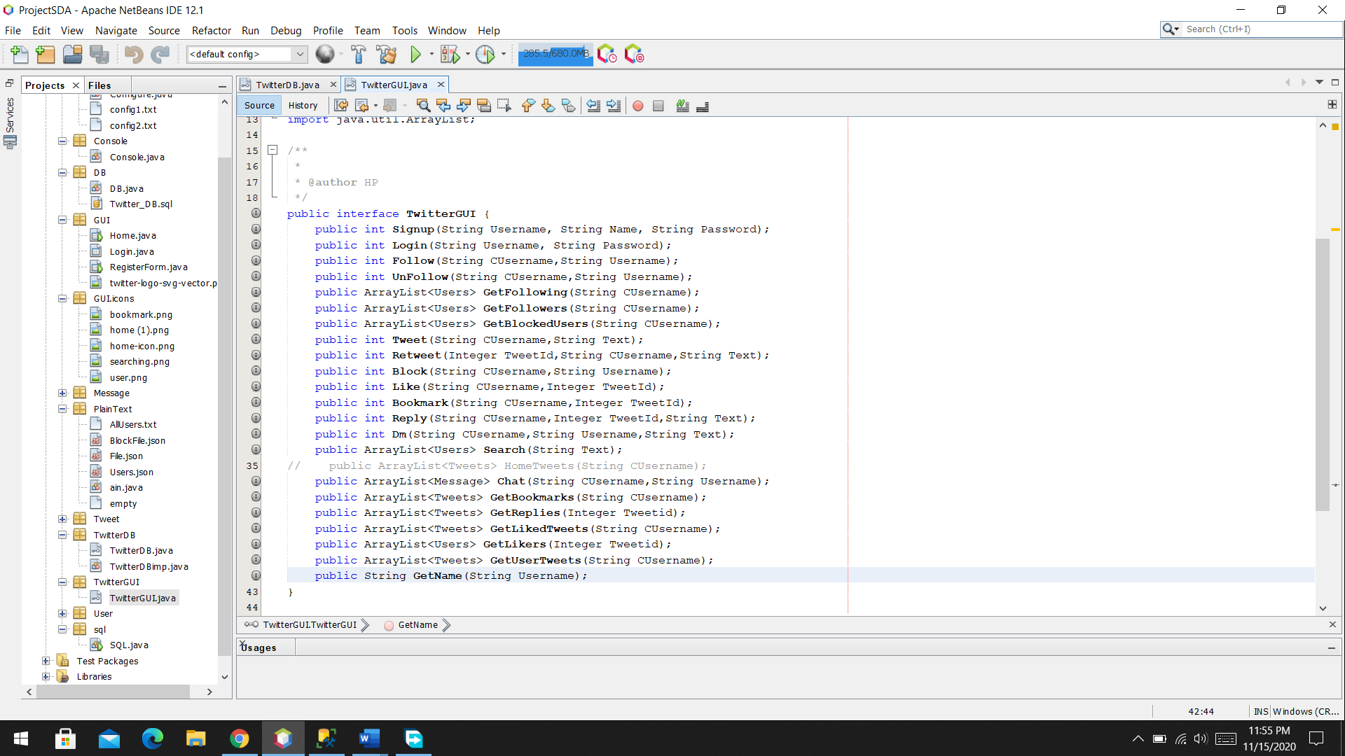

Layer instruction:

Config1 file store the info about User interface store ‘c’ for Console and ‘g’ for GUI.

Config2 file store the info about database store ‘d’ for SQL db and ‘f’ for Filing.