# FIRJA AL

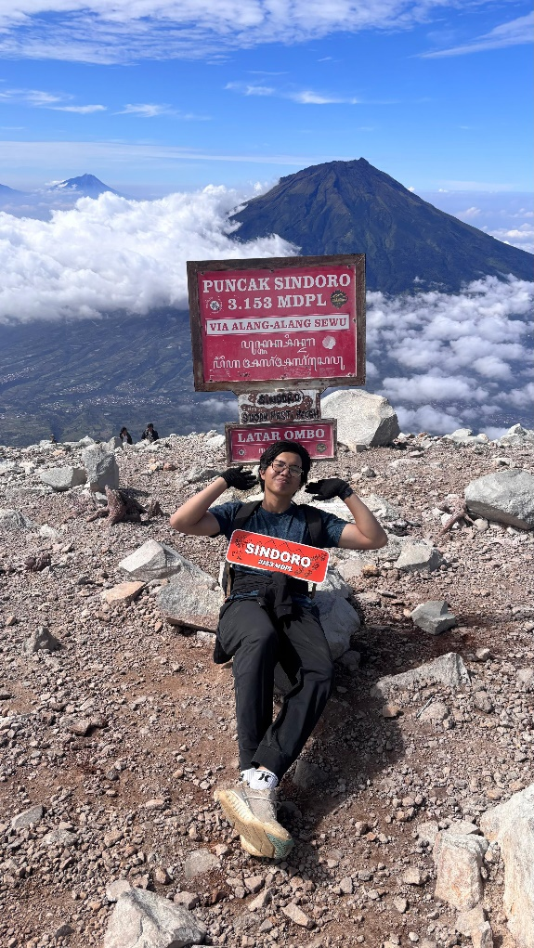

# GHIFARI

WEB DEVELOPER

I am a dynamic Computer Science student with three core interests: web development, media design, and manufacturing technology. I am passionate about media design for creating engaging interfaces and enthusiastic about learning how technology can optimize manufacturing processes. Seeking an internship opportunity to combine my technical skills and industry insights

CONTACT

## LIFE EXPERIENCE

Volunteer of Cleanup Track Mandiri Jogja / 21st June 2025

+62 877 6917 7763

Social Media Designer, HMI Faculty Chapter

2025 – Now

Managed the social media presence for the HMI Chapter for the Faculties of Social-Humanities and Science & Technology, designing all visual content for events, announcements, and local recruitment campaigns.

firja.al2005@gmail.com

## SKILLS



Leadership

Javascript

CSS

 Word Canva

 HTML



Teamwork

Management

COVER LETTER BY

# FIRJA AL GHIFARI

WEB DEVELOPER

DEAR MR. JOHN

I AM WRITING TO EXPRESS MY INTEREST IN OPPORTUNITIES AT YOUR COMPANY. YOUR COMPANY IS KNOWN FOR ITS INNOVATION, PROFESSIONALISM, AND RESULTS-DRIVEN MARKETING STRATEGY, AND I AM CONFIDENT THAT I WOULD BE A VALUABLE ADDITION TO YOUR TEAM. I HAVE ENCLOSED MY RESUME FOR YOUR CONSIDERATION AND AM EAGER TO LEARN MORE ABOUT THE COMPANY AND ANY AVAILABLE POSITIONS.

I AM CONFIDENT THAT MY EXPERIENCE IN THIS FIELD WILL BE AN ASSET TO YOUR COMPANY. AS OUTLINED IN MY RESUME, I HAVE A PROVEN RECORD OF ACHIEVEMENTS THAT WOULD ALLOW ME TO MAKE SIGNIFICANT CONTRIBUTIONS TO YOUR COMPANY'S SUCCESS.

I LOOK FORWARD TO THE OPPORTUNITY TO DISCUSS HOW MY EXPERIENCE AND ABILITIES CAN MEET YOUR NEEDS. PLEASE FEEL FREE TO CONTACT ME BY PHONE AT +62 877 6917 7763 OR BY EMAIL AT firja.al2005@gmail.com WITH ANY QUESTIONS. THANK YOU FOR YOUR TIME AND CONSIDERATION.



Firja Al Ghifari