TATA TECHNOLOGIES LTD.
TECH PULSE FY-26 | AI/ML Capstone Project

TECHNICAL REPORT
Field | Details
Institute / University | PCCOE
Programme / Batch | ____________________________
Student Name | ____________________________
PRN | ____________________________
Case Study ID (CS1–CS5) | CS3
Project Title | TARA Studio Automotive Cybersecurity Assessment Assistant

1. Problem Statement and Intended Users
Automotive cybersecurity engineers must connect system architecture, protected assets, threat scenarios, controls and verification evidence. Manual preparation can leave inconsistent assumptions and fragmented traceability. TARA Studio supports this work with source-grounded draft assessments and an explicit human-review workflow.
The v1.1 AI Assessment page accepts a new system description, retrieves supporting guidance, requests structured output from a local Ollama model and saves the draft to PostgreSQL when the provided AI deployment is used. Intended users are cybersecurity engineers, system architects, student project teams and faculty evaluators. The application does not certify a vehicle or replace expert risk assessment.

2. Input Data / Knowledge Base
Item | Description
Sources | Original synthetic OTA architectures, threat handbook, pattern library and user-supplied system descriptions. No proprietary OEM data or standards clauses.
Size and format | 12 handbook passages; 5 baseline patterns; 2 architecture JSON versions; 18 baseline evaluation questions; 2 fresh text descriptions for Bluetooth access and EV charging.
Preprocessing / EDA done | Text extraction, source locators, identifier validation and deterministic tokenization. No statistical model training or dataset EDA is claimed.
Chunking strategy | Knowledge uploads: up to 1,200 characters with 100-character overlap. AI input description: non-overlapping 1,000-character source chunks, maximum 8,000 characters.

3. Solution Architecture
FastAPI serves the browser interface and coordinates a single-worker background generation job. The new assessment route does not call the predefined threat-pattern engine. The offline workspace remains available separately for comparison and basic workflow demonstrations.
Component | Choice name version and hosting
Pre-trained model | Qwen2.5 3B Instruct via local Ollama, tag qwen2.5:3b-instruct. Model weights must be downloaded separately. Exact digest is captured from the installed model when generation runs.
Embedding model | No pretrained embedding model in this release. Deterministic signed token-hash vectors, 384 dimensions, with BM25 lexical ranking.
Vector store (FAISS / ChromaDB) | PostgreSQL with pgvector in the supplied AI deployment. FAISS and ChromaDB are not used. SQLite remains the native fallback and is labelled in the interface.
RAG pipeline / AI-agent design | Retrieve up to 4 reference passages, add source-addressable system input, generate constrained JSON, validate references and save a draft. No autonomous tool-executing agent.
Service layer and UI | Python; FastAPI 0.115.12; Uvicorn 0.34.2; Pydantic 2.11.4; local HTML/CSS/JavaScript.
Tools / deterministic rules | pypdf 5.5.0; psycopg 3.2.9; JSON schema, citation and asset-link checks; review revision checks; educational risk matrix in the baseline only.

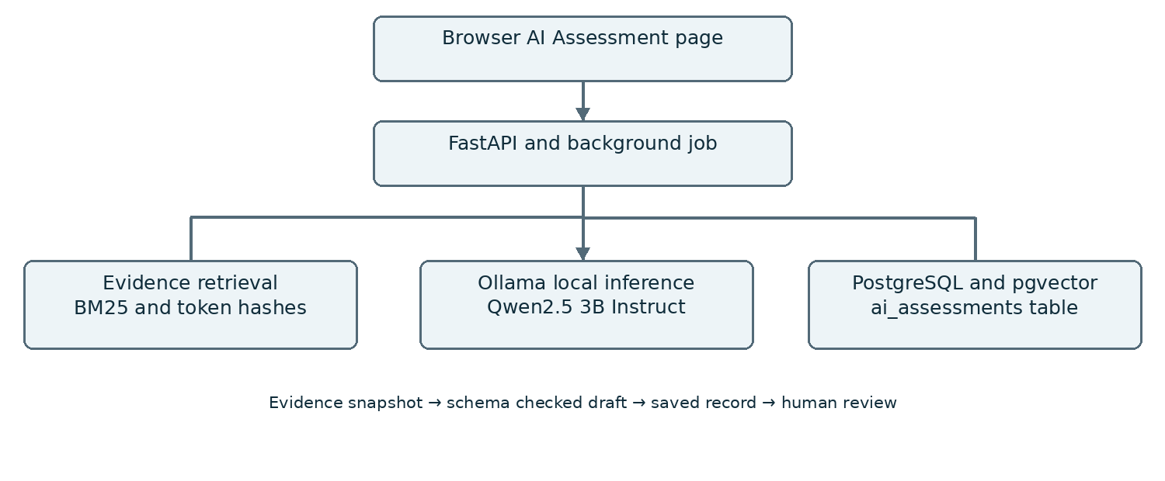
Architecture of the v1.1 generative assessment route. Local model and database services are provisioned by compose.ai.yaml.

4. Implementation and Configuration
1. Ingestion: the user enters a title and a new automotive system description or loads a text file. The request accepts 100 to 8,000 characters and requests 1 to 6 threats; starting with 1 threat reduces initial CPU inference time.
2. Retrieval: the backend snapshots input as SYS-xx evidence and retrieves up to four relevant knowledge passages. The lexical ranker combines BM25 with a 0.25-weight token-hash cosine term. PostgreSQL mode retrieves up to 30 vector candidates before re-ranking.
3. Generation: Ollama /api/generate receives the description, evidence, system prompt and the Pydantic-generated JSON schema. Configuration is temperature 0, num_ctx 8192, num_predict 4096 and a 600-second default timeout. The model drafts assets, threat and damage scenarios, hypothesized attack paths, controls, assumptions, mitigations, requirements and verification proposals.
4. Response handling: the application checks schema validity, unique identifiers, asset references, source membership and at least one submitted-system citation per asset and threat. Invalid output becomes Failed; there is no canned success fallback. Citation membership does not establish semantic correctness.
5. Persistence: queued jobs, progress, model metadata, input, evidence, output and review state are written to ai_assessments. PostgreSQL uses parameterized SQL and conflict-safe record updates. The page polls the job and displays the saved result. JSON export preserves the evidence snapshot.
6. Human review: generated records begin as Draft and risk remains Unassessed. A reviewer can record Reviewed or Rejected with a rationale. This is not formal security acceptance. Previously stored offline architecture findings are not overwritten.
Deployment: compose.ai.yaml connects app, PostgreSQL/pgvector and Ollama on a local container network. Only the app is published on localhost port 8000. Initial package, image and model downloads need internet; subsequent inference uses local services. Model and image digests must be recorded on the demonstration machine.
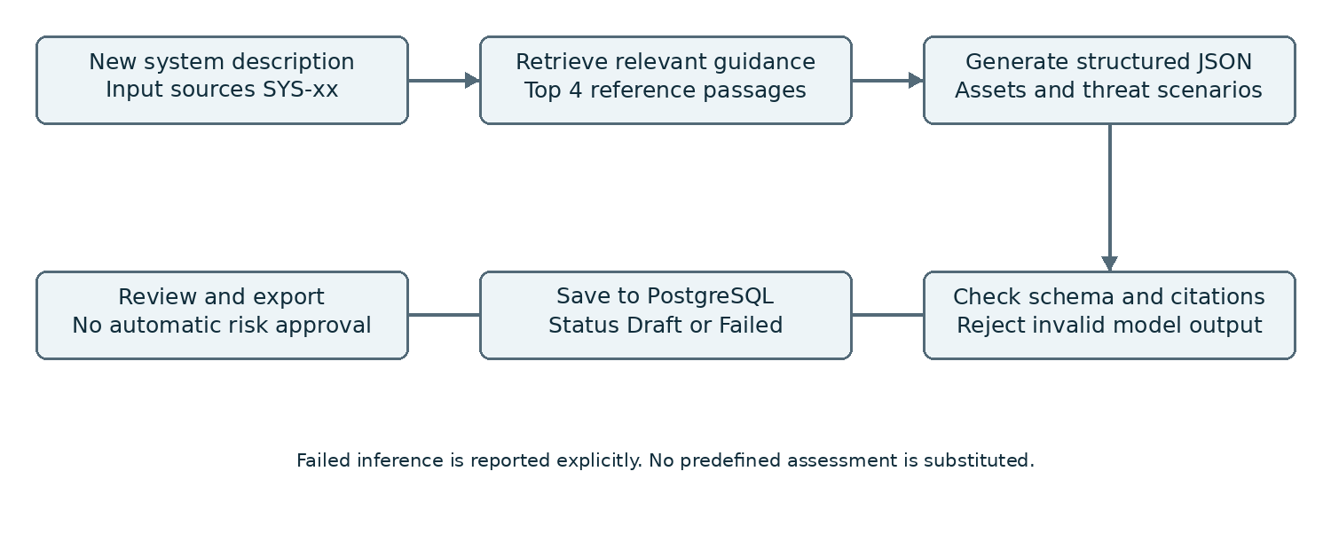

5. Evaluation Steps and Results
The recorded results below come from earlier offline-baseline and software-fixture runs. Further test validation was not performed for the final update. No live Qwen generation quality, PostgreSQL deployment result or student review is represented as completed. The synthetic questions were authored with the reference handbook and are not an independent automotive benchmark.
# | Test question / scenario | Expected answer / behaviour | Result Pass Fail notes
1 | Prevent firmware rollback | Retrieve KB-02 | Pass in recorded offline baseline
2 | Correctly signed but obsolete release | Retrieve KB-02 | Fail: KB-11 ranked first; expected source absent from top 3
3 | Who may authorize software packages | Retrieve KB-03 | Fail at rank 1: KB-04 first, KB-03 second
4 | Weather in Pune tomorrow | Abstain without evidence | Pass in recorded offline baseline
5 | New Bluetooth / charging system with Qwen and PostgreSQL | Generate a new structured draft and persist it | Not run end to end; local execution pending

Metric | Score / observation
Offline top-1 expected-source accuracy | 87.5% (14/16 positive questions)
Offline retrieval recall at 3 | 93.75% (15/16)
Offline MRR at 3 | 0.90625
Offline paraphrase top-1 | 50% (2/4)
Offline out-of-domain abstention | 2/2 questions
Mean offline evaluation latency | 0.845 ms in recorded small-corpus run; not LLM latency
Software tests before final update | 38 passed in prior run; AI adapter tests used simulated model responses. These are not real-model quality results.
LLM faithfulness and PostgreSQL runtime | Not measured. No new result or accuracy claim is supplied.

Source evidence: Evaluation_Results/metrics.json, retrieval_results.json, test_run.txt and test_run_v1_1.txt. Live generation output should be exported from the AI Assessment page after local setup. The optional verification utility is supplied but was not run for this final update.

6. Responsible AI Measures
Area | Measure adopted in this project
Grounding and citations | Snapshot submitted input and retrieved passages; require known source IDs and input citations. Distinguish source existence from factual support.
Privacy | Use synthetic or approved inputs. Ollama is local. No external cloud LLM API is required. Model and container downloads occur during setup.
Security | Validate structured output; parameterize SQL; escape rendered text; reject cross-origin writes; keep services local. No production authentication or tamper-proof audit is claimed.
Human oversight / review | All LLM assessments are drafts. Unknown controls are not treated as absent. Human reviewers evaluate assumptions, controls and proposed requirements; risk stays Unassessed.

7. Innovation Highlights
The main extension is a separate generative assessment workflow for new system descriptions. Unlike the baseline tag-to-pattern demonstration, this route asks the model to identify assets and propose context-specific scenarios. It retains an evidence snapshot, model digest and review state for each run.
The application combines a reviewable AI output with structured persistence and explicit failure reporting. A new assessment can be reopened, reviewed and exported without regenerating it. The existing version-comparison workflow demonstrates how changes can invalidate older baseline findings. Automatic change propagation from free-text AI assessments into that graph is not implemented.
The approach is intentionally compact for a student implementation: one service layer, a small local model, a single PostgreSQL service for records and vectors, and a browser interface. Its value depends on meaningful source data and reviewer judgment; it is not evidence of superior threat coverage.

8. Screenshots, Logs and Evidence
The following screenshots were captured from the earlier offline application. They demonstrate retrieval and change analysis only, not live Qwen generation. New AI-page output and PostgreSQL evidence must be captured after running the updated package locally.
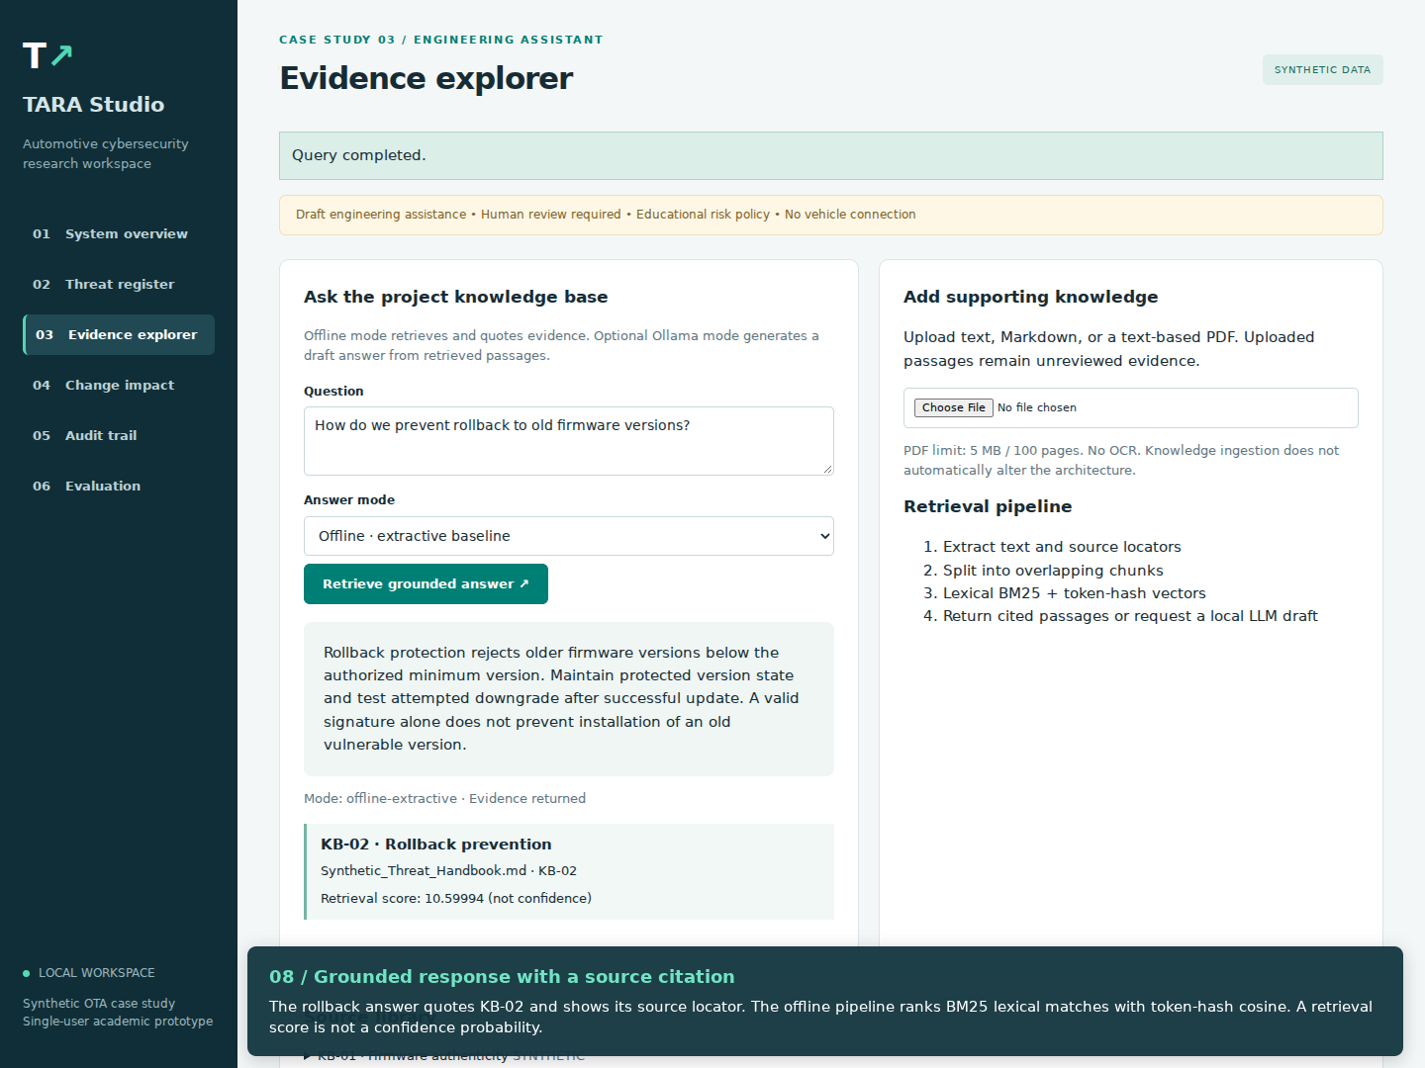
Figure 1 Offline evidence explorer returning the KB-02 rollback passage with its source reference.
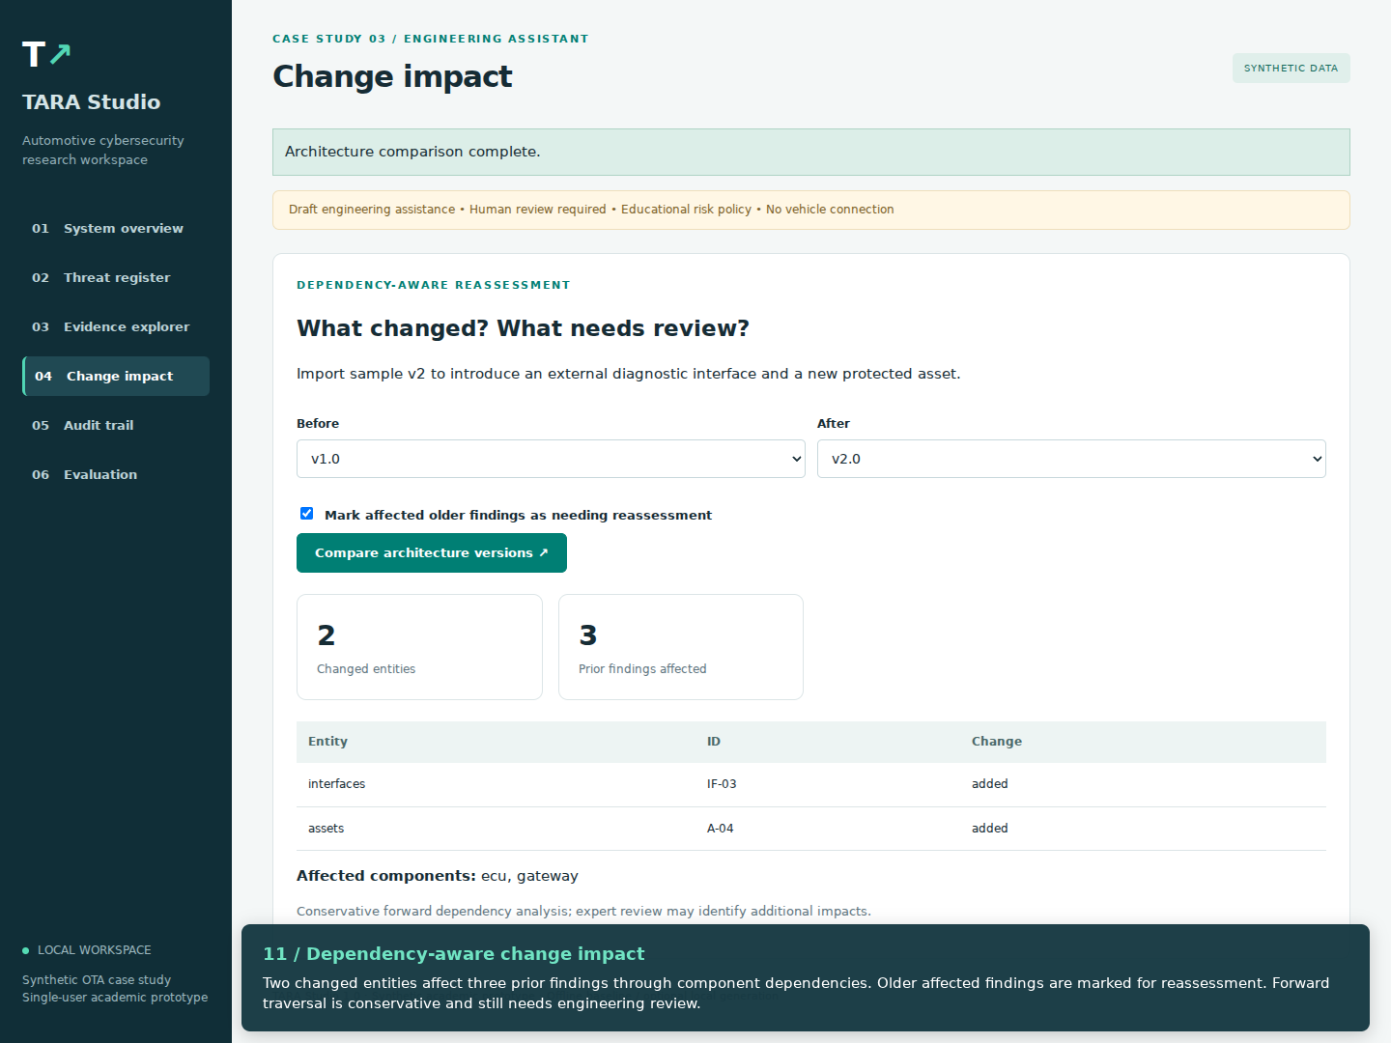
Figure 2 Baseline architecture comparison showing changed entities and affected prior findings.

9. Reflection and Conclusions
The baseline established data handling, traceability and review behavior but relied on prepared threat content. Version 1.1 adds the missing generative route: a fresh system description is sent to a local instruction model, and structured draft output is saved for review. This improves the scope of the implementation without turning generated advice into an approved assessment.
The main remaining uncertainty is real-model quality and deployment behavior on the evaluation machine. A small model can omit threats, infer unsupported controls or produce an invalid schema. Lexical retrieval also struggles with paraphrases, as the recorded failures show. Future improvements include domain-reviewed examples, learned semantic embeddings and expert-scored independent evaluations.

10. AI-Tool Usage Declaration
AI tool / model | Purpose | Artifact affected | Verified By Student Y/N
ChatGPT / Codex | Coding assistance, synthetic data, documentation and configuration drafting | Source, test scripts, input examples, report and synopsis | Pending student review
Qwen2.5 3B Instruct via Ollama | Runtime structured automotive assessment generation | Generated assets, threats, mitigations and requirements | Not run in this final update

Students must record their actual implementation, review and demonstration contributions. Generated assistance must not be presented as independently authored or empirically validated work without supporting evidence.

11. Student Declaration
I confirm that this report represents my own understanding and contribution, that the work follows the approved case-study scope, and that I can explain every significant part of the implementation.
Signature: | ________________ | Date: | ________________
Name: | ________________ | PRN: | ________________

Complete and sign after reviewing the implementation and obtaining the required faculty approval.
Technical references: FastAPI testing documentation (fastapi.tiangolo.com/tutorial/testing/); Ollama structured outputs and model listing (docs.ollama.com, ollama.com/library/qwen2.5:3b-instruct); pgvector official repository (github.com/pgvector/pgvector); supplied Automotive Engineering AI case study document, CS3. Accessed 9 October 2026.

