TATA TECHNOLOGIES LTD.
TECH PULSE FY-26 | AI/ML Capstone Project

PROJECT SYNOPSIS

Student Details
Institute/University: PCCOE
Programme / Batch: ______________________________
Student Name: ______________________________
PRN: ______________________________

1. Case Study ID and Project Title / Topic
Case Study ID: CS3
Project Title / Topic: TARA Studio Automotive Cybersecurity Assessment Assistant

2. Objectives
- Extract candidate cybersecurity assets from a new automotive system description using a local instruction model.
- Generate evidence-linked draft threat and damage scenarios with assumptions, mitigations, requirements and verification proposals.
- Persist model outputs and review history in PostgreSQL and make each assessment retrievable and exportable.
- Maintain clear limits through citations, schema checks, unassessed risk and human review.

3. Scope
In Scope – To Be Implemented
A browser-based AI Assessment page; local Ollama inference; retrieval from synthetic or approved reference content; structured output checks; PostgreSQL persistence; review and JSON export. The offline baseline also supplies architecture version comparison and educational risk support.
Out of Scope – Will Not Be Implemented
Autonomous cybersecurity acceptance, certified standards scoring, live vehicle exploitation, arbitrary diagram understanding, production multi-user security and automatic conversion of generated text into an approved architecture graph.

4. Proposed Approach
Pre-trained model name version and hosting
Qwen2.5 3B Instruct, Ollama tag qwen2.5:3b-instruct, local inference. Capture the installed digest; weights are downloaded separately.
Embedding model
No pretrained embedding model. The initial retriever uses BM25 with deterministic 384-dimensional token-hash vectors.
Vector store FAISS or ChromaDB
PostgreSQL with pgvector is selected instead of FAISS/ChromaDB; SQLite is a labelled local fallback.
RAG pipeline and AI-agent design
Snapshot the description as SYS-xx sources, retrieve up to four relevant reference passages, generate a structured assessment and validate identifiers before saving. No autonomous tool execution.
Service layer and UI
FastAPI and Python backend, Uvicorn server, Pydantic schemas and local HTML/CSS/JavaScript interface.
Tools and deterministic rules
pypdf ingestion, parameterized PostgreSQL writes, schema and citation checks, job states, review revision control, baseline educational risk matrix.
Proposed System / Architecture
The application, Ollama and PostgreSQL run as separate local services using Docker Compose.
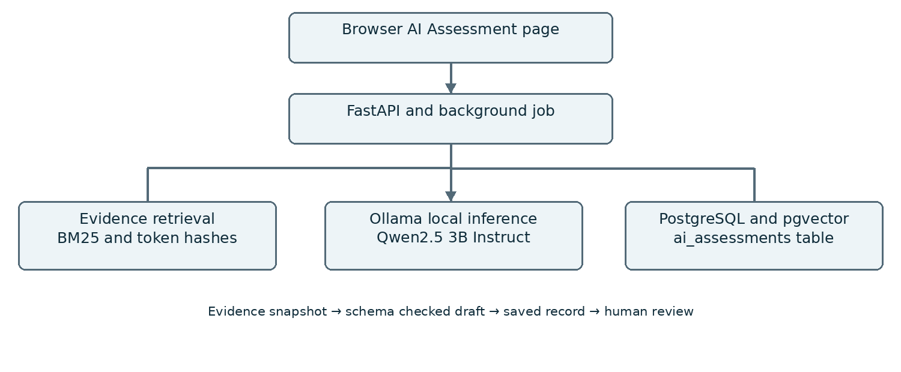

5. Input Data / Knowledge Base
Data / Knowledge Sources
Original synthetic OTA architectures and a 12-passage reference handbook, plus newly entered system descriptions. Bluetooth vehicle access and EV charging descriptions are supplied as additional inputs. Use approved or synthetic data only.
Approximate Size and Format
Two architecture JSON versions, five baseline threat patterns, twelve knowledge passages, eighteen baseline questions, and two text descriptions. AI input is limited to 8,000 characters per assessment.
Preprocessing and EDA Planned
Extract text and preserve source metadata. Use 1,200-character knowledge windows with 100-character overlap; create 1,000-character non-overlapping submitted-input chunks. Validate references and distinguish assumptions from facts.

6. Expected Outcomes and Evaluation Plan
Expected Outputs
A saved draft assessment containing extracted assets, threats, damage scenarios, hypotheses, controls, assumptions, evidence IDs, mitigations, requirements and verification proposals. Risk remains Unassessed until a suitable human-led method is applied.
Evaluation Method
Use the recorded synthetic retrieval benchmark as a baseline. For a later live-model evaluation, inspect generated results from new system descriptions, source support, omitted threats, valid identifiers, persistence and latency. Do not equate software fixture tests with model quality; no further validations are claimed in this final update.
Responsible AI Measures
Local processing, approved or synthetic inputs, source snapshots, explicit failure states, no fabricated citations, no autonomous approval and documented human review. Factual support still requires review.
MLOps / Deployment Elements Planned
Versioned prompts and configuration, containerized services, persistent database/model volumes, model digest capture, structured job records and JSON export.

7. Planned AI-Tool Usage
AI Tool / Model: ChatGPT / Codex for development assistance; Qwen2.5 3B Instruct via Ollama for runtime generation.
Purpose: Assist source-code and document preparation, and generate structured candidate automotive assessments.
Artifact Affected: Application code, synthetic inputs, prompts, report, synopsis and generated assessment records. Students must disclose their actual contributions and review.

Student Declaration
[ ] I will not change the approved case-study scope, major methodology, or implementation approach without prior faculty approval.
[ ] I confirm that the work submitted under this synopsis represents my own understanding and contribution, and I will be responsible for explaining every significant part of the selected case study and its implementation.
Name and Signature: ______________________________ Date: ________________

Faculty Approval Record
Faculty guide: __________________________________________
Decision: [ ] Approved [ ] Approved with changes [ ] Revise
Comments: ______________________________________________
________________________________________________________
Faculty signature: ________________________ Date: ___________
Approval is pending until the faculty member reviews and signs this record.

