**MATERI 10**

1. **Relasi Dosen dan Matakuliah**

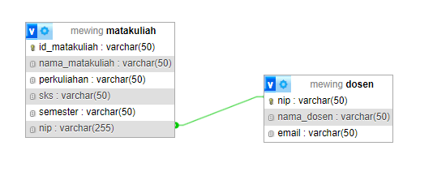

1. **Model**

* <?php
* namespace App\Models;
* use Illuminate\Database\Eloquent\Factories\HasFactory;
* use Illuminate\Database\Eloquent\Model;
* class Matakuliah extends Model
* {
* protected $table = 'matakuliah';
* protected $primaryKey = 'id_matakuliah';
* protected $fillable = ['id_matakuliah','nama_matakuliah','perkuliahan','sks','semester','nip'];
* public $timestamps = false;
* public function dosen(){
* return $this->belongsTo(Dosen::class, 'nip', 'nip'); *// Nama model harus Dosen*
* }
* }

1. **Controller (MatakuliahController)**

Disini kita menggunakan ORM ‘with’ karena ingin membawa beberapa atribut dari tabel dosen yang sudah diinisialisasikan di bagian model

* public function tampilMatakuliah(){
* $data = Matakuliah::with('dosen')->orderBy('id_matakuliah', 'desc')->get();
* return view('matakuliah/manage-matakuliah')->with('data', $data);
* }

1. **Routes(web.php):**

* Route::get('/matakuliah/manage-matakuliah', [MatakuliahController::class, 'tampilMatakuliah']);

1. **Views(matakuliah/manage-matakuliah.blade.php):**

* <x-layout>
* <x-slot:heading>
* <h1>Matakuliah Page</h1>
* </x-slot:heading>
* @if (session('success'))
* <div *style*="color: green">
* {{ session('success') }}
* </div>
* @endif
* <table *border*="1">
* <tr>
* <th>No</th>
* <th>ID Matakuliah</th>
* <th>Nama Matakuliah</th>
* <th>Perkuliahan</th>
* <th>Sks</th>
* <th>Semester</th>
* <th>Nama Dosen</th>
* </tr>
* @foreach ($data as $matakuliah)
* <tr>
* <td>{{ $loop->**iteration** }}</td>
* <td>{{ $matakuliah->**id_matakuliah** }}</td>
* <td>{{ $matakuliah->**nama_matakuliah** }}</td>
* <td>{{ $matakuliah->**perkuliahan** }}</td>
* <td>{{ $matakuliah->**sks** }}</td>
* <td>{{ $matakuliah->**semester** }}</td>
* <td>{{ $matakuliah->**dosen**->**nama_dosen** ?? 'No Dosen Assigned' }}</td>
* </tr>
* @endforeach
* </table>
* <x-nav-link *href*="/matakuliah/tambah-matakuliah">+ Tambah Matakuliah</x-nav-link>
* </x-layout>