**MATERI 13**

**RELATIONAL UPDATE**

1. **Model(Matakuliah.php)**

* <?php
* namespace App\Models;
* use Illuminate\Database\Eloquent\Factories\HasFactory;
* use Illuminate\Database\Eloquent\Model;
* class Matakuliah extends Model
* {
* protected $table = 'matakuliah';
* protected $primaryKey = 'id_matakuliah';
* protected $fillable = ['id_matakuliah','nama_matakuliah','perkuliahan','sks','semester','nip'];
* public $timestamps = false;
* public function dosen(){
* return $this->belongsTo(Dosen::class, 'nip', 'nip'); *// Nama model harus Dosen*
* }
* }

1. **Controller(MatakuliahController) Function 1 Membuka halaman Edit**

Disini terdapat 2 variabel dimana:

$matakuliah = variabel untuk menampilkan data yang di pilih di view.

$dosen = sebagai menampilkan data yang berelasi yaitu dosen.

* public function halamanUpdateMatakuliah($id_matakuliah){
* $matakuliah = Matakuliah::findOrFail($id_matakuliah);
* $dosen = Dosen::all();
* return view('matakuliah.edit-matakuliah', ['matakuliah'=>$matakuliah, 'dosen'=> $dosen]);
* }

1. **Controller(MatakuliahController) Function 2 Mengubah Data**

* public function updateMatakuliah(Request $request, $id_matakuliah){
* $request->validate([
* 'id_matakuliah' => 'required|string|max:50',
* 'nama_matakuliah' => 'required|string',
* 'perkuliahan' => 'required|string',
* 'sks' => 'required|string',
* 'semester' => 'required|string',
* 'nip'=>'required|exists:dosen,nip'
* ]);
* $matakuliah = Matakuliah::findOrFail($id_matakuliah);
* $matakuliah->update([
* 'id_matakuliah'=> $request->**id_matakuliah**,
* 'nama_matakuliah'=> $request->**nama_matakuliah**,
* 'perkuliahan'=> $request->**perkuliahan**,
* 'sks'=> $request->**sks**,
* 'semester'=> $request->**semester**,
* 'nip'=> $request->**nip**,
* ]);
* return redirect()->to('matakuliah/manage-matakuliah')->with('success', 'Data Matakuliah Berhasil Di Edit');
* }

1. **Routes(web.php) rute 1 untuk menampilkan halaman edit**

* Route::get('matakuliah.edit-matakuliah/{id_matakuliah}', [MatakuliahController::class, 'halamanUpdateMatakuliah'])->name('halamanUpdateMatakuliah');

1. **Routes(web.php) rute 2 untuk melakukan proses edit**

* Route::put('matakuliah.edit-matakuliah/{id_matakuliah}', [MatakuliahController::class, 'updateMatakuliah'])->name('updateMatakuliah');

1. **Views(matakuliah/manage-matakuliah.blade.php) view utama**

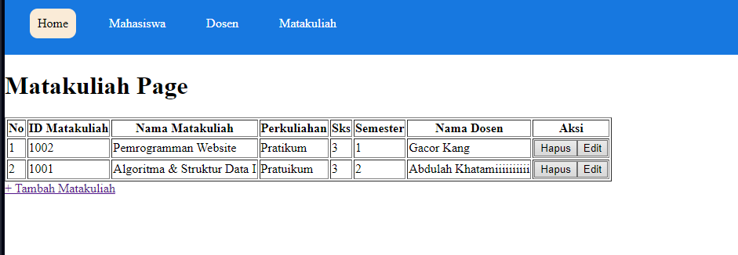

* <x-nav-link *href*="{{ route('halamanUpdateMatakuliah', $matakuliah->**id_matakuliah**) }}">
* <button>Edit</button>
* </x-nav-link>

1. **Views(matakuliah/edit-matakuliah.blade.php) view edit**

* <x-layout>
* <x-slot:heading>
* <h1>
* Edit Matakuliah
* </h1>
* </x-slot:heading>
* <form *action*="{{ route('updateMatakuliah', $matakuliah->**id_matakuliah**) }}" *method*="post">
* @csrf
* @method('PUT')
* <table>
* <tr>
* <td>
* ID Matakuliah
* </td>
* <td>
* :
* </td>
* <td>
* <input *type*="text" *name*="id_matakuliah" *value*="{{ old('id_matakuliah', $matakuliah->**id_matakuliah**) }}">
* @error('id_matakuliah')
* {{ $message }}
* @enderror
* </td>
* </tr>
* <tr>
* <td>
* Nama Matakuliah
* </td>
* <td>
* :
* </td>
* <td>
* <input *type*="text" *name*="nama_matakuliah" *value*="{{ old('nama_matakuliah', $matakuliah->**nama_matakuliah**) }}">
* @error('nama_matakuliah')
* {{ $message }}
* @enderror
* </td>
* </tr>
* <tr>
* <td>
* Perkuliahan
* </td>
* <td>
* :
* </td>
* <td>
* <input *type*="text" *name*="perkuliahan" *value*="{{ old('perkuliahan', $matakuliah->**perkuliahan**) }}">
* @error('perkuliahan')
* {{ $message }}
* @enderror
* </td>
* </tr>
* <tr>
* <td>
* SKS
* </td>
* <td>
* :
* </td>
* <td>
* <input *type*="text" *name*="sks" *value*="{{ old('sks', $matakuliah->**sks**) }}">
* @error('sks')
* {{ $message }}
* @enderror
* </td>
* </tr>
* <tr>
* <td>
* Semester
* </td>
* <td>
* :
* </td>
* <td>
* <input *type*="text" *name*="semester" *value*="{{ old('semester', $matakuliah->**semester**) }}">
* @error('semester')
* {{ $message }}
* @enderror
* </td>
* </tr>
* <tr>
* <td>
* Dosen
* </td>
* <td>
* :
* </td>
* <td>
* <select *name*="nip">
* @foreach($dosen as $dosen) *<!-- Menggunakan $dosens yang dikirim dari controller -->*
* <option *value*="{{ $dosen->**nip** }}" {{ $dosen->**nip** ? 'selected' : '' }}>
* {{ $dosen->**nip** }} - {{ $dosen->**nama_dosen** }}
* </option>
* @endforeach
* </select>
* </td>
* </tr>
* </table>
* <button *type*="submit"> Simpan Update</button>
* <a *href*="/matakuliah/manage-matakuliah"> Kembali </a>
* </form>
* </x-layout>