

American International University- Bangladesh

CSC 3222: Web Technologies

CO1.1 and CO2.1 Evaluation

Project Report

Summer 20-21

Project Title: Tutor Academy (Tutor provider web application)

Section: N

|  |  |
| --- | --- |
| Student Name | Student Id |
| Fahim, Solamen Abdullah | 18-39146-3 |
| Rahman, MD. Musfiqur | 19-40008-1 |
| Oishi, Afifa Tazremin | 19-40028-1 |
| Biswas, Kaushik | 19-40034-1 |

Introduction:

Tutor academy is basically online based education system. Nowadays, online education is quite popular, and it is becoming increasingly popular among our country's students. Beside in covid situation we realized that there is no such a better way for education which can possible from anywhere just by using the advantages of internet. At present some online learning platform are available but they didn’t able serve enough feature from one place for different type of students this is why we are going to cover these things as much as possible.

Background Study

**Porte chai:** Porte Chai is an online educational platform in Bangladesh for University students. It’s mainly a website to hire private tutor for different types of course.

**Reference-** <https://portechai.com/>

**10 minute school:** Ten minute school is an [online educational platform](https://en.wikipedia.org/wiki/Online_tutoring) in Bangladesh created in 2015.

The platform covers academic classes from classes 1 to 12 covering the entire academic syllabus of the [Bangladesh schooling system](https://en.wikipedia.org/wiki/Bangladesh_schooling_system), [university](https://en.wikipedia.org/wiki/University) admission subjects covering different branches of study,

and skills training.

**Reference**- <https://10minuteschool.com/>

**Ghoori Learning:** Ghoori Learning is an e-learning platform in Bangladesh. They used to sell different types of course. These courses are prepared for all types of people. Anyone can access this course after paying the fees by which they can develop their skills on the specific field.

**Reference-**<https://ghoorilearning.com/>

Requirement Analysis:

1. User Category:

There are n-types of Users here. They are:

* Admin
* Instructor
* Student
* Private Tutor

1. Feature List:

* In this project the “**Admin**” has the following features:

1. Can add Teachers/Students.

2. Can approve Teachers/Students registration information.

3. Can verify Teachers/Students profiles -- Can block Teachers/Students.

4. Can manipulate all information (edit-delete-view etc.)

* In this project the “**Instructor**” has the following features:

1. If any of the instructor inserted by the admin then they will allow to upload

course material, notes and write blog related to different course.

1. Can edit course information.
2. Can watch courses.

* In this project the “**Student**” has the following features:

1. Can choose their desire Teachers Form website.

2. can make a payment for selected teachers.

3. Can comment or provide a review to the teachers.

* In this project the “**Private Tutor**” has the following features:

1. Can add their subject for tuition.

2. Can publish their time schedule.

3. Can edit their information.

Design:

Entity diagram:

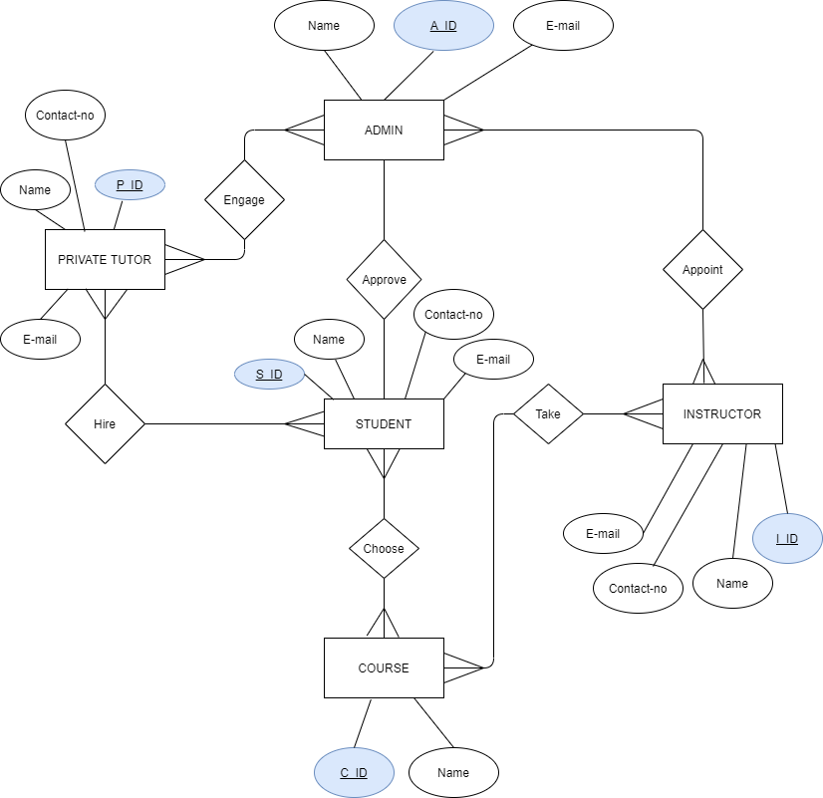

Tools Used:

To develop this project, we have used the following:

• Sublime text, vs code

• Draw.io

• XAMPP

• Google chrome browser

System Images against the Specification:

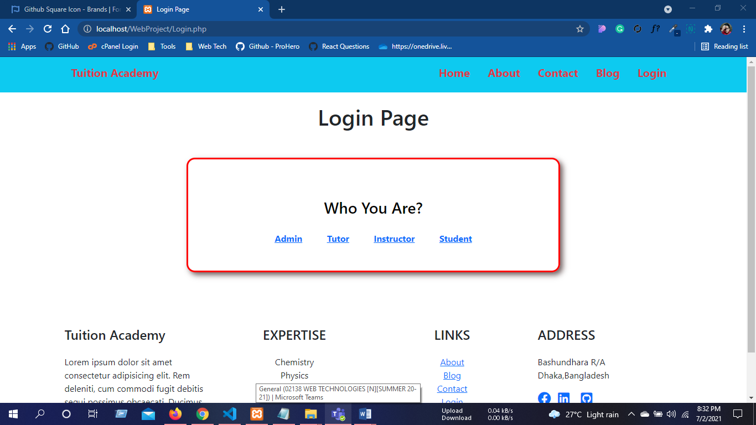

Figure: Login Page for All users

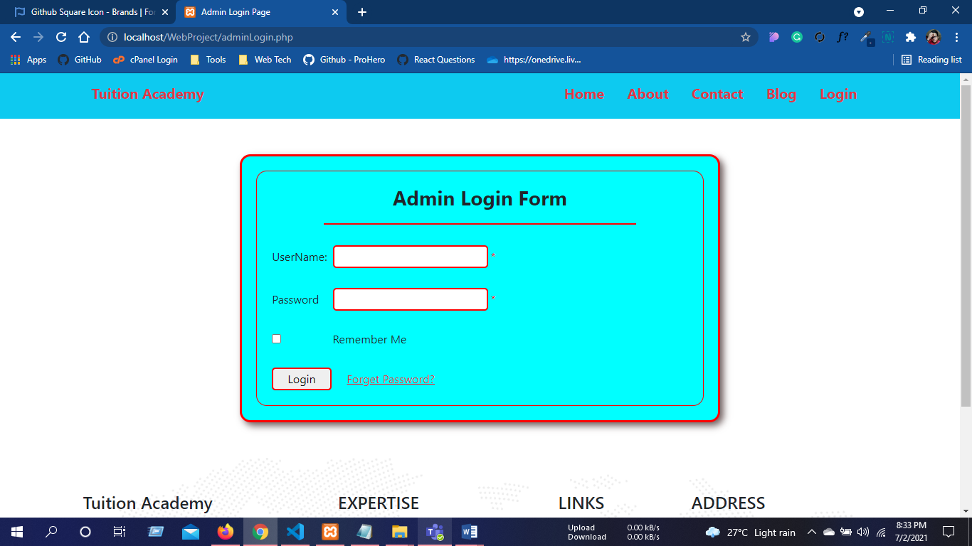

Figure: Users Login

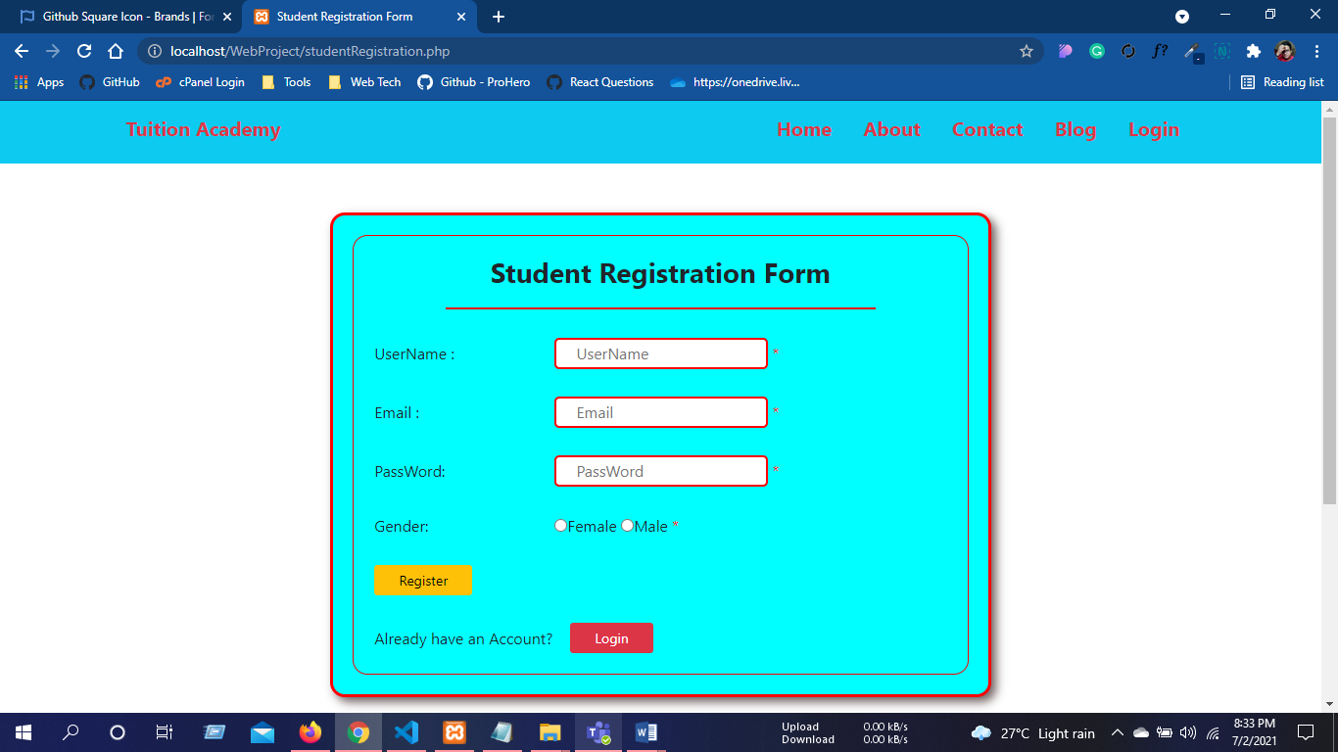Figure: Users Registration Form

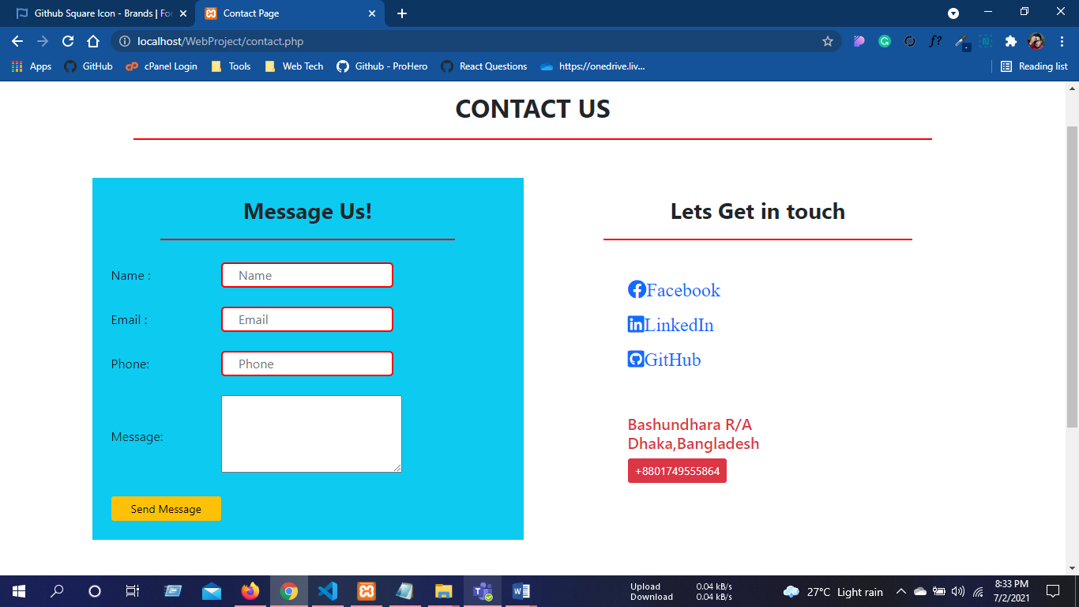Figure: Contact Us Page

Figure: Blog Page (file Read)

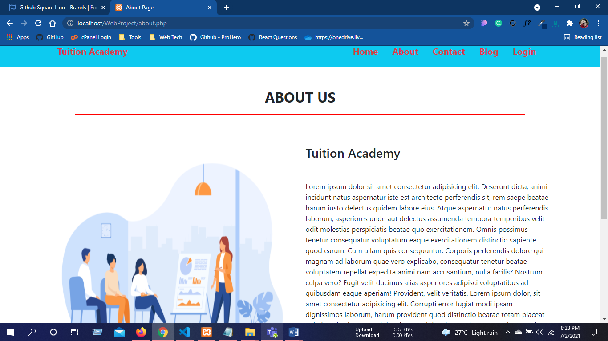

Figure: About Us Page

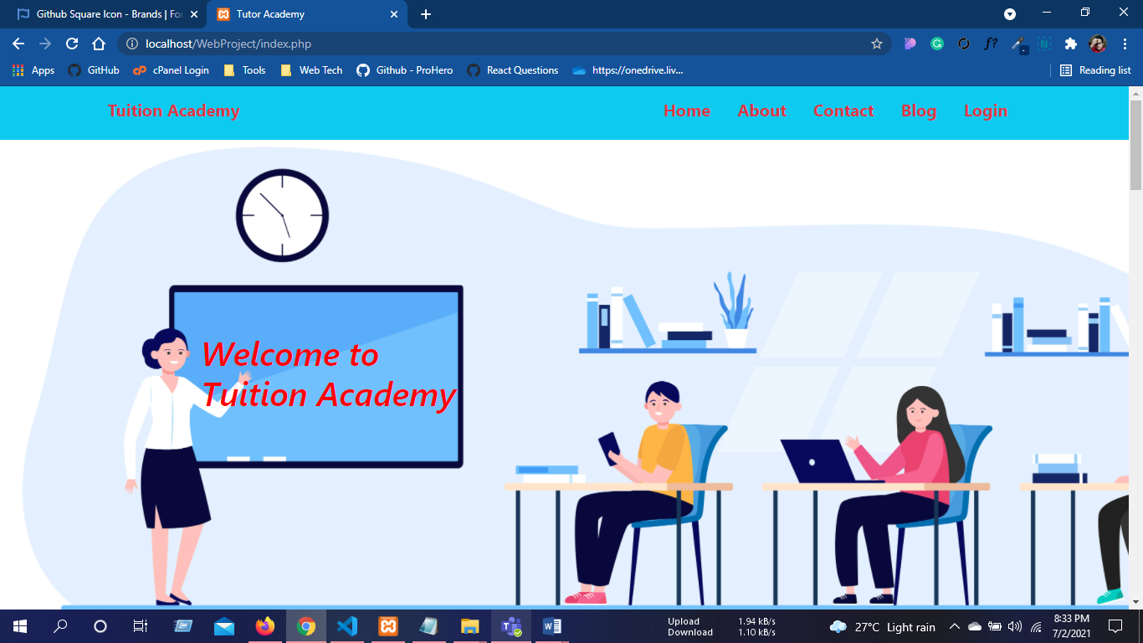

Figure: Home Page

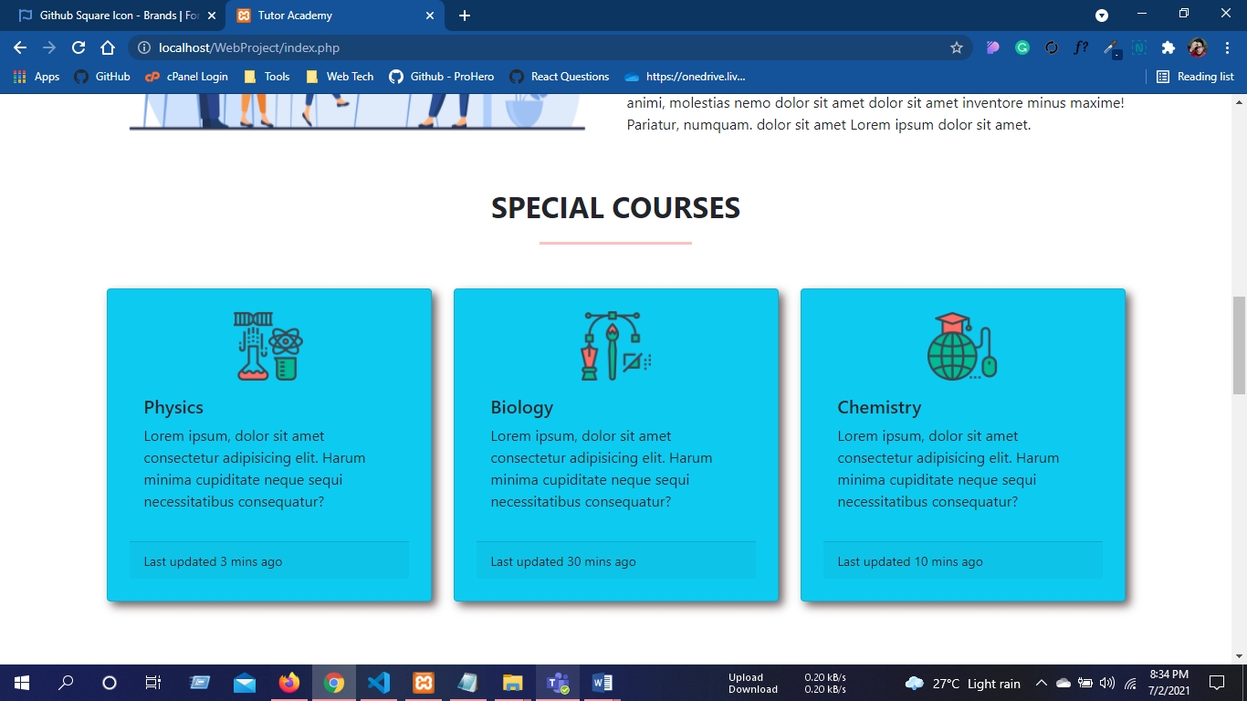

Figure: Special courses Section

Impact of this Project:

There will be many beneficial features of this project. By using this website a student and experienced instructor will be benefitted mostly. The students will be able to enjoy free recorded classes which will be conduct by some of the experienced people related to the course. If they need private tutor they can find and discuss about their problem by paying specific amount of money. Which help other students to earn some money by sharing knowledge. All together we can say that a student can learn for free or by paying money, share knowledge and earn money from one place which is the main impact of this project.

Limitations and Possible Future Improvements:

We didn’t add any portion to take any exam. In future we will try to add a portion to take quiz or exam where student will allow to enter for a specific amount of time and they will be able to check results, answer details of each of the questions just after the exam time so that they can fill up their gaps of learning. By using our site student will not be able to enjoy live features. So, at the beginning we will try to arrange live class by using different social networking app if needed. Here we didn’t set the requirements for instructor yet but in future we will add some requirement from different side and there will be review system for former student as if the next student can hire a good instructor. So, we will try to add these features to make it more beneficial for the students.

|  |  |  |  |  |  |
| --- | --- | --- | --- | --- | --- |
| CO1.1 and CO2.1 Evaluation: Project Report Evaluation | | | | | |
| Project Proposal  (5) | Background  Study  (5) | Requirement Analysis  (5) | Entity  Diagram  (5) | System Images  against the  Specification (5) | Total (25) |
|  |  |  |  |  |  |
|  | | | | | |