z1791755

mysql -u z1791755 -h courses -p

\T assign6;

show databases;

use henrybooks;

show tables;

1. SELECT \* FROM Author ORDER BY AuthorFirst;

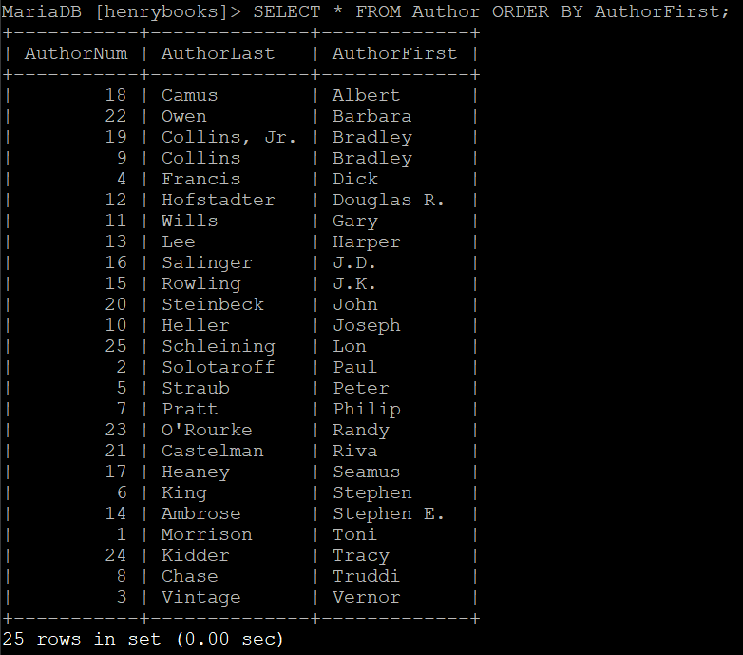

1. SELECT DISTINCT City FROM Publisher;

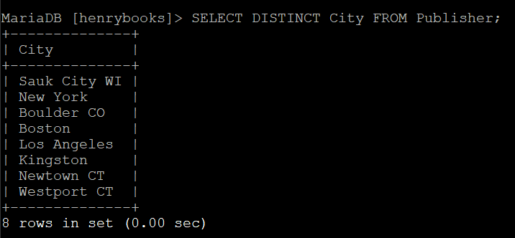

1. SELECT DISTINCT \* FROM Book;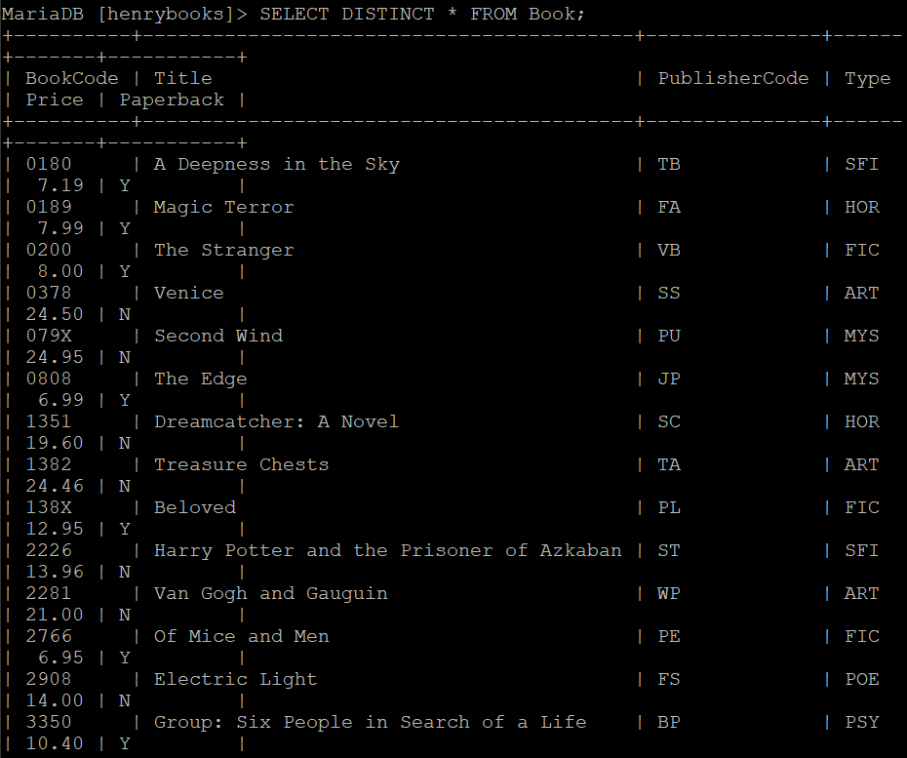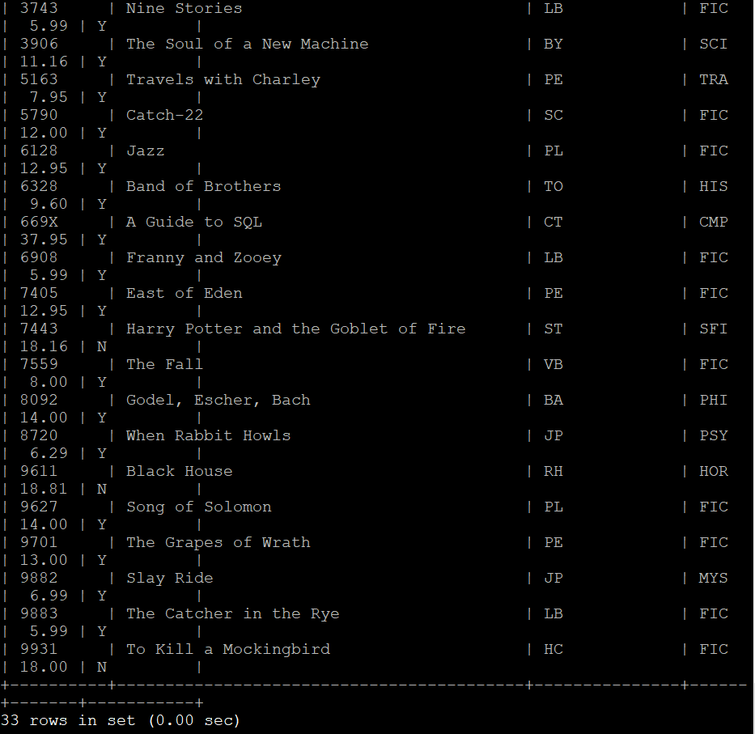There are 33 books.
2. SELECT DISTINCT BranchName, Title FROM Branch, Book;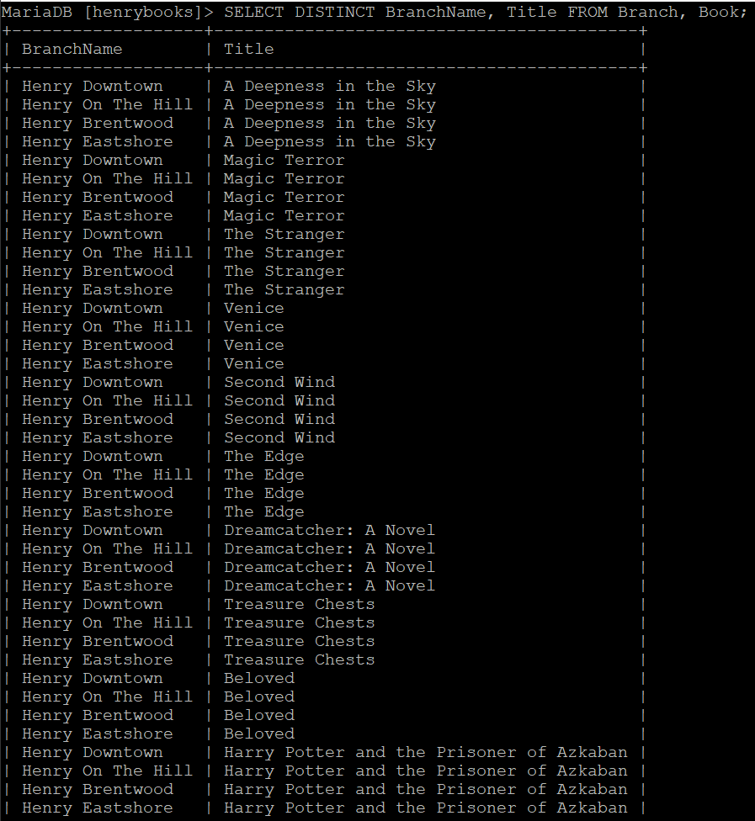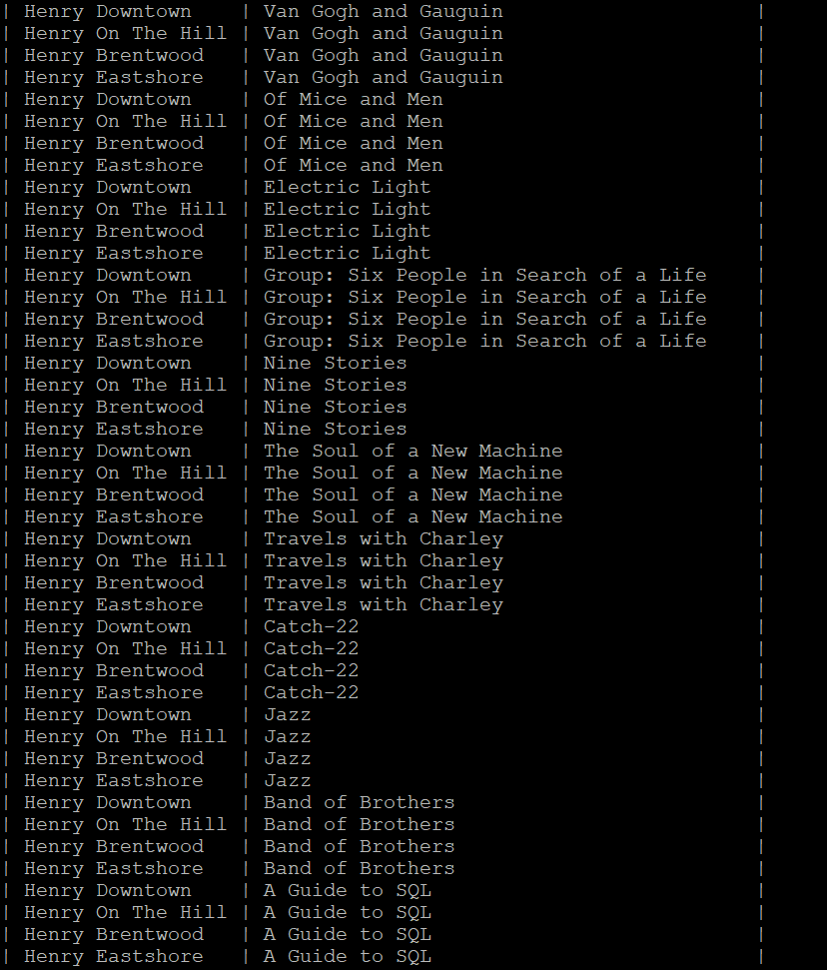

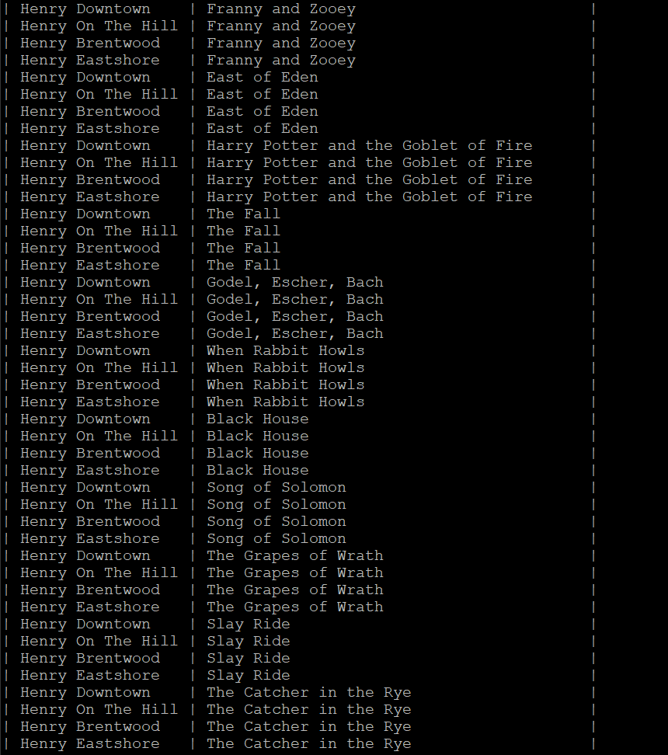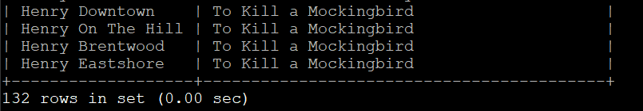

1. SELECT SUM(NumEmployees) FROM Branch;

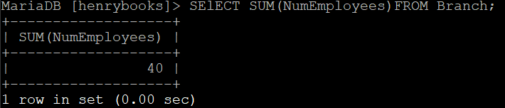

1. List the titles of all of the books written by Stephen King.
2. SELECT Title, Paperback, Price FROM Book WHERE Paperback = ‘Y’;

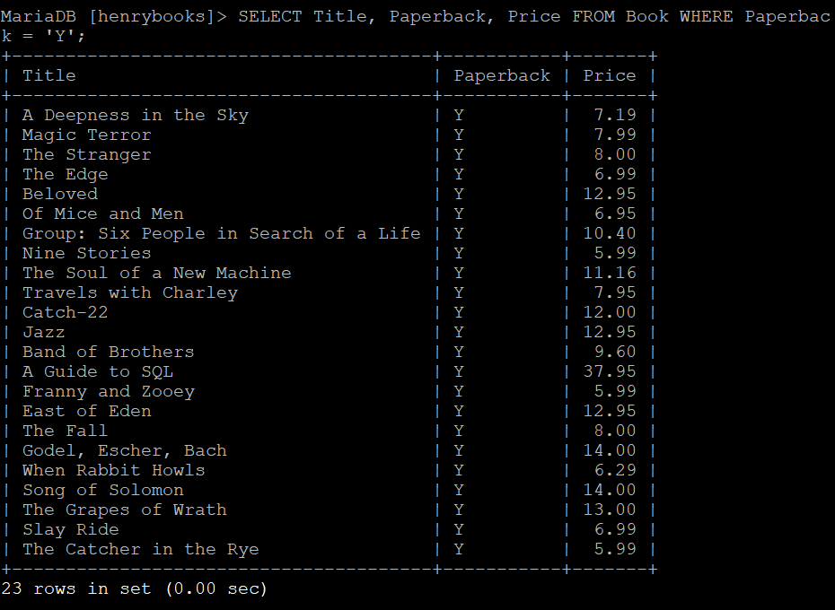

1. X
2. X
3. SELECT \* FROM Book WHERE Price < ’10.00’;

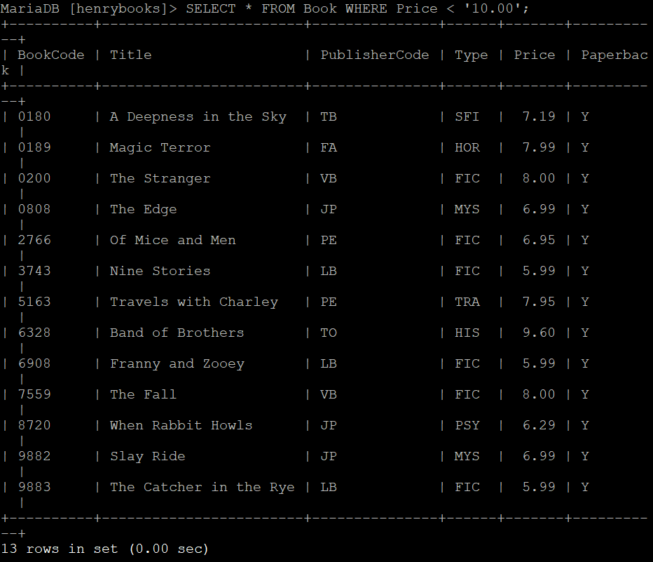

There are 13 books under $10.00.

1. X
2. X
3. X
4. X
5. X
6. X
7. X
8. X
9. X
10. X
11. X
12. X