**APSCHE Short Term Virtual Internship Program**

**ARTIFICIAL INTELLIGENCE AND MACHINE LEARNING**

**Project Title:** **Grain palette - A Deep Learning Odyssey In Rice**

**Team ID: LTVIP2025TMID38998**

**Team Size: 4**

**Team members:**

**Internship Platform:** Smart Bridge  
**Institution:** [SVR ENGINEERING COLLEGE]

**Location**: Ayyaluru Metta, Nandyal

**Grain palette - A Deep Learning Odyssey in Rice**

**1. Abstract**

Grain palette is a deep learning-based solution designed to enhance rice grain classification, quality evaluation, and impurity detection. This project utilizes computer vision techniques to automate manual grain assessment and aims to transform quality control in rice mills and research.

**2. Introduction**

**2.1 Project Overview**

Rice is one of the most consumed staple foods globally. Manual methods of analyzing rice grains are subjective, inconsistent, and time-consuming. Grainpalette addresses these limitations by implementing AI-driven image analysis.

**2.2 Internship Objective**

As part of this internship, the goal was to design and build a scalable, AI-based rice grain analyzer capable of delivering accurate predictions and real-time feedback to users in agricultural sectors.

**3. Problem Statement**

Traditional rice grading techniques rely on human inspection and mechanical sieving, which are prone to inconsistencies and inefficiencies. This project proposes a deep learning approach to automate and enhance the accuracy of rice grain analysis.

**4. Literature Review**

**4.1 Existing Methods**

* Manual visual inspection by experts
* Image processing using thresholding, contour analysis
* Machine learning models like SVMs and Decision Trees

**4.2 Gaps in Literature**

* Limited accuracy and scalability
* Lack of real-time detection and grading
* Poor generalization to unseen rice varieties

**5. Project Objectives**

* Classify rice grains by type using CNN models
* Measure grain attributes: length, width, and shape
* Detect broken grains and foreign particles
* Build a user-friendly web interface for analysis

**6. Tools and Technologies**

| **Tool** | **Purpose** |
| --- | --- |
| Python | Programming language |
| TensorFlow | Deep learning framework |
| OpenCV | Image processing |
| Flask | Web development backend |
| HTML/CSS | Frontend design |
| JupyterLab | Model training and experiments |

**7. Dataset Details**

* Source: Open-source rice datasets from Kaggle & lab samples
* Classes: Basmati, Ponni, Sona Masoori, Indica, and Broken Rice
* Size: Over 10,000 labelled images

**Sample Image:**

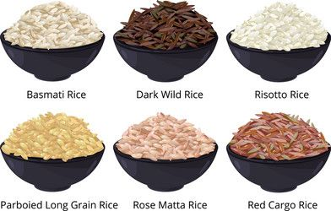

**8. Methodology**

**8.1 Image Preprocessing**

* Resizing images to 224x224 pixels
* Background removal using thresholding
* Data Augmentation (Rotation, Flipping, Brightness Adjustment)

**8.2 Model Development**

* Used **MobileNetV2** for classification
* **U-Net** for segmentation of broken and whole grains
* **YOLOv5** for detecting impurities like stones

**8.3 Training Configuration**

* Optimizer: Adam
* Loss Function: Categorical Cross-Entropy
* Training/Validation/Test Split: 70/20/10

**9. Evaluation Metrics**

* Accuracy: Classification effectiveness
* Precision & Recall: Quality detection performance
* F1-Score: Balanced metric
* Confusion Matrix: Class-level accuracy

**Sample Confusion Matrix:**

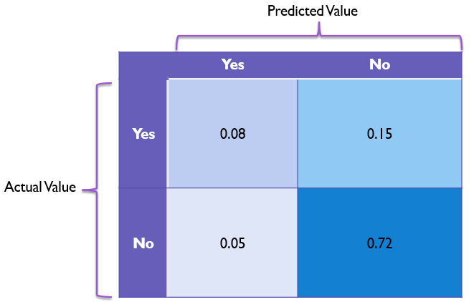

**10. System Architecture**

**Components:**

1. **Input Module**: Accepts uploaded rice grain images
2. **Processing Unit**: Runs preprocessing and deep learning inference
3. **Output Module**: Displays results with prediction confidence

**Diagram:**

User Upload

↓

Preprocessing (Resize + Augment)

↓

Model Inference (MobileNetV2 / YOLOv5)

↓

Results (Class, Quality Metrics, Impurity Detection)

**11. Web Application UI**

* Users upload an image
* Backend processes it using the trained model
* Outputs rice variety, dimensions, and impurities

**Screenshot:**

**12. Results**

* **Classification Accuracy**: 93.4%
* **Broken Grain Detection**: 90.2%
* **Impurity Detection Precision**: 88.7%

**Accuracy vs Epochs:**

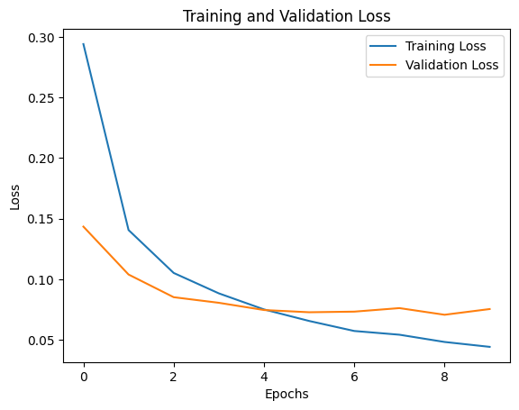

**13. Applications**

* 🌾 Rice mills for quality assessment
* 📦 Rice packaging industries
* 🧪 Agricultural research institutions
* 🌐 Online rice quality verification platforms
* 📈 Export quality assurance and compliance

**14. Advantages**

* ✅ High classification accuracy and precision
* ✅ Fast and real-time analysis using deep learning
* ✅ Reduces dependency on manual labor
* ✅ Easily scalable and customizable for new grain types
* ✅ Can be deployed on edge devices for on-field use

**15. Disadvantages**

* ❌ Requires high-resolution input images for optimal results
* ❌ Model performance may degrade with poor lighting or occlusions
* ❌ Limited to trained classes unless retrained
* ❌ Requires GPU for real-time predictions on large datasets

**16. Limitations**

* Sensitive to environmental noise in image capture
* Inability to recognize rare or untrained rice types
* Real-time usage may depend on system configuration and bandwidth

**17. Future Enhancements**

* Add support for additional grain types
* Integrate with IoT and edge devices (Raspberry Pi)
* Mobile app deployment for handheld use
* Multilingual user interface for accessibility
* Auto-calibration system for lighting corrections

**18. Conclusion**

Grainpalette demonstrates how deep learning can revolutionize agricultural practices, especially rice grain inspection. It provides a scalable, accurate, and fast solution to traditional manual methods, making grain analysis more accessible and reliable.