|  |  |  |  |  |
| --- | --- | --- | --- | --- |
|  | Finolex Academy of Management and Technology, Ratnagiri | | | |
| **Department of Information Technology** | | | |
| **Subject:** | **Python Lab. (ITL404)** | | | |
| **Class:** | **SE IT / Semester – IV (Rev-2019 ‘C’) / Academic year: 2020-21** | | | |
| **Name of Student:** | **Borkar Afiya Ayub** | | | |
| **Roll No:** | **06** | | **Date of performance (DOP) :** |  |
| **Assignment/Experiment No:** | | **02** | **Date of checking (DOC) :** |  |
| **Title: Program to demonstrate relational, logical and membership operators with decision control instructions** | | | | |
| **Marks:** | |  | **Teacher’s Signature:** |  |

**1. Aim**: To understand basic methods of List and String

**2. Prerequisites**:

1. Basics of programming disciplines.

**3. Hardware Requirements**:

1. PC with minimum 2GB RAM

**4. Software Requirements:**

1. Windows / Linux OS.
2. Python 3.6 or higher

**5. Learning Objectives:**

1. To understand Python as a software development platform.
2. To understand the use of relational, logical and membership operators with decision control instructions.

**6. Learning Objectives Applicable: LO 1**

**7. Program Outcomes Applicable: PO 1,2**

**8. Program Education Objectives Applicable: PEO 1**

**9. Theory:**

**● Relational Operators :**

A relational operator is a programming language construct or operator that tests or defines some kind of relation between two entities. These include numerical equality (e.g., 5 = 5) and inequalities (e.g., 4 ≥ 3). ..and so on .**Relational operators**are used for comparing the values. It either returns True or False according to the condition. These operators are also known as**Comparison Operators.**

**Given below is a list of Relational (Logical) operators :**

|  |  |  |  |  |
| --- | --- | --- | --- | --- |
| Sr.  No. | Operator  Symbol | Operator  Name | Description | Syntax |
| 1 | > | Greater than | True if the left operand is greater than the right | x > y |
| 2 | < | Less than | True if the left operand is less than the right | x < y |
| 3 | == | Equal to | True if both operands are equal | x == y |
| 4 | != | Not equal to | True if operands are not equal | x != y |
| 5 | >= | Greater than or equal to | Greater than or equal to: True if left operand is greater than or equal to the right | x >= y |
| 6 | <= | Less than or equal to | Less than or equal to: True if left operand is less than or equal to the right | x <= y |

**● Logical Operators:**

Logical Operators in Python are used to perform logical operations on the values of variables. The value is either true or false. We can figure out the conditions by the result of the truth values. There are mainly three types of logical operators in python : logical AND, logical OR and logical NOT. Operators are represented by keywords or special characters.

Given below is a list of logical operators .

|  |  |  |  |  |
| --- | --- | --- | --- | --- |
| Sr.  No. | Operator  Symbol | Operator  Name | Description | Syntax |
| 1 | and | Logical AND | True if both the operands are true | x and y |
| 2 | or | Logical OR | True if either of the operands is true | x or y |
| 3 | not | Logical NO: | True if operand is false | not x |

**● Membership Operators:**

These operators test for membership in a sequence such as lists, strings or tuples. There are two membership operators that are used in Python. (in, not in). It gives the result based on the variable present in specified sequence or string.

Following is the list of Membership Operators

|  |  |  |  |
| --- | --- | --- | --- |
| Sr. No. | Operator | Description | Syntax |
| 1 | in | Returns True if a sequence with the specified value is present in the object | x in y |
| 2 | not in | Returns True if a sequence with the specified value is not present in the object | x not in y |

**Program code:**

x = int(input("Enter the value of x: "))

y = int(input("\nEnter the value of y: "))

print("\nx : ",x)

print("y : ",y)

print("\n*** Relational Operators ***")

print("\nx<y = ",x<y)

print("x>y = ",x>y)

print("x<=y = ",x<=y)

print("x>=y = ",x>=y)

print("x!=y = ",x!=y)

print("x==y = ",x==y)

print("\n*** Logical Operators ***")

print("\nTrue and False : ",True and False)

print("True or False : ",True or False)

print("not True : ",not True)

print("\n*** Membership Operators ***")

a = input("\nEnter a string : ")

print("a =",a)

if ('to' in a):

print("'to' in a = ", 'to' in a)

else:

print("'to' is not present in a")

if ('in' not in a):

print("'for' not in a = ", 'in' not in a)

else:

print("'for' is present in a")

**10. Results:**

**Output:**

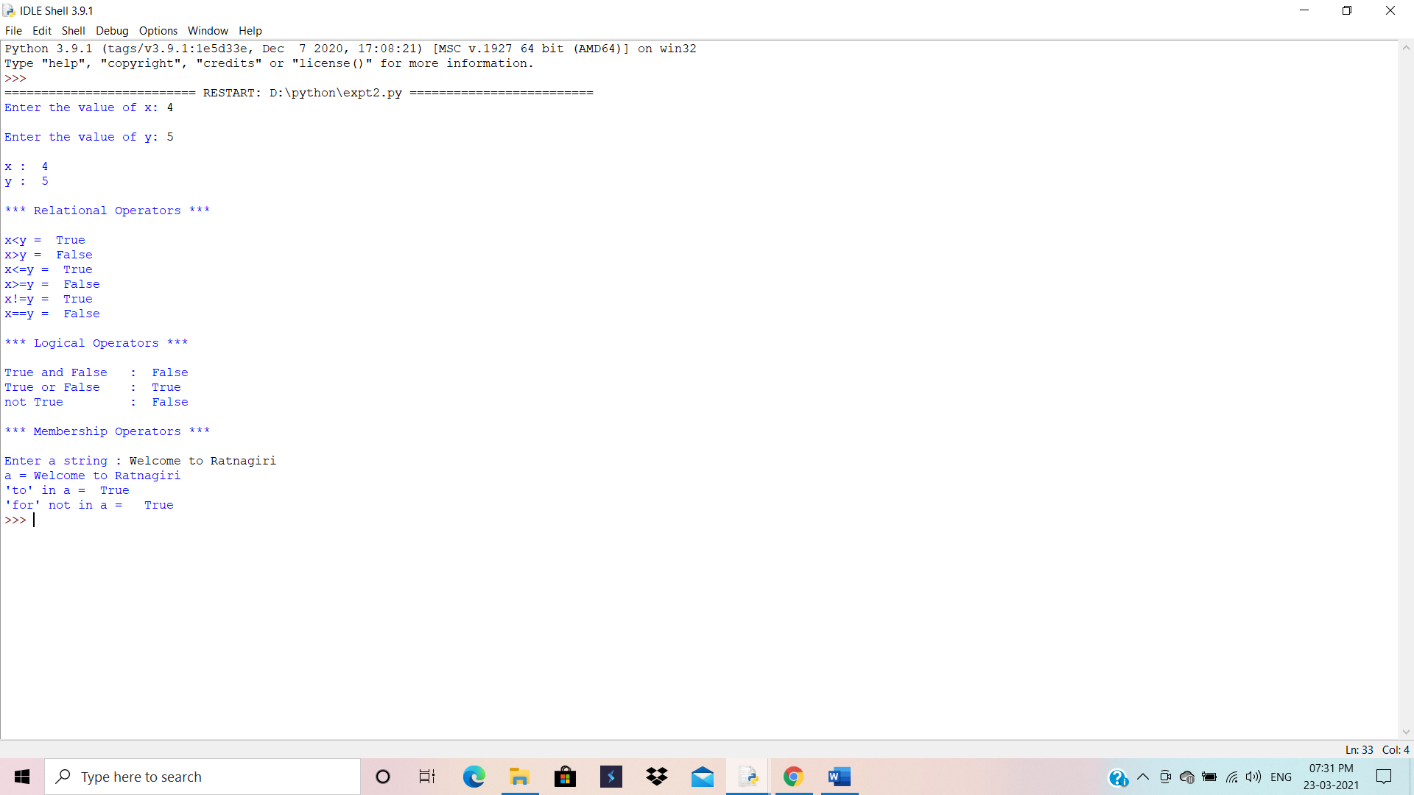

**11. Learning Outcomes Achieved:**

1. Understood Python as a software development platform.

2. Understood the use of relational, logical and membership operator’s with decision control instructions.

**12. Conclusion:**

Studied basic methods of List and String

**13. Experiment/Assignment Evaluation**

|  |  |  |  |  |  |
| --- | --- | --- | --- | --- | --- |
| **Experiment/Assignment Evaluation:** | | | | | |
| **Sr. No.** | **Parameters** | | | **Marks obtained** | **Out of** |
| **1** | Technical Understanding (Assessment may be done based on Q & A **or** any other relevant method.) Teacher should mention the other method used - | | |  | 6 |
| **2** | Neatness/presentation | | |  | 2 |
| **3** | Punctuality | | |  | 2 |
| **Date of performance (DOP)** | |  | **Total marks obtained** |  | **10** |
| **Date of checking (DOC)** | |  | **Signature of teacher** | | |

**References**:

[1] James Payne, “Beginning Python using Python 2.6 and Python 3.1”, Wrox Publications.

[2] Dr. R. Nageswara Rao, “Core Python Programming”, Dreamtech Press, Wiley Publications.

[3] [Charles R. Severance](https://www.google.co.in/search?tbo=p&tbm=bks&q=inauthor:%22Charles+R.+Severance%22&source=gbs_metadata_r&cad=3) “Python for Everybody: Exploring Data in Python 3”

**Viva Questions**

1. What are relational operators in Python?
2. What are logical operators in Python?
3. What are different decision control instructions in Python?
4. What are different membership operators in Python