**Accuracy**

For randomly selected training and test data.

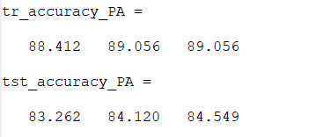Training and testing accuracies for iterations 1,2 and 10 for PA

Training and testing accuracies for iterations 1,2 and 10 for PA-I

Training and testing accuracies for iterations 1,2 and 10 for PA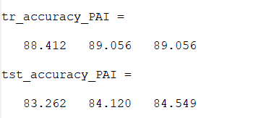-II

