**Conclusion**

From the assignment implementing Passive aggressive algorithm it could be understood that the maximum learning is done almost in one iteration, that is increasing the iteration does not give any considerable improvement in weights or accuracy. And from the given dataset and obtained predictions there were not much difference observed between the accuracy of the proposed update methods PA and PA -I, they were approximately similar it was noticed PA-II had slightly higher accuracy.

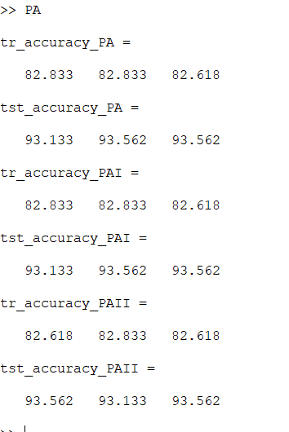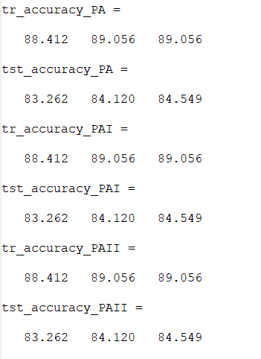

Figure 1--training,testing accuracies for PA,PA-I and PA-II for max iterations 1,2,20(first 466 as train dat)

Figure 2-training,testing accuracies for PA,PA-I and PA-II for max iterations 1,2,20(Randomly selected data)

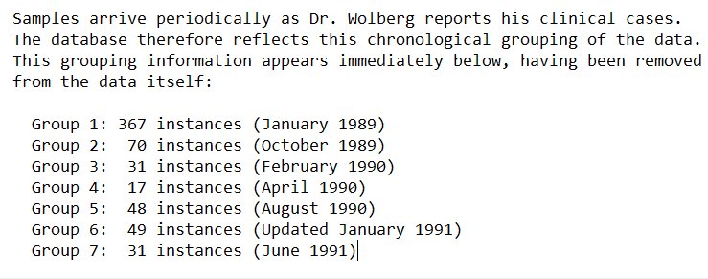Initially training and testing data were selected from the dataset by choosing first 2/3rd of the given data for training and the remaining was taken as test data, later the data were chosen randomly. It was observed that the accuracy remains maximum for the first method of data selection where the first 466 rows of data were selected for training. The reason for this could be understood from the description of data given,

As first 466 rows of data contain most data (367) collected in the same year which would have more similar patterns.