ProfIQ: Professor Recommendation System
Final Project Report - CS 210 Data Management for Data Science
Student: Afnan Haider
Date: May 2026
Repository: https://github.com/Afn377/ProfIQ
Project type: End-to-end data management, NLP analytics, and web application
Executive summary
ProfIQ helps students search, evaluate, and compare professors by combining public review signals with a normalized database, repeatable ingestion commands, sentiment analysis, and a React/Django web interface. The project emphasizes data-management choices: entity normalization, deduplication, source-aware ingestion, API design, reproducibility, and an intentionally minimal raw-text storage policy.
- Implements a normalized professor-review schema with Source, Department, Professor, Course, Review, SentimentResult, and ProfessorStats tables.
- Supports large-scale professor catalog crawling while avoiding bulk persistence of raw review text.
- Compares a domain-tuned VADER baseline with TF-IDF + Logistic Regression and DistilBERT sentiment models.
- Adds a MiniLM content-based recommender for similar-professor discovery.
- Provides a usable web application with search, filtering, detail pages, live reviews, sentiment/theme charts, and comparison views.

1. Problem Definition and Background
Students often choose courses using fragmented information: official catalog metadata, informal peer advice, RateMyProfessors-style ratings, and discussion posts. These signals are useful but scattered, inconsistent, and difficult to compare across professors. ProfIQ addresses this problem as a data-management system: it collects review signals, normalizes entities and sources, computes analytics, and exposes the results through searchable APIs and visual frontend workflows.
The project connects directly to CS 210 concepts. It requires schema design, data cleaning, deduplication, source integration, reproducible ETL, denormalized analytics for fast reads, and evaluation of models trained from scraped data. The system also makes an explicit engineering tradeoff: it persists catalog metadata and aggregate statistics while fetching raw review text live or during bounded analysis jobs, reducing storage footprint and avoiding unnecessary redistribution of scraped text.
Prior work and tools
The rule-based baseline builds on VADER, a sentiment method designed for short social text [1]. The neural comparison uses DistilBERT, a compact transformer model derived from BERT [2, 3]. The recommender uses sentence embeddings inspired by Sentence-BERT-style semantic similarity [4]. ProfIQ differs from those general-purpose tools by applying them inside an end-to-end data-management pipeline for professor review search and comparison.
Research questions
- Can public professor review signals be organized into a clean relational system that supports fast search, comparison, and analytics?
- Does a trained sentiment classifier improve over a hand-tuned VADER baseline on labeled RMP review text?
- Can content embeddings identify professors with similar teaching-style language better than random matching?

2. Data Description
ProfIQ uses three data layers. First, seed JSON data supports local demonstration and schema testing. Second, a RateMyProfessors directory crawl populates the professor catalog with names, institutions, departments, external IDs, and source-level rating summaries. Third, a one-off ML corpus stores review text in Parquet for model training and evaluation rather than in the production database.
Dataset / source | Format | Fields used | Role in project
Seed reviews | JSON | source, department, course, professor, review text, rating | Small reproducible demo path for local setup and ORM/API checks.
RMP catalog | SQLite rows from crawler | professor name, institution, department, external_ref, average rating, rating count | Large searchable catalog; current local DB contains 1,702,324 professors and 3,272 departments.
Live RMP reviews | API response, not persisted | comment, helpfulness/clarity rating, course, date | Detail-page review display and lazy aggregate sentiment analysis.
Reddit mentions | Public JSON/PRAW-compatible collector | comment text, URL, timestamp, professor mention slice | Auxiliary qualitative signal on first live-review page.
ML corpus | Parquet | 350,018 review rows across 4,793 professors and 49 institutions | Training/evaluating classifiers and building recommender embeddings.

3. Database and Pipeline Methodology
The relational schema separates entities that would otherwise be duplicated in raw review data. Professor belongs to an optional Department and has many Courses; Review links a professor, optional course, and Source; SentimentResult stores one NLP result per persisted Review; ProfessorStats stores denormalized aggregates for dashboard queries. Unique constraints on professor identity, external references, course codes, source names, and review source URLs support idempotent ingestion.
Stage | Persistent writes | Intentionally not written | Reason
Directory crawl | Professor, Department, source rating/count | Raw review text | Keeps the catalog searchable without storing millions of review rows.
Seed ingest | Sources, courses, demo reviews, sentiment rows, stats | Duplicate source URLs | Provides a reproducible small-data path for setup and tests.
Lazy analyze | One ProfessorStats row per professor | Review/comment text | Computes aggregates once while respecting the minimal-storage design.
Live review endpoint | Nothing persistent | Any database rows | Returns per-review sentiment inline for the user session.

This design is central to the project. A grader inspecting the production-scale SQLite database may see zero rows in Review and SentimentResult after a directory crawl; that is expected. The large catalog stores professor metadata and source summaries, while raw review text is fetched live, analyzed in memory, and discarded. The seed path still demonstrates the full normalized review schema when persistent example reviews are needed.

4. Sentiment and Recommendation Methods
The baseline sentiment analyzer extends NLTK VADER with an academic-review lexicon, idiom rules, and a star-rating blend. The lexicon adds terms such as 'avoid', 'useless', 'helpful', and 'engaging'; the idiom layer catches multi-word phrases like 'avoid like the plague' and 'would not recommend'; the rating blend maps 1-5 star scores to the VADER compound scale as a secondary signal. Each review is also tagged for teaching themes: clarity, fairness, workload, helpfulness, engagement, and grading.
The supervised ML classifier labels RMP reviews using averaged helpfulness and clarity ratings: ratings <= 2.0 are negative, 2.0-3.5 are neutral, and > 3.5 are positive. Splits are hash-stratified by source URL so repeated runs place the same review in the same train/validation/test bucket. TF-IDF + Logistic Regression is the live default because it is fast and compact; DistilBERT is kept as a deeper offline comparison.
For similar-professor search, ProfIQ builds one MiniLM embedding per professor by concatenating review text, normalizing vectors, and using cosine similarity. Runtime lookup is a matrix-vector product followed by DB hydration and optional department/institution filtering.

5. API and Frontend Implementation
The backend exposes REST endpoints for the user workflows. The frontend is a React/Vite app that calls those endpoints and renders search results, professor detail pages, comparison views, sentiment distributions, theme charts, live reviews, and similar-professor recommendations.
Endpoint | Purpose
GET /api/summary/ | Platform summary and top-ranked professors.
GET /api/professors/ | Search/filter by professor, department, institution, course, and sort mode.
POST /api/professors/ | Validated, throttled, deduplicated student-submitted professor creation.
GET /api/professors/<id>/ | Professor detail with courses, stats, source ratings, and lazy-analysis trigger.
GET /api/professors/<id>/reviews/ | Live RMP review page plus first-page Reddit mentions, analyzed inline.
GET /api/compare/?ids=... | Compact multi-professor comparison data.
GET /api/professors/<id>/similar/ | MiniLM-based similar-professor recommendations when embeddings are available.

6. Results and Analysis
The implementation was verified with automated tests and a production frontend build. The sentiment unit tests cover lexicon behavior, idiom handling, rating blending, ML fallback behavior, and recommender artifact fallback/warm-up behavior. Professor creation tests cover validation, fictional/joke-name rejection, case-insensitive deduplication, and happy-path persistence.
Check | Result | Interpretation
python3 -m unittest sentiment.tests -v | 28 passed | Core sentiment/recommender helpers behave as expected.
python3 manage.py test professors -v 2 | 13 passed | Create-professor API validation/dedup logic passes.
npm run build | Passed | Frontend compiles successfully; Vite reports only a non-fatal chunk-size warning.

The model comparison shows that learned models outperform the VADER baseline on headline metrics. DistilBERT has the highest raw accuracy and weighted-F1 on the benchmark split, but Logistic Regression has the strongest macro-F1 in the saved artifacts because class weighting improves recall on the minority neutral class. This matters for the product: neutral reviews are common in real course selection, and a model that never predicts neutral would overstate student sentiment.
Model | Test rows | Accuracy | Macro-F1 | Weighted-F1 | Use
VADER + domain rules | 7,427 | 0.764 | 0.533 | 0.737 | Always-available baseline.
TF-IDF + LogReg | 52,445 | 0.802 | 0.719 | 0.817 | Live default ML augmentation.
DistilBERT | 7,427 | 0.857 | 0.636 | 0.831 | Offline comparison / optional live model.

Figure 1. Sentiment model metrics from the saved evaluation artifacts.
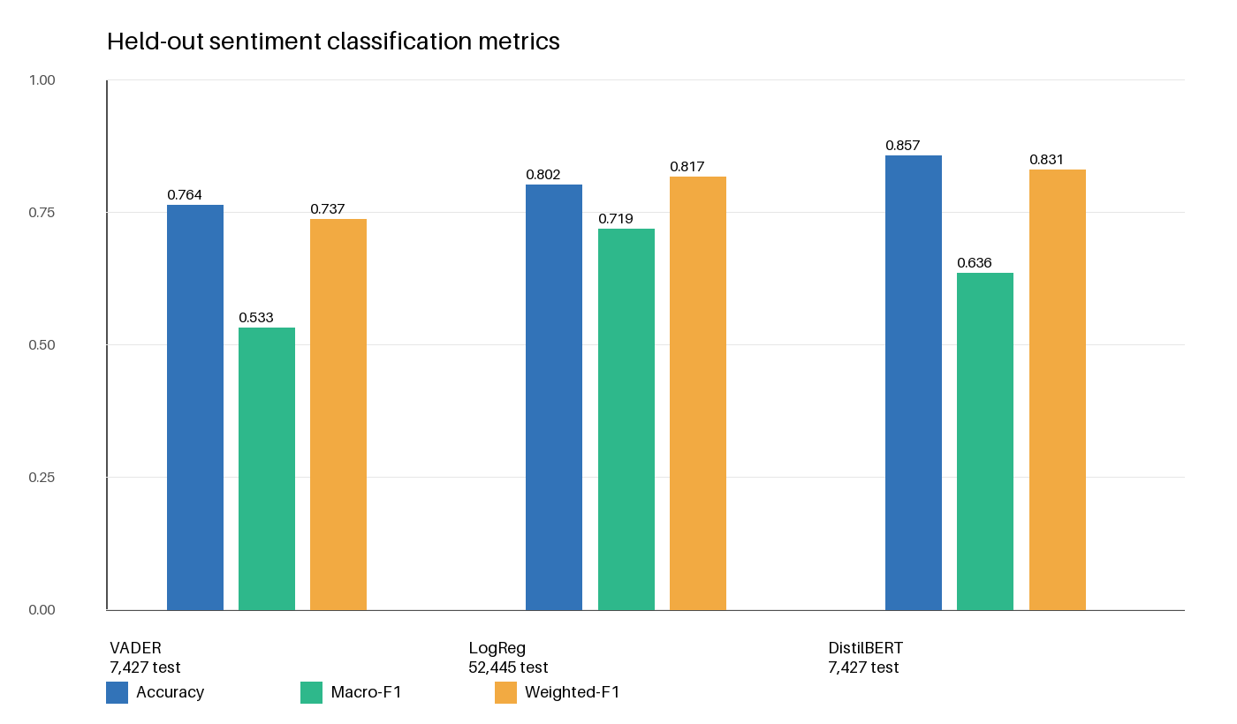
The recommender evaluation uses purity@5: the fraction of each professor's top-five neighbors sharing a department or institution. Department purity reaches 0.230 versus a 0.055 random baseline, a 4.2x lift. Institution purity reaches 0.093 versus 0.050 random, a 1.9x lift. The stronger department lift is useful because it suggests the embedding captures subject-matter and teaching-language patterns more than campus identity alone.
Metric | ProfIQ purity@5 | Random baseline | Lift | Interpretation
Department | 0.230 | 0.055 | 4.2x | Embeddings recover teaching/content similarity better than chance.
Institution | 0.093 | 0.050 | 1.9x | Location signal exists but is weaker than department/content signal.

Figure 2. Similar-professor recommender lift over random baselines.
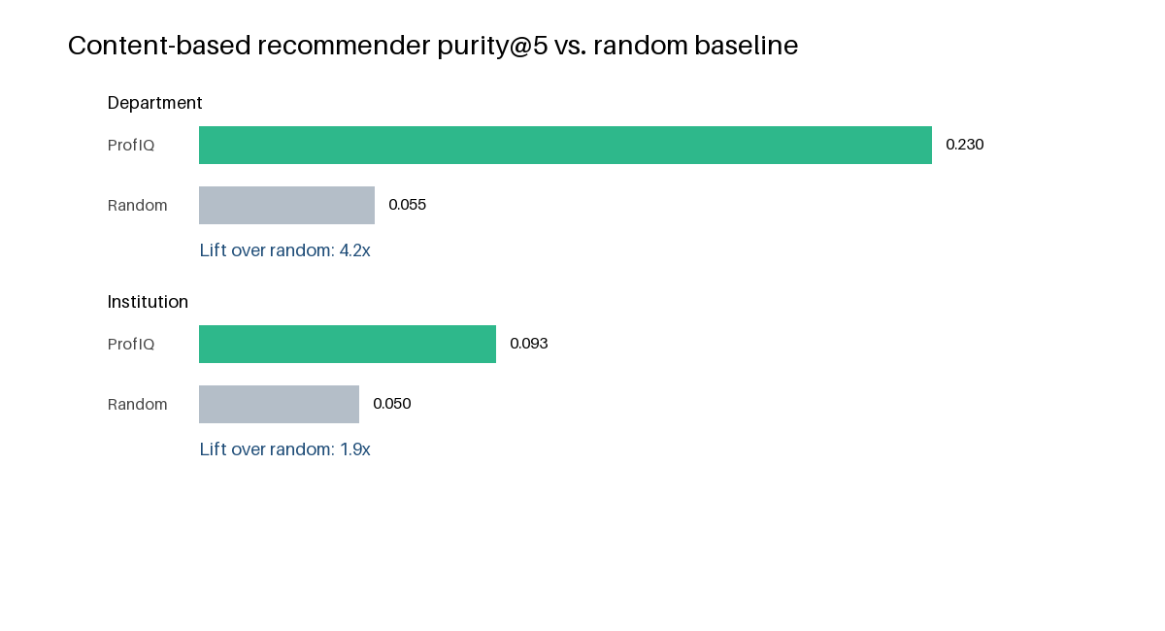

7. Discussion, Limitations, and Ethics
ProfIQ's main advantage is that it demonstrates the full data lifecycle: collection, cleaning, normalization, deduplication, analytics, serving, visualization, and model evaluation. The system is usable as an application, but the more important data-management contribution is the boundary between persisted metadata/aggregates and transient raw review text.
- Source bias: RMP and Reddit comments are self-selected and may overrepresent unusually positive or negative experiences.
- Label noise: using RMP helpfulness/clarity ratings as sentiment labels is practical but imperfect because star ratings do not always match review text.
- Neutral-class difficulty: both VADER and DistilBERT struggle with neutral reviews; LogReg improves macro-F1 but still has room to improve.
- External-source reliability: RMP and Reddit access can be rate-limited or change without warning, so live review display must degrade gracefully.
- Ethics and terms: the project minimizes raw-text persistence and is intended for educational analysis rather than redistribution of scraped review corpora.
- Operational scaling: production deployment should move from SQLite to PostgreSQL and use a real background queue instead of in-process threads.
Future work would add better entity resolution across campuses, topic modeling or lemmatized theme extraction, calibration checks for sentiment scores, user preference controls, cache invalidation policies, and accessibility/performance hardening for the frontend.

8. Reproducibility
The repository includes the backend, frontend, migrations, requirements, README, ML report, evaluation notebook, and example data. A fresh local run uses the seed ingest path; large crawls and ML artifacts can be rebuilt from the documented management commands.
Step | Command
Install backend | python3 -m venv .venv; source .venv/bin/activate; pip install -r backend/requirements.txt
Initialize database | cd backend; python manage.py migrate; python manage.py ingest_seed --reset
Run backend | python manage.py runserver 8000
Run frontend | cd frontend; npm install; npm run dev
Run tests | cd backend; python3 -m unittest sentiment.tests -v; python3 manage.py test professors -v 2
Build frontend | cd frontend; npm run build

9. Conclusion
ProfIQ satisfies the project objective by delivering both a working application and a documented data-management workflow. The system integrates multiple public data sources, normalizes professor-review entities, computes interpretable sentiment/theme analytics, evaluates learned models against a rule baseline, and exposes the results through a web interface. The final design is intentionally pragmatic: it keeps the database queryable and small while still giving students live access to review-level evidence when they need it.

References
Hutto, C. J., & Gilbert, E. (2014). VADER: A parsimonious rule-based model for sentiment analysis of social media text. International AAAI Conference on Web and Social Media.
Devlin, J., Chang, M.-W., Lee, K., & Toutanova, K. (2019). BERT: Pre-training of deep bidirectional transformers for language understanding. NAACL-HLT.
Sanh, V., Debut, L., Chaumond, J., & Wolf, T. (2019). DistilBERT, a distilled version of BERT: smaller, faster, cheaper and lighter. arXiv:1910.01108.
Reimers, N., & Gurevych, I. (2019). Sentence-BERT: Sentence embeddings using Siamese BERT-networks. EMNLP-IJCNLP.
Pedregosa, F. et al. (2011). Scikit-learn: Machine learning in Python. Journal of Machine Learning Research.
Django Software Foundation. Django documentation. https://docs.djangoproject.com/
React documentation. https://react.dev/

