CSE320: Data Communication

Assignment 01 [Spring 26]
1. PC2 using port number 49543 has sent a request packet to a Web server (port number 443). The packet is currently at router R1, moving towards the server. Identify the source and destination Port, IP, and MAC Addresses of this request packet. Consider the alphabets as physical addresses and the numbers as logical addresses (given beside the devices in the figure).
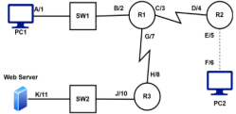

2. Find the frequency and time period of the given signal. Find out if the signal suffers from any kind of transmission impairment.
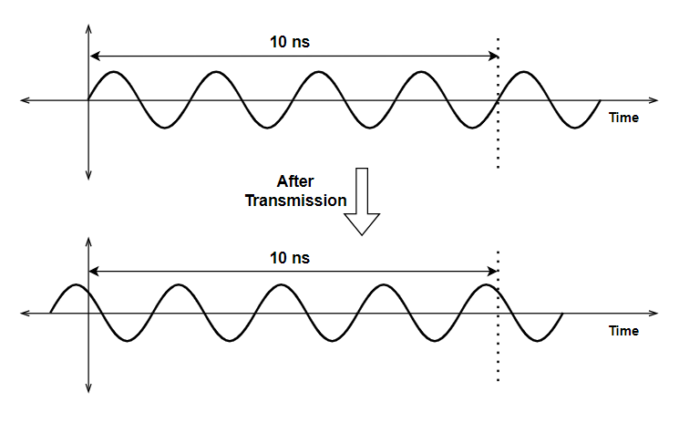
3. A periodic composite signal has a bandwidth of 20 kHz and a starting (minimum) frequency of 25 kHz. The signal exhibits peak amplitudes of 12V, 18V, and 24V corresponding to the lowest, highest, and midpoint frequencies within its range, respectively. [In other words, the lowest frequency has an amplitude of 12V, the highest frequency has an amplitude of 18V, and the midpoint frequency has an amplitude of 24V. The question in the exam may not have such clear wording.] Calculate the maximum frequency of the signal and present its frequency domain representation.
4. Consider the composite signal of Question 3 to be non-periodic and present its frequency domain representation.
5. Suppose you're streaming gameplay or a presentation from your Full HD (FHD) monitor, which has a resolution of 1920x1080 pixels and an aspect ratio of 16:9. The monitor operates at a 60 Hz refresh rate, meaning the display updates 60 times per second. Each pixel on the screen is represented by 24 bits (for RGB color). To reduce data usage, the streaming application compresses the video quality to 0.5% of the original quality.
- Calculate the bit rate required to stream this screen. [hint: bit rate = data / time, here time = 1s]
- If the data is transmitted through a noiseless channel that uses 32 signal levels. Calculate the bandwidth (Hz).
- Now suppose the channel mentioned in question (b) becomes noisy due to inference. The capacity of the channel needs to be 20% more than the actual bitrate transmitting through it. Find the SNR of the channel. [Hint: Use Shanon’s formula. Bandwidth stays the same as (b), bitrate will become 20% more so 1.2 times the previous bitrate.]
6. Suppose, a transmission line is 10 km long. Along this line, any signal deteriorates at an average rate of 3W/km. To prevent the signal from degrading too much, a 15x amplifier is placed at 6 km distance from source. The signal strength at source is calculated to be 20W. Calculate attenuation in each part of the transmission medium and the total attenuation.
7. A signal with a power of 3.6 mW at source is being transmitted through a signal that has an attenuation of 0.45 dB / km. Find the power of the signal at 10 km distance from the source.
8. A document containing 1.35X10^8 characters takes 5 minutes to download over a noisy channel that has a bandwidth of 100 kHz. This data rate is 75% of the Shannon capacity of the channel.
- Calculate the actual bit rate and the Shannon capacity of the noisy channel.
- Use Shannon capacity to find the SNR of the channel.
- Calculate the signal level. [Hint: Use the Nyquist formula to calculate the signal level. The value of C in the formula will be the actual bit rate.]
9. Suppose, a frame of size 5MB is being sent through a fiber-optic transmission medium with 10 routers. Each router has a queuing time of 2 μs and a processing time of 1 μs. The length of the medium is 2000 km. The speed of light inside the fiber optic medium is 2 × 10^8 m/s. The medium has an average throughput of 5 Mbps. Calculate the latency (total delay) of this transmission. Which component of the total delay is dominant? Which one is negligible?
10. Draw signal for the bit stream 100001011110 using NRZ-L, NRZ-I, and MLT-3.
11. The following signal is drawn using HDB3 scrambling technique. 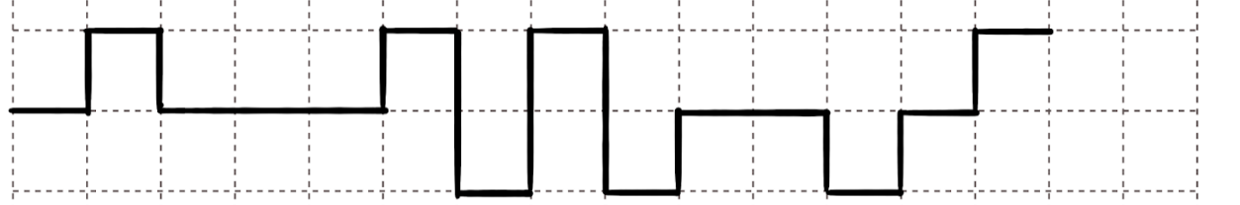
- Decode the bit stream from the signal.
- Suppose we want to use a line coding scheme for transmitting the decoded bits, which must not suffer from any kind of baseline wandering and DC components issue. Suggest what line coding schemes we can use. Draw the corresponding signals for each of them. Which of them is better and why?
12. The following signal was obtained using a particular line coding scheme.
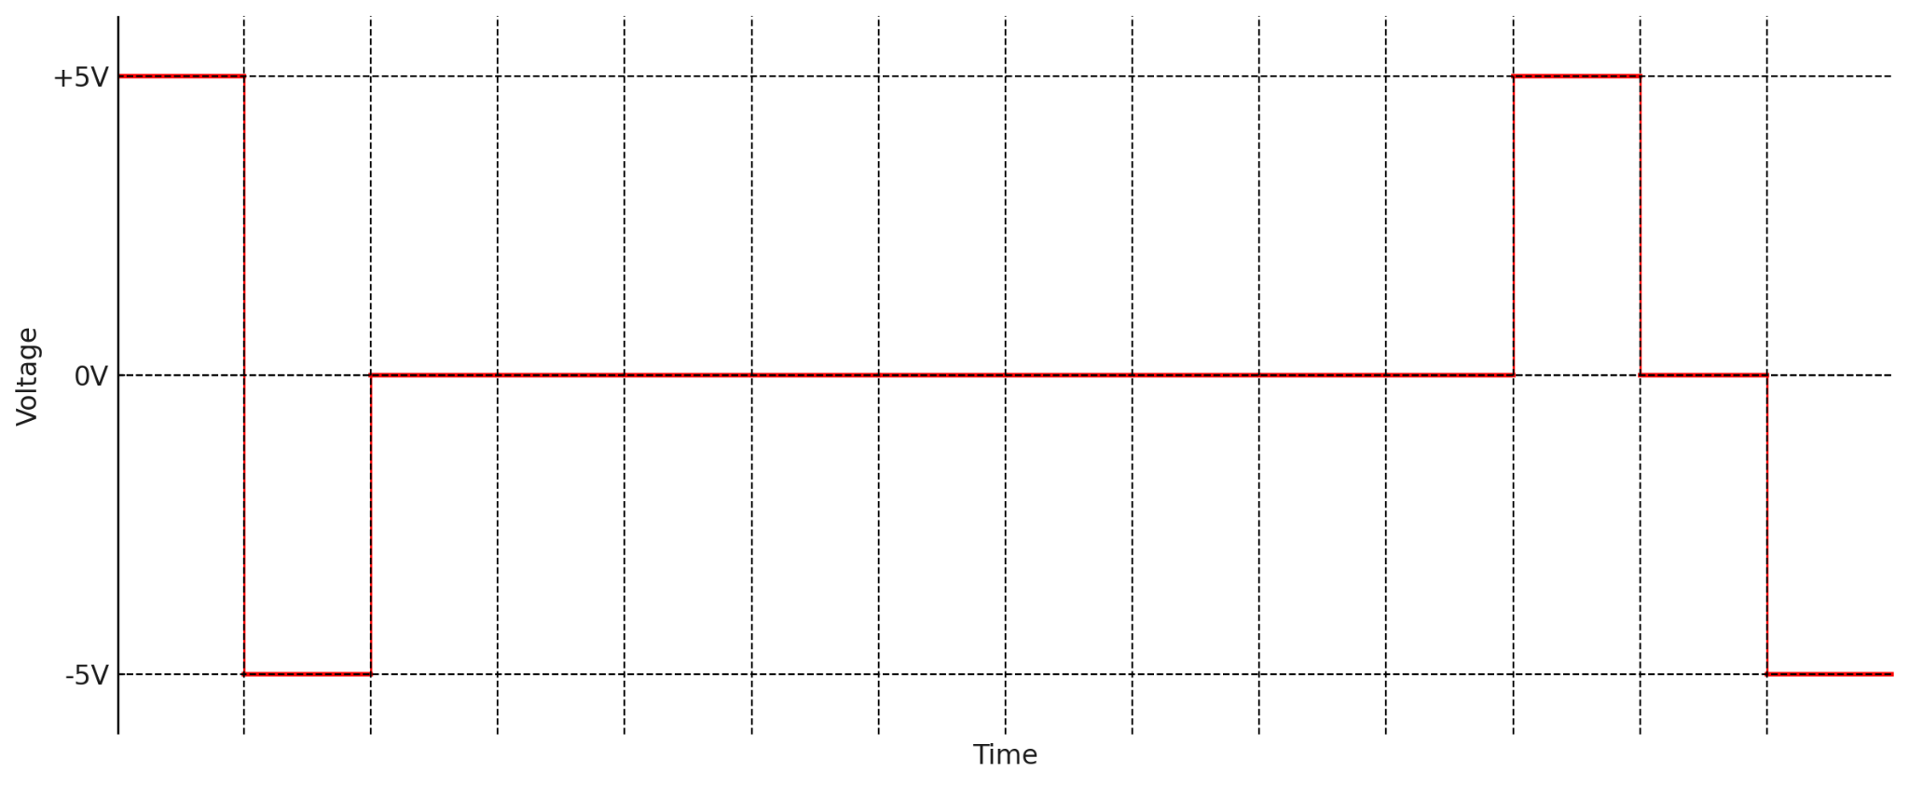
- Deduce which line coding scheme was used and decode the signal. [Hint: it uses 3 levels, and it does not have the staircase pattern.]
- Explain what problem does this signal suffer from.
- Use a suitable scrambling technique to solve this problem. [Note: carefully review how many consecutive 0s are there, you will choose B8ZS/HDB3 based on this.]

13. Construct a 3B/4B block coding table. You must maintain the following specified rules:
- The encoded sequences cannot have 3 or more consecutive 0s
- If the first bit is 1, it must be followed by a 0
- If the first bit is 1, it cannot be followed by a 1
- 0111 is reserved for control sequence so you cannot use it for encoding data
[Hint: Since it is 3B/4B, there are 8 data sequences. We would need one encoded sequence for each of these 8 data sequences. Using 4 bits for encoding, we have 16 combinations, from which we will need 8 combinations only. First write all 16 possible numbers using 4 bits. Then cross out the ones that cannot be used (e.g. 0000, 0001, 1100, 1101, etc). From the remaining options, choose the mappings as needed. For example, both 0010 and 0011 are valid encoded sequences. So we can use them as encoded sequences like this: 000 -> 0010, 001 -> 0011, etc.]

14. Suppose in a system, a multi-level line coding scheme is being used. There is no synchronization. Moreover, a long sequence of 0’s causes a DC component, but a long sequence of 1’s does not contribute to any such problems.
- Which line coding technique will be followed?
- Encode the following binary bits using the technique in question (a): 110000101011
- Apply a technique that can resolve both the synchronization issues and the DC problem for a long sequence of 0’s without requiring any extra bandwidth. What is the name of the technique? Draw the signal in (b) using that technique.

