Use machine learning XGBoost to improve the prediction of breast cancer risk
Research Plan
Student Name: Afnan Alkhaibari
Student ID: 1718597
Word count: 1986

- Motivation:
Breast cancer (BC) is still one of the most commonly diagnosed cancers worldwide, with around 2.3 million new cases reported each year [1]. Predicting how the disease will progress or how patients will respond to treatment is an important part of clinical decision-making, but it is not straightforward because real-world BC populations are heterogeneous in both clinical presentation and underlying biology, which challenges model generalisability across datasets [2]. Despite AUC scores exceeding 95% on single datasets [3], [4], performance drops of up to 15% have been reported when models are tested on independent cohorts [2], highlighting the need for cross-dataset validation.
Machine learning (ML) is increasingly applied in BC prediction [2]. However, many studies only test their models on a single-dataset [3], [5], [6]. This can give some indication of performance, but it does not really show whether the model would behave in the same way on data from different patient groups.
Extreme Gradient Boosting (XGBoost) ML is widely used in healthcare for structured tabular data [7]. Some studies have shown good results when using it on clinical datasets [4], [6], [8]. It can handle missing values and capture more complex patterns among variables, which is useful for this type of data [9]. While Random Forest and LightGBM have also been applied to similar tasks, XGBoost has demonstrated consistently higher AUC on structured clinical tabular data in comparable BC studies [3], [4], justifying its selection here.
Another issue is how easy it is to understand what the model is doing. In medical use, having an accurate model is not always enough. Doctors usually need to understand why a model made a certain prediction before they can trust or use it in real clinical decisions [10].
Shapley Additive Explanations (SHAP) is applied to investigate the consistency of feature importance across datasets, addressing the interpretability gap identified in prior clinical ML studies [11]. For this reason, the present study evaluates an XGBoost pipeline across three independent BC cohorts to assess both predictive generalisation and feature consistency [7].

- Research Question:
Does an XGBoost pipeline, trained and evaluated independently on three breast cancer cohorts of different size and feature composition, maintain consistent predictive performance (AUC-ROC variation ≤ 10%) across all cohorts, and do the most influential SHAP-derived features remain consistent across the three datasets?"
This question addresses a gap identified in prior work: studies such as Zhou et al. [3] and Hoque et al. [4] evaluated XGBoost on single datasets, making it unclear whether strong performance reflects genuine model capability or dataset-specific characteristics. By specifying a ≤10% AUC-ROC variation threshold, this study provides a measurable criterion for generalisation that previous work has not defined.

- Investigation Method:
  - Datasets
This study uses three publicly available BC datasets. The first is the Wisconsin Diagnostic Breast Cancer (WDBC) dataset, which contains 569 samples and 30 features, derived from cell nucleus measurements [12]. The second dataset is the Molecular Taxonomy of Breast Cancer International Consortium (METABRIC), which includes 2,503 patients [13], [14], [15]. The third dataset is the Cancer Genome Atlas – Breast invasive carcinoma (TCGA-BRCA), with 1,097 patients [13], [14], [15].
Relying on a single dataset can lead to overly optimistic results, since it represents only one population or data collection process.

  - Data Preprocessing:
The proposed methodology is summarised in (Figure 1). The same preprocessing steps were used for all datasets to ensure comparable results. Missing values were imputed using column-wise medians, a strategy chosen for its robustness to outliers and suitability for skewed clinical distributions [16].
Categorical variables such as cancer stage and hormone receptor status were converted into numeric form using label encoding so they could be used as input features to the XGBoost classifier, which requires numeric data [17]. For ordinal variables such as cancer stage, this encoding preserves the clinically meaningful ordering of categories. For the remaining categorical variables, label encoding was applied, given XGBoost's tree-based structure, which features at learned thresholds and does not assume linear relationships between encoded values. For nominal variables, this limitation is considered acceptable given XGBoost's tree-based splitting mechanism [7]. Duplicate rows were also removed where present. TCGA-BRCA is imbalanced, with many more living than deceased patients. To deal with this, the scale_pos_weight parameter in XGBoost was used, so the model pays more attention to the less frequent class [7].
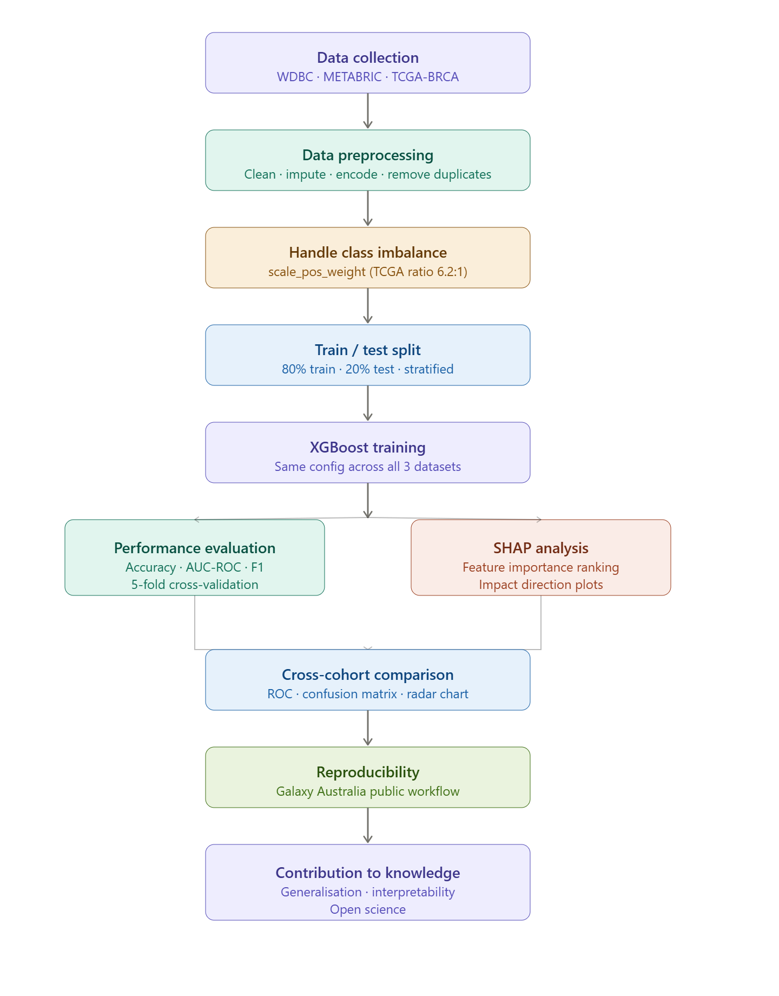
Figure 1: Overview of the proposed XGBoost classification pipeline.

  - Model Training:
The same XGBoost setup was used for all datasets, so differences in performance are due to the data rather than changes in the model. It has 200 trees, a maximum depth of 4, a learning rate of 0.1, and subsamples of 0.8. These values follow the configuration recommended by Chen et al. [7] for structured clinical data. Hyperparameter tuning was not performed to maintain a consistent configuration across all three datasets, ensuring that performance differences reflect dataset characteristics rather than optimisation artefacts. These default values are consistent with those reported in prior XGBoost-based clinical studies [4], [7]. Class imbalance is addressed through the scale_pos_weight parameter during model training rather than through data-level resampling, ensuring no data leakage occurs across the train/test split. For WDBC and METABRIC, where class imbalance is minimal, scale_pos_weight is set to 1 by default.
Each dataset was divided into 80% for training and 20% for testing, using stratified sampling to ensure the class distribution remained stable across both sets [18]. Five-fold cross-validation was also used to get a more stable estimate of performance. A fixed random seed was used to ensure reproducible results [19].

  - Reproducibility
All code, data preprocessing steps, and results are shared through a Galaxy Australia public history, accessible at: https://usegalaxy.org.au/u/afnan_alkhaibari/h/xgboost-breast-cancer-pipeline-wdbc-metabric-tcga.
This allows the complete pipeline to be rerun by others without needing to rebuild it from scratch [20].

- Analysis Method:
  - Performance Evaluation
Three metrics will be shown to evaluate model output. Accuracy was the starting point; it shows the overall ratio of correct predictions. But accuracy alone can be deceptive here because the datasets are imbalanced [21]. In TCGA-BRCA, for example, there are roughly 6.2 living patients for every deceased one, so a model that always predicts “living” would still look 86% accurate without learning anything useful [22].
This is why AUC-ROC was included. It measures whether the model can distinguish between the two groups across several decision thresholds, giving a clearer picture of performance under class imbalance [23].
The third metric, weighted F1-score, was chosen because the two types of errors in this setting carry varying weights. False negatives carry greater clinical risk than false positives. F1-score accounts for precision and recall in a single number, weighted by how many patients fall into each class [24].
ROC curves for all three datasets were shown on the same plot, so it is easy to compare them visually (Figure 2a). Confusion matrices will show exactly where the model makes mistakes, with both raw numbers and percentages (Figure 2b). Confidence intervals will be reported as mean ± standard deviation (Table 1) [25]. DeLong and McNemar tests will be used to assess whether performance differences across cohorts are statistically significant. Pilot experiments suggest that the pipeline can achieve high AUC-ROC and stable cross-validated performance; the full study will formally evaluate these properties [25].
Table 1: Planned summary of accuracy, AUC-ROC, weighted F1-score and cross-validated AUC (mean ± standard deviation) for the three datasets.
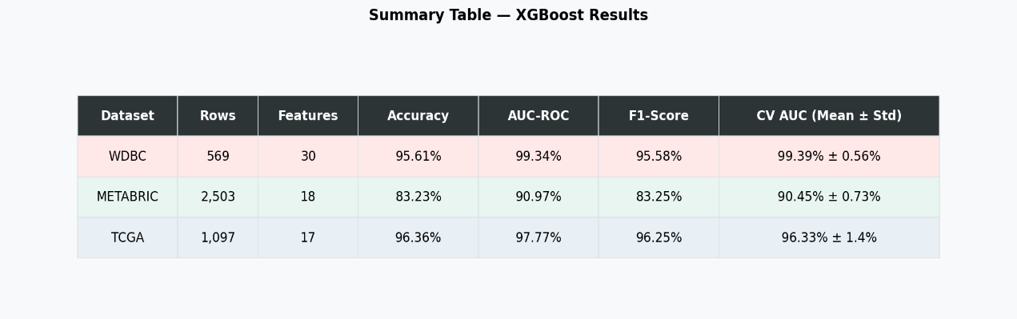
The pilot results show AUC-ROC scores of around 99.3% for WDBC, 91.0% for METABRIC, and 97.8% for TCGA-BRCA. The variation between folds is low (under 1.5%), which suggests the model is stable. The lower AUC in METABRIC (90.97%) reflects its greater clinical complexity and mixed variable types and will be examined in the full study to determine whether it represents genuine dataset heterogeneity.
Table 2: DeLong and McNemar statistical test results for cross-cohort AUC and error pattern comparison.
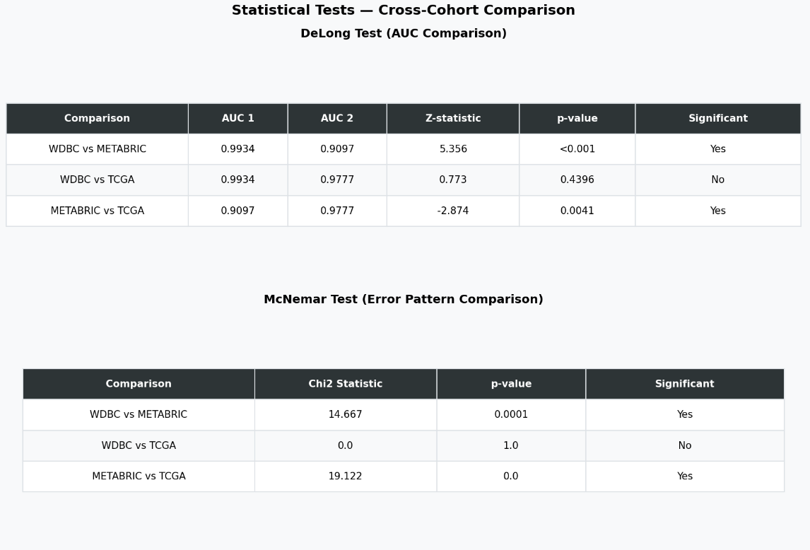

Figure 2:
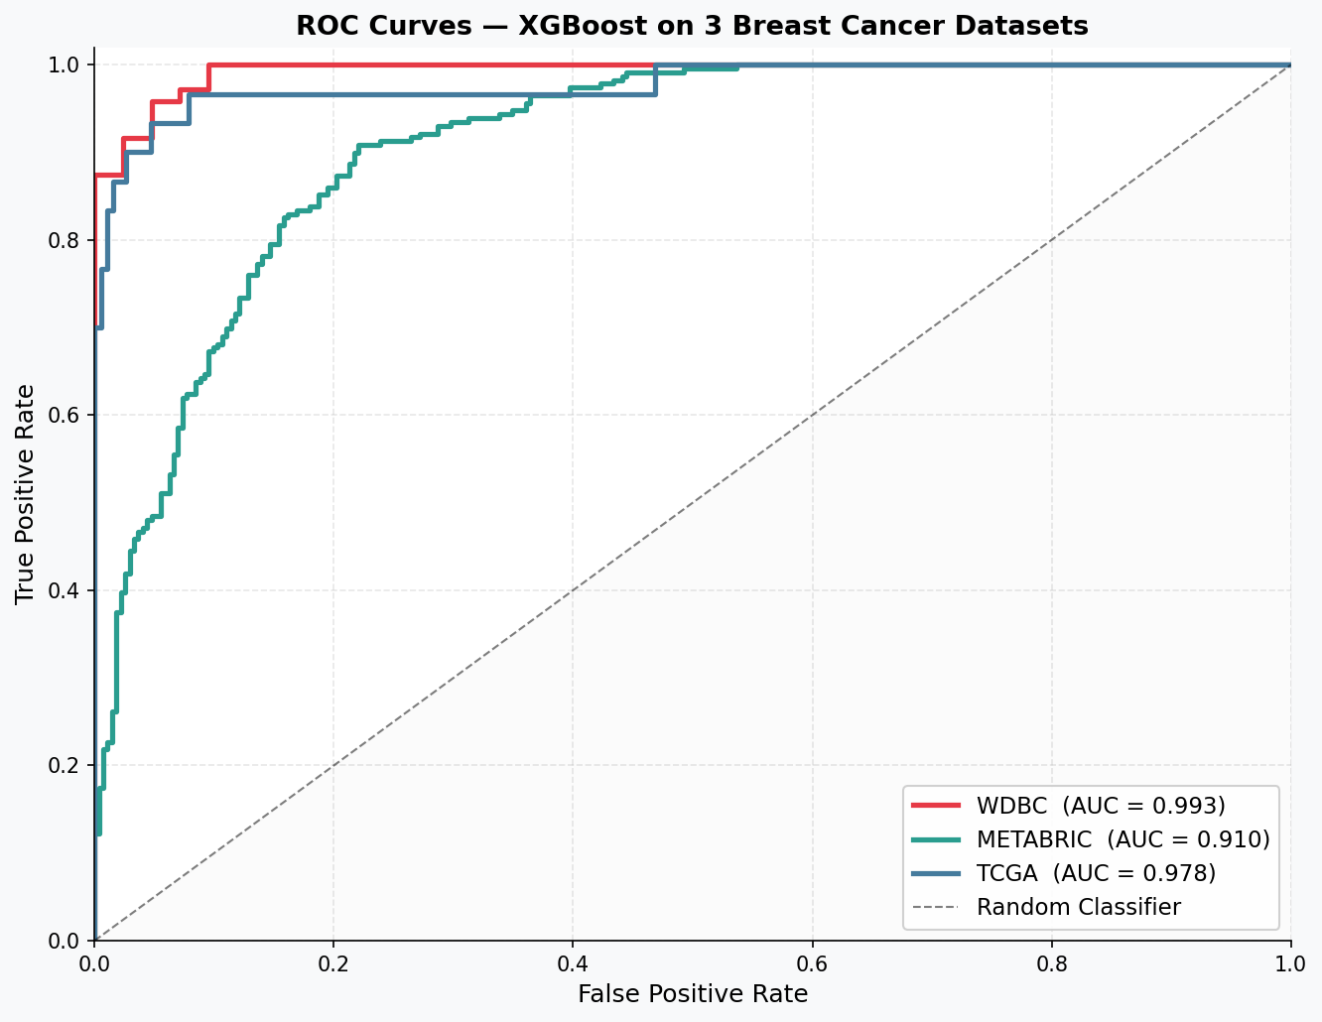
  - ROC curves illustrating how discriminative performance were compared across WDBC, METABRIC and TCGA-BRCA.

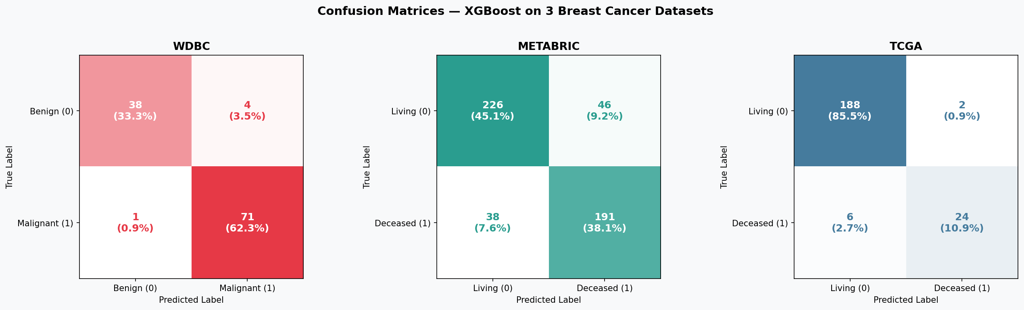
b) confusion matrices showing class-specific error patterns, including false negatives.

  - SHAP Analysis
SHAP is used in this study to explain what the model has learned. For each dataset, we compute the average absolute SHAP value of every feature across the test set [11]. This gives a simple ranking of which features matter most overall (Figure 3).
Additionally, SHAP direction plots are generated. These plots show not only which features are important, but also whether higher values of a feature push the prediction toward a better or worse outcome [26].
Comparing the most important features among WDBC, METABRIC, and TCGA-BRCA is an essential part of the study. SHAP provides actionable insights that can support risk stratification and data-driven clinical decision-making by highlighting which features drive individual predictions [27]. Consistently identifying the same features as highly significant in all three datasets provides strong evidence that the model is detecting genuine biological signals rather than random noise or dataset-specific artifacts. This is especially important for features already recognised as clinically relevant in BC, such as hormone receptor status and tumour stage; their presence among the top-ranked features would further validate the overall methodology [28].
Feature consistency across datasets will be quantified by computing the overlap percentage of the top 10 SHAP-ranked features between each pair of cohorts, providing a measurable criterion for cross-cohort interpretability. A limitation of cross-cohort SHAP comparison in this study is that the three datasets share no common features. Therefore, consistency is assessed conceptually, whether clinically recognised risk factors (e.g. tumour stage, hormone receptor status) appear among top-ranked features in each dataset, rather than through direct feature overlap [27], [28].

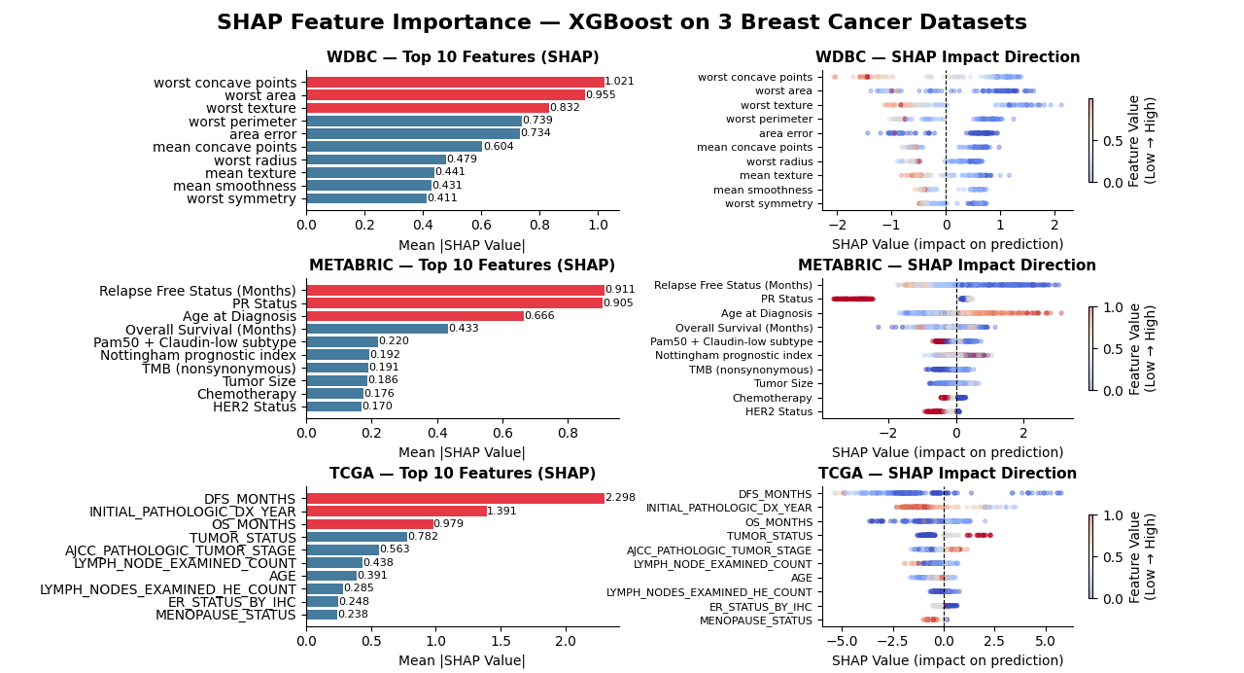
Figure 3: SHAP summary plot highlighting the most influential features and their effect directions.

  - Cross-Cohort Comparison
A group bar chart will show accuracy, AUC-ROC (Figure 4a), and F1-score side by side for all three datasets (Figure 4b). A radar chart will give an overview of how the pipeline performs across all metrics at once (Figure 4c). These visualisations make it easy to see whether performance is consistent or whether there are large differences between datasets [25].
Figure 4:
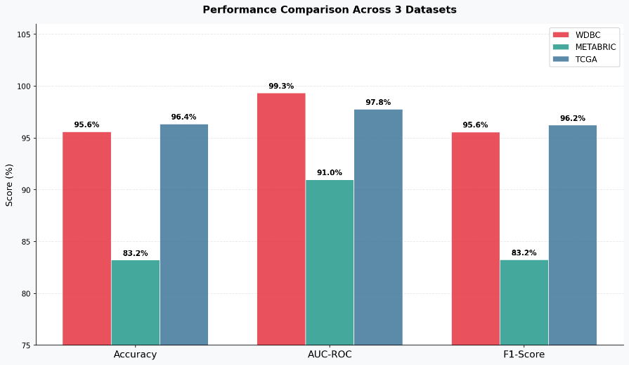
a) Grouped bar chart comparing accuracy, AUC-ROC, and weighted F1-score across the three datasets.

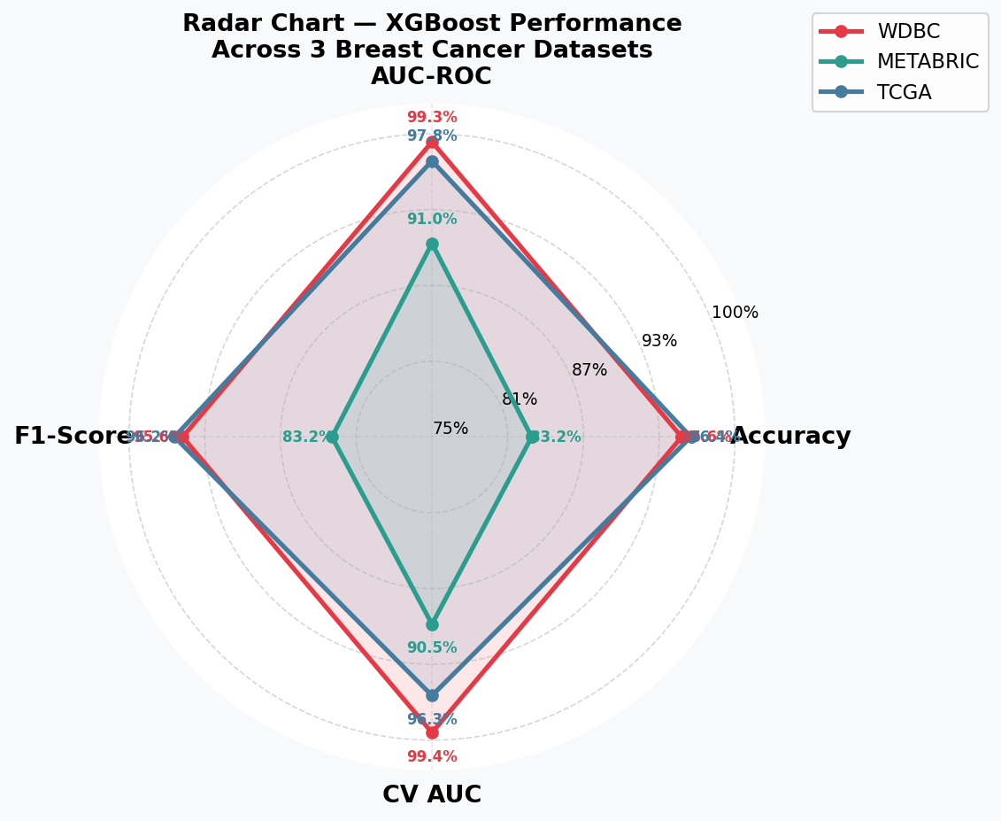
b) Radar-chart summarising the overall performance profile of the XGBoost pipeline across WDBC, METABRIC, and TCGA-BRCA datasets.

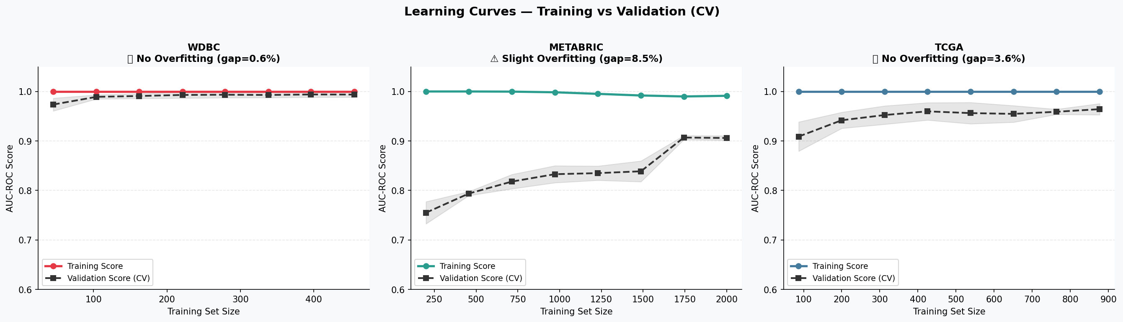
c) learning curves (Training vs Validation CV) summarising the generalisation performance of the pipeline across WDBC, METABRIC, and TCGA-BRCA.

- Contribution to Knowledge:
Though there is previous research applying ML to BC classification, there has been limited research evaluating the same pipeline across multiple independent cohorts while also addressing model interpretability. For instance, Zhou et al. [3] and Hoque et al. [4] applied XGBoost to BC classification but evaluated their models on a single dataset, limiting the generalisability of their findings. Similarly, Jaiswal et al. [6] used ensemble methods without incorporating explainability analysis. The present study addresses both limitations by evaluating a unified pipeline across three independent cohorts and applying SHAP analysis to assess feature consistency. Limitations of this study include the absence of hyperparameter tuning and the potential impact of label encoding on nominal variables; both may be addressed in future work. Compared with single-dataset studies, one key difference in this work is that the pipeline must perform consistently across datasets that differ substantially in size, feature composition, and clinical context. For example, a preprocessing step that works well for the WDBC dataset, which contains only numerical cell measurements, must also handle the mixed clinical and categorical variables found in METABRIC and TCGA-BRCA. Hence, this research aims to identify the design decisions that allow a unified XGBoost pipeline to generalise across heterogeneous cohorts. SHAP analysis is applied to each trained model to assess whether the same features emerge as important across datasets, and the full pipeline is made publicly available through Galaxy Australia to support reproducibility and future research in this area.
Consistent performance and feature importance across three independent cohorts would provide preliminary evidence that the pipeline may generalise to diverse clinical populations, supporting its potential value beyond controlled experimental settings.

Reference
[1] S. Lei et al., “Global patterns of breast cancer incidence and mortality: A population‐based cancer registry data analysis from 2000 to 2020,” Cancer Commun, vol. 41, no. 11, pp. 1183–1194, 2021, doi: 10.1002/cac2.12207.
[2] H. Behravan, J. M. Hartikainen, M. Tengström, V. Kosma, and A. Mannermaa, “Predicting breast cancer risk using interacting genetic and demographic factors and machine learning,” Sci Rep, vol. 10, no. 1, p. 11044, 2020, doi: 10.1038/s41598-020-66907-9.
[3] S. Zhou, C. Hu, S. Wei, and X. Yan, “Breast Cancer Prediction Based on Multiple Machine Learning Algorithms,” Technol Cancer Res Treat, vol. 23, p. 15330338241234791, 2024, doi: 10.1177/15330338241234791.
[4] Rahmanul Hoque, Suman Das, and Mahmudul Hoque, “Breast Cancer Classification using XGBoost,” World J. Adv. Res. Rev., vol. 21, no. 2, pp. 1985–1994, 2024, doi: 10.30574/wjarr.2024.21.2.0625.
[5] A. Al Tawil, L. Almazaydeh, B. Alqudah, A. Zaid Abualkishik, and A. A. Alwan, “Predictive modeling for breast cancer based on machine learning algorithms and features selection methods,” IJECE, vol. 14, no. 2, p. 1937, 2024, doi: 10.11591/ijece.v14i2.pp1937-1947.
[6] V. Jaiswal, P. Saurabh, U. K. Lilhore, M. Pathak, S. Simaiya, and S. Dalal, “A breast cancer risk predication and classification model with ensemble learning and big data fusion,” Decision Analytics Journal, vol. 8, p. 100298, 2023, doi: 10.1016/j.dajour.2023.100298.
[7] T. Chen and C. Guestrin, “XGBoost: A Scalable Tree Boosting System,” in Proceedings of the 22nd ACM SIGKDD International Conference on Knowledge Discovery and Data Mining, 2016, pp. 785–794. doi: 10.1145/2939672.2939785.
[8] D. Zuo, L. Yang, Y. Jin, H. Qi, Y. Liu, and L. Ren, “Machine learning-based models for the prediction of breast cancer recurrence risk,” BMC Med Inform Decis Mak, vol. 23, no. 1, p. 276, 2023, doi: 10.1186/s12911-023-02377-z.
[9] Z. Obermeyer, “Predicting the Future — Big Data, Machine Learning, and Clinical Medicine,” n engl j med, vol. 375, no. 13, pp. 1216–1219, 2016, doi: 10.1056/NEJMp1609300.
[10] W. Samek and K.-R. Müller, “Towards Explainable Artificial Intelligence,” vol. 11700, 2019, pp. 5–22. doi: 10.1007/978-3-030-28954-6_1.
[11] S. Lundberg and S.-I. Lee, “A Unified Approach to Interpreting Model Predictions,” 2017, arXiv:1705.07874. doi: 10.48550/arXiv.1705.07874.
[12] O. M. William Wolberg, “Breast Cancer Wisconsin (Diagnostic).” UCI Machine Learning Repository, 1993. doi: 10.24432/C5DW2B.
[13] I. De Bruijn et al., “Analysis and Visualization of Longitudinal Genomic and Clinical Data from the AACR Project GENIE Biopharma Collaborative in cBioPortal,” Cancer Research, vol. 83, no. 23, pp. 3861–3867, 2023, doi: 10.1158/0008-5472.CAN-23-0816.
[14] J. Gao et al., “Integrative Analysis of Complex Cancer Genomics and Clinical Profiles Using the cBioPortal,” Sci. Signal., vol. 6, no. 269, 2013, doi: 10.1126/scisignal.2004088.
[15] E. Cerami et al., “The cBio Cancer Genomics Portal: An Open Platform for Exploring Multidimensional Cancer Genomics Data,” Cancer Discovery, vol. 2, no. 5, pp. 401–404, 2012, doi: 10.1158/2159-8290.CD-12-0095.
[16] A. Rasool, C. Bunterngchit, L. Tiejian, Md. R. Islam, Q. Qu, and Q. Jiang, “Improved Machine Learning-Based Predictive Models for Breast Cancer Diagnosis,” IJERPH, vol. 19, no. 6, p. 3211, 2022, doi: 10.3390/ijerph19063211.
[17] F. Nuraeni, D. Tresnawati, Y. H. Agustin, R. R. Agusiady, R. Gunawan, and H. Mistialustina, “Enhancing Categorical Data Classification for Lung Disease Prediction Using Information-Theory Based Encoding and XGBoost,” in 2025 19th International Conference on Telecommunication Systems, Services, and Applications (TSSA), Yogyakarta, Indonesia: IEEE, 2025, pp. 1–5. doi: 10.1109/TSSA68467.2025.11303820.
[18] F. Pedregosa et al., “Scikit-learn: Machine Learning in Python,” Machine Learning in Python, 2011.
[19] scikit-learn developers, “scikit-learn 1.4.2: train_test_split documentation.” 2024. [Online]. Available: https://scikit-learn.org/stable/modules/cross_validation.html
[20] Q. Gu et al., “Galaxy-ML: An accessible, reproducible, and scalable machine learning toolkit for biomedicine,” PLoS Comput Biol, vol. 17, no. 6, p. e1009014, 2021, doi: 10.1371/journal.pcbi.1009014.
[21] M. Ghanem et al., “Limitations in Evaluating Machine Learning Models for Imbalanced Binary Outcome Classification in Spine Surgery: A Systematic Review,” Brain Sciences, vol. 13, no. 12, p. 1723, 2023, doi: 10.3390/brainsci13121723.
[22] S. Pichai, G. Kanimozhi, M. M. S. Rani, and N. K. Riyaz, “Multimodal Data-Driven Intelligent Systems for Breast Cancer Prediction,” EAI Endorsed Trans Perv Health Tech, vol. 10, 2024, doi: 10.4108/eetpht.10.6424.
[23] E. Richardson, R. Trevizani, J. A. Greenbaum, H. Carter, M. Nielsen, and B. Peters, “The receiver operating characteristic curve accurately assesses imbalanced datasets,” Patterns, vol. 5, no. 6, p. 100994, 2024, doi: 10.1016/j.patter.2024.100994.
[24] R. H. Hridoy, A. D. Arni, S. K. Ghosh, N. R. Chakraborty, and I. Mahmud, “Performance enhancement of machine learning algorithm for breast cancer diagnosis using hyperparameter optimization,” IJECE, vol. 14, no. 2, p. 2181, 2024, doi: 10.11591/ijece.v14i2.pp2181-2190.
[25] O. Rainio, J. Teuho, and R. Klén, “Evaluation metrics and statistical tests for machine learning,” Sci Rep, vol. 14, no. 1, p. 6086, 2024, doi: 10.1038/s41598-024-56706-x.
[26] C. Molnar, Interpretable machine learning: a guide for making black box models explainable, Second edition. Munich, Germany: Christoph Molnar, 2022.
[27] Y. Xiang et al., “Explainable machine learning model for predicting internal mammary node metastasis in breast cancer: Multi-method development and cross-cohort validation,” The Breast, vol. 82, p. 104517, 2025, doi: 10.1016/j.breast.2025.104517.
[28] A. V. Ponce‐Bobadilla, V. Schmitt, C. S. Maier, S. Mensing, and S. Stodtmann, “Practical guide to SHAP analysis: Explaining supervised machine learning model predictions in drug development,” Clinical Translational Sci, vol. 17, no. 11, p. e70056, 2024, doi: 10.1111/cts.70056.

