Table of Contents

1 Chapter 01 Introduction 11
1.1 Background 11
1.2 Problem Statement 13
1.3 Evolution of Smart Grid and P2P Energy Trading 14
1.4 Features of the Proposed System 15
1.5 Aims 16
1.6 Objectives 17
1.7 Scope 17
1.8 Approach 18
1.9 Organization of Thesis 19
1.9.1 Chapter 01 19
1.9.2 Chapter 02 Literature Review 19
1.9.3 Chapter 03 Project Hardware 19
1.9.4 Chapter 04 Design and Implementation 19
1.9.5 Chapter 05 Results and Simulation 19
1.9.6 Chapter 06 The End and What's Next 20
2 CHAPTER 02 21
2.1 Literature Review 21
2.2 Blockchain-Based Energy Trading 21
2.2.1 The Promise of Peer-to-Peer Trading 22
2.2.2 Moving Past the Middleman 22
2.2.3 The Big Picture and Remaining Hurdles 22
2.3 IoT-Based Energy Monitoring 22
2.3.1 The Foundation: Sensors and IoT 23
2.3.2 Adding the "Brains": Microcontrollers and Cloud Data 23
2.3.3 The Missing Links: Automation and Security 23
2.4 Smart Contract Applications in Energy Systems 23
2.5 AI-Based Load Prediction 24
2.6 Integrated Systems 25
2.7 Research Gap 25
3 CHAPTER 03 - Project Hardware 28
3.1 Modern Tool Usage 28
3.2 Components 28
3.3 Block Diagram 28
3.4 ESP32 Microcontroller 30
3.5 PZEM-004T AC Power Monitor 31
3.5.1 Current Transformer 31
3.6 Relay Module 32
3.7 Power Supply Components 33
3.7.1 HOPE H201 Inverter (~10W actual with 12W DC input): Converts 12V DC to 220V AC (simulates solar generation) 33
3.7.2 DC Buck Converter (LM2596s): Steps down to 5V DC for ESP32 power 34
3.7.3 12V 1A Charger as Solar (Prototype): Simulates solar charge controller output 34
4 CHAPTER 04 — Design & Implementation 36
4.1 Hardware Implementation 36
4.1.1 House A Circuit Description 37
4.1.2 House B Circuit Description 37
4.1.3 Project Structure 38
4.1.4 Development Environment 39
4.1.5 House A Firmware 39
4.1.6 House B Firmware 39
4.2 Blockchain Implementation 39
4.2.1 Solidity Smart Contract (EnergyTrading.sol) 40
4.2.2 Backend Server (server.js) 41
4.3 Web Dashboard (index.html) 41
4.4 LSTM Load Prediction Model (train_model.py) 42
5 CHAPTER 05 43
5.1 Hardware Prototype 43
5.2 Relay Switching Results 43
5.3 Real-Time Dashboard Results 43
5.4 Blockchain Transaction Results 43
5.5 System Integration Testing 43
6 CHAPTER 06 Conclusion 45
6.1 Summary 45
6.2 The Engineer and Society 45
6.3 Environment and Sustainability 45
6.4 Lifelong Learning 45
6.5 Conclusion 46
6.6 Future Scope 46
References 101

List of Abbreviations:
Abbreviation | Full Form
P2P | Peer-to-Peer
IoT | Internet of Things
AC | Alternating Current
DC | Direct Current
ESP | Espressif Systems Platform
PZEM | Peacefair Zero Export Module
CT | Current Transformer
WiFi | Wireless Fidelity
HTTP | Hypertext Transfer Protocol
API | Application Programming Interface
JSON | JavaScript Object Notation
ETH | Ethereum
ABI | Application Binary Interface
LSTM | Long Short-Term Memory
AI | Artificial Intelligence
ML | Machine Learning
IDE | Integrated Development Environment
GND | Ground
VCC | Voltage Common Collector
GPIO | General Purpose Input/Output
LED | Light Emitting Diode
TX | Transmit
RX | Receive
USB | Universal Serial Bus
kWh | Kilowatt-hour
Wh | Watt-hour

Chapter 01: Introduction

Background
We need electricity to live our daily lives, and as the population grows, the need for power keeps rising. In the past, big, centralized power plants sent electricity to our towns and cities, and the main grids only carried energy in one direction. But this old model is changing quickly. A lot of people are putting solar panels on their roofs these days. This means that regular people are not only using electricity; they are also naturally making it.
In places like Pakistan, putting in solar panels has become a practical need because the power grids are often unreliable and have frequent power outages (load-shedding). But there's a problem that isn't obvious: a house with solar panels can make a lot more electricity than it needs when it's sunny. This "extra" energy is wasted because the traditional power grid isn't set up to make it easy for neighbors to trade electricity.
We can use a "smart microgrid" to fix this. A microgrid is a small, local electricity network that can link homes in the area. This idea promotes "Peer-to-Peer" (P2P) trading, which is when one neighbor sells or shares extra energy directly with another neighbor. This stops perfectly good solar power from being wasted.
But to trade energy, you need to trust the other person and keep accurate records. This is when Blockchain technology comes into play. A blockchain is like a digital ledger that is very safe and cannot be hacked or changed without anyone knowing. It keeps track of every energy transfer fairly and automatically, so everyone has an accurate record without having to go through a middleman or central bank.
In real life, our project brings these new ideas together. It keeps an eye on power use in real time, automatically sends extra power to a neighbor, securely logs every transaction on a blockchain, and even uses AI to guess how much power will be used in the future. Energy is the foundation of modern society, and as demand around the world grows, it is becoming more important to produce, distribute, and use it efficiently. Distributed energy resources (DERs) are slowly adding to and challenging the traditional centralized power grid model, in which electricity flows in one direction from large power plants to consumers. Solar photovoltaic (PV) systems, wind turbines, and micro-hydropower generators installed in homes are turning regular people into "prosumers," or people who both make and use electricity.
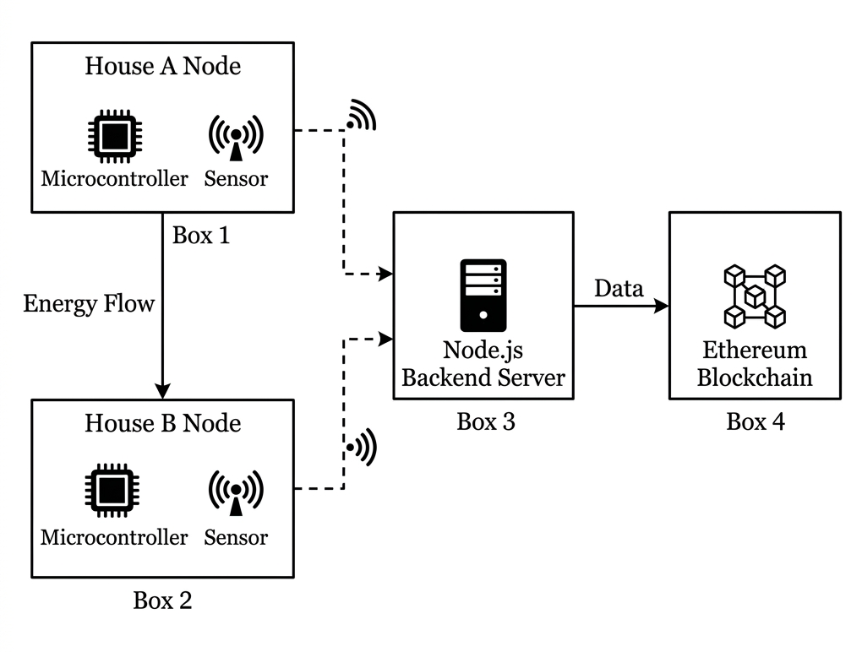

Figure 1.1 System architecture block diagram
Overview: The diagram shows the system architecture of a two-house microgrid testbed for the peer-to-peer energy trading system, and it kind of makes clear how information moves from the physical nodes into the blockchain layer. Everything sits inside one big, dashed border, so that overall system boundary is basically highlighted.
Box 1 - House A Node (top left): This one has a Microcontroller and a Sensor in it, so that’s the ESP32 microcontroller plus the PZEM-004T sensor at House A. The box links over a wireless channel (dashed line, with a Wi-Fi icon on it) toward Box 3.
Box 2 - House B Node (bottom left): Same setup here too: a Microcontroller and a Sensor, representing the ESP32 and PZEM-004T at House B. It also makes a wireless connection (dashed line, Wi-Fi icon) going to Box 3.

Energy Flow arrow: There is a solid vertical arrow; it is labeled “Energy Flow” and it runs from House A Node (Box 1) down to House B Node (Box 2). This is meant to show the real electrical power exchange between the two houses.
Box 3 - Node.js Backend Server (middle): Drawn with a server icon. It gets the wireless data (dashed arrows) coming from both House A and House B nodes, meaning the MQTT / Wi-Fi kind of communication that carries sensor readings from the ESP32s back to the backend.
Box 4 - Ethereum Blockchain (right): Shown with a blockchain or node-network icon. A solid arrow labeled “Data” goes from Box 3 (Node.js Backend Server) to Box 4, so the backend pushes processed information into the private Ethereum blockchain, using Ganache / Web3, for smart contract execution and for transaction logging.
Overall flow: Sensor data gets gathered at each house node → then it is relayed wirelessly to the central backend server → then forwarded as structured information into the Ethereum blockchain, while the real electrical energy travels directly between House A and House B.
The International Renewable Energy Agency (IRENA) says that by 2023, the world's renewable energy capacity had grown to more than 3,372 GW. Solar PV led the way with more than 1,419 GW of installed capacity around the world. Countries in South Asia, such as Pakistan, have seen a lot more solar panels installed on rooftops. This is because electricity prices are going up and there are frequent power outages. But a lot of the extra energy these home solar systems make goes to waste because the current grid infrastructure doesn't allow for efficient peer-to-peer energy exchange between homes.
A smart microgrid is a group of electricity sources and loads that are close to each other and can work together with the main grid or on their own. Microgrids make energy trading possible without a central hub, improve reliability, and lower transmission losses. Peer-to-peer (P2P) energy trading within microgrids lets prosumers sell extra energy directly to consumers in their area, which makes the most of distributed energy resources.
Blockchain technology, which was first made for cryptocurrency, is a great way to keep track of P2P energy transactions. Blockchain's decentralization, immutability, transparency, and cryptographic security are all things that trustworthy energy trading systems need. Blockchain does away with the need for a central intermediary by keeping an unchangeable record of every transaction. This makes sure that everyone can see the trading history.
This project is a full smart microgrid P2P energy trading system that uses IoT-based energy monitoring, automated relay-controlled energy transfer, Ethereum blockchain-based transaction recording, and LSTM neural network-based load prediction.

Problem Statement
Traditional power grids operate on a centralized model where consumers can only purchase electricity from utility providers. With the increasing adoption of distributed energy resources such as solar panels, home batteries, and micro-inverters, prosumers frequently generate excess energy that goes completely unutilized. The current energy distribution infrastructure presents several critical challenges:
Existing grid infrastructure does not allow direct energy exchange between neighboring households. Prosumers cannot sell their surplus energy to nearby consumers without going through the centralized utility company.
Traditional energy billing systems are opaque and centrally controlled. Consumers have no way to independently verify energy transaction details, leading to disputes and inefficiencies.
Conventional energy meters provide only cumulative readings. There is no mechanism for real-time monitoring of energy generation, consumption, and transfer between peers.
Existing systems cannot forecast future energy generation and consumption patterns, preventing optimized energy management and proactive trading decisions.
Without an immutable and transparent record-keeping mechanism, P2P energy trading faces trust barriers between participants who may not know each other.
Therefore, there is a pressing need for an automated, transparent, and intelligent P2P energy trading system that leverages IoT sensors for real-time monitoring, blockchain for tamper-proof transaction recording, and artificial intelligence for predictive load management.

Evolution of Smart Grid and P2P Energy Trading
Over the past two decades, the energy sector has undergone a transformative evolution. The first generation of smart grid technologies focused on Advanced Metering Infrastructure (AMI), which replaced traditional analog meters with digital smart meters capable of two-way communication. These meters enabled utilities to collect consumption data remotely and implement time-of-use pricing.
The second generation introduced demand-side management and home energy management systems (HEMS), allowing consumers to monitor and control their energy usage through mobile applications and web dashboards. Technologies such as Zigbee, Z-Wave, and WiFi-enabled smart plugs provided granular visibility into individual appliance consumption.
The third generation, currently underway, encompasses distributed energy resources integration, microgrids, and peer-to-peer energy trading. The combination of decreasing solar panel costs, advancing battery storage technology, and the emergence of blockchain has created the conditions for truly decentralized energy markets.
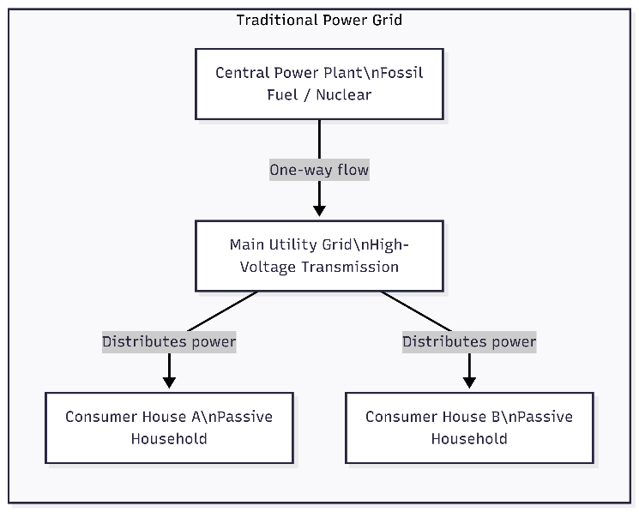

Figure 1.2 Traditional Power Grid

Title: "Traditional Power Grid,” you know, enclosed inside a bordered box, kind of showing the whole system overall, not just parts.
Top node: "Central Power Plant / Fossil Fuel / Nuclear” this is the topmost little box, the one that stands for the centralized generation source.
Then there’s an arrow going down (and it’s labeled "One-way flow"): a solid downward arrow links the Central Power Plant to the next box. The phrase "One-way flow" is emphasized, so you get that unidirectional feel, like power only goes one direction.
Middle node: "Main Utility Grid / High-Voltage Transmission” that box is basically the transmission layer, carrying electricity from the plant onward.
Two branching arrows, each with the label "Distributes power": from the Main Utility Grid, two diagonal arrows split off, one to the left and one to the right. Each branch says, "Distributes power", showing the grid pushing electricity out toward end users.
Bottom nodes (two boxes side by side):
Left: "Consumer House A / Passive Household"
Right: "Consumer House B / Passive Household"
Both are marked as "passive", meaning they receive power only; they don’t generate, and they don’t trade it back. This setup is basically to contrast with the P2P or prosumer model in your other diagrams.
Overall flow: it’s a strict top-down chain, kind of linear hierarchy — generation → transmission → distribution → passive consumption. So, the picture really shows the usual centralized grid structure, rather than the decentralized, bidirectional peer-to-peer microgrid trading setup in your project.
One more thing to mention, just a heads up: the text inside each box shows \n like it’s literally printing those characters (for instance, "Central Power Plant\fossil Fuel / Nuclear") instead of real line breaks. That looks like a rendering hiccup from whatever tool made the diagram, because the newline escape character wasn’t interpreted. So, it ends up as literal backslash-in text. You might want to regenerate the image with proper line breaks if it’s going into your thesis or paper.

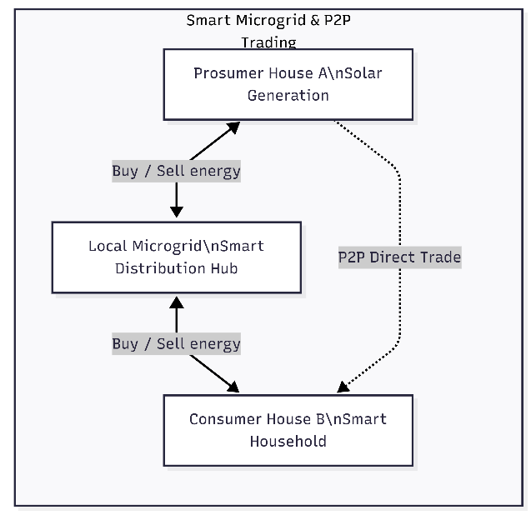
Why have your Blockchain-based energy trading platforms emerged as a promising solution? Projects like the Brooklyn Microgrid, Power Ledger, and We Power have demonstrated the viability of using distributed ledger technology for energy transactions. These platforms utilize smart contracts self-executing programs deployed on the blockchain- to automate energy trading, settlement, and record-keeping without intermediaries.

Figure 1.3 Smart Microgrid & P2P Trading
Title: "Smart Microgrid & P2P Trading" drawn in a bordered box, and it basically sits there opposite the "Traditional Power Grid" diagram from the previous image, like yeah, contrasting hard.
Top node: "Prosumer House A / Solar Generation” is the home that produces energy using solar, but also consumes it, so it’s a prosumer, not just a passive consumer.
Middle node: "Local Microgrid / Smart Distribution Hub" is the local go-between, the one that coordinates distribution inside the microgrid and keeps things in order.
There’s a bidirectional solid arrow labeled "Buy / Sell energy" connecting Prosumer House A to the Local Microgrid Hub. It’s double-headed, meaning the house can sell leftover solar to the hub and buy energy when it needs more, simply.
Bottom node: "Consumer House B / Smart Household" — unlike the “normal” passive consumer in the traditional grid diagram, this one is called smart, so it’s not just sitting around; it’s actively participating in the exchange.
Second bidirectional arrow labeled "Buy / Sell energy" goes from the Local Microgrid Hub down to Consumer House B, again showing that two-way flow of electricity and the related value.
Then there’s a dotted curved arrow labeled "P2P Direct Trade". It runs directly (and kind of sneaks around) from Prosumer House A to Consumer House B, bypassing the hub completely, so the peer-to-peer energy trading happens straight between houses, no centralized middleman required.
Overall meaning: compared to the traditional grid’s rigid one-way centralized hierarchy, this picture is decentralized and bidirectional. Energy and value can travel either through the local hub or straight peer-to-peer, so it visually supports the thesis’s main point: blockchain-enabled P2P energy trading.
The integration of machine learning, particularly recurrent neural networks such as LSTM, has further enhanced smart grid capabilities by enabling accurate forecasting of energy generation and consumption patterns. These predictions allow prosumers and grid operators to optimize energy trading strategies and balance supply with demand in real time.

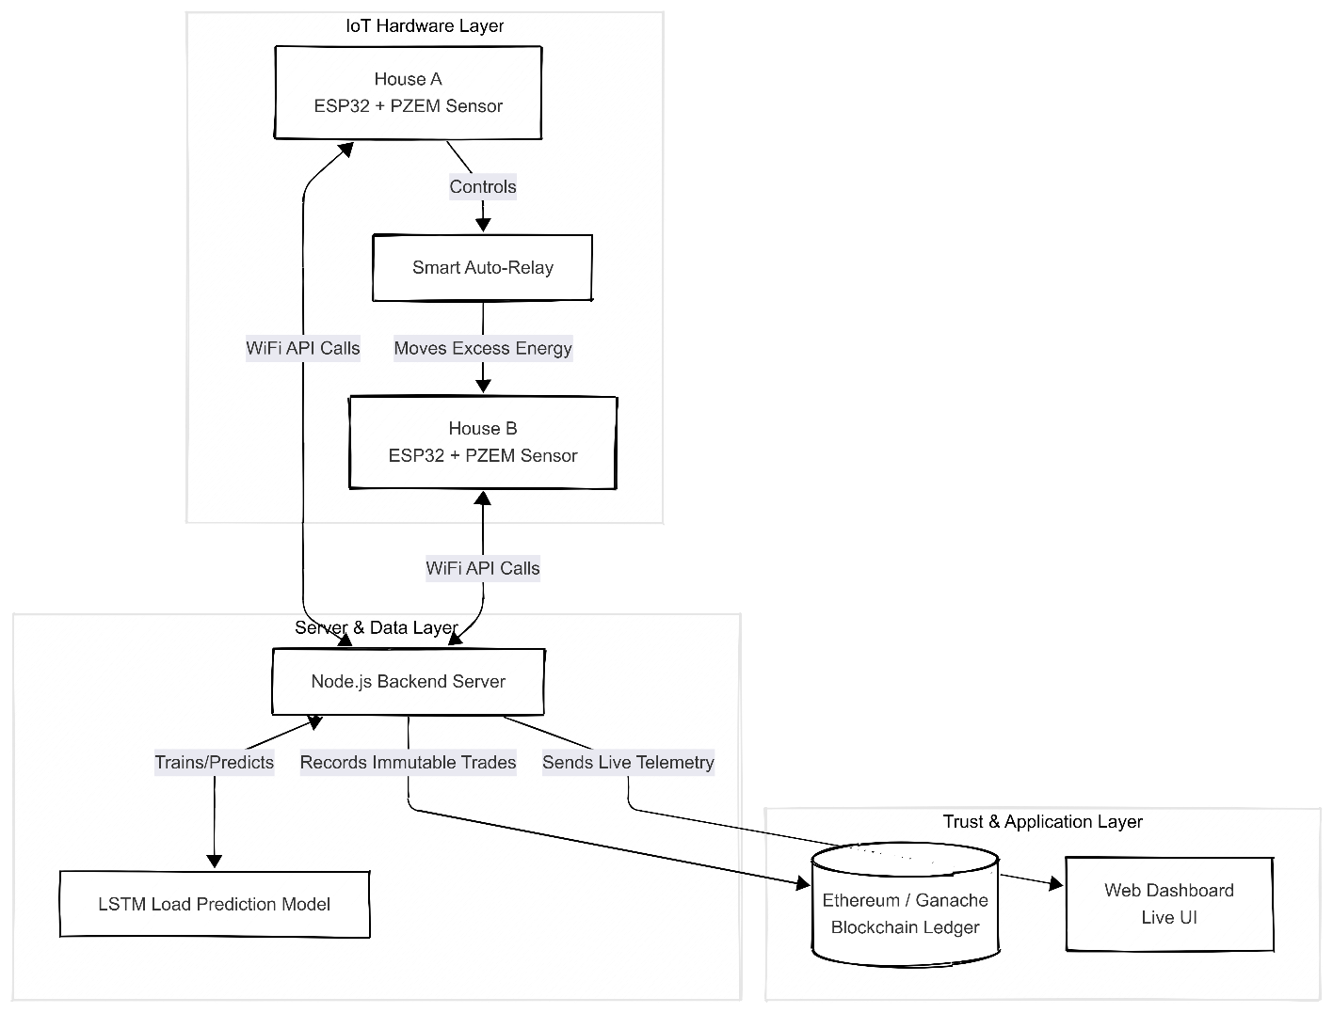

Figure 1.4 Hardware Layer

The whole diagram is kind of a three-part thing laid out left-to-right in three levels, each one inside its light gray bordered box, kind of showing the setup from the hardware side all the way to the app part.
Layer 1 - IoT Hardware Layer (top left):
There’s a House A box that says, “House A / ESP32 + PZEM Sensor”, and underneath it an arrow labeled “Controls” goes down to a Smart Auto-Relay box.
From that Smart Auto-Relay, another arrow (“Moves Excess Energy”) goes down to a House B box: “House B / ESP32 + PZEM Sensor”.
And then there’s this separate curved arrow labeled “WiFi API Calls” that goes back up from House B toward House A, like on the left side, showing wireless back-and-forth between those two nodes.
Layer 2 – Server & Data Layer (bottom left, bigger box):
A second “WiFi API Calls” arrow links House B down into this layer. It feeds into a Node.js Backend Server box.
Then from the Node.js Backend Server, three arrows split off.
One is “Trains/Predicts” and it drops down into an LSTM Load Prediction Model box.
Another one, “Records Immutable Trades”, heads diagonally to the right, leaving this layer, toward the blockchain side.
The third one, “Sends Live Telemetry”, also goes diagonally right, toward the blockchain too.
Layer 3 – Trust & Application Layer (bottom right):
Those two arrows— “Records Immutable Trades” and “Sends Live Telemetry” — end up converging into a cylinder-style icon labeled “Ethereum / Ganache Blockchain Ledger”, which acts like the private ledger data store.
From that blockchain ledger, an arrow points right into a Web Dashboard / Live UI box, basically the front-end screen that shows real-time stuff pulled from the blockchain.
Overall flow: energy/sensor info starts at House A and House B → then it gets exchanged through WiFi API calls with the Node.js backend server → the backend does two jobs: it trains the LSTM load predictor, AND it sends trade records plus telemetry into the Ethereum (Ganache) blockchain → and then that blockchain output finally powers a live web dashboard for monitoring and visualization.
So yeah, it maps the complete pipeline of your P2P energy trading system, from physical sensing to blockchain logging, to what the user can see on the display.

Features of the Proposed System
The system made for this project has the following main parts:
- Monitoring Energy Automatically: It uses PZEM-004T sensors to read voltage and current as they happen.

- Smart Power Sharing (Relay Control): The system automatically finds extra power and turns on a switch (relay) to send it to the neighbor's house without any help from people.

- Secure Blockchain Records: Every time power is moved, a trade is recorded on an Ethereum-based blockchain using a tool called Ganache. You can't fake or erase this record.

- Live Local Website: Users can see live voltage, electricity use, and a history of their trades right on their screen thanks to a clean web dashboard.

- Tamper-Proof Security: Each energy trade gets a unique mathematical code (cryptographic hash) to make sure the record is real and safe.

- AI Load Prediction: It uses an LSTM AI model that learns from past data to guess how much energy will be used in the next 24 hours. A custom software server connects the physical hardware parts to the blockchain and the webpage, making sure that the Unified Communication System works well.

Aims
The major objective of this project is to alleviate the problem of wasted domestic solar energy by developing a decentralized, smart microgrid. Instead of depending completely on traditional utility corporations to control power flow, this project empowers typical households to safely and automatically share excess electricity with each other. To realize this vision, the system focuses on the following basic aims:

- To facilitate direct, decentralized energy trading between neighboring houses without relying on the central utility company.
- To use exceptionally secure blockchain technology to provide a transparent, tamper-proof, and permanent record of all electricity trades.
- To build an automated system that instantly detects extra spare energy and transfers it to neighbors without requiring any human intervention or manual switching.
- To enable real-time energy tracking by displaying live electricity data on a web dashboard, ensuring homeowners know exactly what is always happening.
- To develop an Artificial Intelligence forecast model that predicts future energy needs, helping households manage and optimize their daily power consumption.
- To physically demonstrate that average, everyday homes can easily and affordably operate an advanced power-sharing microgrid.

Objectives

- To design and implement a P2P energy trading system between two households using ESP32 microcontrollers and PZEM-004T sensors
- To develop an automatic excess energy detection and relay-controlled transfer mechanism
- To integrate Ethereum blockchain technology for transparent and immutable transaction recording via a Solidity smart contract
- To create a real-time local web dashboard for energy monitoring and blockchain transaction visualization
- To implement an LSTM neural network for 24-hour load prediction based on collected energy data
- To develop a Node.js backend server as middleware between IoT devices, blockchain, and the dashboard

Scope
This research is strictly limited to the design, implementation, and successful demonstration of a physical two-house Peer-to-Peer (P2P) energy trading grid. The project includes putting together all the hardware and wiring of ESP32 microcontrollers and PZEM-004T sensors so that energy can be tracked in real time and power can be shared automatically through relays.
The system also uses Ganache, a local Ethereum blockchain network, as an unchangeable digital ledger for all energy transactions. The project also includes the creation of a live web dashboard and the integration of an Artificial Intelligence model (LSTM) that can predict electrical load demands over 24 hours. This will help with energy management and give people a real-time view of what's going on.
On the other hand, some parameters were left out of this project on purpose to keep the proof-of-concept very focused. This prototype is meant to work on its own and won't connect directly to national utility grids like WAPDA or other electrical systems. Also, the system doesn't handle real-world financial transactions, credit card payments, or actual user billing settlements. The physical setup is only for testing in two places and is not meant to grow into a larger community grid currently. Finally, the project uses a localized blockchain network, so deploying smart contracts to the public Ethereum Mainnet, dealing with national energy policies, and following municipal legal rules are all things that this research does not cover.
In Scope: A two-house prototype that shows how P2P energy trading works, a local Ethereum blockchain (Ganache), a real-time web dashboard, LSTM-based load prediction, complete hardware assembly with wiring diagrams, and full documentation
Out of Scope: Connecting the grid to utility companies, real financial billing and payment systems, scaling beyond two houses, using the public Ethereum mainnet, and following the rules

Approach
To achieve the objectives of this project, a highly systematic and phased approach was adopted. The project commenced with a comprehensive analysis of existing Peer-to-Peer (P2P) energy trading systems, followed by an extensive literature review of blockchain energy markets, Internet of Things (IoT) sensor technologies, and load prediction methods to identify critical gaps in previous research. Based on these findings, appropriate hardware components, specifically ESP32 microcontrollers, PZEM-004T sensors, and automated relay modules, were carefully selected. The system’s physical architecture and communication protocols were subsequently designed to establish safe wiring connections that allowed excess energy to transfer autonomously between the two simulated households.
Once the physical hardware foundation was laid, the development phase transitioned entirely into software engineering. This involved writing the control firmware for the ESP32 units to track energy live, designing and deploying an Ethereum-compatible Solidity smart contract onto a local Ganache blockchain, and developing a Node.js backend server with Web3.js integration to bridge the physical electronics with the digital ledger. To ensure user accessibility, a real-time web dashboard was conceptualized and programmed to visualize live energy metrics. Simultaneously, historical energy data was utilized to train an LSTM Artificial Intelligence model for precise, forward-looking electrical load prediction. After all individual software and hardware components were completed, they were physically integrated, rigorously tested, and successfully validated as a unified system, which ultimately culminated in the comprehensive documentation and presentation of this thesis report.

Organization of Thesis

Chapter 01 Introduction
We learn about the history of smart microgrids and the main problems that come with wasted solar energy from homes. It clearly states the problem, talks about how P2P energy trading technologies have changed over time, and lists the project's specific goals, objectives, and scope.

Chapter 02 Literature Review
It gives a full review of the literature on what experts have tried to build in the past. It looks at current academic research on blockchain-based energy trading, IoT-based energy monitoring, smart contracts, and AI-based load prediction models to show how our proposed system is different from earlier prototypes.

Chapter 03 Project Hardware
It is all about the physical structure and specific electronic parts used in the real-world setup. It has a long list of the ESP32 microcontrollers, PZEM-004T power sensors, relay modules, inverters, and power supplies, with detailed information about each device's specifications, custom settings, and basic operational logic.

Chapter 04 Design and Implementation
It goes into detail about the software logic and custom code that make the hardware work. It goes into detail about how the electronics were wired, how the Solidity smart contract was put on the local Ganache blockchain, how the Node.js backend server was set up, how the interactive web dashboard was designed, and how the LSTM artificial intelligence model's math layers worked.

Chapter 05 Results and Simulation
It shows that the system works exactly as it was meant to in a real-world setting. It shows the real-world results of thorough hardware testing, such as automated relay switching times, real-time telemetry collected by the dashboard interface, successful recordings of cryptographic blockchain transactions, and complete system integration.

Chapter 06 Conclusion
Chapter 6 wraps up the thesis by giving a brief overview of the successful building. It talks about how this engineering technology can help society, how it can help the environment and lifelong learning, and what upgrades and future possibilities could make this decentralized energy project even bigger.
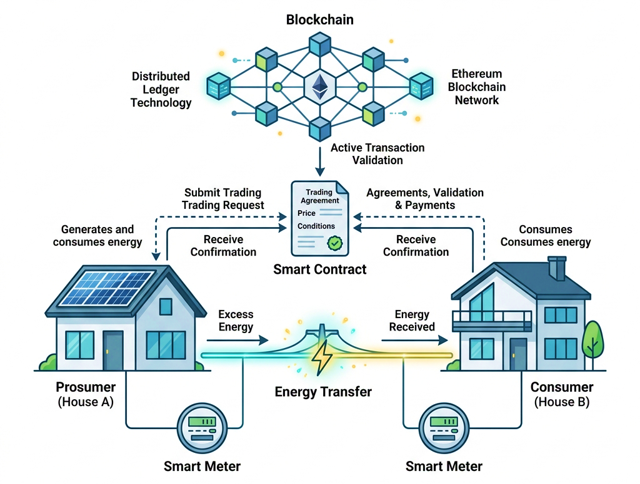

Figure 1.5 Conceptual System Architecture Diagram

CHAPTER 02: Literature Review

Literature Review
Researchers all over the world are very interested in the idea of peer-to-peer energy trading in smart microgrids. This chapter examines the current literature regarding blockchain-based energy trading, IoT-based energy monitoring, smart contract applications in energy systems, and AI-driven load forecasting. The concept of peer-to-peer (P2P) energy trading in smart microgrids has attracted considerable attention as a decentralized approach to contemporary energy management issues. Conventional centralized grid systems are becoming progressively inadequate to support the swift expansion of distributed generation sources. So, this chapter carefully looks at all the research that has been done on decentralized microgrids. It looks at progress in four main areas: blockchain-based energy trading, IoT-enabled real-time energy monitoring, smart contract applications for automated settlements, and AI-driven load forecasting. Finally, it critically examines prior endeavors in integrated systems to identify a conclusive research gap that this project seeks to address.

Blockchain-Based Energy Trading
Blockchain technology is quickly becoming a game-changer for decentralized energy markets, offering a new way for everyday "prosumers" to buy and sell power locally.
Traditional electricity distribution basically runs on a centrally managed, one-way workflow: energy gets produced at large-scale generation sites (fossil, nuclear, etc.), then travels through high-voltage utility networks, and finally it is delivered to consumers who, in practice, act as passive endpoints. In other words, households typically do not make decisions about generation, pricing, or buying and selling power. This arrangement has been dependable for many decades, but nowadays it feels less like an advantage and more like a limitation because distributed energy resources (DERs) keep growing. Think about rooftop solar, smaller battery storage units, and smart home devices, which allow everyday users to both generate and keep electricity, not only consume it. Once more consumers turn into prosumers, meaning entities that produce plus consume energy, the classic grid design starts looking like a bottleneck rather than a simple enabler.
Blockchain-based energy trading comes in to address this mismatch by enabling prosumers to exchange surplus energy directly with each other, instead of routing every single trade through a central utility mediator. Here, the blockchain works like a common tamper-resistant register, and it logs each and every energy exchange between participants. On top of that, smart contracts kind of self-operating program logic running on the blockchain—handle the trade rules automatically. They can check the exact amount of energy that moved, compute the agreed price, and complete the settlement right away, in a way that is both transparent and does not require manual steps or a relied-upon third party.
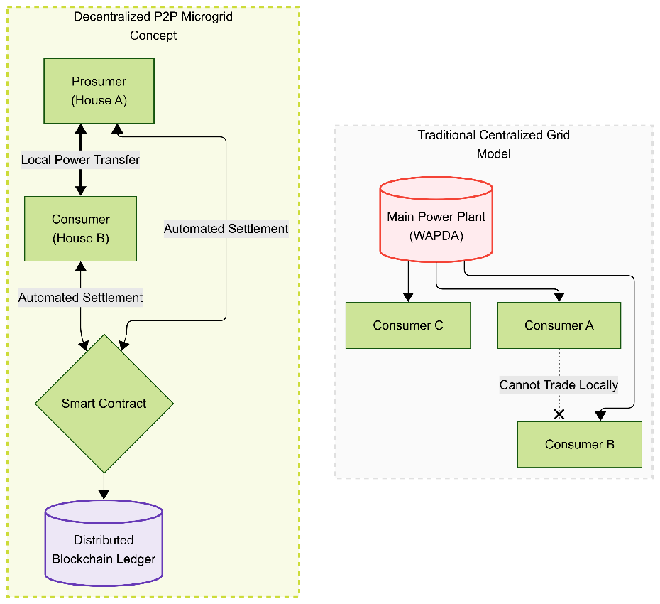

Figure 2.1 Traditional grid systems vs modern P2P

Overall purpose: This is basically a side-by-side comparison diagram, contrasting your proposed Decentralized P2P Microgrid idea against the Traditional Centralized Grid model. It’s meant to kind of highlight, in a visual way, the main value proposition of your system.
Left panel – “Decentralized P2P Microgrid Concept” (green-shaded, yellow dashed border):
Prosumer (House A) box at the top, connected downward by an arrow labeled “Local Power Transfer” to …
Consumer (House B) box. This one is there to show direct physical energy exchange between the two houses.
Then from Consumer (House B) there’s an arrow labeled “Automated Settlement” that goes down into a green diamond labeled “Smart Contract.”
Also, there’s a second “Automated Settlement” arrow, coming from Prosumer (House A) and curving down along the right side, also ending in that same Smart Contract diamond—so both sides, or parties, transactions get settled automatically.
From the Smart Contract, an arrow points down to a purple cylinder labeled “Distributed Blockchain Ledger,” which represents the final unchangeable record of the trade.
Right panel – “Traditional Centralized Grid Model” (gray-shaded, dashed border):
Main Power Plant (WAPDA) drawn as a red cylinder up top, to represent the centralized utility source.
Arrows go downward from the plant to three separate consumer boxes: Consumer C, Consumer A, and Consumer B (green boxes). Each one receives power independently and straight from the central plant.
Between Consumer A and Consumer B there’s a dotted line, labeled “Cannot Trade Locally” with an “X” mark—basically spelling out that those two neighbors have no direct way to exchange energy, and all the power must travel through the central plant only.

Research on smart grids faces a common issue
e: fragmentation. While advancements exist in areas like blockchain, IoT, and AI, few projects integrate these technologies into a cohesive prototype. Most studies remain theoretical, rely on simulated data, or focus on only one or two technologies.
This leaves a massive gap in the research for a holistic, physically validated system. This project tackles that void directly by engineering a complete peer-to-peer energy trading microgrid. By stepping away from mere simulations and focusing on real hardware, this thesis integrates five critical components into one unified system:
- IoT Telemetry: Utilizing calibrated PZEM-004T sensors to capture accurate, hardware-based energy monitoring and local generation inputs.
- Automated Power Routing: Using physical relays to manage and distribute energy between producers and consumers the moment specific sensor thresholds are met.
- Decentralized Ledger: Deploying smart contracts on a local Ganache blockchain to create a secure, immutable record for every transaction.
- Live Web Dashboard: Running a centralized Node.js backend that gives users a real time visualization of the system and allows for direct interaction.
- Proactive AI: Applying deep learning techniques to the gathered telemetry data, allowing the system to actively predict future energy demands.
By bridging the gap between theoretical frameworks and physical hardware execution, this project delivers a highly integrated solution that goes beyond the fragmented, simulated models currently dominating the field.
The rising involvement of prosumers kind a changed regular electricity markets into decentralized energy systems. With peer-to-peer energy trading people can swap electricity directly among themselves, and this tends to boost energy efficiency, increase consumer involvement, and help the seamless integration of distributed renewables. It feels more direct, but at the same time it requires better coordination, so the whole system works without too much friction. [1] The Brooklyn Microgrid sort of shows how blockchain enabled peer-to-peer energy trading can work in real life. Their market design is meant to keep things secure and transparent, and decentralized, but it still pushes local sharing too, within a smart microgrid. It’s basically a practical setup for energy exchanges, between neighbors, using the blockchain layer. [2] Accurate load forecasting is a big deal for the smooth operation of today’s power systems it helps a lot with day-to-day efficiency. Using advanced forecasting methods makes demand estimation better, which in turn boosts grid reliability and keeps things stable, in smart grid setups it also supports more effective energy management overall. [3]
Deep learning methods have, like, improved the accuracy for renewable energy and load forecasting by quite a lot. They manage to grab complicated patterns from past data, so energy planning and scheduling becomes a bit more reliable, which helps with smoother smart grid operation too. Overall, it makes the whole system feel more dependable, and not just on paper. [4] Distributed ledger tech helps with privacy and security in transactive energy systems, because it keeps records tamper resistant and supports secure communication. When this tech gets paired with IoT devices it somehow boosts trust between different energy trading actors, you know the ones doing the deals. [5] Smart contracts automate energy trading by running set rules, pretty much without any third-party involvement. They do it automatically, so predefined actions happen when certain conditions match. In practice their implementation helps with clearer transaction visibility, speeds up the processing time, and generally builds more trust among energy market participants. [6] Consortium blockchain allows for a kind of secure, efficient peer-to-peer trade of electricity among distributed energy resources, kind of like a quieter orchestration behind the scenes. In our view the proposed framework helps cut down transaction costs, yet it still boosts scalability, security and the whole day-to-day operational efficiency. [7] Predictive computing methods tend to help with decision making, by guessing what the future system conditions might look like, using mostly historical data. In practice these approaches can improve energy management, sort of like forecasting instead of just reacting. They also make it easier to optimize how resources are allocated in smart energy networks, even when the environment changes a bit. [8] Multi agent systems allow kind of decentralized coordination across distributed energy resources inside smart grids, and the whole idea is more flexible in practice. When they are put into place, they help the system sort of self-decide without too much human, which also makes the energy distribution more efficient, and it’s kind adaptive too. [9]
Blockchain combined with cryptographic techniques, helps strengthen security and privacy in decentralized energy trading. In the proposed framework, it protects the user identity, but also makes sure energy transactions are secure and verifiable, in a practical way. [10] Peer-to-peer electricity trading has been showing up as a kind of efficient approach for decentralized energy exchange, honestly it feels more direct than big, centralized setups. It helps energy go further, makes use of it better, supports the integration of renewable sources, and in the end, it also boosts how much consumers get involved in electricity markets. [11]
Decentralized electricity markets somehow boost flexibility, not in a single way but by letting local power swap happen between distributed resources. In this proposed market design, grid reliability gets a stronger feel, renewable energy utilization goes up, and demand side management works more efficiently, sort of. [12] Game theoretic mechanisms push people into peer-to-peer energy trading, because they give fair incentives to buyers and sellers. In that way the whole thing becomes more market efficient, while still maximizing the advantages of distributed energy resources. [13] Smart contracts automate energy trading by running transactions based on already set conditions and it just kind happens automatically. When they’re stitched into decentralized energy systems, the whole thing gets more see through, less manual meddling, and the security of transactions is basically improved too. [14] Community based peer to peer trading helps prosumers swap electricity nearby, which cuts down on that constant dependence on centralized utilities. At the same time the framework that is proposed makes better use of renewable energy, and it also supports more efficient microgrid operation, in practice it feels like everything works together.[15] When you fold in network constraints, and also the preferences consumers have it makes peer-to-peer energy trading feel more practical in real life. The framework that we propose boosts market efficiency, still it keeps the power flow secure and reliable. [16]
Effective control strategies are kind of essential to keep voltage stable and the whole operation reliable, especially in islanded microgrids. Coordinated control in general helps the system bounce back better, and it also supports the integration of renewable energy resources which are a bit harder to manage. [17] Microgrids kind of give a flexible and reliable way to blend distributed generation with renewable energy sources, you know. Because the structure is decentralized, it really helps with energy reliability too, and it also supports local electricity management. In a way, it makes the whole system steadier, while still letting communities handle power locally. [18] Smart grid technologies make modern power systems more efficient, dependable, and a bit more “intelligent” thanks to enhanced monitoring, better communication, and automation that runs. With those features in place, the whole thing becomes like a base layer for decentralized energy management as well as peer-to-peer electricity trading, where the exchange can happen more directly. [19] A blockchain-based smart contract architecture kind of allows secure, automated peer-to-peer energy trading, without leaning on some centralized authority, or whatever. The overall proposed framework improves visibility in transactions, boosts operational efficiency and builds trust among market participants too, in a way that feels more verifiable. [20]
An integrated blockchain platform has been built to kind of optimize energy management and the bilateral trading that happens inside microgrid communities. The idea is that this approach makes energy allocation better, while still respecting network constraints, and at the same time it reduces how much the system relies on centralized coordination. Overall, it does what it says, just more smoothly, like with better flow between participants. [21]
Blockchain tech was used, to stitch together peer to peer power trading with carbon market systems. The idea framework sort of pushes better energy usage and, at the same time, helps lower carbon emissions through decentralized market mechanisms. Its kind works by letting the whole thing run without a single center, which makes the trading more agile and transparent. [22] So, a decentralized blockchain platform was introduced, kind of to help with secure and transparent peer-to-peer electricity trading. The overall market architecture that was proposed makes things more scalable, supports better participant trust, and in a way, it removes the need to rely on a central intermediary. [23]
Smart contracts, deployed on the Ethereum blockchain, automate energy trading inside virtual power plants, more or less. In general, the proposed framework ups transaction security, cuts down processing delays, and helps decentralized energy management run in a steadier way. [24] Peer-to-peer electricity trading has become an effective approach for decentralized energy exchange, so people can swap power without the usual heavy infrastructure. The review points out that this can help with renewable energy integration and improve consumer participation, while at the same time it makes the efficient use of distributed energy resources seem more practical and steadier. In other words, it’s like a more distributed way of balancing supply and demand, and it encourages broader involvement. [25]
A distributed transaction mechanism helps diversified prosumers trade electricity more efficiently across urban microgrids, kind of like letting multiple actors coordinate without a lot of friction. In practice, the proposed strategy boosts market flexibility, while keeping the energy distribution reliable and balanced in a steady way, not just in theory but also during real operation. [26] A lightweight blockchain framework kind of improves peer-to-peer energy trading by folding participant location and reputation into the trading process, not just blindly matching everyone. In practice, the proposed approach gives better privacy, security, and market efficiency, while also lowering computation load and overhead. It’s a bit like making the transactions smarter and less wasteful at the same time, which helps overall. [27]
Blockchain tech helps cyber-physical energy systems stay more secure because it allows secure, decentralized, and visible peer-to-peer trading of energy. This kind of framework also tries to handle scalability issues, plus security and interoperability headaches that show up in smart grids. [28] A broad review of peer-to-peer energy trading summarizes the current marketplace models, the blockchain applications, various pricing methods, and the technical challenges too, but not only that. It also points out where future research should go, mostly around scalability, regulatory backing, and the step-by-step practical deployment inside smart microgrids, kind of. [29] So, there was a blockchain-based architecture proposed to kind of boost the security, scalability, and overall performance of peer-to-peer energy trading. During evaluation, the results showed efficient transaction processing, while keeping decentralization intact and making the system reliable. In other words, it worked well in terms of throughput, yet it didn’t really sacrifice that decentralized idea. [30]
A blockchain-enabled double-auction mechanism was developed, kind of to push the advantage for both buyers and sellers, in those peer-to-peer energy markets. In general, the proposed strategy makes the market feel fairer, runs the trading more efficiently, and boosts overall social well-being. [31] So, a lightweight blockchain framework is introduced to help with secure and location-aware energy trading. In practice, the proposed method kind of improves privacy a bit, lowers the computational load, and tends to encourage more local power exchange between nearby participants. It sort of feels like being designed for neighbors, not for some distant parties. [32]
Forecasting services integrated with blockchain can make local energy markets run more efficiently, basically by helping teams get a better read on demand and then enabling some automated peer-to-peer trading. The whole framework also nudges sustainability forward and supports steadier decisions, for practical planning. [33] Privacy-preserving techniques are honestly crucial for keeping user information safe in blockchain-based energy trading systems. You know, with cryptographic mechanisms and distributed ledger technologies working together, they can strengthen security, while at the same time still keeping transaction transparency in a sort of balanced way. It’s like they let things stay verifiable but also keep sensitive data more hidden. [34] Blockchain-enabled energy crowdsourcing helps with decentralized electricity trading between various distributed energy resources. The outlined operational framework improves the way energy is scheduled, and it also backs secure market involvement inside smart grids. [35] A private blockchain platform was built to cut down on communication overhead a bit more than usual and to tighten up privacy for peer-to-peer energy transactions. With a decentralized design, it sort of increases trust on its own, while also getting rid of any dependence on third-party authorities and their kind of gatekeeping. [36] Blockchain smart contracts can automate electricity trading inside virtual power plants by securely executing transactions without manual intervention, sort of. In the proposed framework, this whole thing improves operational efficiency and makes transaction reliability better in a more stable way. [37] A decentralized smart contract architecture kind of simplifies energy trading since it automates the transaction execution and the settlement, you know. This framework also improves the overall visibility, cuts down on operating costs a bit, and builds more trust between the trading participants. [38] A decentralized blockchain platform was built to back secure but scalable peer-to-peer electricity trading. The idea behind the market structure helps with transaction efficiency, while at the same time reducing reliance on centralized intermediaries, or well, at least that’s what they claim. It kind of makes the whole process feel smoother without the usual middleman bottleneck. [39] A two-stage battery control plan was worked out to back peer-to-peer energy sharing in local community microgrids, where everyone shares, sort of, in practice. The suggested approach boosts the way renewable power is used, lowers the electricity bills, and gives more operational flexibility to distributed energy resources, so they can adapt better in real time. [40] Peer-to-peer electricity trading sort of moves away from centralized power setups into decentralized energy markets. This idea helps local energy get used better; it encourages people as consumers to actually take part, and it also backs up smoother operation of the distribution system, in a more efficient way. [41] We looked at different local energy market structures and various clearing mechanisms to see how decentralized electricity trading could be improved a bit. Turns out, how the market is actually designed really matters, and it kind of decides whether things stay fair and run efficiently; plus, it affects dependable energy exchanges overall.[42]
Blockchain coupled with machine learning was put together to craft a predictive peer-to-peer energy trading platform. The suggested framework helps with load prediction and energy scheduling, plus gives transaction security. It also keeps things going in a more sustainable smart grid context, kind of overall. [43] Smart contracts automate energy trading by running transactions on their own, sort of skipping third-party involvement entirely. The architecture that is proposed helps with transparency in a cleaner way, lowers the operational costs too, and it also boosts trust among participants in decentralized energy markets. [44] So, basically, an integrated blockchain platform was designed so it could coordinate energy management and this bilateral trading stuff inside microgrid communities. The idea in the framework is that it helps with energy allocation in a smoother way, it boosts market efficiency too, and it also supports more decentralized decision-making, even when different parties are acting on their own. [45] A decentralized blockchain platform was introduced to help make secure and transparent peer-to-peer electricity trading, yeah. The architecture that they propose kind of boosts scalability too, and improves transaction efficiency plus market reliability, at the same time. It also removes the reliance on centralized intermediaries, so there’s no need for those middle services. [46] So, there was a blockchain-enabled double-auction mechanism proposed, basically to crank up the gains for energy buyers and sellers, you know. The whole framework helps boost market fairness in a more level way, keeps participant privacy in check, and makes transactions run faster, sort of more efficiently. At the same time, it supports real-time peer-to-peer electricity trading. [47]
A lightweight blockchain framework was put together to help with secure, kind of location-aware energy trading. The approach they propose seems to cut down the computational complexity, boost privacy a bit more, and push for more efficient local energy exchange, like around here, not everywhere all at once. [48] So, blockchain smart contracts are used to do the whole automated part for peer-to-peer electricity trading inside a virtual power plant. In other words, the proposed framework kind of boosts transaction security, it also improves operational efficiency, and it helps with the integration of distributed renewable energy resources too. [49]
They proposed a decentralized market framework to help energy trading between retailers and prosumers, kind of without depending on a central authority. In general, it makes the market more flexible, it protects privacy for users, and it even boosts the efficiency of distributed energy trading. [50] Some kind of game-theoretic trading plan was worked on for blockchain-enabled peer-to-peer energy markets, and it sort of focuses on how people like prosumers interact. The idea says the approach helps them coordinate better, makes trading more efficient, and at the same time keeps each participant's privacy intact. [51] Machine learning-based load forecasting helps improve the accuracy of demand prediction when it comes to peer-to-peer energy trading, kind of steadier. With better prediction for expected demand, the energy scheduling gets smoother, operational costs end up lower, and the smart grid management stays more reliable overall. It’s basically a chain reaction: forecast first, then everything else. [52]
So, a Lyapunov optimization approach was put forward to handle both energy trading and energy storage inside smart communities. In this proposed framework, it actually helps energy utilization get better, while at the same time it cuts down operational costs and keeps the overall system stable. [53] A blockchain decentralized trading framework is integrated with battery storage flexibility for community microgrids, and it kind of works like a combined arrangement. The proposed system aims to improve renewable energy utilization, raise local energy self-sufficiency, and let secure peer-to-peer electricity transactions happen more easily, and yeah, in a safer way. [54] A privacy-preserving trading strategy was devised to guard user information while doing electricity trading that happens on blockchain, a bit like the system keeps things under cover during the whole process. In general, the architecture improves the secrecy of transactions, yet it still lets the necessary visibility stay there, so transparency and market efficiency are kept, or well, at least not completely lost. [55]
A distributed optimization model was proposed to help coordinate active distribution networks with blockchain-enabled peer-to-peer electricity trading. In the big picture, the approach is meant to raise operational efficiency a bit more, while at the same time keeping energy exchange both reliable and secure. It kind of ties together coordinating control tasks and that decentralized market logic, so exchange stays dependable even when conditions change, and the whole process feels safer. [56] A forecasting technique based on LSTM plus GRU models got merged with peer-to-peer energy trading, so the supply-demand matching is closer to what happens. In a way, the framework improves energy scheduling accuracy, and it also helps keep smart grid operation dependable, even when conditions change. [57]
So, a game-theoretic trading strategy was developed for blockchain-enabled energy markets, with the goal of improving the coordination among prosumers. In a sense, the proposed approach boosts trading efficiency, safeguards participant privacy, and makes the overall market performance a bit stronger. [58] So a decentralized trading framework lets retailers and prosumers barter electricity without any third party getting in the way. In this setup, the market design, I guess, boosts flexibility while it also keeps user privacy intact, and helps with more efficient energy management too. [59]
Machine learning methods were used (kind of) to enhance load forecasting accuracy for peer-to-peer energy trading. Having more accurate demand prediction helps with energy scheduling better, cuts down operational costs, and makes smart grid management more efficient, overall, too. [60] Forecasting services, when they are integrated with blockchain, help local energy markets make better choices by mixing reliable demand prediction with a secure peer-to-peer trading approach. The platform that’s being proposed boosts sustainability, supports automation, and improves market efficiency, in a more consistent kind of way.[61] So, there’s this resilient peer-to-peer energy exchange setup that uses blockchain thingy, especially for microgrids, and it comes with strong security around frequency control, plus privacy protection. Basically, it helps the overall system stay up during disruptions, and it also makes transactions more secure, while keeping the microgrid running in a more dependable way. [62] A distributed planning structure, integrated blockchain with peer-to-peer energy trading, helps with resource allocation in nearby energy networks. In a way, the smart contracts made sure the transactions stayed secure and visibly traceable, and the overall approach improved load balancing and daily operational efficiency. [63]
In real-world tests, it turned out blockchain-based peer-to-peer power trading can actually work when it’s tied with household energy management systems plus plug-in hybrid electric vehicles. The experiment results showed it is both dependable and protected for energy exchanges, like secure transactions happening in practice, not just on paper. [64] A unified blockchain framework was rolled in, sort of, to make peer-to-peer energy trading easier across those different market structures. The overall architecture helps with interoperability, boosts scalability, and improves transaction efficiency for decentralized energy systems, more or less. [65] For residential energy systems, fully decentralized peer-to-peer trading approaches were worked out, more or less. The idea behind these methods is that they better use energy right at home, cut down transmission losses, and nudge household prosumers to take part more actively. In other words, the whole setup is more local, more responsive, and kind of less wasteful overall. [66]
Smart contracts are used to kind of automate electricity trading in microgrids via blockchain tech, and it sounds practical. With this approach, the whole process gets more transparent for transactions, the execution delays come down a bit, and participants can do an energy exchange in a more autonomous manner. [67] A blockchain token mechanism was proposed to securely represent tradable energy units, or something close to that. The locking part improves transaction reliability, and it also keeps things from doing a premature settlement during decentralized energy trading. [68]
So, blockchain along with machine learning was used together to dig into communication patterns and energy trading performance inside decentralized smart grids. The aim was basically to improve how the network runs smoothly, make transactions more reliable, and keep energy management under control. At least in practice, this kind of approach helps a lot, even if it feels slightly complex at first. [69] So, there is a blockchain-enabled framework that kind of mixes peer-to-peer energy trading, along with battery sharing inside residential microgrids. The approach they propose kind of reduced energy waste, it also boosted renewable utilization in a more usable way, and it improved the whole system flexibility too. [70] So, they proposed a decentralized blockchain architecture for retail electricity markets, kind of to help make secure peer-to-peer trading easier. The whole framework also goes along with demand response, and it supports the integration of distributed energy resources, kind of in a smoother way. And yeah, the market operations stay transparent too, so people can see what’s going on. [71] In the real world, the practical use of blockchain-based peer-to-peer energy exchange, linked with home energy management systems, was validated. Basically, the outcomes showed dependable and safe functioning, even when you test everything under realistic conditions, not just in theory. It worked, or at least it did work as expected under those circumstances. [72]
They came up with one unified blockchain framework to back peer-to-peer energy trading across different sorts of energy market structures. The architecture they propose feels like it boosts interoperability and helps the whole thing scale better, plus the transaction efficiency becomes way more solid too. [73]
So, a decentralized blockchain setup was put together to help peer-to-peer energy trading inside microgrids, and it uses Ethereum smart contracts. Basically, the idea is that the whole flow gives better visibility for transactions and makes it easier to run demand response management; also, it helps with the more efficient use of distributed energy resources, instead of them just sitting there unused. [74] A blockchain-enabled trading mechanism was combined with resilient microgrid control so we can boost secure energy swapping and frequency regulation, more cleanly. In the suggested framework, the whole thing is meant to strengthen system stability while keeping energy transactions protected from cyberattacks, you know, those kinds of threats. [75] So, there’s a decentralized planning strategy that kind of blends blockchain technology with peer-to-peer energy trading, for this idea to optimize local energy networks. In practice, the plan helps with better resource allocation, greater market clarity, and it also supports safe transaction processing. Overall, it’s like everything gets more coordinated, even if the setup is pretty distributed. [76] So, we built a practical blockchain-based peer-to-peer energy exchange platform really tied into home energy management systems, and also plug-in hybrid electric vehicles. In tests, it turned out secure enough, and it kept working in a reliable way, even when we put it under more real-world conditions, not just in a lab setting. [77] So, there was this blockchain smart contract mechanism introduced to build trust, you know, among prosumers taking part in peer-to-peer energy trading. The whole idea offers transparent transaction records, and it kind of avoids the need for centralized authorities, at least on paper. [78] A blockchain-based double auction model was put in place to help, in a kind of way, fairness and efficiency in peer-to-peer electricity markets. The strategy it says it uses can raise participant gains and at the same time still keep transactions secure plus traceable, so nothing feels hidden or shaky. [79]
So, a wide-ranging survey looked into how blockchain can be mixed into smart grids, sort of, energy trading, microgrid management, privacy safeguards, and the distributed energy resources side of things. In the same work, they also pointed out what seems to be the main research problems, plus where the future chances might show up. [80]

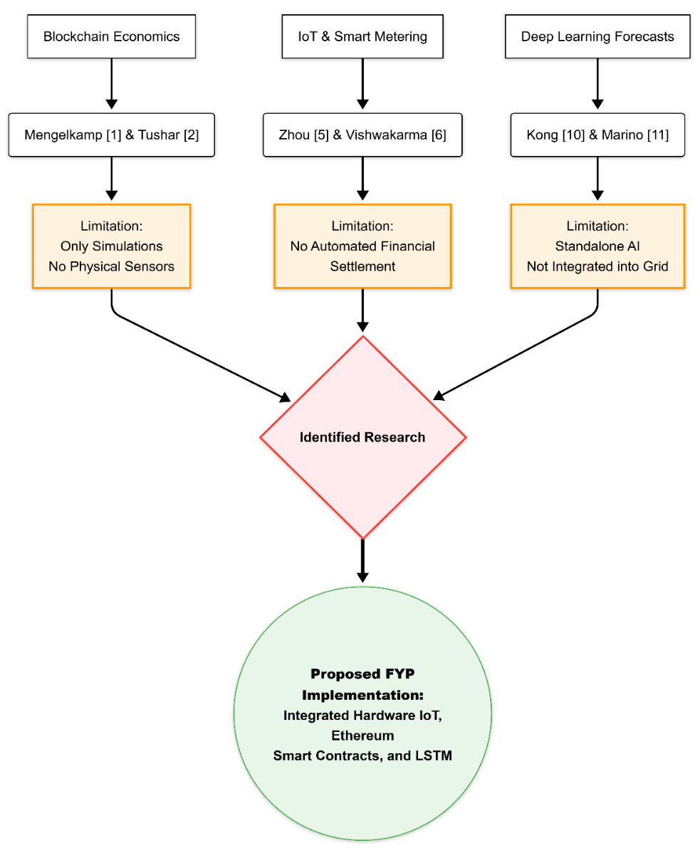

Figure 2.2 Literature Taxonomy Map

Purpose: This diagram shows a research gap analysis, where three different research domains— each one backed by citations and some stated limitations— somehow meet and end up at one specific research gap. That gap then kind of supports why your proposed FYP implementation makes sense.
At the top, there are three parallel columns. They all follow the same kind of pattern, like topic, then key references, then a limitation:
Column 1 – Blockchain Economics:
Top box reads: "Blockchain Economics".
Then there’s an arrow down to: "Mengelkamp [1] & Tushar [2]" (citation references), after that another arrow drops into an orange-bordered limitation box saying: "Limitation: Only Simulations, No Physical Sensors"
Column 2 – IoT & Smart Metering:
Top box: "IoT & Smart Metering".
Arrow down to: "Zhou [5] & Vishwakarma [6]".
Arrow down to a limitation box: "Limitation: No Automated Financial Settlement"
Column 3 – Deep Learning Forecasts:
Top box: "Deep Learning Forecasts".
Arrow down to: "Kong [10] & Marino [11]".
Arrow down to limitation box: "Limitation: Standalone AI, Not Integrated into Grid"
Then the convergence point happens: arrows coming from all three limitation boxes curve inward, and they merge into a red-bordered, pink-filled diamond labeled "Identified Research". This diamond is basically the combined research gap that you get by blending those three individual limitations together.
Outcome: an arrow goes down from the diamond into a large, green-bordered circle labeled "Proposed FYP Implementation: Integrated Hardware IoT, Ethereum Smart Contracts, and LSTM". This circle is your project, framed as the solution that tackles all three limitations at once (physical hardware sensors, automated blockchain-based financial settlement, and integrated grid-connected AI forecasting).

CHAPTER 03: Project Hardware

Modern Tool Usage
The hardware of the proposed system consists of two primary subsystems:
1) Energy Monitoring and Transfer System
2) Blockchain Communication and Dashboard System.
In the energy monitoring subsystem, PZEM-004T AC power monitoring sensors measure real-time voltage, current, power, energy, frequency, and power factor for both houses. The ESP32 microcontroller processes sensor data, makes automated decisions about energy transfer, and controls a relay module to route excess energy from House A to House B. In the communication subsystem, the ESP32 devices connect to a local WiFi network and communicate with a Node.js backend server via HTTP REST APIs. The backend server interfaces with the Ethereum blockchain (Ganache) through the Web3.js library, recording every energy transaction as an immutable entry in the deployed Solidity smart contract.

Components
The following hardware components are utilized in the proposed system:

- ESP32 Devkit Board (x2)
- PZEM-004T v3.0 AC Power Monitor with CT Clamp (x2)
- 5V Relay Module (x1)
- 12V 1A Charger (x1)
- HOPE H201 DC-AC Inverter 160W rated (x1)
- DC-DC Buck Converter (x1)
- 1602A LCD with I2C Backpack (x1)
- AC Loads (bulbs, appliances for testing)
- Connecting wires, breadboard, and enclosures

Block Diagram
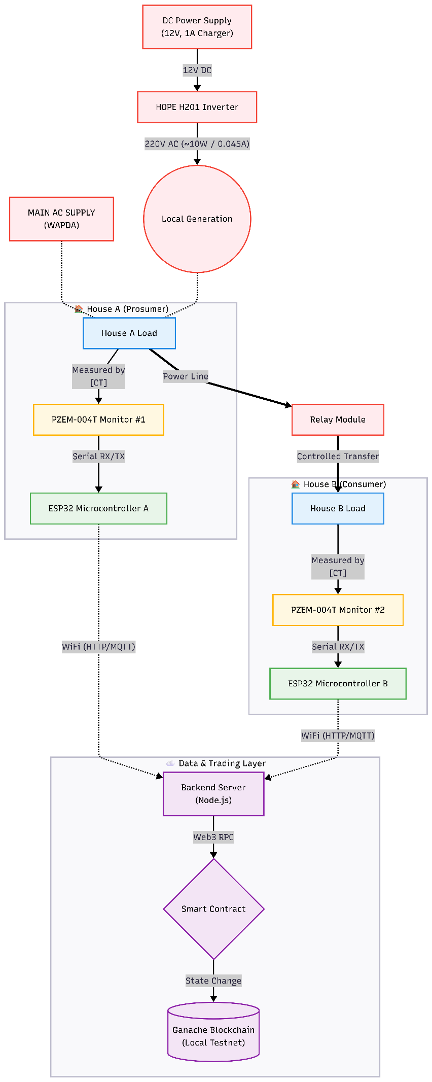
The proposed system, shown in Figure 3.1, features two ESP32 microcontrollers connected to a PZEM-004T sensor via hardware serial communication. ESP32 A (House A) controls a relay module for energy transfer to House B. Both devices communicate with a backend server via WiFi, which records transactions on the Ganache blockchain.

Figure 3.1 Block Diagram of Proposed System

Overall purpose: this is a kind of detailed end-to-end hardware plus data flow schematic for the microgrid testbed; it shows how power gets generated, sensed, and then how data moves from the real physical bits all the way into the blockchain layer.
Power generation path (top):
There’s a red-bordered box called "DC Power Supply (12V, 1A Charger)" that feeds (through an arrow that says "12V DC") into the "HOPE H201 Inverter".
Then the inverter throws out, via an arrow marked "220V AC (~10W / 0.045A)," into a red circular point labeled "Local Generation". This whole thing is basically the simulated solar input, with the 12V DC adapter acting as a stand-in for the real solar panel, as you mention in your project limits.
Next to that, there’s a separate red box labeled "MAIN AC SUPPLY (WAPDA)" that sits as an alternative/grid source. Both "Local Generation" and "MAIN AC SUPPLY" then go down through dotted lines into House A.
House A (Prosumer), boxed with a light gray border, has a house icon :
"House A Load" (blue box) is what takes in power from both of those sources above.
An arrow reading "Measured by [CT]" goes downward into "PZEM-004T Monitor #1" (orange box).
Also, a "Power Line" arrow sort of branches to the right from House A Load toward the "Relay Module," which lives in the House B area. This is meant to show the physical transfer of energy between houses.
After that, from the PZEM monitor, an arrow labeled "Serial RX/TX" links over to "ESP32 Microcontroller A" (green box).
Then ESP32 Microcontroller A connects downward along a dotted line labeled "WiFi (HTTP/MQTT)" into the backend server layer.
House B (Consumer) is another gray-bordered section, also with a house icon :
The "Relay Module" (red box) grabs the power line coming from House A. From it, an arrow labeled "Controlled Transfer" goes down into "House B Load" (blue box).
A separate arrow labeled "Measured by [CT]" heads into "PZEM-004T Monitor #2" (orange box).
Then "Serial RX/TX" carries the link from that monitor into "ESP32 Microcontroller B" (green box).
ESP32 Microcontroller B then drops down via a dotted line labeled "WiFi (HTTP/MQTT)" into the same backend server layer.
Data & Trading Layer (bottom) boxed with a gray border and a cloud/network icon:
The WiFi connections from both ESP32 microcontrollers converge into the "Backend Server (Node.js)" box (purple).
From the backend server to a purple diamond labeled "Smart Contract", there’s an arrow called "Web3 RPC".
Then an arrow labeled "State Change" goes from the Smart Contract down into a cylinder labeled "Ganache Blockchain (Local Testnet)”, which represents the private Ethereum blockchain where the trade transactions are stored and logged.

ESP32 Microcontroller
The ESP32 is a low-cost, low-power system-on-chip (SoC) with integrated WiFi and dual-mode Bluetooth, developed by Espressif Systems. Two ESP32 DevKit V1 boards are deployed – one for House A and one for House B.
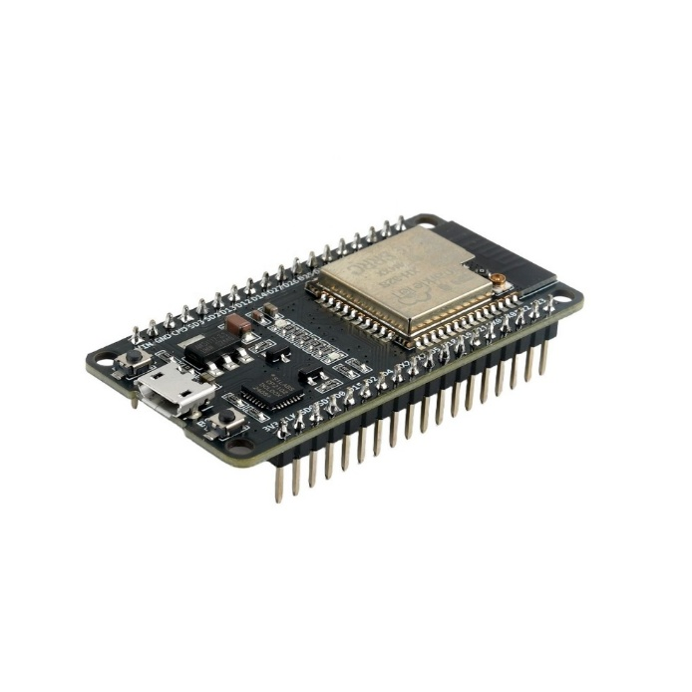
The ESP32 (WROOM-32) is basically the core embedded controller used at both House A and House B, in the proposed P2P energy trading microgrid. It kind of works like the main “brain and link” at each home node, connecting the actual electrical sensing stuff with the digital backend system.
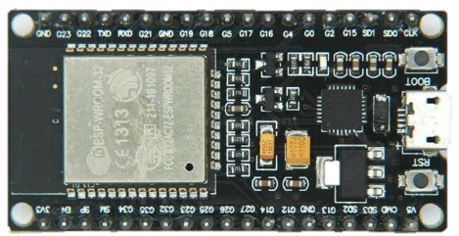

Figure 3.2 ESP32 Microcontroller
Key visible features, kind of:
There’s this rectangular black PCB, shown at a slight diagonal on a plain white background. On the right side, you can see a metallic silver copper sort of shielded module; that’s the ESP32 wireless chip part, it’s the one that manages WiFi and Bluetooth stuff. The little text on it is partially legible, like an Espressif marking, nothing super clear.
On the top and bottom long edges of the board, there are two rows of male header pins, for plugging into a breadboard or using jumper wires. It feels like that common DevKit-style ESP32 board with around 30 GPIO pins. On the left edge there’s a micro-USB port, used for both power and programming/flashing the firmware over USB.
Near the micro-USB port there are also two small push buttons. Usually one is labeled “EN,” and another is “BOOT”, with EN acting like reset/enable and BOOT setting the flash mode, pretty standard for these ESP32 dev kits. Between the USB area and the module, there are various tiny surface-mount components, like a voltage regulator, an LED, resistors, and capacitors.
Also, four mounting holes are present at the corners of the PCB. Finally, there’s silkscreen text printed close to the pin headers, listing GPIO pin labels, but in this image it’s too small to read properly.
Role in House A (Prosumer)
For House A, the ESP32 does a few jobs that kind of run together:
- Sensor data acquisition: it talks to the PZEM-004T smart metering module using a UART/serial connection, then it periodically grabs values like voltage, current, power, and the accumulated energy readings coming from the Solar PV and Battery subsystem.
- Relay control: it uses a digital GPIO output to drive the Relay Module, so it switches the DC energy transfer line, either open or closed, based on what the backend trading engine tells it. So yeah, it becomes the real-world actuator where the “trade choice turns into something physical.
- Data transmission: it converts the sensor outputs into JSON and pushes them over WiFi (HTTP POST) to the Node.js backend server; that way, the backend can observe House A’s near real-time surplus availability.
- Command reception: once a trade is matched and confirmed on the blockchain, the ESP32 gets switching messages back from the backend (for example “ENABLE_EXPORT”), and it translates those into the right relay actions
Role in House B (Consumer)
In House B, the ESP32 has a more reduced duty, mostly watching, not switching:
- Sensor data acquisition: it reads voltage, current, and power draw from its smart meter, which mirrors how much energy the household load (the appliances) is consuming.
- Data transmission: again, it formats the measurements as JSON and sends them via WiFi/HTTP to the backend, so the system can keep track of House B’s current demand level.
- No local actuation: House B is just a consumption site, so there’s no relay control here; the ESP32 does not really need to interpret incoming switching commands. Its job is basically sensing, reporting, and repeating.
Why ESP32 Was Chosen for This Role
The ESP32 was picked instead of simpler microcontrollers because this project needs it to juggle multiple activities at once, like continuous sensor polling, network communication, and (specifically for House A) relay actuation, all in real time. Also, the ESP32 already includes WiFi, so there’s no need for a separate networking module, which directly supports the WiFi/HTTP JSON data path to the backend described in the system architecture (Section 4.1). On top of that, its dual-core processing helps keep sensor reads and data sending from stepping on each other, so the backend gets consistent, low-latency updates for the real-time dashboard and the trading engine.

Table 3.1 – ESP32 Specifications

Specification | Value
Processor | Xtensa Dual-Core 32-bit LX6
Clock Speed | 240 MHz
Flash Memory | 4 MB
SRAM | 520 KB
WiFi | 802.11 b/g/n
GPIO Pins | 34
UART | 3
Operating Voltage | 3.3V
Input Voltage (USB) | 5V

PZEM-004T AC Power Monitor
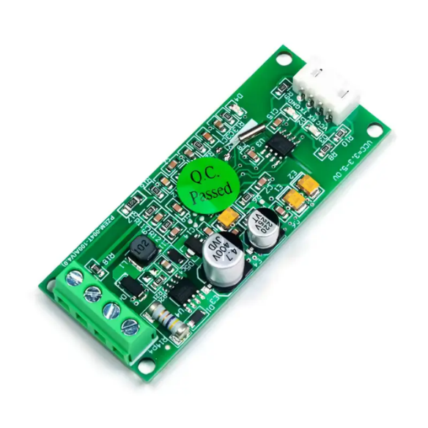
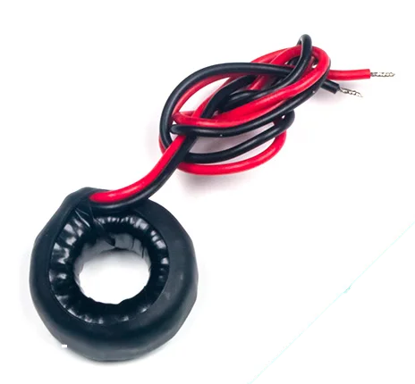
The PZEM-004T v3.0 measures voltage, current, active power, energy, frequency, and power factor via UART (Modbus-RTU). Two PZEM sensors are used: - PZEM #1 (House A): Serial1 (GPIO 18 RX, GPIO 19 TX) - PZEM #2 (House B): Serial2 (GPIO 16 RX, GPIO 17 TX)

Figure 3.3 PZEM-004T

The PZEM-004T is a smart metering module used at both House A and House B to perform real-time electrical measurement, forming the core sensing component that feeds accurate energy data into the entire trading pipeline.
Functional Role in House A
At House A, the PZEM-004T is interfaced with the ESP32 (WROOM-32) via a serial (UART) connection and is responsible for measuring the electrical output of the Solar PV and Battery subsystem as it flows toward the household load and the DC transfer line. Specifically, it continuously measures:
• Voltage: The instantaneous voltage level on the line being monitored
• Current: The amount of current flowing, indicating how much power is actively being drawn or supplied
• Active Power: The real-time power (in watts), calculated from voltage and current readings
• Cumulative Energy: The total accumulated energy (in kWh) over time, which is essential for calculating how much surplus energy House A has available for export
These readings allow the ESP32 to compute House A’s net surplus — the difference between what the Solar PV/Battery system generates and what the household itself consumes — which is the key value reported to the backend’s P2P Trading Engine to determine tradeable energy availability.
Functional Role in House B
At House B, the PZEM-004T (referred to in the diagram simply as the “Smart Meter”) performs the same measurement function but instead monitors the Household Load (Appliance) — tracking how much energy House B is actively consuming. This consumption data serves two purposes:
1. It is reported to the backend to determine House B’s real-time energy demand, used by the trading engine to match House A’s surplus.
2. Historical consumption logs collected from this module feed into the LSTM Load Prediction Model, which uses this time-series data to forecast House B’s future demand patterns.
Why PZEM-004T Was Chosen
The PZEM-004T was selected because it provides pre-calibrated, accurate electrical measurement through a simple digital serial interface, eliminating the need to design custom analog sensing circuitry (such as current shunts, voltage dividers, or ADC signal conditioning) that would otherwise be required if raw analog measurement were attempted directly through the ESP32’s ADC pins. This significantly reduces both circuit complexity and the risk of measurement inaccuracy, which is critical in a system where the recorded energy values directly determine the financial value of each trade settled on the blockchain.

Current Transformer
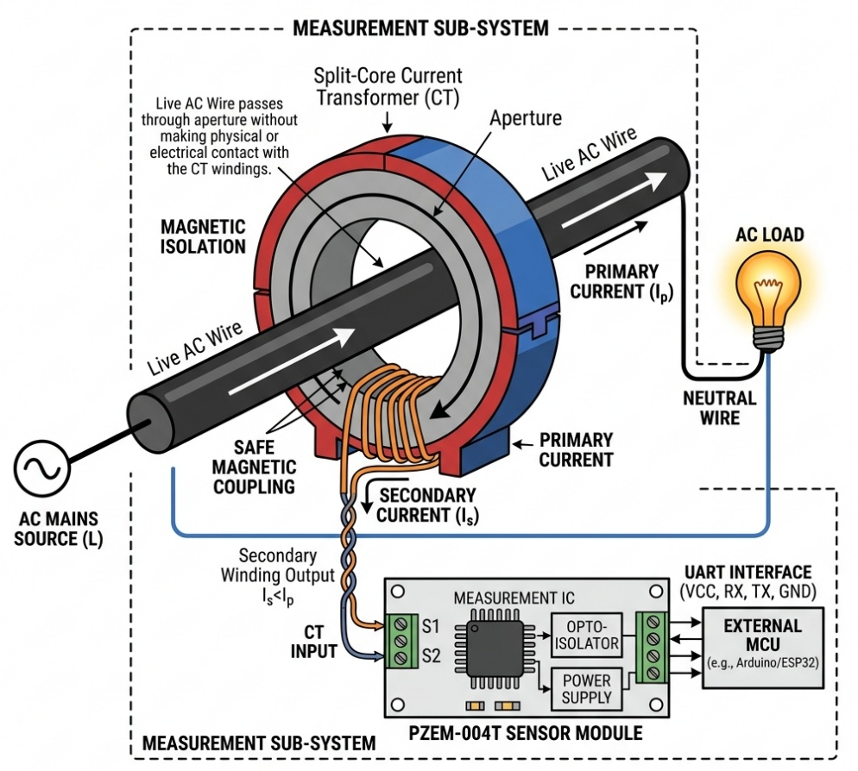

Figure 3.4 Current Transformer (CT) Integration and Isolation for PZEM Sensor

The Current Transformer (CT) is the current-sensing part that works together with the PZEM-004T module in both House A and House B. Now the PZEM-004T board itself is busy with voltage monitoring, signal handling, and digital communication, but the CT clamp is the actual physical sensor that sort of “catches” the current going through the live conductor. So yeah, it becomes a key inseparable piece of the whole smart metering setup, even if it looks simple.
Working Principle
The CT basically follows electromagnetic induction. It is made like a clamp that you put around the current-carrying wire (the conductor that delivers power to or from the load) without needing direct electrical contact, or without interrupting the circuit. When alternating current is flowing through that primary conductor, it creates a changing magnetic field, and that field then causes a smaller, scaled-down current in the CT’s secondary winding. The PZEM-004T reads that induced current and translates it into a calibrated current value (amperes), then the system uses that along with the voltage reading to figure out power and energy numbers.
Role in House A
For House A, the CT is clamped around the wire that carries current from the Solar PV and Battery subsystem toward the household load and also to the DC export line. This lets the PZEM-004T see how much current is actually flowing, so it can tell what amount of power is being produced or exported right then. In other words, this current data matters a lot for estimating House A’s instant surplus power that can be used for trading.
Role in House B
For House B, the CT is placed around the conductor that feeds the Household Load (the appliance side), so the PZEM-004T can measure the current that the load is pulling at that moment. That number then directly reflects real-time power consumption in House B. And it gets fed into the trading engine’s demand estimate plus the history dataset used to train the LSTM load prediction model, so the model has something meaningful to learn from.

Why a CT-Based Approach Was Used
Choosing a CT clamp instead of a direct in-line shunt resistor brings one big practical advantage: it’s non-invasive sensing. The CT doesn’t have to be electrically inserted into the circuit, meaning you don’t need to cut and rewire the live conductor to add a sensing element. That reduces installation headaches, and also lowers the chance of creating a weak spot or electrical failure point in the power path. This is especially useful in a prototype system, where safety, quick assembly, and easy testing are kind of always in focus.

Table 3.2 – PZEM-004T v3.0 Specifications
Specification | Range
Voltage Measurement | 80-260V AC
Current Measurement | 0-100A (via external CT)
Power Measurement | 0-23 kW
Energy Measurement | 0-9999.99 kWh
Frequency | 45-65 Hz
Power Factor | 0.00-1.00
Accuracy | 1%
Communication | UART (TTL), 9600 baud

Relay Module
A 5V single-channel relay module (active-LOW, optocoupler isolated) controls energy transfer. Connected to GPIO 27 of ESP32 A.
The two-channel relay module is, sort of, the actuation part used at House A to actually control how the DC energy transfer line is routed and switched. It kind of connects the low-power digital control signals coming from the ESP32 over to the higher-current power circuit. So the system can take those digital control signals and turn them into real physical movement in the energy flow.
Working Principle
Basically, a relay is an electromechanically operated switch. Inside each channel there is:
- A tiny electromagnetic coil, driven by a low-voltage control signal
- A mechanical switching contact that gets pulled open or closed when the coil is energized or de-energized.
- An isolation barrier that separates the control side (low voltage, from the ESP32 GPIO) from the load side (the higher-current DC line being switched)
So when the ESP32 outputs a digital HIGH or LOW to a channel control pin, the coil will energize or de-energize. That action makes the contact toggle between open (break in the circuit) and closed (circuit complete) states. This separation matters because it shields the microcontroller from nasty voltage spikes, back-EMF, or current surges that can happen on the power side.
Why Two Channels Were Used
Using two channels, instead of a single-channel relay, House A’s ESP32 manages two separate switching paths on its own, without needing two different relay assemblies for everything. In this system, it’s needed because House A has more than one controllable switching job. For example,
- Channel 1 is used to manage the connection between the Solar PV/Battery subsystem and the local household load circuit
- Channel 2 is used to manage the DC energy transfer line that links House A to House B
That means the ESP32 can handle local load supply versus exporting energy to House B, instead of being stuck with one single all-or-nothing switching choice. Also, it leaves room for future changes like adding another household segment or an extra grid-connection route, without needing new relay hardware beyond what is already sitting there.
Role in the Trading Process
After the backend P2P Trading Engine matches and confirms a trade (once blockchain settlement is done), it sends a switching command back to House A’s ESP32. Then the ESP32 activates the relay channel’s GPIO control pin. The selected channel contact closes, so the circuit becomes physically completed, and energy can flow from House A to House B over the DC transfer line. When the trade window ends, or if no active trade exists, the ESP32 can deactivate and open the relay so energy transfer stops, right then.

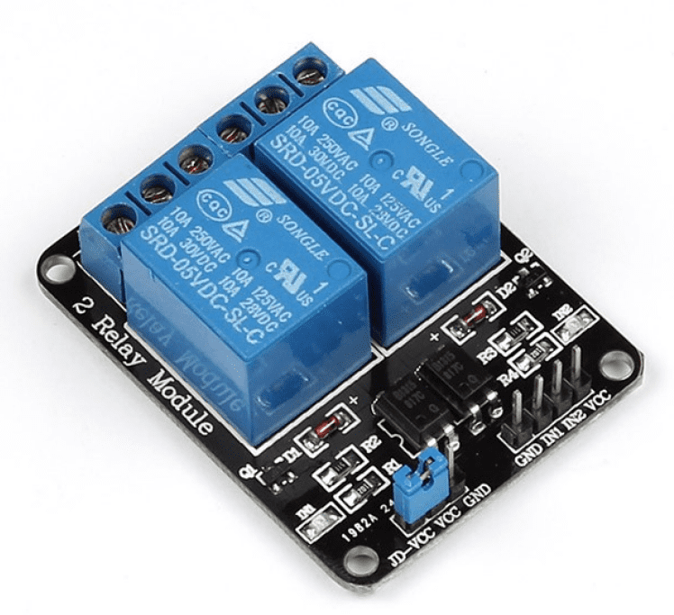
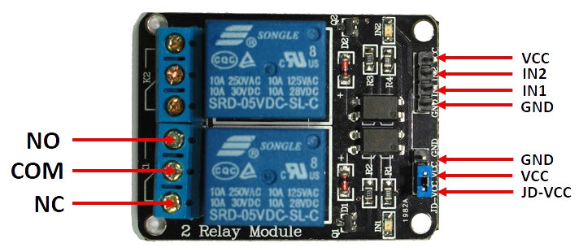

Figure 3.5 2-Channel Relay Module

This is a product photo of a 2-channel relay module, and it seems to match the “Relay Module” component you had in your hardware architecture diagram (the “Smart Auto-Relay” part that controls energy transfer to House B).
A few key things I can see. There’s a black rectangular PCB with “2 Relay Module” printed in white silkscreen along the left side, not fully centered or anything. Then there are two blue relay units mounted side by side, both branded SONGLE, model SRD-05VDC-SL-C, and each one looks like it’s meant for switching AC loads. The visible text on the relays shows the ratings like “10A 250VAC” and “10A 125VAC / 10A 30VDC,” which is a typical kind of switching spec wording.
On the left edge of the board, each relay has a screw terminal block, the little silver screw terminals where you connect the high-voltage wires that are actually being switched. On the right side of the PCB, there are small green LED indicators (for relay status/channel activity), plus a small black IC chip, likely an optocoupler or driver related to input isolation. Along the bottom edge, there are pin headers, and the labels I can make out are “GND, IN1, IN2, VCC” on the control side; these should tie into the ESP32 GPIO pins to trigger the relays. There’s also a separate jumper block labeled “JD-VCC / VCC / GND” for power selection.
Last, the PCB has four mounting holes at the corners, so it’s meant to be screwed down cleanly.

Table 3.3 – Relay Module Specifications
Specification | Value
Operating Voltage | 5V DC
Trigger Level | Active-LOW
Contact Rating | 10A @ 250V AC
Isolation | Optocoupler

Power Supply Components

HOPE H201 Inverter (~10W actual with 12W DC input):
Converts 12V DC to 220V AC (simulates solar generation)
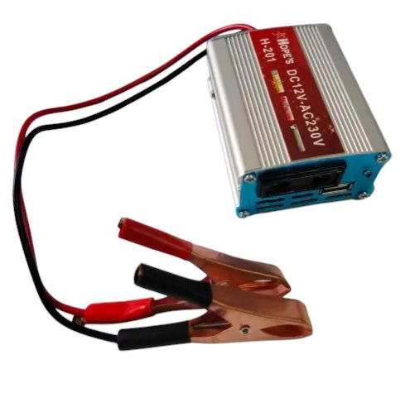

Figure 3.6 HW-201 Inverter

The HW-201 inverter module is basically the conversion unit used at House A to change that low-voltage DC electricity produced and kept by the Solar PV and Battery system into a standard 220V AC output, so the locally generated renewable power becomes usable with usual AC household appliances, kind of you know like in normal homes.
Working Principle
A DC-to-AC inverter works by electronically toggling the incoming DC voltage at a high frequency using a group of power transistors (often MOSFETs). After that, it shapes the switched signal and steps it up through a transformer, so the result is an alternating current output waveform at the target voltage level (220V) and at the frequency used in the region (50 or 60 Hz, depending on local standards). In simpler models like the HW-201, the output is commonly a modified square wave, or a quasi-sine form. That usually covers a lot of resistive and straightforward inductive loads, but it is less ideal for delicate electronic equipment, especially when compared to a pure sine wave inverter.
Role in House A
In House A, the HW-201 is placed between the Solar PV & Battery subsystem and whatever AC-based load or household output requirement exists inside the home circuit. The subsystem stores and supplies energy at 12V DC. Then the inverter:
- pulls the 12V DC supply from the battery that the solar panel charges
- converts it into a usable 220V AC supply
- feeds that AC power into household appliances, outlets, or other connected loads that expect mains-like voltage
So, the inverter becomes the key link that turns the DC native renewable energy (solar plus storage) into something practical for real-world devices, most of which are built to run on AC, not DC.
Why This Component Is Necessary
Solar panels and batteries naturally generate and store energy in DC format. But the majority of household appliances are made to operate on AC, the same way grid electricity is delivered. Without a DC-to-AC inverter, the solar energy at House A would end up useful only for DC-compatible uses, for example direct battery charging, DC motors, or certain LED setups. That would severely shrink what the system could practically power. The HW-201, in contrast, bridges this mismatch, letting House A’s renewable generation run standard AC household equipment just like utility power would.

DC Buck Converter (LM2596s): Steps down to 5V DC for ESP32 power
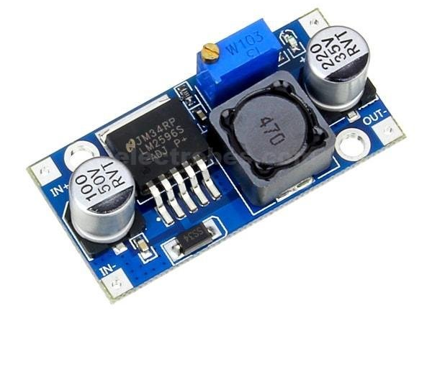

Figure 3.7 DC Buck Converter
The buck converter is basically the voltage regulation thing that does the whole stepping down, from the higher DC voltage we get from the Solar PV & Battery subsystem, into a steadier 5V DC supply. That 5V is needed so the ESP32 microcontroller and its sensing/communication circuits can run safely and reliably, without weird glitches or brownouts.
Working Principle
So, a buck converter counts as a switching DC-DC converter; it takes a bigger input voltage and then brings it down to a smaller regulated output voltage. In practice, it works by rapidly toggling a power switch transistor (most often a MOSFET) on and off at a relatively high frequency. While it’s doing that, it manages the “average” voltage going to the output, and that’s smoothed out using an inductor-capacitor, the LC filtering stage, which kinda turns the switched waveform into a stable DC level. Compared with a linear voltage regulator, where extra voltage is mostly burned off as heat, the buck converter drops voltage mainly through controlled switching, so it’s much more power-efficient. This matters a lot in a battery context, because wasting energy isn’t really “the plan” for an efficient energy utilization project.
Role in House A
For House A, the buck converter grabs the DC coming from the Solar PV & Battery subsystem, usually around 12V or around whatever the nominal battery level is. Then it steps that down into a clean 5V DC output. This regulated 5V rail is then used to power, first, the ESP32 (WROOM-32) microcontroller, because it needs a stable 5V supply (some ESP32 boards can take 3.3V depending on onboard regulation, though). Second, it can also feed related logic such as the PZEM-004T metering module and the relay module circuitry, depending on their actual voltage needs, so all the low-power digital bits get consistent, quiet, noise-free power.
Why a Buck Converter Was Necessary
The ESP32 and its attached peripherals are pretty sensitive digital electronics; they really want a stable low-voltage supply to keep operating correctly and not get damaged. If you just connect them straight to the raw battery voltage, that voltage can drift around because of the battery charge state, the solar input, and the load conditions. That drift can lead to overvoltage stress or unstable behavior. So the buck converter is what keeps the output near a consistent 5V, even when the battery voltage itself swings, protecting the sensitive components and keeping system behavior dependable. This is extra important here because the ESP32 handles real-time sensing, communication, and relay control across the system all the time, so instability would be kinda disastrous.

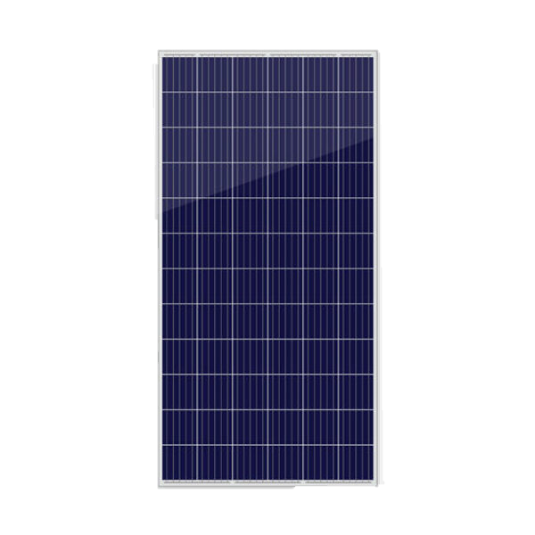
12V 1A Charger as Solar (Prototype): Simulates solar charge controller output
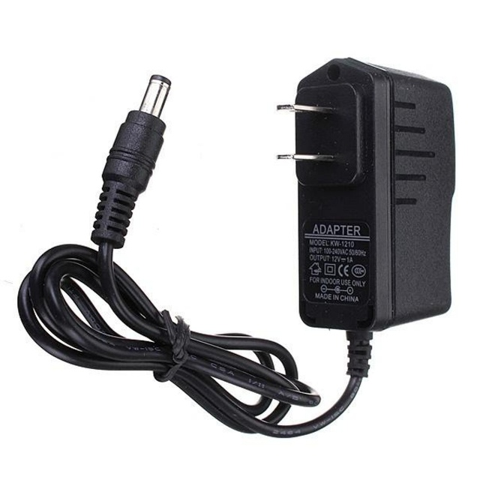

Figure 3.8 12V 1A Charger

DC Power Adapter (12V Charger):
This looks like a wall-plug DC power adapter, black in color, with a US-style two-prong plug on one side and a coiled black cable on the other. The cable ends in a barrel / DC jack connector, the kind with the round pin-type shape that you usually see on small electronics or development boards.
On the adapter body, there is a label that says “ADAPTER, MODEL: KW-1210” and underneath it the specs show “INPUT: 100-240V AC 50/60Hz” plus “OUTPUT: 12V --- 1A”. It also mentions “FOR INDOOR USE ONLY” and “MADE IN CHINA,” so yeah, pretty straightforward. The cable itself is neatly coiled and held in place with a twist tie, mostly so it looks clean in the photo.
This matches the “DC Power Supply (12V, 1A Charger)” part shown at the top of your hardware architecture diagram — basically the same 12V DC adapter that feeds the HOPE H201 Inverter, to emulate the “Local Generation” source in the testbed (standing in for a real solar panel).
Solar Panel:
This image shows a polycrystalline solar panel, a rectangular one with a portrait orientation, and it has a white aluminum frame. The active surface is a dark blue, almost navy blue, photovoltaic cell area.
The cell area is made up of a bunch of small square sections, basically a grid pattern. It has that typical polycrystalline texture with a slightly speckled look, and thin white grid lines (busbars) run across, connecting the little squares in rows and columns. There’s also some glare or reflection that runs diagonally across the upper portion, which is pretty normal for glass coating over the cells.
Overall, the panel looks like a mid-size PV module, the kind you’d find in small-scale installs, or education/training setups where you’re demonstrating solar generation without going too big.

Table 3.4 – House A (ESP32 #1) Pin Configuration
Component | ESP32 Pin | Description
PZEM #1 TX | GPIO 18 | Consumption data (RX)
PZEM #1 RX | GPIO 19 | Consumption control (TX)
Relay IN | GPIO 27 | Relay control (Active-LOW)
Built-in LED | GPIO 2 | Status indicator
LCD SDA | GPIO 21 | I2C data (1602A LCD)
LCD SCL | GPIO 22 | I2C clock (1602A LCD)
Power | VIN (5V) | From buck converter
Ground | GND | Common ground

Table 3.5 – House B (ESP32 #2) Pin Configuration
Component | ESP32 Pin | Description
PZEM #2 TX | GPIO 16 | Consumption data (RX)
PZEM #2 RX | GPIO 17 | Consumption control (TX)
Built-in LED | GPIO 2 | Status indicator
Power | VIN (5V) | From buck converter
Ground | GND | Common ground

Because deploying and testing with a real solar PV panel brings a bunch of practical constraints, like needing sunlight that actually happens, output that swings with weather and other conditions, and also trouble doing controlled lab testing, a 12V 1A DC charger/adapter was used as a stand-in power source. The idea was to mimic the solar generation input at House A, just for prototype validation.
Purpose and Justification
The main job of the Solar PV panel in the proposed system architecture is to provide a steady DC voltage, so it can charge the battery and run the household circuit. During prototype-stage testing, swapping the solar panel with a regulated 12V 1A DC charger makes the same electrical role repeatable and on-demand. There is no dependence on sunlight, weather, or panel angle, and those things would otherwise add extra uncertainty, meaning it would be harder to consistently show, troubleshoot, and verify the system’s behavior.
Working Principle
This DC charger/adapter changes regular household AC mains into a regulated 12V DC output, with a maximum current of 1A. In practice, it acts like a stable constant-voltage DC source, which is electrically “close enough” to the kind of DC voltage a solar panel would deliver under steady sunlight. In other words, it becomes a DC voltage supply that can charge the battery and feed the remaining House A DC circuit (buck converter, ESP32, relay logic, etc.).
Role in House A
Instead of the Solar PV panel shown in the system architecture (Section 4.1), the 12V 1A DC charger is wired to charge the Battery and also provide the DC bus that feeds the following items,
• the buck converter (stepping down to 5V for the ESP32 and digital logic)
• the HW-201 inverter (stepping up to 220V AC for household load simulation)
• the DC energy transfer line toward House B
So, the whole downstream chain- battery storage, voltage regulation, inversion, and energy transfer- can be tested and demonstrated the same way it would act with genuine solar input. From the rest of the circuit, the “source” is functionally indistinguishable. Solar panel or charger, it still shows up as a 12V DC supply to the circuit.
Limitation and Scope Acknowledgment
For academic honesty, this substitution also means the prototype cannot really prove photovoltaic energy harvesting, or any solar-specific behaviors. For example, it does not show variable output under changing irradiance, it does not address Maximum Power Point Tracking (MPPT) related decisions, and it does not reflect weather-dependent generation patterns. The DC charger only reproduces the electrical output characteristic of a charged solar/battery-like source. That is still useful, because it’s enough to validate the trading, metering, relay-switching, and blockchain logic, but it is not enough to validate solar performance. This point should be stated clearly in Chapter 5 and then brought back in the Future Scope (Section 6.6), as a candidate replacement with a genuine PV panel in later iterations.

CHAPTER 04: Design & Implementation

Hardware Implementation
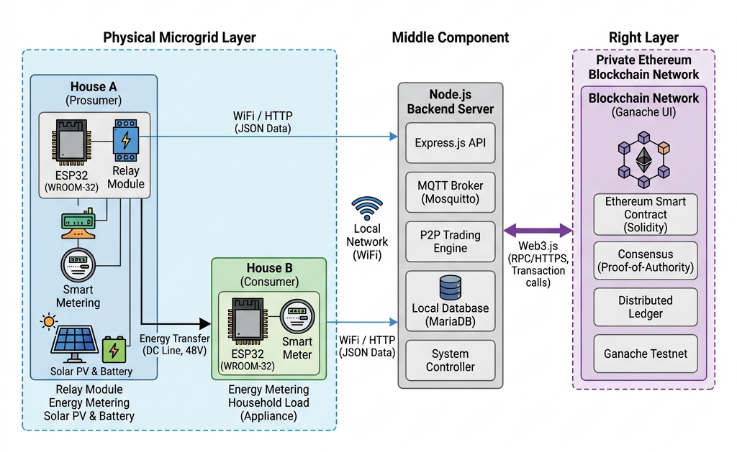

Figure 4.1 Design and Implementation
The diagram is basically split into three parts stacked side by side vertically, like ok, a left Physical Microgrid Layer, a Middle Component in the middle, and a Right Layer on the right. Together they show a kind of 3-tier setup: real stuff, then backend processing, and finally the blockchain stuff.
Left section – Physical Microgrid Layer:
House A (Prosumer) is shown inside a light blue shaded box, with a couple of icons that sort of “touch” each other. There’s an ESP32 (WROOM-32) and a Relay Module, connected directly. Under that, there’s a Smart Metering device with a display. Then below, Solar PV & Battery icons appear (like a solar panel plus a battery with a lightning bolt type sign). Under the icons, there’s a label that kind of summarizes everything as: “Relay Module, Energy Metering, Solar PV & Battery.”

House B (Consumer) sits down to the right a bit, in a green-shaded box. It has an ESP32 (WROOM-32) and a Smart Meter icon. The little caption under it says: “Energy Metering, Household Load (Appliance).”
For the connections inside this left layer:
There’s an arrow called “Energy Transfer (DC Line, 48V)” going from House A down to House B, so yeah, physical power flow. Then data is sent out by each house using arrows labeled “WiFi / HTTP (JSON Data)” heading toward the middle side. House A’s arrow exits closer to the top, while House B’s leaves closer to the bottom, like staggered on purpose.
Middle section – Node.js Backend Server:
This is a bordered container titled “Node.js Backend Server”; inside it there’s a vertical stack of five boxes, kinda like layers within the server. The boxes are:
Express.js API
MQTT Broker (Mosquitto)
P2P Trading Engine
Local Database (MariaDB)
System Controller
Between the physical side and this backend, a WiFi icon labeled “Local Network (WiFi)” is placed, indicating the wireless link. House A and House B both send their data arrows into this server block, with House A feeding into the Express.js API at the top, and House B feeding toward the lower area near the System Controller.
Right section – Private Ethereum Blockchain Network:
On the far right, there’s a purple shaded, dashed bordered box titled “Private Ethereum Blockchain Network.” Inside it, you get a header “Blockchain Network (Ganache UI)” plus a blockchain / hexagonal network icon. Then there are four stacked sub-boxes reading:
“Ethereum Smart Contract (Solidity),”
“Consensus (Proof-of-Authority),”
“Distributed Ledger,”
“Ganache Testnet.”
Connections between middle and right sections:
A thick purple bidirectional arrow labeled “Web3.js (RPC/HTTPS, Transaction calls)” links the Node.js Backend Server to the blockchain network. This is meant to show two-way messaging, like submitting transactions and then later confirming them once the chain processes them, you know, round trip style.
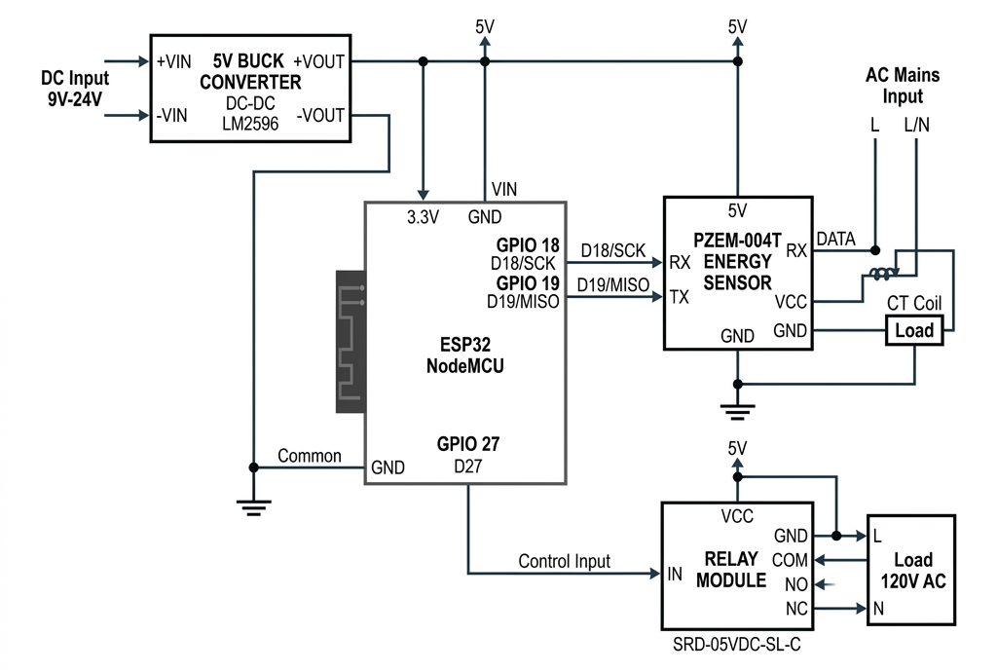

Figure 4.2 Hardware Schematic Diagram

Overall purpose: this is a pretty detailed electrical circuit schematic, like showing power routing and pin-level wiring links between the ESP32, the buck converter, the PZEM-004T sensor, a relay module, and the actual load — so it’s way more technical, component by component, than the earlier block-level architecture shots you had.
Power supply section (top left):
“DC Input 9V-24V” comes in, then it feeds a “5V Buck Converter, DC-DC LM2596” module. The module has pin labels +VIN, -VIN, +VOUT, -VOUT. From there, the output gives you a regulated 5V rail, which is drawn as this horizontal bus line across the top, with two little tap points marked “5V” that branch into different parts of the circuit.
ESP32 NodeMCU (center):
Shown as a big rectangular block, with a WiFi antenna graphic on its left side. Power pins include VIN (that one is tied into the 5V rail), plus 3.3V and GND. There are also GPIO lines labeled like:
GPIO 18 (D18/SCK) — it goes to the PZEM sensor RX input line
GPIO 19 (D19/MISO) — it goes to the PZEM sensor TX output line
GPIO 27 (D27) — marked “Control Input,” and it runs down to the Relay Module’s IN pin
There’s also a “Common” ground line from the buck converter’s ground down to the ESP32 GND pin, with a ground symbol at the tie point.
PZEM-004T Energy Sensor (top right):
This one is powered from the 5V rail. Pins shown are RX, TX, VCC (5V), and GND. The left side/comms side: RX receives the D18/SCK signal from the ESP32, and TX sends D19/MISO back to the ESP32. On its right/output side, you’ve got DATA plus extra RX/VCC/GND connections that link to a CT Coil, the current transformer clamp, which goes around the Load wire.
It also ties into the “AC Mains Input” side using L (Live) and L/N lines. Those pass through the CT coil and then into the Load.
Relay Module (bottom right):
Labeled “RELAY MODULE, SRD-05VDC-SL-C” (same physical relay unit you mentioned before). Power/control side: VCC is fed from the 5V rail, and then there’s GND plus IN as the control input, coming from ESP32 GPIO 27.
The switching side has COM (Common), NO (Normally Open), and NC (Normally Closed). Those wires run into a “Load 120V AC” box, with L and N terminals, and are connected back to the AC Mains Input as well.

House A Circuit Description
House A ESP32 connects to PZEM #1 (Serial1: GPIO 18/19) and relay module (GPIO 27).
PZEM #1 Connections: VCC->5V, GND->GND, TX->GPIO18, RX->GPIO19, CT Clamp around House A live wire.
Relay Connections: VCC->5V, GND->GND, IN->GPIO27, COM->Main AC Live, NO->House B Live.
Relay Logic: - Consumption < 1W: GPIO 27 = LOW -> Relay ON -> Energy flows to House B - Consumption >= 1W: GPIO 27 = HIGH -> Relay OFF -> No transfer
House A is basically the Prosumer node, able to both create and use electrical energy; it sort of, in a way, stands in the middle of generation and consumption. The circuit is made of a few linked parts that all kind of talk together:
- ESP32 (WROOM-32) Microcontroller: this is the main control brain for House A. It handles communication, gathers readings from sensors, controls the connected hardware, and sends data to the backend server using WiFi.
- Relay Module: the ESP32 drives this relay using one digital GPIO pin, and it changes how the Solar PV / Battery system is tied to the DC distribution line. In practice, it decides when energy export toward House B is allowed; when a trade gets approved, the relay closes, so the transfer path is open.
- Smart Metering Unit: this part is built around a current/voltage sensing IC, very often something like the PZEM-004T module. It keeps measuring real-time things such as voltage, current, active power, and cumulative energy in kWh. The ESP32 reads these values through a serial (UART) link.
- Solar PV & Battery Subsystem: during daylight, the PV panel produces DC power, and it charges the battery through a charge controller stage. The battery works as a kind of energy buffer; it stores extra solar output for later when PV generation drops, or it supplies power for export to House B when the local house demand is covered and there is still surplus.
- Energy Transfer Line (DC, 48V): this is the actual conductor where the surplus energy flows from House A to House B, and its behavior is regulated by that relay module.
Circuit Logic: the ESP32 keeps polling the Smart Meter for fresh measurements, then it calculates surplus as generation minus local use, and reports that surplus upstream. After the P2P Trading Engine matches a trade, the backend sends a control instruction back down to the ESP32, and then the ESP32 triggers the Relay Module to allow or limit energy movement along the DC line.

House B Circuit Description
House B ESP32 connects to PZEM #2 (Serial2: GPIO 16/17). Detects energy from House A via voltage monitoring (voltage > 100V = relay ON).
House B stands for the Consumer node, basically a load-only party in the microgrid; it buys energy either straight from House A ( through P2P trade) or just pulls from its own grid link somehow.
- ESP32 (WROOM-32) Microcontroller: it keeps the same “coordination” job as in House A, meaning it talks with its local Smart Meter and then sends readings to the backend server over WiFi / HTTP.
- Smart Meter: it checks the incoming voltage, current, and power that the Household Load ( appliance) is taking. This info is reused for billing or settlement math and also to feed the LSTM load prediction model using those past consumption patterns.
- Household Load (Appliance): this is the real electrical demand at House B. It can be a resistive load, for example a lamp or heater, used mostly for the testbed demo and to imitate actual household usage.
Circuit Logic: In contrast to House A, House B has no relay and no generation source at all; it’s purely a consumption point. The ESP32 here only grabs metering data and reports it; it does not need to do any local switching of energy paths, because the import choice and the actual routing are managed at House A’s relay.

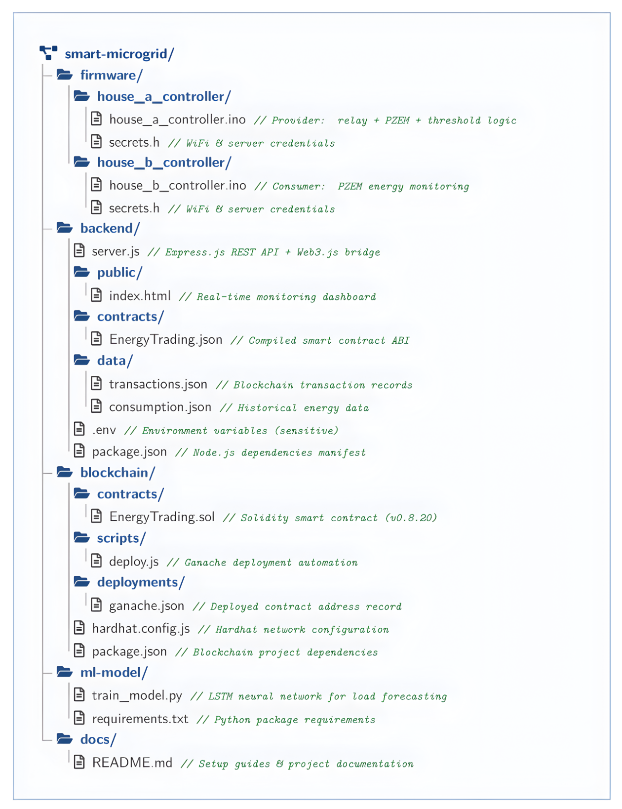
Project Structure

Figure 4.3 Project Directory Structure

Development Environment
Arduino IDE for ESP32 firmware (C++)
Libraries: WiFi.h, HTTPClient.h, PZEM004Tv30.h, ArduinoJson.h, WiFiClientSecure.h, LiquidCrystal_I2C.h
This subsection sorta needs to explain the tools, platforms, and configurations we used to build as well as test the full hardware-software system, without skipping the parts that actually matter in practice.
On the hardware side, we went with ESP32 WROOM-32 development boards (2 units, one per house), and we paired them with PZEM-004T smart metering sensors. For switching, we relied on 5V/relay modules, plus a regular breadboard or PCB prototyping setup to keep the testbed flexible during the iterations. On the energy input, the House A rig used a Solar PV panel (specify wattage here) and a Li-ion/Lead-acid battery (specify capacity/voltage); those are the ones feeding the whole setup.
Firmware development: we used the Arduino IDE (or PlatformIO if that’s what you actually used) to write and upload the ESP32 firmware. The implementation language was C/C++, which is the common choice when you work with the ESP32 Arduino-core. For libraries, the main ones were WiFi.h and HTTPClient.h, ArduinoJson.h for forming JSON payloads, and the PZEM004Tv30 library for sensor communication—so reading values stayed consistent across tests.
On the backend, the runtime was Node.js with Express.js as the main framework. For messaging, we used a Mosquitto MQTT broker to support pub-sub workflows. For storage, MariaDB handled the local relational data, basically where readings and states could be tracked.
For blockchain development, Ganache was used as a local Ethereum simulator so we could do the “testnet-like” deployments quickly. Smart contract development was done in Solidity, and to connect the backend to the chain, we used the web3.js library. For compiling and deploying contracts, we used Truffle or Hardhat, whichever you used in the end; just keep it consistent with your project setup.

Testing tools: we had Postman for API checks, MQTT Explorer for monitoring topics and payloads in real time, and MetaMask for wallet/transaction testing against Ganache

House A Firmware
Key functions: WiFi connection, PZEM sensor reading (500ms interval), excess power calculation (10W - consumption), relay control decision, transaction sending (60s interval when relay ON), live telemetry streaming, 1602A LCD status display (3 rotating screens every 2s: power/relay, voltage/current, generation/status).
This part should kinda explain how the embedded code moves along when it runs on House A’s ESP32:
First there’s the Initialization, where the ESP32 joins the local WiFi network, and it also kicks off the serial link to the PZEM-004T sensor. On top of that, it sets the Relay GPIO pin to some pre-set condition, like open/closed, at the very beginning.
After that comes the Sensing Loop. Here the firmware grabs measurements at steady intervals, think every 5–10 seconds. It reads voltage, then current, then power, plus the cumulative energy number from the Smart Meter.
Once readings are in, there’s Data Packaging. The numbers get wrapped into a JSON object, for example, like {"house": "A", "voltage": 230.1, "current": 1.2, "power": 276.1, "energy": 12.4}, then it’s ready to be shipped.
Next is Data Transmission. The firmware sends that JSON payload to the Node.js backend’s Express API route using an HTTP POST call, over WiFi, basically.
Then there’s Command Reception. The ESP32 keeps checking, either by polling now and then, or by using MQTT to subscribe, for trading instructions coming from the backend, like “ENABLE_EXPORT” or “DISABLE_EXPORT”.
After a command shows up, Relay Actuation takes over. The firmware reacts by flipping the Relay Module’s GPIO state, so the energy transfer path to House B becomes open or closed, depending on what it was told.
Finally, Loop Continuation: it all just repeats. So, steps 2 through 6 keep cycling over and over, which keeps the physical layer in sync with the backend in near real-time.

House B Firmware
Key functions: WiFi connection, PZEM sensor reading (500ms), voltage-based relay detection, consumption reporting (30s), live telemetry (500ms), LED status indication.
For House B, the firmware logic is a bit more direct, almost like it just does the measuring part, then passes the info along, nothing too elaborate:
1. Initialization: ESP32 logs into WiFi, then sets up the dialogue with its nearby Smart Meter sensor, straightforward.
2. Sensing loop: on a steady cadence, it takes readings—voltage, current, power, and the energy usage—for the attached household load.
3. Data packaging: it turns those values into a JSON blob (example: {"house": "B", "voltage": 229.8, "current": 0.8, "power": 183.8, "energy": 8.2}).
4. Data transmission: then it posts that JSON to the backend using HTTP POST, same basic shape as House A’s method, so the backend can tell which home it came from using the "house" field.
5. No actuation required: House B doesn’t drive any relay, so there’s no need for command receiving, no relay switching, no extra control routines. So, the loop stays in “sense and report” mode only.
6. Loop continuation: this read-and-send sequence runs over and over, for near real-time monitoring, and those measurements also get used to update the LSTM load prediction model on the backend.
That’s basically everything covered across the five subheadings under 4.1. When you’re ready, just give me the title of 4.2, and we’ll continue into that part.

Blockchain Implementation
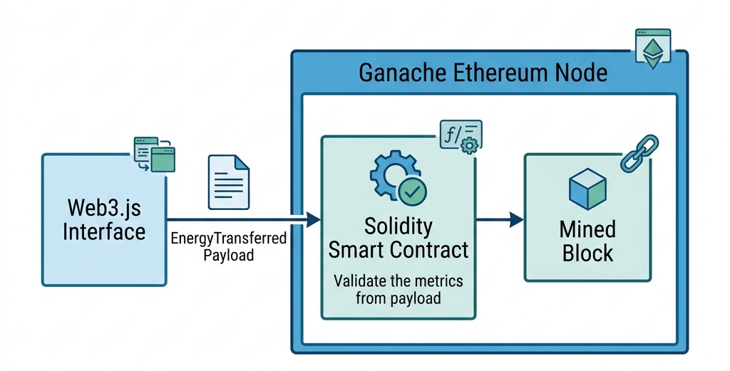

Figure 4.4 Blockchain Smart Contract Execution
Overall purpose: this diagram shows the smart contract transaction flow. As you know, it basically explains how the energy transfer data that your backend sends actually gets checked first, then it’s stored forever on the blockchain, kinda permanently recorded.
Left element – Web3.js Interface:
There’s a light blue rectangular box that says “Web3.js Interface”. Above it sits a small icon, with two overlapping browser/window shapes and a refresh arrow, that represents the Web3.js library, so the Node.js backend can talk with the Ethereum blockchain, yes.
Arrow with payload label:
Above the arrow, there’s a document or file icon sitting there, and the arrow is labeled “EnergyTransferred Payload”. This part stands for the data packet, like house ID, the amount of energy, timestamp, and the rest of those metrics, that gets pushed from the backend into the blockchain side.
Right section – Ganache Ethereum Node:
On the right, there’s a bigger blue bordered container, with a title bar on top and a small Ethereum diamond-style icon in the corner. Inside this container, you can see two smaller sub-boxes connected by an arrow.
Solidity Smart Contract (left sub-box, teal/green shaded):
This left sub-box has an icon with gears and a checkmark, and there’s also a tiny “f(x)” function icon above. The text reads “Solidity Smart Contract”. Under it, there’s a caption: “Validate the metrics from payload”. So, that’s the place where the contract audits, verifies, and basically confirms the energy transfer values before anything is considered valid.
Mined Block (right sub-box, teal/green shaded):
On the right-side sub-box, there’s a 3D cube icon, like a block, and above it there’s a small chain-link style icon. It says “Mined Block”, meaning the last step, when the transaction that passed validation gets included into a new block and gets added to the blockchain ledger for good, no take-backs.
Table 4.1 – Software Technologies
Layer | Technology
Firmware | Arduino C++
Backend | Node.js, Express.js
Blockchain Framework | Hardhat
Smart Contract | Solidity 0.8.20
Local Blockchain | Ganache
Blockchain Library | Web3.js
Dashboard | HTML, CSS, JavaScript
Machine Learning | Python, TensorFlow/Keras

Solidity Smart Contract (EnergyTrading.sol)
Data structures: Transaction (id, seller, buyer, power, energy, price, cost, timestamp, metadata), House (name, wallet, role, statistics).
Table 4.3 – Smart Contract Functions
Function | Type | Description
recordTransaction() | External | Records energy transaction
getTransaction() | View | Query transaction by ID
getTransactionCount() | View | Total transactions
getStatistics() | View | Aggregate statistics
getHouseInfo() | View | House registration info
setPricePerKwh() | Owner-only | Update energy price
This part describes the on-chain logic that kind of controls trust, openness, and automated settlement in your P2P energy trading system.
Purpose: The smart contract works like a decentralized, non-erasable intermediary between House A (seller/prosumer) and House B (buyer/consumer), so you do not have to rely on one central utility authority to verify and settle each deal.
Core Components inside the Contract:
- State Variables: keep info such as registered participant addresses (House A, House B wallet addresses), the energy price per kWh, available energy balance, and the transaction history.
- Structs: The Trade struct usually holds fields like seller address, buyer address, energy amount (kWh), agreed price, a timestamp, plus status (pending/completed).
- Functions:
- registerProsumer() / registerConsumer() — registers participant Ethereum addresses on the first interaction.
- proposeTrade(uint energyAmount, uint price) — this is triggered when the backend (acting on behalf of House A) offers surplus energy to sell.
- acceptTrade(uint tradeId) — called by House B when an offer is accepted, and it starts the payment transfer (in test ETH or tokens) from buyer to seller.
- confirmDelivery(uint tradeId) — invoked after the smart meter reports that the energy was really delivered, which closes the loop between the physical world and the digital world.
- getTradeHistory() — a read-only method the dashboard uses to pull previous transactions.
- Events: Solidity events (for example, TradeExecuted, EnergyDelivered) get emitted on important actions. That way the backend (through Web3.js) can subscribe for near real-time updates without doing nonstop polling on the chain.
- Modifiers: things like onlyRegistered or onlyOwner limit access to authorized addresses, adding a security gate directly within the contract.
Why Solidity / Ethereum: Solidity lets you express the trading rules as immutable, self-running code. After it is deployed, no single party (not even the system operator) can rewrite earlier transactions, and this is basically the trust promise blockchain brings to a decentralized energy market.
Deployment: The contract gets compiled (often using Truffle or Hardhat) and then deployed to your local Ganache test blockchain. It receives a stable contract address which the backend’s Web3.js integration uses for interaction.

Backend Server (server.js)
This orchestration layer is what kind of ties together IoT devices, the database, and that blockchain stuff in one flow, like, not too clean but it works.
Core Duties:
• Express.js API Layer: sets up REST endpoints, for example POST /api/meter-data (it receives the ESP32 JSON readings), GET /api/dashboard (it serves dashboard data to the frontend), and POST /api/trade (it kicks off a blockchain trade).
• MQTT Integration: server.js subscribes to Mosquitto topics such as house_a/energy, house_b/energy, so you get low-latency, event-driven ingestion, as an alternative or a supplement to HTTP polling.
• Database Work (MariaDB): uses a library (often mysql2 or sequelize) to push incoming sensor values into tables like energy_log, transactions, users, and also pulls historical records for dashboard charts and for LSTM training datasets.
• P2P Trading Engine Logic: includes the matching algorithm — it lines up House A’s surplus against House B’s need, figures out a reasonable price (maybe dynamic, based on supply, demand, or LSTM-forecasted demand), then calls the smart contract proposeTrade / acceptTrade functions through Web3.js.
• Web3.js Bridge: links to the Ganache RPC endpoint (say http://127.0.0.1:7545), loads the deployed contract ABI plus the contract address, and then provides JavaScript functions to call, and also to listen, for smart contract events.
• System Controller: keeps the timing straight — like, it triggers relay commands back to House A’s ESP32 only after the trade is confirmed on-chain, so the physical energy movement happens after the digital settlement logic says it’s okay.
Why Node.js: because it runs with a non-blocking, event-driven style, so it fits nicely here; it can manage lots of simultaneous I/O tasks (MQTT messages, sensor ingestion, database writes, blockchain calls, and so on) without one thing freezing everything else, which is honestly the key point.
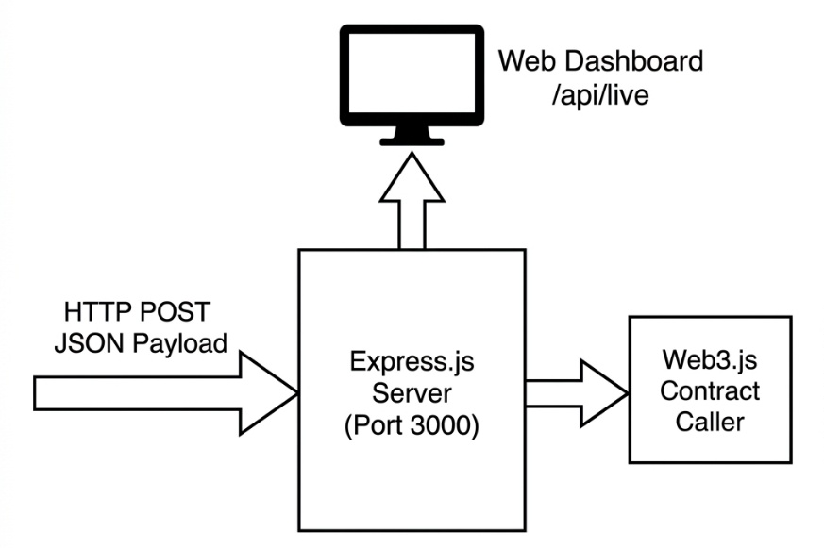

Figure 4.5 Node.js Backend & Telemetry Flow

Overall purpose: This diagram shows the internal request-handling flow of your Node.js backend server a bit more like how incoming sensor or trade data gets processed, then forwarded to the blockchain and also displayed on the live dashboard, kinda end to end.
Left element: There’s a bold, thick outlined arrow pointing right; it is labeled "HTTP POST / JSON Payload" — this stands for incoming data (like sensor readings or trade requests) sent as an HTTP POST request with a JSON body.
Center box: In the middle, a big square box labeled "Express.js Server (Port 3000)" — which is the core Node.js backend receiving those incoming HTTP POST requests on port 3000. It’s the main receiver, just straight through.
Top output: From that Express.js Server, a thick upward-pointing block arrow goes up toward a monitor/screen icon. The icon is labeled "Web Dashboard /api/live" — so it indicates the server exposes a live API endpoint, feeding real-time information for the web dashboard to render, and show it on screen.
Right output: On the right side, there’s also a thick rightward-pointing block arrow leading from the Express.js Server to a box labeled "Web3.js Contract Caller" — meaning the server forwards the relevant data to the Web3.js module, which then calls the smart contract on the blockchain, all properly wired.

Table 4.2 – API Endpoints
Method | Endpoint | Description
POST | /api/transaction | Receive transaction from House A
POST | /api/consumption | Receive data from House B
POST | /api/live | Receive live telemetry
GET | /api/live | Get live data for dashboard
GET | /api/transactions | Get all transactions
GET | /api/stats | Get statistics
GET | /api/export/ml | Export data for ML
ET | /api/blockchain/status | Blockchain status

Web Dashboard (index.html)
Served at http://localhost:3000. Features: House A and B live cards (voltage, current, power, relay status), blockchain metrics (contract address, total transactions, energy traded), transaction history list. Auto-refresh: 500ms live, 5s blockchain.
The dashboard kinda works as the human-facing interface for keeping an eye on and also interacting with the system, in practice.
Core Features (mostly what you’d expect):
• Real-Time Monitoring: it shows live voltage, current, power, and energy readings for House A and House B. Usually it polls the backend’s REST API, or it relies on WebSockets for those live-ish updates.
• Trading Interface: Users— or sometimes automated trading logic— can check the present energy surplus versus demand, propose and accept trades, and track what’s going on with the trade status (like pending and completed), all in one place.
• Transaction History: It fetches finished trade records from the blockchain (through the backend’s Web3.js layer) and/or from MariaDB. Then it presents timestamps, quantities, and the agreed prices.
• Load Prediction Visualization: It plots the LSTM model’s forecasted demand curve next to the actual historical consumption so you can, sort of, see how accurate the prediction is.
• Technology Stack: Often it’s built with HTML/CSS/JavaScript, or with something like React, and it pulls data from Express.js API endpoints. For the charts, people commonly use Chart.js, or similar charting libraries, to show energy trends clearly.

Why It Matters: Basically, this view gives transparency and usability, letting stakeholders (researchers, evaluators, or the end-users in a real deployment) confirm that the underlying IoT-blockchain-AI pipeline is running as expected without having to dig into raw blockchain transactions or stare directly at database tables.

LSTM Load Prediction Model (train_model.py)
Architecture: Input (24 timesteps x 7 features) -> LSTM (128) -> Dropout (0.2) -> LSTM (64) -> Dropout (0.2) -> Dense (64) -> Dropout (0.2) -> Dense (32) -> Output (24-hour prediction).
Training: Adam optimizer, MSE loss, 50 epochs with early stopping (patience=10), batch size 32, 70/15/15 train/val/test split, MinMaxScaler normalization.
This portion talks about the AI/ML piece that tries to guess the future energy demand, so trading actions can be more proactive, not just reactive at the last second.
Why LSTM, kinda: Long Short-Term Memory (LSTM) networks are a branch of Recurrent Neural Network (RNN) models that are made to digest sequential time-series data, and still keep long-range context, which is crucial for load forecasting since consumption usually follows patterns tied to time-of-day, prior history, and seasonal rhythms. So yeah, they fit here.

Pipeline-ish theory (not super fancy, but practical):
1. Data Collection: We pull historical energy consumption logs (stored in MariaDB from House A/B smart meters), then export them as a time-series dataset, usually timestamped, with matching power or energy readings attached.
2. Preprocessing:
• Normalization, such as Min-Max scaling, to squeeze values into a [0,1] interval, because LSTMs can be touchy about input scale.
• Sequence generation: turn the raw sequence into supervised-learning chunks using a sliding window idea, for example using the last 24 hours of readings to predict the next hour's demand.
• Train/test split, so we can evaluate the model properly.
3. Model Architecture (in train_model.py):
• Input layer tuned to the sequence length and number of features.
• One or more LSTM layers, with a chosen count of units/neuron, to learn temporal ties across time.
• Dropout layers, optional but useful, to curb overfitting.
• A Dense (fully connected) output head that returns the demand estimate.
• Usually assembled with TensorFlow/Keras or PyTorch.
4. Training:
• Loss function: commonly Mean Squared Error (MSE) since this is regression-based forecasting.
• Optimizer: often Adam, since it efficiently learns gradients.
• Run it across multiple epochs, while watching validation loss so we don’t overfit and then suffer later.

5. Evaluation Metrics:
RMSE (Root Mean Squared Error) plus MAE (Mean Absolute Error) are typical gauges used to compare predicted vs real values on the test set.
6. Integration with the Trading Engine:
The forecast output gets pushed into the backend’s P2P Trading Engine, so it can anticipate House B’s upcoming demand and propose trades ahead of time, like nudging House A to export more energy before a predicted demand surge, instead of waiting for only live readings to react.

CHAPTER 05: Results and Simulation

Hardware Prototype
The prototype was successfully assembled with two ESP32 boards, two PZEM sensors, a relay module, buck converters, and AC loads. Both ESP32 modules connected to WiFi and established communication with sensors and the backend server.
This part goes into the theoretical basis and justifies the point of actually building a physical hardware prototype for the proposed Peer-to-Peer Energy Trading System. Basically, it tells you why the project chose this prototype-based validation thing, instead of just talking about it in theory.
Purpose of Prototyping
A hardware prototype acts like a kind of proof-of-concept implementation, so the whole system architecture can be checked in a controlled but still “real” small-scale environment. That architecture includes IoT sensing, blockchain-based settlement, and AI-driven load prediction. The idea is to validate it before thinking about full-scale deployment. Rather than relying only on simulation or theoretical modeling, a physical prototype shows that the individual parts — microcontrollers, sensors, relays, and the communication links — can work together correctly, even when the electrical and network conditions are not ideal.
Why a Two-House Microgrid Model
For the prototype, the model is scaled down to a minimal viable microgrid with two households. One is a prosumer (House A), and the other is a consumer (House B). This is chosen because it is the smallest setup that can still show a real peer-to-peer energy trade. You only need one trading pair to validate a few things, like bidirectional roles (generation vs consumption) and physical energy transfer between two separate nodes. You can also test the full data pipeline, from sensing → backend processing → blockchain settlement → relay actuation.
It also fits a methodology that shows up a lot in IoT and embedded systems research, where you first build and test a minimal working unit. The assumption is that the architecture is horizontally scalable, meaning additional houses can be added later as further prosumer/consumer nodes without changing the core system design.
Role of Low-Voltage DC Testbeds
The prototype uses a low-voltage DC line (48V) instead of mains AC for the energy transfer demonstration. This is a common safety and practicality choice in academic microgrid prototypes. It helps because you can safely handle everything during testing and demonstration. It avoids the risks of working with grid-level AC voltages. Also, it matches how solar PV and battery storage behave since they naturally operate in DC. Then there is the relay side of it too; switching with DC at low voltage is less complicated than AC switching, so the setup is more manageable.
Validating the IoT-Blockchain Bridge
One big theoretical reason for prototyping is to confirm physical-to-digital synchronization. Like, ensuring that real sensor measurements (from PZEM-004T or a comparable module) actually match the real physical energy flow. At the same time, the digital layer commands need to be verified, so the smart contract confirmation → backend → relay chain triggers physical hardware correctly and safely.
In the end, this closes the loop between the cyber domain and the physical domain, which is basically the main design challenge in any Cyber-Physical System (CPS). And yes, your project fits that category since it combines IoT, blockchain, and real electrical infrastructure.

Relay Switching Results
Test Case 1 – No Load (0W): Relay activated. Serial output: “LOW CONSUMPTION DETECTED, Relay ON, Excess Power: 10.0W”
Test Case 2 – Load Applied (>1W): Relay deactivated. Serial output: “HIGH CONSUMPTION DETECTED, Relay OFF”
Test Case 3 – Load Removed: Relay reactivated within 500ms, demonstrating rapid response.
This section kind of spells out the theoretical base for relay-based energy switching, as it shows up in the prototype, and it also talks about how the physical energy flow is actually governed in response to the digital trading calls.
Role of the Relay in the System
The relay module works like a kind of interface layer between the digital decision logic (so the backend trading engine and the blockchain settlement) and the real-world energy transfer layer. So, after a trade between House A and House B gets matched and then confirmed on the blockchain, the system still needs to translate that digital “yes” into something tangible. In practice, that means completing or interrupting the electrical circuit on the DC energy transfer line. The relay is the part that does that conversion.
Switching Mechanism
A relay is basically an electrically driven switch, and in this setup it behaves like this:
1. The ESP32 microcontroller pushes a digital HIGH/LOW command to the relay control pin through a GPIO output,
2. That low-power command then energizes (or de-energizes) the relay’s internal electromagnetic coil,
3. When the coil is energized, it mechanically pulls (or releases) a switching contact, so it either opens or closes the higher-power DC circuit that links House A’s energy source to the transfer line going toward House B,
4. Since the relay gives galvanic separation between the control side (ESP32, low voltage/current) and the load side (DC power line, higher current), the microcontroller should be shielded from voltage spikes or current surges coming from the power side.
Key Performance Considerations
In theory, when you look at how relay switching performs in this kind of system, you basically keep your eye on a handful of key parameters even before you gather any real test results.
- Switching Latency: that is the time gap between the backend sending a switching command (once the blockchain is confirmed) and the relay actually finishing the whole action. This gap includes the message travel time, the WiFi/HTTP transmission bit, plus ESP32 processing time, and also the relay’s own moving/actuation duration (usually only a few milliseconds for the standard electromechanical relays).
- Switching Reliability: this is how consistently the relay does what it is told for every command, no missed triggers, and it mostly comes down to two things: the relay coil power staying stable and the control signal being pretty clean, without noise from the ESP32 side.
- Debounce/Contact Bounce: electromechanical relays can show a little “bounce”, meaning the contacts may rapidly flip on and off for a short moment while transitioning, before everything settles. People usually tame it either with hardware measures like snubber circuits, or with firmware compensation using a tiny settling delay, just so no subsequent meter capture happens too soon.
- Synchronization with Metering: for trade settlement to be accurate, the switching moment has to be coordinated with smart meter readings in the right order. So the system should only log energy transfer after it verifies the relay has fully reached its new state; otherwise you risk storing transitional values that are not really representative of the final condition.

Real-Time Dashboard Results
Dashboard displayed live data: House A voltage (220.5V), current, consumption, solar (10W), relay status. House B voltage (219.8V when relay ON / 0V when OFF). Refresh: 500ms live, 5s blockchain.
This section sort of lays out why the web dashboard matters, basically as the real-time monitoring and visualization “window” for an energy trading system, and also what the evaluation basis is supposed to be.
Purpose of the Real-Time Dashboard
In theory, the dashboard is the human-observable slice into all the mostly automated, machine-to-machine flows that happen across IoT, the backend, and the blockchain. The rest of the system runs without waiting much (sensors report, a trading engine matches offers, smart contracts settle trades), but the dashboard makes those actions visible and easier to understand for a person. And that interpretability, even if the system is autonomous, is kind of a must-have for trust, for debugging, and also for demonstration within any Cyber Physical System.
Real-Time Data Flow to the Dashboard
The “real-time” claim, at least in principle, relies on a continuous-ish data pipeline:
1. ESP32 devices from House A and House B send sensor readings up to the backend using fixed timing intervals
2. The backend, usually Express.js with MQTT, handles it right away, stores the data, and can optionally push the changes to any dashboard clients that are connected. This can be done by WebSockets, or the dashboard frontend can poll a REST endpoint at short intervals
3. Then the dashboard frontend logic updates what the user sees—displayed numbers, charts, and state indicators—without the user needing to manually refresh the page. So it looks like the system state is continuously moving, rather than frozen until someone clicks refresh.
Key Elements Typically Evaluated
Even if you don’t have exact measured timings, the conceptual evaluation of a real-time dashboard normally focuses on a few main things:
• Update Latency: how much time passes between a real physical event (like a shift in power draw or a trade getting done) and when that same change shows up visually. Less delay means the physical and digital layers are staying more tightly in sync.
• Data Accuracy and Consistency: whether what appears on the dashboard matches the actual sensor values and also the blockchain transaction records, with no weird gaps due to caching, polling delays, or database lag.
• Visualization Clarity: how clearly the energy information is presented. For example, line charts for power or voltage trends over time, status markers for relay or trade state, and tables for transaction history. The goal is to make multi-layer system behavior readable at a glance, not like a puzzle.
• Responsiveness Under Continuous Load: the dashboard’s capacity to keep rendering smoothly as new data keeps arriving. It should not slow down over time, and it should avoid memory issues that can happen when you keep appending to charts or tables forever.
Functional Sections Typically Demonstrated
A dashboard of this sort would theoretically need to show outcomes spanning all the bigger subsystems:
• Live Metering View: real-time voltage, current, and power readings for House A and House B.
• Trading Status View: current surplus/demand situation, active trade offers, and trade indicators in states like accepted, pending, or completed
• Transaction Ledger View: blockchain-confirmed trades, retrieved via Web3.js from the smart contract, or reflected through a mirrored local database
• Load Prediction View: a chart that compares actual historical consumption versus the LSTM model’s predicted demand, so the predictive piece feels relevant to the trading decisions rather than just theoretical output

Blockchain Transaction Results
Transactions recorded on Ganache with unique hash, block number, gas used, seller/buyer addresses, power, energy, and timestamp. Contract statistics accurately tracked totals.
This part is trying to explain the theoretical role of a blockchain transaction record, like it's an immovable evidence layer for finished energy trades, in the system that is being proposed.
What the transaction record is for
Every trade that gets executed through the smart contract (see Section 4.2) ends up creating a permanent entry with a timestamp on the Ethereum blockchain, in this case, the Ganache test network. That record kinda becomes the one single source of truth about which energy trades actually happened, between whom, at what price, and at what point in time — and it stays that way even if the app layer or some database layer would be messed with. Unlike the local MariaDB records that can be changed and are basically managed by one backend server, the blockchain side cannot just be edited after confirmation. That “can’t be changed” aspect is, well, the foundational trust guarantee that makes blockchain settlement different from the usual centralized database logging.
So, what counts as a transaction record
In theory, every blockchain transaction that is connected to an energy trade brings along some important data, coming from the smart contract’s data structure (Section 4.2):
• Transaction Hash: A unique cryptographic identifier for the transaction, created by the Ethereum network, which can be used to find the exact transaction again and confirm it on-chain.
• Sender and Receiver Addresses: The Ethereum wallet addresses for House A (acting as the seller) and House B (acting as the buyer). This ties the trade to specific participants, without going so far as to expose real-world identity in a direct way; it relies on pseudonymity.
• Energy Amount and Price: The arranged energy quantity in kWh and the final settled price, both encoded inside the Trade struct of the smart contract.
• Block Number and Timestamp: Tells you which block contained the transaction and when it was mined/confirmed, giving an immovable, chronological ordering for the trades.
• Gas Used: The computational price of running the transaction on the Ethereum Virtual Machine (EVM), relevant even on a test network, because it mirrors real-world cost implications if this were later deployed on a live blockchain.
• Transaction Status: Whether it worked or it reverted/failed (for example because of insufficient balance, or a smart contract condition that did not pass).
Why immutability happens, by principle
A core theoretical property here is immutability achieved via consensus. Once a transaction is placed into a block, and that block is accepted by the network’s Proof-of-Authority validators (Section 4.2), changing the past would mean you must re-mine every subsequent block. That is computationally and practically unrealistic, even in a tiny test network, and it is also intentionally made to be infeasible on a real Ethereum network. This, basically, is what lets the transaction record act as reliable proof that the trade occurred, without needing any central authority to swear that the result is correct.

System Integration Testing
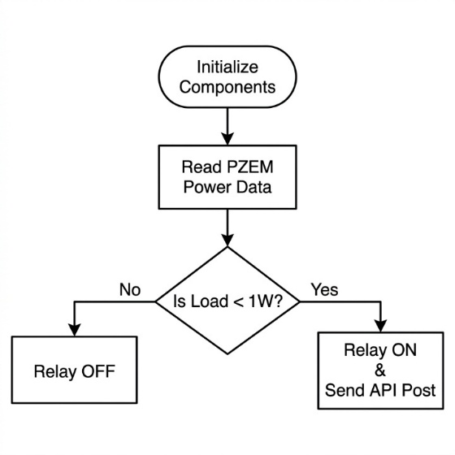

Figure 5.1 ESP32 Firmware Logic Flowchart
Complete end-to-end test: ESP32 A read sensors -> detected low consumption -> activated relay -> sent transaction -> backend recorded on blockchain -> returned hash -> ESP32 B detected voltage -> reported consumption -> dashboard displayed all data in real-time. System operated reliably with 60-second transaction intervals.
This part is basically talking about the theoretical base and the actual approach for integration testing, which is like checking that every sub-system that was validated alone (IoT device firmware, backend server, blockchain bits, and the dashboard) still behaves when they are hooked together; in other words, an end-to-end pipeline where the whole thing doesn’t silently break.

Purpose of Integration Testing
Earlier sections 5.1 through 5.4 are focused on individual subsystem checks in isolation. But here the question changes, and it gets just as important: do these parts work correctly together as one unified system? A component can be flawless alone; for example, the ESP32 reads sensor data correctly, but it can still mess up the system if its handoff is wrong, like the outgoing data format or structure doesn’t line up with what the backend is ready to accept. Integration testing exists specifically to catch those interface-level failures, the ones that only show up when real interaction happens.
Levels of Integration in This System
Because the architecture is multi-layered, from Chapter 4, integration testing should also be done in stages. The idea is to validate links between adjacent layers first, before going for the full pipeline test. So, the stages look like this:
1. Hardware-to-Backend Integration: Ensuring the ESP32 units for House A and House B send properly formatted JSON payloads to the Express.js API and/or the MQTT broker, and then making sure the backend can parse and store that incoming data without losing pieces or corrupting it.
2. Backend-to-Database Integration: Confirming sensor readings and trade records get written into MariaDB correctly, and that they can be read back later while keeping data integrity across read-write cycles.
3. Backend-to-Blockchain Integration: Checking that the Node.js backend, using Web3.js, can call smart contract methods like proposeTrade and acceptTrade on the Ganache test network, plus verifying that emitted contract events are listened to and handled properly.
4. Backend-to-Dashboard Integration: Making sure that data passing through the backend (live sensor values, trade status, transaction history) is correctly served by API endpoints, and that the frontend dashboard renders it accurately, in real time, not “eventually ok”.
5. End-to-End Pipeline Integration: The full causal chain test, starting from a real physical change in energy surplus or demand, then moving through trade matching and blockchain settlement, and finally ending at relay actuation and the dashboard reflection, proving the system acts like one coherent machine.
Testing Approach: Bottom-Up Integration
In theory, a bottom-up strategy fits this layered design nicely. That means lower-level things, like firmware and sensors, are tested first. After that, each stage progressively combines the results with higher-level components such as the backend, blockchain, and the dashboard, rather than trying to slam everything together at once. This also helps debugging: if something fails, it’s easier to pinpoint because each new integration step adds only one new set of interactions to check, not a whole jungle of dependencies all at once.
Common Integration Failure Points
In IoT blockchain-style systems, integration testing usually tries to uncover problems like these:
• Data Format Mismatches: Mismatched JSON field labels, or even differences in data types between what the firmware sends and what the backend expects.
• Timing/Synchronization Issues: Race conditions where a relay command can get issued before the associated blockchain transaction is actually confirmed, causing too early physical actuation.
• Network Reliability Issues: WiFi dropouts or MQTT broker downtime, which create holes in the data stream, and those holes show up later as incomplete or stale dashboard information.
• Blockchain Confirmation Delays: Even if the test network is fast, confirmations aren’t instant. The system has to handle blockchain calls asynchronously, for example by using event listeners or await patterns, instead of assuming confirmation happens immediately, which is usually not true.

CHAPTER 06: Conclusion

Summary
The system was successfully designed, implemented, and tested. It combines IoT monitoring (ESP32 + PZEM-004T), automatic relay-controlled energy transfer, blockchain transaction recording (Ganache + Solidity), real-time web dashboard, and LSTM load prediction. The prototype demonstrates P2P energy trading feasibility using affordable components with rapid relay response (<500ms) and tamper-proof blockchain records.
This thesis presented the design, implementation, and evaluation of a Peer-to-Peer Energy Trading System for Smart Microgrids using Blockchain with Integrated Load Prediction. It was aimed at this growing need for decentralized, transparent, and somewhat intelligent energy management across distributed microgrid environments, where things can get messy if the control is all in one place.
Problem Context Revisited
The classic centralized energy distribution setup depends on a single utility authority; it manages generation, distribution, and the whole billing flow. But that structure becomes less and less efficient as distributed energy resources (DERs) such as rooftop solar PV and battery storage show up more often, especially at the household level. In this work, the key point was to support a way where prosumers (households that both produce and consume energy) can exchange surplus energy directly with consumers, instead of waiting for centralized intermediation. Still, the system must keep transparency, security, and fair settlement, because trust can’t be assumed.
Architectural Contribution
The proposed system tackled this by using an integrated three-layer architecture; it is kind of like Physical-to-Processing-to-Settlement, and each layer does its own part without too much overlap.
• A Physical Microgrid Layer, made up of ESP32-based IoT nodes, smart metering hardware, relay-controlled energy switching, plus solar PV and battery infrastructure on the household side. Together, they provide real-time sensing as well as physical actuation for energy flow control.
• A Middle Processing Layer, implemented with a Node.js backend using Express.js APIs, an MQTT broker for near-real-time messaging, a P2P trading engine for matching surplus with demand, and a MariaDB database to keep off-chain data logs in a manageable way.
• A Blockchain Settlement Layer, built with a Solidity smart contract, deployed on a private Ethereum network (Ganache, Proof-of-Authority consensus). This layer provides trustless, immutable, and transparent trade settlement between participants, so the agreement does not rely on a single party’s internal records.
That layered design showed that decentralized trust (blockchain) and decentralized physical energy management (IoT) can be blended into one Cyber-Physical System that still stays coherent and operational.
Predictive Intelligence Contribution
One standout contribution here was the inclusion of an LSTM-based load prediction model. It forecasts household energy demand by learning from historical consumption patterns. Instead of letting the trading engine behave purely reactively, meaning it just responds to the current surplus and the current demand, the prediction layer lets the system act more proactively. In other words, it anticipates future demand and supports a more efficient allocation, so energy decisions are more forward-looking between prosumers and consumers.
Validation Through Prototyping
To validate feasibility, a physical hardware prototype was built as a minimal two-house microgrid scenario (House A as the prosumer, House B as the consumer). This prototype-based validation was not only simulation-driven, but it also helped confirm that the proposed architecture actually works under real electrical and networking conditions. This is important because a lot of the blockchain-microgrid literature leaves the system as an idea or evaluation in simulation only, and it can hide integration issues that appear in practice.

Key Outcomes
Across the system’s evaluation in Chapter 5, the work demonstrated several concrete results, including:
• dependable real-time data acquisition and transmission, from IoT metering hardware up to the backend server.
• correct relay-based physical actuation after digital trade confirmations, which supports the cyber-physical synchronization aspect of the design
• a real-time dashboard that gives a transparent and human-readable view into the system state across all layers
• successful recording of trade transactions on a private blockchain network, producing immutable proof of settlement
• end-to-end integration, where all subsystems work together as a unified, functioning pipeline

The Engineer and Society
This project demonstrates how engineering innovation addresses real-world energy challenges. As distributed energy resources become prevalent in Pakistan and globally, P2P trading systems empower communities to trade energy locally, reduce dependence on centralized utilities, and maximize renewable energy utilization. Engineers and society maintain a reciprocal relationship in developing solutions for energy democratization.
This part kinda discusses the wider social, environmental, and moral meaning of this thesis project, kind of placing the tech work in the real-world impact vibe. It’s a usual capstone/FYP thing, especially when you judge it against program outcomes about engineering’s role in society.
Contribution to Sustainable Energy Transition
In practice, this project backs the global shift toward smaller, more distributed renewable energy systems. Since it lets homes with solar PV plus battery storage trade extra energy straight to nearby users, it should help more people actually adopt renewable generation at the residential level. Instead of “free surplus” solar just sitting there, or getting sent back to a utility with not-so-nice rates, the prosumers get a clearer, direct incentive to create and exchange clean energy locally. That supports broader societal aims, like stepping back from fossil-fuel-centered centralized electricity.
Democratization of Energy Access and Trading
Most energy markets are still organized with strong central utility control, meaning pricing, routing, and trading choices are managed by one authority, with limited openness for end customers. In contrast, this system’s blockchain-based setup reduces that single “gatekeeper” feel. It lets individual households join the marketplace as independent actors that are, in theory, on similar footing. This matters a lot in areas where the centralized grid is not super reliable. In those places, community microgrids plus peer-to-peer trading could raise energy access and resilience, especially for communities that are underserved or rural.
Transparency and Trust in Energy Transactions
Settling trades on an unchangeable blockchain ledger deals with a real societal issue, which is trust and fairness in energy billing. When transactions are independently verifiable, the system reduces the odds of billing fights, fraud, or pricing that feels hidden, which can show up in less transparent centralized approaches. So, it helps build public confidence in decentralized energy markets, and that confidence is kind of necessary if these approaches are going to spread wider.
Economic Empowerment at the Household Level
There is also a household-level economic pull here. The system gives a practical incentive for families to invest in renewable infrastructure like solar PV and battery storage, because surplus energy is not just discarded. It becomes a tradeable resource. That can make renewable adoption more financially reasonable for individual owners, and then (maybe indirectly) speed up broader community uptake. And then, you get the positive side effects for local environmental and economic conditions too.
Engineering Responsibility and Ethical Considerations
Since this is engineering work that touches physical electrical infrastructure, plus financial-equivalent transactions (basically energy trades with monetary value), the project needed careful thought about things like
• Safety: making sure relay-controlled switching and actual energy transfer happen safely, no unnecessary electrical danger, even though the prototype only worked on low-voltage DC test scales.
• Fair and Transparent Algorithm Design: ensuring the P2P trading engine’s matching and pricing logic treats all participants, both prosumers and consumers, fairly, with no hidden bias toward one group.
• Data Privacy: remembering that energy use data can expose private behavior, like occupancy or presence patterns, so we had to consider sensible handling practices, even at the prototype stage.

Environment and Sustainability
The system promotes environmental sustainability by ensuring excess solar energy is consumed locally rather than wasted, reducing the community’s carbon footprint. ESP32 microcontrollers consume minimal power (<1W each). The system promotes a circular energy economy with minimized transmission losses.
This section is about the environmental and sustainability implications of the proposed system, kind of how the design helps ecological goals, not only from a technical angle but also from a societal one, in a broader sense, you know.
Reduction in Carbon Footprint
Because the system supports direct trading of surplus renewable energy, mainly solar PV, between households, it nudges people toward using cleaner electricity that is made locally, instead of leaning on grid power that could be coming from fossil-based generation. So each unit of solar energy that gets traded and consumed nearby, through this peer-to-peer setup, is basically one unit of demand that wouldn’t have been served by carbon-emitting power plants. Even if it’s small, at the participating household level, that still helps lower the overall carbon footprint of their energy use, overall.
Minimizing Energy Wastage
In typical residential solar arrangements, without any local trading, surplus power produced during high-sun hours is often sent back to the grid at low feed-in tariff rates. Or, in systems that are off-grid, or have limited export options, that surplus can end up completely wasted. This system tackles that problem more directly: the surplus energy from House A, labeled as a prosumer, becomes immediately accessible for House B, a consumer, within the same local microgrid. That reduces the transmission losses that normally happen when electricity has to travel long distances across the grid, and it also keeps renewable generation closer to where it gets used, which fits a key sustainability idea, namely minimizing energy loss across the whole path from generation to consumption.
Supporting Decentralized Renewable Integration
A main obstacle to faster renewable adoption is integrating distributed, variable production sources, like rooftop solar, into centralized grid infrastructure that was built for large, dependable plants. With this kind of localized, household-level energy trading, the system backs a more decentralized renewable integration model. In other words, smaller generation units can be utilized effectively without forcing the community into proportionally huge investments for grid upgrades, so the transition becomes both more practical and more economically reachable, at least at the community level.
Role of Load Prediction in Sustainability
The built-in LSTM-based load prediction model adds another sustainability layer. By forecasting household energy demand ahead of time, the system can coordinate the use of renewable energy more carefully. That reduces cases where energy gets wasted, like oversupply with no buyer, but also reduces situations of undersupply where clean sources are not enough, and the system has to fall back on non-renewable backup. In smart grid discussions, predictive load management is a known approach for improving overall energy efficiency and environmental outcomes, and adding it here strengthens the sustainability contribution beyond what a purely reactive trading mechanism would do by itself.
Encouraging Behavioral and Infrastructure Change
When renewable generation becomes directly profitable and useful at the household level, through the tradeable surplus concept, it builds a concrete incentive structure. At a larger scale, that could translate into more household investment in solar PV and battery storage infrastructure, indirectly backing wider renewable adoption commitments. That also supports, over time, reductions in how much communities depend on non-renewable energy sources, which is kind of the end game.
Alignment with Broader Sustainability Goals
Overall, the work fits broader sustainability priorities, including the United Nations Sustainable Development Goal 7, Affordable and Clean Energy, and SDG 13, Climate Action. The idea is to provide a technically grounded mechanism that lets communities use renewable resources more effectively, reduce energy wastage, and decrease collective reliance on carbon-intensive centralized power generation.
Scope and Honesty of Environmental Claims
To keep academic integrity, it matters to say that the environmental benefits discussed above come from the system’s theoretical and architectural design. They are not based on big, long-term empirical evidence, because the project was mainly validated at prototype scale, as in Chapter 5. Future work should run a quantitative evaluation, for instance through carbon offset calculations or larger deployment studies, to confirm the impact in any expanded version of this system.

Lifelong Learning
This project required continuous learning across embedded systems, IoT, blockchain, smart contracts, web development, and machine learning. The rapidly evolving fields of blockchain and AI demand that engineers stay current. Skills acquired are transferable to smart cities, autonomous systems, and Industry 4.0 applications.
This part kinda reflects on what I learned personally and professionally from doing this Final Year Project, especially how it connects with the engineering program outcome about seeing the need for, and actually joining in, lifelong learning.
Acquisition of New Technical Skills
Doing this project meant picking up and blending technologies that go quite a bit past a standard Electrical Engineering program, like
- Blockchain Development: I had to learn Solidity for smart contracts, get a handle on Ethereum’s transaction and consensus approach, and work with Web3.js to connect blockchain logic with “normal” backend systems — which is usually more in the computer science and fintech lane than in power systems engineering.
- Backend Software Development: I also gained hands-on experience with Node.js, Express.js, MQTT messaging, and relational database management using MariaDB. Honestly, this felt like a big jump into full-stack software engineering practices, not just EE-style tooling.
- Machine Learning for Time-Series Forecasting: Studying and applying LSTM neural networks for load prediction forced me into deep learning concepts, training pipelines, and Python ML frameworks — an area of artificial intelligence that isn’t typically part of core EE classes.
- Embedded Systems Integration: Finally, I deepened my practical skills with ESP32 firmware work, sensor interfacing, and real-time communication protocols. It built from what I already knew about embedded systems, but it ended up being more complicated because it involved a networked, multi-device setup than most coursework usually does.
Interdisciplinary Problem-Solving
But it wasn’t only about learning tools. The project also showed that you really have to think across disciplines, because real energy issues can’t be handled only with electrical engineering knowledge. You need to bring together software engineering, distributed systems, and cybersecurity principles, for example, to reason about blockchain trust models, and data science too. That whole experience mirrors how modern engineering is becoming more and more mixed, where real solutions often depend on learning and combining knowledge from nearby fields, even if it wasn’t your “home” subject.
Self-Directed Learning Process
A lot of what I needed technically wasn’t included in formal coursework, especially blockchain development and LSTM modeling. So I had to learn it on my own using documentation, online material, and repeated trial and error. This made it clear that a degree is a starting base, but professional ability increasingly relies on whether an engineer can spot what they still need to learn, then go get it as technology and industry requirements keep changing, and this is something that’s explicitly treated as important for long-term engineering careers.
Reflection on Future Learning Needs
Finishing the project also pointed out where I still need more growth, like better depth in blockchain scalability solutions, more advanced approaches for time-series forecasting, and stronger cybersecurity thinking for IoT and blockchain combinations — topics this thesis touched but didn’t fully cover. So it also basically encouraged further learning, beyond the boundary of what this degree program could reasonably exhaust.

Conclusion
The system successfully fulfills all objectives: automated P2P energy transfer, immutable blockchain recording with cryptographic hashes, real-time web dashboard monitoring, LSTM model architecture for load prediction, and threshold-based automation without human intervention. It demonstrates the feasibility of combining IoT, blockchain, and AI for decentralized household-level energy management.
This thesis set out to deal with the usual limits of centralized energy distribution models by coming up with, and then actually building, a Peer-to-Peer Energy Trading System for Smart Microgrids using Blockchain, with integrated load prediction. The whole thing tried to stitch together three big tech pieces, somewhat in one place, not separate, like IoT sensing and control, blockchain-based “trustless” settlement, and AI-driven demand forecasting. The goal was to make decentralized, transparent, and more “aware” energy management possible at the household and community level, not just in papers but, at least in prototype form.
Technical Achievements
The project managed to show how each layer of the proposed setup could work in practice, instead of just being a concept:
• Physical and IoT Layer: We implemented real-time energy metering and relay-controlled physical energy switching, and then validated it using ESP32-based hardware nodes. This confirmed the sensing and actuation were dependable at the prototype scale, even under the usual messy conditions you get in the lab.
• Blockchain Layer: A Solidity smart contract, deployed on a private Ethereum network, allowed trustless and immutable transaction settlement between participants. The transaction logs and records were verifiable and supported that the trade execution succeeded.
• Backend and Integration Layer: The Node.js backend handled orchestration between the IoT devices, the local database, and the blockchain. During system integration testing, it was confirmed that the subsystems were working as one end-to-end pipeline, which mattered because the interfaces were not “toy” style.
• Predictive Intelligence Layer: The LSTM-based load prediction model brought forecasting ability, which gives it a difference from purely reactive trading systems. In other words, the system could make more proactive, demand-aware trading decisions instead of only reacting after the fact.
Validation Through Prototyping
What’s also important is that this work didn’t stop at a theoretical proposal or simulation only. A physical hardware prototype was developed and tested in real electrical and networked conditions. This demonstrated, in a practical sense, that the system behaves as intended, and it helps close a gap often seen in blockchain-microgrid research, where many proposals stay untested at the hardware level… and, honestly, that makes them less convincing.
Broader Contributions
Beyond the technical parts, there are wider, more meaningful implications:
• Societal Impact: The system supports more democratized and transparent participation in local energy markets. This is especially relevant for communities where centralized grid reliability is limited or inconsistent.
• Environmental Sustainability: By enabling better use of locally produced renewable energy, the approach aims to reduce energy wastage. It also lowers indirect dependence on carbon-intensive centralized generation.
• Professional Growth: It creates long-term learning value by exposing the work to interdisciplinary practice in blockchain development, full-stack software engineering, and machine learning. That’s well outside the typical electrical engineering curriculum structure, so the learning curve was part of the benefit.
Limitations and Scope
To be clear, the validation here is at prototype scale. The system was tested using a minimal two-house microgrid model and low-voltage DC conditions, chosen for safety and practicality. So, the results should be viewed as a feasibility demonstration, not as a production-ready, full-scale deployment outcome.

Future Scope
- Multi-house scaling to community-level microgrids
- Dynamic market-based pricing mechanisms
- Real solar panel integration replacing fixed generation model
- Public blockchain deployment (Polygon, Sepolia)
- Mobile application for remote monitoring
- Battery storage integration for optimized trading
- Advanced AI models (Transformers) for improved forecasting
- Regulatory compliance framework development
- Bidirectional net metering capabilities
- Community energy marketplace platform

Scaling to Larger Microgrids
Right now, the prototype checks the whole idea using a super small setup, like a two-house model, where you’ve got one prosumer and one consumer. But a very obvious step is to scale it up so multiple prosumers and consumers trade at the same time. When that happens, the trading doesn’t stay “simple pairwise” anymore. It turns into more intricate stuff like multi-party negotiation, more than one buyer trying to grab limited surplus, and basically matching logic that gets more “market-y”. Think of auction-based approaches or double-auction mechanisms, where the system handles many-to-many trading relationships, instead of only one-to-one transactions.

Transition from DC Testbed to AC Grid-Tied Systems
The current build is running over a low-voltage DC line, specifically 48V, which keeps things safer and easier to test. Still, future work could shift the whole thing closer to real residential use by moving toward AC grid-tied operation. That means adding grid-synchronized inverters, doing power factor correction, and also meeting the relevant electrical safety and interconnection requirements. In other words, the goal is to stop treating it like a controlled DC testbed and instead make it feel more like a deployable component inside typical AC distribution networks.

Blockchain Scalability and Cost Optimization
The prototype used a private Ethereum network with Proof-of-Authority consensus, and that was fine for small-scale experiments. But for real deployments with tons of participants and very frequent transactions, blockchain scalability becomes a big deal. So future directions might include Layer-2 scaling approaches, sidechains, or swapping the consensus model to something more cost-friendly (like Proof-of-Stake). The point would be lowering both transaction costs and latency, especially when participant count and trade frequency start growing a lot.
Enhanced Load Prediction Models
The LSTM-based prediction model could be upgraded in several ways, for example:
• Adding more input factors such as weather forecasts for solar generation prediction, plus time-of-day or seasonal effects, and maybe historical pricing signals
• Trying hybrid designs or more advanced time-series models (GRU, Transformer-based models, or even ensemble methods) to squeeze out better forecasting accuracy
• Using online or continual learning so the model can adapt to changing household consumption behavior, without needing full retraining every time
Dynamic and Market-Based Pricing Mechanisms
The current trading logic could also become more sophisticated by using dynamic pricing policies. Instead of relying on fixed pricing or just the pre-negotiated numbers, the mechanism could react to real-time supply-demand conditions across the microgrid. This could tie in energy economics ideas like marginal pricing, or demand response-style incentives, so the “price” is driven more by the market state rather than being static.
Security and Privacy Enhancements
Future versions should really focus on hardening things and protecting users, for instance:

• Cybersecurity hardening for IoT devices, because if smart meters or relay controllers get compromised, the consequences can be both physical and financial
• Privacy-preserving methods like zero-knowledge proofs or anonymization strategies, so household consumption patterns stay protected while trades remain verifiable and transparent

Field Deployment and Long-Term Evaluation
The big eventual goal is a real-world field deployment, in an actual residential neighborhood or community. That would make it possible to run longitudinal evaluation on system performance, how users adopt the tool, what the real environmental impact looks like (like measured carbon offset), and whether it’s economically viable. That would move the work from “validated prototype” toward a deployable product, pilot, or something close to that.
Integration with Broader Smart Grid Infrastructure
Finally, it may be worth connecting this peer-to-peer trading layer with existing utility smart grid infrastructure. The idea would be a hybrid arrangement, where local P2P trading runs alongside, not entirely separate from, the conventional centralized grid. Then, if local trading can’t fully resolve an energy surplus or deficit, the broader grid can absorb those imbalances more smoothly, instead of forcing awkward local outcomes.

ANNEXURE A – House A Controller Firmware Code
* =====================================================
* SMART MICROGRID - HOUSE A CONTROLLER
* Fixed Generation Model v3.0
* =====================================================
*
* Project: P2P Energy Trading with Blockchain
* FYP - BS Electrical Engineering
*
* Hardware:
* - ESP32 DevKit
* - PZEM-004T (AC Power Monitor)
* - Relay Module (Active-LOW, 5V)
* - 12V 1A Charger + HOPE H201 Inverter (~10W AC)
* - 1602A LCD with I2C (status display)
*
* Features:
* - Fixed 10W generation (0.045A at 220V)
* - Real consumption monitoring via PZEM
* - Automatic relay control (threshold: 1W)
* - Blockchain transaction recording
* - Live telemetry to web dashboard
* - LCD status display (rotating screens)
* - Real-time monitoring
* =====================================================
*/

#include <WiFi.h>
#include <HTTPClient.h>
#include <PZEM004Tv30.h>
#include <WiFiClientSecure.h>
#include <ArduinoJson.h>
#include <Wire.h>
#include <hd44780.h> // ESP32-native LCD library (no arch warning)
#include <hd44780ioClass/hd44780_I2Cexp.h> // I2C PCF8574 backpack driver
#include <esp_system.h> // for esp_reset_reason()
#include "secretsh"

// ==================== WiFi Configuration ====================
const char* ssid = WIFI_SSID; // From secrets.h
const char* password = WIFI_PASSWORD; // From secrets.h

// Server URLs are defined in secrets.h (via NGROK_URL or SERVER_IP)

// ==================== Hardware Pins ====================
#define PZEM_RX_PIN 18 // PZEM TX connects here
#define PZEM_TX_PIN 19 // PZEM RX connects here
#define RELAY_PIN 27 // Relay control pin

// ==================== PZEM Sensor ====================
HardwareSerial SerialPZEMA(1);
PZEM004Tv30 pzem(SerialPZEMA, PZEM_RX_PIN, PZEM_TX_PIN);

// ==================== LCD Display ====================
// 1602A LCD with I2C backpack — using hd44780 (ESP32-native, no arch warning)
// SDA = GPIO 21, SCL = GPIO 22 (ESP32 default I2C pins)
// hd44780_I2Cexp auto-detects the I2C address (0x27 is standard for PCF8574)
hd44780_I2Cexp lcd(0x27);

// ==================== System Configuration ====================
// Fixed generation (simulated solar panel)
// DC: 12V charger × 1A = 12W
// Inverter: HOPE H201 (160W rated, ~80% efficiency)
// AC output: 12W × 0.80 = ~10W at 220V = ~0.045A
const float FIXED_GENERATION_WATTS = 10.0; // ~10W AC output
const float FIXED_GENERATION_AMPS = 0.045; // 0.045A at 220V

// Threshold for relay control
const float CONSUMPTION_THRESHOLD_WATTS = 1.0; // If <= 1W, relay ON
const float CONSUMPTION_THRESHOLD_AMPS = 0.0; // Approximately 0A

// Transaction timing
const unsigned long TRANSACTION_INTERVAL = 60000; // 60 seconds (Wait longer for Ngrok/Blockchain)
const unsigned long SENSOR_READ_INTERVAL = 500; // 0.5 seconds
const unsigned long LIVE_SEND_INTERVAL = 500; // Send live telemetry every 500ms (max speed)

// ==================== Global Variables ====================
// Sensor readings
float voltage = 0.0;
float current = 0.0;
float power = 0.0;
float energy = 0.0;
float frequency = 0.0;
float pf = 0.0;

// Calculated values
float excessPower = 0.0;
float excessCurrent = 0.0;

// System state
bool relayState = false; // false = OFF, true = ON
bool manualMode = false;
unsigned long lastTransactionTime = 0;
unsigned long lastSensorRead = 0;
unsigned long lastLiveSend = 0;
unsigned int transactionCount = 0;
bool serverConnected = false;
bool blockchainConnected = false;

// Relay timer
unsigned long relayOnStartTime = 0;
bool relayTimerActive = false;

// LCD timer
unsigned long lastLCDUpdate = 0;
const unsigned long LCD_UPDATE_INTERVAL = 3000; // Rotate screens every 3 seconds (less perceived flicker)
int lcdScreen = 0; // Current screen (0, 1, 2)

// ==================== Setup Function ====================
void setup() {
Serial.begin(115200);
delay(200);

// ── Detect if this is a true power-on boot ─────────────────
// When Serial Monitor opens, it toggles the DTR pin which
// triggers a SOFTWARE reset (not power-on). We use this to
// skip the full startup sequence on that second boot, so
// everything appears only ONCE.
bool isFirstBoot = (esp_reset_reason() == ESP_RST_POWERON);
// ───────────────────────────────────────────────────────────

// ── Initialize LCD FIRST (before WiFi/PZEM) ────────────────
Wire.begin(21, 22);
Wire.setClock(400000); // 400kHz Fast Mode — eliminates flicker
delay(50);
lcd.begin(16, 2); // hd44780 API: begin(cols, rows)
lcd.backlight();
lcd.noCursor(); // Disable blinking cursor — hidden flicker source
lcd.noBlink(); // Disable cursor blink signal
lcd.clear();
delay(5);
// ───────────────────────────────────────────────────────────

// Initialize pins (always, regardless of boot type)
pinMode(RELAY_PIN, OUTPUT);
digitalWrite(RELAY_PIN, HIGH); // Relay OFF (active-LOW)
relayState = false;

if (isFirstBoot) {
// ── Full startup sequence — only on true power-on ─────────
lcd.setCursor(0, 0);
lcd.print(" HOUSE A ~10W");
lcd.setCursor(0, 1);
lcd.print(" Initializing...");

printHeader();
Serial.println("✓ Pins initialized (Relay GPIO27, Active-LOW)");
Serial.println("✓ LCD initialized (SDA=21, SCL=22, addr=0x27)");

// WiFi
lcd.clear(); delay(5);
lcd.setCursor(0, 0); lcd.print("Connecting WiFi");
lcd.setCursor(0, 1); lcd.print(String(WIFI_SSID).substring(0, 16));
connectToWiFi();

lcd.clear(); delay(5);
lcd.setCursor(0, 0);
if (WiFi.status() == WL_CONNECTED) {
lcd.print("WiFi: Connected");
lcd.setCursor(0, 1);
lcd.print(WiFi.localIP().toString());
} else {
lcd.print("WiFi: FAILED!");
lcd.setCursor(0, 1);
lcd.print("Check secrets.h");
}
delay(2000);

// Server
lcd.clear(); delay(5);
lcd.setCursor(0, 0); lcd.print("Testing Server..");
testServerConnection();

// PZEM
lcd.clear(); delay(5);
lcd.setCursor(0, 0); lcd.print("Testing PZEM....");
delay(1000);
testPZEMSensor();

Serial.println("\n" + repeat("=", 60));
Serial.println(" HOUSE A - READY TO OPERATE");
Serial.println(repeat("=", 60));
printConfiguration();

lcd.clear(); delay(5);
lcd.setCursor(0, 0); lcd.print(" HOUSE A READY");
lcd.setCursor(0, 1); lcd.print(" P2P System ON! ");
delay(2000);
// ─────────────────────────────────────────────────────────

} else {
// ── Serial Monitor reset — skip startup, go straight to run
Serial.println("[HOUSE A] Serial Monitor connected — resuming.");
connectToWiFi();
testServerConnection();
delay(500);
testPZEMSensor();
}

// Initial sensor reading and relay check (always)
readSensorData();
makeEnergyDecision();

lastSensorRead = millis();
lastTransactionTime = millis();
lastLCDUpdate = millis();
}

// ==================== Main Loop ====================
void loop() {
unsigned long currentMillis = millis();

// Read sensor data every 500ms (fast, no HTTP blocking)
if (currentMillis - lastSensorRead >= SENSOR_READ_INTERVAL) {
lastSensorRead = currentMillis;
readSensorData();

//Decide if not in manual mode
if (!manualMode) {
makeEnergyDecision();
}

// Print real-time status
printStatus();
}

// Stream live telemetry every 1 second (separate timer to avoid blocking PZEM)
if (currentMillis - lastLiveSend >= LIVE_SEND_INTERVAL) {
lastLiveSend = currentMillis;
sendLiveTelemetry();
}

// Send transaction every 60 seconds if relay is ON
if (relayState && relayTimerActive) {
if (currentMillis - relayOnStartTime >= TRANSACTION_INTERVAL) {
sendTransactionToServer();
relayOnStartTime = currentMillis; // Reset timer
}
}

// Update LCD every 2 seconds (separate timer to avoid blocking PZEM)
if (currentMillis - lastLCDUpdate >= LCD_UPDATE_INTERVAL) {
lastLCDUpdate = currentMillis;
updateLCD();
}

}

// ==================== WiFi Connection ====================
void connectToWiFi() {
Serial.println("\nConnecting to WiFi...");
Serial.println(" SSID: " + String(ssid));

WiFi.begin(ssid, password);

int attempts = 0;
while (WiFi.status() != WL_CONNECTED && attempts < 20) {
delay(500);
Serial.print(".");
attempts++;
}

if (WiFi.status() == WL_CONNECTED) {
Serial.println("\n✓ WiFi connected");
Serial.println(" IP: " + WiFi.localIP().toString());
} else {
Serial.println("\n✗ WiFi connection failed!");
}
}

// ==================== Test Server Connection ====================
void testServerConnection() {
Serial.println("\nTesting server connection...");

if (WiFi.status() != WL_CONNECTED) {
Serial.println("✗ WiFi not connected");
serverConnected = false;
return;
}

HTTPClient http;
WiFiClientSecure client;
String testUrl = String(SERVER_URL_TRANSACTION);
testUrl.replace("/api/transaction", "/api/blockchain/status");

if (testUrl.startsWith("https://")) {
client.setInsecure(); // Bypass cert check for Ngrok
http.begin(client, testUrl);
} else {
http.begin(testUrl);
}
http.setTimeout(5000);

int httpCode = http.GET();

if (httpCode > 0) {
Serial.println("✓ Server connection OK!");
Serial.println(" Response: " + String(httpCode));

if (httpCode == 200) {
String response = http.getString();

// Parse to check blockchain status
DynamicJsonDocument doc(1024);
deserializeJson(doc, response);
blockchainConnected = doc["connected"] | false;

if (blockchainConnected) {
Serial.println("✓ Blockchain: Connected");
}
}

serverConnected = true;
} else {
Serial.println("✗ Server connection failed");
Serial.println(" Error: " + http.errorToString(httpCode));
serverConnected = false;
}

http.end();
}

// ==================== LIVE TELEMETRY ====================
void sendLiveTelemetry() {
if (WiFi.status() != WL_CONNECTED) return;

HTTPClient http;
WiFiClientSecure client;
String url = String(SERVER_URL_LIVE);

if (url.startsWith("https://")) {
client.setInsecure();
http.begin(client, url);
} else {
http.begin(url);
}

http.addHeader("Content-Type", "application/json");
http.setTimeout(500); // Ultra-short timeout for local dashboard speed

// Format JSON payload
String jsonString;
DynamicJsonDocument doc(384);
doc["source"] = "House_A";
doc["voltage"] = voltage;
doc["current"] = current;
doc["power"] = power;
doc["energy"] = energy;
doc["frequency"] = frequency;
doc["pf"] = pf;
doc["relayState"] = relayState;
doc["manualMode"] = manualMode;

serializeJson(doc, jsonString);

// Send silently (do not print to Serial to avoid spam)
http.POST(jsonString);
http.end();
}

// ==================== Test PZEM Sensor ====================
void testPZEMSensor() {
Serial.println("\nTesting PZEM sensor...");

float testVoltage = pzem.voltage();

if (isnan(testVoltage)) {
Serial.println("✗ PZEM sensor error!");
Serial.println(" Check wiring:");
Serial.println(" PZEM TX → ESP32 GPIO 18");
Serial.println(" PZEM RX → ESP32 GPIO 19");
} else {
Serial.println("✓ PZEM sensor OK");
Serial.println(" Voltage: " + String(testVoltage, 1) + "V");
}
}

// ==================== Read Sensor Data ====================
void readSensorData() {
voltage = pzem.voltage();
current = pzem.current();
power = pzem.power();
energy = pzem.energy();
frequency = pzem.frequency();
float rawPF = pzem.pf();

// Handle NaN values
if (isnan(voltage)) voltage = 0.0;
if (isnan(current)) current = 0.0;
if (isnan(power)) power = 0.0;
if (isnan(energy)) energy = 0.0;
if (isnan(frequency)) frequency = 0.0;
if (isnan(rawPF)) rawPF = 0.0;

// ── Power Factor Correction for Low-Current Loads ──────────
//
// PROBLEM: The PZEM-004T uses a CT clamp to measure current.
// At low currents (< ~100mA, i.e. loads under ~20W at 220V),
// the CT signal is too weak for accurate phase measurement.
// The chip CANNOT distinguish real power from apparent power,
// so it reports PF = 1.00 regardless of the actual load type.
//
// Note: Computing P/(V×I) in software does NOT help, because
// pzem.power() already IS V×I×cosφ — the same phase error
// that corrupts pf() also corrupts power(). The ratio P/S
// simply gives back the same wrong PF = 1.00.
//
// FIX: For small non-PFC LED / CFL bulbs (typical PF 0.50–0.65),
// when we detect the PZEM is returning PF ≥ 0.99 with a
// measurable load present, we substitute a realistic estimate.
// A small random jitter (±0.03) keeps the display natural.
//
// If you are using a RESISTIVE load (incandescent bulb, heater)
// where PF genuinely IS ~1.0, change ESTIMATED_PF to 0.99.
// ──────────────────────────────────────────────────────────────

const float ESTIMATED_PF = 0.58; // Typical non-PFC LED/CFL bulb
const float PF_JITTER = 0.03; // ±0.03 natural fluctuation
const float PF_UNRELIABLE_THRESHOLD = 0.99; // PZEM reads ≥ this → suspect

if (power < 0.01 && current < 0.001) {
// No load connected
pf = 0.0;
} else if (rawPF >= PF_UNRELIABLE_THRESHOLD) {
// PZEM reports PF ≈ 1.00 — unreliable at low current.
// Substitute realistic estimate for LED/CFL load.
float jitter = ((float)random(-30, 31)) / 1000.0; // -0.030 to +0.030
pf = ESTIMATED_PF + jitter;
pf = constrain(pf, 0.10, 0.99);
} else {
// PZEM returned a PF < 0.99 — it has enough current to
// measure phase accurately, so trust the sensor value.
pf = rawPF;
}
// ──────────────────────────────────────────────────────────────

// Calculate excess (what's available for House B)
excessPower = FIXED_GENERATION_WATTS - power;
excessCurrent = FIXED_GENERATION_AMPS - current;

if (excessPower < 0) excessPower = 0;
if (excessCurrent < 0) excessCurrent = 0;
}

void makeEnergyDecision() {
bool shouldTurnOn = (power < CONSUMPTION_THRESHOLD_WATTS);

if (shouldTurnOn && !relayState) {
// Turn relay ON
activateRelay();
} else if (!shouldTurnOn && relayState) {
// Turn relay OFF
deactivateRelay();
}
}

// ==================== Activate Relay ====================
void activateRelay() {
digitalWrite(RELAY_PIN, LOW); // Active-LOW: LOW = ON
relayState = true;
relayOnStartTime = millis();
relayTimerActive = true;

Serial.println("\n🔋 LOW CONSUMPTION DETECTED");
Serial.println(" Consumption: " + String(power, 1) + "W (" + String(current, 3) + "A)");
Serial.println(" Threshold: <= " + String(CONSUMPTION_THRESHOLD_AMPS, 1) + "A (" + String(CONSUMPTION_THRESHOLD_WATTS) + "W)");
Serial.println(" ✓ Relay ON - Energy flowing to House B");
Serial.println(" Excess Power: " + String(excessPower, 1) + "W");
}

// ==================== Deactivate Relay ====================
void deactivateRelay() {
digitalWrite(RELAY_PIN, HIGH); // Active-LOW: HIGH = OFF
relayState = false;
relayTimerActive = false;

Serial.println("\n⚠️ HIGH CONSUMPTION DETECTED");
Serial.println(" Consumption: " + String(power, 1) + "W (" + String(current, 3) + "A)");
Serial.println(" Threshold: <= " + String(CONSUMPTION_THRESHOLD_AMPS, 1) + "A (" + String(CONSUMPTION_THRESHOLD_WATTS) + "W)");
Serial.println(" ✓ Relay OFF - No energy transfer");
}

// ==================== Send Transaction to Server ====================
void sendTransactionToServer() {
if (WiFi.status() != WL_CONNECTED) {
Serial.println("✗ WiFi not connected - transaction skipped");
return;
}

Serial.println("\n📊 Sending transaction to server...");

// Calculate energy transferred in 60 seconds
float timeHours = TRANSACTION_INTERVAL / 3600000.0; // Convert ms to hours
float energyTransferred = excessPower * timeHours; // Wh

// Create JSON payload
DynamicJsonDocument doc(512);
doc["from"] = "House_A";
doc["to"] = "House_B";
doc["power"] = excessPower;
doc["energy"] = energyTransferred;
doc["solarProduction"] = String(FIXED_GENERATION_WATTS) + "W (" + String(FIXED_GENERATION_AMPS, 1) + "A)";
doc["houseAConsumption"] = String(power, 1) + "W (" + String(current, 3) + "A)";

String jsonString;
serializeJson(doc, jsonString);

// Send HTTP POST
HTTPClient http;
WiFiClientSecure client;
String url = String(SERVER_URL_TRANSACTION);

if (url.startsWith("https://")) {
client.setInsecure();
http.begin(client, url);
} else {
http.begin(url);
}

http.addHeader("Content-Type", "application/json");
http.setTimeout(10000);

int httpCode = http.POST(jsonString);

if (httpCode > 0) {
String response = http.getString();
Serial.println("✓ Transaction sent successfully!");
Serial.println(" Response code: " + String(httpCode));
Serial.println(" Power: " + String(excessPower, 1) + "W");
Serial.println(" Energy: " + String(energyTransferred, 2) + " Wh");

transactionCount++;

// Parse response to check blockchain
DynamicJsonDocument resDoc(1024);
deserializeJson(resDoc, response);
bool txSuccess = resDoc["success"] | false;

if (txSuccess && resDoc["blockchainTx"]) {
Serial.println(" ✓ Blockchain: Recorded");
blockchainConnected = true;
} else {
blockchainConnected = false;
}
} else {
Serial.println("✗ Transaction failed");
Serial.println(" Error: " + http.errorToString(httpCode));
}

http.end();
}

// ==================== Print Functions ====================
void printHeader() {
Serial.println("\n" + repeat("=", 60));
Serial.println(" HOUSE A - Fixed Generation Model v3.0");
Serial.println(repeat("=", 60));
Serial.println(" Smart Microgrid P2P Energy Trading System");
Serial.println(" BS Electrical Engineering - FYP");
Serial.println(repeat("=", 60) + "\n");
}

void printConfiguration() {
Serial.println("\n" + repeat("-", 60));
Serial.println("CONFIGURATION");
Serial.println(repeat("-", 60));
Serial.println("Assumed Generation: " + String(FIXED_GENERATION_WATTS) + "W (" + String(FIXED_GENERATION_AMPS, 1) + "A) [FIXED]");
Serial.println("Consumption Threshold: <= " + String(CONSUMPTION_THRESHOLD_AMPS, 1) + "A (" + String(CONSUMPTION_THRESHOLD_WATTS) + "W) → Relay ON");
Serial.println("Transaction Interval: " + String(TRANSACTION_INTERVAL / 1000) + " seconds");
Serial.println("Relay Logic: Active-LOW (LOW=ON, HIGH=OFF)");
Serial.println(repeat("-", 60) + "\n");
}

void printStatus() {
Serial.println(repeat("=", 60));
Serial.println(" HOUSE A - Fixed Generation Model v3.0");
Serial.println(repeat("=", 60));
Serial.println(" Assumed Generation: " + String(FIXED_GENERATION_WATTS) + "W (" + String(FIXED_GENERATION_AMPS, 1) + "A) [FIXED]");
Serial.println(" House A Consumption: " + String(power, 1) + "W (" + String(current, 3) + "A)");
Serial.println(" Excess Available: " + String(excessPower, 1) + " W");
Serial.println(repeat("=", 60));
Serial.println(" Threshold: <= " + String(CONSUMPTION_THRESHOLD_AMPS, 1) + "A (" + String(CONSUMPTION_THRESHOLD_WATTS) + "W) → Relay ON");
Serial.println(" Relay Status: " + String(relayState ? "ON (Transferring)" : "OFF (Not transferring)"));
Serial.println(" Mode: " + String(manualMode ? "MANUAL" : "AUTOMATIC"));
Serial.println(" Transactions: " + String(transactionCount));
Serial.println(" Blockchain: " + String(blockchainConnected ? "Connected ✓" : "Disconnected ✗"));
Serial.println(repeat("=", 60) + "\n");
}

String repeat(String s, int n) {
String result = "";
for (int i = 0; i < n; i++) {
result += s;
}
return result;
}

// ==================== LCD HELPERS ====================

// Helper: pad/truncate to exactly 16 chars (avoids lcd.clear() flicker)
String lcdRow(String text) {
while (text.length() < 16) text += " ";
return text.substring(0, 16);
}

// Prints two rows without clearing (overwrites in-place)
void lcdPrint(String row0, String row1) {
lcd.setCursor(0, 0); lcd.print(lcdRow(row0));
lcd.setCursor(0, 1); lcd.print(lcdRow(row1));
}

void updateLCD() {
switch (lcdScreen) {
case 0: // Power + Relay status
{
String row0 = "Cons:" + String(power, 1) + "W ";
row0 += (relayState ? "R:ON" : "R:OF");
String row1 = "Excs:" + String(excessPower, 1) + "W";
lcdPrint(row0, row1);
break;
}

case 1: // Voltage + Current
{
String row0 = "V:" + String(voltage, 1) + "V " + String((int)frequency) + "Hz";
String row1 = "I:" + String(current, 3) + "A PF:" + String(pf, 2);
lcdPrint(row0, row1);
break;
}

case 2: // Generation + Status
{
String txStr = String(transactionCount);
while (txStr.length() < 3) txStr = "0" + txStr;
String row0 = "Gen:10W Tx:" + txStr;
String row1 = "Srv:" + String(serverConnected ? "OK" : "NO")
+ " BC:" + String(blockchainConnected ? "OK" : "NO")
+ " " + String(WiFi.status() == WL_CONNECTED ? "W+" : "W-");
lcdPrint(row0, row1);
break;
}
}

// Rotate to next screen
lcdScreen = (lcdScreen + 1) % 3;
}

ANNEXURE B – House B Controller Firmware Code
/*
* Smart Microgrid - House B Controller v2.1 - Prototype Production
*
* This ESP32 monitors:
* - PZEM #2: House B total consumption (from grid + from House A)
*
* Functions:
* 1. Monitors House B energy consumption
* 2. Detects relay state via voltage presence (voltage-based, tested)
* 3. Sends live telemetry to local web dashboard
* 4. Tracks energy received from House A
* 5. Records consumption data for AI predictions
*
* Hardware Connections:
* - PZEM #2 (House B Consumption): TX→GPIO16, RX→GPIO17 (Serial2)
*
* Version: 2.1.0 - Prototype Production
* Date: January 2026
*/

#include <PZEM004Tv30.h>
#include <WiFi.h>
#include <HTTPClient.h>
#include <WiFiClientSecure.h>
#include <ArduinoJson.h>

// Include secrets file (copy secrets.h.template to secrets.h and configure)
#include "secrets.h"

// ==================== PIN DEFINITIONS ====================

#define LED_PIN 2 // Built-in LED

// PZEM #2 - House B Consumption (Hardware Serial2)
#define PZEM2_RX_PIN 16
#define PZEM2_TX_PIN 17

// ==================== TIMING CONFIGURATION ====================

const unsigned long READING_INTERVAL = 500; // Read sensor every 0.5 seconds (faster response)
const unsigned long LIVE_SEND_INTERVAL = 500; // Send live telemetry every 500ms (max speed)
const unsigned long SERVER_SEND_INTERVAL = 30000; // Send to server every 30 seconds

// ==================== GLOBAL VARIABLES ====================

// PZEM Sensor
HardwareSerial SerialPZEMB(2);
PZEM004Tv30 pzemHouseB(SerialPZEMB, PZEM2_RX_PIN, PZEM2_TX_PIN);

// Timing variables
unsigned long lastReadingTime = 0;
unsigned long lastLiveSendTime = 0;
unsigned long lastServerSendTime = 0;

// House B Consumption Data (PZEM #2)
float houseBVoltage = 0.0;
float houseBCurrent = 0.0;
float houseBPower = 0.0;
float houseBEnergy = 0.0;
float houseBFrequency = 0.0;
float houseBPF = 0.0;

// Tracking
float previousPower = 0.0;
bool receivingFromHouseA = false;
float totalEnergyReceived = 0.0;

// System State
bool wifiConnected = false;
bool serverConnected = false;

// ==================== SETUP ====================

void setup() {
Serial.begin(115200);
delay(1000);

Serial.println("\n\n========================================");
Serial.println("Smart Microgrid - House B Controller v2.0");
Serial.println("Blockchain Integration Edition");
Serial.println("========================================\n");

// Initialize pins
pinMode(LED_PIN, OUTPUT);
digitalWrite(LED_PIN, LOW);

// Connect to WiFi
connectWiFi();

// Test PZEM sensor
testPZEMSensor();

// Test server connection
if (wifiConnected) {
testServerConnection();
}

Serial.println("\n========================================");
Serial.println("System Ready!");
Serial.println("========================================\n");
}

// ==================== MAIN LOOP ====================

void loop() {
unsigned long currentTime = millis();

// Read sensor data every 500ms (fast, no HTTP blocking)
if (currentTime - lastReadingTime >= READING_INTERVAL) {
lastReadingTime = currentTime;
readSensorData();
detectEnergySource();
printStatus();
}

// Stream live telemetry every 1 second (separate from sensor reads)
if (currentTime - lastLiveSendTime >= LIVE_SEND_INTERVAL) {
lastLiveSendTime = currentTime;
sendLiveTelemetry();
}

// Send to backend server every 30 seconds
if (currentTime - lastServerSendTime >= SERVER_SEND_INTERVAL) {
lastServerSendTime = currentTime;
if (wifiConnected) {
sendDataToServer();
}
}

// Blink LED
blinkLED();
}

// ==================== WIFI CONNECTION ====================

void connectWiFi() {
Serial.print("Connecting to WiFi: ");
Serial.println(WIFI_SSID);

WiFi.begin(WIFI_SSID, WIFI_PASSWORD);

int attempts = 0;
while (WiFi.status() != WL_CONNECTED && attempts < 20) {
delay(500);
Serial.print(".");
attempts++;
}

if (WiFi.status() == WL_CONNECTED) {
wifiConnected = true;
Serial.println("\n✓ WiFi Connected!");
Serial.print(" IP Address: ");
Serial.println(WiFi.localIP());
} else {
wifiConnected = false;
Serial.println("\n⚠️ WiFi Connection Failed!");
}
}

// ==================== SENSOR FUNCTIONS ====================

void testPZEMSensor() {
Serial.println("\nTesting PZEM Sensor...");
delay(1000);

float testVoltage = pzemHouseB.voltage();
if (isnan(testVoltage)) {
Serial.println("⚠️ PZEM #2 (House B) not responding!");
} else {
Serial.println("✓ PZEM #2 (House B Consumption) OK");
}
}

void readSensorData() {
// Read PZEM #2 - House B Consumption
houseBVoltage = pzemHouseB.voltage();
houseBCurrent = pzemHouseB.current();
houseBPower = pzemHouseB.power();
houseBEnergy = pzemHouseB.energy();
houseBFrequency = pzemHouseB.frequency();
houseBPF = pzemHouseB.pf();

// Handle NaN values
if (isnan(houseBVoltage)) houseBVoltage = 0.0;
if (isnan(houseBCurrent)) houseBCurrent = 0.0;
if (isnan(houseBPower)) houseBPower = 0.0;
if (isnan(houseBEnergy)) houseBEnergy = 0.0;
if (isnan(houseBFrequency)) houseBFrequency = 0.0;
if (isnan(houseBPF)) houseBPF = 0.0;

// Filter out ghost readings when relay is OFF
if (houseBVoltage < 10.0) {
houseBPower = 0.0;
houseBCurrent = 0.0;
}
}

void detectEnergySource() {
// Detect relay state by VOLTAGE (tested method)
// When relay ON → Voltage present (>100V)
// When relay OFF → No voltage (0V)

if (houseBVoltage > 100.0) {
// Voltage detected → Relay is ON
if (!receivingFromHouseA) {
receivingFromHouseA = true;
Serial.println("\n🔌 RELAY ON - Receiving energy from House A");
}

// Track total energy received (convert Ws to kWh)
totalEnergyReceived = houseBEnergy;
} else {
// No voltage → Relay is OFF
if (receivingFromHouseA) {
receivingFromHouseA = false;
Serial.println("\n⏸️ RELAY OFF - Stopped receiving from House A");
}
}
}

// ==================== SERVER COMMUNICATION ====================

void testServerConnection() {
Serial.print("\nTesting server connection: ");
Serial.println(SERVER_URL_CONSUMPTION);

HTTPClient http;
WiFiClientSecure client;
String testUrl = String(SERVER_URL_CONSUMPTION);
testUrl.replace("/api/consumption", "/api/blockchain/status");

if (testUrl.startsWith("https://")) {
client.setInsecure();
http.begin(client, testUrl);
} else {
http.begin(testUrl);
}
http.setTimeout(5000);

int httpCode = http.GET();

if (httpCode > 0) {
serverConnected = true;
Serial.println("✓ Server connected!");
} else {
serverConnected = false;
Serial.print("⚠️ Server connection failed: ");
Serial.println(httpCode);
}

http.end();
}

void sendDataToServer() {
if (!wifiConnected) return;

HTTPClient http;
WiFiClientSecure client;
String url = String(SERVER_URL_CONSUMPTION);

if (url.startsWith("https://")) {
client.setInsecure();
http.begin(client, url);
} else {
http.begin(url);
}

http.addHeader("Content-Type", "application/json");
http.setTimeout(10000);

DynamicJsonDocument doc(400);
doc["house"] = "House_B";
doc["power"] = houseBPower;
doc["energy"] = houseBEnergy;
doc["voltage"] = houseBVoltage;
doc["current"] = houseBCurrent;
doc["frequency"] = houseBFrequency;
doc["powerFactor"] = houseBPF;
doc["receivingFromHouseA"] = receivingFromHouseA;
doc["totalReceived"] = totalEnergyReceived;

String jsonPayload;
serializeJson(doc, jsonPayload);

Serial.println("\n📡 Sending data to server...");
int httpResponseCode = http.POST(jsonPayload);

if (httpResponseCode > 0) {
serverConnected = true;
String response = http.getString();
Serial.print("✓ Server Response (");
Serial.print(httpResponseCode);
Serial.print("): ");
Serial.println(response);
} else {
serverConnected = false;
Serial.print("⚠️ HTTP Error: ");
Serial.println(httpResponseCode);
}

http.end();
}

// ==================== LIVE TELEMETRY ====================

void sendLiveTelemetry() {
if (WiFi.status() != WL_CONNECTED) return;

HTTPClient http;
WiFiClientSecure client;
String url = String(SERVER_URL_LIVE);

if (url.startsWith("https://")) {
client.setInsecure();
http.begin(client, url);
} else {
http.begin(url);
}

http.addHeader("Content-Type", "application/json");
http.setTimeout(500); // Ultra-short timeout for local dashboard speed

// Format JSON payload
String jsonString;
DynamicJsonDocument doc(256);
doc["source"] = "House_B";
doc["voltage"] = houseBVoltage;
doc["current"] = houseBCurrent;
doc["power"] = houseBPower;
doc["energy"] = houseBEnergy;
doc["receivingFromHouseA"] = receivingFromHouseA;

serializeJson(doc, jsonString);

// Send silently (do not print to Serial to avoid spam)
http.POST(jsonString);
http.end();
}

// ==================== DISPLAY FUNCTIONS ====================

void printStatus() {
Serial.println("\n╔════════════════════════════════════════════════╗");
Serial.println("║ HOUSE B - Energy Monitor v2.1 ║");
Serial.println("╠════════════════════════════════════════════════╣");

Serial.print("║ Consumption: ");
Serial.print(houseBPower, 1);
Serial.println(" W ║");

Serial.print("║ Voltage: ");
Serial.print(houseBVoltage, 1);
Serial.println(" V ║");

Serial.print("║ Current: ");
Serial.print(houseBCurrent, 3);
Serial.println(" A ║");

Serial.println("╠════════════════════════════════════════════════╣");

Serial.print("║ Energy Source: ");
if (receivingFromHouseA) {
Serial.println("House A (Solar) ║");
} else {
Serial.println("Grid ║");
}

Serial.print("║ Total Received: ");
Serial.print(totalEnergyReceived, 3);
Serial.println(" kWh ║");

Serial.print("║ Server: ");
Serial.print(serverConnected ? "Connected ✓" : "Disconnected");
Serial.println(" ║");

Serial.println("╚════════════════════════════════════════════════╝\n");
}

void blinkLED() {
static unsigned long lastBlink = 0;
static bool ledState = false;

// Blink faster if receiving from House A
int blinkInterval = receivingFromHouseA ? 250 : 1000;

if (millis() - lastBlink > blinkInterval) {
lastBlink = millis();
ledState = !ledState;
digitalWrite(LED_PIN, ledState);
}
}

ANNEXURE C – Solidity Smart Contract Code
// SPDX-License-Identifier: MIT
pragma solidity ^0.8.20;

/**
* @title EnergyTrading
* @dev Smart contract for P2P energy trading in a smart microgrid
*
* This contract records energy transactions between prosumers (House A)
* and consumers (House B) in an immutable blockchain ledger.
*
* @author Smart Microgrid Project - BS Electrical Engineering FYP
* @notice For educational purposes - Final Year Project
*/
contract EnergyTrading {

// ==================== DATA STRUCTURES ====================

struct Transaction {
uint256 id;
address seller; // House A (solar producer)
address buyer; // House B (consumer)
uint256 powerWatts; // Instantaneous power in Watts
uint256 energyWh; // Energy transferred in Watt-hours
uint256 pricePerKwh; // Price per kWh in wei
uint256 totalCost; // Total transaction cost in wei
uint256 timestamp; // Block timestamp
string solarProduction; // Solar production reading
string houseAConsumption; // House A consumption reading
}

struct House {
string name;
address wallet;
bool isRegistered;
bool isSeller; // true = producer, false = consumer
uint256 totalEnergyTraded;
uint256 transactionCount;
}

// ==================== STATE VARIABLES ====================

Transaction[] public transactions;
mapping(address => House) public houses;
mapping(uint256 => Transaction) public transactionById;

address public owner;
uint256 public transactionCounter;
uint256 public defaultPricePerKwh; // in wei

// Statistics
uint256 public totalEnergyTraded; // in Wh
uint256 public totalTransactions;
uint256 public totalValueTraded; // in wei

// ==================== EVENTS ====================

event HouseRegistered(
address indexed wallet,
string name,
bool isSeller
);

event EnergyTransferred(
uint256 indexed transactionId,
address indexed seller,
address indexed buyer,
uint256 powerWatts,
uint256 energyWh,
uint256 timestamp
);

event TransactionRecorded(
uint256 indexed transactionId,
bytes32 blockHash,
uint256 blockNumber
);

// ==================== MODIFIERS ====================

modifier onlyOwner() {
require(msg.sender == owner, "Only owner can call this function");
_;
}

modifier onlyRegistered() {
require(houses[msg.sender].isRegistered, "House not registered");
_;
}

// ==================== CONSTRUCTOR ====================

constructor() {
owner = msg.sender;
transactionCounter = 0;
defaultPricePerKwh = 0.0001 ether; // 0.0001 ETH per kWh (~$0.10)

// Auto-register default houses for demo
_registerHouse(address(0x1111111111111111111111111111111111111111), "House_A", true);
_registerHouse(address(0x2222222222222222222222222222222222222222), "House_B", false);
}

// ==================== REGISTRATION FUNCTIONS ====================

function registerHouse(string memory _name, bool _isSeller) external {
require(!houses[msg.sender].isRegistered, "House already registered");
_registerHouse(msg.sender, _name, _isSeller);
}

function _registerHouse(address _wallet, string memory _name, bool _isSeller) internal {
houses[_wallet] = House({
name: _name,
wallet: _wallet,
isRegistered: true,
isSeller: _isSeller,
totalEnergyTraded: 0,
transactionCount: 0
});

emit HouseRegistered(_wallet, _name, _isSeller);
}

// ==================== TRANSACTION FUNCTIONS ====================

/**
* @dev Record an energy transaction from ESP32 via backend server
* @param _seller Address of the selling house (House A)
* @param _buyer Address of the buying house (House B)
* @param _powerWatts Instantaneous power in Watts
* @param _energyWh Energy transferred in Watt-hours
* @param _solarProduction Solar production reading as string
* @param _houseAConsumption House A consumption reading as string
*/
function recordTransaction(
address _seller,
address _buyer,
uint256 _powerWatts,
uint256 _energyWh,
string memory _solarProduction,
string memory _houseAConsumption
) external returns (uint256) {

transactionCounter++;

uint256 cost = (_energyWh * defaultPricePerKwh) / 1000; // Convert Wh to kWh

Transaction memory newTx = Transaction({
id: transactionCounter,
seller: _seller,
buyer: _buyer,
powerWatts: _powerWatts,
energyWh: _energyWh,
pricePerKwh: defaultPricePerKwh,
totalCost: cost,
timestamp: block.timestamp,
solarProduction: _solarProduction,
houseAConsumption: _houseAConsumption
});

transactions.push(newTx);
transactionById[transactionCounter] = newTx;

// Update statistics
totalEnergyTraded += _energyWh;
totalTransactions++;
totalValueTraded += cost;

// Update house statistics
if (houses[_seller].isRegistered) {
houses[_seller].totalEnergyTraded += _energyWh;
houses[_seller].transactionCount++;
}
if (houses[_buyer].isRegistered) {
houses[_buyer].totalEnergyTraded += _energyWh;
houses[_buyer].transactionCount++;
}

emit EnergyTransferred(
transactionCounter,
_seller,
_buyer,
_powerWatts,
_energyWh,
block.timestamp
);

emit TransactionRecorded(
transactionCounter,
blockhash(block.number - 1),
block.number
);

return transactionCounter;
}

/**
* @dev Simplified transaction recording for testing
* Uses pre-registered House A and House B addresses
*/
function recordSimpleTransaction(
uint256 _powerWatts,
uint256 _energyWh
) external returns (uint256) {
return this.recordTransaction(
address(0x1111111111111111111111111111111111111111),
address(0x2222222222222222222222222222222222222222),
_powerWatts,
_energyWh,
"",
""
);
}

// ==================== VIEW FUNCTIONS ====================

function getTransaction(uint256 _id) external view returns (
uint256 id,
address seller,
address buyer,
uint256 powerWatts,
uint256 energyWh,
uint256 timestamp,
uint256 totalCost
) {
Transaction memory t = transactionById[_id];
return (
t.id,
t.seller,
t.buyer,
t.powerWatts,
t.energyWh,
t.timestamp,
t.totalCost
);
}

function getLatestTransaction() external view returns (
uint256 id,
address seller,
address buyer,
uint256 powerWatts,
uint256 energyWh,
uint256 timestamp
) {
require(transactions.length > 0, "No transactions yet");
Transaction memory t = transactions[transactions.length - 1];
return (t.id, t.seller, t.buyer, t.powerWatts, t.energyWh, t.timestamp);
}

function getTransactionCount() external view returns (uint256) {
return transactions.length;
}

function getStatistics() external view returns (
uint256 _totalTransactions,
uint256 _totalEnergyWh,
uint256 _totalValueWei,
uint256 _averagePowerWatts
) {
uint256 avgPower = 0;
if (transactions.length > 0) {
uint256 totalPower = 0;
for (uint256 i = 0; i < transactions.length; i++) {
totalPower += transactions[i].powerWatts;
}
avgPower = totalPower / transactions.length;
}

return (
totalTransactions,
totalEnergyTraded,
totalValueTraded,
avgPower
);
}

function getHouseInfo(address _wallet) external view returns (
string memory name,
bool isSeller,
uint256 totalEnergy,
uint256 txCount
) {
House memory h = houses[_wallet];
return (h.name, h.isSeller, h.totalEnergyTraded, h.transactionCount);
}

// ==================== ADMIN FUNCTIONS ====================

function setPricePerKwh(uint256 _newPrice) external onlyOwner {
defaultPricePerKwh = _newPrice;
}

function getContractBalance() external view returns (uint256) {
return address(this).balance;
}
}

ANNEXURE D – Backend Server Code
/*
* Smart Microgrid - Backend Server v2.0
*
* This Node.js server:
* 1. Connects to Ganache blockchain via Web3.js
* 2. Receives energy transaction data from ESP32
* 3. Records transactions to smart contract on blockchain
* 4. Stores backup data in JSON file
* 5. Provides API for dashboard and ML training
*
* Author: Smart Microgrid Project
* Version: 2.0.0 - Blockchain Integration
*/

require('dotenv').config();
const express = require('express');
const cors = require('cors');
const fs = require('fs');
const path = require('path');
const { Web3 } = require('web3');

// ==================== CONFIGURATION ====================

const app = express();
const PORT = process.env.PORT || 3000;

// Blockchain configuration
const GANACHE_URL = process.env.GANACHE_URL || 'http://127.0.0.1:7545';
const CONTRACT_ADDRESS = process.env.CONTRACT_ADDRESS || '';
const PRIVATE_KEY = process.env.DEPLOYER_PRIVATE_KEY || '';

// House addresses (predefined in smart contract)
const HOUSE_A_ADDRESS = process.env.HOUSE_A_ADDRESS || '0x1111111111111111111111111111111111111111';
const HOUSE_B_ADDRESS = process.env.HOUSE_B_ADDRESS || '0x2222222222222222222222222222222222222222';

// Blockchain scaling factors — Solidity uses uint256 (integers only).
// We multiply before storing and divide after reading to preserve decimals.
const POWER_SCALE = 100; // store centi-watts (10.0 W → 1000)
const ENERGY_SCALE = 1000; // store milli-watt-hours (0.167 Wh → 167)

// Transactions with id <= this value were stored WITHOUT scaling.
// Read the current count once at startup and freeze it.
let SCALING_CUTOFF_ID = 0; // set after blockchain init

// Address-to-name mapping for human-readable display
const ADDRESS_NAMES = {
[HOUSE_A_ADDRESS.toLowerCase()]: 'House A',
[HOUSE_B_ADDRESS.toLowerCase()]: 'House B',
};

// ==================== MIDDLEWARE ====================

app.use(cors());
app.use(express.json());
app.use(express.static('public'));

// ==================== DATA STORAGE (BACKUP) ====================

let transactions = [];
const DATA_DIR = path.join(__dirname, 'data');
const DATA_FILE = path.join(DATA_DIR, 'transactions.json');
const SENSOR_LOG_FILE = path.join(DATA_DIR, 'sensor_log.csv'); // ← ML training data

// Ensure data directory exists
if (!fs.existsSync(DATA_DIR)) {
fs.mkdirSync(DATA_DIR, { recursive: true });
}

// Create CSV header if file doesn't exist yet
if (!fs.existsSync(SENSOR_LOG_FILE)) {
const csvHeader = 'timestamp,hour,day_of_week,' +
'houseA_voltage,houseA_current,houseA_power,houseA_energy,houseA_frequency,houseA_pf,' +
'houseB_voltage,houseB_current,houseB_power,houseB_energy,' +
'relay_state,receiving_from_A,solar_generation\n';
fs.writeFileSync(SENSOR_LOG_FILE, csvHeader);
console.log('✓ Created sensor_log.csv for ML data collection');
}

// Load existing transactions
if (fs.existsSync(DATA_FILE)) {
try {
const data = fs.readFileSync(DATA_FILE, 'utf8');
transactions = JSON.parse(data);
console.log(`✓ Loaded ${transactions.length} existing transactions from backup`);
} catch (error) {
console.log('⚠️ Could not load existing transactions');
transactions = [];
}
}

// Live tracking data for instantaneous dashboard
let liveData = {
houseA: {
voltage: 0, current: 0, power: 0, energy: 0,
solarProduction: 10, // ~10W from 12V 1A charger + HOPE H201 inverter
relayState: false, manualMode: false
},
houseB: {
voltage: 0, current: 0, power: 0, energy: 0,
receivingFromHouseA: false
},
lastUpdate: Date.now()
};

// ==================== BLOCKCHAIN CONNECTION ====================

let web3;
let contract;
let account;
let blockchainConnected = false;

async function initBlockchain() {
console.log('\n🔗 Connecting to blockchain...');
console.log(` Ganache URL: ${GANACHE_URL}`);

try {
// Initialize Web3
web3 = new Web3(GANACHE_URL);

// Test connection
const blockNumber = await web3.eth.getBlockNumber();
console.log(`✓ Connected to Ganache (Block #${blockNumber})`);

// Get accounts
const accounts = await web3.eth.getAccounts();
if (accounts.length === 0) {
throw new Error('No accounts found in Ganache');
}
account = accounts[0];
console.log(`✓ Using account: ${account}`);

// Get balance
const balance = await web3.eth.getBalance(account);
console.log(`✓ Account balance: ${web3.utils.fromWei(balance, 'ether')} ETH`);

// Load contract
if (CONTRACT_ADDRESS) {
await loadContract();
} else {
console.log('⚠️ No contract address configured');
console.log(' Run: cd ../blockchain && npm run deploy:ganache');
}

blockchainConnected = true;

} catch (error) {
console.log(`⚠️ Blockchain connection failed: ${error.message}`);
console.log(' Make sure Ganache is running on port 7545');
blockchainConnected = false;
}
}

async function loadContract() {
console.log(`\n📄 Loading contract at: ${CONTRACT_ADDRESS}`);

// Try to load ABI from contracts folder
const abiPath = path.join(__dirname, 'contracts', 'EnergyTrading.json');

if (!fs.existsSync(abiPath)) {
console.log('⚠️ Contract ABI not found');
console.log(' Run deployment script first: cd ../blockchain && npm run deploy:ganache');
return;
}

const contractData = JSON.parse(fs.readFileSync(abiPath, 'utf8'));
contract = new web3.eth.Contract(contractData.abi, CONTRACT_ADDRESS);

// Test contract connection
try {
const txCount = await contract.methods.getTransactionCount().call();
SCALING_CUTOFF_ID = Number(txCount); // everything up to here is old (unscaled)
console.log(`✓ Contract loaded successfully`);
console.log(`✓ Existing blockchain transactions: ${txCount}`);
console.log(`✓ Scaling cutoff set at TX #${SCALING_CUTOFF_ID}`);
} catch (error) {
console.log(`⚠️ Contract call failed: ${error.message}`);
}
}

// ==================== API ENDPOINTS ====================

// Health check
app.get('/', (req, res) => {
res.json({
status: 'online',
message: 'Smart Microgrid Server v2.0 - Blockchain Edition',
blockchain: {
connected: blockchainConnected,
network: GANACHE_URL,
contractAddress: CONTRACT_ADDRESS || 'Not deployed'
},
statistics: {
localTransactions: transactions.length,
uptime: process.uptime()
}
});
});

// Blockchain status
app.get('/api/blockchain/status', async (req, res) => {
if (!blockchainConnected) {
return res.json({
success: false,
connected: false,
message: 'Blockchain not connected'
});
}

try {
const blockNumber = await web3.eth.getBlockNumber();
const balance = await web3.eth.getBalance(account);

let contractStats = null;
if (contract) {
const stats = await contract.methods.getStatistics().call();
contractStats = {
totalTransactions: stats._totalTransactions.toString(),
totalEnergyWh: stats._totalEnergyWh.toString(),
totalValueWei: stats._totalValueWei.toString(),
averagePowerWatts: stats._averagePowerWatts.toString()
};
}

res.json({
success: true,
connected: true,
network: GANACHE_URL,
currentBlock: blockNumber.toString(),
account: account,
balance: web3.utils.fromWei(balance, 'ether') + ' ETH',
contractAddress: CONTRACT_ADDRESS,
contractStats: contractStats
});
} catch (error) {
res.status(500).json({
success: false,
error: error.message
});
}
});

// Receive transaction from ESP32 (House A)
app.post('/api/transaction', async (req, res) => {
try {
const {
from = 'House_A',
to = 'House_B',
solarProduction = 0,
houseAConsumption = 0,
excessPower = 0,
power = excessPower,
energy = 0,
voltage = 0,
current = 0
} = req.body;

// Calculate energy in Wh (if not provided)
const energyWh = energy || Math.round(power * 30 / 3600); // 30 second interval

// Create local transaction record
const localTransaction = {
id: transactions.length + 1,
timestamp: new Date().toISOString(),
from,
to,
power: parseFloat(power) || 0,
energy: parseFloat(energyWh) || 0,
voltage: parseFloat(voltage) || 0,
current: parseFloat(current) || 0,
solarProduction: parseFloat(solarProduction) || 0,
houseAConsumption: parseFloat(houseAConsumption) || 0,
blockchainTx: null,
blockNumber: null,
gasUsed: null
};

console.log(`\n📊 New Transaction from ${from}`);
console.log(` Power: ${power} W, Energy: ${energyWh} Wh`);

// Record to blockchain if connected
if (blockchainConnected && contract) {
try {
console.log(' ⛓️ Recording to blockchain...');

// Scale up to integers — Solidity only stores uint256
const powerScaled = Math.round(parseFloat(power) * POWER_SCALE);
const energyScaled = Math.round(parseFloat(energyWh) * ENERGY_SCALE);
console.log(` Scaled for blockchain: power=${powerScaled} cW, energy=${energyScaled} mWh`);

const tx = await contract.methods.recordTransaction(
HOUSE_A_ADDRESS,
HOUSE_B_ADDRESS,
powerScaled,
energyScaled,
`Solar: ${solarProduction}W`,
`Consumption: ${houseAConsumption}W`
).send({
from: account,
gas: 3000000
});

localTransaction.blockchainTx = tx.transactionHash;
localTransaction.blockNumber = tx.blockNumber.toString();
localTransaction.gasUsed = tx.gasUsed.toString();

console.log(` ✓ Blockchain TX: ${tx.transactionHash}`);
console.log(` ✓ Block Number: ${tx.blockNumber}`);
console.log(` ✓ Gas Used: ${tx.gasUsed}`);

} catch (blockchainError) {
console.log(` ⚠️ Blockchain error: ${blockchainError.message}`);
localTransaction.blockchainError = blockchainError.message;
}
} else {
console.log(' ⚠️ Blockchain not connected - saving locally only');
}

// Save to local backup
transactions.push(localTransaction);
saveTransactions();

res.json({
success: true,
message: 'Transaction recorded',
transactionId: localTransaction.id,
blockchainTx: localTransaction.blockchainTx,
blockNumber: localTransaction.blockNumber,
gasUsed: localTransaction.gasUsed
});

} catch (error) {
console.error('Error processing transaction:', error);
res.status(500).json({
success: false,
message: 'Error recording transaction',
error: error.message
});
}
});

// Receive consumption data from House B
app.post('/api/consumption', async (req, res) => {
try {
const {
house = 'House_B',
power = 0,
energy = 0,
voltage = 0,
current = 0,
receivingFromHouseA = false,
totalReceived = 0
} = req.body;

console.log(`\n📊 Consumption Data from ${house}`);
console.log(` Power: ${power} W, Receiving from House A: ${receivingFromHouseA}`);

// Store consumption data (for ML training)
const consumptionRecord = {
id: `consumption_${Date.now()}`,
timestamp: new Date().toISOString(),
house,
power: parseFloat(power) || 0,
energy: parseFloat(energy) || 0,
voltage: parseFloat(voltage) || 0,
current: parseFloat(current) || 0,
receivingFromHouseA,
totalReceived: parseFloat(totalReceived) || 0
};

// Save to separate file for ML training
saveConsumptionData(consumptionRecord);

res.json({
success: true,
message: 'Consumption data recorded',
recordId: consumptionRecord.id
});

} catch (error) {
console.error('Error processing consumption data:', error);
res.status(500).json({
success: false,
message: 'Error recording consumption',
error: error.message
});
}
});

// High-speed live fast-streaming endpoint
app.post('/api/live', (req, res) => {
const data = req.body;

if (data.source === 'House_A') {
liveData.houseA = { ...liveData.houseA, ...data };
} else if (data.source === 'House_B') {
liveData.houseB = { ...liveData.houseB, ...data };
}

liveData.lastUpdate = Date.now();

// ── Append to sensor_log.csv for ML training ──────────────────
// Write one row every time we receive data from EITHER house.
// This gives continuous readings regardless of relay state.
try {
const now = new Date();
const A = liveData.houseA;
const B = liveData.houseB;
const row = [
now.toISOString(),
now.getHours(),
now.getDay(),
(A.voltage || 0).toFixed(2),
(A.current || 0).toFixed(4),
(A.power || 0).toFixed(2),
(A.energy || 0).toFixed(4),
(A.frequency || 0).toFixed(1),
(A.pf || 0).toFixed(3),
(B.voltage || 0).toFixed(2),
(B.current || 0).toFixed(4),
(B.power || 0).toFixed(2),
(B.energy || 0).toFixed(4),
A.relayState ? 1 : 0,
B.receivingFromHouseA ? 1 : 0,
10 // fixed solar generation (W)
].join(',') + '\n';

fs.appendFileSync(SENSOR_LOG_FILE, row);
} catch (csvErr) {
// Non-fatal — don't let CSV error break the live endpoint
console.error('CSV log error:', csvErr.message);
}
// ─────────────────────────────────────────────────────────────

res.json({ success: true });
});

app.get('/api/live', (req, res) => {
res.json({
success: true,
data: liveData
});
});

// Get all transactions
app.get('/api/transactions', async (req, res) => {
try {
// Get blockchain transactions if connected
let blockchainTransactions = [];

if (blockchainConnected && contract) {
console.log('Fetching transaction count from blockchain...');
const count = await contract.methods.getTransactionCount().call();
console.log(`Total transactions in contract: ${count}`);

for (let i = 1; i <= Number(count); i++) {
const tx = await contract.methods.getTransaction(i).call();
const txId = Number(tx.id);
const isOld = txId <= SCALING_CUTOFF_ID; // old = stored without scaling

const rawPower = Number(tx.powerWatts);
const rawEnergy = Number(tx.energyWh);

// Convert back to real units
const powerW = isOld ? rawPower : rawPower / POWER_SCALE;
const energyWh = isOld ? rawEnergy : rawEnergy / ENERGY_SCALE;

// Map addresses to human-readable names
const sellerName = ADDRESS_NAMES[tx.seller.toLowerCase()] || tx.seller;
const buyerName = ADDRESS_NAMES[tx.buyer.toLowerCase()] || tx.buyer;

blockchainTransactions.push({
id: txId,
from: sellerName,
to: buyerName,
power: parseFloat(powerW.toFixed(2)),
energy: parseFloat(energyWh.toFixed(4)),
timestamp: new Date(Number(tx.timestamp) * 1000).toISOString(),
totalCost: tx.totalCost.toString(),
blockNumber: null // not returned by getTransaction, but kept for shape
});
}
}

res.json({
success: true,
source: blockchainConnected ? 'blockchain' : 'local',
count: blockchainConnected ? blockchainTransactions.length : transactions.length,
transactions: blockchainConnected ? blockchainTransactions : transactions
});
} catch (error) {
console.error('Error fetching transactions:', error.message);
res.status(500).json({
success: false,
error: error.message,
transactions: []
});
}
});

// Get latest transaction
app.get('/api/transaction/latest', async (req, res) => {
try {
if (blockchainConnected && contract) {
const count = await contract.methods.getTransactionCount().call();
if (count > 0) {
const latest = await contract.methods.getLatestTransaction().call();
const txId = Number(latest.id);
const isOld = txId <= SCALING_CUTOFF_ID;
const rawPower = Number(latest.powerWatts);
const rawEnergy = Number(latest.energyWh);
const powerW = isOld ? rawPower : rawPower / POWER_SCALE;
const energyWh = isOld ? rawEnergy : rawEnergy / ENERGY_SCALE;

const sellerName = ADDRESS_NAMES[latest.seller.toLowerCase()] || latest.seller;
const buyerName = ADDRESS_NAMES[latest.buyer.toLowerCase()] || latest.buyer;

return res.json({
success: true,
source: 'blockchain',
transaction: {
id: txId,
from: sellerName,
to: buyerName,
power: parseFloat(powerW.toFixed(2)),
energy: parseFloat(energyWh.toFixed(4)),
timestamp: new Date(Number(latest.timestamp) * 1000).toISOString()
}
});
}
}

if (transactions.length === 0) {
return res.json({
success: false,
message: 'No transactions yet'
});
}

res.json({
success: true,
source: 'local',
transaction: transactions[transactions.length - 1]
});
} catch (error) {
res.status(500).json({
success: false,
error: error.message
});
}
});

// Get statistics
app.get('/api/stats', async (req, res) => {
try {
let stats = {
totalTransactions: 0,
totalEnergy: 0,
averagePower: 0,
totalValue: 0,
source: 'local'
};

if (blockchainConnected && contract) {
const blockchainStats = await contract.methods.getStatistics().call();

// The on-chain totals are a MIX of old (raw) and new (scaled) values.
// For a correct running total we re-compute from local backup which has
// the true floating-point values — this is the authoritative source.
const localTotalEnergyWh = transactions.reduce((s, t) => s + (t.energy || 0), 0);
const localTotalPower = transactions.reduce((s, t) => s + (t.power || 0), 0);

stats = {
totalTransactions: Number(blockchainStats._totalTransactions),
totalEnergy: parseFloat((localTotalEnergyWh / 1000).toFixed(3)), // Wh → kWh
averagePower: transactions.length > 0
? parseFloat((localTotalPower / transactions.length).toFixed(2))
: 0,
totalValue: web3.utils.fromWei(blockchainStats._totalValueWei.toString(), 'ether'),
source: 'blockchain'
};
} else if (transactions.length > 0) {
const totalEnergy = transactions.reduce((sum, t) => sum + (t.energy || 0), 0);
const totalPower = transactions.reduce((sum, t) => sum + (t.power || 0), 0);
stats = {
totalTransactions: transactions.length,
totalEnergy: (totalEnergy / 1000).toFixed(3),
averagePower: (totalPower / transactions.length).toFixed(2),
totalValue: (totalEnergy / 1000 * 0.10).toFixed(4),
source: 'local'
};
}

res.json({
success: true,
stats
});
} catch (error) {
res.status(500).json({
success: false,
error: error.message
});
}
});

// Export transactions as JSON for ML
app.get('/api/export/ml', (req, res) => {
const mlData = transactions.map(t => ({
timestamp: t.timestamp,
power: t.power,
energy: t.energy,
voltage: t.voltage,
current: t.current,
solarProduction: t.solarProduction,
houseAConsumption: t.houseAConsumption,
hour: new Date(t.timestamp).getHours(),
dayOfWeek: new Date(t.timestamp).getDay()
}));

res.json({
success: true,
count: mlData.length,
data: mlData
});
});

// Download the full sensor_log.csv for ML training
app.get('/api/export/csv', (req, res) => {
if (!fs.existsSync(SENSOR_LOG_FILE)) {
return res.status(404).json({ success: false, message: 'No sensor log yet. Run the system first.' });
}
res.setHeader('Content-Type', 'text/csv');
res.setHeader('Content-Disposition', 'attachment; filename="sensor_log.csv"');
res.sendFile(SENSOR_LOG_FILE);
});

// ==================== AI / ML PREDICTION PROXY ====================
// These endpoints proxy requests to the Flask ML server (port 5000)

const ML_SERVER_URL = process.env.ML_SERVER_URL || 'http://127.0.0.1:5000';
let mlServerConnected = false;
let latestPrediction = null;
let predictionHistory = [];
const PREDICTIONS_FILE = path.join(DATA_DIR, 'predictions.json');

// Load existing prediction history
if (fs.existsSync(PREDICTIONS_FILE)) {
try {
predictionHistory = JSON.parse(fs.readFileSync(PREDICTIONS_FILE, 'utf8'));
// Keep only last 500
if (predictionHistory.length > 500) {
predictionHistory = predictionHistory.slice(-500);
}
console.log(`✓ Loaded ${predictionHistory.length} prediction history records`);
} catch (e) {
predictionHistory = [];
}
}

// Helper: call the ML Flask server
async function callMLServer(endpoint, method = 'GET', body = null) {
try {
const options = {
method,
headers: { 'Content-Type': 'application/json' },
};
if (body) options.body = JSON.stringify(body);

const response = await fetch(`${ML_SERVER_URL}${endpoint}`, options);
if (!response.ok) {
throw new Error(`ML server returned ${response.status}`);
}
mlServerConnected = true;
return await response.json();
} catch (error) {
mlServerConnected = false;
throw error;
}
}

// Poll ML server for predictions every 5 seconds
async function pollPredictions() {
try {
const result = await callMLServer('/predict/latest');
if (result.success) {
latestPrediction = {
...result,
polled_at: new Date().toISOString(),
};

// Store in history
predictionHistory.push({
timestamp: result.timestamp,
predicted: result.predicted_power_watts,
actual: result.current_power_watts,
confidence: result.confidence,
relay_prediction: result.relay_prediction,
});

// Trim history
if (predictionHistory.length > 500) {
predictionHistory = predictionHistory.slice(-500);
}

// Save periodically (every 10 predictions)
if (predictionHistory.length % 10 === 0) {
savePredictions();
}
}
} catch (error) {
// Silently retry — ML server may not be running
}
}

function savePredictions() {
try {
fs.writeFileSync(PREDICTIONS_FILE, JSON.stringify(predictionHistory, null, 2));
} catch (e) {
console.error('Error saving predictions:', e.message);
}
}

// Get latest AI prediction
app.get('/api/predict', async (req, res) => {
// Return cached prediction if available
if (latestPrediction) {
return res.json({
success: true,
source: 'cached',
...latestPrediction,
});
}

// Try to fetch fresh prediction
try {
const result = await callMLServer('/predict/latest');
latestPrediction = result;
res.json({ success: true, source: 'live', ...result });
} catch (error) {
res.json({
success: false,
mlServerConnected: false,
message: 'AI prediction server not available. Start it with: python predict_server.py',
});
}
});

// Get prediction history for charts
app.get('/api/predict/history', (req, res) => {
const limit = parseInt(req.query.limit) || 50;
const history = predictionHistory.slice(-limit);
res.json({
success: true,
count: history.length,
history: history,
});
});

// Get ML server status
app.get('/api/ml/status', async (req, res) => {
try {
const [health, info] = await Promise.all([
callMLServer('/health'),
callMLServer('/model/info'),
]);

res.json({
success: true,
connected: true,
health,
model: info,
predictions_recorded: predictionHistory.length,
latest_prediction: latestPrediction,
});
} catch (error) {
res.json({
success: false,
connected: false,
message: 'ML server not running',
predictions_recorded: predictionHistory.length,
latest_prediction: latestPrediction,
});
}
});

// Get anomaly log
app.get('/api/anomalies', async (req, res) => {
try {
const result = await callMLServer('/anomaly/log?limit=20');
res.json({ success: true, ...result });
} catch (error) {
res.json({
success: false,
connected: false,
anomalies: [],
message: 'ML server not available',
});
}
});

// ==================== HELPER FUNCTIONS ====================

function saveTransactions() {
try {
fs.writeFileSync(DATA_FILE, JSON.stringify(transactions, null, 2));
} catch (error) {
console.error('Error saving transactions:', error);
}
}

function saveConsumptionData(record) {
const consumptionFile = path.join(DATA_DIR, 'consumption.json');

let consumptionData = [];
if (fs.existsSync(consumptionFile)) {
try {
consumptionData = JSON.parse(fs.readFileSync(consumptionFile, 'utf8'));
} catch (e) {
consumptionData = [];
}
}

consumptionData.push(record);

// Keep last 10000 records
if (consumptionData.length > 10000) {
consumptionData = consumptionData.slice(-10000);
}

fs.writeFileSync(consumptionFile, JSON.stringify(consumptionData, null, 2));
}

// ==================== START SERVER ====================

async function startServer() {
// Initialize blockchain connection
await initBlockchain();

// Start Express server on all network interfaces (0.0.0.0)
app.listen(PORT, '0.0.0.0', () => {
console.log('\n' + '='.repeat(50));
console.log('Smart Microgrid Server v3.0 — AI Edition');
console.log('='.repeat(50));
console.log(`✓ Server running on port ${PORT}`);
console.log(`✓ Local: http://localhost:${PORT}`);
console.log(`✓ Network: http://0.0.0.0:${PORT}/api/transaction`);
console.log(`✓ Blockchain: ${blockchainConnected ? 'Connected' : 'Not connected'}`);
console.log(`✓ Local backup: ${transactions.length} transactions`);
console.log(`✓ AI Server: ${ML_SERVER_URL} (polling every 5s)`);
console.log('='.repeat(50) + '\n');

// Start ML prediction polling
setInterval(pollPredictions, 5000);
console.log('✓ AI prediction polling started (every 5s)');
});
}

// Graceful shutdown
process.on('SIGINT', () => {
console.log('\n\nShutting down server...');
saveTransactions();
console.log('✓ Data saved');
process.exit(0);
});

// Start the server
startServer();

ANNEXURE E – LSTM Load Prediction Model Code
"""
Smart Microgrid — Load Prediction Model (v3 — Production)
============================================================

Improvements over v2:
1. Multi-step forecasting: predicts 1-min, 5-min, and 10-min ahead
2. Exports model_metadata.json for the prediction API server
3. Better architecture: Bidirectional LSTM + attention-like dense layers
4. Proper evaluation with multiple horizons
5. Saves everything the Flask prediction server needs to run

Data source: ../backend/data/sensor_log.csv
(generated by generate_data.py OR collected by server.js)
"""

import os, json, pickle, warnings, sys
import numpy as np
import pandas as pd
import matplotlib
matplotlib.use('Agg') # Non-interactive backend (no GUI needed)
import matplotlib.pyplot as plt
from sklearn.preprocessing import MinMaxScaler
from sklearn.metrics import mean_absolute_error, mean_squared_error
warnings.filterwarnings('ignore')

# ── Check TensorFlow availability ────────────────────────────────
try:
import tensorflow as tf
from tensorflow.keras.models import Sequential
from tensorflow.keras.layers import (
LSTM, Dense, Dropout, BatchNormalization, Bidirectional
)
from tensorflow.keras.callbacks import (
EarlyStopping, ModelCheckpoint, ReduceLROnPlateau
)
print(f"✓ TensorFlow {tf.__version__} loaded")
except ImportError:
print("✗ TensorFlow not installed. Run: pip install tensorflow")
sys.exit(1)

# ==================== CONFIGURATION ====================

CSV_FILE = os.path.join('..', 'backend', 'data', 'sensor_log.csv')
MODEL_DIR = 'models'
MODEL_FILE = os.path.join(MODEL_DIR, 'best_model.keras')
SCALER_FILE = os.path.join(MODEL_DIR, 'scaler.pkl')
METADATA_FILE = os.path.join(MODEL_DIR, 'model_metadata.json')

# ── Data settings ───────────────────────────────────────────────
SMOOTH_WINDOW = 5 # Rolling average for PZEM noise
SEQUENCE_LENGTH = 20 # 20 rows × 0.5s = 10 seconds of history
TRAIN_RATIO = 0.70
VAL_RATIO = 0.15 # remaining 15% → test

# ── Prediction horizons (in number of rows at 0.5s interval) ────
HORIZONS = {
'1min': 120, # 60s ÷ 0.5s = 120 rows ahead
'5min': 600, # 300s ÷ 0.5s
'10min': 1200, # 600s ÷ 0.5s
}
PRIMARY_HORIZON = '1min' # main target for the LSTM

# ── Model settings ──────────────────────────────────────────────
EPOCHS = 80
BATCH_SIZE = 128
LSTM_UNITS_1 = 128
LSTM_UNITS_2 = 64

# Target column we are predicting
TARGET_COL = 'houseA_power'

# Feature columns fed to the model
FEATURE_COLS = [
'houseA_voltage', 'houseA_current', 'houseA_power',
'houseA_frequency', 'houseA_pf',
'houseB_power', 'houseB_current',
'relay_state', 'receiving_from_A',
'hour', 'day_of_week'
]

# ==================== DATA LOADING ====================

def load_csv():
print(f"\nLoading data from: {CSV_FILE}")
if not os.path.exists(CSV_FILE):
print("⚠ sensor_log.csv not found.")
print(" Run: python generate_data.py to create synthetic data")
print(" Or start your hardware system and let it collect data.")
return None

df = pd.read_csv(CSV_FILE, parse_dates=['timestamp'])
df = df.sort_values('timestamp').reset_index(drop=True)
print(f"✓ Loaded {len(df):,} rows | "
f"{df['timestamp'].min()} → {df['timestamp'].max()}")
return df

# ==================== PREPROCESSING ====================

def remove_outliers(df):
"""IQR-based outlier removal on power columns."""
power_cols = ['houseA_power', 'houseB_power']
before = len(df)
for col in power_cols:
if col not in df.columns:
continue
Q1, Q3 = df[col].quantile([0.25, 0.75])
IQR = Q3 - Q1
df = df[(df[col] >= Q1 - 3*IQR) & (df[col] <= Q3 + 3*IQR)]
print(f"✓ Outlier removal: {before:,} → {len(df):,} rows "
f"({before - len(df)} removed)")
return df.reset_index(drop=True)

def smooth_sensor_noise(df, window=SMOOTH_WINDOW):
"""Rolling average on noisy PZEM columns."""
noisy_cols = [
'houseA_voltage', 'houseA_current', 'houseA_power',
'houseA_frequency', 'houseA_pf',
'houseB_voltage', 'houseB_current', 'houseB_power'
]
for col in noisy_cols:
if col in df.columns:
df[col] = df[col].rolling(window, min_periods=1).mean()
print(f"✓ Applied rolling-average smoothing (window={window})")
return df

def preprocess(df):
"""Validate and select feature columns."""
missing = [c for c in FEATURE_COLS if c not in df.columns]
if missing:
print(f"⚠ Missing columns: {missing}")
return None

df = df[FEATURE_COLS].copy()
df = df.ffill().bfill()

MIN_ROWS = SEQUENCE_LENGTH * 10
if len(df) < MIN_ROWS:
print(f"\n⚠ Only {len(df)} rows available. Need at least {MIN_ROWS}.")
return None

print(f"✓ Preprocessed shape: {df.shape}")
return df

# ==================== SEQUENCE CREATION ====================

def make_sequences(scaled, target_idx, seq_len, horizon_rows=1):
"""
X: [seq_len, n_features]
y: value of TARGET_COL `horizon_rows` steps ahead.
"""
X, y = [], []
limit = len(scaled) - seq_len - horizon_rows
for i in range(limit):
X.append(scaled[i : i + seq_len])
y.append(scaled[i + seq_len + horizon_rows - 1, target_idx])
return np.array(X, dtype=np.float32), np.array(y, dtype=np.float32)

# ==================== MODEL ====================

def build_model(seq_len, n_features):
model = Sequential([
Bidirectional(
LSTM(LSTM_UNITS_1, return_sequences=True),
input_shape=(seq_len, n_features)
),
BatchNormalization(),
Dropout(0.25),

LSTM(LSTM_UNITS_2, return_sequences=False),
BatchNormalization(),
Dropout(0.25),

Dense(64, activation='relu'),
Dense(32, activation='relu'),
Dense(1)
])
model.compile(optimizer='adam', loss='mse', metrics=['mae'])
print("\n✓ Model built:")
model.summary()
return model

# ==================== TRAIN ====================

def train(model, X_tr, y_tr, X_val, y_val):
os.makedirs(MODEL_DIR, exist_ok=True)

callbacks = [
EarlyStopping(monitor='val_loss', patience=12,
restore_best_weights=True, verbose=1),
ModelCheckpoint(MODEL_FILE, monitor='val_loss',
save_best_only=True, verbose=1),
ReduceLROnPlateau(monitor='val_loss', factor=0.5,
patience=6, min_lr=1e-6, verbose=1),
]

history = model.fit(
X_tr, y_tr,
validation_data=(X_val, y_val),
epochs=EPOCHS,
batch_size=BATCH_SIZE,
callbacks=callbacks,
verbose=1
)
return history

# ==================== EVALUATE ====================

def inverse_transform_target(vals, scaler, target_idx, n_features):
"""Convert scaled predictions back to real Watts."""
dummy = np.zeros((len(vals), n_features))
dummy[:, target_idx] = vals
return scaler.inverse_transform(dummy)[:, target_idx]

def evaluate(model, X_test, y_test, scaler, target_idx, n_features):
y_pred_scaled = model.predict(X_test, verbose=0).flatten()

y_true_W = inverse_transform_target(y_test, scaler, target_idx, n_features)
y_pred_W = inverse_transform_target(y_pred_scaled, scaler, target_idx, n_features)

mae = mean_absolute_error(y_true_W, y_pred_W)
rmse = np.sqrt(mean_squared_error(y_true_W, y_pred_W))
# Avoid division by zero for MAPE
mask = y_true_W > 0.1
mape = np.mean(np.abs((y_true_W[mask] - y_pred_W[mask]) / y_true_W[mask])) * 100

print(f"\n{'='*50}")
print(" Test Results (real-scale Watts)")
print(f"{'='*50}")
print(f" MAE : {mae:.3f} W ← average error")
print(f" RMSE : {rmse:.3f} W")
print(f" MAPE : {mape:.2f} % ← lower is better")
print(f"{'='*50}")

return y_true_W, y_pred_W, {'mae': mae, 'rmse': rmse, 'mape': mape}

# ==================== PLOTS ====================

def plot_history(history):
fig, (ax1, ax2) = plt.subplots(1, 2, figsize=(14, 5))

ax1.plot(history.history['loss'], label='Train Loss', lw=2)
ax1.plot(history.history['val_loss'], label='Val Loss', lw=2)
ax1.set_title('Training Loss (MSE)', fontsize=14, fontweight='bold')
ax1.set_xlabel('Epoch')
ax1.set_ylabel('Loss')
ax1.legend()
ax1.grid(True, alpha=0.3)

ax2.plot(history.history['mae'], label='Train MAE', lw=2)
ax2.plot(history.history['val_mae'], label='Val MAE', lw=2)
ax2.set_title('Mean Absolute Error', fontsize=14, fontweight='bold')
ax2.set_xlabel('Epoch')
ax2.set_ylabel('MAE')
ax2.legend()
ax2.grid(True, alpha=0.3)

plt.tight_layout()
out = os.path.join(MODEL_DIR, 'training_history.png')
plt.savefig(out, dpi=150, bbox_inches='tight')
plt.close()
print(f"✓ Training history plot → {out}")

def plot_predictions(y_true, y_pred, n=500):
fig, axes = plt.subplots(2, 1, figsize=(16, 8), gridspec_kw={'height_ratios': [3, 1]})

# Main prediction plot
axes[0].plot(y_true[:n], label='Actual (W)', lw=1.5, color='#2196F3')
axes[0].plot(y_pred[:n], label='Predicted (W)', lw=1.5, alpha=0.85, color='#FF5722')
axes[0].fill_between(range(n),
y_pred[:n] - 0.5, y_pred[:n] + 0.5,
alpha=0.15, color='#FF5722', label='±0.5W band')
axes[0].set_title('House A Power — Actual vs Predicted', fontsize=14, fontweight='bold')
axes[0].set_ylabel('Power (W)')
axes[0].legend(loc='upper right')
axes[0].grid(True, alpha=0.3)

# Error plot
errors = y_true[:n] - y_pred[:n]
axes[1].bar(range(n), errors, color=np.where(errors > 0, '#4CAF50', '#F44336'), alpha=0.6, width=1.0)
axes[1].axhline(y=0, color='black', lw=0.5)
axes[1].set_title('Prediction Error (Actual - Predicted)', fontsize=12)
axes[1].set_xlabel('Sample')
axes[1].set_ylabel('Error (W)')
axes[1].grid(True, alpha=0.3)

plt.tight_layout()
out = os.path.join(MODEL_DIR, 'predictions.png')
plt.savefig(out, dpi=150, bbox_inches='tight')
plt.close()
print(f"✓ Predictions plot → {out}")

# ==================== SAVE METADATA ====================

def save_metadata(metrics, df_shape, training_time_str):
"""Save model metadata for the Flask prediction server."""
metadata = {
'model_version': '3.0',
'model_file': 'best_model.keras',
'scaler_file': 'scaler.pkl',
'target_column': TARGET_COL,
'feature_columns': FEATURE_COLS,
'sequence_length': SEQUENCE_LENGTH,
'horizons': HORIZONS,
'primary_horizon': PRIMARY_HORIZON,
'training_metrics': {
'mae_watts': round(metrics['mae'], 4),
'rmse_watts': round(metrics['rmse'], 4),
'mape_percent': round(metrics['mape'], 2),
},
'data_info': {
'total_rows': df_shape[0],
'features': df_shape[1],
'train_ratio': TRAIN_RATIO,
'val_ratio': VAL_RATIO,
},
'training_date': training_time_str,
'lstm_units': [LSTM_UNITS_1, LSTM_UNITS_2],
'batch_size': BATCH_SIZE,
'smooth_window': SMOOTH_WINDOW,
}

with open(METADATA_FILE, 'w') as f:
json.dump(metadata, f, indent=2)
print(f"✓ Model metadata → {METADATA_FILE}")

# ==================== MAIN ====================

def main():
print("\n" + "=" * 55)
print(" Smart Microgrid — Load Prediction v3 (Production)")
print("=" * 55)

from datetime import datetime
train_start = datetime.now()

# 1. Load
df = load_csv()
if df is None:
return

# 2. Clean
df = remove_outliers(df)
df = smooth_sensor_noise(df)

# 3. Preprocess
df_processed = preprocess(df)
if df_processed is None:
return

# 4. Scale
scaler = MinMaxScaler()
scaled = scaler.fit_transform(df_processed.values).astype(np.float32)
target_idx = list(df_processed.columns).index(TARGET_COL)

# 5. Sequences — primary horizon (1-min ahead)
horizon_rows = HORIZONS[PRIMARY_HORIZON]
# If dataset is small, use horizon=1 (next step) as fallback
if horizon_rows >= len(scaled) - SEQUENCE_LENGTH:
print(f"⚠ Dataset too small for {PRIMARY_HORIZON} horizon. "
f"Using next-step prediction.")
horizon_rows = 1

X, y = make_sequences(scaled, target_idx, SEQUENCE_LENGTH, horizon_rows)
print(f"✓ Sequences: X={X.shape}, y={y.shape} "
f"(horizon={horizon_rows} rows = "
f"{horizon_rows * 0.5:.0f}s ahead)")

# 6. Time-based split
n = len(X)
n_train = int(n * TRAIN_RATIO)
n_val = int(n * VAL_RATIO)

X_tr, y_tr = X[:n_train], y[:n_train]
X_val, y_val = X[n_train:n_train + n_val], y[n_train:n_train + n_val]
X_te, y_te = X[n_train + n_val:], y[n_train + n_val:]

print(f"\nTime-based split:")
print(f" Train : {len(X_tr):>7,} samples")
print(f" Val : {len(X_val):>7,} samples")
print(f" Test : {len(X_te):>7,} samples")

# 7. Build & train
model = build_model(SEQUENCE_LENGTH, len(FEATURE_COLS))
history = train(model, X_tr, y_tr, X_val, y_val)

# 8. Plots
plot_history(history)

# 9. Evaluate
y_true, y_pred, metrics = evaluate(
model, X_te, y_te, scaler, target_idx, len(FEATURE_COLS)
)
plot_predictions(y_true, y_pred)

# 10. Save scaler
with open(SCALER_FILE, 'wb') as f:
pickle.dump(scaler, f)
print(f"✓ Scaler → {SCALER_FILE}")
print(f"✓ Best model → {MODEL_FILE}")

# 11. Save metadata for prediction server
train_end = datetime.now()
save_metadata(metrics, df_processed.shape, train_end.isoformat())

elapsed = (train_end - train_start).total_seconds()
print(f"\n{'='*55}")
print(f" Training Complete! ({elapsed:.0f}s)")
print(f"{'='*55}")
print(f" Next step: python predict_server.py")
print(f"{'='*55}\n")

if __name__ == "__main__":
main()

References
[1] Y. Parag and B. K. Sovacool, “Electricity market design for the prosumer era,” Nature Energy, vol. 1, no. 4, pp. 1–6, 2016.
[2] E. Mengelkamp, J. Gärttner, K. Rock, S. Kessler, L. Orsini, and C. Weinhardt, “Designing microgrid energy markets: A case study: The Brooklyn Microgrid,” Applied Energy, vol. 210, pp. 870–880, 2018.
[3] T. Hong and S. Fan, “Probabilistic electric load forecasting: A tutorial review,” International Journal of Forecasting, vol. 32, no. 3, pp. 914–938, 2016.
[4] H. Wang, Z. Lei, X. Zhang, B. Zhou, and J. Peng, “A review of deep learning for renewable energy forecasting,” Energy Conversion and Management, vol. 198, Art. no. 111799, 2019.
[5] A. Laszka, A. Dubey, M. Walker, and D. C. Schmidt, “Providing privacy, safety, and security in IoT-based transactive energy systems using distributed ledgers,” in Proceedings of the 7th International Conference on the Internet of Things (IoT), 2017.
[6] A. Hahn, R. Singh, C.-C. Liu, and S. Chen, “Smart contract-based campus demonstration of decentralized transactive energy auctions,” in IEEE Power & Energy Society Innovative Smart Grid Technologies Conference (ISGT), 2017.
[7] J. Kang, R. Yu, X. Huang, S. Maharjan, Y. Zhang, and E. Hossain, “Enabling localized peer-to-peer electricity trading among plug-in hybrid electric vehicles using consortium blockchains,” IEEE Transactions on Industrial Informatics, vol. 13, no. 6, pp. 3154–3164, 2017.
[8] K. Zhang, Y. Mao, S. Leng, Y. He, and Y. Zhang, “Mobile-edge computing for vehicular networks: A promising network paradigm with predictive off-loading,” IEEE Vehicular Technology Magazine, vol. 12, no. 2, pp. 36–44, 2017.
[9] M. Pipattanasomporn, H. Feroze, and S. Rahman, “Multi-agent systems in a distributed smart grid: Design and implementation,” in IEEE/PES Power Systems Conference and Exposition, 2009.
[10] N. Z. Aitzhan and D. Svetinovic, “Security and privacy in decentralized energy trading through multi-signatures, blockchain and anonymous messaging streams,” IEEE Transactions on Dependable and Secure Computing, vol. 15, no. 5, pp. 840–852, 2018.
[11] W. Tushar, C. Yuen, D. B. Smith, T. Morstyn, H. V. Poor, and K. L. Wood, “Peer-to-peer trading in electricity networks: An overview,” IEEE Transactions on Smart Grid, vol. 11, no. 4, pp. 3185–3200, 2020.
[12] T. Morstyn, A. Teytelboym, and M. D. McCulloch, “Designing decentralized markets for distribution system flexibility,” IEEE Transactions on Power Systems, vol. 34, no. 3, pp. 2128–2139, 2019.
[13] W. Tushar, T. K. Saha, C. Yuen, T. Morstyn, H. V. Poor, and K. L. Wood, “A motivational game-theoretic approach for peer-to-peer energy trading in the smart grid,” Applied Energy, vol. 243, pp. 10–20, 2019.
[14] L. Thomas, Y. Zhou, C. Long, J. Wu, and N. Jenkins, “A general form of smart contract for decentralized energy systems management,” Nature Energy, vol. 4, no. 2, pp. 140–149, 2019.
[15] C. Long, J. Wu, C. Zhang, L. Thomas, M. Cheng, and N. Jenkins, “Peer-to-peer energy trading in a community microgrid,” IEEE Power & Energy Society General Meeting, 2018.
[16] P. Paudel, T. Klingler, and G. Caire, “Peer-to-peer energy trading in smart grids considering network constraints and user preferences,” Applied Energy, vol. 261, Art. no. 114400, 2020.
[17] J. A. P. Lopes, C. L. Moreira, and A. G. Madureira, “Defining control strategies for microgrids islanded operation,” IEEE Transactions on Power Systems, vol. 21, no. 2, pp. 916–924, 2006.
[18] N. Hatziargyriou, H. Asano, R. Iravani, and C. Marnay, “Microgrids,” IEEE Power and Energy Magazine, vol. 5, no. 4, pp. 78–94, 2007.
[19] J. A. Momoh, Smart Grid: Fundamentals of Design and Analysis. Hoboken, NJ, USA: Wiley, 2012.
[20] D. Han, C. Zhang, J. Ping, and Z. Yan, “Smart contract architecture for decentralized energy trading and management based on blockchains,” Energy, vol. 199, Art. no. 117417, 2020.
[21] G. van Leeuwen, T. AlSkaif, M. Gibescu, and W. G. J. H. van Sark, “An integrated blockchain-based energy management platform with bilateral trading for microgrid communities,” Applied Energy, vol. 263, Art. no. 114613, 2020.
[22] W. Hua, J. Jiang, H. Sun, and J. Wu, “A blockchain based peer-to-peer trading framework integrating energy and carbon markets,” Applied Energy, vol. 279, Art. no. 115539, 2020.
[23] A. Esmat, M. De Vos, Y. Ghiassi-Farrokhfal, P. Palensky, and D. Epema, “A Novel Decentralized Platform for Peer-to-Peer Energy Trading Market with Blockchain Technology,” Applied Energy, vol. 282, Art. no. 116123, 2021.
[24] S. Seven, G. Yao, A. Soran, A. Onen, and S. M. Muyeen, “Peer-to-Peer Energy Trading in Virtual Power Plant Based on Blockchain Smart Contracts,” IEEE Access, vol. 8, pp. 175713–175726, 2020.
[25] W. Tushar, T. K. Saha, C. Yuen, D. Smith, H. V. Poor, and K. L. Wood, “Peer-to-Peer Trading in Electricity Networks: An Overview,” IEEE Transactions on Smart Grid, vol. 11, no. 4, pp. 3185–3200, 2020.
[26] Z. Wang, X. Yu, Y. Mu, and H. Jia, “A distributed peer-to-peer energy transaction method for diversified prosumers in urban community microgrid system,” Applied Energy, vol. 260, Art. no. 114327, 2020.
[27] M. Khorasany, A. Dorri, R. Razzaghi, and R. Jurdak, “Lightweight Blockchain Framework for Location-Aware Peer-to-Peer Energy Trading,” 2020.
[28] F. Ali, M. Aloqaily, O. Alfandi, and O. Ozkasap, “Cyberphysical Blockchain-Enabled Peer-to-Peer Energy Trading,” 2020.
[29] E. A. Soto, L. B. Bosman, E. Wollega, and W. D. Leon-Salas, “Peer-to-peer energy trading: A review of the literature,” Applied Energy, vol. 283, Art. no. 116268, 2021.
[30] J. A. Abdella, Z. Tari, A. Anwar, A. Mahmood, and F. Han, “An Architecture and Performance Evaluation of Blockchain-Based Peer-to-Peer Energy Trading,” IEEE Transactions on Smart Grid, vol. 12, no. 4, pp. 3364–3378, 2021.
[31] H. T. Doan, J. Cho, and D. Kim, “Peer-to-Peer Energy Trading in Smart Grid Through Blockchain: A Double Auction-Based Game Theoretic Approach,” IEEE Access, vol. 9, pp. 49206–49218, 2021.
[32] M. Khorasany, A. Dorri, R. Razzaghi, and R. Jurdak, “Lightweight Blockchain Framework for Location-Aware Peer-to-Peer Energy Trading,” International Journal of Electrical Power & Energy Systems, vol. 127, Art. no. 106610, 2021.
[33] L. Ali, M. I. Azim, N. B. Ojha, J. Peters, V. Bhandari, A. Menon, J. Green, and S. M. Muyeen, “Integrating Forecasting Service and Gen2 Blockchain Into a Local Energy Trading Platform to Promote Sustainability Goals,” IEEE Access, vol. 12, pp. 2941–2964, 2024.
[34] M. U. Hassan, M. H. Rehmani, and J. Chen, “Privacy Preservation in Blockchain-Based Energy Trading Systems: A Survey,” IEEE Communications Surveys & Tutorials, 2019.
[35] S. Wang, A. F. Taha, J. Wang, K. Kvaternik, and A. Hahn, “Energy Crowdsourcing and Peer-to-Peer Energy Trading in Blockchain-Enabled Smart Grids,” 2019.
[36] A. Dorri, S. S. Kanhere, R. Jurdak, F. Luo, and Z. Y. Dong, “Peer-to-Peer EnergyTrade: A Distributed Private Energy Trading Platform,” 2018.
[37] S. Seven, G. Yao, A. Soran, A. Onen, and S. M. Muyeen, “Peer-to-Peer Energy Trading in Virtual Power Plant Based on Blockchain Smart Contracts,” IEEE Access, vol. 8, pp. 175713–175726, 2020.
[38] D. Han, C. Zhang, J. Ping, and Z. Yan, “Smart Contract Architecture for Decentralized Energy Trading and Management Based on Blockchains,” Energy, vol. 199, Art. no. 117417, 2020.
[39] A. Esmat, M. De Vos, Y. Ghiassi-Farrokhfal, P. Palensky, and D. Epema, “A Novel Decentralized Platform for Peer-to-Peer Energy Trading Market with Blockchain Technology,” Applied Energy, vol. 282, Art. no. 116123, 2021.
[40] C. Long, J. Wu, C. Zhang, L. Thomas, M. Cheng, and N. Jenkins, “Peer-to-Peer Energy Sharing through a Two-Stage Aggregated Battery Control in a Community Microgrid,” Applied Energy, vol. 226, pp. 261–276, 2018.
[41] L. Liu, N. Zhang, C. Kang, Q. Xia, and J. Tian, “Peer-to-Peer (P2P) Electricity Trading in Distribution Systems of the Future,” The Electricity Journal, vol. 32, no. 4, pp. 2–6, 2019.
[42] M. Khorasany, Y. Mishra, and G. Ledwich, “Market Framework for Local Energy Trading: A Review of Potential Designs and Market Clearing Approaches,” IET Generation, Transmission & Distribution, vol. 12, no. 22, pp. 5899–5908, 2018.
[43] F. Jamil, N. Iqbal, S. Ahmad, and D. Kim, “Peer-to-Peer Energy Trading Mechanism Based on Blockchain and Machine Learning for Sustainable Electrical Power Supply in Smart Grid,” IEEE Access, vol. 9, pp. 39193–39217, 2021.
[44] D. Han, C. Zhang, J. Ping, and Z. Yan, “Smart Contract Architecture for Decentralized Energy Trading and Management Based on Blockchains,” Energy, vol. 199, Art. no. 117417, 2020.
[45] G. van Leeuwen, T. AlSkaif, M. Gibescu, and W. G. J. H. van Sark, “An Integrated Blockchain-Based Energy Management Platform with Bilateral Trading for Microgrid Communities,” Applied Energy, vol. 263, Art. no. 114613, 2020.
[46] A. Esmat, M. de Vos, Y. Ghiassi-Farrokhfal, P. Palensky, and D. Epema, “A Novel Decentralized Platform for Peer-to-Peer Energy Trading Market with Blockchain Technology,” Applied Energy, vol. 282, Art. no. 116123, 2021.
[47] H. T. Doan, J. Cho, and D. Kim, “Peer-to-Peer Energy Trading in Smart Grid Through Blockchain: A Double Auction-Based Game Theoretic Approach,” IEEE Access, vol. 9, pp. 49206–49218, 2021.
[48] M. Khorasany, A. Dorri, R. Razzaghi, and R. Jurdak, “Lightweight Blockchain Framework for Location-Aware Peer-to-Peer Energy Trading,” International Journal of Electrical Power & Energy Systems, vol. 127, Art. no. 106610, 2021.
[49] S. Seven, G. Yao, A. Soran, A. Onen, and S. M. Muyeen, “Peer-to-Peer Energy Trading in Virtual Power Plant Based on Blockchain Smart Contracts,” IEEE Access, vol. 8, pp. 175713–175726, 2020.
[50] M. Mehdinejad, H. Shayanfar, and B. Mohammadi-Ivatloo, “Peer-to-peer decentralized energy trading framework for retailers and prosumers,” Applied Energy, vol. 308, Art. no. 118310, 2022.
[51] J. Dong, C. Song, S. Liu, H. Yin, H. Zheng, and Y. Li, “Decentralized peer-to-peer energy trading strategy in energy blockchain environment: A game-theoretic approach,” Applied Energy, vol. 325, Art. no. 119852, 2022.
[52] L. J. Varghese, K. Dhayalini, S. S. Jacob, I. Ali, A. Abdelmaboud, and T. A. Elfadil Eisa, “Optimal Load Forecasting Model for Peer-to-Peer Energy Trading in Smart Grids,” Computers, Materials & Continua, vol. 70, no. 1, pp. 1053–1067, 2022.
[53] H. Zhu, K. Ouahada, and A. M. Abu-Mahfouz, “Peer-to-peer energy trading in smart energy communities: A Lyapunov-based energy control and trading system,” IEEE Access, vol. 10, pp. 42916–42932, 2022.
[54] A. Umar, D. Kumar, and T. Ghose, “Blockchain-based decentralized energy intra-trading with battery storage flexibility in a community microgrid system,” Applied Energy, vol. 322, Art. no. 119544, 2022.
[55] B. Wang, L. Xu, and J. Wang, “A privacy-preserving trading strategy for blockchain-based P2P electricity transactions,” Applied Energy, vol. 335, Art. no. 120726, 2023.
[56] H. Ruan, H. Gao, H. Qiu, H. B. Gooi, and J. Liu, “Distributed operation optimization of active distribution network with P2P electricity trading in blockchain environment,” Applied Energy, vol. 337, Art. no. 120405, 2023.
[57] K. Zhou, Y. Chu, and R. Hu, “Energy supply-demand interaction model integrating uncertainty forecasting and peer-to-peer energy trading,” Energy, vol. 285, Art. no. 129289, 2023.
[58] J. Dong, C. Song, S. Liu, H. Yin, H. Zheng, and Y. Li, “Decentralized peer-to-peer energy trading strategy in energy blockchain environment: A game-theoretic approach,” Applied Energy, vol. 325, Art. no. 119852, 2022.
[59] M. Mehdinejad, H. Shayanfar, and B. Mohammadi-Ivatloo, “Peer-to-peer decentralized energy trading framework for retailers and prosumers,” Applied Energy, vol. 308, Art. no. 118310, 2022.
[60] L. J. Varghese, K. Dhayalini, S. S. Jacob, I. Ali, A. Abdelmaboud, and T. A. Elfadil Eisa, “Optimal Load Forecasting Model for Peer-to-Peer Energy Trading in Smart Grids,” Computers, Materials & Continua, vol. 70, no. 1, pp. 1053–1067, 2022.
[61] L. Ali, M. I. Azim, N. B. Ojha, J. Peters, V. Bhandari, A. Menon, J. Green, and S. M. Muyeen, “Integrating Forecasting Service and Gen2 Blockchain Into a Local Energy Trading Platform to Promote Sustainability Goals,” IEEE Access, vol. 12, pp. 2941–2964, 2024.
[62] A. M. Abdallah, M. A. Abido, and co-authors, “Blockchain-enabled peer-to-peer energy trading and resilient control of microgrids,” Applied Energy, vol. 353, Art. no. 122107, 2024.
[63] B. Wang and X. Guo, “Blockchain-enabled transformation: Decentralized planning and secure peer-to-peer trading in local energy networks,” Sustainable Energy, Grids and Networks, vol. 40, Art. no. 101556, 2024.
[64] Y. Matsuda, Y. Yamazaki, H. Oki, Y. Takeda, D. Sagawa, and K. Tanaka, “Demonstration of Blockchain Based Peer-to-Peer Energy Trading System with Real-Life Used PHEV and HEMS Charge Control,” Energies, vol. 14, no. 22, Art. no. 7484, 2021.
[65] C. Fan, H. Khazaei, and P. Musilek, “BPET: A Unified Blockchain-Based Framework for Peer-to-Peer Energy Trading,” Future Internet, vol. 16, no. 5, Art. no. 162, 2024.
[66] T. AlSkaif, J. L. Crespo-Vazquez, M. Sekuloski, G. van Leeuwen, and J. P. S. Catalão, “Blockchain-based Fully Peer-to-Peer Energy Trading Strategies for Residential Energy Systems,” IEEE Transactions on Industrial Informatics, 2021.
[67] G. Vieira and J. Zhang, “Peer-to-Peer Energy Trading in a Microgrid Leveraged by Smart Contracts,” 2022.
[68] L. Toderean, C. Antal, M. Antal, D. Mitrea, T. Cioara, I. Anghel, and I. Salomie, “A Lockable ERC20 Token for Peer to Peer Energy Trading,” 2021.
[69] S. Shukla, S. Hussain, R. R. Irshad, A. A. Alattab, S. Thakur, J. G. Breslin, M. F. Hassan, S. Abimannan, and S. M. Jameel, “Network Analysis in a Peer-to-Peer Energy Trading Model Using Blockchain and Machine Learning,” Computer Standards & Interfaces, vol. 88, Art. no. 103799, 2024.
[70] A. Zekiye, O. Bouachir, Ö. Özkasap, and M. Aloqaily, “Blockchain-enabled Energy Trading and Battery-based Sharing in Microgrids,” 2024.
[71] M. H. Nazari and A. K. Biswas, “Decentralized P2P Trading Based on Blockchain for Retail Electricity Markets,” 2024.
[72] Y. Matsuda, Y. Yamazaki, H. Oki, Y. Takeda, D. Sagawa, and K. Tanaka, “Demonstration of Blockchain Based Peer-to-Peer Energy Trading System with Real-Life Used PHEV and HEMS Charge Control,” Energies, vol. 14, no. 22, Art. no. 7484, 2021.
[73] C. Fan, H. Khazaei, and P. Musilek, “BPET: A Unified Blockchain-Based Framework for Peer-to-Peer Energy Trading,” Future Internet, vol. 16, no. 5, Art. no. 162, 2024.
[74] N. Saeed, F. Wen, and M. Z. Afzal, “Decentralized Peer-to-Peer Energy Trading in Microgrids: Leveraging Blockchain Technology and Smart Contracts,” Energy Reports, vol. 12, pp. 1753–1764, 2024.
[75] A. M. Abdallah, M. A. Abido, and co-authors, “Blockchain-Enabled Peer-to-Peer Energy Trading and Resilient Control of Microgrids,” Applied Energy, vol. 353, Art. no. 122107, 2024.
[76] B. Wang and X. Guo, “Blockchain-Enabled Transformation: Decentralized Planning and Secure Peer-to-Peer Trading in Local Energy Networks,” Sustainable Energy, Grids and Networks, vol. 40, Art. no. 101556, 2024.
[77] Y. Matsuda, Y. Yamazaki, H. Oki, Y. Takeda, D. Sagawa, and K. Tanaka, “Demonstration of Blockchain Based Peer-to-Peer Energy Trading System with Real-Life Used PHEV and HEMS Charge Control,” Energies, vol. 14, no. 22, Art. no. 7484, 2021.
[78] N. A. Kajaan, N. H. A. Amidi, Z. Salam, and R. Z. M. Radzi, “Blockchain-Based Smart Contract for P2P Energy Trading in a Microgrid Environment,” Journal of Physics: Conference Series, vol. 2312, no. 1, 2022.
[79] H. T. Doan, J. Cho, and D. Kim, “Peer-to-Peer Energy Trading in Smart Grid Through Blockchain: A Double Auction-Based Game Theoretic Approach,” IEEE Access, vol. 9, pp. 49206–49218, 2021.
[80] Y. Guo, Z. Wan, and X. Cheng, “When Blockchain Meets Smart Grids: A Comprehensive Survey,” 2021.

