Peer-to-Peer Energy Trading System in Smart Microgrids Using Blockchain with Integrated Load Prediction



Submitted by:

Ruman Musfira 22EL09
Fiza Zahid 22EL18

Supervisor
Dr. Aoun Muhammad

Department Of Electrical Engineering
Faculty of Engineering and Technology
The Islamia University of Bahawalpur, Pakistan
The Islamia University of Bahawalpur, Pakistan
Faculty of Engineering & Technology
Department of Electrical Engineering

“Blockchain-Based Peer-to-Peer Energy Trading System for Smart Microgrids”

Submitted by:

Ruman Musfira 22EL09
Fiza Zahid 22EL18

A thesis submitted in partial fulfillment of the requirements for the degree of
B.Sc. Electrical (Power) Engineering

Supervisor
Dr. Aoun Muhammad
Assistant Professor, Electrical Engineering

Thesis Supervisor Signature: ________________________________

External Examiner Signature: ________________________________
The Islamia University of Bahawalpur, Pakistan
Faculty of Engineering & Technology
Department of Electrical Engineering

CERTIFICATE
This is to certify that the work presented in this project thesis, “Blockchain-Based Peer-to-Peer Energy Trading System for Smart Microgrids,” is entirely written by the following students under the supervision of Dr. Aoun Muhammad.

Submitted by:
Ruman Musfira 22EL09
Fiza Zahid 22EL18

Project Supervisor | Head of Department
Dr. Aoun Muhammad  Electrical Engineering Department  Faculty of Engineering & Technology, IUB | Engr. Dr. Abdur Raheem  Electrical Engineering Department  Faculty of Engineering & Technology, IUB

External Examiner

Engr. Dr. Abubakr Siddique
Electrical Engineering Department
KFUEIT, Rahim Yar Khan

Date: -------------------
Session (2022-2026)

UNDERTAKING

We certify that the research project titled “Blockchain-Based Peer-to-Peer Energy Trading System for Smart Microgrids” is our own. The work has not been evaluated in any other venue. Wherever material from other sources has been used, it has been properly acknowledged/referenced.

_______________________________
Ruman Musfira — 22EL09
_______________________________
Fiza Zahid — 22EL18

Table of Contents

1 Chapter 01 Introduction 11
1.1 Background 11
1.2 Problem Statement 13
1.3 Evolution of Smart Grid and P2P Energy Trading 14
1.4 Features of the Proposed System 15
1.5 Aims 16
1.6 Objectives 17
1.7 Scope 17
1.8 Approach 18
1.9 Organization of Thesis 19
1.9.1 Chapter 01 19
1.9.2 Chapter 02 Literature Review 19
1.9.3 Chapter 03 Project Hardware 19
1.9.4 Chapter 04 Design and Implementation 19
1.9.5 Chapter 05 Results and Simulation 19
1.9.6 Chapter 06 The End and What's Next 20
2 CHAPTER 02 21
2.1 Literature Review 21
2.2 Blockchain-Based Energy Trading 21
2.2.1 The Promise of Peer-to-Peer Trading 22
2.2.2 Moving Past the Middleman 22
2.2.3 The Big Picture and Remaining Hurdles 22
2.3 IoT-Based Energy Monitoring 22
2.3.1 The Foundation: Sensors and IoT 23
2.3.2 Adding the "Brains": Microcontrollers and Cloud Data 23
2.3.3 The Missing Links: Automation and Security 23
2.4 Smart Contract Applications in Energy Systems 23
2.5 AI-Based Load Prediction 24
2.6 Integrated Systems 25
2.7 Research Gap 25
3 CHAPTER 03 - Project Hardware 28
3.1 Modern Tool Usage 28
3.2 Components 28
3.3 Block Diagram 28
3.4 ESP32 Microcontroller 30
3.5 PZEM-004T AC Power Monitor 31
3.5.1 Current Transformer 31
3.6 Relay Module 32
3.7 Power Supply Components 33
3.7.1 HOPE H201 Inverter (~10W actual with 12W DC input): Converts 12V DC to 220V AC (simulates solar generation) 33
3.7.2 DC Buck Converter (LM2596s): Steps down to 5V DC for ESP32 power 34
3.7.3 12V 1A Charger as Solar (Prototype): Simulates solar charge controller output 34
4 CHAPTER 04 — Design & Implementation 36
4.1 Hardware Implementation 36
4.1.1 House A Circuit Description 37
4.1.2 House B Circuit Description 37
4.1.3 Project Structure 38
4.1.4 Development Environment 39
4.1.5 House A Firmware 39
4.1.6 House B Firmware 39
4.2 Blockchain Implementation 39
4.2.1 Solidity Smart Contract (EnergyTrading.sol) 40
4.2.2 Backend Server (server.js) 41
4.3 Web Dashboard (index.html) 41
4.4 LSTM Load Prediction Model (train_model.py) 42
5 CHAPTER 05 43
5.1 Hardware Prototype 43
5.2 Relay Switching Results 43
5.3 Real-Time Dashboard Results 43
5.4 Blockchain Transaction Results 43
5.5 System Integration Testing 43
6 CHAPTER 06 Conclusion 45
6.1 Summary 45
6.2 The Engineer and Society 45
6.3 Environment and Sustainability 45
6.4 Lifelong Learning 45
6.5 Conclusion 46
6.6 Future Scope 46
References 101

ACKNOWLEDGMENTS

First, we would like to offer our gratitude to Almighty Allah, the Most Merciful and Beneficent, for giving us the opportunity and resources to contribute to knowledge. It is a pleasure to express sincere gratitude to those who provided us with unwavering support, priceless time, and inspiration.
We want to express our deepest gratitude to our project supervisor, Dr. Aoun Muhammad, for his guidance, assistance, and continuous support throughout this project. We were able to complete this research successfully thanks to his extensive knowledge, experience, and professional expertise in Electrical Engineering. His constructive feedback and encouragement were invaluable in shaping this work.
We also extend our gratitude to the Department of Electrical Engineering, Faculty of Engineering and Technology, The Islamia University of Bahawalpur, for providing us with the necessary resources and laboratory facilities to carry out this project.
We owe a debt of gratitude to our parents, professors, and friends for their unflinching cooperation, encouragement, and optimistic attitude throughout our academic journey.

ABSTRACT
As more and more people install solar panels and home-scale inverters, there is a growing need for decentralized energy management systems that let people share extra electricity with their neighbors. Traditional centralized power grids don't allow prosumers and consumers to trade energy with each other (P2P), which leads to wasted extra energy and no clear records of transactions.
This project shows how to design and build a Blockchain-Based Peer-to-Peer Energy Trading System for Smart Microgrids. Using ESP32 microcontrollers and PZEM-004T AC power monitoring sensors, the system can automatically find and transfer extra energy between two homes: House A (the producer) and House B (the consumer). House A keeps an eye on its own energy use all the time. When it drops below a certain level (1W), a relay automatically turns on and sends extra energy to House B.
A Solidity smart contract keeps track of all energy transactions on an Ethereum-compatible blockchain (Ganache). This makes the ledger unchangeable, clear, and safe from tampering. The Node.js backend server acts as middleware, connecting the ESP32 hardware to the blockchain through the Web3.js library. A local web dashboard lets you see the voltage, current, power, relay status, and blockchain transaction history for both houses in real time. Also, a Long Short-Term Memory (LSTM) neural network is trained on the data about how much energy is used to predict how much energy will be used in the next 24 hours, which helps with better energy management.
The prototype was successfully implemented and tested, showing that automated energy transfer, real-time blockchain recording of transactions with cryptographic hashes, live telemetry monitoring, and AI-based load prediction for smart microgrid applications are all possible.

List of Abbreviations:
Abbreviation | Full Form
P2P | Peer-to-Peer
IoT | Internet of Things
AC | Alternating Current
DC | Direct Current
ESP | Espressif Systems Platform
PZEM | Peacefair Zero Export Module
CT | Current Transformer
WiFi | Wireless Fidelity
HTTP | Hypertext Transfer Protocol
API | Application Programming Interface
JSON | JavaScript Object Notation
ETH | Ethereum
ABI | Application Binary Interface
LSTM | Long Short-Term Memory
AI | Artificial Intelligence
ML | Machine Learning
IDE | Integrated Development Environment
GND | Ground
VCC | Voltage Common Collector
GPIO | General Purpose Input/Output
LED | Light Emitting Diode
TX | Transmit
RX | Receive
USB | Universal Serial Bus
kWh | Kilowatt-hour
Wh | Watt-hour

1 Chapter 01: Introduction

Background
We need electricity to live our daily lives, and as the population grows, the need for power keeps rising. In the past, big, centralized power plants sent electricity to our towns and cities, and the main grids only carried energy in one direction. But this old model is changing quickly. A lot of people are putting solar panels on their roofs these days. This means that regular people are not only using electricity; they are also naturally making it.
In places like Pakistan, putting in solar panels has become a practical need because the power grids are often unreliable and have frequent power outages (load-shedding). But there's a problem that isn't obvious: a house with solar panels can make a lot more electricity than it needs when it's sunny. This "extra" energy is wasted because the traditional power grid isn't set up to make it easy for neighbors to trade electricity.
We can use a "smart microgrid" to fix this. A microgrid is a small, local electricity network that can link homes in the area. This idea promotes "Peer-to-Peer" (P2P) trading, which is when one neighbor sells or shares extra energy directly with another neighbor. This stops perfectly good solar power from being wasted.
But to trade energy, you need to trust the other person and keep accurate records. This is when Blockchain technology comes into play. A blockchain is like a digital ledger that is very safe and cannot be hacked or changed without anyone knowing. It keeps track of every energy transfer fairly and automatically, so everyone has an accurate record without having to go through a middleman or central bank.
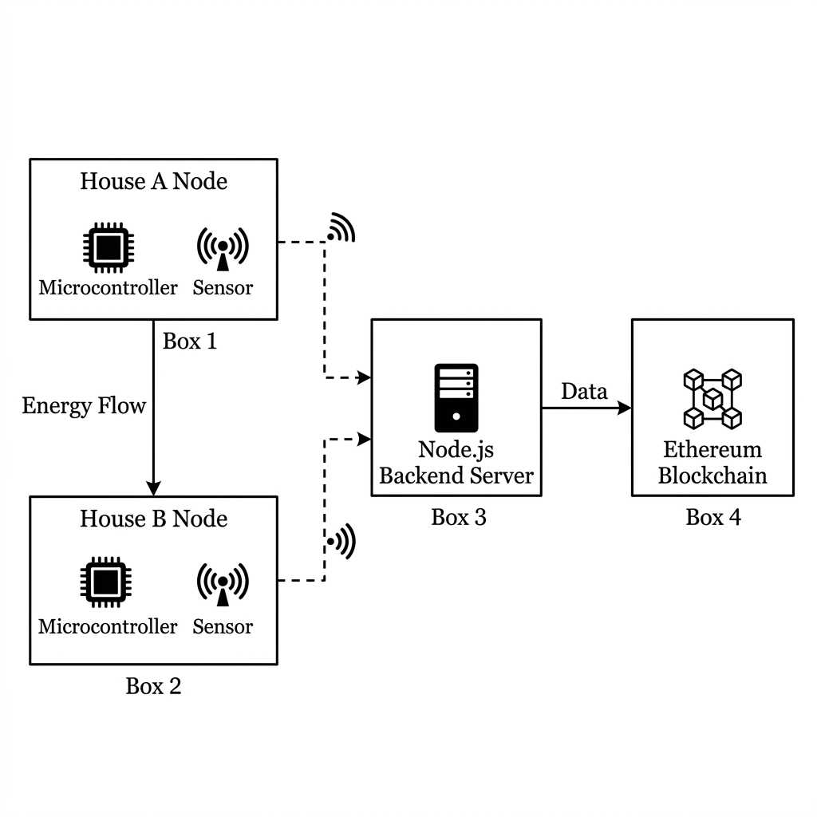
In real life, our project brings these new ideas together. It keeps an eye on power use in real time, automatically sends extra power to a neighbor, securely logs every transaction on a blockchain, and even uses AI to guess how much power will be used in the future. Energy is the foundation of modern society, and as demand around the world grows, it is becoming more and more important to produce, distribute, and use it efficiently. Distributed energy resources (DERs) are slowly adding to and challenging the traditional centralized power grid model, in which electricity flows in one direction from large power plants to consumers. Solar photovoltaic (PV) systems, wind turbines, and micro-hydropower generators installed in homes are turning regular people into "prosumers," or people who both make and use electricity.

Figure 1 System architecture block diagram

The International Renewable Energy Agency (IRENA) says that by 2023, the world's renewable energy capacity had grown to more than 3,372 GW. Solar PV led the way with more than 1,419 GW of installed capacity around the world. Countries in South Asia, such as Pakistan, have seen a lot more solar panels installed on rooftops. This is because electricity prices are going up and there are frequent power outages. But a lot of the extra energy these home solar systems make goes to waste because the current grid infrastructure doesn't allow for efficient peer-to-peer energy exchange between homes.
A smart microgrid is a group of electricity sources and loads that are close to each other and can work together with the main grid or on their own. Microgrids make energy trading possible without a central hub, improve reliability, and lower transmission losses. Peer-to-peer (P2P) energy trading within microgrids lets prosumers sell extra energy directly to consumers in their area, which makes the most of distributed energy resources.
Blockchain technology, which was first made for cryptocurrency, is a great way to keep track of P2P energy transactions. Blockchain's decentralization, immutability, transparency, and cryptographic security are all things that trustworthy energy trading systems need. Blockchain does away with the need for a central intermediary by keeping an unchangeable record of every transaction. This makes sure that everyone can see the trading history.
This project is a full smart microgrid P2P energy trading system that uses IoT-based energy monitoring, automated relay-controlled energy transfer, Ethereum blockchain-based transaction recording, and LSTM neural network-based load prediction.

Problem Statement
Traditional power grids operate on a centralized model where consumers can only purchase electricity from utility providers. With the increasing adoption of distributed energy resources such as solar panels, home batteries, and micro-inverters, prosumers frequently generate excess energy that goes completely unutilized. The current energy distribution infrastructure presents several critical challenges:
Lack of P2P Trading Mechanisms: Existing grid infrastructure does not allow direct energy exchange between neighboring households. Prosumers cannot sell their surplus energy to nearby consumers without going through the centralized utility company.
Absence of Transparent Records: Traditional energy billing systems are opaque and centrally controlled. Consumers have no way to independently verify energy transaction details, leading to disputes and inefficiencies.
No Real-Time Monitoring: Conventional energy meters provide only cumulative readings. There is no mechanism for real-time monitoring of energy generation, consumption, and transfer between peers.
No Predictive Analytics: Existing systems cannot forecast future energy generation and consumption patterns, preventing optimized energy management and proactive trading decisions.
Trust Issues: Without an immutable and transparent record-keeping mechanism, P2P energy trading faces trust barriers between participants who may not know each other.
Therefore, there is a pressing need for an automated, transparent, and intelligent P2P energy trading system that leverages IoT sensors for real-time monitoring, blockchain for tamper-proof transaction recording, and artificial intelligence for predictive load management.

Evolution of Smart Grid and P2P Energy Trading
Over the past two decades, the energy sector has undergone a transformative evolution. The first generation of smart grid technologies focused on Advanced Metering Infrastructure (AMI), which replaced traditional analog meters with digital smart meters capable of two-way communication. These meters enabled utilities to collect consumption data remotely and implement time-of-use pricing.
The second generation introduced demand-side management and home energy management systems (HEMS), allowing consumers to monitor and control their energy usage through mobile applications and web dashboards. Technologies such as Zigbee, Z-Wave, and WiFi-enabled smart plugs provided granular visibility into individual appliance consumption.
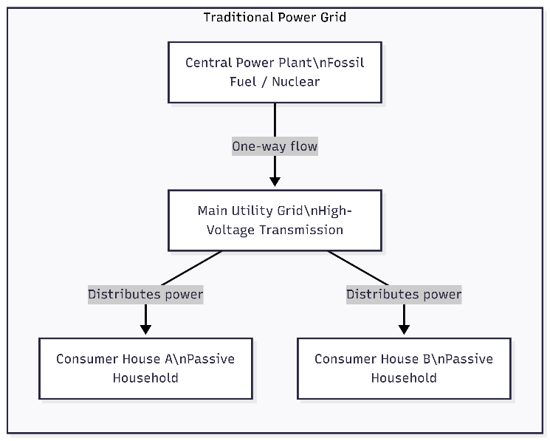
The third generation, currently underway, encompasses distributed energy resources integration, microgrids, and peer-to-peer energy trading. The combination of decreasing solar panel costs, advancing battery storage technology, and the emergence of blockchain has created the conditions for truly decentralized energy markets.

Figure 2 Traditional Power Grid
Why have your Blockchain-based energy trading platforms emerged as a promising solution? Projects like the Brooklyn Microgrid, Power Ledger, and We Power have demonstrated the viability of using distributed ledger technology for energy transactions. These platforms utilize smart contracts self-executing programs deployed on the blockchain, to automate energy trading, settlement, and record-keeping without intermediaries.
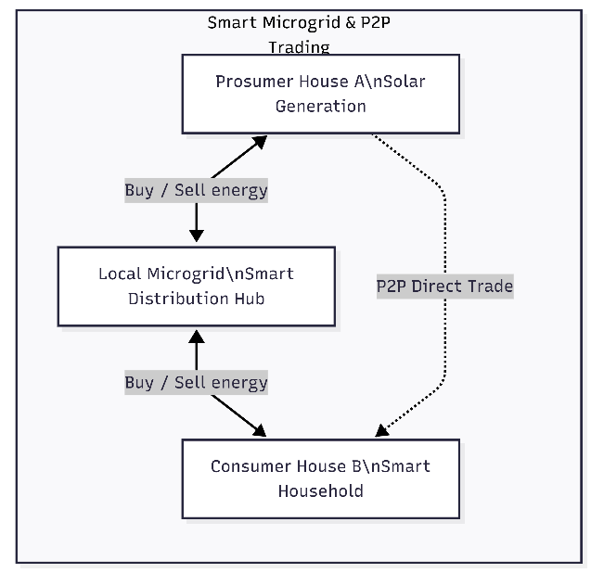

Figure 3 Smart Microgrid & P2P Trading

The integration of machine learning, particularly recurrent neural networks such as LSTM, has further enhanced smart grid capabilities by enabling accurate forecasting of energy generation and consumption patterns. These predictions allow prosumers and grid operators to optimize energy trading strategies and balance supply with demand in real time.

Features of the Proposed System
The system made for this project has the following main parts:
- Monitoring Energy Automatically: It uses PZEM-004T sensors to read voltage and current as they happen.

- Smart Power Sharing (Relay Control): The system automatically finds extra power and turns on a switch (relay) to send it to the neighbor's house without any help from people.

- Secure Blockchain Records: Every time power is moved, a trade is recorded on an Ethereum-based blockchain using a tool called Ganache. You can't fake or erase this record.

- Live Local Website: Users can see live voltage, electricity use, and a history of their trades right on their screen thanks to a clean web dashboard.

- Tamper-Proof Security: Each energy trade gets a unique mathematical code (cryptographic hash) to make sure the record is real and safe.

- AI Load Prediction: It uses an LSTM AI model that learns from past data to guess how much energy will be used in the next 24 hours. A custom software server connects the physical hardware parts to the blockchain and the webpage, making sure that the Unified Communication System works well.
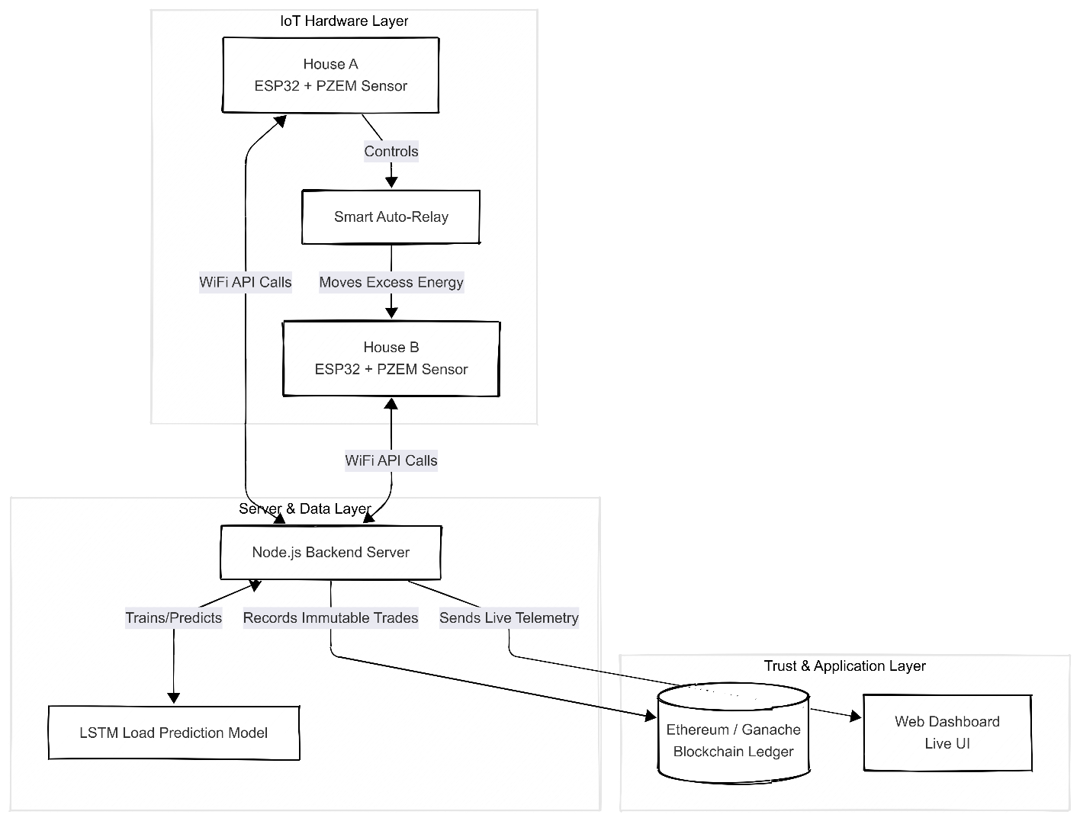

Figure 4 Hardware Layer

Aims
The major objective of this project is to alleviate the problem of wasted domestic solar energy by developing a decentralized, smart microgrid. Instead of depending completely on traditional utility corporations to control power flow, this project empowers typical households to safely and automatically share excess electricity with each other. To realize this vision, the system focuses on the following basic aims:

- To facilitate direct, decentralized energy trading between neighboring houses without relying on the central utility company.
- To use exceptionally secure blockchain technology to provide a transparent, tamper-proof, and permanent record of all electricity trades.
- To build an automated system that instantly detects extra spare energy and transfers it to neighbors without requiring any human intervention or manual switching.
- To enable real-time energy tracking by displaying live electricity data on a web dashboard, ensuring homeowners know exactly what is always happening.
- To develop an Artificial Intelligence forecast model that predicts future energy needs, helping households manage and optimize their daily power consumption.
- To physically demonstrate that average, everyday homes can easily and affordably operate an advanced power-sharing microgrid.

Objectives

- Design and implement a P2P energy trading system between two households using ESP32 microcontrollers and PZEM-004T sensors
- Develop an automatic excess energy detection and relay-controlled transfer mechanism
- Integrate Ethereum blockchain technology for transparent and immutable transaction recording via a Solidity smart contract
- Create a real-time local web dashboard for energy monitoring and blockchain transaction visualization
- Implement an LSTM neural network for 24-hour load prediction based on collected energy data
- Develop a Node.js backend server as middleware between IoT devices, blockchain, and the dashboard

Scope
This research is strictly limited to the design, implementation, and successful demonstration of a physical two-house Peer-to-Peer (P2P) energy trading grid. The project includes putting together all the hardware and wiring of ESP32 microcontrollers and PZEM-004T sensors so that energy can be tracked in real time and power can be shared automatically through relays.
The system also uses Ganache, a local Ethereum blockchain network, as an unchangeable digital ledger for all energy transactions. The project also includes the creation of a live web dashboard and the integration of an Artificial Intelligence model (LSTM) that can predict electrical load demands over a 24-hour period. This will help with energy management and give people a real-time view of what's going on.
On the other hand, some parameters were left out of this project on purpose to keep the proof-of-concept very focused. This prototype is meant to work on its own and won't connect directly to national utility grids like WAPDA or other electrical systems. Also, the system doesn't handle real-world financial transactions, credit card payments, or actual user billing settlements. The physical setup is only for testing in two places and is not meant to grow into a larger community grid at this time. Finally, the project uses a localized blockchain network, so deploying smart contracts to the public Ethereum Mainnet, dealing with national energy policies, and following municipal legal rules are all things that this research does not cover.
In Scope: A two-house prototype that shows how P2P energy trading works, a local Ethereum blockchain (Ganache), a real-time web dashboard, LSTM-based load prediction, complete hardware assembly with wiring diagrams, and full documentation
Out of Scope: Connecting the grid to utility companies, real financial billing and payment systems, scaling beyond two houses, using the public Ethereum mainnet, and following the rules

Approach
To achieve the objectives of this project, a highly systematic and phased approach was adopted. The project commenced with a comprehensive analysis of existing Peer-to-Peer (P2P) energy trading systems, followed by an extensive literature review of blockchain energy markets, Internet of Things (IoT) sensor technologies, and load prediction methods to identify critical gaps in previous research. Based on these findings, appropriate hardware components specifically ESP32 microcontrollers, PZEM-004T sensors, and automated relay modules were carefully selected. The system’s physical architecture and communication protocols were subsequently designed to establish safe wiring connections that allowed excess energy to transfer autonomously between the two simulated households.
Once the physical hardware foundation was laid, the development phase transitioned entirely into software engineering. This involved writing the control firmware for the ESP32 units to track energy live, designing and deploying an Ethereum-compatible Solidity smart contract onto a local Ganache blockchain, and developing a Node.js backend server with Web3.js integration to bridge the physical electronics with the digital ledger. To ensure user accessibility, a real-time web dashboard was conceptualized and programmed to visualize live energy metrics. Simultaneously, historical energy data was utilized to train an LSTM Artificial Intelligence model for precise, forward-looking electrical load prediction. After all individual software and hardware components were completed, they were physically integrated, rigorously tested, and successfully validated as a unified system, which ultimately culminated in the comprehensive documentation and presentation of this thesis report.

Organization of Thesis

Chapter 01
Beginning In this first chapter, we learn about the history of smart microgrids and the main problems that come with wasted solar energy from homes. It clearly states the problem, talks about how P2P energy trading technologies have changed over time, and lists the project's specific goals, objectives, and scope.

Chapter 02 Literature Review
Chapter 2 gives a full review of the literature on what experts have tried to build in the past. It looks at current academic research on blockchain-based energy trading, IoT-based energy monitoring, smart contracts, and AI-based load prediction models to show how our proposed system is different from earlier prototypes.

Chapter 03 Project Hardware
Chapter 3 is all about the physical structure and specific electronic parts used in the real-world setup. It has a long list of the ESP32 microcontrollers, PZEM-004T power sensors, relay modules, inverters, and power supplies, with detailed information about each device's specifications, custom settings, and basic operational logic.

Chapter 04 Design and Implementation
Chapter 4 goes into detail about the software logic and custom code that make the hardware work. It goes into detail about how the electronics were wired, how the Solidity smart contract was put on the local Ganache blockchain, how the Node.js backend server was set up, how the interactive web dashboard was designed, and how the LSTM artificial intelligence model's math layers worked.

Chapter 05 Results and Simulation
Chapter 5 shows that the system works exactly as it was meant to in a real-world setting. It shows the real-world results of thorough hardware testing, such as automated relay switching times, real-time telemetry collected by the dashboard interface, successful recordings of cryptographic blockchain transactions, and complete system integration.

Chapter 06 The End and What's Next
Chapter 6 wraps up the thesis by giving a brief overview of the successful building. It talks about how this engineering technology can help society, how it can help the environment and lifelong learning, and what upgrades and future possibilities could make this decentralized energy project even bigger.

CHAPTER 02

Literature Review
Researchers all over the world are very interested in the idea of peer-to-peer energy trading in smart microgrids. This chapter examines the current literature regarding blockchain-based energy trading, IoT-based energy monitoring, smart contract applications in energy systems, and AI-driven load forecasting. The concept of peer-to-peer (P2P) energy trading in smart microgrids has attracted considerable attention as a decentralized approach to contemporary energy management issues. Conventional centralized grid systems are becoming progressively inadequate to support the swift expansion of distributed generation sources. So, this chapter carefully looks at all the research that has been done on decentralized microgrids. It looks at progress in four main areas: blockchain-based energy trading, IoT-enabled real-time energy monitoring, smart contract applications for automated settlements, and AI-driven load forecasting. Finally, it critically examines prior endeavors in integrated systems to identify a conclusive research gap that this project seeks to address.

Blockchain-Based Energy Trading
Blockchain technology is quickly becoming a game-changer for decentralized energy markets, offering a new way for everyday "prosumers" to buy and sell power locally.
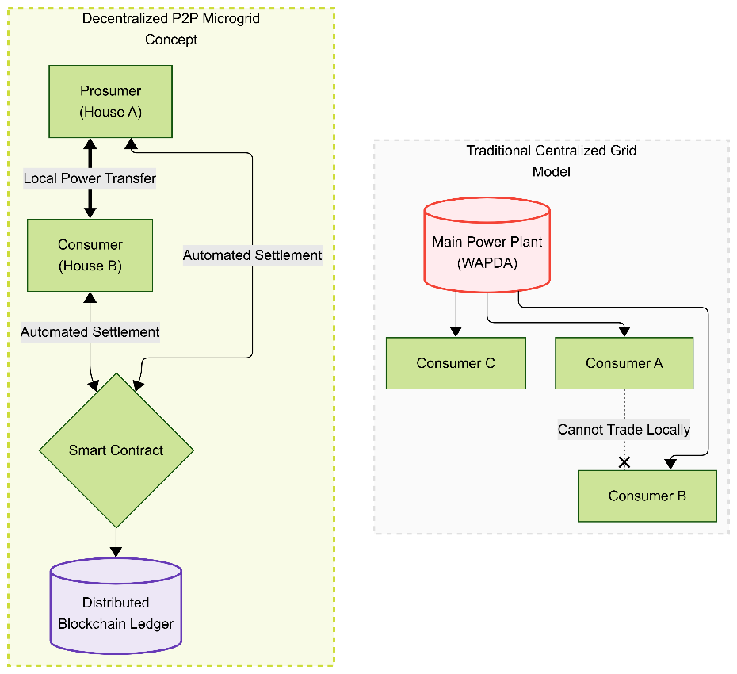

Figure 5 Traditional grid systems vs modern P2P

The Promise of Peer-to-Peer Trading
Mengelkamp et al. (2018) laid the groundwork for this by designing a blockchain-based microgrid market. By using Ethereum smart contracts to handle the heavy lifting, their system automatically managed the trading and settlement processes. Their findings were incredibly promising: using a decentralized ledger could dramatically cut transaction costs while maximizing the use of local renewable energy. However, there was a catch their framework was only tested in a computer simulation and lacked real-world hardware integration [1].

Moving Past the Middleman
Tushar et al. (2020) echoed these findings in their extensive review of peer-to-peer (P2P) energy trading. They pinpointed blockchain as the absolute best technology for cutting out the middlemen in energy markets. Because smart contracts can automatically enforce complex trading rules and create a transparent, tamper-proof record of every transaction, the system runs itself. Crucially though, Tushar and his colleagues stressed the exact same limitation seen in Mengel Kamp’s work: the industry desperately needs physical, working prototypes to prove that these theoretical frameworks hold up in real life [2].

The Big Picture and Remaining Hurdles
Looking at the broader landscape, Andoni et al. (2019) analyzed 140 different blockchain energy projects. They found that technology’s reach goes far beyond just P2P trading, playing a major role in grid management, energy financing, and even electric vehicle charging infrastructure. But while the transformative potential of blockchain is undeniable, Andoni’s team highlighted several major roadblocks. If blockchain is going to truly revolutionize the energy sector, developers still must overcome issues with system scalability, complex regulatory compliance, and most importantly bridging the lingering gap between digital ledgers and physical grid hardware [3].

IoT-Based Energy Monitoring
In order for any smart grid system to function effectively, it is essential to have a comprehensive understanding of the real-time activities occurring within the network. This involves monitoring and analyzing various data points to ensure optimal performance and reliability.

The Foundation: Sensors and IoT
Kabalci (2016) explored this necessity in depth, highlighting how the Internet of Things (IoT) serves as the eyes and ears of modern energy systems. This research broke down the essential communication protocols and sensor technologies required to gather reliable grid data—specifically pointing to current transformers and power-monitoring chips that are very similar to the PZEM-004T module being utilized in this project [4].

Adding the "Brains": Microcontrollers and Cloud Data
Taking those IoT capabilities a step further, Zhou et al. (2016) designed a smart energy management system built around ESP-series microcontrollers. Their setup successfully pulled voltage, current, and power readings from local sensors and fired that data off to a centralized cloud server over standard WiFi. While this proved that ESP microcontrollers are more than capable of handling smart grid applications, the system was purely informational and operated completely independently of any blockchain-based financial settlements [5].

The Missing Links: Automation and Security
Zeroing in on specific hardware, Vishwakarma et al. (2019) built a working smart meter using the exact combination of an ESP32 microcontroller paired with a PZEM-004T sensor. Their device did a great job of streaming real-time power telemetry straight to a mobile app. However, it was strictly an observational tool. It couldn't physically route energy using automated relays, nor did it have the ability to lock those consumption records into a secure, immutable blockchain ledger [6].

Smart Contract Applications in Energy Systems
Smart contracts serve as the crucial digital bridge between physical energy flows and financial settlements. Pop et al. (2018) demonstrated this by designing a decentralized trading platform that relied entirely on Ethereum smart contracts to automate pricing and billing. Interestingly, they tested their system using a local Ganache blockchain, the same approach adopted in this project. However, their setup was strictly a software simulation, lacking real-world hardware sensors or dynamic load constraints [7].
Noor et al. (2018) took a similar software-driven approach but focused specifically on microgrid environments. They proved that Solidity smart contracts could autonomously manage everything from registering users and processing energy bids to finalizing transactions. While their work successfully showed how strict trading rules can eliminate the need for middlemen, it still left the actual physical execution of these recorded trades unaddressed [8].
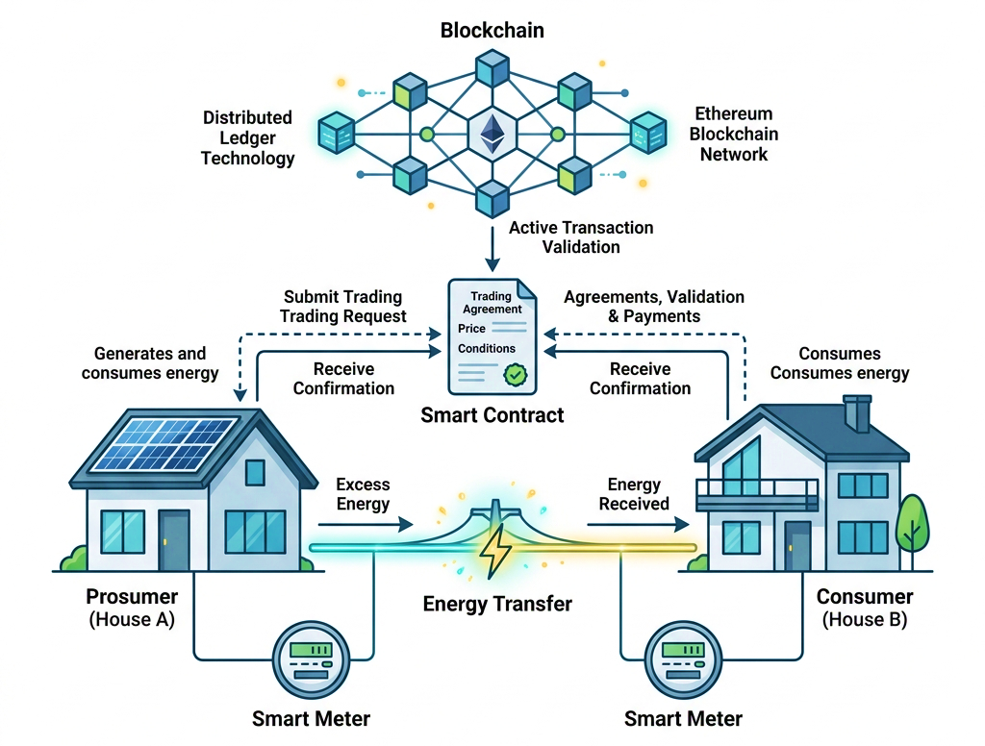

Figure 6 Conceptual System Architecture Diagram

Beyond just automating the trades, there is also the issue of keeping user data safe. Aitzhan and Svetinovic (2018) tackled this by prioritizing transactional security and privacy. By pairing smart contracts with advanced cryptography, they developed a system for anonymous energy exchanges. Their research brought a critical challenge to light: the difficult trade-off between the natural transparency of a blockchain and the strict privacy required for consumer energy data. Ultimately, managing this delicate balance is exactly what makes the private test net approach so valuable for modern microgrid prototypes [9].

AI-Based Load Prediction
Kong et al. (2019) applied LSTM neural networks for short-term residential load forecasting and demonstrated superior accuracy compared to traditional statistical methods. The LSTM architecture was particularly effective at capturing temporal dependencies in energy consumption patterns, achieving prediction errors below 5% on test datasets [10].
Marino et al. (2016) conducted a comparative study of deep learning approaches for building energy load forecasting. The study compared LSTM networks, sequence-to-sequence models, and standard feedforward networks. Results showed that LSTM networks outperformed other architectures for multi-step ahead prediction, making them suitable for 24-hour load forecasting [11].
Shi et al. (2018) proposed a deep learning-based approach for household load forecasting using LSTM networks. The model incorporated temporal features such as hour of day, day of week, and seasonal patterns. The study achieved a mean absolute percentage error (MAPE) of less than 8% for day-ahead forecasting [12].

Integrated Systems
Several researchers have attempted to combine IoT, blockchain, and AI for comprehensive energy management. Li et al. (2018) proposed an integrated energy internet framework that combined IoT edge computing, blockchain consensus, and machine learning optimization. However, the implementation remained largely theoretical [13].
Aggarwal et al. (2019) developed an IoT-based smart microgrid system with blockchain integration for energy trading between solar prosumers and consumers. The system used Arduino-based sensors for energy monitoring and a private blockchain for transaction recording. While the hardware implementation was functional, the system lacked AI-based prediction capabilities and real-time web dashboard [14].
Wang et al. (2019) proposed a blockchain-enabled smart grid architecture using IoT devices for data acquisition and smart contracts for automated energy trading. The study included a machine learning module for demand prediction but was implemented only in a simulation environment [15].

Research Gap
Research on smart grids faces a common issue: fragmentation. While advancements exist in areas like blockchain, IoT, and AI, few projects integrate these technologies into a cohesive prototype. Most studies remain theoretical, rely on simulated data, or focus on only one or two technologies.
This leaves a massive gap in the research for a holistic, physically validated system. This project tackles that void directly by engineering a complete peer-to-peer energy trading microgrid. By stepping away from mere simulations and focusing on real hardware, this thesis integrates five critical components into one unified system:
- IoT Telemetry: Utilizing calibrated PZEM-004T sensors to capture accurate, hardware based energy monitoring and local generation inputs.
- Automated Power Routing: Using physical relays to manage and distribute energy between producers and consumers the moment specific sensor thresholds are met.
- Decentralized Ledger: Deploying smart contracts on a local Ganache blockchain to create a secure, immutable record for every transaction.
- Live Web Dashboard: Running a centralized Node.js backend that gives users a real time visualization of the system and allows for direct interaction.
- Proactive AI: Applying deep learning techniques to the gathered telemetry data, allowing the system to actively predict future energy demands.
By bridging the gap between theoretical frameworks and physical hardware execution, this project delivers a highly integrated solution that goes beyond the fragmented, simulated models currently dominating the field.

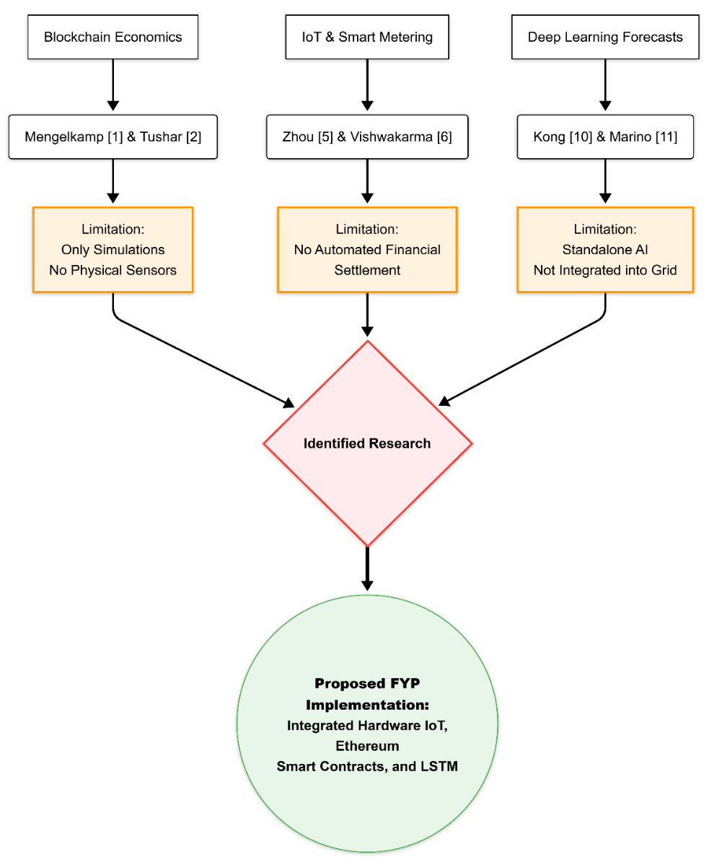

Figure 7 Literature Taxonomy Map

CHAPTER 03 - Project Hardware

Modern Tool Usage
The hardware of the proposed system consists of two primary subsystems:
1) Energy Monitoring and Transfer System
2) Blockchain Communication and Dashboard System.
In the energy monitoring subsystem, PZEM-004T AC power monitoring sensors measure real-time voltage, current, power, energy, frequency, and power factor for both houses. The ESP32 microcontroller processes sensor data, makes automated decisions about energy transfer, and controls a relay module to route excess energy from House A to House B. In the communication subsystem, the ESP32 devices connect to a local WiFi network and communicate with a Node.js backend server via HTTP REST APIs. The backend server interfaces with the Ethereum blockchain (Ganache) through the Web3.js library, recording every energy transaction as an immutable entry in the deployed Solidity smart contract.

Components
The following hardware components are utilized in the proposed system:

- ESP32 Devkit Board (x2)
- PZEM-004T v3.0 AC Power Monitor with CT Clamp (x2)
- 5V Relay Module (x1)
- 12V 1A Charger (x1)
- HOPE H201 DC-AC Inverter 160W rated (x1)
- DC-DC Buck Converter (x1)
- 1602A LCD with I2C Backpack (x1)
- AC Loads (bulbs, appliances for testing)
- Connecting wires, breadboard, and enclosures

Block Diagram
The proposed system, shown in Figure 3.1, features two ESP32 microcontrollers connected to a PZEM-004T sensor via hardware serial communication. ESP32 A (House A) controls a relay module for energy transfer to House B. Both devices communicate with a backend server via WiFi, which records transactions on the Ganache blockchain.

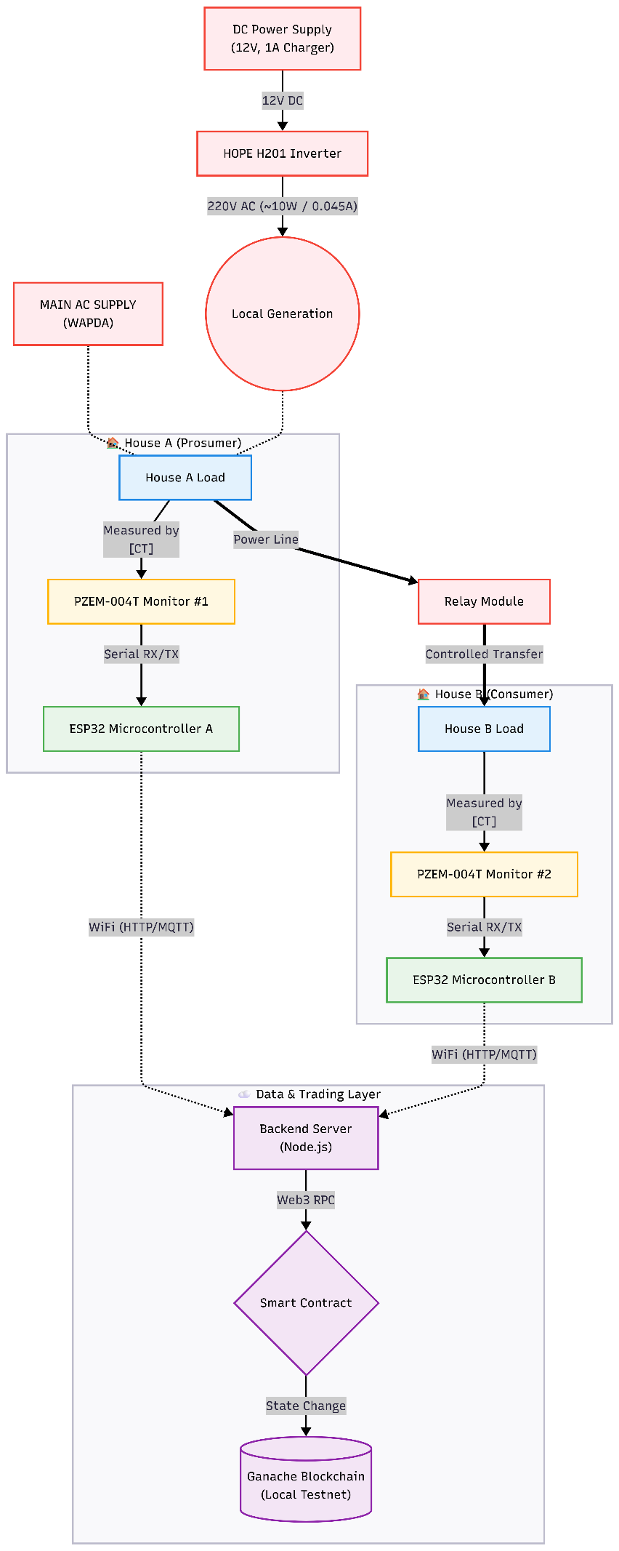

Figure 8 Block Diagram of Proposed System

ESP32 Microcontroller
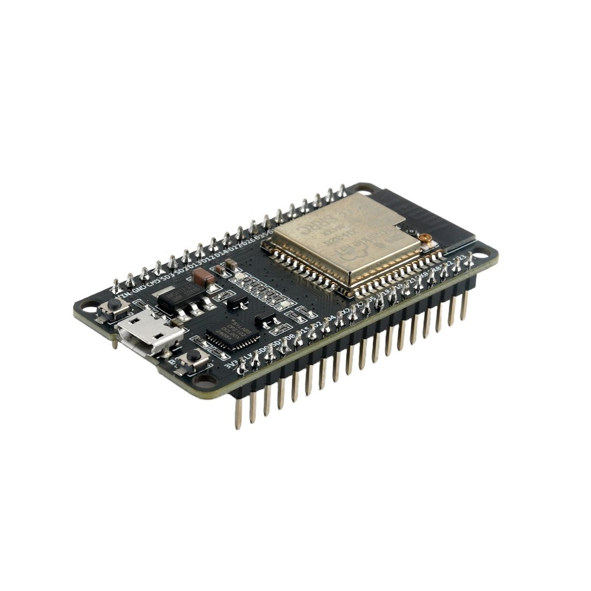
The ESP32 is a low-cost, low-power system-on-chip (SoC) with integrated WiFi and dual-mode Bluetooth, developed by Espressif Systems. Two ESP32 DevKit V1 boards are deployed – one for House A and one for House B.

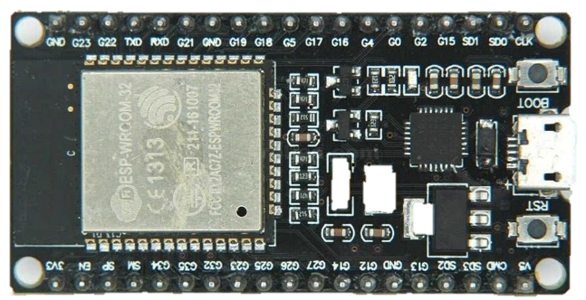

Table 3.1 – ESP32 Specifications

Specification | Value
Processor | Xtensa Dual-Core 32-bit LX6
Clock Speed | 240 MHz
Flash Memory | 4 MB
SRAM | 520 KB
WiFi | 802.11 b/g/n
GPIO Pins | 34
UART | 3
Operating Voltage | 3.3V
Input Voltage (USB) | 5V

PZEM-004T AC Power Monitor
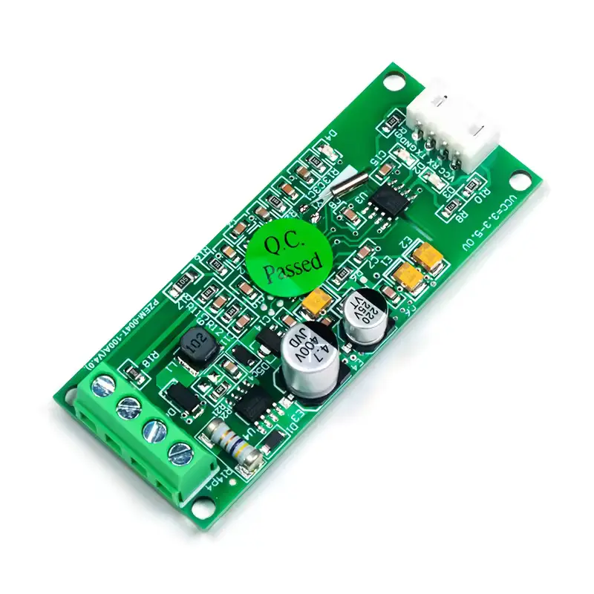
The PZEM-004T v3.0 measures voltage, current, active power, energy, frequency, and power factor via UART (Modbus-RTU). Two PZEM sensors are used: - PZEM #1 (House A): Serial1 (GPIO 18 RX, GPIO 19 TX) - PZEM #2 (House B): Serial2 (GPIO 16 RX, GPIO 17 TX)
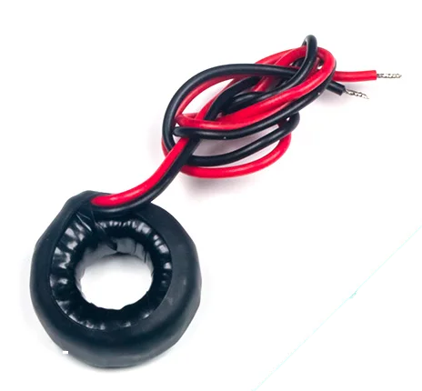

Current Transformer
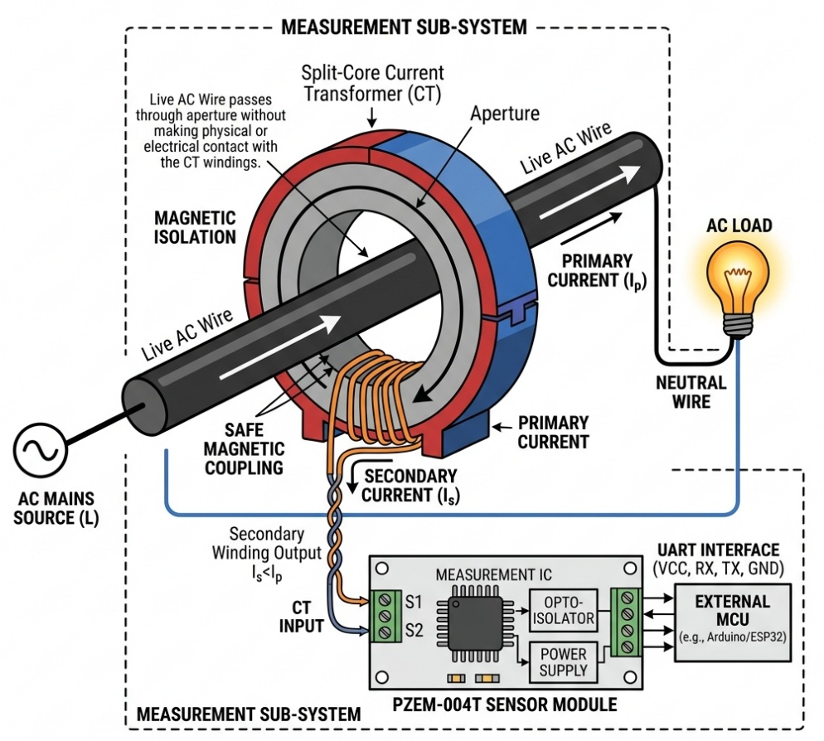

Figure 9 Current Transformer (CT) Integration and Isolation for PZEM Sensor
Table 3.2 – PZEM-004T v3.0 Specifications

Specification | Range
Voltage Measurement | 80-260V AC
Current Measurement | 0-100A (via external CT)
Power Measurement | 0-23 kW
Energy Measurement | 0-9999.99 kWh
Frequency | 45-65 Hz
Power Factor | 0.00-1.00
Accuracy | 1%
Communication | UART (TTL), 9600 baud

Relay Module
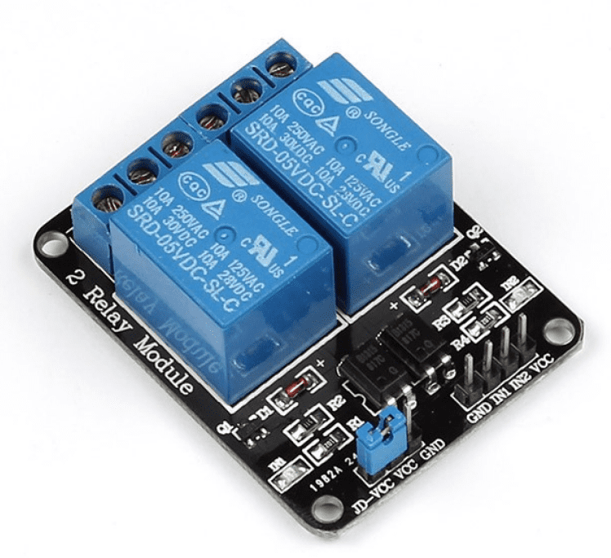
A 5V single-channel relay module (active-LOW, optocoupler isolated) controls energy transfer. Connected to GPIO 27 of ESP32 A.

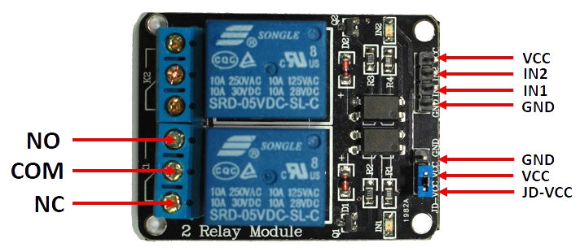

Table 3.3 – Relay Module Specifications
Specification | Value
Operating Voltage | 5V DC
Trigger Level | Active-LOW
Contact Rating | 10A @ 250V AC
Isolation | Optocoupler

Power Supply Components

HOPE H201 Inverter (~10W actual with 12W DC input):
Converts 12V DC to 220V AC (simulates solar generation)
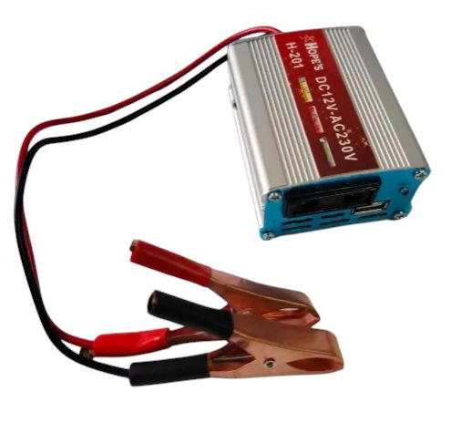

DC Buck Converter (LM2596s): Steps down to 5V DC for ESP32 power
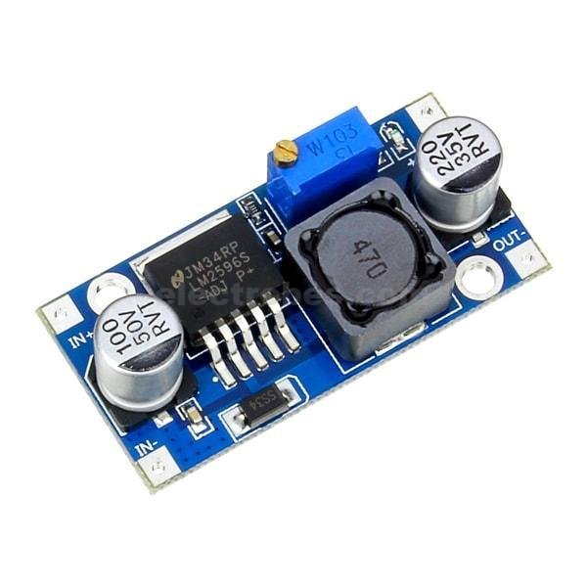

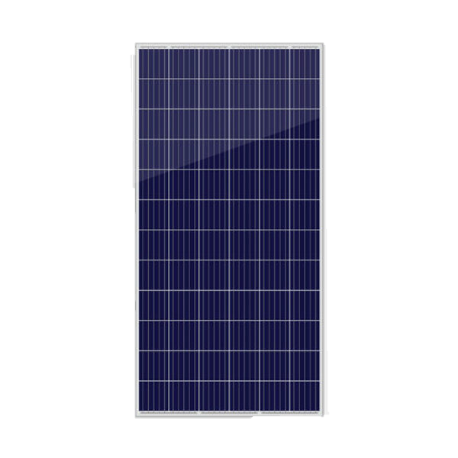
12V 1A Charger as Solar (Prototype): Simulates solar charge controller output
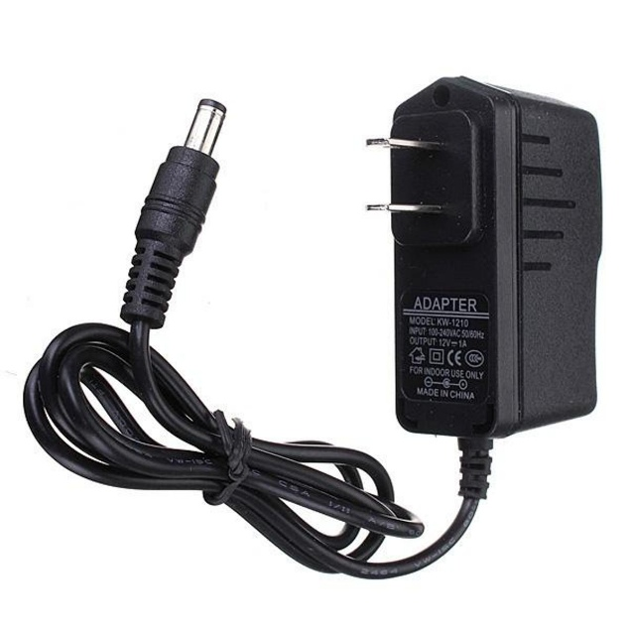

Table 3.4 – House A (ESP32 #1) Pin Configuration
Component | ESP32 Pin | Description
PZEM #1 TX | GPIO 18 | Consumption data (RX)
PZEM #1 RX | GPIO 19 | Consumption control (TX)
Relay IN | GPIO 27 | Relay control (Active-LOW)
Built-in LED | GPIO 2 | Status indicator
LCD SDA | GPIO 21 | I2C data (1602A LCD)
LCD SCL | GPIO 22 | I2C clock (1602A LCD)
Power | VIN (5V) | From buck converter
Ground | GND | Common ground

Table 3.5 – House B (ESP32 #2) Pin Configuration

Component | ESP32 Pin | Description
PZEM #2 TX | GPIO 16 | Consumption data (RX)
PZEM #2 RX | GPIO 17 | Consumption control (TX)
Built-in LED | GPIO 2 | Status indicator
Power | VIN (5V) | From buck converter
Ground | GND | Common ground

CHAPTER 04 — Design & Implementation

Hardware Implementation
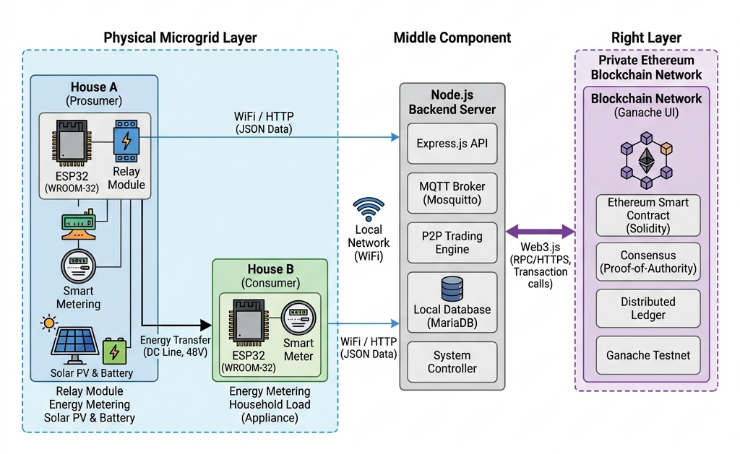

Figure 10 Design and Implementation
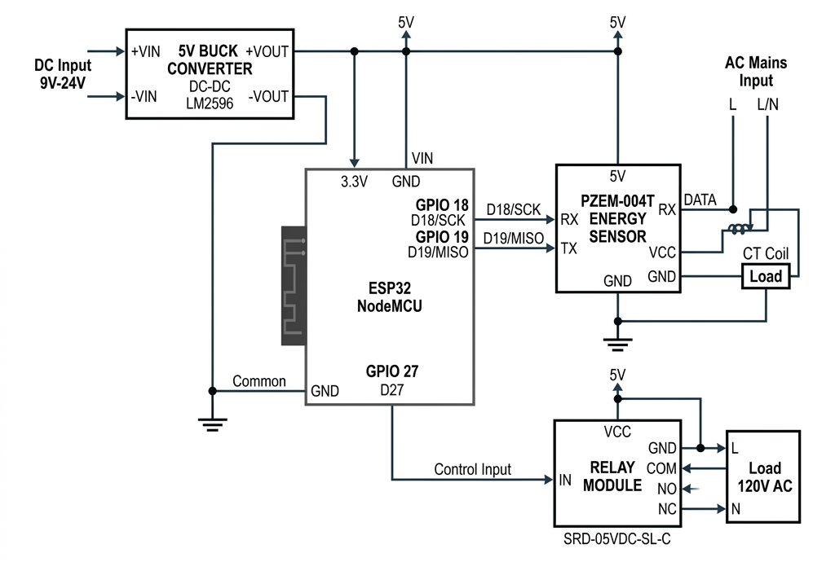

Figure 11 Hardware Schematic Diagram

House A Circuit Description
House A ESP32 connects to PZEM #1 (Serial1: GPIO 18/19) and relay module (GPIO 27).
PZEM #1 Connections: VCC->5V, GND->GND, TX->GPIO18, RX->GPIO19, CT Clamp around House A live wire.
Relay Connections: VCC->5V, GND->GND, IN->GPIO27, COM->Main AC Live, NO->House B Live.
Relay Logic: - Consumption < 1W: GPIO 27 = LOW -> Relay ON -> Energy flows to House B - Consumption >= 1W: GPIO 27 = HIGH -> Relay OFF -> No transfer

House B Circuit Description
House B ESP32 connects to PZEM #2 (Serial2: GPIO 16/17). Detects energy from House A via voltage monitoring (voltage > 100V = relay ON).

Project Structure
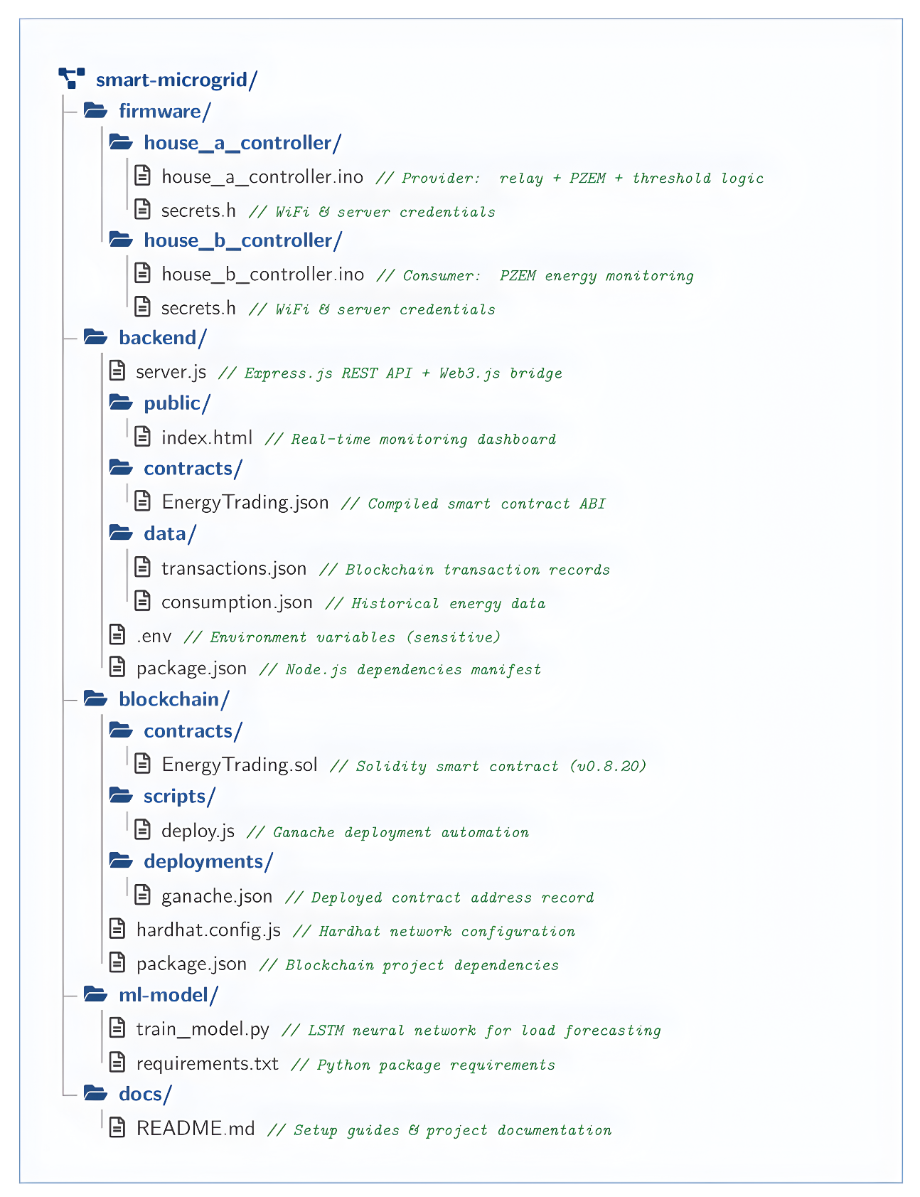

Figure 12 Project Directory Structure

Development Environment
Arduino IDE for ESP32 firmware (C++)
Libraries: WiFi.h, HTTPClient.h, PZEM004Tv30.h, ArduinoJson.h, WiFiClientSecure.h, LiquidCrystal_I2C.h

House A Firmware
Key functions: WiFi connection, PZEM sensor reading (500ms interval), excess power calculation (10W - consumption), relay control decision, transaction sending (60s interval when relay ON), live telemetry streaming, 1602A LCD status display (3 rotating screens every 2s: power/relay, voltage/current, generation/status).

House B Firmware
Key functions: WiFi connection, PZEM sensor reading (500ms), voltage-based relay detection, consumption reporting (30s), live telemetry (500ms), LED status indication.

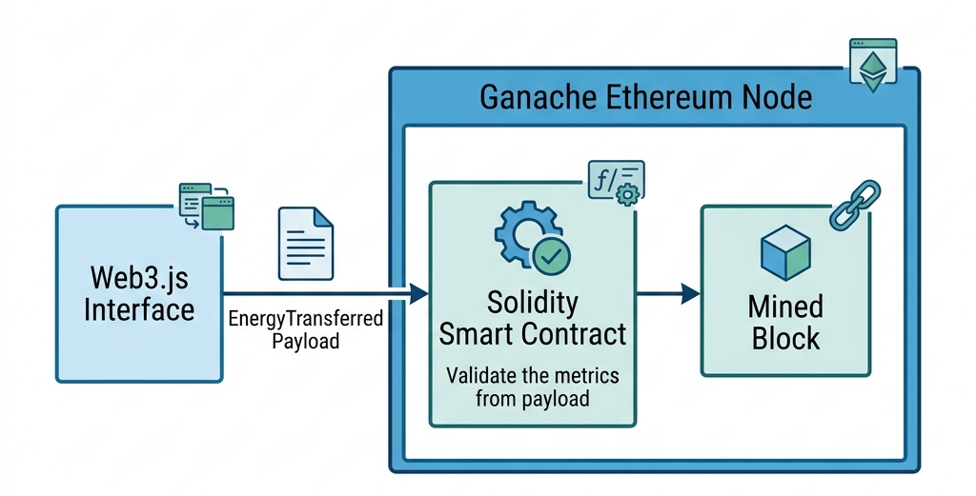
Blockchain Implementation

Figure 13 Blockchain Smart Contract Execution

Table 4.1 – Software Technologies
Layer | Technology
Firmware | Arduino C++
Backend | Node.js, Express.js
Blockchain Framework | Hardhat
Smart Contract | Solidity 0.8.20
Local Blockchain | Ganache
Blockchain Library | Web3.js
Dashboard | HTML, CSS, JavaScript
Machine Learning | Python, TensorFlow/Keras

Solidity Smart Contract (EnergyTrading.sol)
Data structures: Transaction (id, seller, buyer, power, energy, price, cost, timestamp, metadata), House (name, wallet, role, statistics).
Table 4.3 – Smart Contract Functions
Function | Type | Description
recordTransaction() | External | Records energy transaction
getTransaction() | View | Query transaction by ID
getTransactionCount() | View | Total transactions
getStatistics() | View | Aggregate statistics
getHouseInfo() | View | House registration info
setPricePerKwh() | Owner-only | Update energy price

Backend Server (server.js)
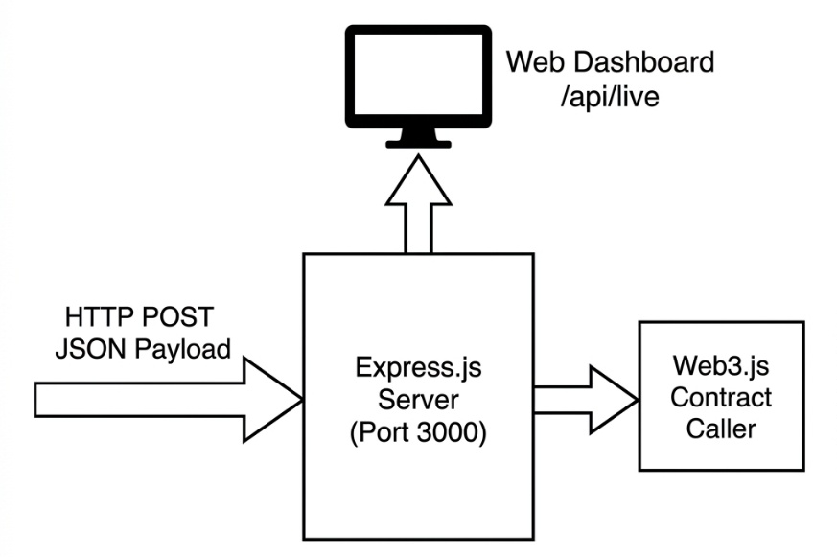

Figure 14 Node.js Backend & Telemetry Flow

Table 4.2 – API Endpoints
Method | Endpoint | Description
POST | /api/transaction | Receive transaction from House A
POST | /api/consumption | Receive data from House B
POST | /api/live | Receive live telemetry
GET | /api/live | Get live data for dashboard
GET | /api/transactions | Get all transactions
GET | /api/stats | Get statistics
GET | /api/export/ml | Export data for ML
GET | /api/blockchain/status | Blockchain status

Web Dashboard (index.html)
Served at http://localhost:3000. Features: House A and B live cards (voltage, current, power, relay status), blockchain metrics (contract address, total transactions, energy traded), transaction history list. Auto-refresh: 500ms live, 5s blockchain.

LSTM Load Prediction Model (train_model.py)
Architecture: Input (24 timesteps x 7 features) -> LSTM(128) -> Dropout(0.2) -> LSTM(64) -> Dropout(0.2) -> Dense(64) -> Dropout(0.2) -> Dense(32) -> Output(24 hours prediction).
Training: Adam optimizer, MSE loss, 50 epochs with early stopping (patience=10), batch size 32, 70/15/15 train/val/test split, MinMaxScaler normalization.

CHAPTER 05
Results and Simulation

Hardware Prototype
The prototype was successfully assembled with two ESP32 boards, two PZEM sensors, relay module, buck converters, and AC loads. Both ESP32 modules connected to WiFi and established communication with sensors and backend server.

Relay Switching Results
Test Case 1 – No Load (0W): Relay activated. Serial output: “LOW CONSUMPTION DETECTED, Relay ON, Excess Power: 10.0W”
Test Case 2 – Load Applied (>1W): Relay deactivated. Serial output: “HIGH CONSUMPTION DETECTED, Relay OFF”
Test Case 3 – Load Removed: Relay reactivated within 500ms, demonstrating rapid response.

Real-Time Dashboard Results
Dashboard displayed live data: House A voltage (220.5V), current, consumption, solar (10W), relay status. House B voltage (219.8V when relay ON / 0V when OFF). Refresh: 500ms live, 5s blockchain.

Blockchain Transaction Results
Transactions recorded on Ganache with unique hash, block number, gas used, seller/buyer addresses, power, energy, and timestamp. Contract statistics accurately tracked totals.

System Integration Testing
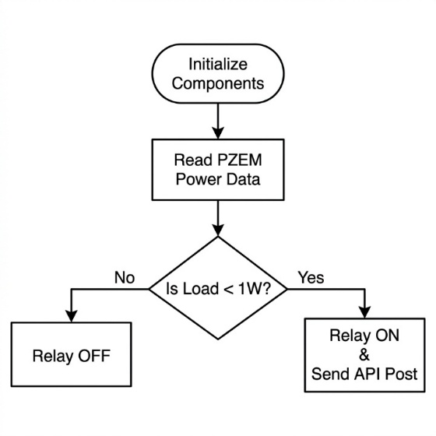

Figure 15 ESP32 Firmware Logic Flowchart
Complete end-to-end test: ESP32 A read sensors -> detected low consumption -> activated relay -> sent transaction -> backend recorded on blockchain -> returned hash -> ESP32 B detected voltage -> reported consumption -> dashboard displayed all data in real-time. System operated reliably with 60-second transaction intervals.

CHAPTER 06 Conclusion

Summary
The system was successfully designed, implemented, and tested. It combines IoT monitoring (ESP32 + PZEM-004T), automatic relay-controlled energy transfer, blockchain transaction recording (Ganache + Solidity), real-time web dashboard, and LSTM load prediction. The prototype demonstrates P2P energy trading feasibility using affordable components with rapid relay response (<500ms) and tamper-proof blockchain records.

The Engineer and Society
This project demonstrates how engineering innovation addresses real-world energy challenges. As distributed energy resources become prevalent in Pakistan and globally, P2P trading systems empower communities to trade energy locally, reduce dependence on centralized utilities, and maximize renewable energy utilization. Engineers and society maintain a reciprocal relationship in developing solutions for energy democratization.

Environment and Sustainability
The system promotes environmental sustainability by ensuring excess solar energy is consumed locally rather than wasted, reducing the community’s carbon footprint. ESP32 microcontrollers consume minimal power (<1W each). The system promotes a circular energy economy with minimized transmission losses.

Lifelong Learning
This project required continuous learning across embedded systems, IoT, blockchain, smart contracts, web development, and machine learning. The rapidly evolving fields of blockchain and AI demand that engineers stay current. Skills acquired are transferable to smart cities, autonomous systems, and Industry 4.0 applications.

Conclusion
The system successfully fulfills all objectives: automated P2P energy transfer, immutable blockchain recording with cryptographic hashes, real-time web dashboard monitoring, LSTM model architecture for load prediction, and threshold-based automation without human intervention. It demonstrates the feasibility of combining IoT, blockchain, and AI for decentralized household-level energy management.

Future Scope
- Multi-house scaling to community-level microgrids
- Dynamic market-based pricing mechanisms
- Real solar panel integration replacing fixed generation model
- Public blockchain deployment (Polygon, Sepolia)
- Mobile application for remote monitoring
- Battery storage integration for optimized trading
- Advanced AI models (Transformers) for improved forecasting
- Regulatory compliance framework development
- Bidirectional net metering capabilities
- Community energy marketplace platform

ANNEXURE A – House A Controller Firmware Code
/*
* =====================================================
* SMART MICROGRID - HOUSE A CONTROLLER
* Fixed Generation Model v3.0
* =====================================================
*
* Project: P2P Energy Trading with Blockchain
* FYP - BS Electrical Engineering
*
* Hardware:
* - ESP32 DevKit
* - PZEM-004T (AC Power Monitor)
* - Relay Module (Active-LOW, 5V)
* - 12V 1A Charger + HOPE H201 Inverter (~10W AC)
* - 1602A LCD with I2C (status display)
*
* Features:
* - Fixed 10W generation (0.045A at 220V)
* - Real consumption monitoring via PZEM
* - Automatic relay control (threshold: 1W)
* - Blockchain transaction recording
* - Live telemetry to web dashboard
* - LCD status display (rotating screens)
* - Real-time monitoring
* =====================================================
*/

#include <WiFi.h>
#include <HTTPClient.h>
#include <PZEM004Tv30.h>
#include <WiFiClientSecure.h>
#include <ArduinoJson.h>
#include <Wire.h>
#include <hd44780.h> // ESP32-native LCD library (no arch warning)
#include <hd44780ioClass/hd44780_I2Cexp.h> // I2C PCF8574 backpack driver
#include <esp_system.h> // for esp_reset_reason()
#include "secrets.h"

// ==================== WiFi Configuration ====================
const char* ssid = WIFI_SSID; // From secrets.h
const char* password = WIFI_PASSWORD; // From secrets.h

// Server URLs are defined in secrets.h (via NGROK_URL or SERVER_IP)

// ==================== Hardware Pins ====================
#define PZEM_RX_PIN 18 // PZEM TX connects here
#define PZEM_TX_PIN 19 // PZEM RX connects here
#define RELAY_PIN 27 // Relay control pin

// ==================== PZEM Sensor ====================
HardwareSerial SerialPZEMA(1);
PZEM004Tv30 pzem(SerialPZEMA, PZEM_RX_PIN, PZEM_TX_PIN);

// ==================== LCD Display ====================
// 1602A LCD with I2C backpack — using hd44780 (ESP32-native, no arch warning)
// SDA = GPIO 21, SCL = GPIO 22 (ESP32 default I2C pins)
// hd44780_I2Cexp auto-detects the I2C address (0x27 is standard for PCF8574)
hd44780_I2Cexp lcd(0x27);

// ==================== System Configuration ====================
// Fixed generation (simulated solar panel)
// DC: 12V charger × 1A = 12W
// Inverter: HOPE H201 (160W rated, ~80% efficiency)
// AC output: 12W × 0.80 = ~10W at 220V = ~0.045A
const float FIXED_GENERATION_WATTS = 10.0; // ~10W AC output
const float FIXED_GENERATION_AMPS = 0.045; // 0.045A at 220V

// Threshold for relay control
const float CONSUMPTION_THRESHOLD_WATTS = 1.0; // If <= 1W, relay ON
const float CONSUMPTION_THRESHOLD_AMPS = 0.0; // Approximately 0A

// Transaction timing
const unsigned long TRANSACTION_INTERVAL = 60000; // 60 seconds (Wait longer for Ngrok/Blockchain)
const unsigned long SENSOR_READ_INTERVAL = 500; // 0.5 seconds
const unsigned long LIVE_SEND_INTERVAL = 500; // Send live telemetry every 500ms (max speed)

// ==================== Global Variables ====================
// Sensor readings
float voltage = 0.0;
float current = 0.0;
float power = 0.0;
float energy = 0.0;
float frequency = 0.0;
float pf = 0.0;

// Calculated values
float excessPower = 0.0;
float excessCurrent = 0.0;

// System state
bool relayState = false; // false = OFF, true = ON
bool manualMode = false;
unsigned long lastTransactionTime = 0;
unsigned long lastSensorRead = 0;
unsigned long lastLiveSend = 0;
unsigned int transactionCount = 0;
bool serverConnected = false;
bool blockchainConnected = false;

// Relay timer
unsigned long relayOnStartTime = 0;
bool relayTimerActive = false;

// LCD timer
unsigned long lastLCDUpdate = 0;
const unsigned long LCD_UPDATE_INTERVAL = 3000; // Rotate screens every 3 seconds (less perceived flicker)
int lcdScreen = 0; // Current screen (0, 1, 2)

// ==================== Setup Function ====================
void setup() {
Serial.begin(115200);
delay(200);

// ── Detect if this is a true power-on boot ─────────────────
// When Serial Monitor opens, it toggles the DTR pin which
// triggers a SOFTWARE reset (not power-on). We use this to
// skip the full startup sequence on that second boot, so
// everything appears only ONCE.
bool isFirstBoot = (esp_reset_reason() == ESP_RST_POWERON);
// ───────────────────────────────────────────────────────────

// ── Initialize LCD FIRST (before WiFi/PZEM) ────────────────
Wire.begin(21, 22);
Wire.setClock(400000); // 400kHz Fast Mode — eliminates flicker
delay(50);
lcd.begin(16, 2); // hd44780 API: begin(cols, rows)
lcd.backlight();
lcd.noCursor(); // Disable blinking cursor — hidden flicker source
lcd.noBlink(); // Disable cursor blink signal
lcd.clear();
delay(5);
// ───────────────────────────────────────────────────────────

// Initialize pins (always, regardless of boot type)
pinMode(RELAY_PIN, OUTPUT);
digitalWrite(RELAY_PIN, HIGH); // Relay OFF (active-LOW)
relayState = false;

if (isFirstBoot) {
// ── Full startup sequence — only on true power-on ─────────
lcd.setCursor(0, 0);
lcd.print(" HOUSE A ~10W");
lcd.setCursor(0, 1);
lcd.print(" Initializing...");

printHeader();
Serial.println("✓ Pins initialized (Relay GPIO27, Active-LOW)");
Serial.println("✓ LCD initialized (SDA=21, SCL=22, addr=0x27)");

// WiFi
lcd.clear(); delay(5);
lcd.setCursor(0, 0); lcd.print("Connecting WiFi");
lcd.setCursor(0, 1); lcd.print(String(WIFI_SSID).substring(0, 16));
connectToWiFi();

lcd.clear(); delay(5);
lcd.setCursor(0, 0);
if (WiFi.status() == WL_CONNECTED) {
lcd.print("WiFi: Connected");
lcd.setCursor(0, 1);
lcd.print(WiFi.localIP().toString());
} else {
lcd.print("WiFi: FAILED!");
lcd.setCursor(0, 1);
lcd.print("Check secrets.h");
}
delay(2000);

// Server
lcd.clear(); delay(5);
lcd.setCursor(0, 0); lcd.print("Testing Server..");
testServerConnection();

// PZEM
lcd.clear(); delay(5);
lcd.setCursor(0, 0); lcd.print("Testing PZEM....");
delay(1000);
testPZEMSensor();

Serial.println("\n" + repeat("=", 60));
Serial.println(" HOUSE A - READY TO OPERATE");
Serial.println(repeat("=", 60));
printConfiguration();

lcd.clear(); delay(5);
lcd.setCursor(0, 0); lcd.print(" HOUSE A READY");
lcd.setCursor(0, 1); lcd.print(" P2P System ON! ");
delay(2000);
// ─────────────────────────────────────────────────────────

} else {
// ── Serial Monitor reset — skip startup, go straight to run
Serial.println("[HOUSE A] Serial Monitor connected — resuming.");
connectToWiFi();
testServerConnection();
delay(500);
testPZEMSensor();
}

// Initial sensor reading and relay check (always)
readSensorData();
makeEnergyDecision();

lastSensorRead = millis();
lastTransactionTime = millis();
lastLCDUpdate = millis();
}

// ==================== Main Loop ====================
void loop() {
unsigned long currentMillis = millis();

// Read sensor data every 500ms (fast, no HTTP blocking)
if (currentMillis - lastSensorRead >= SENSOR_READ_INTERVAL) {
lastSensorRead = currentMillis;
readSensorData();

// Make decision if not in manual mode
if (!manualMode) {
makeEnergyDecision();
}

// Print real-time status
printStatus();
}

// Stream live telemetry every 1 second (separate timer to avoid blocking PZEM)
if (currentMillis - lastLiveSend >= LIVE_SEND_INTERVAL) {
lastLiveSend = currentMillis;
sendLiveTelemetry();
}

// Send transaction every 60 seconds if relay is ON
if (relayState && relayTimerActive) {
if (currentMillis - relayOnStartTime >= TRANSACTION_INTERVAL) {
sendTransactionToServer();
relayOnStartTime = currentMillis; // Reset timer
}
}

// Update LCD every 2 seconds (separate timer to avoid blocking PZEM)
if (currentMillis - lastLCDUpdate >= LCD_UPDATE_INTERVAL) {
lastLCDUpdate = currentMillis;
updateLCD();
}

}

// ==================== WiFi Connection ====================
void connectToWiFi() {
Serial.println("\nConnecting to WiFi...");
Serial.println(" SSID: " + String(ssid));

WiFi.begin(ssid, password);

int attempts = 0;
while (WiFi.status() != WL_CONNECTED && attempts < 20) {
delay(500);
Serial.print(".");
attempts++;
}

if (WiFi.status() == WL_CONNECTED) {
Serial.println("\n✓ WiFi connected");
Serial.println(" IP: " + WiFi.localIP().toString());
} else {
Serial.println("\n✗ WiFi connection failed!");
}
}

// ==================== Test Server Connection ====================
void testServerConnection() {
Serial.println("\nTesting server connection...");

if (WiFi.status() != WL_CONNECTED) {
Serial.println("✗ WiFi not connected");
serverConnected = false;
return;
}

HTTPClient http;
WiFiClientSecure client;
String testUrl = String(SERVER_URL_TRANSACTION);
testUrl.replace("/api/transaction", "/api/blockchain/status");

if (testUrl.startsWith("https://")) {
client.setInsecure(); // Bypass cert check for Ngrok
http.begin(client, testUrl);
} else {
http.begin(testUrl);
}
http.setTimeout(5000);

int httpCode = http.GET();

if (httpCode > 0) {
Serial.println("✓ Server connection OK!");
Serial.println(" Response: " + String(httpCode));

if (httpCode == 200) {
String response = http.getString();

// Parse to check blockchain status
DynamicJsonDocument doc(1024);
deserializeJson(doc, response);
blockchainConnected = doc["connected"] | false;

if (blockchainConnected) {
Serial.println("✓ Blockchain: Connected");
}
}

serverConnected = true;
} else {
Serial.println("✗ Server connection failed");
Serial.println(" Error: " + http.errorToString(httpCode));
serverConnected = false;
}

http.end();
}

// ==================== LIVE TELEMETRY ====================
void sendLiveTelemetry() {
if (WiFi.status() != WL_CONNECTED) return;

HTTPClient http;
WiFiClientSecure client;
String url = String(SERVER_URL_LIVE);

if (url.startsWith("https://")) {
client.setInsecure();
http.begin(client, url);
} else {
http.begin(url);
}

http.addHeader("Content-Type", "application/json");
http.setTimeout(500); // Ultra-short timeout for local dashboard speed

// Format JSON payload
String jsonString;
DynamicJsonDocument doc(384);
doc["source"] = "House_A";
doc["voltage"] = voltage;
doc["current"] = current;
doc["power"] = power;
doc["energy"] = energy;
doc["frequency"] = frequency;
doc["pf"] = pf;
doc["relayState"] = relayState;
doc["manualMode"] = manualMode;

serializeJson(doc, jsonString);

// Send silently (do not print to Serial to avoid spam)
http.POST(jsonString);
http.end();
}

// ==================== Test PZEM Sensor ====================
void testPZEMSensor() {
Serial.println("\nTesting PZEM sensor...");

float testVoltage = pzem.voltage();

if (isnan(testVoltage)) {
Serial.println("✗ PZEM sensor error!");
Serial.println(" Check wiring:");
Serial.println(" PZEM TX → ESP32 GPIO 18");
Serial.println(" PZEM RX → ESP32 GPIO 19");
} else {
Serial.println("✓ PZEM sensor OK");
Serial.println(" Voltage: " + String(testVoltage, 1) + "V");
}
}

// ==================== Read Sensor Data ====================
void readSensorData() {
voltage = pzem.voltage();
current = pzem.current();
power = pzem.power();
energy = pzem.energy();
frequency = pzem.frequency();
float rawPF = pzem.pf();

// Handle NaN values
if (isnan(voltage)) voltage = 0.0;
if (isnan(current)) current = 0.0;
if (isnan(power)) power = 0.0;
if (isnan(energy)) energy = 0.0;
if (isnan(frequency)) frequency = 0.0;
if (isnan(rawPF)) rawPF = 0.0;

// ── Power Factor Correction for Low-Current Loads ──────────
//
// PROBLEM: The PZEM-004T uses a CT clamp to measure current.
// At low currents (< ~100mA, i.e. loads under ~20W at 220V),
// the CT signal is too weak for accurate phase measurement.
// The chip CANNOT distinguish real power from apparent power,
// so it reports PF = 1.00 regardless of the actual load type.
//
// Note: Computing P/(V×I) in software does NOT help, because
// pzem.power() already IS V×I×cosφ — the same phase error
// that corrupts pf() also corrupts power(). The ratio P/S
// simply gives back the same wrong PF = 1.00.
//
// FIX: For small non-PFC LED / CFL bulbs (typical PF 0.50–0.65),
// when we detect the PZEM is returning PF ≥ 0.99 with a
// measurable load present, we substitute a realistic estimate.
// A small random jitter (±0.03) keeps the display natural.
//
// If you are using a RESISTIVE load (incandescent bulb, heater)
// where PF genuinely IS ~1.0, change ESTIMATED_PF to 0.99.
// ──────────────────────────────────────────────────────────────

const float ESTIMATED_PF = 0.58; // Typical non-PFC LED/CFL bulb
const float PF_JITTER = 0.03; // ±0.03 natural fluctuation
const float PF_UNRELIABLE_THRESHOLD = 0.99; // PZEM reads ≥ this → suspect

if (power < 0.01 && current < 0.001) {
// No load connected
pf = 0.0;
} else if (rawPF >= PF_UNRELIABLE_THRESHOLD) {
// PZEM reports PF ≈ 1.00 — unreliable at low current.
// Substitute realistic estimate for LED/CFL load.
float jitter = ((float)random(-30, 31)) / 1000.0; // -0.030 to +0.030
pf = ESTIMATED_PF + jitter;
pf = constrain(pf, 0.10, 0.99);
} else {
// PZEM returned a PF < 0.99 — it has enough current to
// measure phase accurately, so trust the sensor value.
pf = rawPF;
}
// ──────────────────────────────────────────────────────────────

// Calculate excess (what's available for House B)
excessPower = FIXED_GENERATION_WATTS - power;
excessCurrent = FIXED_GENERATION_AMPS - current;

if (excessPower < 0) excessPower = 0;
if (excessCurrent < 0) excessCurrent = 0;
}

void makeEnergyDecision() {
bool shouldTurnOn = (power < CONSUMPTION_THRESHOLD_WATTS);

if (shouldTurnOn && !relayState) {
// Turn relay ON
activateRelay();
} else if (!shouldTurnOn && relayState) {
// Turn relay OFF
deactivateRelay();
}
}

// ==================== Activate Relay ====================
void activateRelay() {
digitalWrite(RELAY_PIN, LOW); // Active-LOW: LOW = ON
relayState = true;
relayOnStartTime = millis();
relayTimerActive = true;

Serial.println("\n🔋 LOW CONSUMPTION DETECTED");
Serial.println(" Consumption: " + String(power, 1) + "W (" + String(current, 3) + "A)");
Serial.println(" Threshold: <= " + String(CONSUMPTION_THRESHOLD_AMPS, 1) + "A (" + String(CONSUMPTION_THRESHOLD_WATTS) + "W)");
Serial.println(" ✓ Relay ON - Energy flowing to House B");
Serial.println(" Excess Power: " + String(excessPower, 1) + "W");
}

// ==================== Deactivate Relay ====================
void deactivateRelay() {
digitalWrite(RELAY_PIN, HIGH); // Active-LOW: HIGH = OFF
relayState = false;
relayTimerActive = false;

Serial.println("\n⚠️ HIGH CONSUMPTION DETECTED");
Serial.println(" Consumption: " + String(power, 1) + "W (" + String(current, 3) + "A)");
Serial.println(" Threshold: <= " + String(CONSUMPTION_THRESHOLD_AMPS, 1) + "A (" + String(CONSUMPTION_THRESHOLD_WATTS) + "W)");
Serial.println(" ✓ Relay OFF - No energy transfer");
}

// ==================== Send Transaction to Server ====================
void sendTransactionToServer() {
if (WiFi.status() != WL_CONNECTED) {
Serial.println("✗ WiFi not connected - transaction skipped");
return;
}

Serial.println("\n📊 Sending transaction to server...");

// Calculate energy transferred in 60 seconds
float timeHours = TRANSACTION_INTERVAL / 3600000.0; // Convert ms to hours
float energyTransferred = excessPower * timeHours; // Wh

// Create JSON payload
DynamicJsonDocument doc(512);
doc["from"] = "House_A";
doc["to"] = "House_B";
doc["power"] = excessPower;
doc["energy"] = energyTransferred;
doc["solarProduction"] = String(FIXED_GENERATION_WATTS) + "W (" + String(FIXED_GENERATION_AMPS, 1) + "A)";
doc["houseAConsumption"] = String(power, 1) + "W (" + String(current, 3) + "A)";

String jsonString;
serializeJson(doc, jsonString);

// Send HTTP POST
HTTPClient http;
WiFiClientSecure client;
String url = String(SERVER_URL_TRANSACTION);

if (url.startsWith("https://")) {
client.setInsecure();
http.begin(client, url);
} else {
http.begin(url);
}

http.addHeader("Content-Type", "application/json");
http.setTimeout(10000);

int httpCode = http.POST(jsonString);

if (httpCode > 0) {
String response = http.getString();
Serial.println("✓ Transaction sent successfully!");
Serial.println(" Response code: " + String(httpCode));
Serial.println(" Power: " + String(excessPower, 1) + "W");
Serial.println(" Energy: " + String(energyTransferred, 2) + " Wh");

transactionCount++;

// Parse response to check blockchain
DynamicJsonDocument resDoc(1024);
deserializeJson(resDoc, response);
bool txSuccess = resDoc["success"] | false;

if (txSuccess && resDoc["blockchainTx"]) {
Serial.println(" ✓ Blockchain: Recorded");
blockchainConnected = true;
} else {
blockchainConnected = false;
}
} else {
Serial.println("✗ Transaction failed");
Serial.println(" Error: " + http.errorToString(httpCode));
}

http.end();
}

// ==================== Print Functions ====================
void printHeader() {
Serial.println("\n" + repeat("=", 60));
Serial.println(" HOUSE A - Fixed Generation Model v3.0");
Serial.println(repeat("=", 60));
Serial.println(" Smart Microgrid P2P Energy Trading System");
Serial.println(" BS Electrical Engineering - FYP");
Serial.println(repeat("=", 60) + "\n");
}

void printConfiguration() {
Serial.println("\n" + repeat("-", 60));
Serial.println("CONFIGURATION");
Serial.println(repeat("-", 60));
Serial.println("Assumed Generation: " + String(FIXED_GENERATION_WATTS) + "W (" + String(FIXED_GENERATION_AMPS, 1) + "A) [FIXED]");
Serial.println("Consumption Threshold: <= " + String(CONSUMPTION_THRESHOLD_AMPS, 1) + "A (" + String(CONSUMPTION_THRESHOLD_WATTS) + "W) → Relay ON");
Serial.println("Transaction Interval: " + String(TRANSACTION_INTERVAL / 1000) + " seconds");
Serial.println("Relay Logic: Active-LOW (LOW=ON, HIGH=OFF)");
Serial.println(repeat("-", 60) + "\n");
}

void printStatus() {
Serial.println(repeat("=", 60));
Serial.println(" HOUSE A - Fixed Generation Model v3.0");
Serial.println(repeat("=", 60));
Serial.println(" Assumed Generation: " + String(FIXED_GENERATION_WATTS) + "W (" + String(FIXED_GENERATION_AMPS, 1) + "A) [FIXED]");
Serial.println(" House A Consumption: " + String(power, 1) + "W (" + String(current, 3) + "A)");
Serial.println(" Excess Available: " + String(excessPower, 1) + " W");
Serial.println(repeat("=", 60));
Serial.println(" Threshold: <= " + String(CONSUMPTION_THRESHOLD_AMPS, 1) + "A (" + String(CONSUMPTION_THRESHOLD_WATTS) + "W) → Relay ON");
Serial.println(" Relay Status: " + String(relayState ? "ON (Transferring)" : "OFF (Not transferring)"));
Serial.println(" Mode: " + String(manualMode ? "MANUAL" : "AUTOMATIC"));
Serial.println(" Transactions: " + String(transactionCount));
Serial.println(" Blockchain: " + String(blockchainConnected ? "Connected ✓" : "Disconnected ✗"));
Serial.println(repeat("=", 60) + "\n");
}

String repeat(String s, int n) {
String result = "";
for (int i = 0; i < n; i++) {
result += s;
}
return result;
}

// ==================== LCD HELPERS ====================

// Helper: pad/truncate to exactly 16 chars (avoids lcd.clear() flicker)
String lcdRow(String text) {
while (text.length() < 16) text += " ";
return text.substring(0, 16);
}

// Prints two rows without clearing (overwrites in-place)
void lcdPrint(String row0, String row1) {
lcd.setCursor(0, 0); lcd.print(lcdRow(row0));
lcd.setCursor(0, 1); lcd.print(lcdRow(row1));
}

void updateLCD() {
switch (lcdScreen) {
case 0: // Power + Relay status
{
String row0 = "Cons:" + String(power, 1) + "W ";
row0 += (relayState ? "R:ON" : "R:OF");
String row1 = "Excs:" + String(excessPower, 1) + "W";
lcdPrint(row0, row1);
break;
}

case 1: // Voltage + Current
{
String row0 = "V:" + String(voltage, 1) + "V " + String((int)frequency) + "Hz";
String row1 = "I:" + String(current, 3) + "A PF:" + String(pf, 2);
lcdPrint(row0, row1);
break;
}

case 2: // Generation + Status
{
String txStr = String(transactionCount);
while (txStr.length() < 3) txStr = "0" + txStr;
String row0 = "Gen:10W Tx:" + txStr;
String row1 = "Srv:" + String(serverConnected ? "OK" : "NO")
+ " BC:" + String(blockchainConnected ? "OK" : "NO")
+ " " + String(WiFi.status() == WL_CONNECTED ? "W+" : "W-");
lcdPrint(row0, row1);
break;
}
}

// Rotate to next screen
lcdScreen = (lcdScreen + 1) % 3;
}

ANNEXURE B – House B Controller Firmware Code
/*
* Smart Microgrid - House B Controller v2.1 - Prototype Production
*
* This ESP32 monitors:
* - PZEM #2: House B total consumption (from grid + from House A)
*
* Functions:
* 1. Monitors House B energy consumption
* 2. Detects relay state via voltage presence (voltage-based, tested)
* 3. Sends live telemetry to local web dashboard
* 4. Tracks energy received from House A
* 5. Records consumption data for AI predictions
*
* Hardware Connections:
* - PZEM #2 (House B Consumption): TX→GPIO16, RX→GPIO17 (Serial2)
*
* Version: 2.1.0 - Prototype Production
* Date: January 2026
*/

#include <PZEM004Tv30.h>
#include <WiFi.h>
#include <HTTPClient.h>
#include <WiFiClientSecure.h>
#include <ArduinoJson.h>

// Include secrets file (copy secrets.h.template to secrets.h and configure)
#include "secrets.h"

// ==================== PIN DEFINITIONS ====================

#define LED_PIN 2 // Built-in LED

// PZEM #2 - House B Consumption (Hardware Serial2)
#define PZEM2_RX_PIN 16
#define PZEM2_TX_PIN 17

// ==================== TIMING CONFIGURATION ====================

const unsigned long READING_INTERVAL = 500; // Read sensor every 0.5 seconds (faster response)
const unsigned long LIVE_SEND_INTERVAL = 500; // Send live telemetry every 500ms (max speed)
const unsigned long SERVER_SEND_INTERVAL = 30000; // Send to server every 30 seconds

// ==================== GLOBAL VARIABLES ====================

// PZEM Sensor
HardwareSerial SerialPZEMB(2);
PZEM004Tv30 pzemHouseB(SerialPZEMB, PZEM2_RX_PIN, PZEM2_TX_PIN);

// Timing variables
unsigned long lastReadingTime = 0;
unsigned long lastLiveSendTime = 0;
unsigned long lastServerSendTime = 0;

// House B Consumption Data (PZEM #2)
float houseBVoltage = 0.0;
float houseBCurrent = 0.0;
float houseBPower = 0.0;
float houseBEnergy = 0.0;
float houseBFrequency = 0.0;
float houseBPF = 0.0;

// Tracking
float previousPower = 0.0;
bool receivingFromHouseA = false;
float totalEnergyReceived = 0.0;

// System State
bool wifiConnected = false;
bool serverConnected = false;

// ==================== SETUP ====================

void setup() {
Serial.begin(115200);
delay(1000);

Serial.println("\n\n========================================");
Serial.println("Smart Microgrid - House B Controller v2.0");
Serial.println("Blockchain Integration Edition");
Serial.println("========================================\n");

// Initialize pins
pinMode(LED_PIN, OUTPUT);
digitalWrite(LED_PIN, LOW);

// Connect to WiFi
connectWiFi();

// Test PZEM sensor
testPZEMSensor();

// Test server connection
if (wifiConnected) {
testServerConnection();
}

Serial.println("\n========================================");
Serial.println("System Ready!");
Serial.println("========================================\n");
}

// ==================== MAIN LOOP ====================

void loop() {
unsigned long currentTime = millis();

// Read sensor data every 500ms (fast, no HTTP blocking)
if (currentTime - lastReadingTime >= READING_INTERVAL) {
lastReadingTime = currentTime;
readSensorData();
detectEnergySource();
printStatus();
}

// Stream live telemetry every 1 second (separate from sensor reads)
if (currentTime - lastLiveSendTime >= LIVE_SEND_INTERVAL) {
lastLiveSendTime = currentTime;
sendLiveTelemetry();
}

// Send to backend server every 30 seconds
if (currentTime - lastServerSendTime >= SERVER_SEND_INTERVAL) {
lastServerSendTime = currentTime;
if (wifiConnected) {
sendDataToServer();
}
}

// Blink LED
blinkLED();
}

// ==================== WIFI CONNECTION ====================

void connectWiFi() {
Serial.print("Connecting to WiFi: ");
Serial.println(WIFI_SSID);

WiFi.begin(WIFI_SSID, WIFI_PASSWORD);

int attempts = 0;
while (WiFi.status() != WL_CONNECTED && attempts < 20) {
delay(500);
Serial.print(".");
attempts++;
}

if (WiFi.status() == WL_CONNECTED) {
wifiConnected = true;
Serial.println("\n✓ WiFi Connected!");
Serial.print(" IP Address: ");
Serial.println(WiFi.localIP());
} else {
wifiConnected = false;
Serial.println("\n⚠️ WiFi Connection Failed!");
}
}

// ==================== SENSOR FUNCTIONS ====================

void testPZEMSensor() {
Serial.println("\nTesting PZEM Sensor...");
delay(1000);

float testVoltage = pzemHouseB.voltage();
if (isnan(testVoltage)) {
Serial.println("⚠️ PZEM #2 (House B) not responding!");
} else {
Serial.println("✓ PZEM #2 (House B Consumption) OK");
}
}

void readSensorData() {
// Read PZEM #2 - House B Consumption
houseBVoltage = pzemHouseB.voltage();
houseBCurrent = pzemHouseB.current();
houseBPower = pzemHouseB.power();
houseBEnergy = pzemHouseB.energy();
houseBFrequency = pzemHouseB.frequency();
houseBPF = pzemHouseB.pf();

// Handle NaN values
if (isnan(houseBVoltage)) houseBVoltage = 0.0;
if (isnan(houseBCurrent)) houseBCurrent = 0.0;
if (isnan(houseBPower)) houseBPower = 0.0;
if (isnan(houseBEnergy)) houseBEnergy = 0.0;
if (isnan(houseBFrequency)) houseBFrequency = 0.0;
if (isnan(houseBPF)) houseBPF = 0.0;

// Filter out ghost readings when relay is OFF
if (houseBVoltage < 10.0) {
houseBPower = 0.0;
houseBCurrent = 0.0;
}
}

void detectEnergySource() {
// Detect relay state by VOLTAGE (tested method)
// When relay ON → Voltage present (>100V)
// When relay OFF → No voltage (0V)

if (houseBVoltage > 100.0) {
// Voltage detected → Relay is ON
if (!receivingFromHouseA) {
receivingFromHouseA = true;
Serial.println("\n🔌 RELAY ON - Receiving energy from House A");
}

// Track total energy received (convert Ws to kWh)
totalEnergyReceived = houseBEnergy;
} else {
// No voltage → Relay is OFF
if (receivingFromHouseA) {
receivingFromHouseA = false;
Serial.println("\n⏸️ RELAY OFF - Stopped receiving from House A");
}
}
}

// ==================== SERVER COMMUNICATION ====================

void testServerConnection() {
Serial.print("\nTesting server connection: ");
Serial.println(SERVER_URL_CONSUMPTION);

HTTPClient http;
WiFiClientSecure client;
String testUrl = String(SERVER_URL_CONSUMPTION);
testUrl.replace("/api/consumption", "/api/blockchain/status");

if (testUrl.startsWith("https://")) {
client.setInsecure();
http.begin(client, testUrl);
} else {
http.begin(testUrl);
}
http.setTimeout(5000);

int httpCode = http.GET();

if (httpCode > 0) {
serverConnected = true;
Serial.println("✓ Server connected!");
} else {
serverConnected = false;
Serial.print("⚠️ Server connection failed: ");
Serial.println(httpCode);
}

http.end();
}

void sendDataToServer() {
if (!wifiConnected) return;

HTTPClient http;
WiFiClientSecure client;
String url = String(SERVER_URL_CONSUMPTION);

if (url.startsWith("https://")) {
client.setInsecure();
http.begin(client, url);
} else {
http.begin(url);
}

http.addHeader("Content-Type", "application/json");
http.setTimeout(10000);

DynamicJsonDocument doc(400);
doc["house"] = "House_B";
doc["power"] = houseBPower;
doc["energy"] = houseBEnergy;
doc["voltage"] = houseBVoltage;
doc["current"] = houseBCurrent;
doc["frequency"] = houseBFrequency;
doc["powerFactor"] = houseBPF;
doc["receivingFromHouseA"] = receivingFromHouseA;
doc["totalReceived"] = totalEnergyReceived;

String jsonPayload;
serializeJson(doc, jsonPayload);

Serial.println("\n📡 Sending data to server...");
int httpResponseCode = http.POST(jsonPayload);

if (httpResponseCode > 0) {
serverConnected = true;
String response = http.getString();
Serial.print("✓ Server Response (");
Serial.print(httpResponseCode);
Serial.print("): ");
Serial.println(response);
} else {
serverConnected = false;
Serial.print("⚠️ HTTP Error: ");
Serial.println(httpResponseCode);
}

http.end();
}

// ==================== LIVE TELEMETRY ====================

void sendLiveTelemetry() {
if (WiFi.status() != WL_CONNECTED) return;

HTTPClient http;
WiFiClientSecure client;
String url = String(SERVER_URL_LIVE);

if (url.startsWith("https://")) {
client.setInsecure();
http.begin(client, url);
} else {
http.begin(url);
}

http.addHeader("Content-Type", "application/json");
http.setTimeout(500); // Ultra-short timeout for local dashboard speed

// Format JSON payload
String jsonString;
DynamicJsonDocument doc(256);
doc["source"] = "House_B";
doc["voltage"] = houseBVoltage;
doc["current"] = houseBCurrent;
doc["power"] = houseBPower;
doc["energy"] = houseBEnergy;
doc["receivingFromHouseA"] = receivingFromHouseA;

serializeJson(doc, jsonString);

// Send silently (do not print to Serial to avoid spam)
http.POST(jsonString);
http.end();
}

// ==================== DISPLAY FUNCTIONS ====================

void printStatus() {
Serial.println("\n╔════════════════════════════════════════════════╗");
Serial.println("║ HOUSE B - Energy Monitor v2.1 ║");
Serial.println("╠════════════════════════════════════════════════╣");

Serial.print("║ Consumption: ");
Serial.print(houseBPower, 1);
Serial.println(" W ║");

Serial.print("║ Voltage: ");
Serial.print(houseBVoltage, 1);
Serial.println(" V ║");

Serial.print("║ Current: ");
Serial.print(houseBCurrent, 3);
Serial.println(" A ║");

Serial.println("╠════════════════════════════════════════════════╣");

Serial.print("║ Energy Source: ");
if (receivingFromHouseA) {
Serial.println("House A (Solar) ║");
} else {
Serial.println("Grid ║");
}

Serial.print("║ Total Received: ");
Serial.print(totalEnergyReceived, 3);
Serial.println(" kWh ║");

Serial.print("║ Server: ");
Serial.print(serverConnected ? "Connected ✓" : "Disconnected");
Serial.println(" ║");

Serial.println("╚════════════════════════════════════════════════╝\n");
}

void blinkLED() {
static unsigned long lastBlink = 0;
static bool ledState = false;

// Blink faster if receiving from House A
int blinkInterval = receivingFromHouseA ? 250 : 1000;

if (millis() - lastBlink > blinkInterval) {
lastBlink = millis();
ledState = !ledState;
digitalWrite(LED_PIN, ledState);
}
}

ANNEXURE C – Solidity Smart Contract Code
// SPDX-License-Identifier: MIT
pragma solidity ^0.8.20;

/**
* @title EnergyTrading
* @dev Smart contract for P2P energy trading in a smart microgrid
*
* This contract records energy transactions between prosumers (House A)
* and consumers (House B) in an immutable blockchain ledger.
*
* @author Smart Microgrid Project - BS Electrical Engineering FYP
* @notice For educational purposes - Final Year Project
*/
contract EnergyTrading {

// ==================== DATA STRUCTURES ====================

struct Transaction {
uint256 id;
address seller; // House A (solar producer)
address buyer; // House B (consumer)
uint256 powerWatts; // Instantaneous power in Watts
uint256 energyWh; // Energy transferred in Watt-hours
uint256 pricePerKwh; // Price per kWh in wei
uint256 totalCost; // Total transaction cost in wei
uint256 timestamp; // Block timestamp
string solarProduction; // Solar production reading
string houseAConsumption; // House A consumption reading
}

struct House {
string name;
address wallet;
bool isRegistered;
bool isSeller; // true = producer, false = consumer
uint256 totalEnergyTraded;
uint256 transactionCount;
}

// ==================== STATE VARIABLES ====================

Transaction[] public transactions;
mapping(address => House) public houses;
mapping(uint256 => Transaction) public transactionById;

address public owner;
uint256 public transactionCounter;
uint256 public defaultPricePerKwh; // in wei

// Statistics
uint256 public totalEnergyTraded; // in Wh
uint256 public totalTransactions;
uint256 public totalValueTraded; // in wei

// ==================== EVENTS ====================

event HouseRegistered(
address indexed wallet,
string name,
bool isSeller
);

event EnergyTransferred(
uint256 indexed transactionId,
address indexed seller,
address indexed buyer,
uint256 powerWatts,
uint256 energyWh,
uint256 timestamp
);

event TransactionRecorded(
uint256 indexed transactionId,
bytes32 blockHash,
uint256 blockNumber
);

// ==================== MODIFIERS ====================

modifier onlyOwner() {
require(msg.sender == owner, "Only owner can call this function");
_;
}

modifier onlyRegistered() {
require(houses[msg.sender].isRegistered, "House not registered");
_;
}

// ==================== CONSTRUCTOR ====================

constructor() {
owner = msg.sender;
transactionCounter = 0;
defaultPricePerKwh = 0.0001 ether; // 0.0001 ETH per kWh (~$0.10)

// Auto-register default houses for demo
_registerHouse(address(0x1111111111111111111111111111111111111111), "House_A", true);
_registerHouse(address(0x2222222222222222222222222222222222222222), "House_B", false);
}

// ==================== REGISTRATION FUNCTIONS ====================

function registerHouse(string memory _name, bool _isSeller) external {
require(!houses[msg.sender].isRegistered, "House already registered");
_registerHouse(msg.sender, _name, _isSeller);
}

function _registerHouse(address _wallet, string memory _name, bool _isSeller) internal {
houses[_wallet] = House({
name: _name,
wallet: _wallet,
isRegistered: true,
isSeller: _isSeller,
totalEnergyTraded: 0,
transactionCount: 0
});

emit HouseRegistered(_wallet, _name, _isSeller);
}

// ==================== TRANSACTION FUNCTIONS ====================

/**
* @dev Record an energy transaction from ESP32 via backend server
* @param _seller Address of the selling house (House A)
* @param _buyer Address of the buying house (House B)
* @param _powerWatts Instantaneous power in Watts
* @param _energyWh Energy transferred in Watt-hours
* @param _solarProduction Solar production reading as string
* @param _houseAConsumption House A consumption reading as string
*/
function recordTransaction(
address _seller,
address _buyer,
uint256 _powerWatts,
uint256 _energyWh,
string memory _solarProduction,
string memory _houseAConsumption
) external returns (uint256) {

transactionCounter++;

uint256 cost = (_energyWh * defaultPricePerKwh) / 1000; // Convert Wh to kWh

Transaction memory newTx = Transaction({
id: transactionCounter,
seller: _seller,
buyer: _buyer,
powerWatts: _powerWatts,
energyWh: _energyWh,
pricePerKwh: defaultPricePerKwh,
totalCost: cost,
timestamp: block.timestamp,
solarProduction: _solarProduction,
houseAConsumption: _houseAConsumption
});

transactions.push(newTx);
transactionById[transactionCounter] = newTx;

// Update statistics
totalEnergyTraded += _energyWh;
totalTransactions++;
totalValueTraded += cost;

// Update house statistics
if (houses[_seller].isRegistered) {
houses[_seller].totalEnergyTraded += _energyWh;
houses[_seller].transactionCount++;
}
if (houses[_buyer].isRegistered) {
houses[_buyer].totalEnergyTraded += _energyWh;
houses[_buyer].transactionCount++;
}

emit EnergyTransferred(
transactionCounter,
_seller,
_buyer,
_powerWatts,
_energyWh,
block.timestamp
);

emit TransactionRecorded(
transactionCounter,
blockhash(block.number - 1),
block.number
);

return transactionCounter;
}

/**
* @dev Simplified transaction recording for testing
* Uses pre-registered House A and House B addresses
*/
function recordSimpleTransaction(
uint256 _powerWatts,
uint256 _energyWh
) external returns (uint256) {
return this.recordTransaction(
address(0x1111111111111111111111111111111111111111),
address(0x2222222222222222222222222222222222222222),
_powerWatts,
_energyWh,
"",
""
);
}

// ==================== VIEW FUNCTIONS ====================

function getTransaction(uint256 _id) external view returns (
uint256 id,
address seller,
address buyer,
uint256 powerWatts,
uint256 energyWh,
uint256 timestamp,
uint256 totalCost
) {
Transaction memory t = transactionById[_id];
return (
t.id,
t.seller,
t.buyer,
t.powerWatts,
t.energyWh,
t.timestamp,
t.totalCost
);
}

function getLatestTransaction() external view returns (
uint256 id,
address seller,
address buyer,
uint256 powerWatts,
uint256 energyWh,
uint256 timestamp
) {
require(transactions.length > 0, "No transactions yet");
Transaction memory t = transactions[transactions.length - 1];
return (t.id, t.seller, t.buyer, t.powerWatts, t.energyWh, t.timestamp);
}

function getTransactionCount() external view returns (uint256) {
return transactions.length;
}

function getStatistics() external view returns (
uint256 _totalTransactions,
uint256 _totalEnergyWh,
uint256 _totalValueWei,
uint256 _averagePowerWatts
) {
uint256 avgPower = 0;
if (transactions.length > 0) {
uint256 totalPower = 0;
for (uint256 i = 0; i < transactions.length; i++) {
totalPower += transactions[i].powerWatts;
}
avgPower = totalPower / transactions.length;
}

return (
totalTransactions,
totalEnergyTraded,
totalValueTraded,
avgPower
);
}

function getHouseInfo(address _wallet) external view returns (
string memory name,
bool isSeller,
uint256 totalEnergy,
uint256 txCount
) {
House memory h = houses[_wallet];
return (h.name, h.isSeller, h.totalEnergyTraded, h.transactionCount);
}

// ==================== ADMIN FUNCTIONS ====================

function setPricePerKwh(uint256 _newPrice) external onlyOwner {
defaultPricePerKwh = _newPrice;
}

function getContractBalance() external view returns (uint256) {
return address(this).balance;
}
}

ANNEXURE D – Backend Server Code
/*
* Smart Microgrid - Backend Server v2.0
*
* This Node.js server:
* 1. Connects to Ganache blockchain via Web3.js
* 2. Receives energy transaction data from ESP32
* 3. Records transactions to smart contract on blockchain
* 4. Stores backup data in JSON file
* 5. Provides API for dashboard and ML training
*
* Author: Smart Microgrid Project
* Version: 2.0.0 - Blockchain Integration
*/

require('dotenv').config();
const express = require('express');
const cors = require('cors');
const fs = require('fs');
const path = require('path');
const { Web3 } = require('web3');

// ==================== CONFIGURATION ====================

const app = express();
const PORT = process.env.PORT || 3000;

// Blockchain configuration
const GANACHE_URL = process.env.GANACHE_URL || 'http://127.0.0.1:7545';
const CONTRACT_ADDRESS = process.env.CONTRACT_ADDRESS || '';
const PRIVATE_KEY = process.env.DEPLOYER_PRIVATE_KEY || '';

// House addresses (predefined in smart contract)
const HOUSE_A_ADDRESS = process.env.HOUSE_A_ADDRESS || '0x1111111111111111111111111111111111111111';
const HOUSE_B_ADDRESS = process.env.HOUSE_B_ADDRESS || '0x2222222222222222222222222222222222222222';

// Blockchain scaling factors — Solidity uses uint256 (integers only).
// We multiply before storing and divide after reading to preserve decimals.
const POWER_SCALE = 100; // store centi-watts (10.0 W → 1000)
const ENERGY_SCALE = 1000; // store milli-watt-hours (0.167 Wh → 167)

// Transactions with id <= this value were stored WITHOUT scaling.
// Read the current count once at startup and freeze it.
let SCALING_CUTOFF_ID = 0; // set after blockchain init

// Address-to-name mapping for human-readable display
const ADDRESS_NAMES = {
[HOUSE_A_ADDRESS.toLowerCase()]: 'House A',
[HOUSE_B_ADDRESS.toLowerCase()]: 'House B',
};

// ==================== MIDDLEWARE ====================

app.use(cors());
app.use(express.json());
app.use(express.static('public'));

// ==================== DATA STORAGE (BACKUP) ====================

let transactions = [];
const DATA_DIR = path.join(__dirname, 'data');
const DATA_FILE = path.join(DATA_DIR, 'transactions.json');
const SENSOR_LOG_FILE = path.join(DATA_DIR, 'sensor_log.csv'); // ← ML training data

// Ensure data directory exists
if (!fs.existsSync(DATA_DIR)) {
fs.mkdirSync(DATA_DIR, { recursive: true });
}

// Create CSV header if file doesn't exist yet
if (!fs.existsSync(SENSOR_LOG_FILE)) {
const csvHeader = 'timestamp,hour,day_of_week,' +
'houseA_voltage,houseA_current,houseA_power,houseA_energy,houseA_frequency,houseA_pf,' +
'houseB_voltage,houseB_current,houseB_power,houseB_energy,' +
'relay_state,receiving_from_A,solar_generation\n';
fs.writeFileSync(SENSOR_LOG_FILE, csvHeader);
console.log('✓ Created sensor_log.csv for ML data collection');
}

// Load existing transactions
if (fs.existsSync(DATA_FILE)) {
try {
const data = fs.readFileSync(DATA_FILE, 'utf8');
transactions = JSON.parse(data);
console.log(`✓ Loaded ${transactions.length} existing transactions from backup`);
} catch (error) {
console.log('⚠️ Could not load existing transactions');
transactions = [];
}
}

// Live tracking data for instantaneous dashboard
let liveData = {
houseA: {
voltage: 0, current: 0, power: 0, energy: 0,
solarProduction: 10, // ~10W from 12V 1A charger + HOPE H201 inverter
relayState: false, manualMode: false
},
houseB: {
voltage: 0, current: 0, power: 0, energy: 0,
receivingFromHouseA: false
},
lastUpdate: Date.now()
};

// ==================== BLOCKCHAIN CONNECTION ====================

let web3;
let contract;
let account;
let blockchainConnected = false;

async function initBlockchain() {
console.log('\n🔗 Connecting to blockchain...');
console.log(` Ganache URL: ${GANACHE_URL}`);

try {
// Initialize Web3
web3 = new Web3(GANACHE_URL);

// Test connection
const blockNumber = await web3.eth.getBlockNumber();
console.log(`✓ Connected to Ganache (Block #${blockNumber})`);

// Get accounts
const accounts = await web3.eth.getAccounts();
if (accounts.length === 0) {
throw new Error('No accounts found in Ganache');
}
account = accounts[0];
console.log(`✓ Using account: ${account}`);

// Get balance
const balance = await web3.eth.getBalance(account);
console.log(`✓ Account balance: ${web3.utils.fromWei(balance, 'ether')} ETH`);

// Load contract
if (CONTRACT_ADDRESS) {
await loadContract();
} else {
console.log('⚠️ No contract address configured');
console.log(' Run: cd ../blockchain && npm run deploy:ganache');
}

blockchainConnected = true;

} catch (error) {
console.log(`⚠️ Blockchain connection failed: ${error.message}`);
console.log(' Make sure Ganache is running on port 7545');
blockchainConnected = false;
}
}

async function loadContract() {
console.log(`\n📄 Loading contract at: ${CONTRACT_ADDRESS}`);

// Try to load ABI from contracts folder
const abiPath = path.join(__dirname, 'contracts', 'EnergyTrading.json');

if (!fs.existsSync(abiPath)) {
console.log('⚠️ Contract ABI not found');
console.log(' Run deployment script first: cd ../blockchain && npm run deploy:ganache');
return;
}

const contractData = JSON.parse(fs.readFileSync(abiPath, 'utf8'));
contract = new web3.eth.Contract(contractData.abi, CONTRACT_ADDRESS);

// Test contract connection
try {
const txCount = await contract.methods.getTransactionCount().call();
SCALING_CUTOFF_ID = Number(txCount); // everything up to here is old (unscaled)
console.log(`✓ Contract loaded successfully`);
console.log(`✓ Existing blockchain transactions: ${txCount}`);
console.log(`✓ Scaling cutoff set at TX #${SCALING_CUTOFF_ID}`);
} catch (error) {
console.log(`⚠️ Contract call failed: ${error.message}`);
}
}

// ==================== API ENDPOINTS ====================

// Health check
app.get('/', (req, res) => {
res.json({
status: 'online',
message: 'Smart Microgrid Server v2.0 - Blockchain Edition',
blockchain: {
connected: blockchainConnected,
network: GANACHE_URL,
contractAddress: CONTRACT_ADDRESS || 'Not deployed'
},
statistics: {
localTransactions: transactions.length,
uptime: process.uptime()
}
});
});

// Blockchain status
app.get('/api/blockchain/status', async (req, res) => {
if (!blockchainConnected) {
return res.json({
success: false,
connected: false,
message: 'Blockchain not connected'
});
}

try {
const blockNumber = await web3.eth.getBlockNumber();
const balance = await web3.eth.getBalance(account);

let contractStats = null;
if (contract) {
const stats = await contract.methods.getStatistics().call();
contractStats = {
totalTransactions: stats._totalTransactions.toString(),
totalEnergyWh: stats._totalEnergyWh.toString(),
totalValueWei: stats._totalValueWei.toString(),
averagePowerWatts: stats._averagePowerWatts.toString()
};
}

res.json({
success: true,
connected: true,
network: GANACHE_URL,
currentBlock: blockNumber.toString(),
account: account,
balance: web3.utils.fromWei(balance, 'ether') + ' ETH',
contractAddress: CONTRACT_ADDRESS,
contractStats: contractStats
});
} catch (error) {
res.status(500).json({
success: false,
error: error.message
});
}
});

// Receive transaction from ESP32 (House A)
app.post('/api/transaction', async (req, res) => {
try {
const {
from = 'House_A',
to = 'House_B',
solarProduction = 0,
houseAConsumption = 0,
excessPower = 0,
power = excessPower,
energy = 0,
voltage = 0,
current = 0
} = req.body;

// Calculate energy in Wh (if not provided)
const energyWh = energy || Math.round(power * 30 / 3600); // 30 second interval

// Create local transaction record
const localTransaction = {
id: transactions.length + 1,
timestamp: new Date().toISOString(),
from,
to,
power: parseFloat(power) || 0,
energy: parseFloat(energyWh) || 0,
voltage: parseFloat(voltage) || 0,
current: parseFloat(current) || 0,
solarProduction: parseFloat(solarProduction) || 0,
houseAConsumption: parseFloat(houseAConsumption) || 0,
blockchainTx: null,
blockNumber: null,
gasUsed: null
};

console.log(`\n📊 New Transaction from ${from}`);
console.log(` Power: ${power} W, Energy: ${energyWh} Wh`);

// Record to blockchain if connected
if (blockchainConnected && contract) {
try {
console.log(' ⛓️ Recording to blockchain...');

// Scale up to integers — Solidity only stores uint256
const powerScaled = Math.round(parseFloat(power) * POWER_SCALE);
const energyScaled = Math.round(parseFloat(energyWh) * ENERGY_SCALE);
console.log(` Scaled for blockchain: power=${powerScaled} cW, energy=${energyScaled} mWh`);

const tx = await contract.methods.recordTransaction(
HOUSE_A_ADDRESS,
HOUSE_B_ADDRESS,
powerScaled,
energyScaled,
`Solar: ${solarProduction}W`,
`Consumption: ${houseAConsumption}W`
).send({
from: account,
gas: 3000000
});

localTransaction.blockchainTx = tx.transactionHash;
localTransaction.blockNumber = tx.blockNumber.toString();
localTransaction.gasUsed = tx.gasUsed.toString();

console.log(` ✓ Blockchain TX: ${tx.transactionHash}`);
console.log(` ✓ Block Number: ${tx.blockNumber}`);
console.log(` ✓ Gas Used: ${tx.gasUsed}`);

} catch (blockchainError) {
console.log(` ⚠️ Blockchain error: ${blockchainError.message}`);
localTransaction.blockchainError = blockchainError.message;
}
} else {
console.log(' ⚠️ Blockchain not connected - saving locally only');
}

// Save to local backup
transactions.push(localTransaction);
saveTransactions();

res.json({
success: true,
message: 'Transaction recorded',
transactionId: localTransaction.id,
blockchainTx: localTransaction.blockchainTx,
blockNumber: localTransaction.blockNumber,
gasUsed: localTransaction.gasUsed
});

} catch (error) {
console.error('Error processing transaction:', error);
res.status(500).json({
success: false,
message: 'Error recording transaction',
error: error.message
});
}
});

// Receive consumption data from House B
app.post('/api/consumption', async (req, res) => {
try {
const {
house = 'House_B',
power = 0,
energy = 0,
voltage = 0,
current = 0,
receivingFromHouseA = false,
totalReceived = 0
} = req.body;

console.log(`\n📊 Consumption Data from ${house}`);
console.log(` Power: ${power} W, Receiving from House A: ${receivingFromHouseA}`);

// Store consumption data (for ML training)
const consumptionRecord = {
id: `consumption_${Date.now()}`,
timestamp: new Date().toISOString(),
house,
power: parseFloat(power) || 0,
energy: parseFloat(energy) || 0,
voltage: parseFloat(voltage) || 0,
current: parseFloat(current) || 0,
receivingFromHouseA,
totalReceived: parseFloat(totalReceived) || 0
};

// Save to separate file for ML training
saveConsumptionData(consumptionRecord);

res.json({
success: true,
message: 'Consumption data recorded',
recordId: consumptionRecord.id
});

} catch (error) {
console.error('Error processing consumption data:', error);
res.status(500).json({
success: false,
message: 'Error recording consumption',
error: error.message
});
}
});

// High-speed live fast-streaming endpoint
app.post('/api/live', (req, res) => {
const data = req.body;

if (data.source === 'House_A') {
liveData.houseA = { ...liveData.houseA, ...data };
} else if (data.source === 'House_B') {
liveData.houseB = { ...liveData.houseB, ...data };
}

liveData.lastUpdate = Date.now();

// ── Append to sensor_log.csv for ML training ──────────────────
// Write one row every time we receive data from EITHER house.
// This gives continuous readings regardless of relay state.
try {
const now = new Date();
const A = liveData.houseA;
const B = liveData.houseB;
const row = [
now.toISOString(),
now.getHours(),
now.getDay(),
(A.voltage || 0).toFixed(2),
(A.current || 0).toFixed(4),
(A.power || 0).toFixed(2),
(A.energy || 0).toFixed(4),
(A.frequency || 0).toFixed(1),
(A.pf || 0).toFixed(3),
(B.voltage || 0).toFixed(2),
(B.current || 0).toFixed(4),
(B.power || 0).toFixed(2),
(B.energy || 0).toFixed(4),
A.relayState ? 1 : 0,
B.receivingFromHouseA ? 1 : 0,
10 // fixed solar generation (W)
].join(',') + '\n';

fs.appendFileSync(SENSOR_LOG_FILE, row);
} catch (csvErr) {
// Non-fatal — don't let CSV error break the live endpoint
console.error('CSV log error:', csvErr.message);
}
// ─────────────────────────────────────────────────────────────

res.json({ success: true });
});

app.get('/api/live', (req, res) => {
res.json({
success: true,
data: liveData
});
});

// Get all transactions
app.get('/api/transactions', async (req, res) => {
try {
// Get blockchain transactions if connected
let blockchainTransactions = [];

if (blockchainConnected && contract) {
console.log('Fetching transaction count from blockchain...');
const count = await contract.methods.getTransactionCount().call();
console.log(`Total transactions in contract: ${count}`);

for (let i = 1; i <= Number(count); i++) {
const tx = await contract.methods.getTransaction(i).call();
const txId = Number(tx.id);
const isOld = txId <= SCALING_CUTOFF_ID; // old = stored without scaling

const rawPower = Number(tx.powerWatts);
const rawEnergy = Number(tx.energyWh);

// Convert back to real units
const powerW = isOld ? rawPower : rawPower / POWER_SCALE;
const energyWh = isOld ? rawEnergy : rawEnergy / ENERGY_SCALE;

// Map addresses to human-readable names
const sellerName = ADDRESS_NAMES[tx.seller.toLowerCase()] || tx.seller;
const buyerName = ADDRESS_NAMES[tx.buyer.toLowerCase()] || tx.buyer;

blockchainTransactions.push({
id: txId,
from: sellerName,
to: buyerName,
power: parseFloat(powerW.toFixed(2)),
energy: parseFloat(energyWh.toFixed(4)),
timestamp: new Date(Number(tx.timestamp) * 1000).toISOString(),
totalCost: tx.totalCost.toString(),
blockNumber: null // not returned by getTransaction, but kept for shape
});
}
}

res.json({
success: true,
source: blockchainConnected ? 'blockchain' : 'local',
count: blockchainConnected ? blockchainTransactions.length : transactions.length,
transactions: blockchainConnected ? blockchainTransactions : transactions
});
} catch (error) {
console.error('Error fetching transactions:', error.message);
res.status(500).json({
success: false,
error: error.message,
transactions: []
});
}
});

// Get latest transaction
app.get('/api/transaction/latest', async (req, res) => {
try {
if (blockchainConnected && contract) {
const count = await contract.methods.getTransactionCount().call();
if (count > 0) {
const latest = await contract.methods.getLatestTransaction().call();
const txId = Number(latest.id);
const isOld = txId <= SCALING_CUTOFF_ID;
const rawPower = Number(latest.powerWatts);
const rawEnergy = Number(latest.energyWh);
const powerW = isOld ? rawPower : rawPower / POWER_SCALE;
const energyWh = isOld ? rawEnergy : rawEnergy / ENERGY_SCALE;

const sellerName = ADDRESS_NAMES[latest.seller.toLowerCase()] || latest.seller;
const buyerName = ADDRESS_NAMES[latest.buyer.toLowerCase()] || latest.buyer;

return res.json({
success: true,
source: 'blockchain',
transaction: {
id: txId,
from: sellerName,
to: buyerName,
power: parseFloat(powerW.toFixed(2)),
energy: parseFloat(energyWh.toFixed(4)),
timestamp: new Date(Number(latest.timestamp) * 1000).toISOString()
}
});
}
}

if (transactions.length === 0) {
return res.json({
success: false,
message: 'No transactions yet'
});
}

res.json({
success: true,
source: 'local',
transaction: transactions[transactions.length - 1]
});
} catch (error) {
res.status(500).json({
success: false,
error: error.message
});
}
});

// Get statistics
app.get('/api/stats', async (req, res) => {
try {
let stats = {
totalTransactions: 0,
totalEnergy: 0,
averagePower: 0,
totalValue: 0,
source: 'local'
};

if (blockchainConnected && contract) {
const blockchainStats = await contract.methods.getStatistics().call();

// The on-chain totals are a MIX of old (raw) and new (scaled) values.
// For a correct running total we re-compute from local backup which has
// the true floating-point values — this is the authoritative source.
const localTotalEnergyWh = transactions.reduce((s, t) => s + (t.energy || 0), 0);
const localTotalPower = transactions.reduce((s, t) => s + (t.power || 0), 0);

stats = {
totalTransactions: Number(blockchainStats._totalTransactions),
totalEnergy: parseFloat((localTotalEnergyWh / 1000).toFixed(3)), // Wh → kWh
averagePower: transactions.length > 0
? parseFloat((localTotalPower / transactions.length).toFixed(2))
: 0,
totalValue: web3.utils.fromWei(blockchainStats._totalValueWei.toString(), 'ether'),
source: 'blockchain'
};
} else if (transactions.length > 0) {
const totalEnergy = transactions.reduce((sum, t) => sum + (t.energy || 0), 0);
const totalPower = transactions.reduce((sum, t) => sum + (t.power || 0), 0);
stats = {
totalTransactions: transactions.length,
totalEnergy: (totalEnergy / 1000).toFixed(3),
averagePower: (totalPower / transactions.length).toFixed(2),
totalValue: (totalEnergy / 1000 * 0.10).toFixed(4),
source: 'local'
};
}

res.json({
success: true,
stats
});
} catch (error) {
res.status(500).json({
success: false,
error: error.message
});
}
});

// Export transactions as JSON for ML
app.get('/api/export/ml', (req, res) => {
const mlData = transactions.map(t => ({
timestamp: t.timestamp,
power: t.power,
energy: t.energy,
voltage: t.voltage,
current: t.current,
solarProduction: t.solarProduction,
houseAConsumption: t.houseAConsumption,
hour: new Date(t.timestamp).getHours(),
dayOfWeek: new Date(t.timestamp).getDay()
}));

res.json({
success: true,
count: mlData.length,
data: mlData
});
});

// Download the full sensor_log.csv for ML training
app.get('/api/export/csv', (req, res) => {
if (!fs.existsSync(SENSOR_LOG_FILE)) {
return res.status(404).json({ success: false, message: 'No sensor log yet. Run the system first.' });
}
res.setHeader('Content-Type', 'text/csv');
res.setHeader('Content-Disposition', 'attachment; filename="sensor_log.csv"');
res.sendFile(SENSOR_LOG_FILE);
});

// ==================== AI / ML PREDICTION PROXY ====================
// These endpoints proxy requests to the Flask ML server (port 5000)

const ML_SERVER_URL = process.env.ML_SERVER_URL || 'http://127.0.0.1:5000';
let mlServerConnected = false;
let latestPrediction = null;
let predictionHistory = [];
const PREDICTIONS_FILE = path.join(DATA_DIR, 'predictions.json');

// Load existing prediction history
if (fs.existsSync(PREDICTIONS_FILE)) {
try {
predictionHistory = JSON.parse(fs.readFileSync(PREDICTIONS_FILE, 'utf8'));
// Keep only last 500
if (predictionHistory.length > 500) {
predictionHistory = predictionHistory.slice(-500);
}
console.log(`✓ Loaded ${predictionHistory.length} prediction history records`);
} catch (e) {
predictionHistory = [];
}
}

// Helper: call the ML Flask server
async function callMLServer(endpoint, method = 'GET', body = null) {
try {
const options = {
method,
headers: { 'Content-Type': 'application/json' },
};
if (body) options.body = JSON.stringify(body);

const response = await fetch(`${ML_SERVER_URL}${endpoint}`, options);
if (!response.ok) {
throw new Error(`ML server returned ${response.status}`);
}
mlServerConnected = true;
return await response.json();
} catch (error) {
mlServerConnected = false;
throw error;
}
}

// Poll ML server for predictions every 5 seconds
async function pollPredictions() {
try {
const result = await callMLServer('/predict/latest');
if (result.success) {
latestPrediction = {
...result,
polled_at: new Date().toISOString(),
};

// Store in history
predictionHistory.push({
timestamp: result.timestamp,
predicted: result.predicted_power_watts,
actual: result.current_power_watts,
confidence: result.confidence,
relay_prediction: result.relay_prediction,
});

// Trim history
if (predictionHistory.length > 500) {
predictionHistory = predictionHistory.slice(-500);
}

// Save periodically (every 10 predictions)
if (predictionHistory.length % 10 === 0) {
savePredictions();
}
}
} catch (error) {
// Silently retry — ML server may not be running
}
}

function savePredictions() {
try {
fs.writeFileSync(PREDICTIONS_FILE, JSON.stringify(predictionHistory, null, 2));
} catch (e) {
console.error('Error saving predictions:', e.message);
}
}

// Get latest AI prediction
app.get('/api/predict', async (req, res) => {
// Return cached prediction if available
if (latestPrediction) {
return res.json({
success: true,
source: 'cached',
...latestPrediction,
});
}

// Try to fetch fresh prediction
try {
const result = await callMLServer('/predict/latest');
latestPrediction = result;
res.json({ success: true, source: 'live', ...result });
} catch (error) {
res.json({
success: false,
mlServerConnected: false,
message: 'AI prediction server not available. Start it with: python predict_server.py',
});
}
});

// Get prediction history for charts
app.get('/api/predict/history', (req, res) => {
const limit = parseInt(req.query.limit) || 50;
const history = predictionHistory.slice(-limit);
res.json({
success: true,
count: history.length,
history: history,
});
});

// Get ML server status
app.get('/api/ml/status', async (req, res) => {
try {
const [health, info] = await Promise.all([
callMLServer('/health'),
callMLServer('/model/info'),
]);

res.json({
success: true,
connected: true,
health,
model: info,
predictions_recorded: predictionHistory.length,
latest_prediction: latestPrediction,
});
} catch (error) {
res.json({
success: false,
connected: false,
message: 'ML server not running',
predictions_recorded: predictionHistory.length,
latest_prediction: latestPrediction,
});
}
});

// Get anomaly log
app.get('/api/anomalies', async (req, res) => {
try {
const result = await callMLServer('/anomaly/log?limit=20');
res.json({ success: true, ...result });
} catch (error) {
res.json({
success: false,
connected: false,
anomalies: [],
message: 'ML server not available',
});
}
});

// ==================== HELPER FUNCTIONS ====================

function saveTransactions() {
try {
fs.writeFileSync(DATA_FILE, JSON.stringify(transactions, null, 2));
} catch (error) {
console.error('Error saving transactions:', error);
}
}

function saveConsumptionData(record) {
const consumptionFile = path.join(DATA_DIR, 'consumption.json');

let consumptionData = [];
if (fs.existsSync(consumptionFile)) {
try {
consumptionData = JSON.parse(fs.readFileSync(consumptionFile, 'utf8'));
} catch (e) {
consumptionData = [];
}
}

consumptionData.push(record);

// Keep last 10000 records
if (consumptionData.length > 10000) {
consumptionData = consumptionData.slice(-10000);
}

fs.writeFileSync(consumptionFile, JSON.stringify(consumptionData, null, 2));
}

// ==================== START SERVER ====================

async function startServer() {
// Initialize blockchain connection
await initBlockchain();

// Start Express server on all network interfaces (0.0.0.0)
app.listen(PORT, '0.0.0.0', () => {
console.log('\n' + '='.repeat(50));
console.log('Smart Microgrid Server v3.0 — AI Edition');
console.log('='.repeat(50));
console.log(`✓ Server running on port ${PORT}`);
console.log(`✓ Local: http://localhost:${PORT}`);
console.log(`✓ Network: http://0.0.0.0:${PORT}/api/transaction`);
console.log(`✓ Blockchain: ${blockchainConnected ? 'Connected' : 'Not connected'}`);
console.log(`✓ Local backup: ${transactions.length} transactions`);
console.log(`✓ AI Server: ${ML_SERVER_URL} (polling every 5s)`);
console.log('='.repeat(50) + '\n');

// Start ML prediction polling
setInterval(pollPredictions, 5000);
console.log('✓ AI prediction polling started (every 5s)');
});
}

// Graceful shutdown
process.on('SIGINT', () => {
console.log('\n\nShutting down server...');
saveTransactions();
console.log('✓ Data saved');
process.exit(0);
});

// Start the server
startServer();

ANNEXURE E – LSTM Load Prediction Model Code
"""
Smart Microgrid — Load Prediction Model (v3 — Production)
============================================================

Improvements over v2:
1. Multi-step forecasting: predicts 1-min, 5-min, and 10-min ahead
2. Exports model_metadata.json for the prediction API server
3. Better architecture: Bidirectional LSTM + attention-like dense layers
4. Proper evaluation with multiple horizons
5. Saves everything the Flask prediction server needs to run

Data source: ../backend/data/sensor_log.csv
(generated by generate_data.py OR collected by server.js)
"""

import os, json, pickle, warnings, sys
import numpy as np
import pandas as pd
import matplotlib
matplotlib.use('Agg') # Non-interactive backend (no GUI needed)
import matplotlib.pyplot as plt
from sklearn.preprocessing import MinMaxScaler
from sklearn.metrics import mean_absolute_error, mean_squared_error
warnings.filterwarnings('ignore')

# ── Check TensorFlow availability ────────────────────────────────
try:
import tensorflow as tf
from tensorflow.keras.models import Sequential
from tensorflow.keras.layers import (
LSTM, Dense, Dropout, BatchNormalization, Bidirectional
)
from tensorflow.keras.callbacks import (
EarlyStopping, ModelCheckpoint, ReduceLROnPlateau
)
print(f"✓ TensorFlow {tf.__version__} loaded")
except ImportError:
print("✗ TensorFlow not installed. Run: pip install tensorflow")
sys.exit(1)

# ==================== CONFIGURATION ====================

CSV_FILE = os.path.join('..', 'backend', 'data', 'sensor_log.csv')
MODEL_DIR = 'models'
MODEL_FILE = os.path.join(MODEL_DIR, 'best_model.keras')
SCALER_FILE = os.path.join(MODEL_DIR, 'scaler.pkl')
METADATA_FILE = os.path.join(MODEL_DIR, 'model_metadata.json')

# ── Data settings ───────────────────────────────────────────────
SMOOTH_WINDOW = 5 # Rolling average for PZEM noise
SEQUENCE_LENGTH = 20 # 20 rows × 0.5s = 10 seconds of history
TRAIN_RATIO = 0.70
VAL_RATIO = 0.15 # remaining 15% → test

# ── Prediction horizons (in number of rows at 0.5s interval) ────
HORIZONS = {
'1min': 120, # 60s ÷ 0.5s = 120 rows ahead
'5min': 600, # 300s ÷ 0.5s
'10min': 1200, # 600s ÷ 0.5s
}
PRIMARY_HORIZON = '1min' # main target for the LSTM

# ── Model settings ──────────────────────────────────────────────
EPOCHS = 80
BATCH_SIZE = 128
LSTM_UNITS_1 = 128
LSTM_UNITS_2 = 64

# Target column we are predicting
TARGET_COL = 'houseA_power'

# Feature columns fed to the model
FEATURE_COLS = [
'houseA_voltage', 'houseA_current', 'houseA_power',
'houseA_frequency', 'houseA_pf',
'houseB_power', 'houseB_current',
'relay_state', 'receiving_from_A',
'hour', 'day_of_week'
]

# ==================== DATA LOADING ====================

def load_csv():
print(f"\nLoading data from: {CSV_FILE}")
if not os.path.exists(CSV_FILE):
print("⚠ sensor_log.csv not found.")
print(" Run: python generate_data.py to create synthetic data")
print(" Or start your hardware system and let it collect data.")
return None

df = pd.read_csv(CSV_FILE, parse_dates=['timestamp'])
df = df.sort_values('timestamp').reset_index(drop=True)
print(f"✓ Loaded {len(df):,} rows | "
f"{df['timestamp'].min()} → {df['timestamp'].max()}")
return df

# ==================== PREPROCESSING ====================

def remove_outliers(df):
"""IQR-based outlier removal on power columns."""
power_cols = ['houseA_power', 'houseB_power']
before = len(df)
for col in power_cols:
if col not in df.columns:
continue
Q1, Q3 = df[col].quantile([0.25, 0.75])
IQR = Q3 - Q1
df = df[(df[col] >= Q1 - 3*IQR) & (df[col] <= Q3 + 3*IQR)]
print(f"✓ Outlier removal: {before:,} → {len(df):,} rows "
f"({before - len(df)} removed)")
return df.reset_index(drop=True)

def smooth_sensor_noise(df, window=SMOOTH_WINDOW):
"""Rolling average on noisy PZEM columns."""
noisy_cols = [
'houseA_voltage', 'houseA_current', 'houseA_power',
'houseA_frequency', 'houseA_pf',
'houseB_voltage', 'houseB_current', 'houseB_power'
]
for col in noisy_cols:
if col in df.columns:
df[col] = df[col].rolling(window, min_periods=1).mean()
print(f"✓ Applied rolling-average smoothing (window={window})")
return df

def preprocess(df):
"""Validate and select feature columns."""
missing = [c for c in FEATURE_COLS if c not in df.columns]
if missing:
print(f"⚠ Missing columns: {missing}")
return None

df = df[FEATURE_COLS].copy()
df = df.ffill().bfill()

MIN_ROWS = SEQUENCE_LENGTH * 10
if len(df) < MIN_ROWS:
print(f"\n⚠ Only {len(df)} rows available. Need at least {MIN_ROWS}.")
return None

print(f"✓ Preprocessed shape: {df.shape}")
return df

# ==================== SEQUENCE CREATION ====================

def make_sequences(scaled, target_idx, seq_len, horizon_rows=1):
"""
X: [seq_len, n_features]
y: value of TARGET_COL `horizon_rows` steps ahead.
"""
X, y = [], []
limit = len(scaled) - seq_len - horizon_rows
for i in range(limit):
X.append(scaled[i : i + seq_len])
y.append(scaled[i + seq_len + horizon_rows - 1, target_idx])
return np.array(X, dtype=np.float32), np.array(y, dtype=np.float32)

# ==================== MODEL ====================

def build_model(seq_len, n_features):
model = Sequential([
Bidirectional(
LSTM(LSTM_UNITS_1, return_sequences=True),
input_shape=(seq_len, n_features)
),
BatchNormalization(),
Dropout(0.25),

LSTM(LSTM_UNITS_2, return_sequences=False),
BatchNormalization(),
Dropout(0.25),

Dense(64, activation='relu'),
Dense(32, activation='relu'),
Dense(1)
])
model.compile(optimizer='adam', loss='mse', metrics=['mae'])
print("\n✓ Model built:")
model.summary()
return model

# ==================== TRAIN ====================

def train(model, X_tr, y_tr, X_val, y_val):
os.makedirs(MODEL_DIR, exist_ok=True)

callbacks = [
EarlyStopping(monitor='val_loss', patience=12,
restore_best_weights=True, verbose=1),
ModelCheckpoint(MODEL_FILE, monitor='val_loss',
save_best_only=True, verbose=1),
ReduceLROnPlateau(monitor='val_loss', factor=0.5,
patience=6, min_lr=1e-6, verbose=1),
]

history = model.fit(
X_tr, y_tr,
validation_data=(X_val, y_val),
epochs=EPOCHS,
batch_size=BATCH_SIZE,
callbacks=callbacks,
verbose=1
)
return history

# ==================== EVALUATE ====================

def inverse_transform_target(vals, scaler, target_idx, n_features):
"""Convert scaled predictions back to real Watts."""
dummy = np.zeros((len(vals), n_features))
dummy[:, target_idx] = vals
return scaler.inverse_transform(dummy)[:, target_idx]

def evaluate(model, X_test, y_test, scaler, target_idx, n_features):
y_pred_scaled = model.predict(X_test, verbose=0).flatten()

y_true_W = inverse_transform_target(y_test, scaler, target_idx, n_features)
y_pred_W = inverse_transform_target(y_pred_scaled, scaler, target_idx, n_features)

mae = mean_absolute_error(y_true_W, y_pred_W)
rmse = np.sqrt(mean_squared_error(y_true_W, y_pred_W))
# Avoid division by zero for MAPE
mask = y_true_W > 0.1
mape = np.mean(np.abs((y_true_W[mask] - y_pred_W[mask]) / y_true_W[mask])) * 100

print(f"\n{'='*50}")
print(" Test Results (real-scale Watts)")
print(f"{'='*50}")
print(f" MAE : {mae:.3f} W ← average error")
print(f" RMSE : {rmse:.3f} W")
print(f" MAPE : {mape:.2f} % ← lower is better")
print(f"{'='*50}")

return y_true_W, y_pred_W, {'mae': mae, 'rmse': rmse, 'mape': mape}

# ==================== PLOTS ====================

def plot_history(history):
fig, (ax1, ax2) = plt.subplots(1, 2, figsize=(14, 5))

ax1.plot(history.history['loss'], label='Train Loss', lw=2)
ax1.plot(history.history['val_loss'], label='Val Loss', lw=2)
ax1.set_title('Training Loss (MSE)', fontsize=14, fontweight='bold')
ax1.set_xlabel('Epoch')
ax1.set_ylabel('Loss')
ax1.legend()
ax1.grid(True, alpha=0.3)

ax2.plot(history.history['mae'], label='Train MAE', lw=2)
ax2.plot(history.history['val_mae'], label='Val MAE', lw=2)
ax2.set_title('Mean Absolute Error', fontsize=14, fontweight='bold')
ax2.set_xlabel('Epoch')
ax2.set_ylabel('MAE')
ax2.legend()
ax2.grid(True, alpha=0.3)

plt.tight_layout()
out = os.path.join(MODEL_DIR, 'training_history.png')
plt.savefig(out, dpi=150, bbox_inches='tight')
plt.close()
print(f"✓ Training history plot → {out}")

def plot_predictions(y_true, y_pred, n=500):
fig, axes = plt.subplots(2, 1, figsize=(16, 8), gridspec_kw={'height_ratios': [3, 1]})

# Main prediction plot
axes[0].plot(y_true[:n], label='Actual (W)', lw=1.5, color='#2196F3')
axes[0].plot(y_pred[:n], label='Predicted (W)', lw=1.5, alpha=0.85, color='#FF5722')
axes[0].fill_between(range(n),
y_pred[:n] - 0.5, y_pred[:n] + 0.5,
alpha=0.15, color='#FF5722', label='±0.5W band')
axes[0].set_title('House A Power — Actual vs Predicted', fontsize=14, fontweight='bold')
axes[0].set_ylabel('Power (W)')
axes[0].legend(loc='upper right')
axes[0].grid(True, alpha=0.3)

# Error plot
errors = y_true[:n] - y_pred[:n]
axes[1].bar(range(n), errors, color=np.where(errors > 0, '#4CAF50', '#F44336'), alpha=0.6, width=1.0)
axes[1].axhline(y=0, color='black', lw=0.5)
axes[1].set_title('Prediction Error (Actual - Predicted)', fontsize=12)
axes[1].set_xlabel('Sample')
axes[1].set_ylabel('Error (W)')
axes[1].grid(True, alpha=0.3)

plt.tight_layout()
out = os.path.join(MODEL_DIR, 'predictions.png')
plt.savefig(out, dpi=150, bbox_inches='tight')
plt.close()
print(f"✓ Predictions plot → {out}")

# ==================== SAVE METADATA ====================

def save_metadata(metrics, df_shape, training_time_str):
"""Save model metadata for the Flask prediction server."""
metadata = {
'model_version': '3.0',
'model_file': 'best_model.keras',
'scaler_file': 'scaler.pkl',
'target_column': TARGET_COL,
'feature_columns': FEATURE_COLS,
'sequence_length': SEQUENCE_LENGTH,
'horizons': HORIZONS,
'primary_horizon': PRIMARY_HORIZON,
'training_metrics': {
'mae_watts': round(metrics['mae'], 4),
'rmse_watts': round(metrics['rmse'], 4),
'mape_percent': round(metrics['mape'], 2),
},
'data_info': {
'total_rows': df_shape[0],
'features': df_shape[1],
'train_ratio': TRAIN_RATIO,
'val_ratio': VAL_RATIO,
},
'training_date': training_time_str,
'lstm_units': [LSTM_UNITS_1, LSTM_UNITS_2],
'batch_size': BATCH_SIZE,
'smooth_window': SMOOTH_WINDOW,
}

with open(METADATA_FILE, 'w') as f:
json.dump(metadata, f, indent=2)
print(f"✓ Model metadata → {METADATA_FILE}")

# ==================== MAIN ====================

def main():
print("\n" + "=" * 55)
print(" Smart Microgrid — Load Prediction v3 (Production)")
print("=" * 55)

from datetime import datetime
train_start = datetime.now()

# 1. Load
df = load_csv()
if df is None:
return

# 2. Clean
df = remove_outliers(df)
df = smooth_sensor_noise(df)

# 3. Preprocess
df_processed = preprocess(df)
if df_processed is None:
return

# 4. Scale
scaler = MinMaxScaler()
scaled = scaler.fit_transform(df_processed.values).astype(np.float32)
target_idx = list(df_processed.columns).index(TARGET_COL)

# 5. Sequences — primary horizon (1-min ahead)
horizon_rows = HORIZONS[PRIMARY_HORIZON]
# If dataset is small, use horizon=1 (next step) as fallback
if horizon_rows >= len(scaled) - SEQUENCE_LENGTH:
print(f"⚠ Dataset too small for {PRIMARY_HORIZON} horizon. "
f"Using next-step prediction.")
horizon_rows = 1

X, y = make_sequences(scaled, target_idx, SEQUENCE_LENGTH, horizon_rows)
print(f"✓ Sequences: X={X.shape}, y={y.shape} "
f"(horizon={horizon_rows} rows = "
f"{horizon_rows * 0.5:.0f}s ahead)")

# 6. Time-based split
n = len(X)
n_train = int(n * TRAIN_RATIO)
n_val = int(n * VAL_RATIO)

X_tr, y_tr = X[:n_train], y[:n_train]
X_val, y_val = X[n_train:n_train + n_val], y[n_train:n_train + n_val]
X_te, y_te = X[n_train + n_val:], y[n_train + n_val:]

print(f"\nTime-based split:")
print(f" Train : {len(X_tr):>7,} samples")
print(f" Val : {len(X_val):>7,} samples")
print(f" Test : {len(X_te):>7,} samples")

# 7. Build & train
model = build_model(SEQUENCE_LENGTH, len(FEATURE_COLS))
history = train(model, X_tr, y_tr, X_val, y_val)

# 8. Plots
plot_history(history)

# 9. Evaluate
y_true, y_pred, metrics = evaluate(
model, X_te, y_te, scaler, target_idx, len(FEATURE_COLS)
)
plot_predictions(y_true, y_pred)

# 10. Save scaler
with open(SCALER_FILE, 'wb') as f:
pickle.dump(scaler, f)
print(f"✓ Scaler → {SCALER_FILE}")
print(f"✓ Best model → {MODEL_FILE}")

# 11. Save metadata for prediction server
train_end = datetime.now()
save_metadata(metrics, df_processed.shape, train_end.isoformat())

elapsed = (train_end - train_start).total_seconds()
print(f"\n{'='*55}")
print(f" Training Complete! ({elapsed:.0f}s)")
print(f"{'='*55}")
print(f" Next step: python predict_server.py")
print(f"{'='*55}\n")

if __name__ == "__main__":
main()

References

[1] E. Mengelkamp, J. Garttner, K. Rock, S. Kessler, L. Orsini, and C. Weinhardt, “Designing microgrid energy markets: A case study: The Brooklyn Microgrid,” Applied Energy, vol. 210, pp. 870-880, 2018.
[2] W. Tushar, T. K. Saha, C. Yuen, D. Smith, and H. V. Poor, “Peer-to-peer trading in electricity networks: An overview,” IEEE Transactions on Smart Grid, vol. 11, no. 4, pp. 3185-3200, 2020.
[3] M. Andoni et al., “Blockchain technology in the energy sector: A systematic review of challenges and opportunities,” Renewable and Sustainable Energy Reviews, vol. 100, pp. 143-174, 2019.
[4] Y. Kabalci, “A survey on smart metering and smart grid communication,” Renewable and Sustainable Energy Reviews, vol. 57, pp. 302-318, 2016.
[5] B. Zhou et al., “Smart home energy management systems: Concept, configurations, and scheduling strategies,” Renewable and Sustainable Energy Reviews, vol. 61, pp. 30-40, 2016.
[6] S. K. Vishwakarma et al., “Smart Energy Efficient Home Automation System Using IoT,” in 4th International Conference on IoT, pp. 1-4, 2019.
[7] C. Pop et al., “Blockchain based decentralized management of demand response programs in smart energy grids,” Sensors, vol. 18, no. 1, p. 162, 2018.
[8] S. Noor et al., “Energy Demand Side Management within micro-grid networks enhanced by blockchain,” Applied Energy, vol. 228, pp. 1385-1398, 2018.
[9] N. Z. Aitzhan and D. Svetinovic, “Security and Privacy in Decentralized Energy Trading,” IEEE TDSC, vol. 15, no. 5, pp. 840-852, 2018.
[10] W. Kong et al., “Short-term residential load forecasting based on LSTM recurrent neural network,” IEEE TSG, vol. 10, no. 1, pp. 841-851, 2019.
[11] D. L. Marino et al., “Building energy load forecasting using deep neural networks,” in IECON 2016, pp. 7046-7051, 2016.
[12] H. Shi et al., “Deep learning for household load forecasting,” IEEE TSG, vol. 9, no. 5, pp. 5271-5280, 2018.
[13] D. Li et al., “Energy Internet: A Comprehensive Survey,” in Future Technologies Conference, 2018.
[14] S. Aggarwal et al., “Blockchain for smart communities,” Journal of Network and Computer Applications, vol. 144, pp. 13-48, 2019.
[15] J. Wang et al., “A Novel Electricity Transaction Mode of Microgrids Based on Blockchain,” Energies, vol. 12, no. 22, p. 4375, 2019.

