“Implementation of Smart Stick for Blind Persons”


Submitted by:
Muhammad Awais Raza 20EL05
Muhammad Ahsan Nazeer 20EL14
Ushba Sattar 20EL38

Supervisor
Dr. Aoun Muhammad

DEPARTMENT OF ELECTRICAL ENGINEERING
Faculty of Engineering and Technology
The Islamia University of Bahawalpur, Pakistan

June, 2024


The Islamia University of Bahawalpur, Pakistan
Faculty of Engineering & Technology
Department of Electrical Engineering

“Implementation of Smart Stick for Blind Persons”

Submitted by:

Muhammad Awais Raza 20EL05
Muhammad Ahsan Nazeer 20EL14
Ushba Sattar 20EL38

A thesis submitted in partial fulfillment of the requirements for the degree of
B.Sc. Electrical (Power) Engineering

Supervisor
Dr. Aoun Muhammad
Assistant Professor, Electrical Engineering

Thesis Supervisor Signature:

External Examiner Signature:

The Islamia University of Bahawalpur, Pakistan Faculty of Engineering & Technology Department of Electrical Engineering


CERTIFICATE
This is to certify that work presented in this project thesis on “Implementation of Smart Stick for Blind Persons’’ is entirely written by following students under the supervision of Dr. Aoun Muhammad.
Submitted by:

Muhammad Awais Raza
Muhammad Ahsan Nazeer
Ushba Sattar
20EL05
20EL14
20EL38

Project Supervisor | Head of Department
Dr. Aoun Muhammad  Electrical Engineering Department  Faculty of Engineering & Technology, IUB | Engr. Dr. Abdur Raheem  Electrical Engineering Department  Faculty of Engineering & Technology, IUB

External Examiner
Engr. Dr. Abdul Sattar Malik
Chairman/Associate Professor
Electrical Engineering Department, BZU Multan
Date: -------------
Session (2020-2024)

UNDERTAKING

We certify that the research project titled “Implementation of Smart Stick for Blind Person” is our own. The work has not been evaluated in any other venue. Wherever material from other sources has been used, it has been properly acknowledged/ referenced.

__________________________
M Awais Raza 20EL05

__________________________
M Ahsan Nazeer 20EL14

__________________________
Ushba Sattar 20EL38

ACKNOWLEDGMENTS

First, we would like to offer our gratitude to Almighty Allah, the Most Merciful and Beneficent, for giving us the opportunity and resources to contribute to knowledge.
It's a pleasure to express sincere gratitude to those who provide us with unwavering support, priceless time, and inspiration. We would like to express our gratitude to our project supervisor, Dr. Aoun Muhammad, for his assistance and support. We were able to complete this research successfully because of his extensive knowledge, experience, and professional expertise in the field of Electrical Engineering.
We owe a debt of gratitude to our parents, professors, and friends for their unflinching cooperation, encouragement, and optimistic attitude.

ABSTRACT

In daily life routine, visually impaired and blind person faces challenges along their way. For that they use traditional white canes for navigation. With the advancement of technology and the innovation our Smart stick is the assistive tool for them providing safer and independent navigation. The Obstacle detection unit embedded on stick can detect the hurdles by ultrasonic sensor and alert them through audible buzzer sound. The GPS and GSM module is used to send location and message to guardian of blind person as an emergency alert when the smart stick user press the SOS button. Smart Stick for blind person is the best solution to get rid of another person to for assistance. Because it is itself an assistive device which can make their life more easy, safer and independent. The integration of different sensors and modules which possess data from sensors, by controlling the feedback and communication system. Mounted with obstacle detection unit and emergency alert system this device proves the value of blind person to make them safer and more independent while navigation without any chance of injury and accident.

Table of Contents

CERTIFICATE iii
UNDERTAKING iv
ACKNOWLEDGMENTS v
ABSTRACT vi
List of Figures x
List of Tables xi
List of Abbreviations xii
Introduction 1
1.1 Background: 1
1.2 Problem statement 2
1.3 Evolution of Assistive Technologies 3
1.4 Features of Smart Stick: 4
1.5 Aims: 4
1.6 Objectives: 4
1.7 Scope: 5
1.8 Approach 5
1.9 Organization of Thesis 6
1.9.1 Chapter 01 6
1.9.2 Chapter 02 6
1.9.3 Chapter 03 6
1.9.4 Chapter 04 6
1.9.5 Chapter 05 6
1.9.6 Chapter 06 6
CHAPTER 02 7
Literature Review 7
CHAPTER 03 16
Project Hardware 16
3.1 Modern Tool Usage 16
3.2 Components 16
3.3 Block Diagram 17
3.4 Arduino: 18
19
3.4.1 Pin Configuration: 19
20
20
3.5 Ultrasonic Sensor: 21
3.5.1 Working of ultrasonic sensor: 22
3.5.2 Flow Chart of Ultrasonic Sensor: 23
3.6 GSM Module: 24
3.7 GPS Module: 25
3.8 Buzzer 26
3.8.1 Working of Buzzer 26
3.9 Vibration Motor 27
3.10 Push Button 27
3.11 DC buck converter 28
CHAPTER 04 29
Design & Implementation 29
4.1 Hardware Implementation 29
4.2 Software Implementation 29
4.1.1 Circuit Diagram of Smart Stick 29
4.1.2 Circuit description of Obstacle Detection Unit 31
4.1.3 Circuit description of Emergency Alert system: 32
4.2.1 Arduino IDE 33
4.2.2 Proteus 33
4.2.3 Coding 33
CHAPTER 05 34
Results and Simulation 34
5.1 Hardware 34
5.2 Emergency Alert SMS 35
The figure 5.2 shows the result of emergency push button as by pressing the guardian’s mobile got a message along with the location of blind person . 35
35
5.3 Simulation 36
5.3.1 Simulation of Ultrasonic sensors 36
5.3.2 Simulation of GSM and GPS Modules 37
5.3.3 Simulation of proposed system 38
The figure 5.5 shows the simulation of proposed stick along with the ultrasonic sensor for the obstacle detection purpose and the GPS and GSM modules that are used for the emergency situation . 38
CHAPTER 06 39
Conclusion 39
6.1 Summary 39
6.2 The Engineer and Society 39
6.3 Environment and Sustainability 40
6.4 Lifelong Learning 40
6.5 Conclusion 41
6.6 Future Scope 41
ANNEXURE A xii
Coding for Obstacle Detection Unit (Ultrasonic Sensor) xii
ANNEXURE B xiv
Coding for Emergency Alert System (GPS &GSM) xiv
ANNEXURE C xvi
Combined code of both system xvi
References xx

List of Figures

Figure 3. 1 BLOCK DIAGARAM OF PROPOSED SYSTEM 17
Figure 3. 2 ARDUINO UNO 19
Figure 3. 3 Pinout CONFIGURATION OF ARDUINO 20
Figure 3. 4 HC-SR04 ULTRASONIC SENSOR 21
Figure 3. 5 WORKING PRINCIPLE OF ULTRASONIC SENSOR 22
Figure 3. 6 FLOWCHART OF ULTRASONIC SENSOR 23
Figure 3. 7 GPS MODEM SIM800 24
Figure 3. 8 NEO-6M GSM MODULE 25
Figure 3. 9 BUZZER 26
Figure 3. 10 WORKING PRINCIPLE OF BUZZER 27
Figure 3. 11 VIBRATION MOTOR 27
Figure 3. 12 PUSH BUTTON 27
Figure 3. 13 DC BUCK CONVERTER 28
Figure 4.1 CIRCUIT DIAGRAM OF PROPOSED SYSTEM 30
Figure 4.2 GRAPHICAL REPRESENTATION OF OBSTACLE DETECTION UNIT 32

Figure 5.1 HARDWARE ILLUSTRATION OF PROPOSED SYSTEM 34
Figure 5. 2 RESULTS OF EMERGENCY ALERT SYSTEM 35
Figure 5. 3 SIMULATION OF ULTRASONIC SENSOR 36
Figure 5. 4 SIMULATION OF GPS & GSM MODULE 37
Figure 5. 5 PROTEUS SIMULATION OF PROPOSED SYSTEM 38

List of Tables
Table 1. 1 01
Table 3. 1 18
Table 3. 2 21
Table 3. 3 25
Table 3. 5 Error! Bookmark not defined.

List of Abbreviations

WHO | World Health Organization
AI  AC  DC | Artificall Intelligence  Alternating Current  Direct Current
GPS | Global Positioning System
GSM  TTS  STT | Global System for Mobile Communication  Text-to-Speech  Speech-to-text
LDR | Light Dependent Resistor
SOS | Save Our Souls
IR | Infrared Radiations
SMS | Short Message Service
USB | Universal Serial Bus
UV | Ultra Violet
PCB | Printed Circuit Board
IDE | Integrated Development Environment
GND | Ground
VCC | Voltage Common Collector
Rx | Receive
Tx | Transmit

CHAPTER 01

Introduction
________________________________________________________________

Background:
Vision is the most precious part of our body without vision there is no easy way to live independently. Visual Impairment occurs when an eye condition affects the system. Mostly it can be due to cataracts or refractive error of vision, which can be overcome by proper care of eye conditions. But some people lose their vision accidentally and some lose their growing ages as they become old.
Globally over 2.2 billion people have near or distant visual impairment, among them almost 1 billion people could have been prevented or yet to be addressed. The ratio of visually impaired persons around the world according to the causes that affect them is shown in following table 1.1 as:
Table 1.1 The ratio of visually impaired persons according to causes of blindness.
Causes Of Visually Impairment | Amount of People
Cataract Error | 94 million
Refractive Error | 84.6 million
Glaucoma | 8 million
Age-Related Degeneration | 7.7 million
Presbyopia | 826 million

The ratio of visually impaired and blind persons in our country Pakistan analyzed by WHO.
So, according to the World Health Organization globally, there are 43 million people are blind. In Pakistan there is. 1.7 million People are blind with a ratio of approximately 4% of the globally blind people.
Therefore, when considering on the lives of blind persons and persons with visual Impairments one’s naturally consider to their lives and how they can manage their daily routines, and how they work without other sources of help. Losing vision means losing the color of worlds, independence will be preserved to some points, enjoyment will be diminished in some ways, one’s will be deprived of the art and beauty of nature, and the education journey will be too challenging. So, in this way, blindness affects the daily life of blind persons. As a human, it can’t be possible to give anyone the pure vision for their help but the least to make their daily life much easier is to develop the SMART STICK for blind persons.

- Problem statement

Nowadays in this technological era of life, there is a vast field of innovative and assistive technology for human beings. Similarly, many technologies are already designed for different disabilities of the persons. One of the most common disabilities is vision. Such type of people always faces bad experiences and often have accidents. To help blind people walking sticks, guide dogs and human assistance are there. But a walking stick cannot guide them in real time to aware them of obstacles and other things. Guided dogs are expensive and not easily available in many areas. Human assistance is becoming also less because, in this busy era of life, there is no one available for anyone for the time. So, there is a need for something that works as real-time assistance to blind persons without bothering other people.
That's why, introducing smart sticks for blind persons becomes needs that sense the obstacles and other hurdles coming their way so they can change their route accordingly for their safety. This smart stick will provide their independence as they don't need to rely on somebody for their mobility purpose. Blind persons can easily move independently and safely wherever and whenever they want to go.

1.3 Evolution of Assistive Technologies
Over the last few decades, there has been a significant transformation in assistive technologies for individuals with visual impairments. The initial aids, such as white canes, offered basic tactile feedback to help users detect obstacles through physical contact. The introduction of electronic enhancements represented a major advancement, with early innovations incorporating audible alerts to indicate proximity. As technology advanced, the integration of GPS (Global Positioning System) revolutionized mobility aids, allowing users to navigate unfamiliar surroundings with improved spatial awareness and route guidance. Sensor technologies, including ultrasonic and infrared sensors, further improved the capabilities of assistive devices by providing real-time detection of obstacles at different distances and heights.
Integration of audible alerts into canes occurred with the increasing availability of electronic components, aiming to notify users about nearby objects. The introduction of GPS technology in subsequent developments allowed users to navigate unfamiliar environments with more confidence by providing auditory directions and location awareness. Another significant advancement was the integration of sensors such as ultrasonic and infrared detectors, which enabled real-time detection of obstacles at varying heights and distances. Recent innovations have embraced artificial intelligence (AI), enabling smart sticks to adapt dynamically to changing environments, anticipate potential hazards, and offer personalized navigation assistance.
The 21st century saw the rise of smart technologies, which led to the creation of intelligent systems like smart sticks containing sensors, microcontrollers, and AI. These advancements allow for immediate perception of surroundings, adaptable navigation methods, and improved interaction with the environment. The progress in assistive technologies represents a move towards tailored, user-focused solutions that aim to empower people with visual impairments to navigate different settings independently and with increased assurance. This evolution represents a transition from passive aids to proactive systems that grant visually impaired individuals greater independence and safety in navigating complex surroundings.

1.4 Features of Smart Stick:

- Smart stick can detect obstacles and hurdles by ultrasonic sensors to avoid accidents.
- Smart stick has an emergency push button having option of sending and receiving the call/message through GSM module.
- It will give the signals and location to person’s guardian to access them in emergency need.
- Smart stick aware the person by buzzer sound.
- The smart stick makes them independent and safe.
- This smart stick will replace the other assistance in any needed situation.

1.5 Aims:
- To facilitate the life of a blind person.
- To give them a secure and safe journey.
- To improve the detection of obstacles and hurdle along the way.
- To make them more independent and less reliant on others.
- Develop a user-friendly interface.
- To introduce and spread awareness about smart ideas in our community.

1.6 Objectives:
- Developing assistive technology for blind persons.
- Providing them with sensor-based navigation.
- Integrate GPS technology to ensure precise location tracking and provide guidance for routes.
- Include safety functions such as SOS alerts to address emergency situations.
- Connecting them to their family and friends in any emergency.
- Designing lightweight products with user comfortability.

1.7 Scope:
Smart blind sticks play an important part in blind persons by making them feel secure and independent to move around. So, the main scope of this project is in the medical field. Doctors can recommend this smart stick to blind persons instead of traditional white sticks which cannot provide them a real-time assistance as smart blind stick provides them with awareness of obstacles and other things. So, they can move easily and independently wherever and whenever they want to go without becoming a burden on any other family member’s assistance.

1.8 Approach
- Analysis of previous old system.
- Find out problem and its fuzzy solution.
- Literature reviews by relevant problems.
- Study and observation about experiments.
- Comparison study.
- Design prototype.
- Develop Project hardware.
- Results.
- Finalize.

1.9 Organization of Thesis

1.9.1 Chapter 01
The chapter 1 describes about the basics of Smart Stick for Blind person as their assistive device, the historical background of visually impaired and blind persons and their daily life experiences.

1.9.2 Chapter 02
The chapter 2 explains the Literature Review of Smart Stick for blind persons.

1.9.3 Chapter 03
The chapter-3 involves the flow diagram, a detailed introduction of the components, and circuit diagram.

1.9.4 Chapter 04
The chapter 4 explain the hardware implementation & software implementation.

1.9.5 Chapter 05
The chapter 5 includes the results and discussion.

1.9.6 Chapter 06
The chapter 6 includes the conclusion and summary of proposed project.

CHAPTER 02

Literature Review
________________________________________________________________
Our human body is also like the technology nowadays it works as a biological computer as it possesses functions and operations that enable us to interact with the surroundings. The main comparison between the human body and technology can be seen through their sensory capabilities. The Human Body consists of five basic senses: Vision, Hearing, Touch, Taste, and Smell through which we communicate with the environment. Similarly, the purpose of using technology is to enhance the sensory capabilities of the human body for our benefit and ease. These all senses are associated with the specific organs of the body.
- Hearing sense is associated with the ears which detects the sound waves that are translated as auditory information by the brain.
- The nose is responsible for the sense of smell as it identifies various smells of anything.
- Touch is associated with the skin which can feel the temperature, pressure, and pain.
- Taste is associated with the tongue which senses tastebuds that can feel different flavors like sweet, sour, salt, and bitter.
- The most important and related to our topic is the VISION SENSE which is associated with our eyes from them we visualize things, light, and color.
These all senses are connected to each other without any one of them there will be great challenges for that individual person to survive in the surroundings. Blind persons always need some assistance and help with them to move around the surroundings. So, till now engineers and scientists have invented a lot of assistive aid-able elements for both visually impaired and blind persons. So, this proposed research work relates to smart sticks regarding blind persons.
Traditional white cans are the most common and simple tool used by blind people to walk around. But it only provides physical support to blind persons and lacks in detecting obstacles and any emergency which can never aware the blind person of any accidental situations. The methodology of using walking by dogs is also common but requires proper training of the dog that is used for the help of a blind person to walk around surroundings. However, due to the training requirement of dogs, it becomes much more expensive and cannot be affordable for everyone
The author proposed that the smart walking stick for visually impaired persons that would detect the obstacle through the ultrasonic sensor and the water sensor would detect the wet areas coming in the way of blind persons. The microcontroller is used to receive the signals from the sensors and then produce a vibration and buzzer sound in output form. However, the range of the ultrasonic sensor is low and not sufficient for the perfect safety of visually impaired persons[1]. Related research propositioned the automatic cane for visually impaired persons to detect obstacles and movement through ultrasonic sensors installed on the cane at different angles. Arduino Nano is used to receive signals from sensors and then show the output in the form of a buzzer and vibration which can be more confusing for a blind person as it cannot completely tell him about the obstacle or moving object coming towards the blind person[2].
The "I" smart stick for visually impaired person had refurbished that can detect obstacles and hurdles coming across their way from all four directions also can detect wet surfaces by vibration and buzzer sound in the output form. But this technology has less precise information about obstacles and wet surfaces and also has no voice feedback system due to which blind people cannot precisely know about the direction of obstacles coming towards them[3]. Researchers proposed the design and implementation of the smart blind stick as an assistive tool for visually impaired persons by detecting obstacles by using an ultrasonic sensor and wet surfaces by a rain sensor respectively. However, this project has the limitation that it cannot detect the obstacle from behind with also has less precision in detecting the pat-holes due to their nonlinear response[4].
It was established that the smart stick for blind persons by using different sensors to detect the holes, water, stairs, and other obstacles that regularly come across the way of blind persons. The system also had the function of location detection in case of lost and forgotten sticks. But due to all these sensors and equipment the stick may become heavy which is not easily carried by everyone have more chances of upgradation which makes it much expensive and not easy to carry around [5]. The smart stick for blind people using ultrasonic waves and IR sensors which would detect obstacles and wet surfaces and give a response to the user either by vibration or through voice command. But this system become very expensive which makes it difficult for the economically backward class people to afford it [6].
The stick for blind persons was designed to implement three different sensors in their system that are two ultrasonic which are placed front and side of the stick to detect the obstacles coming towards the blind person. One is a Moisture sensor which is used to detect the water by giving their output through vibration. GPs module had also been implemented for real-time location and a panic button for emergencies. However, the stick has lacked in detecting the obstacles behind the person and moisture sensors have some limitations and the whole system’s cost is much expensive [7].
The implementation of ultrasonic sensors and water detector sensors for obstacle detection and wet surface detection respectively in their smart stick for blind people which has some limitations in real-time location through GPS and cannot detect the staircases in front of blind people and cannot detect the obstacle behind the person [8]. The stick has developed by implementing the obstacle detection sensor, water detection sensor, and fire detection sensor by giving their output through a voice module and buzzer. However, the IR sensor used has some limitations in daylight and it also cannot detect the obstacles from behind the user. The pothole detection required some training which is another limitation of this project [9]. The smart stick by using ultrasonic sensors to detect obstacles and navigate the person through the voice assistive module has been projected. This system is simple and has limitations in real-time navigation and emergencies due to this it can be only considered as physical support through detecting obstacles [10].
An intelligent companion for the blind as a smart stick is proposed by using an ultrasonic sensor that can detect obstacles from knee level and has a limitation as it cannot detect the moving object and obstacles coming from behind. Water-detecting sensors and GPS modules are also implemented for location detectors in an emergency which makes it much expensive and also requires some user training [11]. In indoor environments navigation a stick has been introduced having the ability to detect the obstacles and things placed near the user through ultrasonic sensors at different ranges. But as from its title, it can be only suitable for indoor environments and cannot be applicable in outdoor areas [12].
A smart wearable guiding device for visually impaired people by sampling using ultra-sonic sensors. Arduino Uno and vibrator and buzzers. Although it reduces the functionality of a walking stick but has limitations and deficiencies due to its wearable wristband or cloth-type structure as it faces a lot of different angles and ranges at the same time and it becomes more expensive than the other aids [13]. Another different material has been used to make a bamboo stick with the implementation of ultrasonic sensors to detect the obstacles which can be in the four materials as human beings, plastic, wood, and metal. It detects all materials and gives the output in the form of vibration. But lack in providing the panic button and GPS to find the stick when it lost or be forgotten anywhere[14].
This is a very simple and initiative-projectable method that is generally used as assistive help for blind persons to develop the smart stick for the help of blind persons for obstacle and pit detection system by using ultrasonic sensors of different ranges set on the stick at different angles by providing the output in the form of vibration and buzzer sound if any obstacle is found. [15].The study projected on the construction of a technical named walking stick for blind persons using GPS in which they used an IR sensor to detect the obstacles and GPS for real-time navigation to ensure the safety of blind persons but have some limitations regarding to button in any emergency[16]. An electronic walking stick had developed for blind people by using ultrasonic sensors to detect obstacles and a Raspberry Pi module along with Arduino as a microcontroller to produce output in the form of a speaker. GSM and GPS modules had implemented for navigation around. Raspberry Pi and the different sensors used in this project make it much more expensive and complex which is not easily accessible to everyone[17].
Laser sensor smart stick had projected for blind persons by using laser sensors to detect any hurdles that come their way similar to ultrasonic senser for obstacle detection. This design is very simple and intuitive and can only detect the obstacles and cannot provide the physical support and there is no assistance to direct them[18]. Recent advancements in object recognition technology have been applied to autonomous vehicles, robots, and industrial facilities, yet the visually impaired have not benefited as much. This research proposes a deep learning-based object identification system for the visually impaired. Voice recognition technology determines the objects a blind person seeks, and object recognition locates them. Voice guidance informs users of object locations. The system uses the SSD neural network architecture for object recognition, speech-to-text (STT) for voice recognition, and text-to-speech (TTS) for voice announcements. Built with Python and OpenCV, the system effectively helps the blind locate objects independently, with its performance validated through experiments[19]. An ultrasonic blind walking stick utilized Arduino technology has been projected . According to WHO, 30 million people are permanently blind, and 285 million have vision impairments, often requiring assistance to navigate. This smart stick allows users to walk more confidently by detecting obstacles and alerting them through vibrations or commands. It provides a reliable solution to help visually impaired individuals overcome daily challenges and move independently[20].

To assist blind individuals the smart stick system had introduced by helping them to detect obstacles and dangers while walking. The system acts as an artificial vision and alarm unit, comprising an ultrasonic sensor, vibrator motor, water sensor, light sensor (LDR), and an Arduino Uno R3 microcontroller to process signals and trigger buzzers, vibrators, and voice alarms. GPS navigation on mobile devices aids in guiding users to new and unfamiliar places. The goal was to provide an affordable, lightweight, and widely accessible smart stick for blind individuals and their families[21].

In research according to Robotics Engineers obstacle detection is crucial in designing mobile robots, allowing them to navigate environments and avoid collisions. Various systems have been developed, each differing in sensor selection, path planning, and navigation processes. It presents a low-cost ultrasonic distance sensor to enhance anti-collision in mobile robot navigation. Using C/C++ programming on the Arduino IDE, the system is implemented on the Arduino microcontroller. The ultrasonic sensor detects obstacles and sends data to the controller, which directs the motor driver to stop or move the robot along a predefined path marked by a black line, detected by an IR sensor. Experimental results show the system achieves 96.4% accuracy at a 50 cm distance from obstacles [22]. Equipped with an infrared sensor to detect staircases, ultrasonic sensors to detect obstacles within four meters, and a sensor at the bottom to avoid puddles the smart stick for the assistance of blind persons had developed for their safe navigation. A speech warning is triggered upon detecting any obstacle. With about 39 million people permanently blind and 285 million visually impaired, many face challenges in navigating safely. Blind Stand with Voice Control to Guide Blind People, utilizes Arduino UNO, ultrasonic sensors, and a voice module to inform users of hazards, helping them walk safely and comfortably[23].
The smart walking stick had proposed for visually impaired individuals, utilizing ultrasonic sensors and Arduino technology. According to the World Health Organization, around 37 million people worldwide are blind. Many rely on external assistance from humans, trained dogs, or electronic devices. To address these limitations, we developed a low-cost, lightweight smart cane equipped with ultrasonic sensors. These sensors detect obstacles and activate a buzzer to inform the user. The system includes obstacle and moisture detection sensors that process signals and alert users through beeping sounds, helping them navigate safely. Designed and programmed in C, device can detect obstacles within a 2-meter range and has been tested for accuracy with visually impaired users[24].
Vision is crucial for navigating the world, yet many people lack this ability due to blindness. The work aims to assist the visually impaired by developing a smart blind stick, helping them interact with their surroundings more easily. These individuals often need guidance to reach their destinations. Their smart stick uses ultrasonic sensors to detect obstacles and alert users with a buzzer that intensifies as objects get closer. An LDR sensor helps determine day and night conditions. Their system, powered by an Arduino Nano microcontroller, processes sensor signals and triggers the buzzers, providing a reliable solution to enhance mobility and safety for the visually impaired[25].
Advances in modern technology, such as ultrasound sensors and electronics, have enhanced navigation capabilities, allowing visually impaired people to move independently and safely. This paper presents a voice-guided walking stick designed to improve the mobility of visually impaired individuals. It uses ultrasonic and infrared sensors to detect the direction and position of obstacles and incorporates voice prompts and GPS for location assistance . However, the system's functionality may be limited by the lack of a more complete feedback mechanism, such as vibration alerts or GSM for emergency communication, and the reliance on both ultrasonic and infrared sensors may limit obstacle detection accuracy in a variety of environmental conditions [26].
Researchers developed the Blind Stick to help visually impaired individuals navigate more easily. Their enhanced Blind Stick uses advanced technology, featuring sensors to detect obstacles, darkness, and water. It alerts users with sounds and vibrations when obstacles are detected. Additionally, a special remote control allows users to locate the stick by making it beep. Their goal is to improve the mobility and safety of visually impaired people, ensuring they can navigate independently and find their stick if misplaced. With modern technology and thoughtful design, the Blind Stick enhances safety and peace of mind for visually impaired individuals[27]. The low-cost electronic walking stick has developed that is integrated with advanced technology. It incorporates an ultrasonic sensor to detect obstacles ahead, providing voice alerts to help users avoid potential hazards. Designed for flexibility and safety in daily navigation, this 3D ultrasonic stick enhances personal independence. Designed for flexibility and safety in daily movements, this 3D ultrasonic stick promotes personal independence in navigating environments independently. Additionally, it includes a Short Message Service (SMS) feature for emergency communication, allowing users to send alerts to pre-programmed contacts via the microcontroller. The system's functionality has been validated through computer simulations using Proteus software. The system's effectiveness in emergency situations is diminished by the lack of GPS for exact location tracking, and its reliance on a single ultrasonic sensor may restrict the range and accuracy of obstacle detection [28].
The Smart Blind Stick utilizes an ESP32 microcontroller along with two ultrasonic sensors (middle and bottom) and a soil moisture sensor to enhance safety for visually impaired individuals. The middle ultrasonic sensor detects head-level obstacles, providing tactile feedback via a vibration motor. Meanwhile, the bottom ultrasonic sensor identifies potholes and manholes, issuing audible alerts through a buzzer. A soil moisture sensor equipped with an IS 1820 IC warns of wet surfaces using a speaker. This compact system promotes proactive navigation, giving users enhanced situational awareness and confidence in navigating their surroundings. However, the system could be improved with the addition of a GPS module for emergency location tracking and more detailed voice feedback for better user experience [29].
Another research paper introduces an enhanced electronic Blind stick featuring three Ultrasonic sensors, one Infrared sensor, a toggle switch, a vibrator motor, a microcontroller, an mp3 player Module, and earphones. Ultrasonic sensors detect obstacles in front, left, and right directions, while the Infrared sensor identifies stones and staircases. Users can toggle between vibration feedback from the motor or audio cues through earphones to gauge obstacle distance[30]. This study focuses on developing a GPS-enabled tracking stick to aid visually impaired individuals during outdoor activities. The stick utilizes GPS technology to provide location coordinates, accessible to family members via text message with the keyword "TRACKER". A GSM module sends back the coordinates for visualization on Google Maps. Additionally, an emergency button on the stick allows the blind to send their coordinates as a text message in case of difficulty. The stick also features an ultrasonic sensor to detect obstacles within 100 cm, activating a buzzer for alerts. Observations indicate the stick operates with an average GPS error of 11.89 meters and variable ultrasonic sensor accuracy depending on object distance[31]. Another innovation incorporates ultrasonic wave sensors, moisture sensors, a buzzer, light sensors, GPS, and GSM modules for navigation and safety. It acts as a handheld device empowering visually impaired individuals to navigate independently, reducing reliance on caregivers. The GSM module ensures lost individuals can be located. By leveraging these technologies, blind individuals can engage more fully with their surroundings[32]. The multifunctional blind stick is proposed as a solution to enhance daily living without external assistance. This paper surveys recent advancements in blind sticks, exploring various microcontrollers, sensors, and technologies used to improve functionality and independence for the visually impaired [33].
An advanced blind stick designed to assist visually impaired individuals in navigation and functionality. The stick integrates GPS, Bluetooth, a foldable seat, and an ultrasonic sensor. Ultrasonic sensors emit waves to detect obstacles, with a Raspberry Pi 3 processing and issuing warnings through a buzzer for nearby obstacles. The GPS system aids location tracking and emergency contact via text message. A light sensor enables light detection, and a remote control activates the stick's buzzer for easy location retrieval. The stick also features a tripod base for stability and converts into a seat, enhancing versatility and user comfort [34]. A sensor-based gadget had developed that will improve blind people's awareness and mobility. For distance indication, the prototype combines an ultrasonic sensor, microprocessor, and alarm buzzer has been used . By pointing their palm in different directions, blind people can use the glove-mounted device to sense their environment. However, the system lacks multi-modal feedback, such as vibration or voice prompts, which could provide more comprehensive information, and it does not include GPS or emergency alert features for added safety [35].
The "blind stick" is a specially designed tool to aid the navigation of visually impaired individuals. Our improved version integrates ultrasonic, light, and water sensors. Ultrasonic sensors detect obstacles, sending data to an Arduino UNO for analysis and triggering a buzzer if obstacles are close. It also alerts the user to water presence. The stick distinguishes between light and dark environments. Additionally, it features GPS for location sharing via SMS in emergencies, aiding in stick retrieval if misplaced. This technology enhances obstacle detection and stick recovery for the visually impaired. While the system offers improved obstacle detection and recovery, it could benefit from additional feedback mechanisms, such as voice prompts or vibration, to further enhance user interaction and environmental awareness. [36].

CHAPTER 03

Project Hardware

3.1 Modern Tool Usage
The hardware of proposed system mainly consists of two section one is obstacle detection and other is emergency alert system. In an obstacle detection, ultrasonic sensors are used for detecting any obstacle and hurdles coming across the way of the blind person while walking and alert him/her in advance far away from the obstacle in the form of a buzzer sound and vibration. So Blind person can alter their route accordingly. In the other section of the smart stick, the solution in any emergency is resolved by using GPS and GSM modules along with the push button as an emergency button. By pressing the button an emergency message/call along with a smart stick user's location can be sent to their guardian as their family or friend by collecting the data from the GPRs system. So that, their guardian can approach them in their emergency situation. In this section we will briefly cover the modern tool usage along with their specification and configuration used in the proposed system.

3.2 Components
The following is a list of modern tools that have been utilized and developed in this project:
- Arduino UNO
- Ultrasonic Sensor (HC-SR04)
- DC-DC buck converter (LM2596s)
- GSM Module (SIM800)
- GPS Module (NEO-6M)
- Buzzer
- Vibration Motor
- Power Supply
- Push Button

3.3 Block Diagram
The block diagram as shown in figure 3.1 of components and modern tools used in proposed project can be briefly overview the concept of project as following;

Ultrasonic Sensor

ARDIUNO
Vibration Motor
GPS Module
Buzzer
GSM Module
Power Supply

Figure 3.1 Block diagram of proposed project

3.4 Arduino:
Arduino UNO as shown in Figure 3.2 is the microcontroller. This is the heart of our embedded system. This microcontroller equipped with the various digital/analogue pins having various functions to perform by the simple connection with the computer via USB cable to perform coding for generating require output. It initiates the function with the power supply of AC to DC adaptor or via battery source.
It basically programs on the software provided by the company with the name of Arduino IDE where by doing different coding we can get different projects. In this project we are using Arduino as the basic microcontroller to which our others components are associated to perform their specific functions to gives us the outputs. There are some features of Arduino UNO are given in the below table 3.1[37] :

Table 3.1 Specification of microcontroller
Specifications | Arduino UNO
Operating Voltages | 5V
Input Voltages | 7-10V
Dc Current Range | 20-40mA
Digital Input Pins | 14
Analogue Input Pins | 06
Flash Memory | 32kb
Clock Speed | 16MHz
Weight | 25g

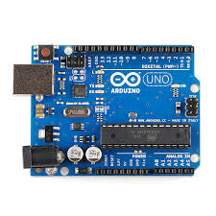
Arduino has the 14 digital input pins and 6 analogue input pin which can be works as the output pins along with the USB port to attached with the other microcontroller or microprocessor and also having the power supply port for input voltages which is 5V at which Arduino operates and initiates its functions. The illustrate of Arduino UNO can be seen in following figure 3.2 ;
Figure 3.2 Arduino UNO

3.4.1 Pin Configuration:
Embedded system is interfaced with the Arduino UNO with the input and output pins also with the analogue and digitals ports of the Arduino. In the figure 3.3 the configuration of pinouts of Arduino UNO can be shown [38];

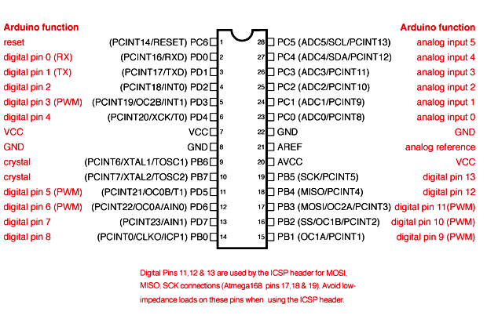

Figure 3.3 Pinout configuration of Arduino UNO

3.5 Ultrasonic Sensor:
Ultrasonic sensor as shown in figure 3.4 is the tool which is used to measure the distance of an object by ultrasonic waves. In this project we are using HC-SR04 ultrasonic sensor for detecting any obstacle and hurdle coming along the way. This sensor consists of transmitter that generates the ultrasonic wave and the receiver which collect the reflected wave coming back after reflection on the object place at some distance. It has 4 pins VCC, ground, echo and trigger which are connected with Arduino and programmed with specific coding to perform its function. In fig 3.5.1 the four pins of ultrasonic sensor can be seen clearly and the specifications of HC-SR04 are described in the table 3.2 as following[39];

Table 3.2 Specification of HC-SR04

Specification | Range
Operating Voltages | 5V
Operating Current | <15mA
Operating Frequency | 40Hz
Measuring Distance Range | 2cm to 400cm
Accuracy | 300cm
Effective Measuring Angle | 15°

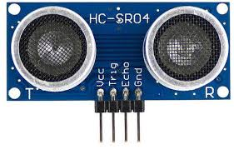
Figure 3.4 HC-SR04 Ultrasonic sensor

3.5.1 Working of ultrasonic sensor:
Ultrasonic consist of four pins. The GND pin used as ground purpose and VCC pin used as input voltages pins. The other two are the main pins Echo and Trig which play main role in working principle of ultrasonic sensor. The ultrasonic wave as shown in figure 3.5 emits from the Trigger pin as original signal and after colliding with the object as an obstacle in their specified distance it goes back to the echo pin as reflected signal and initiate the principle of ultrasonic sensor and signals the buzzer or vibration motor to operates can be animatedly see in the following figure 3.5[40];

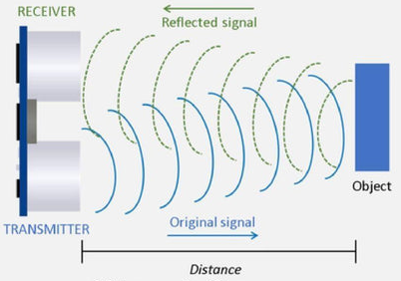

Figure 3.5 Working principle of Ultrasonic sensor

The configuration of HC-SR04 Pinout is
1. VCC
2. TRIG
3. ECHO
4. GND

3.5.2 Flow Chart of Ultrasonic Sensor:
The flow chart of obstacle detection system of proposed project can be shown in figure 3.6 as below ;

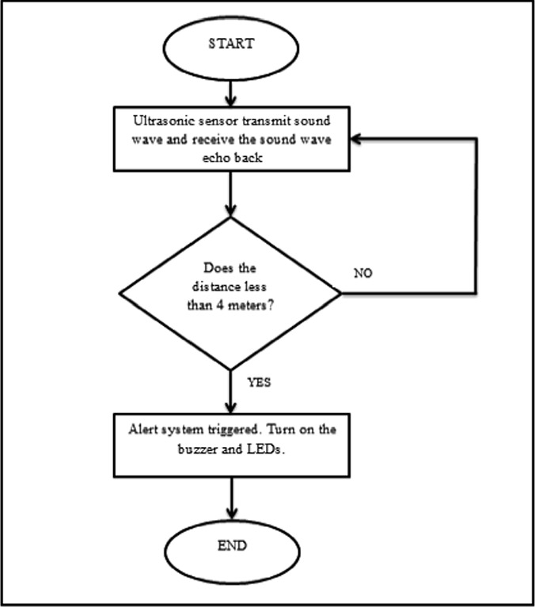

Figure 3.6 flow chart of Ultrasonic sensor

3.6 GSM Module:
GSM module is the miniature modem as shown in the figure 3.7 which is used to make communication network between two parties. Basically, it is the chip or a circuit that is used to correspondence between the mobile device and computing machine having the features of GPS or GPRs system.AS in the proposed system it is used to make a connection between the smart stick of blind persons to the mobile phone of their guardians. In the project we are using SIM800 GSM Module that will work along with the programming on Arduino to perform some tasks. We are using this module in our emergency situation system due to which smart stick user can send an emergency alert to his/her guardian. There are some features of GSM module as given[41];

- Its operating voltages are 3.2-4.3V.
- Its Quad Band consists of 850/900/1900MHz.
- It is used to send/receive audio calls by an external speaker.
- It is used to send/receive text messages.
- It can send/receive GPRs data.
- It accepts Micro SIM.
- It has 12 pins for connection with the Arduino.
- Its working temperature ranges to -40° C to + 85 ° C.
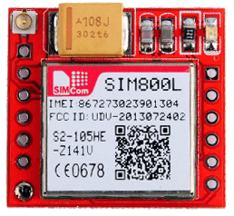

Figure 3.7 GSM Modem SIM800

3.7 GPS Module:
GPS Module is works on the Global Positioning System which is used to determine the navigation and location of something. It provides the location in latitude, longitude and altitude. In this project we are implementing NEO-6M GPS Module which is linked with the GSM module to locate and navigate the location of smart stick user and send along with emergency alert to their guardians. Some features of NEO-6M GPS Module are shown in the following table 3.3 [42];

Table 3.3 specification of GPS Module
Receiver Type | 50 Channels
Navigation Update Rate | 1 – 5Hz
Operating Voltage | 2.7 – 3.6V
Operating Current | 45mA
Operating Temperature | -40°C ~ 85°C
Horizontal Position Accuracy | 2.5m

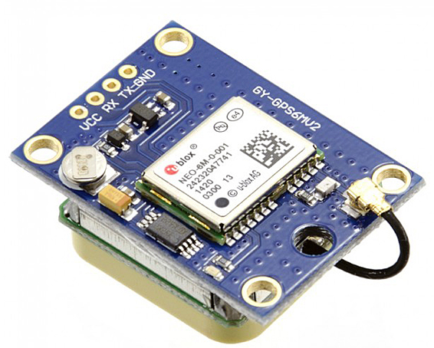

Figure 3.8 NEO-6M GSM Module

3.8 Buzzer
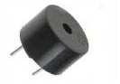
Buzzer is the electronic component as shown in figure 3.9 which produces the sound waves through the transmission of electric signals. Its primary function to produce audible alert signal that typically operates at 5V to 7V. In the proposed system, we are using buzzer for the audible alert for obstacle detection from ultrasonic sensor.

Figure 3.9 Buzzer
33

3.8.1 Working of Buzzer
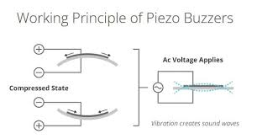
The core of the Piezoelectric buzzer is the piezoelectric effect. The main component is piezoelectric element in this buzzer. It is composed of two types of elements. One is piezoelectric ceramic and another element is metal plate. The metal plate and piezoelectric disc are held together. When an alternating current passes through this device, the piezoelectric material will shrink and expand. It will produce a vibration which will cause creating sound waves that is shown in the figure 3.10 ;
Figure 3.10 Working principle of buzzer

3.9 Vibration Motor
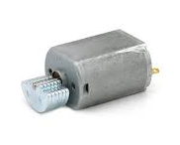
Vibration motors are technical devices as shown in the figure 3.11 that generates and transmit mechanical vibration. In this project we are using vibration motor for alerting blind person when any obstacle detected by ultrasonic sensor.
Figure 3.11 Vibration motor

3.10 Push Button
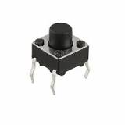
Push button is the type of switch as shown in the Figure 3.12 applies on simple air switch mechanism and electric mechanism to control the electric circuit manually by pressing it. It will switch ON and OFF according to its mechanism. Push button has been used in this project as an emergency button as when blind person presses the button in any emergency situation then the SMS will be sent to the save number in the microcontroller so that the guardian and caretaker of blind person can know about that they need some help.
Figure 3.12 Push button

3.11 DC buck converter
DC buck converter is a simple step-down converter. In this project, we used this for GPS and GSM modules because they operate on 3.3V and we have 5V from Arduino so we use LM2596s DC-DC buck converter as shown in figure 3.13.

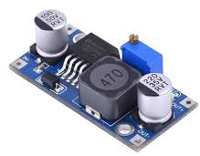

Figure 3.13 DC Buck Converter

CHAPTER 04

Design & Implementation

In this chapter all the material and methods are discussed which are used in the implementation of Smart Stick for blind person. First, the hardware implementation of proposed system will be discussed.

4.1 Hardware Implementation
The hardware implementation of Smart stick involves the integrating various sensors as ultrasonic sensors and modules such as GPS, GSM module into the microcontroller Arduino UNO to detect the obstacles and used for an emergency alert button respectively. It includes;
- Circuit diagram of Smart Stick.
- Circuit description of proposed system.

4.2 Software Implementation
Software implementation of smart stick requires the proper coding for sensor on the proper platform. In this proposed system as we use Arduino UNO as a microcontroller. So, we used Arduino IDE software for its coding. Software requirements for Smart stick includes:
- Arduino IDE
- Proteus
- Coding

4.1.1 Circuit Diagram of Smart Stick
The figure shown in figure 4.1 represents the basic diagram of circuit of smart stick as our proposed system.

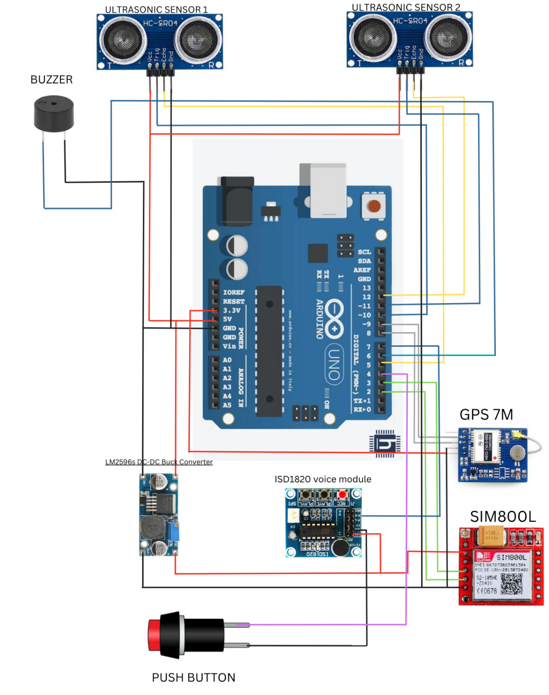
Figure 4.1 Circuit Diagram of Proposed system

4.1.2 Circuit description of Obstacle Detection Unit
In this circuit we have used two ultrasonic sensors for the detection of any obstacle and hurdle come across the way of blind person. To integrate these two sensors with the brain of project Arduino UNO we configure their pins in following ways;
- The GND pin of both Ultrasonic sensor HC-SR03 connected with the GND of Arduino Uno.
- The VCC of Ultrasonic sensors are connected with pin 5V of Arduino UNO
- The ECHO pin of both sensors is connected with the number 5 and 12 digital input pins of Arduino UNO.
- The TRIG pin of both ultrasonic sensors is connected on ~1o and ~11 pin of UNO.
- The P-E pin of voice module ISD-1820 connected with the digital pin 7 of Arduino UNO.
In the obstacle unit , the ultrasonic sensors trigger out the ultrasonic ways and when something will come along the way of these waves then a distortion of wave occurs and it reflects back to ultrasonic sensor . This returning signal will initiate the Uno and then that will give us the output in the form of buzzer sound and human voiceover in English language.
When the bottom one ultrasonic sensor detects anything coming across the way of blind person then the output will be in the form of buzzer sound.
When the middle one ultrasonic sensor detects any hurdles that comes along the way like some signboards, high furniture and any other hurdle like that then it will initiate the voice module which produce the sound of human voice over alerting the blind person by speaking up aloud “Obstacle detects from front”.
By these two different alert systems the blind person will know the hurdles of way and get himself and safe navigation by changing their route accordingly.
So. Basically the purpose of implementing these both ultrasonic sensor is to aware the blind person about obstacle in advance and provide them a safe and easy navigation .

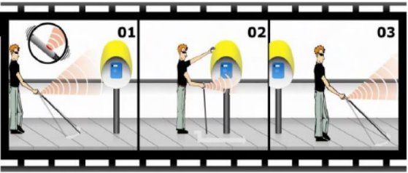

Figure 4.2 Graphical representation of obstacle detection by ultra-sonic sensors

4.1.3 Circuit description of Emergency Alert system:
In the section of emergency alert system, GSM and GPS module are used for the universal communication and send the emergency SMS along with the location of blind person at that time when emergency push button is being pressed to the guardian or family member of blind person .So , that the guardians and family member of blind person can reach him/her in their emergency situation. The configuration of GSM and GPS module with the Arduino Uno is describes as;
- The GND pin of GPS module is for the ground purpose and attached along the circuit.
- The VCC pin of GPS module is for Input pin and attached to the 5V power pin of Arduino.
- The Rx pin of GPS module is attached to the ~9 digital pin of Arduino.
- The Tx pin of GPS module is attached to 8 digital pins of Arduino.
- The first pin of GSM module is attached to 3 digital pins of Arduino.
- The second pin of GSM module is attached to 2 digital pins of Arduino.
- Both Power and GND pins of GSM module is attached to the power and GND pin of Arduino.
In the emergency alert system, the push button is used which is directly integrated with the GSM and GPS module .By pressing that push button the Arduino initiates the process of GPS and GSM module to send tan alert SMS with location of that time to the guardian of blind person .So, that the guardians can reach them and help them if they needed.

4.2.1 Arduino IDE
The Arduino IDE is the simple-to-use programming software generally used for the coding of Arduino. Its full form is Arduino IDE (Integrated Development Environment). The program simplifies the process of developing websites and applications by utilizing a community-driven framework and a simple interface. To utilize beginner-friendly software, there is no need for any technical skills or knowledge. By using the concepts of C++ programming in the different codes for the different outcomes we can generate results according to our will.

4.2.2 Proteus
Proteus is a piece of software that enables the creation of schematics, PCB layouts, code, and even simulations of schematics. The Proteus Design Suite is a closed-source software application suite primarily used for electronic design automation. Electronic design experts and technicians mostly use the software to develop schematics and electronic prints for the purpose of producing printed circuit boards. Proteus in our project is used for the purpose of simulation of proposed idea .

4.2.3 Coding
Coding is the nervous system of brain of our proposed project . Coding has to be done in the Arduino UNO for obtaining the outcomes of sensors and modules integrated with it . The simple C++ coding has been done on the Arduino’s official recommend software Arduino IDE for both obstacle detection unit and emergency alert system.

CHAPTER 05

Results and Simulation

5.1 Hardware
The implementation of smart stick for visually impaired persons and blind persons demonstrated significant improvements in obstacle detection and navigation. When compared to typical white canes, quantitative data gathered from user trials showed a higher success rate for successfully navigating complicated surroundings. Participants' comments emphasized how features like obstacle recognition and real-time feedback increased their confidence and made for a more independent mobility experience.
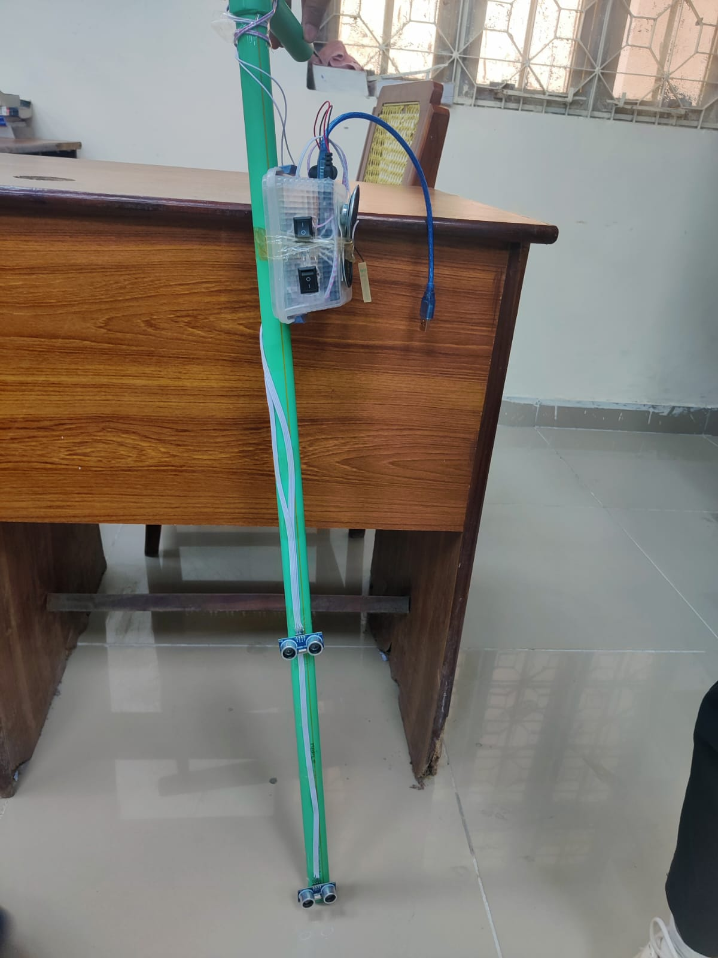
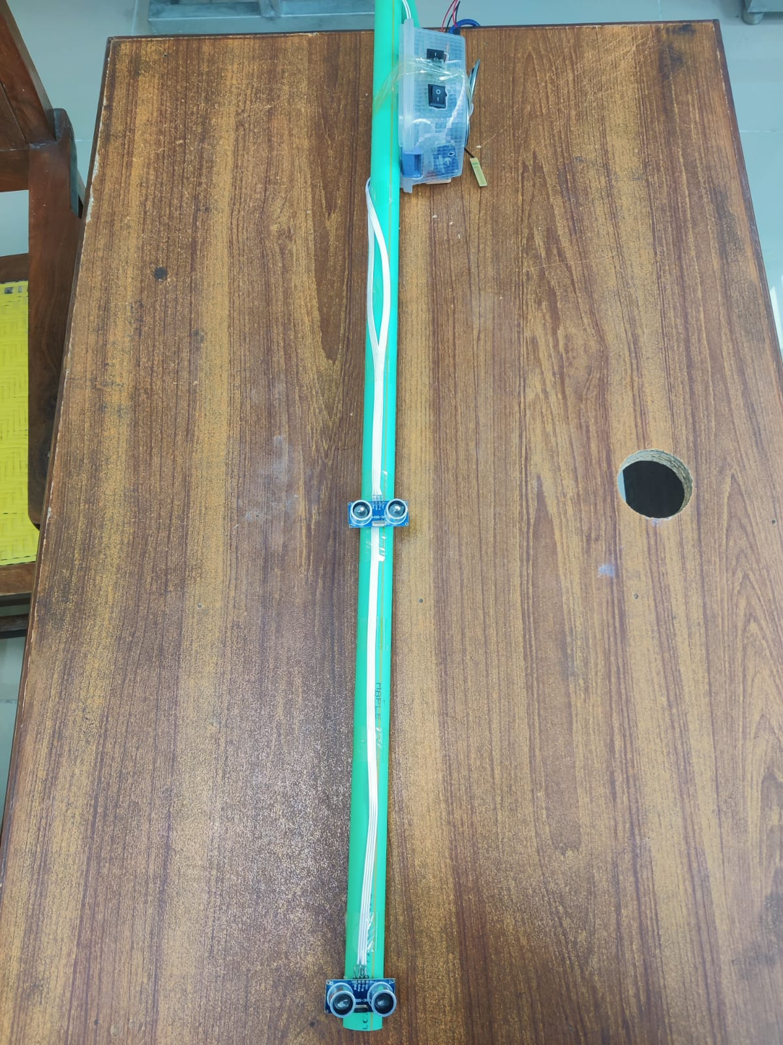
The hardware of proposed smart stick can be seen in figure 5.1 as below:
Figure 5.1 Hardware illustration of Smart stick

5.2 Emergency Alert SMS

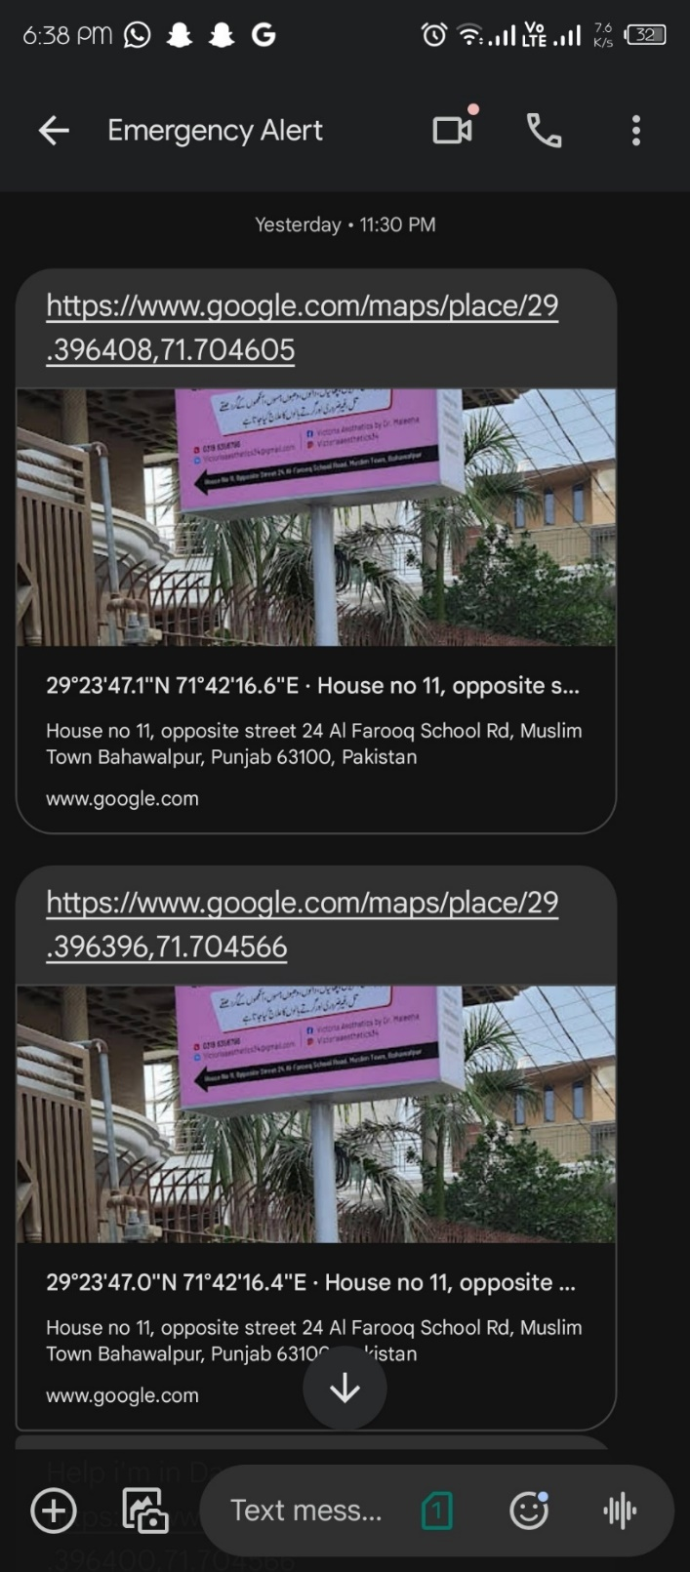
The figure 5.2 shows the result of emergency push button as by pressing the guardian’s mobile got a message along with the location of blind person .
Figure 5.2 Result of Emergency Alert System

5.3 Simulation
We made the simulation for the smart stick on the software named as proteus. The simulation of both obstacle detection unit and emergency alert system has done by separately as well as combined which is shown in figurers below.

5.3.1 Simulation of Ultrasonic sensors
The simulation of ultrasonic sensors has prepared on the proteus software . After detection the obstacle in the way of ultrasonic sensor , then the Arduino initiates the buzzer as the output for alerting signal as shown in the figure 5.3 :

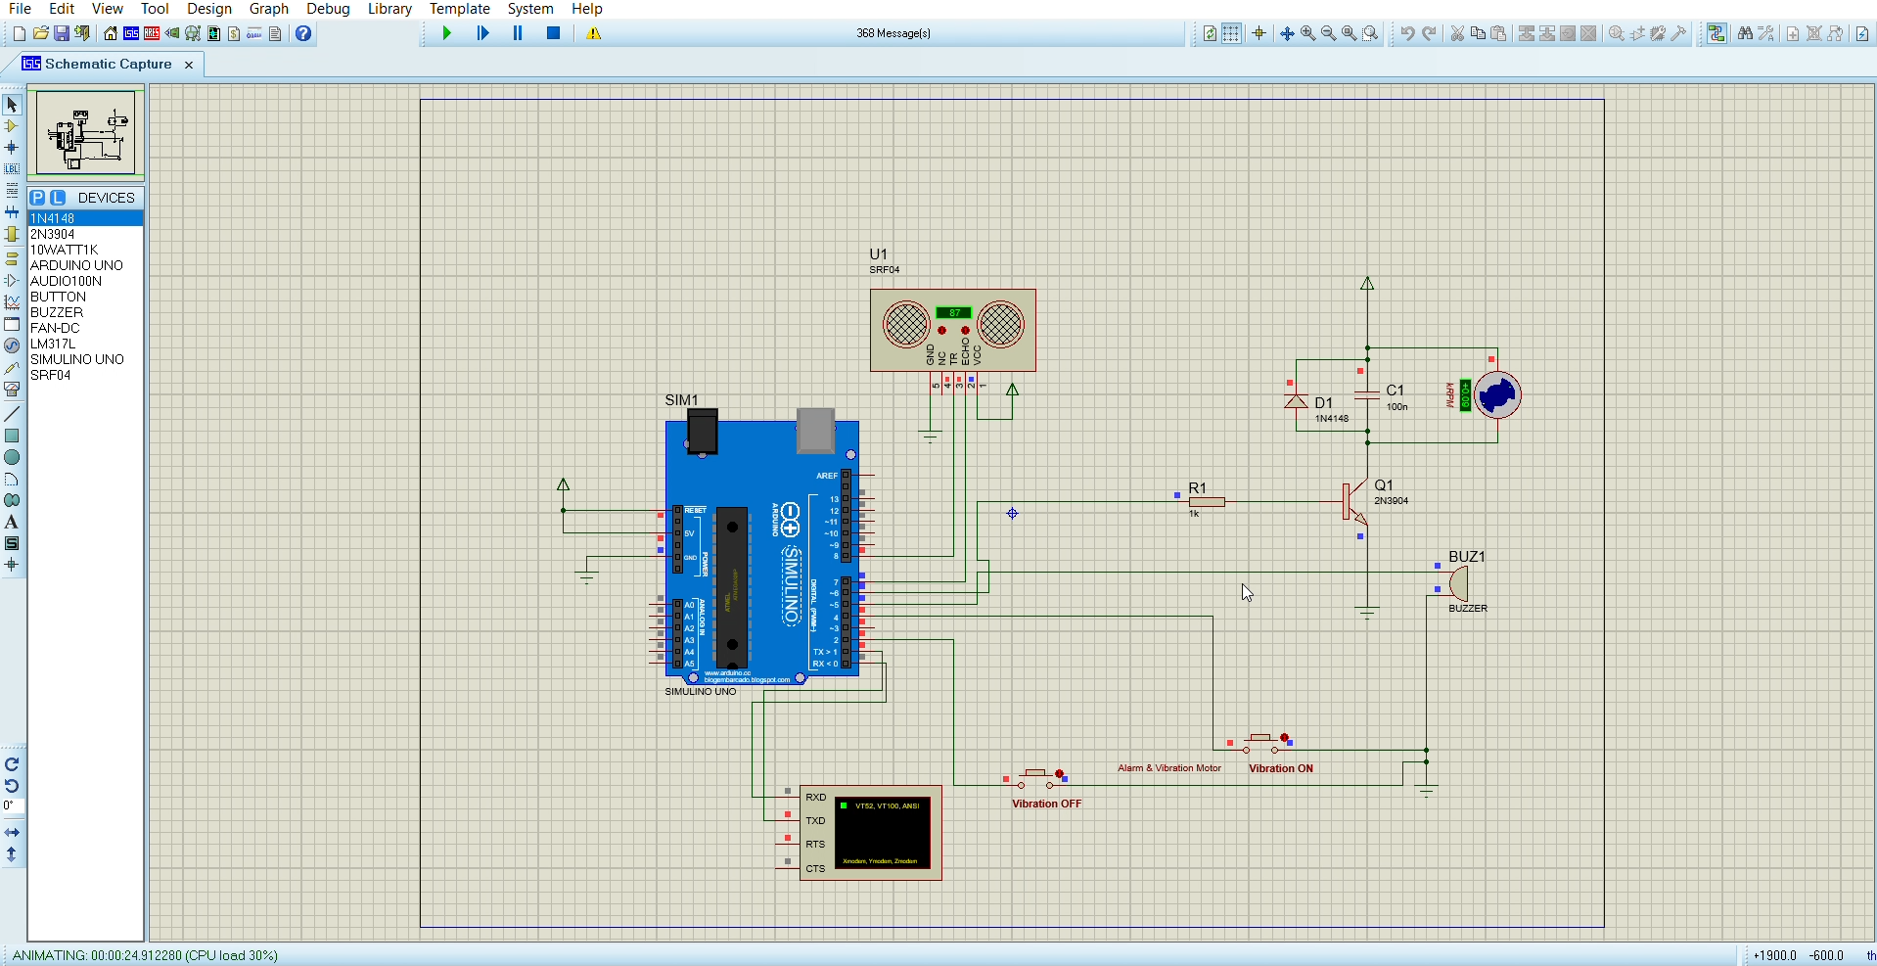

Figure 5.3 Simulation of Ultrasonic sensor

5.3.2 Simulation of GSM and GPS Modules
Similarly , the simulation of GSM and GPS Module has also integrated on the proteus software . When the emergency button has been pressed then the GPS gets the location and GSM module sends that location along with already fed emergency message to the saved contact number of blind person . The Simulation result shown in the figure 5.4 :
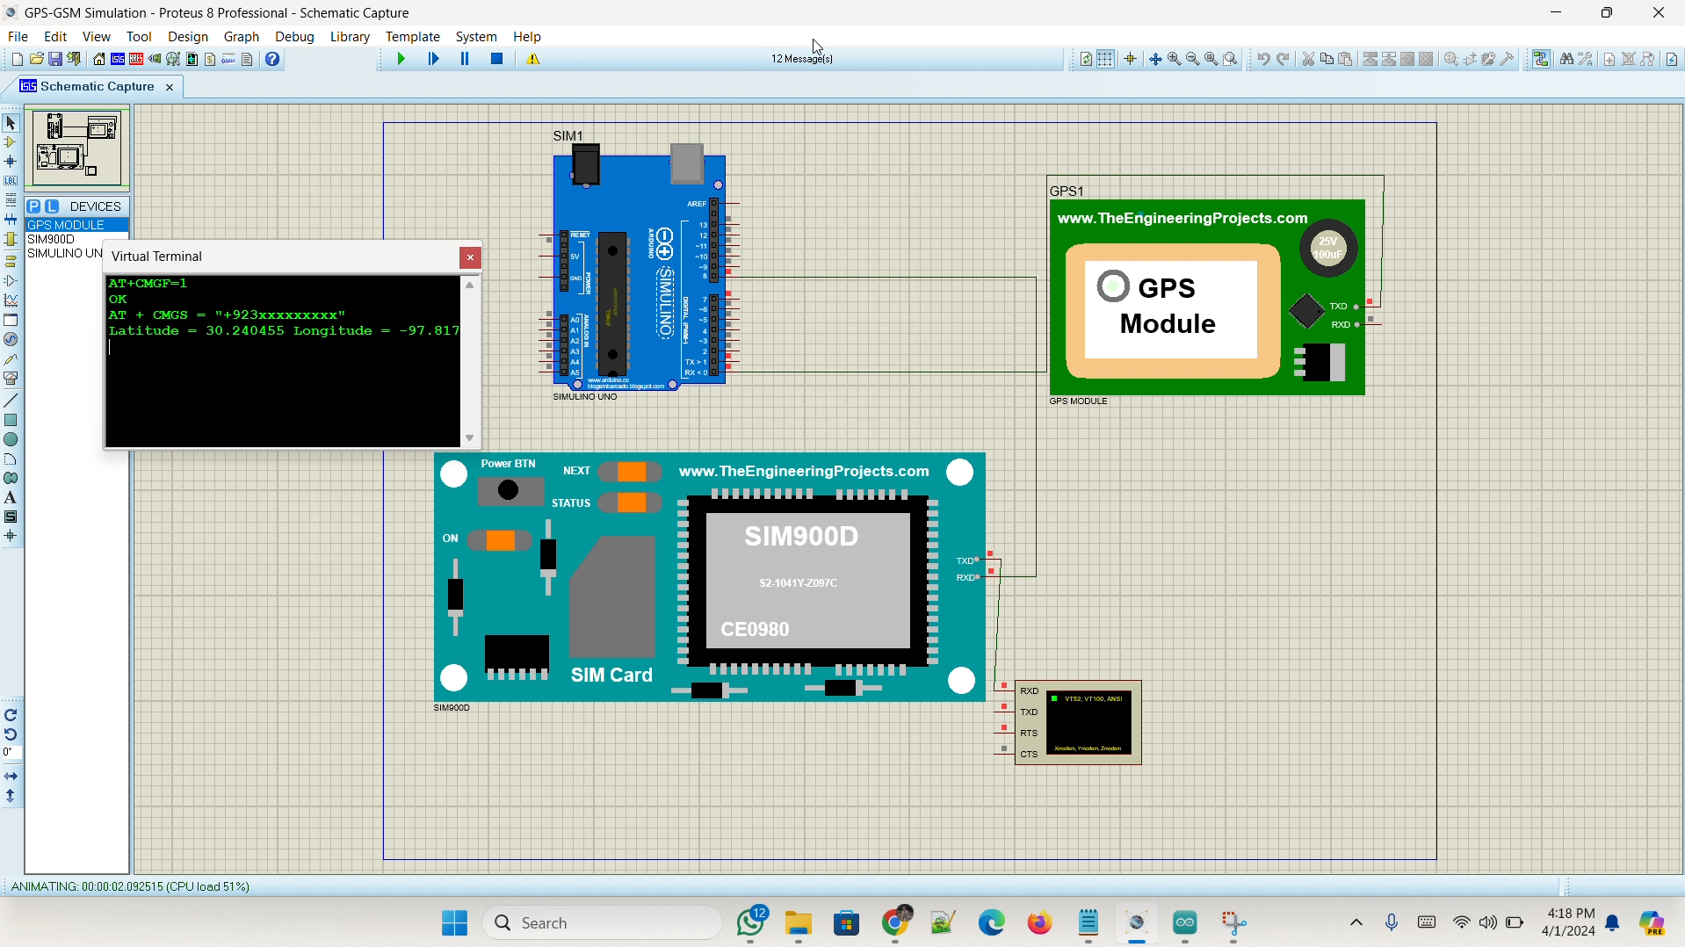

Figure 5.4 Simulation of GSM &GPS Module

5.3.3 Simulation of proposed system

The figure 5.5 shows the simulation of proposed stick along with the ultrasonic sensor for the obstacle detection purpose and the GPS and GSM modules that are used for the emergency situation .
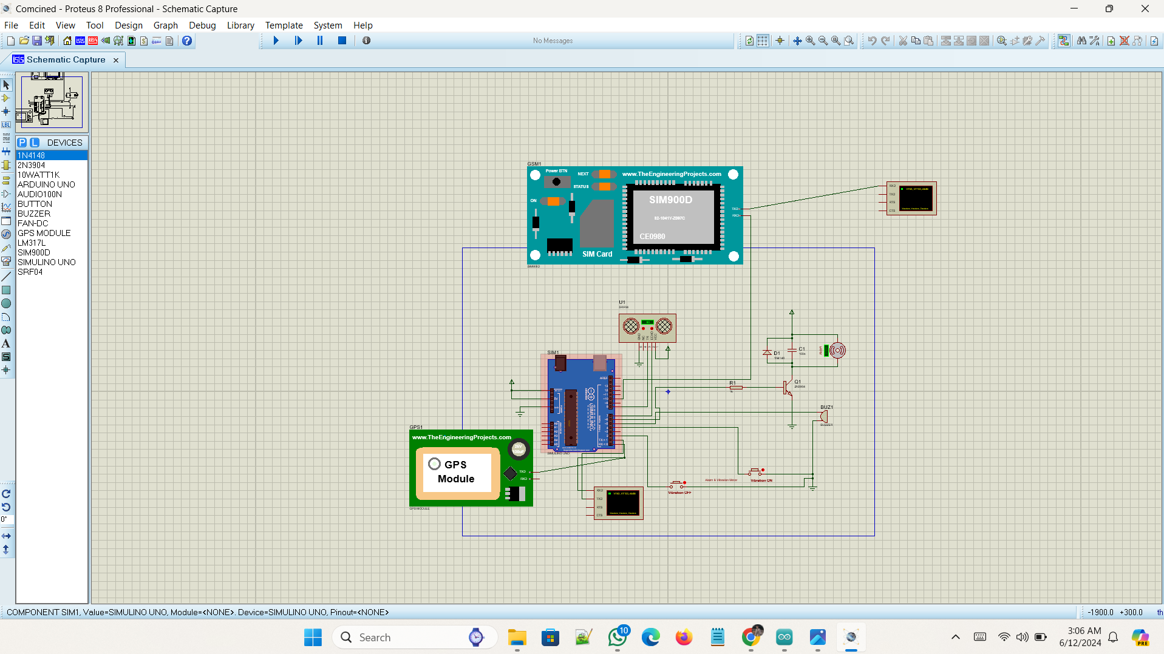

Figure 5.5 Proteus simulation of proposed system

CHAPTER 06

Conclusion

6.1 Summary
Smart stick for blind person is an assistive device which is significantly enhanced the mobility, safety and independence of visually impaired persons and blind persons. Because in the daily routine of life of blind person there are many challenges at their every step as they feel difficulty to mobile freely and safely around the surroundings. Traditionally, blind person uses white cans which can give them physical supports but limited in providing real time obstacle detection to prevent them from any injury and real time navigation system to move freely. Furthermore, White cans does not have any emergency communication capabilities.
So, these challenges of daily life of Blind persons motivates us to develop the engineering system that can give them all the necessities that any blind person should have to move independently and safely. For this the first priority is to develop obstacle detection system due to which blind person can move safely with no worries of any accident and injury. The ultrasonic sensors are embedded in the stick for this purpose which can detect the obstacles from a distance and signals the Arduino to initiate the buzzer sound or vibration as an alert signal. So, that Smart Stick user can adapt the route accordingly. Furthermore, the GPS and GSM module are implanted in the smart stick which perform the function of real time navigation and emergency communication with the user’s family or friends in case they need help.

6.2 The Engineer and Society
In the technological and modest era of life, everything is going to relying on the smart system proposed and updating by the scientists and engineer. Similarly, the implementation of Smart Stick for the blind persons plays the crucial role of engineering technology in the society. As, engineers are capable of developing the systems that can be helpful for the humans and that take less time to perform things which human take long. So, the smart stick is an engineering gadget that is proposed for the betterment and safety of blind persons to get them some ease of life in their daily routine of life. Society along with the engineers is responsible for getting the idea to proposed this system and also is the motivation to implement in the society. So that, everybody who needs Smart Stick can use and get benefits from it. Essentially, engineers and society must maintain a reciprocal relationship, collaborating and supporting each other in their respective efforts. Firstly, Engineers developed the system with all the specifications and features that are the useful and need of target users. Then the society have to play role in proposing this system by supporting the developed project as an assistive aid and for the adaption purpose. In this regard engineer and society both develop the smart stick for the blind person that improves the mobility, safety and independency of visually impaired and blind persons.

6.3 Environment and Sustainability
In development and implementation of smart stick the concept of environment and sustainability is kept in the mind as to ensure the device’s effectiveness on the environment and surroundings. Utilizing and implementing the eco-friendly components as recycled materials, energy efficient electronic equipment which can be helpful in green environment without any waste production. Energy efficiency includes the rechargeable batteries, or use of renewable power production as solar energy production for the instant and charging or power supply of smart stick. Additionally, the smart stick is designed with the features of addition and upgrading methods also with the concept of recycling. So, the implementation of smart stick does not only provide the safety and independence but also full fills the commitment of environment and sustainability development.

6.4 Lifelong Learning
Lifelong learning is the key component of smart stick project for blind persons as it offers the uses and continuous enhancement of the stick. To make sure that smart stick is cutting edge of innovation, engineers and designers participate in ongoing learning, maintaining current on developments in sensor technology, communication systems, and assistive gadgets. Through training programs, users can further develop their lifelong learning and become proficient in using the smart stick for communication and navigation. Furthermore, constant adaptation to innovations in technology guarantees that the smart stick maintains up with new developments and trends, keeping its usefulness and effectiveness in improving the safety and mobility of people with visual impairments and blind persons.

6.5 Conclusion
In conclusion, the development and implementation of Smart Stick for blind persons properly fills the require objectives and features proposed for this project. There are two main primary objectives. First one is to provide the user safe navigation without any accident and injury which is done by the obstacle detection system by using ultrasonic sensors. Ans the other objective is to make a communication panel between the blind person and caretaker to communicate with each other in emergency situation and incase blind person needs help only a push button far away them which is completed by the integrated circuit designing of GSM and GPS module with Arduino UNO to perform the task of sending msg/call on the saved number of smart stick users guardian as an alert message so that they can approach them and save them.
As this stick meets the objectives so, by implementing this a visually impaired person and blind person can move freely, safely and independently without any hesitation and accident situation. Compared to the simple featureless white canes this smart stick proves the most effective, more efficient, more convenient, low cost, less weighted and illuminated with the smart features that is the perfect assistance for visually impaired persons and blind persons.

6.6 Future Scope
The future scope of the smart stick for blind persons includes the several areas of development as follow;
- Obstacle detection system can be more efficient by using advanced sensors
- Navigation system can be developed by machine learning for indoor as well as outdoor surroundings.
- Feature of health monitoring system can be added.
- Addition of customization of length, color, weight, size, features, range, intensity and alerts.
- Real time audio and video assistance feature can be implemented.
- Solar power energy system can be deployed for energy efficient system

ANNEXURE A

Coding for Obstacle Detection Unit (Ultrasonic Sensor)
#define TRIGGER_PIN1 5
#define ECHO_PIN1 10
#define TRIGGER_PIN2 11
#define ECHO_PIN2 12
#define BUZZER_PIN1 6
#define BUZZER_PIN2 7
#define MAX_DISTANCE 200
#define MIN_DISTANCE 10

void setup() {
pinMode(TRIGGER_PIN1, OUTPUT);
pinMode(ECHO_PIN1, INPUT);
pinMode(BUZZER_PIN1, OUTPUT);
pinMode(TRIGGER_PIN2, OUTPUT);
pinMode(ECHO_PIN2, INPUT);
pinMode(BUZZER_PIN2, OUTPUT);
Serial.begin(9600);
}

void loop() {
long duration1, distance1;
long duration2, distance2;

// Sensor 1
digitalWrite(TRIGGER_PIN1, LOW);
delayMicroseconds(2);
digitalWrite(TRIGGER_PIN1, HIGH);
delayMicroseconds(10);
digitalWrite(TRIGGER_PIN1, LOW);

duration1 = pulseIn(ECHO_PIN1, HIGH);
distance1 = (duration1 / 2) / 29.1;

Serial.print("Distance1: ");
Serial.print(distance1);
Serial.println(" cm");

if (distance1 < MIN_DISTANCE) {
// Obstacle is very close, continuous beep
tone(BUZZER_PIN1, 1000); // 1000Hz tone
} else if (distance1 < 30) {
// Obstacle is approaching, short beeps
tone(BUZZER_PIN1, 2000); // 2000Hz tone
delay(100); // Delay for 100ms
noTone(BUZZER_PIN1); // Turn off the buzzer
delay(100); // Delay for 100ms
} else {
// No obstacle, no sound
noTone(BUZZER_PIN1);
}

// Sensor 2
digitalWrite(TRIGGER_PIN2, LOW);
delayMicroseconds(2);
digitalWrite(TRIGGER_PIN2, HIGH);
delayMicroseconds(10);
digitalWrite(TRIGGER_PIN2, LOW);

duration2 = pulseIn(ECHO_PIN2, HIGH);
distance2 = (duration2 / 2) / 29.1;

Serial.print("Distance2: ");
Serial.print(distance2);
Serial.println(" cm");

if (distance2 < MIN_DISTANCE) {
// Obstacle is very close, continuous beep
tone(BUZZER_PIN2, 1000); // 1000Hz tone
} else if (distance2 < 30) {
// Obstacle is approaching, short beeps
tone(BUZZER_PIN2, 2000); // 2000Hz tone
delay(100); // Delay for 100ms
noTone(BUZZER_PIN2); // Turn off the buzzer
delay(100); // Delay for 100ms
} else {
// No obstacle, no sound
noTone(BUZZER_PIN2);
}

delay(200); // Delay between measurements
}

ANNEXURE B

Coding for Emergency Alert System (GPS &GSM)

#include <SoftwareSerial.h>
#include <TinyGPS++.h>

float lattitude, longitude; // Create variable for latitude and longitude
const int buttonPin = 4; // Set the button pin number
SoftwareSerial gpsSerial(8, 9); // TX, RX for GPS
SoftwareSerial gsmm(2, 3); // TX, RX for GSM
TinyGPSPlus gps; // Create GPS object

void setup() {
Serial.begin(9600);

gpsSerial.begin(9600);
gpsSerial.listen();

Serial.println("Starting GPS...");
textgps(); // Acquire GPS coordinates

gsmm.begin(9600);
gsmm.print("\r");
delay(1000);
gsmm.print("AT+CMGF=1\r");
delay(1000);

gsmm.print("AT+CMGS=\"03473177517\"\r");
delay(1000);

// The text of the message to be sent.
gsmm.print("https://www.google.com/maps/place/");
gsmm.print(lattitude, 6);
gsmm.print(",");
gsmm.print(longitude, 6);

delay(1000);
gsmm.write(0x1A);
delay(1000);
}

void loop() {
// Keep the loop empty or add any additional code here if needed
}

void textgps() {
unsigned long start = millis();
while (millis() - start < 5000) { // Try for 5 seconds to get a GPS fix
while (gpsSerial.available() > 0) {
gps.encode(gpsSerial.read());
}

if (gps.location.isUpdated()) {
Serial.print("LAT=");
Serial.println(gps.location.lat(), 6);
Serial.print("LONG=");
Serial.println(gps.location.lng(), 6);
lattitude = gps.location.lat();
longitude = gps.location.lng();
return; // Exit the function once coordinates are obtained
}
}

Serial.println("Failed to get GPS data within 5 seconds.");
}

ANNEXURE C

Combined code of both system
#include <SoftwareSerial.h>
#include <TinyGPS++.h>

float latitude, longitude; // Create variable for latitude and longitude
const int buttonPin = 4; // Set the button pin number
SoftwareSerial gpsSerial(8, 9); // TX, RX for GPS
SoftwareSerial gsmm(2, 3); // TX, RX for GSM
TinyGPSPlus gps; // Create GPS object

#define TRIGGER_PIN1 5
#define ECHO_PIN1 10
#define TRIGGER_PIN2 11
#define ECHO_PIN2 12
#define BUZZER_PIN1 6
#define BUZZER_PIN2 7
#define MAX_DISTANCE 200
#define MIN_DISTANCE 10

void setup() {
pinMode(buttonPin, INPUT_PULLUP); // Configure button pin as input with internal pull-up resistor
pinMode(TRIGGER_PIN1, OUTPUT);
pinMode(ECHO_PIN1, INPUT);
pinMode(BUZZER_PIN1, OUTPUT);
pinMode(TRIGGER_PIN2, OUTPUT);
pinMode(ECHO_PIN2, INPUT);
pinMode(BUZZER_PIN2, OUTPUT);
Serial.begin(9600);
gpsSerial.begin(9600);
gsmm.begin(9600);
gpsSerial.listen();

Serial.println("Starting GPS...");
}

void loop() {
// GSM/GPS functionality
if (digitalRead(buttonPin) == LOW) { // Check if the button is pressed
delay(50); // Debounce delay
if (digitalRead(buttonPin) == LOW) { // Check if the button is still pressed
while (digitalRead(buttonPin) == LOW); // Wait for button release

textgps(); // Acquire GPS coordinates

gsmm.print("\r");
delay(1000);
gsmm.print("AT+CMGF=1\r");
delay(1000);

gsmm.print("AT+CMGS=\"03473177517\"\r");
delay(1000);

// The text of the message to be sent.
gsmm.print("https://www.google.com/maps/place/");
gsmm.print(latitude, 6);
gsmm.print(",");
gsmm.print(longitude, 6);

delay(1000);
gsmm.write(0x1A);
delay(1000);
}
}

// Ultrasonic sensor functionality
long duration1, distance1;
long duration2, distance2;

// Sensor 1
digitalWrite(TRIGGER_PIN1, LOW);
delayMicroseconds(2);
digitalWrite(TRIGGER_PIN1, HIGH);
delayMicroseconds(10);
digitalWrite(TRIGGER_PIN1, LOW);

duration1 = pulseIn(ECHO_PIN1, HIGH);
distance1 = (duration1 / 2) / 29.1;

Serial.print("Distance1: ");
Serial.print(distance1);
Serial.println(" cm");

if (distance1 < MIN_DISTANCE) {
// Obstacle is very close, continuous beep
tone(BUZZER_PIN1, 1000); // 1000Hz tone
} else if (distance1 < 30) {
// Obstacle is approaching, short beeps
tone(BUZZER_PIN1, 2000); // 2000Hz tone
delay(100); // Delay for 100ms
noTone(BUZZER_PIN1); // Turn off the buzzer
delay(100); // Delay for 100ms
} else {
// No obstacle, no sound
noTone(BUZZER_PIN1);
}

// Sensor 2
digitalWrite(TRIGGER_PIN2, LOW);
delayMicroseconds(2);
digitalWrite(TRIGGER_PIN2, HIGH);
delayMicroseconds(10);
digitalWrite(TRIGGER_PIN2, LOW);

duration2 = pulseIn(ECHO_PIN2, HIGH);
distance2 = (duration2 / 2) / 29.1;

Serial.print("Distance2: ");
Serial.print(distance2);
Serial.println(" cm");

if (distance2 < MIN_DISTANCE) {
// Obstacle is very close, continuous beep
tone(BUZZER_PIN2, 1000); // 1000Hz tone
} else if (distance2 < 30) {
// Obstacle is approaching, short beeps
tone(BUZZER_PIN2, 2000); // 2000Hz tone
delay(100); // Delay for 100ms
noTone(BUZZER_PIN2); // Turn off the buzzer
delay(100); // Delay for 100ms
} else {
// No obstacle, no sound
noTone(BUZZER_PIN2);
}

delay(200); // Delay between measurements
}

void textgps() {
unsigned long start = millis();
while (millis() - start < 5000) { // Try for 5 seconds to get a GPS fix
while (gpsSerial.available() > 0) {
gps.encode(gpsSerial.read());
}

if (gps.location.isUpdated()) {
Serial.print("LAT=");
Serial.println(gps.location.lat(), 6);
Serial.print("LONG=");
Serial.println(gps.location.lng(), 6);
latitude = gps.location.lat();
longitude = gps.location.lng();
return; // Exit the function once coordinates are obtained
}
}

Serial.println("Failed to get GPS data within 5 seconds.");
}

References

[1] S. Mohite, M. Patel, K. J. Somaiya, A. Patel, and V. Gaikwad, “SMART WALKING STICK FOR VISUALLY IMPAIRED.” [Online]. Available: https://ssrn.com/abstract=3274784

[2] M. Ashok Utekar and S. N. Mohammad Bilal Assistant Professor, “Automated Hardware Module (Cane) for Visually Impaired Person to Detect Obstacles and Movement.” [Online]. Available: https://ssrn.com/abstract=3561649

[3] S. Khatri, Y. Besoya, V. Yadav, and S. Varshney, “I(Smart Stick For Visually Impaired),” 2019. [Online]. Available: https://ssrn.com/abstract=4349034

[4] S. Bele, S. Ghule, A. Gunjal, and N. D. Anwat, “International Conference on Communication and Information Processing Design and Implementation of Smart Blind Stick,” 2020. [Online]. Available: https://ssrn.com/abstract=3645413

[5] M. Ataur Rahman, R. Hasan, M. Julker Nayeem, and M. Rabiul Islam, “A SMART BLIND STICK FOR PERSONS WITH VISUAL IMPAIRMENT: DESIGN AND IMPLEMENTATION.” [Online]. Available: https://ssrn.com/abstract=4347535

[6] S. Desai, P. Waghela, R. Shah, and B. Madan, “SMART STICK FOR BLIND PEOPLE USING ULTRASONIC WAVES.” [Online]. Available: http://ssrn.com/link/2019-ICAST.html

[7] R. Suryakant Kolhe et al., “Smart Stick for The Blind and Visually Impaired People”, doi: 10.32628/IJSRSET.

[8] D. E. Gbenga, A. I. Shani, and A. L. Adekunle, “Smart Walking Stick for Visually Impaired People Using Ultrasonic Sensors and Arduino,” International Journal of Engineering and Technology, vol. 9, no. 5, pp. 3435–3447, Oct. 2017, doi: 10.21817/ijet/2017/v9i5/170905302.

[9] M. R. Abiramee, P. Nithya, M. M. Naveen Kumar, M. T. E. Samrood Muhammed, and S. Sowmiya, “SMART BLIND STICK USING VOICE MODULE,” International Research Journal of Engineering and Technology, [Online]. Available: www.irjet.net

[10] P. Patil, A. More, M. Rakshe, V. Badwe, and R. Patil, “Voice Assisted Blind Stick using Ultrasonic Sensor,” 2018. [Online]. Available: www.irjet.net
[11] S. H. Shinde, M. V. Munot, P. Kumar, and S. Boob, “Intelligent companion for blind: Smart stick,” International Journal of Innovative Technology and Exploring Engineering, vol. 8, no. 10, pp. 4251–4256, Aug. 2019, doi: 10.35940/ijitee.J9957.0881019.

[12] O. O. Shoewu, ; Oluwafemi, J. Ayangbekun, and D. O. Olayinka, “An Intelligent Walking Stick for the Blind in Indoor Environment,” 2020. [Online]. Available: http://www.akamaiuniversity.us/PJST.htm

[13] K. P. V. Vivek, “A Smart Wearable Guiding Device for The Visually Impaired People,” Int J Res Appl Sci Eng Technol, vol. 10, no. 6, pp. 1568–1572, Jun. 2022, doi: 10.22214/ijraset.2022.44153.

[14] E. D. Markus, F. Kulor, M. W. Apprey, and K. T. Agbevanu, “Low-cost electronic bamboo walking stick: an innovative assistive mobility aid for the blind,” Telkomnika (Telecommunication Computing Electronics and Control), vol. 20, no. 4, pp. 883–891, Aug. 2022, doi: 10.12928/TELKOMNIKA.v20i4.23758.

[15] S. A. Yahaya, L. J. Jilantikiri, G. S. Oyinloye, E. J. Zaccheus, J. O. Ajiboye, and K. A. Akande, “Development of Obstacle and Pit-Detecting Ultrasonic Walking Stick for the Blind,” FUOYE Journal of Engineering and Technology, vol. 4, no. 2, 2019.

[16] U. K. Alam, M. Al-Amin, F. Rabby, N. Bahar Chowdhury, and M. T. Islam, “Study of Construction a Technical Device Named Walking Stick for the Blind Using GPS.” [Online]. Available: www.noveltyjournals.com

[17] V. Abhilash, M. Shajive, T. Sathyajit, G. S. Nair, and A. Professor, “Advanced Electronic Walking Stick for Blind,” 2018. [Online]. Available: www.grdjournals.com

[18] D. S. Vidhya Delicia Perlin Rebelo, M. D. Cecilia Jane, S. Linford William Fernandes, and M. Clarissa Joella Costa, “Obstacle Detection using Ultrasonic Sensors,” IJIRST-International Journal for Innovative Research in Science & Technology|, vol. 2, no. 11, 2016.

[19] “An Efficient Object Detection System for the Blind People,” 2024.

[20] R. Dhanuja, F. Farhana, and G. Savitha, “SMART BLIND STICK USING ARDUINO,” International Research Journal of Engineering and Technology, [Online]. Available: www.irjet.net

[21] S. Mohite, M. Patel, K. J. Somaiya, A. Patel, and V. Gaikwad, “SMART WALKING STICK FOR VISUALLY IMPAIRED.” [Online]. Available: https://ssrn.com/abstract=3274784
[22] D. Z. Yanmida, A. S. Imam, and S. A. Alim, “Obstacle Detection and Anti-Collision Robot Using Ultrasonic Sensor,” ELEKTRIKA- Journal of Electrical Engineering, vol. 22, no. 1, 2023, doi: 10.11113/elektrika.v22n1.404.

[23] M. Adil, J. Ferdoush, M. A. Mahmud, T. Rafa, A. Mahmud, and A. Pathak, “An IoT based Voice Controlled Blind Stick to Guide Blind People.” [Online]. Available: https://www.researchgate.net/publication/339911393

[24] D. E. Gbenga, A. I. Shani, and A. L. Adekunle, “Smart Walking Stick for Visually Impaired People Using Ultrasonic Sensors and Arduino,” International Journal of Engineering and Technology, vol. 9, no. 5, pp. 3435–3447, Oct. 2017, doi: 10.21817/ijet/2017/v9i5/170905302.

[25] “Stick for Helping the Blind Person,” 2022.

[26] E. K. Payne and D. J. Harmah, “Development of Visually Impaired Guided System Using GPS, Sensors and Wireless Detection,” American Journal of Engineering Research (AJER), no. 5, pp. 121–126, 2016, [Online]. Available: www.ajer.org

[27] “ULTRASONIC BLIND STICK USING GPS TRACKING INTERANTIONAL JOURNAL OF SCIENTIFIC RESEARCH IN ENGINEERING AND MANAGEMENT,” 2024.

[28] “Development of e-stick for blind persons using IoT,” 2022.

[29] “Smart Blind Stick Using ESP32,” 2024.

[30] “IMPROVED ELECTRONIC BLIND STICK CIRCUIT,” Dec. 2023.

[31] “Blind People Stick Tracking Using Android Smartphone and GPS Technology,” 2022.
[32] “https://www.researchgate.net/publication/367501498_Third_Eye_for_Blind_Person,” 2023.

[33] Mihir Salunkhe, “Multifunctional Blind Stick Using Machine Learning – A Review,” 2022.

[34] Suman Rajest, Regin Rajan, and Steffi R, “Using Voice Guidance, an Intelligent Walking Assistance Mechanism for the Blind,” 2023.

[35] Husein Lubis, Nopi Purnomo, Feri Irawan, and Ararija, “AUTOMATIC INDICATOR SYSTEM ON DETECTORS FOR THE BLIND,” 2022.
[36]. Thirumalaiah G. ., Dheeraj Reddy, Kavitha P., and M. Sai Nivedhitha A., “A Voice-Assisted Walking Support for Visually Impaired People Utilizing an Wearable Sensor Network,” 2024.

[37] “https://www.tomsonelectronics.com/blogs/news/arduino-uno-specification. (visited on : March 10 , 2024).”

[38] “https://components101.com/microcontrollers/arduino-uno,” Mar. 2024.

[39] “https://lastminuteengineers.com/arduino-sr04-ultrasonic-sensor-tutorial/ (visited on : March 10 , 2024).”

[40] “https://www.elprocus.com/hc-sr04-ultrasonic-sensor-working-and-its-applications/ (visited on : March 10 , 2024)”.

[41] “https://lastminuteengineers.com/sim800l-gsm-module-arduino-tutorial/ (visited on : March 12 , 2024).”

[42] “https://electrobes.com/product/ublox-neo-6m-v2-gps-module/ (visited on : March 12 , 2024).”

