Smart Microgrid P2P Energy Trading System

Final Year Project - BS Electrical Engineering

Project Summary
This project implements a Blockchain-based Peer-to-Peer (P2P) Energy Trading System for smart microgrids. The system enables automated energy sharing between a solar-producing household and a neighboring consumer, with all transactions recorded on an immutable blockchain ledger. Additionally, an AI-based load prediction model forecasts future energy generation and consumption patterns.

Problem Statement
Traditional power grids operate on a centralized model where consumers can only purchase electricity from utility providers. With the rise of distributed energy resources (solar panels, home batteries), prosumers (producer-consumers) often generate excess energy that goes unutilized. Current solutions lack:
- Transparent peer-to-peer trading mechanisms
- Immutable transaction records
- Real-time monitoring and automation
- Predictive analytics for load management

Objectives
- Design and implement a P2P energy trading system between two households
- Develop automatic excess energy detection and transfer mechanism
- Integrate blockchain technology for transparent transaction recording
- Create a mobile application for real-time monitoring
- Implement AI-based load prediction for optimized energy management

Methodology

Hardware Implementation
- Energy Monitoring: PZEM-004T sensors measure voltage, current, power, and energy
- Microcontrollers: ESP32 modules for data acquisition and relay control
- Automatic Transfer: Relay module controlled based on excess energy availability

Software Implementation
- Smart Contract: Solidity-based contract on Ethereum blockchain (Ganache)
- Backend Server: Node.js with Web3.js for blockchain interaction
- Mobile App: Blynk IoT platform for real-time monitoring
- AI Model: LSTM neural network for 24-hour load prediction

System Architecture
┌─────────────────────────────────────────────────────────────────────┐
│ SMART MICROGRID SYSTEM │
├─────────────────────────────────────────────────────────────────────┤
│ │
│ ┌───────────────┐ ┌───────────────┐ │
│ │ HOUSE A │ Excess Energy │ HOUSE B │ │
│ │ (Producer) │ ──────────────────▶ │ (Consumer) │ │
│ │ Solar Panel │ via Relay │ │ │
│ └───────┬───────┘ └───────┬───────┘ │
│ │ │ │
│ │ WiFi │ WiFi │
│ ▼ ▼ │
│ ┌─────────────────────────────────────────────────────┐ │
│ │ BACKEND SERVER (Node.js) │ │
│ │ + Web3.js │ │
│ └─────────────────────────┬───────────────────────────┘ │
│ │ │
│ ▼ │
│ ┌─────────────────────────────────────────────────────┐ │
│ │ BLOCKCHAIN (Ganache - Ethereum) │ │
│ │ Smart Contract Layer │ │
│ └─────────────────────────────────────────────────────┘ │
│ │
└─────────────────────────────────────────────────────────────────────┘

Key Features
Feature | Description
Automatic Energy Transfer | Relay activates when solar excess exceeds 100W threshold
Blockchain Recording | Every transaction stored with cryptographic hash
Real-time Monitoring | Mobile app displays live power readings
AI Prediction | LSTM model forecasts next 24 hours of generation/consumption
Immutable Ledger | Transaction history cannot be altered or deleted

How It Works

Step 1: Energy Generation
House A has a solar panel that generates electricity. The PZEM sensor continuously measures how much power is being produced.

Step 2: Consumption Monitoring
Another sensor monitors how much power House A is consuming for its own appliances (lights, fans, etc.).

Step 3: Excess Calculation
The ESP32 microcontroller calculates: Excess Power = Solar Production - House A Consumption

Step 4: Automatic Transfer Decision
- If excess power ≥ 100W → Relay turns ON → Energy flows to House B - If excess power < 80W → Relay turns OFF → No transfer

Step 5: Blockchain Recording
Every 30 seconds, the transaction data is sent to the backend server, which records it on the blockchain with a unique cryptographic hash. This creates a permanent, tamper-proof record.

Step 6: Real-time Monitoring
Both houses can monitor their energy data in real-time through the Blynk mobile app, including power readings, transfer status, and transaction history.

Step 7: AI Prediction
The collected data is used to train an LSTM neural network that predicts the next 24 hours of solar generation and energy consumption, enabling better energy planning.

Simple Example
Scenario: House A’s solar panel produces 500W. House A uses 200W for its own needs.
Calculation: Excess = 500W - 200W = 300W
Action: Since 300W > 100W threshold, the relay activates and 300W flows to House B.
Record: Transaction recorded on blockchain: “House A transferred 300W to House B at 2:30 PM”

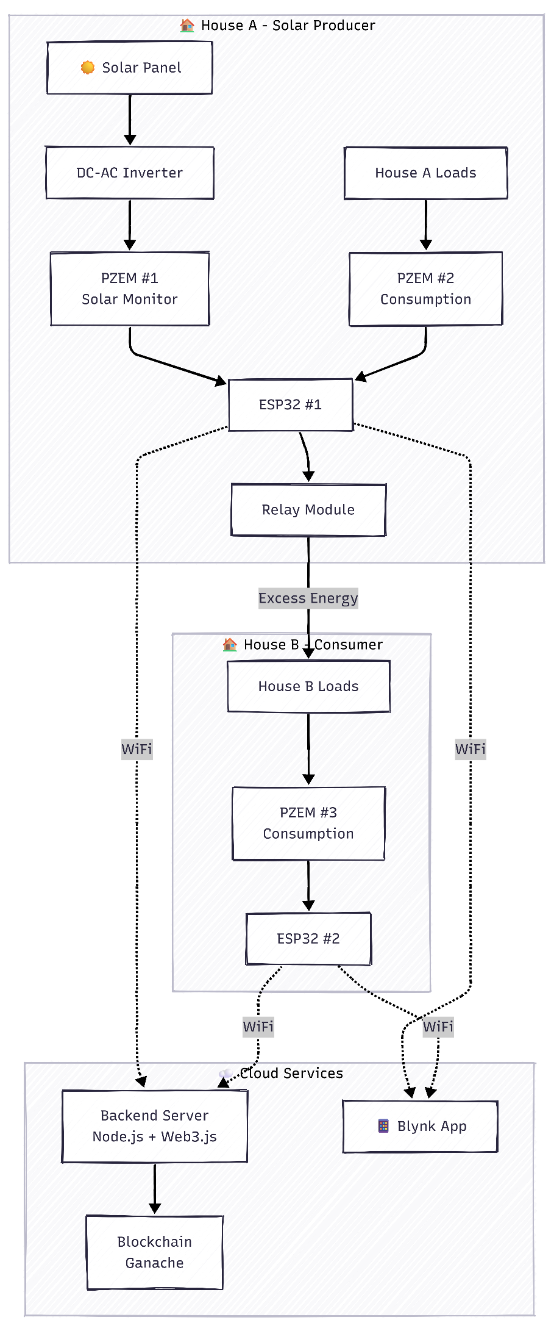
Flow Diagrams

1. System Architecture

2. Energy Flow Diagram

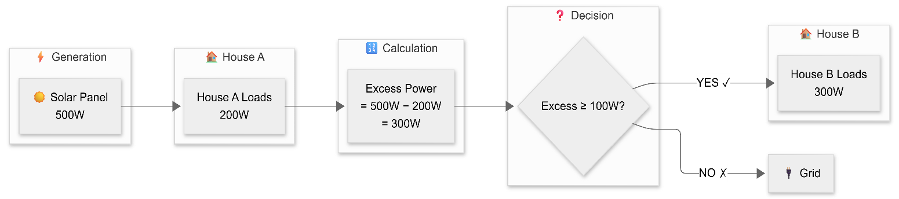

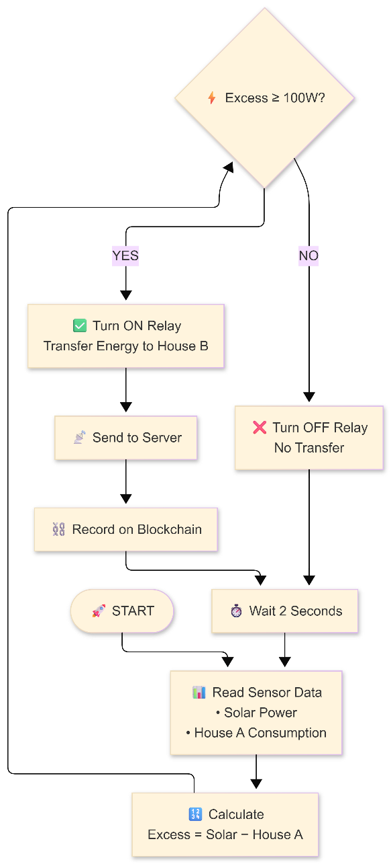
3. Decision Flowchart

Hardware Components
Component | Quantity | Purpose
ESP32 Microcontroller | 2 | Data acquisition & control
PZEM-004T Sensor | 3 | Energy measurement
Relay Module | 1 | Energy transfer switching
DC-AC Inverter | 1 | Solar DC to AC conversion
Solar Panel | 1 | Energy generation

Software Technologies
Layer | Technology
Embedded | Arduino (C++)
Backend | Node.js, Express.js
Blockchain | Solidity, Hardhat, Ganache
Blockchain API | Web3.js
Mobile App | Blynk IoT
Machine Learning | TensorFlow, Keras (LSTM)

Expected Outcomes

- Functional prototype demonstrating P2P energy trading between two houses
- Blockchain ledger with immutable transaction records
- Mobile dashboard for real-time monitoring and control
- AI model capable of predicting energy patterns with >85% accuracy
- Complete documentation including wiring diagrams and user guides

Project Scope
- In Scope: Two-house prototype, local blockchain, mobile monitoring, load prediction
- Out of Scope: Grid integration, billing/payment systems, multi-house scaling

Conclusion
This project demonstrates the feasibility of blockchain-based P2P energy trading at a household level. By combining IoT sensors, smart contracts, and machine learning, the system provides a transparent, automated, and intelligent solution for distributed energy management in smart microgrids.

