

**Palestine Technical University – Kadoorie**

**College of Engineering and Technology**

**Department of Computer Systems Engineering**

**Course name:**

**Software Engineering**

**Project title:**

**DESIGNING A USER-FRIENDLY CAR RENTAL SERVICE WEBSITE FOR CONVENIENT VEHICLE BOOKING IN PALESTINE**

**By:**

**Afnan Abo-Asal – 202111997 - Section 1**

**Layla Al-Saabna – 202110985 - Section 4**

**Rahaf Alawneh – 202112169 - Section 1**

**Supervisors:**

**Dr. Nael Salman**

**Dr. Osama Hamed**

**Tulkarm, Palestine**

**Spring Semester 2023-2024**

**Abstract:**

The process of renting a vehicle in Palestine often encounters various difficulties. This project aims to introduce a user-friendly website designed to streamline the booking process, enabling users to easily rent a vehicle through their devices. By merely selecting the rental duration, pick-up date, and desired vehicle, customers can complete their bookings in just a few clicks. The anticipated outcome of this website's development and launch is a notable increase in user engagement, attributed to its simplification of the car rental process, thereby offering a significantly more convenient solution for users.

**Introduction:**

Cars represent a valuable real asset that most individuals use on a daily basis (Brulé et al., 2022). They serve not only as means of transportation but also as tools for personal freedom, allowing for the exploration of new places and the facilitation of essential activities. Purchasing a vehicle represents a significant financial commitment, yet there are moments when the need for personal transportation becomes urgent. Car rentals offer a practical solution, providing access to vehicles on an as-needed basis without the long-term financial commitment of ownership.

In today's fast-paced world, the convenience of online services has become not just a luxury, but a necessity. They have revolutionized how we access products and services, offering unparalleled convenience, efficiency, and speed. Furthermore, online platforms often feature competitive pricing, broader selection, and the ability to customize services to meet individual needs. In the context of vehicle rentals, this means a smoother, faster, and more enjoyable process for customers, from initial search to final booking.

The Palestinian platform, “<https://www.shobiddak.com/ar>", serves as a bridge connecting users with vehicle rental owners. However, the site was not exclusively designed for vehicle rentals, leading to the oversight of several critical features. Most notably, it lacks the option for users to specify the exact rental period. Additionally, it fails to display the available inventory of vehicles for rent, resulting in a diminished selection as users apply more filters. Furthermore, the process requires direct communication with the vehicle owner, often necessitating a phone call (provided the call is answered) and possibly a physical visit to inspect the vehicle before finalizing the agreement. On a brighter note, there exists a more specialized website, “<https://car-rental-jerusalem.com>", which offers a dedicated car rental service. However, its operations are limited to Jerusalem city, also permitting the rental duration to be only three days or longer.

Our website, 'CarRentalsPalestine', revolutionizes the car rental process by seamlessly transitioning it to an online platform. From selecting the duration to the final booking of the desired vehicle, every step is conveniently digital. Serving all cities and regions across Palestine, our platform ensures a comprehensive service that spans the entire nation. 'CarRentalsPalestine' not only displays detailed information about each car but also simplifies the rental procedure, eliminating the need for users to contact car owners directly for information—unless they prefer to do so. Additionally, our service is designed to cater to anyone looking to rent out their personal vehicles. By providing a detailed description and features of the car, along with all necessary information, we make it effortless for owners to list their vehicles and for renters to find exactly what they need.

**Objective:**

The main goal of the project is to transfer the car rental process from its traditional way into an online platform by designing a user-friendly car rental service website in Palestine. Other objectives can be summarized as follows:

1. To offer an around-the-clock online platform enabling users to effortlessly search for, compare, and book vehicles.
2. To implement advanced filtering options, allowing users to refine their searches based on specific criteria such as car type, rental price, and additional features, thus facilitating a tailored rental experience.
3. To integrate a seamless booking and payment system that ensures a secure and efficient transaction process, coupled with immediate confirmation and digital documentation for users.
4. To aspire the contribution of the broader development of digital services in Palestine.

**Services:**

'CarRentalsPalestine' website provides the following services:

1. **Online Car Rental Process:** Offers a fully digital platform for renting cars, covering all steps from selecting the rental duration to booking the desired vehicle.
2. **Nationwide Coverage:** Operates across all cities and regions in Palestine, ensuring accessibility to users no matter their location.
3. **Detailed Car Information:** Displays comprehensive details for each vehicle, including specifications, features, and rental terms.
4. **Simplified Rental Procedure:** Streamlines the rental process to minimize the need for direct communication between renters and car owners, enhancing user convenience.
5. **Personal Car Rental Listings:** Enables individuals to rent out their personal vehicles, providing a platform to list their cars along with detailed descriptions and all necessary information for potential renters.

**System Description:**

**ER Diagram:**

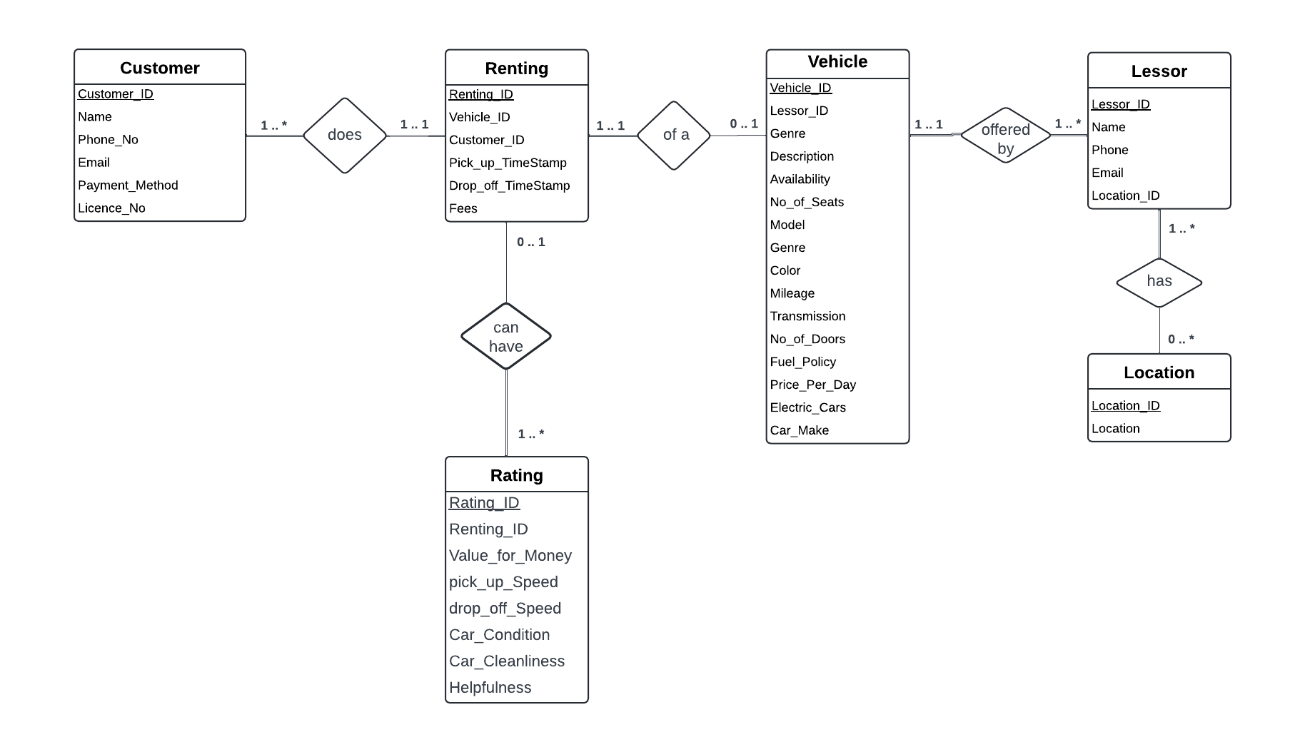

Figure 1: ER diagram for Car Rentals Palestine Website

[Click here to check the ER diagram closely](https://lucid.app/lucidchart/9f1bd0a7-113b-4e68-992c-aa58f51f3c64/edit?viewport_loc=-1125%2C-498%2C3481%2C1404%2C0_0&invitationId=inv_c75e2d48-49d5-496e-a2f0-097d51ad138d)

**Project Timeline:**

We are supposed to start working on this by the beginning of the Spring 2024 semester and finish it by the end of the semester. The proposed project timeline shown in Table 1 serves as a guide to follow during the period of accomplishing this task and who’s responsibility it is to do so. The project timeline is flexible to accommodate for any changes or surprises in the schedule. The suggested timeline of the project will be updated as the further the group progresses in time and the picture becomes clearer.

Table 1: The proposed timeline of the project

|  |  |  |
| --- | --- | --- |
| **Week no.** | **Tasks** | **Task Responsibility** |
| 1 – 6 | System analysis, website designing and implementation research, and gathering data | Cooperative |
| 6 – 11 | Designing and implementing the website | Cooperative but mainly **Layla** |
| 11 – 12 | Testing the system and trouble-shooting process | Cooperative but mainly **Rahaf** |
| 12 – 13 | Writing and proofreading the SRS document | Cooperative but mainly **Afnan** |
| 13 – 14 | Defending | Cooperative |

**References:**

* https://slcc.pressbooks.pub/technicalwritingatslcc/chapter/abstractengineer/ .
* SOFTWARE ENGINEERING Ninth Edition, Ian Sommerville.
* Brulé, G., Ravazzini, L. & Suter, C. The Rolling 50s (and More): Cars and Life Satisfaction Among Seniors Across Europe. *Applied Research Quality Life* **17**, 185–204 (2022). Retrieved from: <https://link.springer.com/article/10.1007/s11482-020-09887-2>