Afnan Ahmed

231485855

Information Security 421 Sec A

**INFORMATION SECURITY**

**Installing Jenkins:**

**$ sudo apt update**

**[sudo] password for afnan:**

**Ign:1 https://pkg.jenkins.io/debian-stable binary/ InRelease**

**Hit:2 https://pkg.jenkins.io/debian-stable binary/ Release**

**Get:3 http://security.ubuntu.com/ubuntu jammy-security InRelease [110 kB]**

**Hit:4 http://pk.archive.ubuntu.com/ubuntu jammy InRelease**

**Get:5 http://pk.archive.ubuntu.com/ubuntu jammy-updates InRelease [119 kB]**

**Get:7 http://pk.archive.ubuntu.com/ubuntu jammy-backports InRelease [108 kB]**

**Get:8 http://security.ubuntu.com/ubuntu jammy-security/main amd64 DEP-11 Metadata [41.5 kB]**

**Get:9 http://security.ubuntu.com/ubuntu jammy-security/universe amd64 DEP-11 Metadata [21.9 kB]**

**Get:10 http://pk.archive.ubuntu.com/ubuntu jammy-updates/main amd64 DEP-11 Metadata [102 kB]**

**Get:11 http://pk.archive.ubuntu.com/ubuntu jammy-updates/universe amd64 DEP-11 Metadata [274 kB]**

**Get:12 http://pk.archive.ubuntu.com/ubuntu jammy-updates/multiverse amd64 DEP-11 Metadata [940 B]**

**Get:13 http://pk.archive.ubuntu.com/ubuntu jammy-backports/main amd64 DEP-11 Metadata [7,996 B]**

**Get:14 http://pk.archive.ubuntu.com/ubuntu jammy-backports/universe amd64 DEP-11 Metadata [16.9 kB]**

**Fetched 802 kB in 10s (83.8 kB/s)**

**Reading package lists... Done**

**Building dependency tree... Done**

**Reading state information... Done**

**208 packages can be upgraded. Run 'apt list --upgradable' to see them.**

**afnan@afnan-VirtualBox:~$ curl -fsSL https://pkg.jenkins.io/debian/jenkins.io-2023.key | sudo tee \**

**/usr/share/keyrings/jenkins-keyring.asc > /dev/null**

**echo deb [signed-by=/usr/share/keyrings/jenkins-keyring.asc] \**

**https://pkg.jenkins.io/debian binary/ | sudo tee \**

**/etc/apt/sources.list.d/jenkins.list > /dev/null**

**sudo apt-get update**

**sudo apt-get install jenkins**

**Hit:1 http://security.ubuntu.com/ubuntu jammy-security InRelease**

**Hit:2 http://pk.archive.ubuntu.com/ubuntu jammy InRelease**

**Ign:3 https://pkg.jenkins.io/debian binary/ InRelease**

**Get:4 https://pkg.jenkins.io/debian binary/ Release [2,044 B]**

**Get:5 https://pkg.jenkins.io/debian binary/ Release.gpg [833 B]**

**Hit:6 http://pk.archive.ubuntu.com/ubuntu jammy-updates InRelease**

**Hit:7 http://pk.archive.ubuntu.com/ubuntu jammy-backports InRelease**

**Get:8 https://pkg.jenkins.io/debian binary/ Packages [54.2 kB]**

**Fetched 57.1 kB in 5s (12.6 kB/s)**

**Reading package lists... Done**

**Reading package lists... Done**

**Building dependency tree... Done**

**Reading state information... Done**

**The following packages will be upgraded:**

**jenkins**

**1 upgraded, 0 newly installed, 0 to remove and 208 not upgraded.**

**Need to get 93.0 MB of archives.**

**After this operation, 4,723 kB disk space will be freed.**

**Ign:1 https://pkg.jenkins.io/debian binary/ jenkins 2.409**

**Ign:1 https://pkg.jenkins.io/debian binary/ jenkins 2.409**

**Ign:1 https://pkg.jenkins.io/debian binary/ jenkins 2.409**

**Err:1 https://pkg.jenkins.io/debian binary/ jenkins 2.409**

**Could not connect to mirrors.jenkins.io:443 (52.167.253.43), connection timed out**

**E: Failed to fetch https://mirrors.jenkins.io/debian/jenkins_2.409_all.deb Could not connect to mirrors.jenkins.io:443 (52.167.253.43), connection timed out**

**E: Unable to fetch some archives, maybe run apt-get update or try with --fix-missing?**

**afnan@afnan-VirtualBox:~$ curl -fsSL https://pkg.jenkins.io/debian-stable/jenkins.io-2023.key | sudo tee \**

**/usr/share/keyrings/jenkins-keyring.asc > /dev/null**

**echo deb [signed-by=/usr/share/keyrings/jenkins-keyring.asc] \**

**https://pkg.jenkins.io/debian-stable binary/ | sudo tee \**

**/etc/apt/sources.list.d/jenkins.list > /dev/null**

**sudo apt-get update**

**sudo apt-get install jenkins**

**Get:1 http://security.ubuntu.com/ubuntu jammy-security InRelease [110 kB]**

**Ign:2 https://pkg.jenkins.io/debian-stable binary/ InRelease**

**Get:3 https://pkg.jenkins.io/debian-stable binary/ Release [2,044 B]**

**Get:4 https://pkg.jenkins.io/debian-stable binary/ Release.gpg [833 B]**

**Hit:5 http://pk.archive.ubuntu.com/ubuntu jammy InRelease**

**Hit:6 http://pk.archive.ubuntu.com/ubuntu jammy-updates InRelease**

**Hit:7 http://pk.archive.ubuntu.com/ubuntu jammy-backports InRelease**

**Get:8 https://pkg.jenkins.io/debian-stable binary/ Packages [24.9 kB]**

**Fetched 138 kB in 4s (35.2 kB/s)**

**Reading package lists... Done**

**Reading package lists... Done**

**Building dependency tree... Done**

**Reading state information... Done**

**jenkins is already the newest version (2.401.1).**

**0 upgraded, 0 newly installed, 0 to remove and 208 not upgraded.**

**afnan@afnan-VirtualBox:~$ sudo apt update**

**sudo apt install openjdk-11-jre**

**java -version**

**openjdk version "11.0.12" 2021-07-20**

**OpenJDK Runtime Environment (build 11.0.12+7-post-Debian-2)**

**OpenJDK 64-Bit Server VM (build 11.0.12+7-post-Debian-2, mixed mode, sharing)**

**Ign:1 https://pkg.jenkins.io/debian-stable binary/ InRelease**

**Hit:2 https://pkg.jenkins.io/debian-stable binary/ Release**

**Hit:3 http://security.ubuntu.com/ubuntu jammy-security InRelease**

**Hit:4 http://pk.archive.ubuntu.com/ubuntu jammy InRelease**

**Get:5 http://pk.archive.ubuntu.com/ubuntu jammy-updates InRelease [119 kB]**

**Get:7 http://pk.archive.ubuntu.com/ubuntu jammy-backports InRelease [108 kB]**

**Get:8 http://pk.archive.ubuntu.com/ubuntu jammy-updates/main i386 Packages [419 kB]**

**Get:9 http://pk.archive.ubuntu.com/ubuntu jammy-updates/main amd64 Packages [672 kB]**

**Get:10 http://pk.archive.ubuntu.com/ubuntu jammy-updates/universe amd64 Packages [920 kB]**

**Fetched 2,238 kB in 10s (233 kB/s)**

**Reading package lists... Done**

**Building dependency tree... Done**

**Reading state information... Done**

**208 packages can be upgraded. Run 'apt list --upgradable' to see them.**

**Reading package lists... Done**

**Building dependency tree... Done**

**Reading state information... Done**

**openjdk-11-jre is already the newest version (11.0.19+7~us1-0ubuntu1~22.04.1).**

**0 upgraded, 0 newly installed, 0 to remove and 208 not upgraded.**

**openjdk version "11.0.19" 2023-04-18**

**OpenJDK Runtime Environment (build 11.0.19+7-post-Ubuntu-0ubuntu122.04.1)**

**OpenJDK 64-Bit Server VM (build 11.0.19+7-post-Ubuntu-0ubuntu122.04.1, mixed mode, sharing)**

**/var/snap/openjdk/1349/openjdk.env**

**bash: syntax error near unexpected token `('**

**bash: syntax error near unexpected token `('**

**afnan@afnan-VirtualBox:~$**

**Turning on the the Jenkins:**

afnan@afnan-VirtualBox:~$ systemcl start jenkins

Command 'systemcl' not found, did you mean:

command 'systemctl' from deb systemd (249.11-0ubuntu3.9)

command 'systemctl' from deb systemctl (1.4.4181-1.1)

Try: sudo apt install <deb name>

afnan@afnan-VirtualBox:~$ systemctl start jenkins

afnan@afnan-VirtualBox:~$ sudo systemctl enable jenkins

[sudo] password for afnan:

Synchronizing state of jenkins.service with SysV service script with /lib/systemd/systemd-sysv-install.

Executing: /lib/systemd/systemd-sysv-install enable jenkins

afnan@afnan-VirtualBox:~$ systemctl start docker

Failed to start docker.service: Unit docker.service not found.

afnan@afnan-VirtualBox:~$ systemctl start docker

Failed to start docker.service: Unit docker.service not found.

afnan@afnan-VirtualBox:~$ /var/lib/jenkins/secrets/initialAdminPassword

bash: /var/lib/jenkins/secrets/initialAdminPassword: Permission denied

afnan@afnan-VirtualBox:~$ /var/lib/jenkins/secrets/afnan123

bash: /var/lib/jenkins/secrets/afnan123: Permission denied

afnan@afnan-VirtualBox:$ sudo ^[[200~systemctl start docker

sudo: systemctl: command not found

afnan@afnan-VirtualBox:~$ sudo systemctl start docker

Failed to start docker.service: Unit docker.service not found.

afnan@afnan-VirtualBox:~$ sudo apt update

Hit:1 http://security.ubuntu.com/ubuntu jammy-security InRelease

Ign:2 https://pkg.jenkins.io/debian-stable binary/ InRelease

Hit:3 https://pkg.jenkins.io/debian-stable binary/ Release

Hit:4 http://pk.archive.ubuntu.com/ubuntu jammy InRelease

Hit:5 http://pk.archive.ubuntu.com/ubuntu jammy-updates InRelease

Get:7 http://pk.archive.ubuntu.com/ubuntu jammy-backports InRelease [108 kB]

Fetched 108 kB in 4s (27.4 kB/s)

Reading package lists... Done

Building dependency tree... Done

Reading state information... Done

208 packages can be upgraded. Run 'apt list --upgradable' to see them.

afnan@afnan-VirtualBox:~$ sudo apt install docker.io

Reading package lists... Done

Building dependency tree... Done

Reading state information... Done

The following additional packages will be installed:

bridge-utils containerd pigz runc ubuntu-fan

Suggested packages:

ifupdown aufs-tools btrfs-progs cgroupfs-mount | cgroup-lite debootstrap

docker-doc rinse zfs-fuse | zfsutils

The following NEW packages will be installed:

bridge-utils containerd docker.io pigz runc ubuntu-fan

0 upgraded, 6 newly installed, 0 to remove and 208 not upgraded.

Need to get 72.1 MB of archives.

After this operation, 286 MB of additional disk space will be used.

Do you want to continue? [Y/n] y

Get:1 http://pk.archive.ubuntu.com/ubuntu jammy/universe amd64 pigz amd64 2.6-1 [63.6 kB]

Get:2 http://pk.archive.ubuntu.com/ubuntu jammy/main amd64 bridge-utils amd64 1.7-1ubuntu3 [34.4 kB]

Get:3 http://pk.archive.ubuntu.com/ubuntu jammy-updates/main amd64 runc amd64 1.1.4-0ubuntu1~22.04.3 [4,244 kB]

Get:4 http://pk.archive.ubuntu.com/ubuntu jammy-updates/main amd64 containerd amd64 1.6.12-0ubuntu1~22.04.1 [34.4 MB]

Get:5 http://pk.archive.ubuntu.com/ubuntu jammy-updates/universe amd64 docker.io amd64 20.10.21-0ubuntu1~22.04.3 [33.3 MB]

Get:6 http://pk.archive.ubuntu.com/ubuntu jammy/universe amd64 ubuntu-fan all 0.12.16 [35.2 kB]

Fetched 72.1 MB in 20s (3,601 kB/s)

Preconfiguring packages ...

Selecting previously unselected package pigz.

(Reading database ... 201040 files and directories currently installed.)

Preparing to unpack .../0-pigz_2.6-1_amd64.deb ...

Unpacking pigz (2.6-1) ...

Selecting previously unselected package bridge-utils.

Preparing to unpack .../1-bridge-utils_1.7-1ubuntu3_amd64.deb ...

Unpacking bridge-utils (1.7-1ubuntu3) ...

Selecting previously unselected package runc.

Preparing to unpack .../2-runc_1.1.4-0ubuntu1~22.04.3_amd64.deb ...

Unpacking runc (1.1.4-0ubuntu1~22.04.3) ...

Selecting previously unselected package containerd.

Preparing to unpack .../3-containerd_1.6.12-0ubuntu1~22.04.1_amd64.deb ...

Unpacking containerd (1.6.12-0ubuntu1~22.04.1) ...

Selecting previously unselected package docker.io.

Preparing to unpack .../4-docker.io_20.10.21-0ubuntu1~22.04.3_amd64.deb ...

Unpacking docker.io (20.10.21-0ubuntu1~22.04.3) ...

Selecting previously unselected package ubuntu-fan.

Preparing to unpack .../5-ubuntu-fan_0.12.16_all.deb ...

Unpacking ubuntu-fan (0.12.16) ...

Setting up runc (1.1.4-0ubuntu1~22.04.3) ...

Setting up bridge-utils (1.7-1ubuntu3) ...

Setting up pigz (2.6-1) ...

Setting up containerd (1.6.12-0ubuntu1~22.04.1) ...

Created symlink /etc/systemd/system/multi-user.target.wants/containerd.service

→ /lib/systemd/system/containerd.service.

Setting up ubuntu-fan (0.12.16) ...

Created symlink /etc/systemd/system/multi-user.target.wants/ubuntu-fan.service

→ /lib/systemd/system/ubuntu-fan.service.

Setting up docker.io (20.10.21-0ubuntu1~22.04.3) ...

Adding group `docker' (GID 138) ...

Done.

Created symlink /etc/systemd/system/multi-user.target.wants/docker.service → /l

ib/systemd/system/docker.service.

Created symlink /etc/systemd/system/sockets.target.wants/docker.socket → /lib/s

ystemd/system/docker.socket.

Processing triggers for man-db (2.10.2-1) ...

Pictures of CI-CD Pipeline:  
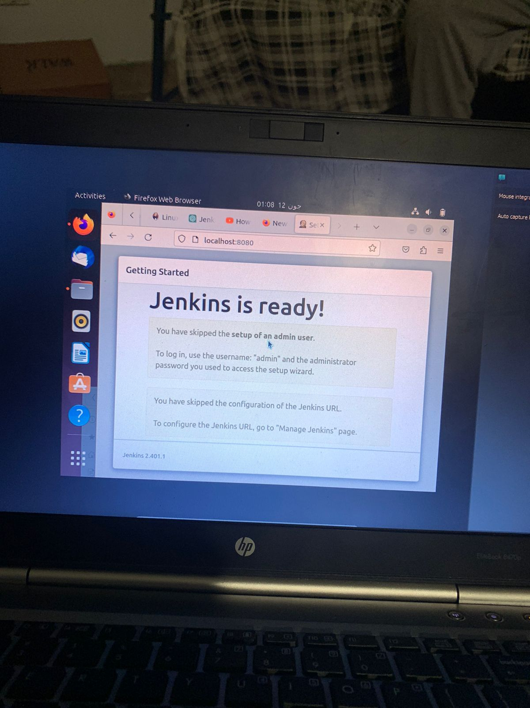

**SONARQUBE:**

**This is the file for sonarqube and the commands have been added to the Ubuntu CMD, to run it.**

**sudo apt update**

**sudo apt upgrade**

**sudo apt install openjdk-11-jdk**

**wget https://binaries.sonarsource.com/Distribution/sonarqube/sonarqube-8.9.2.46101.zip**

**sudo apt install unzip**

**unzip sonarqube-8.9.2.46101.zip**

**sudo mv sonarqube-8.9.2.46101 /opt/sonarqube**

**sudo nano /opt/sonarqube/conf/sonar.properties**

**# Update the sonar.jdbc.username, sonar.jdbc.password, and sonar.jdbc.url accordingly**

**sudo nano /etc/systemd/system/sonarqube.service**

**# Paste the content of the sonarqube.service file as mentioned in the previous response**

**sudo useradd -r -s /bin/false sonarqube**

**sudo chown -R sonarqube:sonarqube /opt/sonarqube**

**sudo systemctl start sonarqube**

**sudo systemctl enable sonarqube**