SQA

AFNAN AHMED

231485855

ASSIGNMENT 1

REPORT OF THE CASES:

THE FIRST CASE:

SUBTRACTION OF THREE NUMBERS:

CODE:

package test;

public class tests {

public int subtraction(int x, int y, int z) {

return x-y-z;

TEST CASES:

package test;

import static org.junit.jupiter.api.Assertions.\*;

import org.junit.jupiter.api.Test;

class subtractiontesting {

*@Test*

void test() {

tests s = new tests();

int op = s.subtraction(5, 3, 1);

*assertEquals*(1, op);

}

OUT OF 5 TESTS ONLY ONE PASSED AS YOU CAN SEE. When the input desired was one and the the op which is output was 1 as well.

THE SECOND CASE:

ADDITION OF FIVE NUMBERS:

CODE:

package test;

public class tests {

public int additionfive(int x) {

return x+x+x+x+x;

}

}

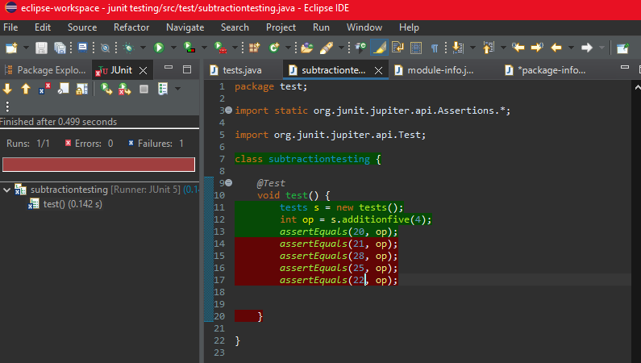

THE THIRD CASE:

DIVISION OF TWO NUMBERS:

CODE:

package test;

import static org.junit.jupiter.api.Assertions.\*;

import org.junit.jupiter.api.Test;

class subtractiontesting {

@Test

void test() {

tests s = new tests();

int op = s.dividetwo(10,2);

assertEquals(5, op);

assertEquals(2, op);

assertEquals(8, op);

assertEquals(4, op);

assertEquals(62, op);

}

}

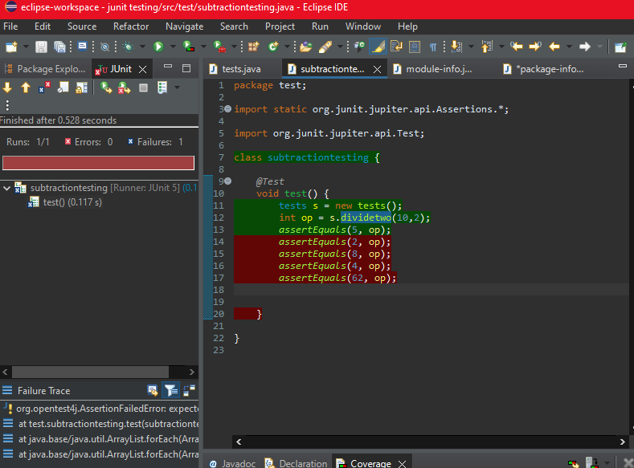

THE FOURTH CASE:

DIVISION OF THREE NUMBERS:

CODE:

package test;

import static org.junit.jupiter.api.Assertions.\*;

import org.junit.jupiter.api.Test;

class subtractiontesting {

@Test

void test() {

tests s = new tests();

int op = s.dividethree(100,1,2);

assertEquals(50, op);

assertEquals(2, op);

assertEquals(8, op);

assertEquals(4, op);

assertEquals(62, op);

}

}

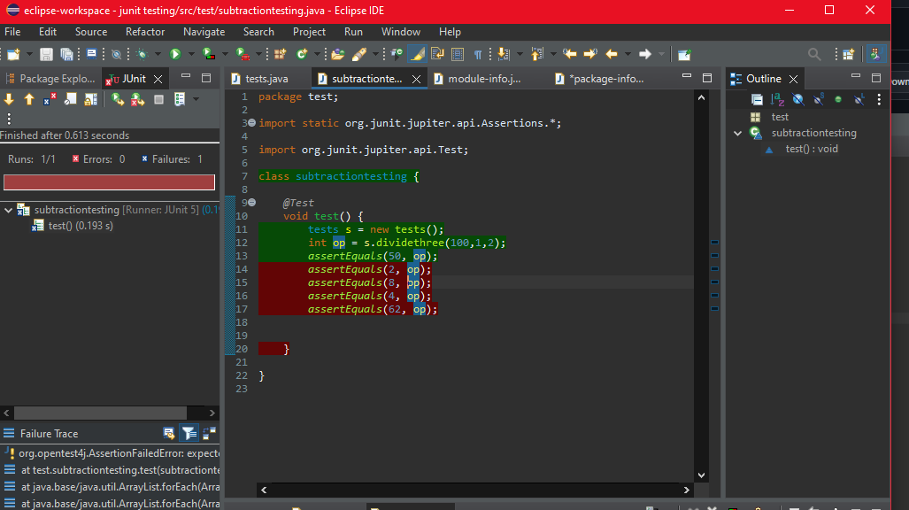

THE FIFTH CASE:

TAKING SQUARE ROOTS

CODE:

package test;

import static org.junit.jupiter.api.Assertions.\*;

import org.junit.jupiter.api.Test;

class subtractiontesting {

@Test

void test() {

tests s = new tests();

int op = s.cuberoot(3);

assertEquals(27, op);

}

}

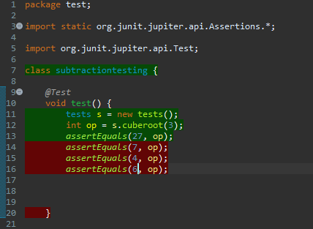

SO THIS WAS ALL THE TASKS, MADE THE PACKAGE BECAUSE EACH PACKAGE WAS TO REBUILT AGAIN SO I CHANGED THE FUNCTION NAMES ONLY AND GREEN SHOWS SUCCESFULLY RUN PROGRAMS AND RED DIDN’T WORKED.