CSS background-color

<!DOCTYPE html>

<html>

<head>

<style>

h1 {

background-color: green;

}

div {

background-color: lightblue;

}

p {

background-color: yellow;

}

</style>

</head>

<body>

<h1>CSS background-color example!</h1>

<div>

This is a text inside a div element.

<p>This paragraph has its own background color.</p>

We are still in the div element.

</div>

</body>

</html>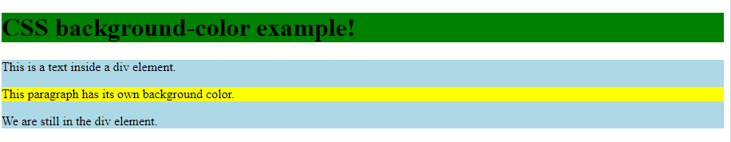

## CSS Border Color

<!DOCTYPE html>

<html>

<body>

<h1 style="border: 2px solid Tomato;">Hello World</h1>

<h1 style="border: 2px solid DodgerBlue;">Hello World</h1>

<h1 style="border: 2px solid Violet;">Hello World</h1>

</body>

</html>

## Using individual margin properties

<!DOCTYPE html>

<html>

<head>

<style>

div {

border: 1px solid black;

margin-top: 100px;

margin-bottom: 100px;

margin-right: 150px;

margin-left: 80px;

background-color: lightblue;

}

</style>

</head>

<body>

<h2>Using individual margin properties</h2>

<div>This div element has a top margin of 100px, a right margin of 150px, a bottom margin of 100px, and a left margin of 80px.</div>

</body>

</html>

# **CSS Fonts**

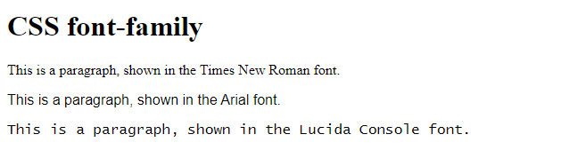<!DOCTYPE html>

<html>

<head>

<style>

.p1 {

font-family: "Times New Roman", Times, serif;

}

.p2 {

font-family: Arial, Helvetica, sans-serif;

}

.p3 {

font-family: "Lucida Console", "Courier New", monospace;

}

</style>

</head>

<body>

<h1>CSS font-family</h1>

<p class="p1">This is a paragraph, shown in the Times New Roman font.</p>

<p class="p2">This is a paragraph, shown in the Arial font.</p>

<p class="p3">This is a paragraph, shown in the Lucida Console font.</p>

</body>

</html>

# **CSS Lists**

<!DOCTYPE html>

<html>

<head>

<style>

ul.a {

list-style-type: circle;

}

ul.b {

list-style-type: square;

}

ol.c {

list-style-type: upper-roman;

}

ol.d {

list-style-type: lower-alpha;

}

</style>

</head>

<body>

<h2>The list-style-type Property</h2>

<p>Example of unordered lists:</p>

<ul class="a">

<li>Coffee</li>

<li>Tea</li>

<li>Coca Cola</li>

</ul>

<ul class="b">

<li>Coffee</li>

<li>Tea</li>

<li>Coca Cola</li>

</ul>

<p>Example of ordered lists:</p>

<ol class="c">

<li>Coffee</li>

<li>Tea</li>

<li>Coca Cola</li>

</ol>

<ol class="d">

<li>Coffee</li>

<li>Tea</li>

<li>Coca Cola</li>

</ol>

</body>

</html>

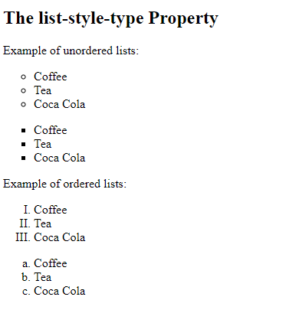

# **CSS Tables**

<!DOCTYPE html>

<html>

<head>

<style>

table, th, td {

border: 1px solid;

}

</style>

</head>

<body>

<h2>Add a border to a table:</h2>

<table>

<tr>

<th>Firstname</th>

<th>Lastname</th>

</tr>

<tr>

<td>Peter</td>

<td>Griffin</td>

</tr>

<tr>

<td>Lois</td>

<td>Griffin</td>

</tr>

</table>

</body>

</html>

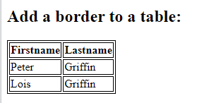

# **CSS Text Effects**

<!DOCTYPE html>

<html>

<head>

<style>

p.test1 {

white-space: nowrap;

width: 200px;

border: 1px solid #000000;

overflow: hidden;

text-overflow: clip;

}

p.test2 {

white-space: nowrap;

width: 200px;

border: 1px solid #000000;

overflow: hidden;

text-overflow: ellipsis;

}

</style>

</head>

<body>

<h1>The text-overflow Property</h1>

<p>The following two paragraphs contains a long text that will not fit in the box.</p>

<h2>text-overflow: clip:</h2>

<p class="test1">This is some long text that will not fit in the box</p>

<h2>text-overflow: ellipsis:</h2>

<p class="test2">This is some long text that will not fit in the box</p>

</body>

</html>

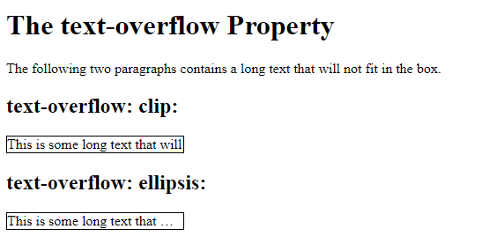

# **CSS Rounded Corners**

<!DOCTYPE html>

<html>

<head>

<style>

#rcorners1 {

border-radius: 25px;

background: #73AD21;

padding: 20px;

width: 200px;

height: 150px;

}

#rcorners2 {

border-radius: 25px;

border: 2px solid #73AD21;

padding: 20px;

width: 200px;

height: 150px;

}

#rcorners3 {

border-radius: 25px;

background: url(paper.gif);

background-position: left top;

background-repeat: repeat;

padding: 20px;

width: 200px;

height: 150px;

}

</style>

</head>

<body>

<h1>The border-radius Property</h1>

<p>Rounded corners for an element with a specified background color:</p>

<p id="rcorners1">Rounded corners!</p>

<p>Rounded corners for an element with a border:</p>

<p id="rcorners2">Rounded corners!</p>

<p>Rounded corners for an element with a background image:</p>

<p id="rcorners3">Rounded corners!</p>

</body>

</html>

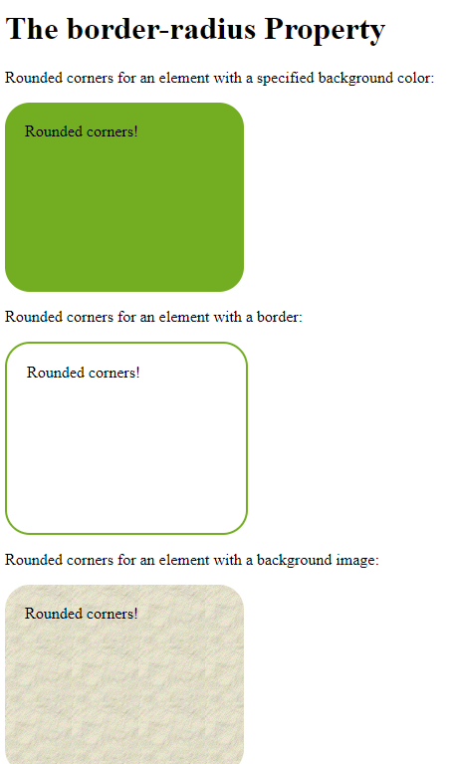

## CSS Padding

<!DOCTYPE html>

<html>

<head>

<style>

div {

padding: 70px;

border: 1px solid #4CAF50;

}

</style>

</head>

<body>

<h2>CSS Padding</h2>

<div>This element has a padding of 70px.</div>

</body>

</html>

