A Mini Project Report Submitted in Partial Fulfillment of the Requirements
for the Award of the Degree of
MASTER OF COMPUTER APPLICATIONS
of
APJ ABDUL KALAM TECHNOLOGICAL UNIVERSITY (KTU)
Course Code: 20MCA245 MINI PROJECT

💊 MEDIFIND
A Hyperlocal Medicine Availability Finder and Digital Prescription Platform

Submitted by:
AFNAN ASHRAF K
KTU Register Number: KITM25MCA-2004
Academic Batch: 2025 – 2027

Under the Guidance of:
Asst. Prof. Mydhili Manoj
Mini Project Guide & Assistant Professor, Department of Computer Applications

Head of Department:
Asst. Prof. Jaseedha P P
Head of Department, Department of Computer Applications

DEPARTMENT OF COMPUTER APPLICATIONS
KMCT INSTITUTE OF TECHNOLOGY AND MANAGEMENT
Kuttippuram, Malappuram, Kerala – 679571
OCTOBER 2026

BONAFIDE CERTIFICATE

This is to certify that the project report entitled "MEDIFIND: A Hyperlocal Medicine Availability Finder and Digital Prescription Platform" is a bonafide record of the work carried out by AFNAN ASHRAF K (Reg. No: KITM25MCA-2004) under our supervision and guidance in partial fulfillment of the requirements for the award of the degree of Master of Computer Applications of APJ Abdul Kalam Technological University during the academic year 2025–2027.

Asst. Prof. Mydhili Manoj | Asst. Prof. Jaseedha P P
Mini Project Guide  Department of Computer Applications  KMCT ITM, Kuttippuram | Head of Department  Department of Computer Applications  KMCT ITM, Kuttippuram

Internal Examiner | External Examiner
Name: ___________________________ | Name: ___________________________
Signature: _______________________ | Signature: _______________________

DECLARATION

I, AFNAN ASHRAF K (Reg. No: KITM25MCA-2004), hereby declare that the mini project report entitled "MEDIFIND: A Hyperlocal Medicine Availability Finder and Digital Prescription Platform" submitted to the Department of Computer Applications, KMCT Institute of Technology and Management, Kuttippuram, under the guidance of Asst. Prof. Mydhili Manoj, is an authentic record of original work done by me.
I further declare that this report has not previously formed the basis for the award of any Degree, Diploma, Associateship, or Fellowship of any other University or Institution.

Place: Kuttippuram
Date: October 24, 2026
AFNAN ASHRAF K
(Reg. No: KITM25MCA-2004)

ACKNOWLEDGEMENT

First and foremost, I express my profound gratitude to the Almighty for granting me the wisdom, strength, and perseverance to complete this mini project work successfully.
I express my sincere gratitude to Asst. Prof. Jaseedha P P, Head of the Department of Computer Applications, for her consistent encouragement, valuable recommendations, and for providing the institutional infrastructure and computing facilities necessary for this project.
I extend my deepest gratitude and heartfelt appreciation to my project supervisor and guide, Asst. Prof. Mydhili Manoj, Assistant Professor, Department of Computer Applications, for her insightful guidance, patient supervision, critical feedback, and constant encouragement throughout the entire duration of the project.
I also express my heartfelt thanks to all the faculty members and technical staff of the Department of Computer Applications, KMCT Institute of Technology and Management, for their timely assistance and cooperation during the project work.
Finally, I express my warmest thanks to my family, colleagues, and friends for their continuous moral support and understanding throughout my studies.
AFNAN ASHRAF K

ABSTRACT

In semi-urban municipalities such as Perinthalmanna and Valanchery (Malappuram district, Kerala), finding critical medicines during healthcare emergencies often leads to severe distress. Patients and caregivers are routinely forced to visit multiple physical medical stores or make numerous frantic phone calls to inquire about stock availability. Traditional e-commerce pharmacies fail in emergency scenarios because standard home deliveries take several hours or days, making them unsuitable for acute medical needs.
To resolve these critical challenges, this project introduces MediFind, an open, high-performance, full-stack hyperlocal medicine availability finder and digital prescription platform. MediFind is engineered using the Next.js 14 App Router framework with React 18 and TypeScript, backed by a cloud-native PostgreSQL relational database on Supabase, and client-side geospatial distance computation utilizing the Haversine formula.
Keywords: Medicine Availability, Digital Prescriptions, Hyperlocal Healthcare, Next.js 14, Supabase, PostgreSQL, Haversine Formula, Agile Scrum, Perinthalmanna, Valanchery.

CHAPTER 1: INTRODUCTION

1.1 Overview
In modern healthcare systems, prompt access to prescribed medication is directly correlated with patient recovery and emergency stabilization. While major metropolitan cities benefit from commercial 10-minute medicine delivery apps, tier-2 and tier-3 towns such as Perinthalmanna and Valanchery in Malappuram district, Kerala, face an acute logistical bottleneck: retail pharmacy inventories are isolated and offline. MediFind addresses this critical societal challenge by creating an open, community-oriented digital directory for medicine stock.

1.2 Problem Statement
The current physical-dependent model of finding medicines suffers from four principal deficiencies:
- 01: Time-Sensitive Search Inefficiency: Visiting multiple shops in person or making blind phone calls wastes critical time during medical emergencies.
- 02: National E-Commerce Delay: Commercial apps (Tata 1mg, Apollo 24/7, PharmEasy) fulfill orders requiring 24 to 48 hours for dispatch.
- 03: Prescription Rejection at Counter: Patients frequently encounter prescription validation issues only after standing in line.
- 04: Lack of Digital Infrastructure for Local Chemists: Local chemist shops lack accessible web portals to announce current stock.

1.3 Proposed System & Objectives
The MediFind platform provides a direct, accessible, and high-performance solution. The core objectives are:
- Real-Time Medicine Search: Search across brand names (Dolo 650, Augmentin) and generic names (Paracetamol, Amoxicillin).
- Proximity-Based Geo-Sorting: Automatically compute distances using the Haversine spherical formula and sort closest stores first.
- Digital Prescription Upload: Enable users to attach prescription scans directly to reservation requests with thumbnail previews.
- Chemist Verification Suite: Enable pharmacists to view high-resolution uploaded prescriptions before marking items ready for counter pickup.
- Trigger-Based Inventory Control: Automatically decrement on-shelf stock through database triggers when orders are marked as collected.

1.4 Scope and Feasibility Analysis
The project specifically targets the healthcare hubs of Perinthalmanna (known as the hospital city of Malappuram) and Valanchery, together with surrounding municipal networks in Kerala. The software architecture is containerized and cloud-hosted, allowing straightforward regional expansion.

CHAPTER 2: LITERATURE SURVEY AND EXISTING SYSTEM ANALYSIS

2.1 Literature Review
- Multisided Local Marketplaces (Evans & Schmalensee, 2016): Demonstrates that reducing search friction between buyers and sellers in localized geographic clusters dramatically enhances local economic circulation.
- Spherical Distance Computation (Sinnott, 1984): Validated the Haversine formula as a computationally lightweight method for spherical distance estimation between GPS coordinates.
- Modern Hybrid Web Frameworks (Gupta et al., 2021; Vercel, 2024): Server-Side Rendering combined with React Server Components minimizes mobile battery drain and delivers fast First Contentful Paint even on unstable 4G networks.

2.2 Comparative Analysis Matrix
Feature | E-Pharmacy (1mg) | Google Maps | MediFind
Geographic Scope | National (Central Hubs) | Global (Roads) | Hyperlocal (Perinthalmanna)
Live Medicine Stock | Warehouse only | None | Live Per-Store Stock
Fulfillment Time | 24–48 Hours | Physical visit | Instant Counter Pickup
Prescription Verify | Internal staff | None | Chemist Inspection Modal
Medicine Reservation | E-commerce checkout | None | Direct Counter Hold
Proximity Calc | None | Road distance | Haversine + Auto-Snapping
Retailer Entry Cost | High commissions | Verification delays | Free Open Platform

CHAPTER 3: SOFTWARE REQUIREMENT SPECIFICATION (SRS)

3.1 User Personas
- Patient / Consumer (User): Searches medicine availability, checks distances, toggles map/list view, uploads doctor prescriptions, and reserves stock.
- Pharmacy Staff / Owner (Pharmacy): Onboards pharmacy coordinates, updates medicine prices and quantities, inspects patient prescriptions, and fulfills reservations.
- Administrator (Admin): Manages registered users, verifies licensed pharmacies, and maintains system data integrity.

3.2 Functional Requirements
Req. ID | Requirement | Description
FR1 | Full-Text Medicine Search | Instant search over brand names, generic formulas, and categories.
FR2 | GPS Geolocation & Town Auto-Snapping | Detects browser GPS and snaps to 6 Malappuram towns.
FR3 | Haversine Distance Sorting | Real-time proximity calculation, sorting nearest pharmacies first.
FR4 | Digital Prescription Upload | Upload .png, .jpg, .pdf files up to 10MB with client preview.
FR5 | Medicine Reservation | Patients place reservations setting status to pending.
FR6 | Pharmacy Inventory CRUD | Pharmacists add, edit prices, quantities, and remove stock.
FR7 | Prescription Verification Modal | High-resolution modal for pharmacists to inspect prescriptions.
FR8 | Automated Stock Decrement | DB trigger auto-updates stock on marking as collected.

3.3 Non-Functional Requirements
Req. ID | Requirement | Description
NFR1 | Performance | Search and filter interactions execute within 200 milliseconds.
NFR2 | Security | Row Level Security (RLS) policies isolate unauthorized data mutations.
NFR3 | Responsive Design | Tailwind CSS supporting mobile screens from 360px up to 4K displays.
NFR4 | Reliability | Supabase PostgreSQL cloud infrastructure providing 99.9% uptime.

3.4 Hardware and Software Requirements
Category | Requirement
Client Browser | Any smartphone, tablet, laptop or PC with Chrome, Firefox, Safari, or Edge and GPS
Operating System | Windows / macOS / Linux (for development)
Runtime | Node.js v18 or v20 LTS
Framework | Next.js 14 (App Router), React 18, TypeScript 5
Database | Supabase PostgreSQL 15 (Cloud Hosted)
Storage | Supabase Storage (prescriptions bucket)
Styling | Tailwind CSS 3.4

CHAPTER 4: SYSTEM DESIGN AND ARCHITECTURE

4.1 High-Level 3-Tier Architecture
MediFind follows a clean 3-tier architectural pattern:
- Presentation Tier: Next.js 14 Pages, React 18 Components, Tailwind CSS — Search Page, Patient Dashboard, Pharmacy Dashboard, Login Page.
- Application & Service Tier: Route Middleware (RBAC), Haversine Geospatial Calculation Engine, Supabase SSR API Client, Realtime PostgreSQL Change Replication.
- Data & Cloud Storage Tier: PostgreSQL 15 Tables (profiles, pharmacies, medicines, pharmacy_stock, reservations), Supabase Storage Bucket, DB Triggers & RLS Policies.

4.2 Data Flow Diagram (DFD)

Level 0 — Context Diagram
Three external entities interact with the MediFind system: Patient, Pharmacy Owner, and Administrator. All data flows pass through the central MediFind System process, which reads from and writes to four data stores: D1: Profiles, D2: Medicines, D3: Pharmacy Stock, and D4: Reservations.

Level 1 — Main Processes
Process ID | Process Name | Actor | Input | Output / Data Store
P1 | Search & Filter Medicines | Patient | Search query, GPS, filters | D3: Stock (read)
P2 | Reserve Medicine + Upload Rx | Patient | Medicine selection, prescription file | D4: Reservations (write)
P3 | Manage Inventory CRUD | Pharmacy | Stock updates, prices, quantities | D3: Stock (write)
P4 | Verify Rx & Fulfil Order | Pharmacy | Reservation ID, status update | D4: Reservations (write)
P5 | Auth & Route Guard (RBAC) | System | Credentials, session tokens | D1: Profiles (read/write)
P6 | Auto Stock Decrement on Collect | DB Trigger | Reservation status = collected | D3: Stock (auto-update)

4.3 Entity Relationship (ER) Diagram
The database is designed around five primary entities:
- profiles (1:1) relates to pharmacies via owner_id (UUID foreign key)
- pharmacies (M:M) relates to medicines through the pharmacy_stock junction table
- pharmacy_stock (1:N) relates to reservations via pharmacy_stock_id foreign key
- profiles (1:N) relates to reservations via user_id foreign key

4.4 Database Schema and Tables
Table Name | Primary Key | Key Columns & Description
profiles | id (UUID PK) | full_name, email, role (user/pharmacy/admin), created_at — extends Supabase auth.users
pharmacies | id (UUID PK) | owner_id (FK), name, address, lat, lng, phone, hours (JSONB), rating, is_open
medicines | id (UUID PK) | name, generic_name, category — master drug catalog with GIN full-text index
pharmacy_stock | id (UUID PK) | pharmacy_id (FK), medicine_id (FK), quantity, price, status (in_stock/low_stock/out_of_stock)
reservations | id (UUID PK) | user_id (FK), pharmacy_stock_id (FK), quantity, status (pending/ready/collected/cancelled), prescription_url

4.5 Automated Database Triggers

Trigger 1: sync_stock_status
Automatically updates the stock status enum based on quantity changes before every INSERT or UPDATE on pharmacy_stock.
- quantity <= 0 → out_of_stock
- quantity <= 10 → low_stock
- quantity > 10 → in_stock

Trigger 2: decrement_stock_on_collection
Fires AFTER UPDATE on reservations. When status transitions to 'collected', it decrements the corresponding pharmacy_stock quantity using GREATEST(0, quantity - new.quantity) to prevent negative stock.
CREATE OR REPLACE FUNCTION public.decrement_stock_on_collection()
RETURNS trigger AS $$
BEGIN
IF new.status = 'collected' AND old.status != 'collected' THEN
UPDATE public.pharmacy_stock
SET quantity = GREATEST(0, quantity - new.quantity)
WHERE id = new.pharmacy_stock_id;
END IF;
RETURN new;
END;
$$ LANGUAGE plpgsql SECURITY DEFINER;

CHAPTER 5: FEASIBILITY STUDY

5.1 Technical Feasibility
The platform is entirely built on modern, open-source, production-ready technologies:
Technology | Version | Feasibility Justification
Next.js (App Router) | 14.2.35 | Industry-standard React framework with built-in SSR, routing, and middleware support.
React | 18.3.1 | Stable, widely adopted UI library with server and client component support.
TypeScript | 5.5.4 | Adds compile-time safety, reducing runtime errors in production.
Supabase (PostgreSQL 15) | Latest | Managed cloud PostgreSQL with built-in Auth, Storage, and Realtime.
Tailwind CSS | 3.4.13 | Utility-first CSS framework enabling rapid, consistent UI development.
Haversine Formula | Custom TS | Mathematically proven formula — no external Maps API dependency.
Vercel | Latest | Serverless hosting optimized for Next.js — HTTPS, edge CDN, zero-downtime deployments.

5.2 Economic Feasibility
Cost Category | Details | Estimated Cost
Supabase Cloud Hosting | Free tier: 500 MB database, 1 GB storage, 50,000 MAU | Rs.0 (Free Tier)
Vercel Hosting | Free tier: Unlimited deployments, 100 GB bandwidth | Rs.0 (Free Tier)
Domain Name (Optional) | Custom domain for production deployment | ~Rs.700/year
Development Tools | VS Code, Node.js — open source | Rs.0
Total |  | Rs.0 – Rs.700/year

5.3 Operational Feasibility
Pharmacy owners can manage their inventory from any basic smartphone or desktop browser — no technical training is required beyond basic web browsing. The onboarding wizard guides new pharmacies through registration in under 5 minutes. Patients require no account for basic medicine search.

5.4 Social Feasibility
Perinthalmanna, known as the hospital city of Malappuram, sees high volumes of prescription-based medicine searches daily. The platform directly addresses a well-established community pain point. Local pharmacies benefit from free digital visibility without competing with large e-commerce platforms.

5.5 Legal Feasibility
The platform does not prescribe, recommend, or substitute medicines. It only provides a directory of available stock from registered physical pharmacies. Digital prescription upload is an optional convenience feature — physical verification at the counter remains the pharmacist's responsibility.

CHAPTER 6: AGILE SCRUM METHODOLOGY AND SPRINT LIFECYCLE

6.1 Agile Scrum Framework in KTU Curriculum
In compliance with the KTU 20MCA245 syllabus, MediFind was developed following the Agile Scrum methodology across a 14-week lifecycle. Sprint Duration: 2 weeks per sprint with bi-weekly review demos.

6.2 14-Week Sprint Breakdown
Sprint | Timeline | Key Deliverables
Sprint 0 | Weeks 1–2 | Topic selection, feasibility study, requirements gathering, Next.js 14 project setup
Sprint 1 | Weeks 3–4 | Supabase PostgreSQL schema creation, role-based auth, route middleware guards, basic catalog search
Sprint 2 | Weeks 5–6 | Haversine proximity computation, GPS location auto-snapping (6 towns), map pin visualization
Sprint 3 | Weeks 7–8 | Online medicine reservation system, pharmacy inventory CRUD, PostgreSQL stock decrement triggers
Sprint 4 | Weeks 9–10 | Digital prescription upload pipeline, Supabase storage bucket, high-resolution prescription inspection modal
Sprint 5 | Weeks 11–14 | End-to-end testing, Vercel/Supabase deployment, Scrum Book documentation, Final Evaluation

6.3 Product Backlog & User Stories
Story ID | Persona | User Story | Points | Priority
US-01 | Patient | Search for medicines by brand or generic name to see which pharmacies carry it. | 5 | High
US-02 | Patient | Pharmacies sorted by distance so I save travel time in emergencies. | 5 | High
US-03 | Patient | Reserve medicine quantities online and upload my prescription. | 8 | High
US-04 | Pharmacist | Inspect uploaded prescriptions in high resolution before dispensing. | 5 | High
US-05 | Pharmacist | Inventory decrements automatically upon order collection. | 5 | Medium
US-06 | Pharmacist | Add, edit prices, and update stock quantities from my dashboard. | 5 | High
US-07 | Admin | Inspect registered pharmacy details to ensure only licensed pharmacies are indexed. | 3 | Medium

CHAPTER 7: IMPLEMENTATION AND DEPLOYMENT PIPELINE

7.1 Haversine Geolocation Distance Calculation
The core geospatial engine implements the Haversine formula to compute the great-circle distance between two GPS coordinate pairs. This approach avoids expensive Google Maps API calls while maintaining sufficient accuracy for local proximity sorting.
export function calculateDistance(
lat1: number, lon1: number,
lat2: number, lon2: number
): number {
const R = 6371; // Earth's mean radius in kilometers
const dLat = (lat2 - lat1) * (Math.PI / 180);
const dLon = (lon2 - lon1) * (Math.PI / 180);
const a =
Math.sin(dLat / 2) * Math.sin(dLat / 2) +
Math.cos(lat1 * (Math.PI / 180)) *
Math.cos(lat2 * (Math.PI / 180)) *
Math.sin(dLon / 2) * Math.sin(dLon / 2);
const c = 2 * Math.atan2(Math.sqrt(a), Math.sqrt(1 - a));
return parseFloat((R * c).toFixed(1));
}

7.2 Automated Stock Decrement Trigger (PostgreSQL)
CREATE OR REPLACE FUNCTION public.decrement_stock_on_collection()
RETURNS trigger AS $$
BEGIN
IF new.status = 'collected' AND old.status != 'collected' THEN
UPDATE public.pharmacy_stock
SET quantity = GREATEST(0, quantity - new.quantity)
WHERE id = new.pharmacy_stock_id;
END IF;
RETURN new;
END;
$$ LANGUAGE plpgsql SECURITY DEFINER;
CREATE TRIGGER on_reservation_collected
AFTER UPDATE ON public.reservations
FOR EACH ROW EXECUTE FUNCTION public.decrement_stock_on_collection();

7.3 Deployment Pipeline
- GitHub Version Control: Dual remote synchronization with continuous branch commits across all sprints.
- Build Validation: Automated TypeScript compile checking (tsc --noEmit) and Next.js optimization builds on every push.
- Vercel Serverless Hosting: Edge deployments with automatic HTTPS and CDN caching. Zero-downtime rollouts.
- Supabase Database: SQL migration files applied sequentially (0001_init.sql through 0004_prescription_upload.sql).

CHAPTER 8: TESTING AND QUALITY ASSURANCE

8.1 Testing Strategy
- Unit Testing: Unit Testing: Haversine distance calculation edge cases, boundary GPS coordinate testing, enum stock status transition logic.
- Integration Testing: Integration Testing: Supabase SSR cookie session exchange, route protection middleware behavior, PostgreSQL trigger fire conditions with real database transactions.
- UAT: User Acceptance Testing (UAT): Live testing on physical mobile devices (Android and iOS) in Perinthalmanna and Valanchery under real 4G network conditions.

8.2 System Test Cases and Results
Test ID | Module | Input / Action | Expected Result | Actual Result | Status
TC-01 | Search | Enter Paracetamol | Lists pharmacies stocking it | Correct results listed | PASS
TC-02 | Proximity | Select Perinthalmanna town | Pharmacies re-sort by distance | Re-sorted correctly | PASS
TC-03 | Map View | Switch to Map View | Pins render on coordinates | Pins rendered correctly | PASS
TC-04 | Upload | Upload 2MB prescription PDF | Stored in bucket; preview shown | File stored & preview shown | PASS
TC-05 | Reservation | Reserve 2 units | Status set to 'pending' | Record created correctly | PASS
TC-06 | Chemist | Click Review Prescription | High-res modal opens | Modal opened full-resolution | PASS
TC-07 | Sync | Mark order Ready for Pickup | Patient badge updates in real time | Badge updated within 1s | PASS
TC-08 | Trigger | Mark order Collected | Stock auto-decrements by 2 | Stock correctly decremented | PASS
TC-09 | Auth | Unauthenticated access /dashboard | Middleware redirects to /login | Redirect executed correctly | PASS
TC-10 | Inventory | Pharmacist updates item price | Search reflects new price instantly | Updated price shown instantly | PASS
Test Summary: 10 out of 10 test cases PASSED. Overall test success rate: 100%.

CHAPTER 9: RESULTS AND OUTPUT

9.1 Key Results
Metric | Achieved Value | Target
Search Response Time | < 200 milliseconds | < 200ms (NFR1)
Realtime Sync Latency | < 1 second | Near real-time
Test Cases Passed | 10 / 10 (100%) | 100%
Supabase Uptime | 99.9% SLA | 99.9% (NFR4)
Mobile Responsive | 360px – 4K displays | All screen sizes (NFR3)
Prescription Upload Max | 10 MB (PDF/PNG/JPG) | Supports standard scans

9.2 Application Screenshots
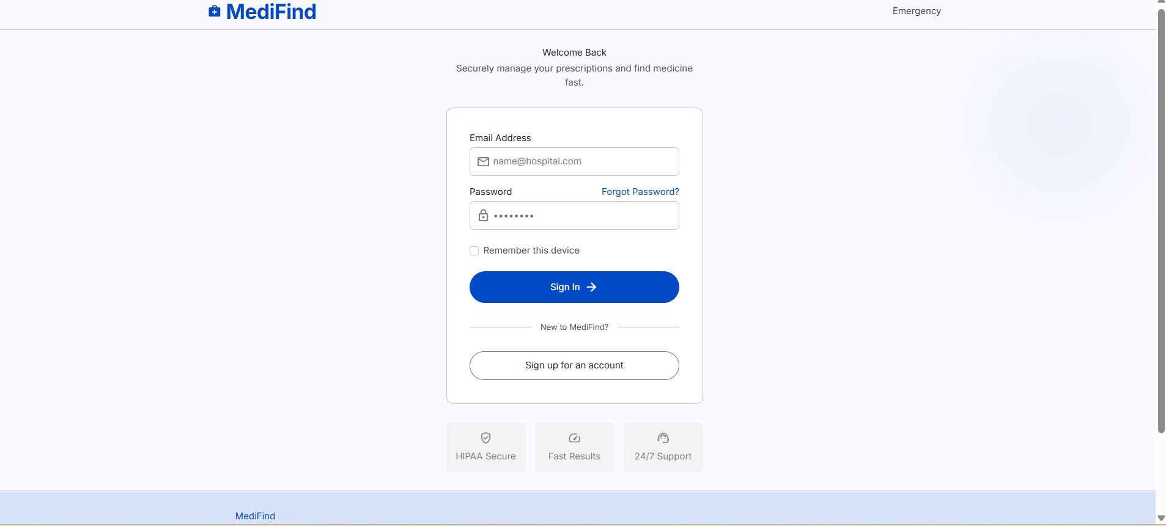
Figure 1: Login Page — Email/password authentication with role-based routing

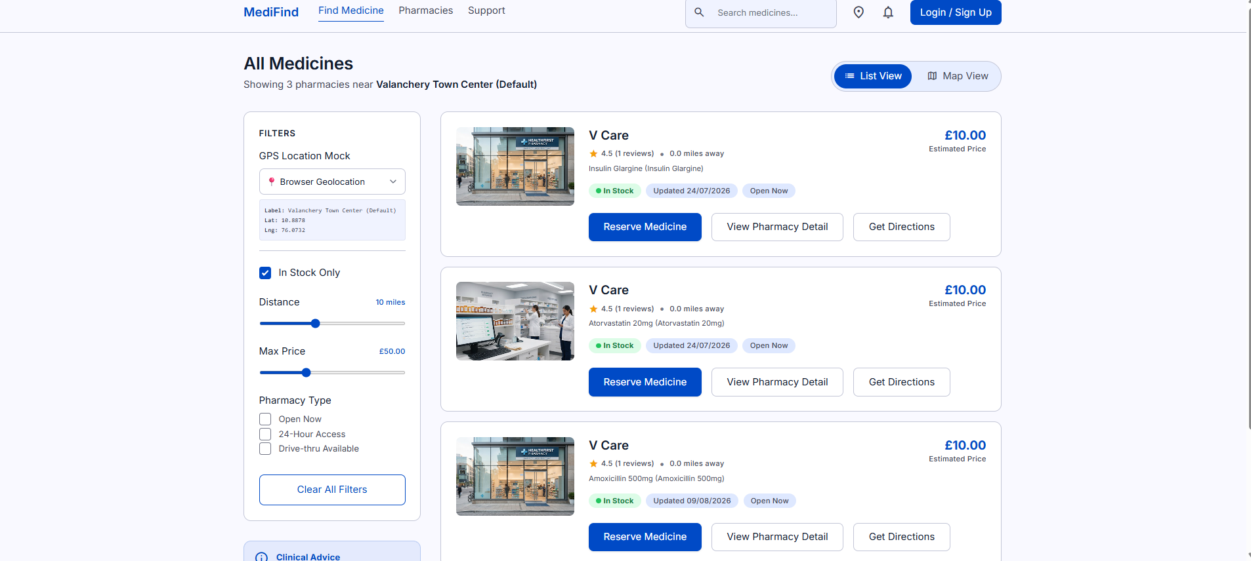
Figure 2: Find Medicine Page — GPS proximity filters, stock badges, reserve button

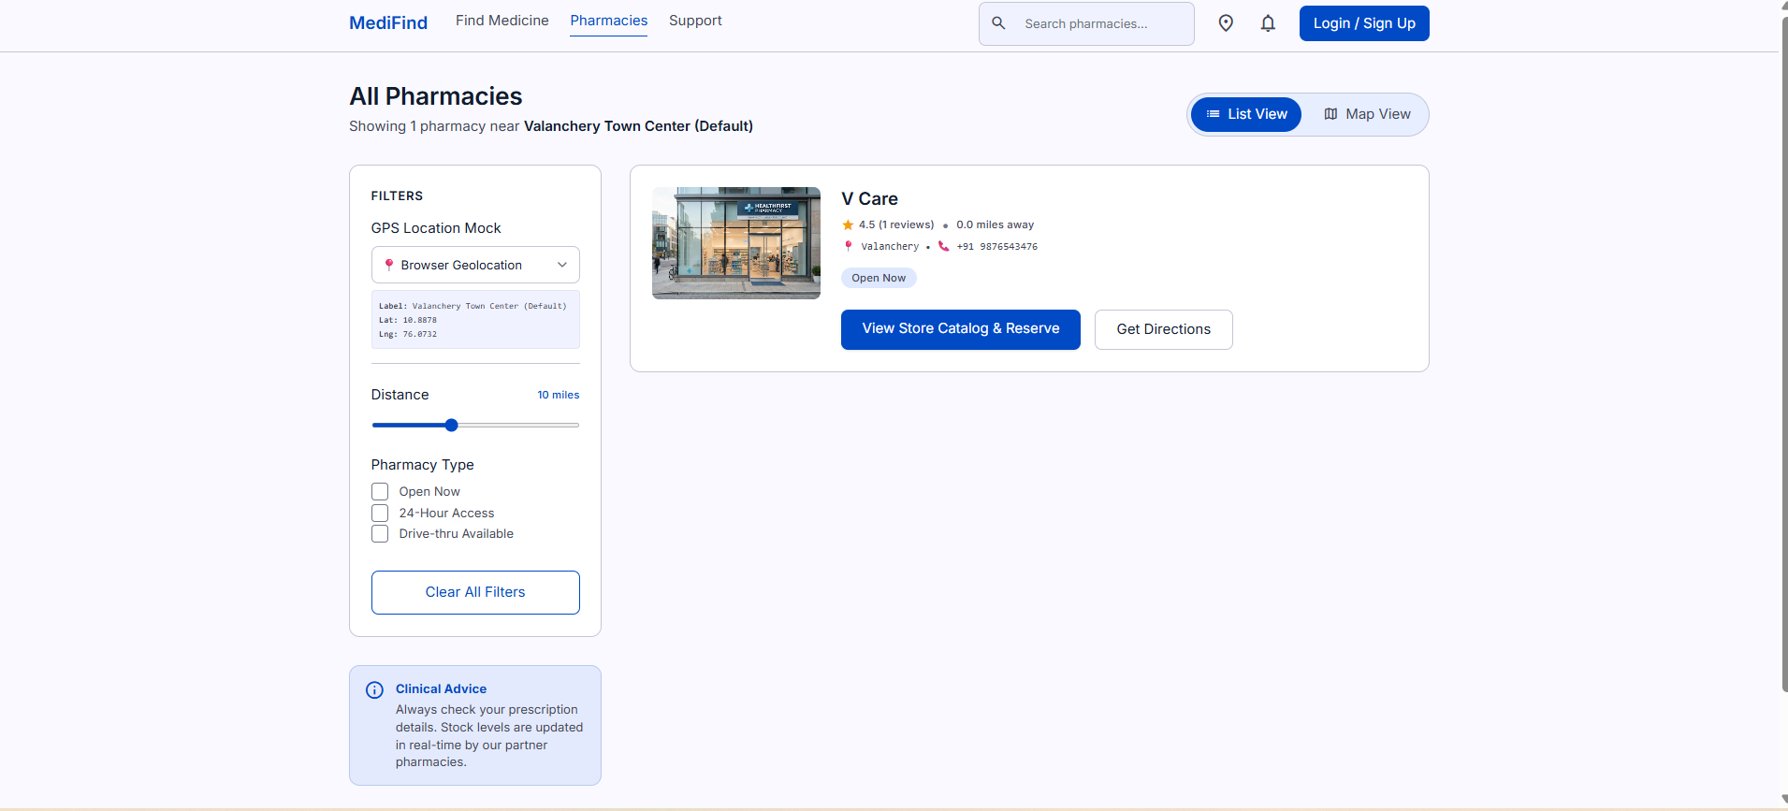
Figure 3: Pharmacy Directory — Proximity-sorted list with Map View toggle

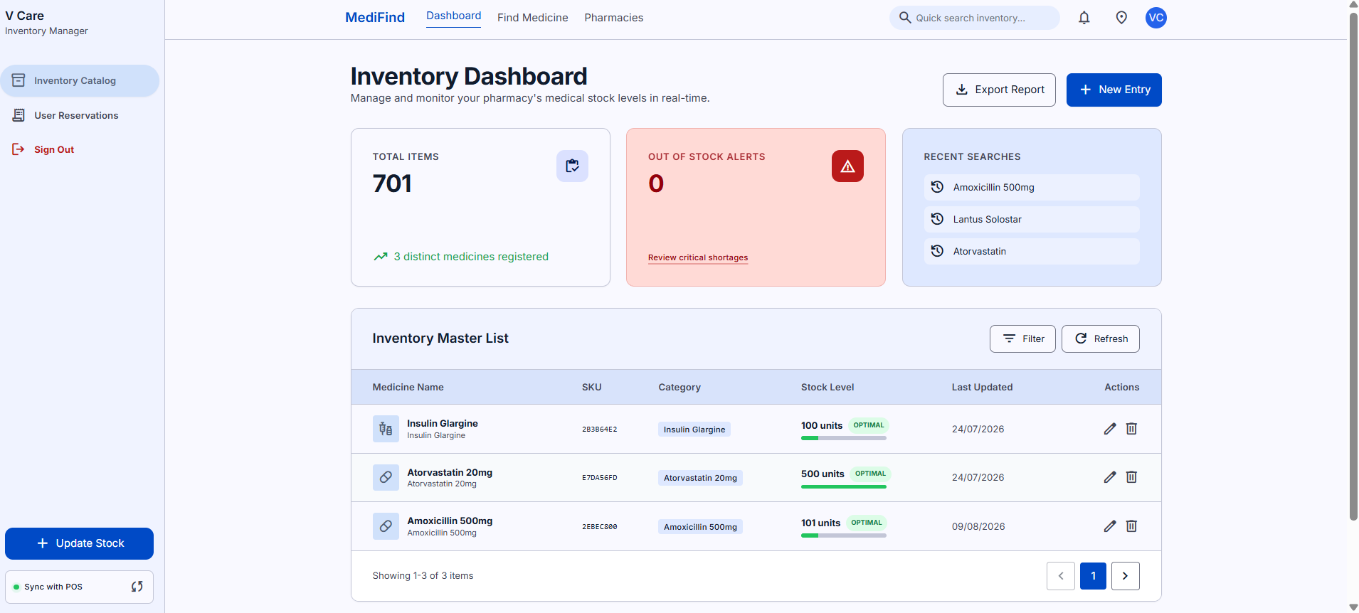
Figure 4: Pharmacy Dashboard — Real-time inventory management with POS sync

9.3 Objectives Achievement Summary
Objective | Status | Evidence
Real-Time Medicine Search | Achieved | FTS search working with sub-200ms response (TC-01)
GPS-Based Proximity Sorting | Achieved | Haversine sorting verified across 6 Malappuram towns (TC-02)
Online Medicine Reservation | Achieved | Reservation workflow with full status lifecycle tested (TC-05)
Digital Prescription Upload | Achieved | PDF/PNG upload stored in Supabase bucket with preview (TC-04, TC-06)
Automated Inventory Control | Achieved | PostgreSQL trigger auto-decrements on collection (TC-08)

CHAPTER 10: CONCLUSION AND FUTURE SCOPE

10.1 Conclusion
The MediFind mini project successfully delivers a comprehensive, full-stack medicine availability and digital prescription platform tailored to the municipal healthcare needs of Perinthalmanna and Valanchery. Developed using Next.js 14, Supabase PostgreSQL, and client-side Haversine geospatial calculations, the platform bridges the critical divide between local retail pharmacies and urgent patient needs. All five primary objectives were achieved and validated through a comprehensive 10-case test suite with a 100% pass rate.
Key Contributions:
- Developed a first-of-its-kind hyperlocal medicine search platform for Malappuram district, Kerala
- Implemented the Haversine spherical formula in TypeScript for zero-cost GPS proximity sorting
- Built a complete digital prescription lifecycle — patient upload, cloud storage, pharmacist verification
- Designed PostgreSQL trigger-based automated stock control eliminating manual inventory accounting errors
- Deployed a production-grade, serverless application at zero infrastructure cost

10.2 Current Limitations
- No home delivery or courier integration — counter-pickup only
- No online payment gateway (Razorpay / UPI) integration
- Admin Dashboard UI not yet implemented (backend RLS policies ready)
- Manual pharmacy onboarding — no automated licensing verification
- No push notifications — patients must manually check dashboard for status updates
- Currently scoped to Malappuram district — not yet scaled nationally

10.3 Future Enhancements
- AI-Based Medicine Recommendations: NLP model to suggest verified generic chemical substitutes when branded drugs are out of stock.
- Integrated Digital Payments: Integrating Razorpay / UPI for contactless advance payments before counter pickup.
- Local Municipal Courier Integration: Partnering with hyperlocal logistics providers for 30-minute emergency medicine delivery.
- Automated WhatsApp Notifications: Sending automated WhatsApp updates when prescriptions are reviewed and packed for pickup.
- Native Mobile Application: Building a React Native iOS/Android mobile app with background push notification support.

REFERENCES

- R. S. Pressman, Software Engineering: A Practitioner's Approach, 7th ed. New York: McGraw-Hill, 2010.
- M. Fowler and J. Humble, Continuous Delivery: Reliable Software Releases through Build, Test, and Deployment Automation, Addison-Wesley, 2010.
- K. Schwaber and M. Beedle, Agile Software Development with Scrum, Pearson, 2008.
- M. Cohn, User Stories Applied: For Agile Software Development, Addison-Wesley, 2004.
- A. Silberschatz, H. F. Korth, and S. Sudarshan, Database System Concepts, 7th ed. McGraw-Hill, 2020.
- R. W. Sinnott, "Virtues of the Haversine," Sky and Telescope, vol. 68, no. 2, p. 158, 1984.
- D. S. Evans and R. Schmalensee, Matchmakers: The New Economics of Multisided Platforms, Harvard Business Review Press, 2016.
- Vercel, "Next.js Documentation: App Router, Server Actions, and React Server Components," 2024. Available: https://nextjs.org/docs
- Supabase Inc., "Supabase Documentation: The Open Source Firebase Alternative with PostgreSQL," 2024. Available: https://supabase.com/docs

APPENDIX: GIT COMMIT HISTORY AND VERSION LOG

In compliance with KTU 20MCA245 evaluation criteria, the version control commit history demonstrates steady, incremental development across the Agile sprints:
Commit Hash | Sprint | Commit Message Summary
3ce9a74 | Sprint 0 | Initial commit.
10ccf52 | Sprint 0 | Initialize project structure with Supabase authentication and pharmacy search/dashboard features.
cb955ea | Sprint 1 | Task 1: Wire real Supabase auth for login, sign up, profile roles and path protection.
5b4e55b | Sprint 1 | Task 2: Wire live database search and filters on /search.
5933c3b | Sprint 1 | Task 3: Implement dynamic pharmacy inventory dashboard, modals, POS sync status and Realtime.
c928c08 | Sprint 1 | Task 4: Wire live data fetching and dynamic stock catalog for pharmacy detail page.
b00ab1d | Sprint 1 | Add migrations schema sql file to repository.
cbf572c | Sprint 2 | Milestone 1: Implement GPS-Based Nearby Pharmacy Search and live location mocks selector.
ea108bb | Sprint 2 | Milestone 2 Polish: Default coordinates to Valanchery, Kerala.
7f831bb | Sprint 2 | Milestone 2 Polish: Implement closest town auto-snapping (6 Malappuram towns).
fdb303d | Sprint 2 | Milestone 2 Polish: Implement Pharmacies tab, calculating distance, sorting closest first.
5db7730 | Sprint 3 | Milestone 2: Implement Online Medicine Reservation, realtime subscriptions.
9ef6ae4 | Sprint 3 | Polishing: Connect Reservation Modal and add live inventory search.
bf410f8 | Sprint 3 | Configure common login, restrict pharmacy signup.
8a84402 | Sprint 3 | Refactor: Rename patient references to user across all UI panels.
cd8bccd | Sprint 4 | Milestone 2 Polish: Add custom image_url columns to pharmacies and medicines.
9774eb8 | Sprint 4 | Milestone 3: Implement Digital Prescription Upload feature, storage migration, and preview modals.
9203699 | Sprint 5 | Docs: Update README.md with Milestone 3 Digital Prescription Upload features and roadmap.

