

AMERICAN INTERNATIONAL UNIVERSITY BANGLADESH (AIUB)
FACULTY OF SCIENCE & TECHNOLOGY

DEPARTMENT OF ELECTRICAL AND ELECTRONICS ENGINEERING
Fall 2024-25
Section: I, Group: 07

EXPERIMENT NO: 07
LAB REPORT ON

Implementation of Asynchronous and synchronous counters using flip-flops.
Supervised By SADMAN SHAHRIAR ALAM

Submitted By

SN | Name | ID
1 | Afnan Bin Islam Nahin | 22-49350-3

Group Members

SN | Name | ID
1 | S.M Takrim | 22-49282-3
2 | Farhin Zahra | 22-46829-1
3 | Md Mohiuddin Khan | 22-48727-3
4 | Shrabasti Adhikari | 21-45450-3

Date of Submission: 27.12.2024

Abstract:

This study compares the design and performance of asynchronous and synchronous counters implemented with flip-flops. Asynchronous counters, often known as ripple counters, work sequentially, whereas synchronous counters trigger simultaneously using a shared clock. The experiment shows that asynchronous counters are simpler but have propagation delays, while synchronous counters are faster and more reliable, albeit more sophisticated. The findings emphasize trade-offs between simplicity and performance, stressing that the choice of counter is determined by system needs such as speed and design complexity.

Introduction:

Counters are combinations of flip-flops arranged so that they can remember how many clock
pulses have been applied over some specified interval. Counters are classified into two broad
categories according to the way they are clocked: asynchronous and synchronous. In
asynchronous counters, commonly called ripple counters, the first flip-flop is clocked by the
external clock pulse and then each successive flip flop is clocked by the output of the preceding
flip-flop. In synchronous counters, the clock input is connected to all of the flip-flops so that
they are clocked simultaneously. The objective of this experiment was to design the following
counters using J-K Flip-Flops (IC 74LS76)

(a) n-bit Binary Asynchronous Counter
(b) n-bit Binary Synchronous Counter

Theory and Methodology:

Asynchronous counter
A three-bit asynchronous counter is shown in the figure 9.1. The external clock is connected to the clock input of the first flip-flop (FF0) only. So, FF0 changes state at the falling edge of each clock pulse, but FF1 changes only when triggered by the falling edge of the Q output of FF0. Because of the inherent propagation delay through a flip-flop, the transition of the input clock pulse and a transition of the Q output of FF0 can never occur at exactly the same time. Therefore, the flip-flops cannot be triggered simultaneously, producing an asynchronous operation.

Figure 9.1 gives a three-bit counter capable of counting from 0 to 7. The clock inputs of the three flip-flops are connected in cascade. The T input of each flip-flop is connected to a constant 1, which means that the state of the flip-flop will be reversed (toggled) at each positive edge of its clock. We are assuming that the purpose of this circuit is to count the number of pulses that occur on the primary input called Clock. Thus the clock input of the first flip-flop is connected to the Clock line. The other two flip-flops have their clock inputs driven by the Q output of the preceding flip-flop. Therefore, they toggle their state whenever the preceding flip-flop changes its state from Q = 1toQ = 0, which results in a positive edge of the Q signal.
Figure 9.1 shows a timing diagram for the counter. The value of Q0 toggles once each clock cycle. The change takes place shortly after the positive edge of the Clock signal. The delay is caused by the propagation delay through the flip-flop. Since the second flip-flop is clocked by Q0, the value of Q1 changes shortly after the negative edge of the Q0 signal.

Similarly, the value of Q2 changes shortly after the negative edge of the Q1 signal. If we look at the values Q2Q1Q0 as the count, then the timing diagram indicates that the counting sequence is 0, 1, 2, 3, 4, 5, 6, 7, 0, 1, and so on. This circuit is a modulo-8 counter. Because it counts in the upward direction, we call it an up-counter.

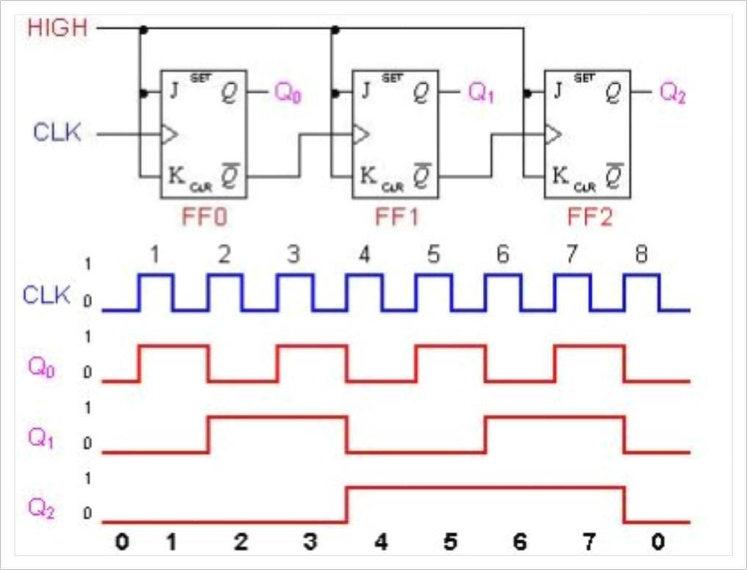

Figure 9.1: 3 bit Asynchronous counter and its timing diagram

Synchronous counter

In synchronous counters, the clock inputs of all the flip-flops are connected together and are triggered by the input pulses. Thus, all the flip-flops change state simultaneously (in parallel). The most important advantage of synchronous counters is that there is no cumulative time delay because all flip-flops are triggered in parallel. Thus, the maximum operating frequency for this counter will be significantly higher than for the corresponding ripple counter.

Table 9.1 shows the contents of a four-bit up-counter for eight consecutive clock cycles, assuming that the count is initially 0. Observing the pattern of bits in each row of the table, it is apparent that bit Q0 changes on each clock cycle. Bit Q1 changes only when Q0 = 1. Bit Q2 changes only when both Q1 and Q0 are equal to 1. In general, for an n-bit up-counter, a given flip-flop changes its state only when all the preceding flip-flops are in the state Q = 1.

Table 9.1
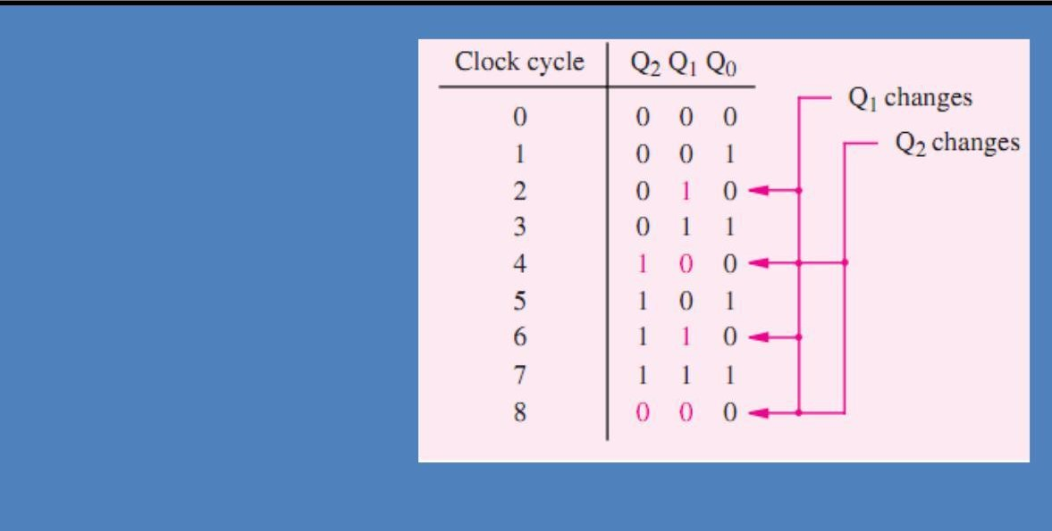
T0 = 1
T1 = Q0
T2 = Q0Q1
T3 = Q0Q1Q2
T4= Q0Q1Q2Q3
·
·
·
Tn = Q0Q1 ···Qn−1

The Circuit diagram of a four-bit counter based on these expressions is given in Figure 9.2a. Figure 9.2b gives a timing diagram. It shows that the circuit behaves as a modulo-16 up- counter. Because all changes take place with the same delay after the active edge of the Clock signal, the circuit is called a synchronous counter.
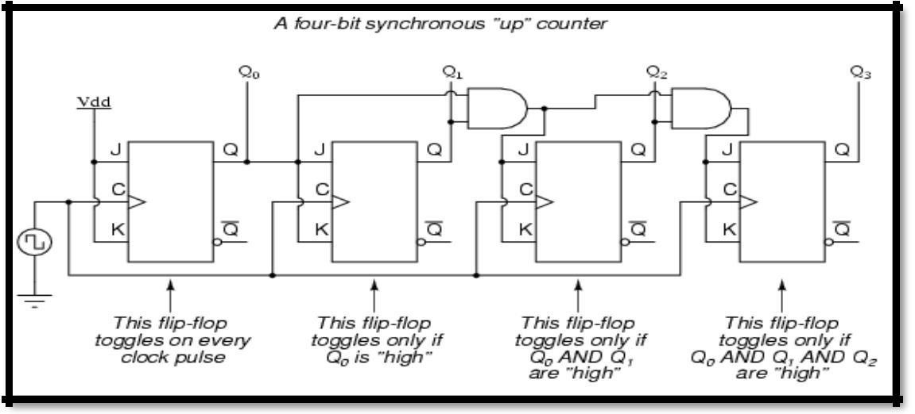
Figure 9.2a: A four-bit Synchronous Up Counter

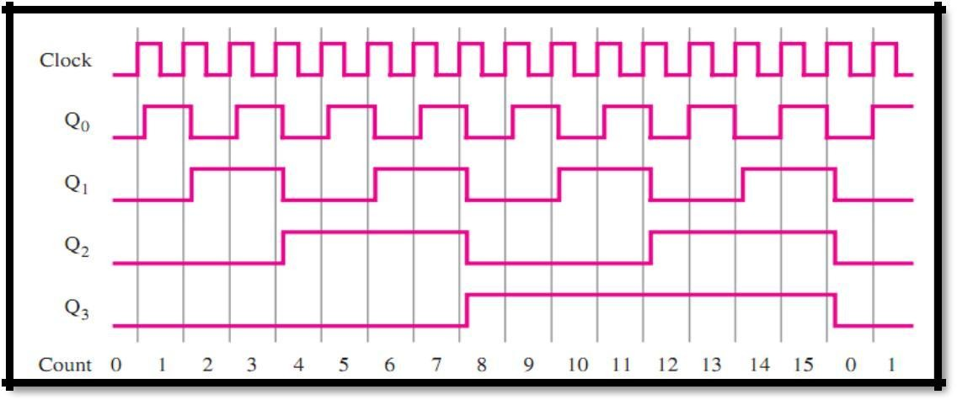
Figure 9.2b: The timing diagram of a four-bit Synchronous Up Counter
Apparatus:

- IC 74LS76 (JK Flip Flop)
- IC 7408 (AND Gate)
- LED Lamps or Display
- Trainer Board
- Oscilloscope
- Connecting Wires

Experimental Procedure:

Part 1: 3 bit Asynchronous Counter

- Design the circuit on the bread board as shown in Figure 9.5.
- Use the trainer board’s signal generator for the clock pulse and power supply for biasing the Flip Flops.
- The output can also be viewed in oscilloscope, just connect the outputs to the different channels of the oscilloscope.
- Observe the output results, record them and also take some pictures for your lab report.

3 bit Synchronous Counter

- Design the circuit on the bread board as shown in Figure 9.6.
- Use the trainer board’s signal generator for the clock pulse and power supply for biasing the Flip Flops.
- The output can also be viewed in oscilloscope, just connect the outputs to the different channels of the oscilloscope.
- Observe the output results and take some pictures for your lab report.

Lab-Work:
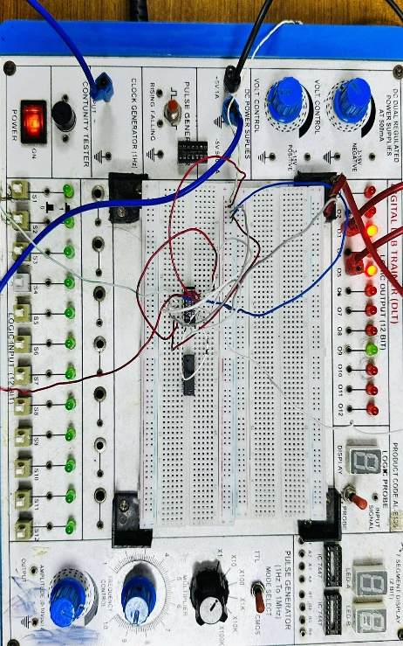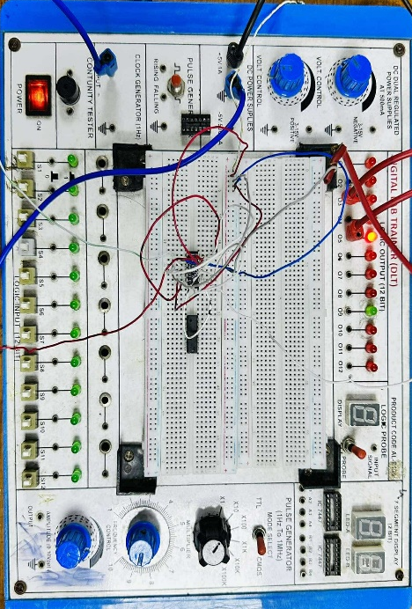
For Asynchronous 2bit flipflop

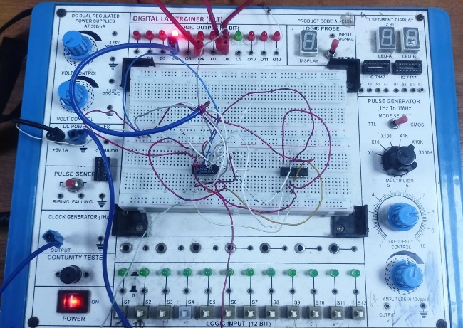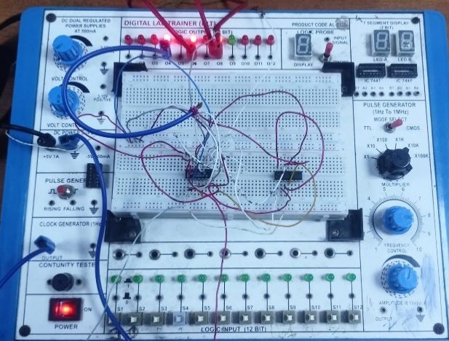
For 3bit asynchronous

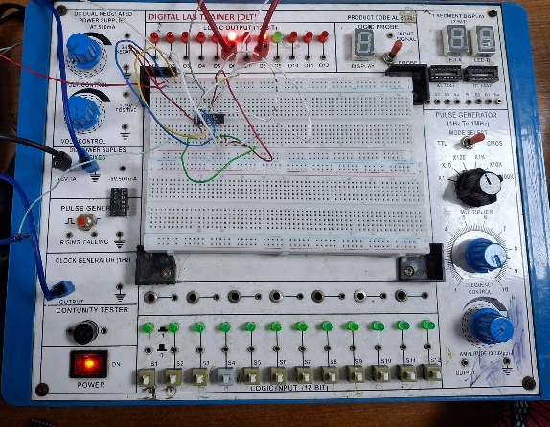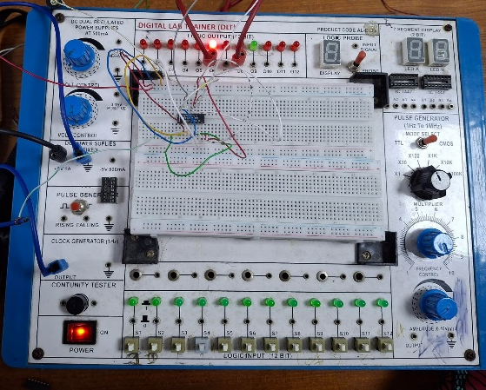
For 2-bit synchronous

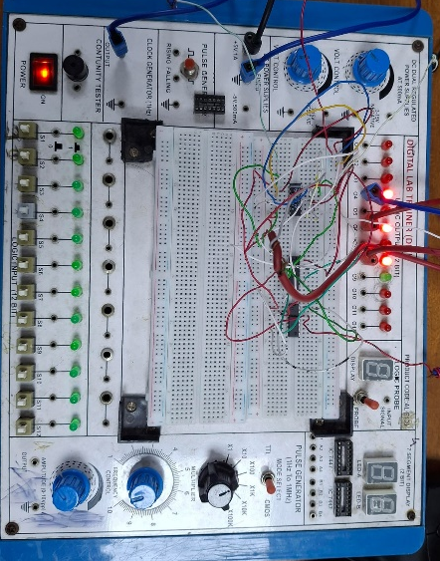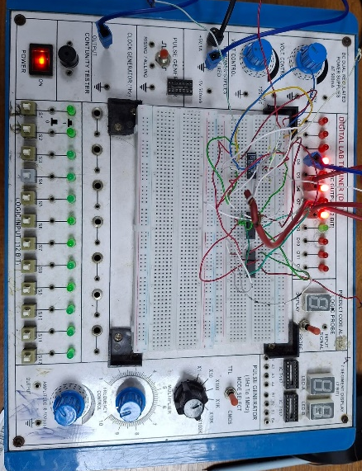
For 3-bit synchronous

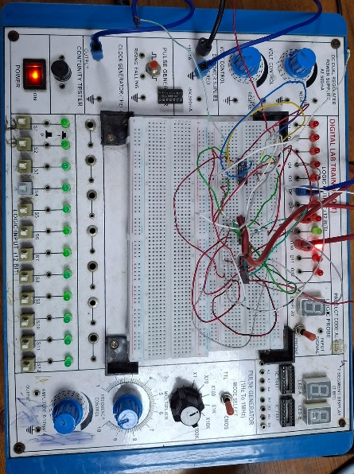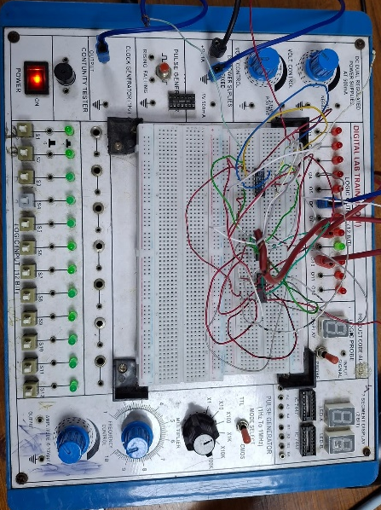
For 4-bit synchronous

Simulation and Measurement:

3-bit Asynchronous Counter
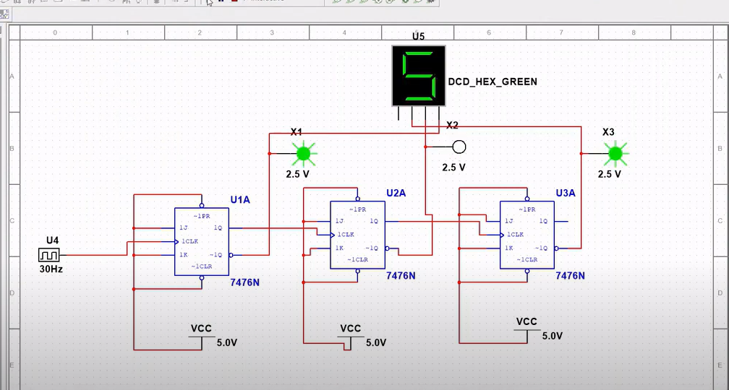

3-bit Synchronous Counter
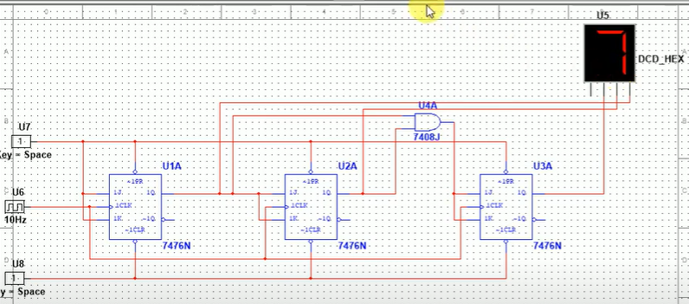

4-bit synchronous
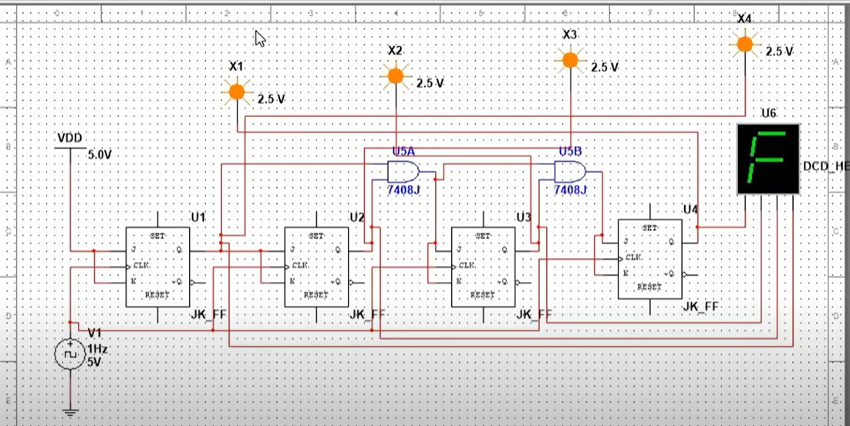

Questions with answers for report writing:

Design a 4 bit Asynchronous Up- Counter:
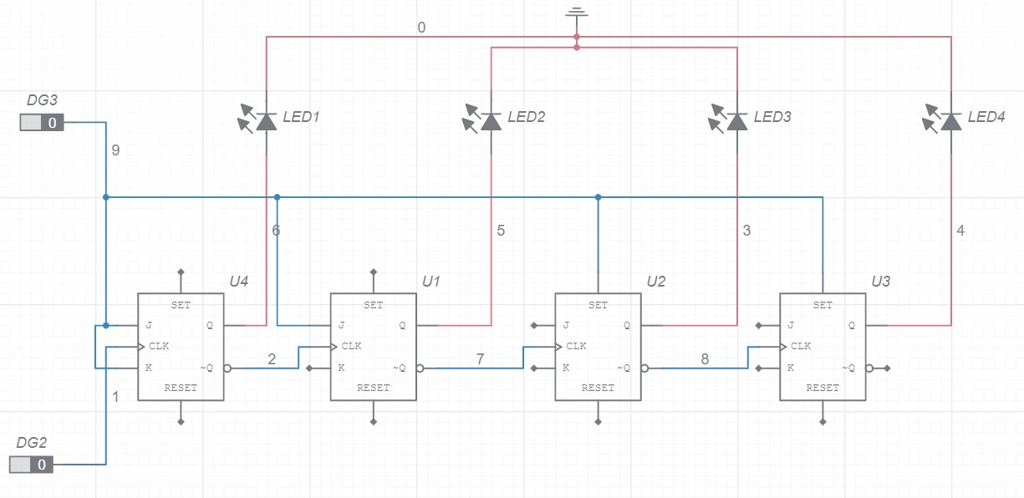

Design of a 4-bit Synchronous Up- Counter:

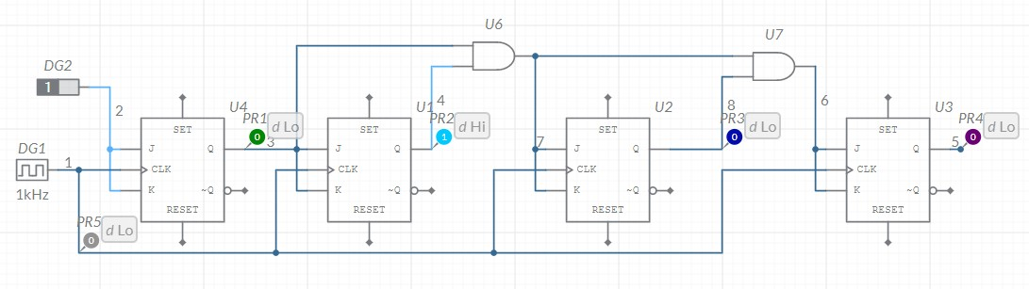

Bonus Question Answers:

Design of a 3-bit Asynchronous down counter.

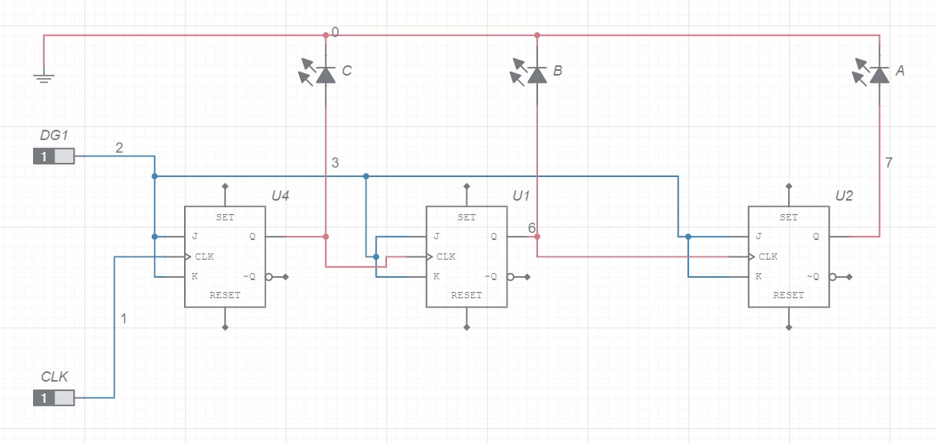

Design of a Mod 10 Synchronous up counter:
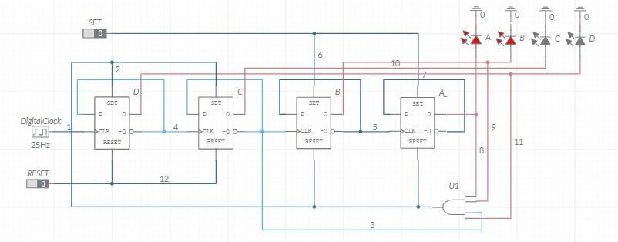

Discussion:
The experiment began with a review of the core concepts of J-K flip-flops and their working principles. The distinctions between asynchronous and synchronous counters were explored, along with their timing diagrams and clock cycle tables. During the hardware implementation, challenges were encountered in generating clock pulses using the trainer board. Despite assembling the circuit, the lack of a functional clock generator prevented the extraction of output, leading to the exclusion of the hardware results from the report.
In the simulation phase, various counters were successfully designed and analyzed using MULTISIM. These included 3-bit and 4-bit asynchronous and synchronous up counters, a 3-bit asynchronous down counter, and a MOD-10 synchronous up counter. Simulations produced results consistent with theoretical expectations, with no discrepancies observed in output values.

Conclusion:
The experiment achieved its objectives by familiarizing participants with J-K flip-flops and their applications in counter design. Although hardware implementation faced challenges, the simulation phase successfully demonstrated the functionality of various counters. The consistent simulation results validated theoretical knowledge, confirming the successful design and analysis of asynchronous and synchronous counters, including MOD-10 counters.

Reference:

i) Thomas L. Floyd, “Digital Fundamentals”, Ninth Edition.

