

AMERICAN INTERNATIONAL UNIVERSITY BANGLADESH (AIUB)
FACULTY OF SCIENCE & TECHNOLOGY

DEPARTMENT OF ELECTRICAL AND ELECTRONICS ENGINEERING
Fall 2024-25
Section: I, Group: 07

LAB REPORT ON

2-bit Asynchronous counters using flip-flops and 555 timer.
Supervised By SADMAN SHAHRIAR ALAM

Submitted By

SN | Name | ID
1 | Afnan Bin Islam Nahin | 22-49350-3

Group Members

SN | Name | ID
1 | S.M Takrim | 22-49282-3
2 | Farhin Zahra | 22-46829-1
3 | Md Mohiuddin Khan | 22-48727-3
4 | Shrabasti Adhikari | 21-45450-3
Date of Submission: 22.1.2025

Title: Open-Ended Laboratory Experiment on Sequential Logic Circuit Design

Purpose:
The purpose of this experiment is to design, implement, and test a 2-bit asynchronous counter using flip-flops and a 555 timer. The main objective is to demonstrate how a 555 timer can be configured in astable mode to generate a stable clock signal, which drives the sequential operation of JK flip-flops, forming a ripple counter.
The laboratory investigation aims to:
- Understand the working principles of the 555 timer as a clock generator.
- Explore the behavior of JK flip-flops in asynchronous counter configurations.
- Verify the frequency division property of ripple counters.
During the experiment, the following results were obtained:
- The 555 timer successfully generated a square wave clock signal with the desired frequency, calculated based on resistor and capacitor values.
- The JK flip-flops operated correctly, toggling sequentially on clock pulses, producing binary outputs.
- The counter demonstrated frequency division, with the first flip-flop toggling at half the input clock frequency and the second flip-flop toggling at one-fourth of the clock frequency.
In conclusion, the experiment successfully demonstrated the design and functionality of a 2-bit asynchronous counter, validating theoretical concepts of digital logic and timing. This project highlights the practical application of 555 timers and flip-flops in building simple sequential circuits.
Objectives:

To design and implement a 2-bit asynchronous counter using flip-flops and a 555 timer, where the 555 timer serves as a clock generator, providing a continuous square wave signal to drive the counter, and the flip-flops divide the clock frequency to produce sequential binary outputs.

This project explains the operating concept of asynchronous (ripple) counters and highlights the integration of essential components in digital logic architecture.
The main goals include: Configuring the 555 timer in astable mode to generate a stable clock signal. Using JK flip-flops to divide the clock signal frequency into two binary outputs.
Observing the asynchronous toggling of flip-flops, yielding binary counting outputs .
Check the circuit's functionality to ensure proper timing, synchronisation, and output accuracy.

Equipment:

- IC 7473(2-BIT JK Flip Flop)
- 555 Timer IC (1 pc)
- Resistors 4.7kΩ (1pc)
- Resistors 10kΩ (1pc)
- Capacitor 100uF (1 pc)
- Connecting Wires
- Capacitor 0.1uF (1 pc)

Procedures:
Follow these steps to construct and test a 2-bit asynchronous counter using a 555 timer and JK flip-flops:
Step 1:
Set Up the 555 Timer Circuit:
1. Gather components: 555 timer IC, resistors (R1=4.7 kΩ , R2=10 kΩ ), a capacitor (C=100 μF), and a breadboard.
2. Connect pin 1 of the 555 timer to ground (GND) and pin 8 to the power supply (VCC=5 V).
3. Connect R1​ between pins 8 and 7 of the timer.
4. Connect R2 between pins 7 and 6.
5. Connect C between pin 6 and ground.
6. Link pins 6 and 2 together to enable the astable mode.
7. Attach a 0.1 µF and 100 µF capacitor between pin 5 (Control Voltage) and ground to stabilize the timer.
8. Tie pin 4 (Reset) to VCC to keep the timer enabled.
9. Take the output clock signal from pin 3 of the 555 timer.
Step 2:
Configure the First JK Flip-Flop:
1. Connect the Q output of the 555 timer (pin 3) to the CLK (Clock) input of the first JK flip-flop.
2. Tie the J and K inputs of the flip-flop to VCC to enable toggling on each clock pulse.
3. Connect the RST (Reset) pin to ground to disable external resets.
4. Ensure the flip-flop receives proper power connections (VCC​ and ground).

Step 3:
Configure the Second JK Flip-Flop:
1. Connect the Q output of the first flip-flop to the CLK input of the second flip-flop to create a ripple counter effect.
2. Tie the J and K inputs of the second flip-flop to VCC​ as in the first flip-flop.
3. Connect the RSTRSTRST pin of the second flip-flop to ground.
4. Power the second flip-flop with VCC​ and ground connections.
Step 4:
Connect Outputs:
1. Connect LEDs to the Q outputs of both flip-flops to visualize the counter states.
By following these steps, we will successfully implement a 2-bit asynchronous counter using a 555 timer and JK flip-flops.

Results and Data Analysis

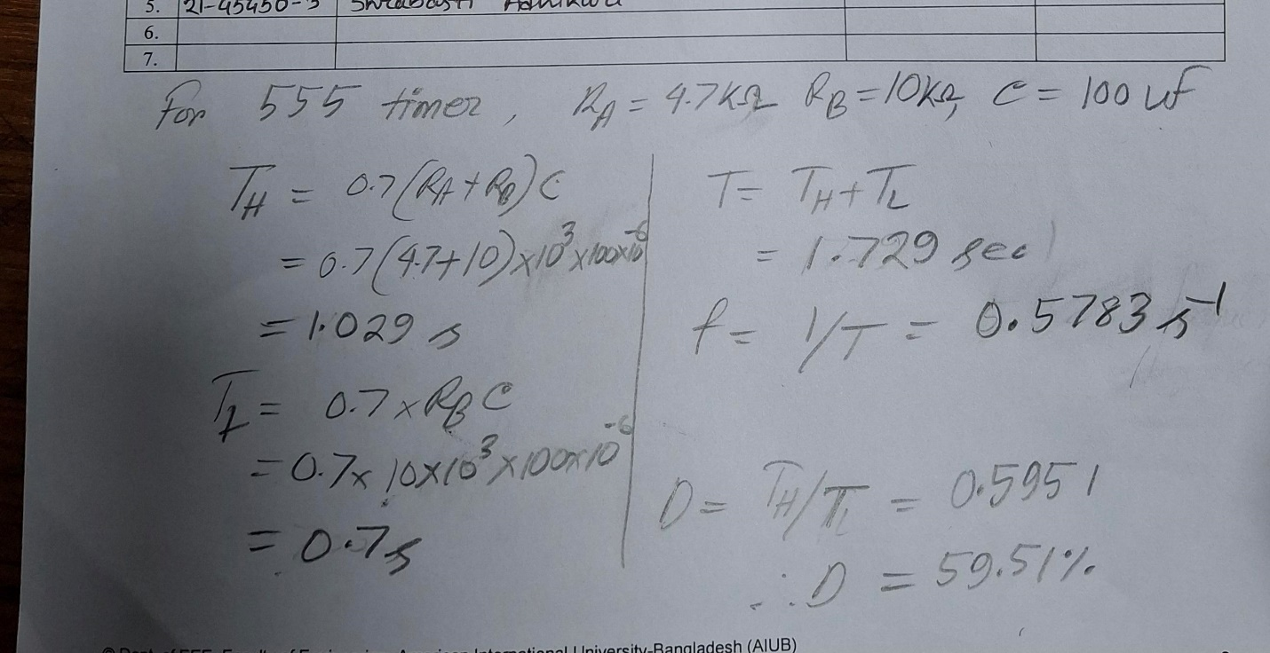

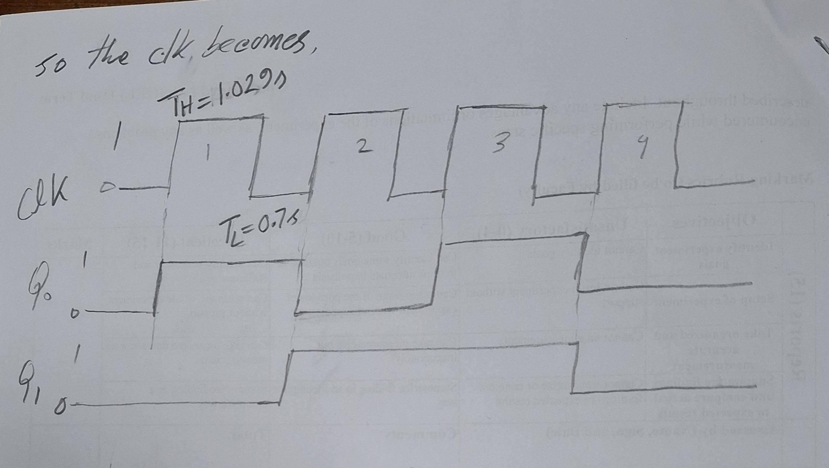

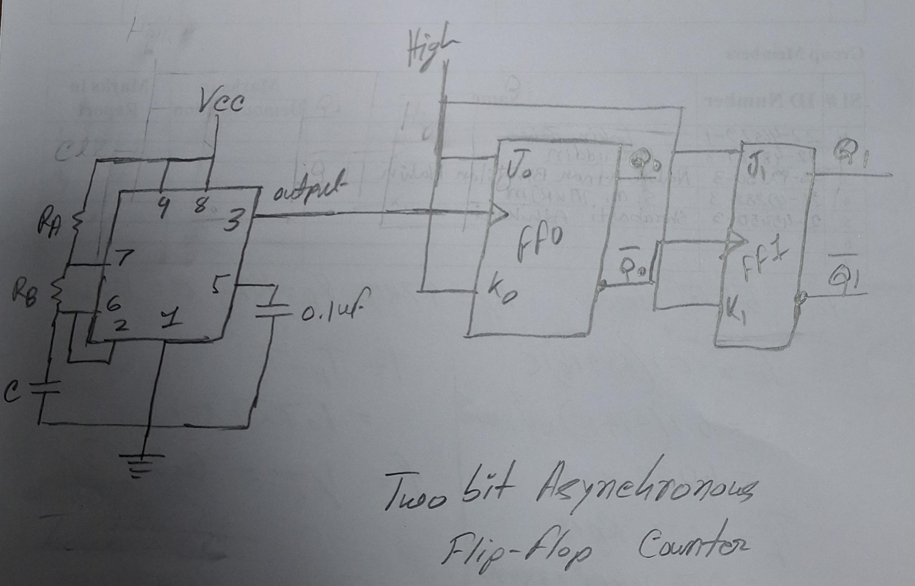

Lab-Work:

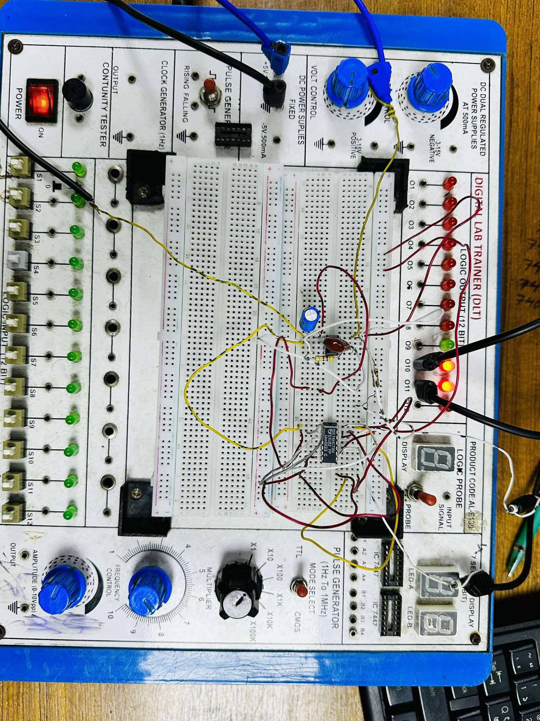

Simulation

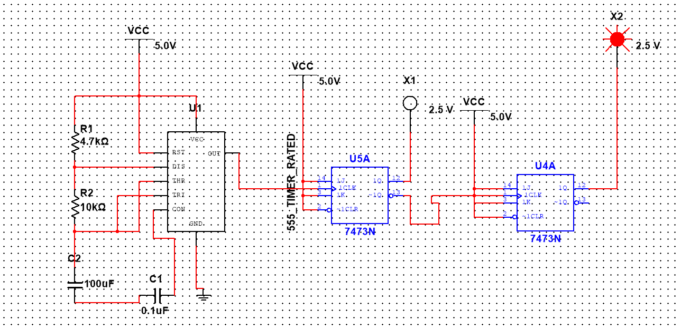

Discussions
This experiment effectively showcased the design and execution of a 2-bit asynchronous counter utilizing a 555 timer as a clock source and JK flip-flops for counting purposes. The ripple counter functioned as anticipated, generating a binary sequence (00, 01, 10, 11) with every clock pulse.

Benefits of the Experiment:
Practical Insight: This experiment offered practical experience in merging analog (555 timer) and digital (flip-flops) elements to create a working digital circuit.
Frequency Division: The counter successfully divided the input clock frequency by 2 and 4, illustrating the basic function of asynchronous counters.
Affordable Components: Employing commonly accessible and low-cost components such as the 555 timer and JK flip-flops rendered the design straightforward and economical.

Constraints of the Experiment:
Asynchronous Design: The ripple counter creates propagation delays since each flip-flop switches after the preceding one. This lag can build up and influence timing precision in higher-bit counters.
Frequency Range: The output frequency of the 555 timer is constrained by the values of the resistor and capacitor. Very high or very low frequencies may lead to instability or unrealistic component values.

Conclusions

This experiment successfully met its goal of creating and evaluating a 2-bit asynchronous counter. The 555 timer ensured a consistent clock signal, and the JK flip-flops appropriately toggled to produce the required binary outputs. The experiment reinforced the theoretical principles surrounding digital logic design and asynchronous counters while also providing insights into practical issues such as propagation delays and sensitivity to noise. Although the circuit design works well for basic applications, asynchronous counters are less suitable for high-speed or high-bit applications due to accumulated delays. Future enhancements could focus on the implementation of a synchronous counter to address timing challenges. In summary, the experiment showcased an effective, cost-efficient method for basic counting tasks while emphasizing areas that could be improved in more sophisticated digital systems.

