
American International University-Bangladesh (AIUB)

Faculty of Science & Technology (FST)
Department of Computer Science

Introduction to Data Science
Mid-Term Project Report
Spring 2025-2026

Section: F
Group:10

Project Contributions

SL  # | Student Name & ID | Contributions (mention every part of the project where you contributed)
1. | Name: Afnan Bin Islam Nahin  ID:22-49350-3 | Dataset selection, data understanding, preprocessing, descriptive statistics, report writing
2. | Name: Aman Ullah  ID:22-49345-3
  Data cleaning, outlier analysis, normalization, visualization, output collection
3. | Name:  ID:
4. | Name:  ID:

Dataset Description

The dataset used in this project is the IBM HR Analytics Employee Attrition dataset. This dataset contains employee-related information and is used to analyze the factors that may influence employee attrition.
The dataset consists of 1470 rows and 35 columns. Each row represents one employee, and each column represents a specific attribute of that employee. The dataset contains both numerical and categorical features, which makes it suitable for data preprocessing and descriptive statistical analysis.
Some important numerical attributes in the dataset are Age, MonthlyIncome, DailyRate, DistanceFromHome, TotalWorkingYears, and YearsAtCompany. Important categorical attributes include Attrition, Gender, Department, JobRole, MaritalStatus, BusinessTravel, and OverTime.
The target variable of this dataset is Attrition, which is categorical in nature. It has two classes:
- Yes = the employee has left the company
- No = the employee is still working in the company
This dataset is suitable for the project because it contains both categorical and numerical variables, has a clearly defined class label, and supports different preprocessing tasks such as missing value checking, duplicate detection, outlier handling, normalization, filtering, class comparison, and variability analysis.

Project Implementation Detail

Title of the task1: Load Dataset and Preview
Description of the task1: This task loads the IBM HR Attrition dataset into R and displays the first few rows to get an initial view of the data.

Code for task1
hr_raw <- read.csv("WA_Fn-UseC_-HR-Employee-Attrition.csv", stringsAsFactors = FALSE)
head(hr_raw[, c("Age","Attrition","Department","JobRole","MonthlyIncome","OverTime")])

Sample output of your code for task1
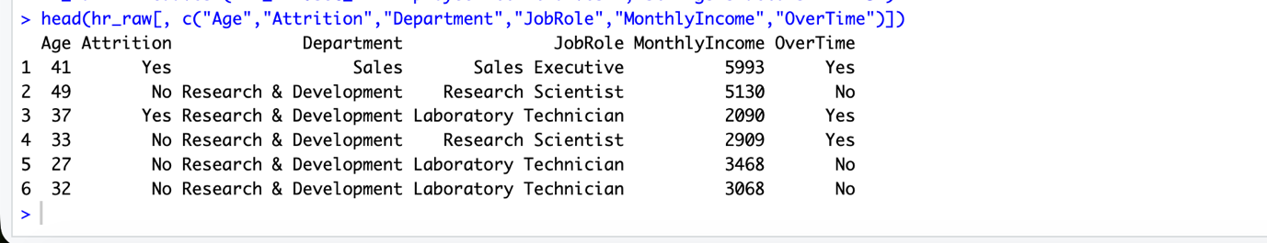

Code description of task1: The read.csv() function is used to import the dataset, and head() is used to display the first six observations for quick inspection.

Title of the task2: Dataset Shape
Description of the task2: This task checks the size of the dataset by showing the total number of rows and columns.
Code for task2
dim(hr_raw)
Sample output of your code for task2
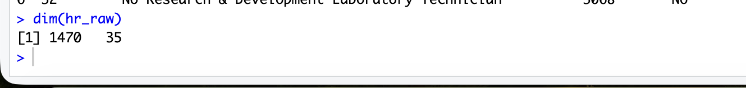Code description of task2: The dim() function returns the number of observations and the number of attributes in the dataset.
Title of the task3: Feature Names
Description of the task3: This task displays all column names in the dataset.

Code for task3
names(hr_raw)
Sample output of your code for task3
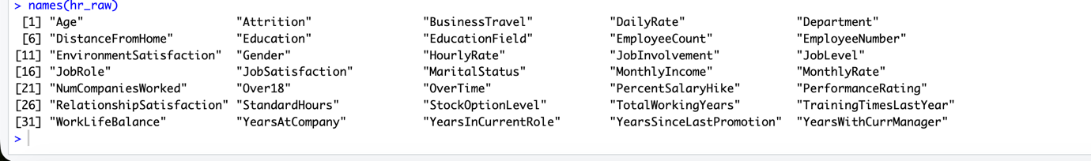
Code description of task3: The names() function is used to print the names of all columns.

Title of the task4: Data Structure
Description of the task4: This task examines the structure of the dataset and identifies the data type of each feature.

Code for task4
str(hr_raw)
Sample output of your code for task4
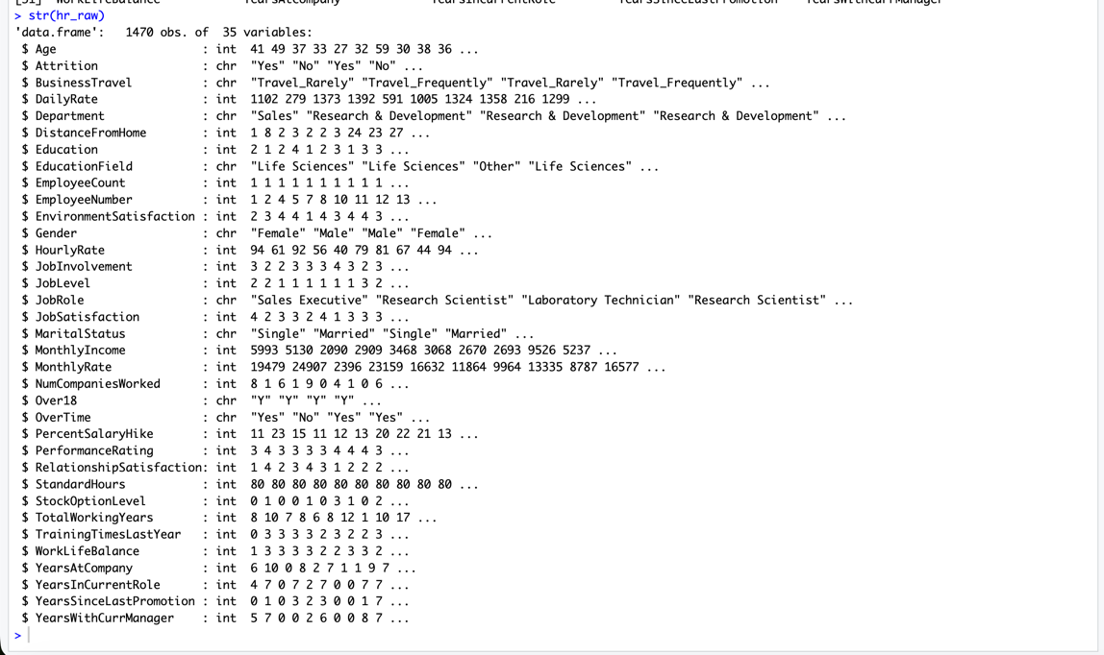
Code description of task4: The str() function provides a compact summary of the dataset structure and variable types.

Title of the task5: Identify Numeric and Categorical Columns
Description of the task5: This task separates numerical and categorical variables for further preprocessing and analysis.
Code for task5
numeric_cols <- names(hr_raw)[sapply(hr_raw, is.numeric)]
categorical_cols <- names(hr_raw)[sapply(hr_raw, is.character)]
length(numeric_cols)
length(categorical_cols)
numeric_cols
categorical_cols
Sample output of your code for task5
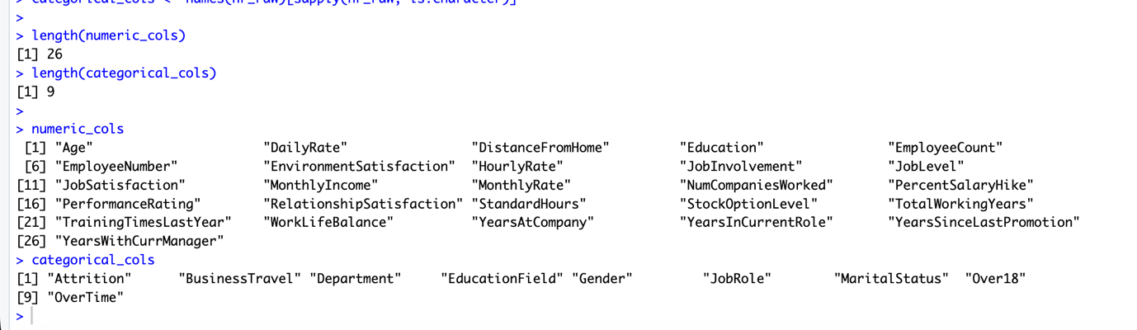
Code description of task5: The sapply() function checks each column type and stores numeric and categorical column names separately.

Title of the task6: Dataset Summary Table
Description of the task6: This task creates a short summary table containing dataset name, number of rows, number of columns, number of numeric columns, number of categorical columns, and target variable.
Code for task6
ds_summary <- data.frame(
Dataset = "IBM HR Analytics Employee Attrition",
Rows = nrow(hr_raw),
Columns = ncol(hr_raw),
Numeric_Columns = length(numeric_cols),
Categorical_Columns = length(categorical_cols),
Target = "Attrition (Yes/No)",
stringsAsFactors = FALSE
)
ds_summary
Sample output of your code for task6
Code description of task6: A data.frame() is created manually to present a compact overview of the dataset.

Title of the task7: Attrition Class Distribution
Description of the task7: This task checks the distribution of the target variable Attrition and shows the class imbalance in the dataset.
Code for task7
attr_table <- table(hr_raw$Attrition)
attr_percent <- round(prop.table(attr_table) * 100, 2)
attr_table
attr_percent

Sample output of your code for task7
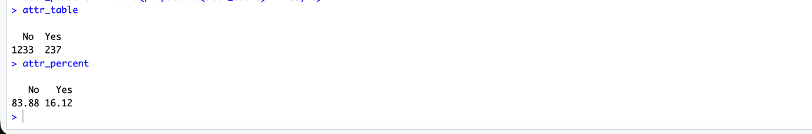
Code description of task7: The table() function counts the occurrences of each class, and prop.table() converts them into percentages.

Title of the task8: Summary of Key Numerical Features
Description of the task8: This task provides basic descriptive statistics for important numerical features.
Code for task8
summary(hr_raw[, c("Age","MonthlyIncome","TotalWorkingYears","DistanceFromHome")])
Sample output of your code for task8
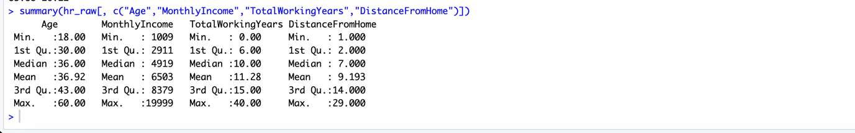
Code description of task8: The summary() function displays minimum, quartiles, median, mean, and maximum values.
Title of the task9: Missing Values Check
Description of the task9: This task checks whether the dataset contains any missing values.
Code for task9
na_col <- colSums(is.na(hr_raw))
na_col
sum(na_col)

Sample output of your code for task9
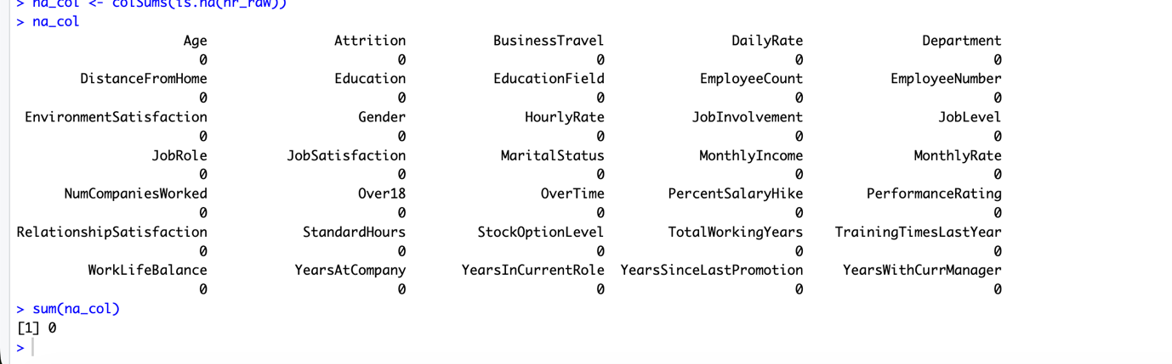
Code description of task9: The is.na() function identifies missing values, and colSums() counts them column-wise.

Title of the task10: Blank String to NA Check
Description of the task10: This task converts blank strings in categorical columns into missing values and checks the dataset again.
Code for task10
hr_step <- hr_raw
for (col in categorical_cols) {
hr_step[[col]][trimws(hr_step[[col]]) == ""] <- NA
}
na_col2 <- colSums(is.na(hr_step))
na_col2
sum(na_col2)
Sample output of your code for task10
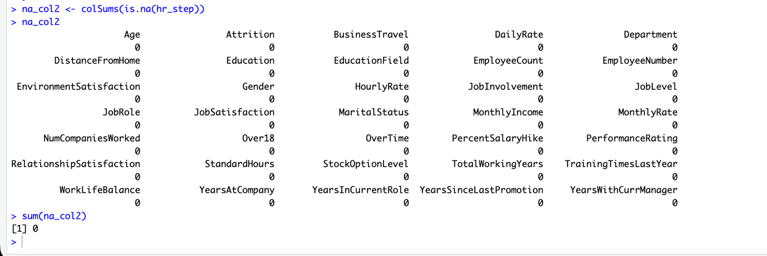
Code description of task10: trimws() removes extra spaces, and blank strings are replaced with NA.
Title of the task11: Missing Value Handling
Description of the task11: This task applies median imputation for numerical variables and mode imputation for categorical variables.
Code for task11
get_mode <- function(x) {
ux <- unique(x[!is.na(x)])
ux[which.max(tabulate(match(x, ux)))]
}
hr_imputed <- hr_step

na_before <- colSums(is.na(hr_imputed))

for (col in numeric_cols) {
hr_imputed[[col]][is.na(hr_imputed[[col]])] <- median(hr_imputed[[col]], na.rm = TRUE)
}

for (col in categorical_cols) {
hr_imputed[[col]][is.na(hr_imputed[[col]])] <- get_mode(hr_imputed[[col]])
}
na_after <- colSums(is.na(hr_imputed))

na_before
na_after
Sample output of your code for task11
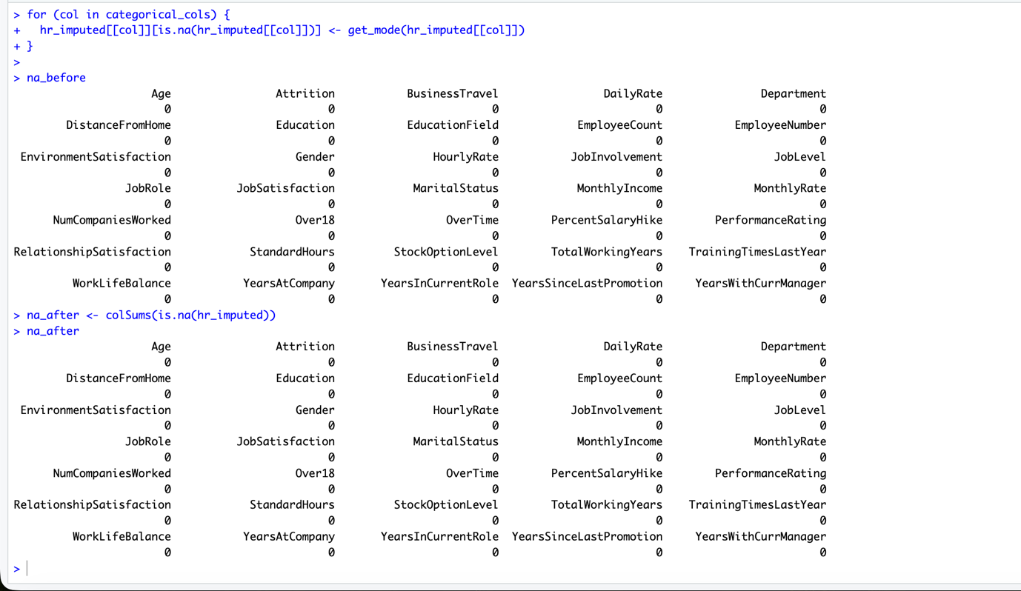
Code description of task11: A custom mode function is used for categorical columns, while median() is used for numerical columns to fill missing values.

Title of the task12: Recommended Columns to Remove
Description of the task12: This task identifies columns that are constant or act like identifiers and are not useful for analysis.
Code for task12
remove_tbl <- data.frame(
Column = c("EmployeeCount","EmployeeNumber","Over18","StandardHours"),
Reason = c(
"Constant column",
"Identifier-like column",
"Constant column",
"Constant column"
),
UniqueValues = c(
length(unique(hr_imputed$EmployeeCount)),
length(unique(hr_imputed$EmployeeNumber)),
length(unique(hr_imputed$Over18)),
length(unique(hr_imputed$StandardHours))
),
stringsAsFactors = FALSE
)

remove_tbl
Sample output of your code for task12
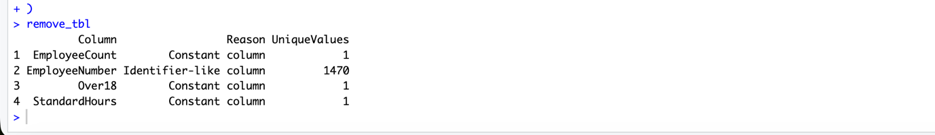
Code description of task12: A small table is created to explain why selected columns should be removed.

Title of the task13: Remove Redundant Columns
Description of the task13: This task removes unnecessary columns and confirms the updated dataset size.
Code for task13
remove_cols <- c("EmployeeCount","EmployeeNumber","Over18","StandardHours")
hr <- hr_imputed[, !(names(hr_imputed) %in% remove_cols)]
dim(hr)
setdiff(remove_cols, names(hr))
Sample output of your code for task13
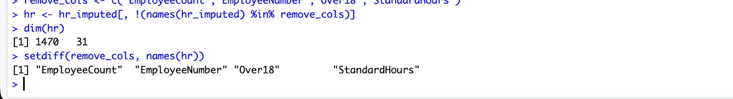
Code description of task13: Columns are removed using logical indexing with %in%.

Title of the task14: Duplicate Rows Check and Removal
Description of the task14: This task checks whether any duplicate rows exist and removes them if found.
Code for task14
dup_before <- sum(duplicated(hr))
rows_before <- nrow(hr)

hr <- hr[!duplicated(hr), ]

rows_after <- nrow(hr)

dup_before
c(Before = rows_before, After = rows_after)
Sample output of your code for task14
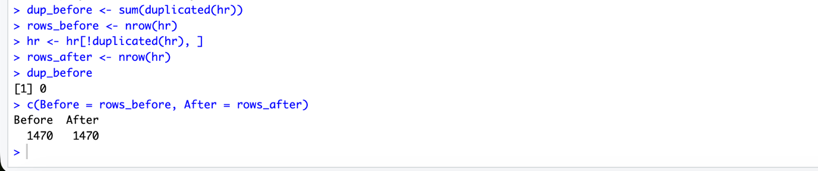
Code description of task14: The duplicated() function identifies repeated rows, and only unique rows are kept.

Title of the task15: Convert Character Columns to Factor
Description of the task15: This task converts categorical text columns into factor type for grouped analysis.

Code for task15
char_cols <- names(hr)[sapply(hr, is.character)]
for (col in char_cols) {
hr[[col]] <- as.factor(hr[[col]])
}
char_cols
sapply(hr[char_cols], class)
lapply(hr[, c("Attrition","OverTime","Department")], levels)
Sample output of your code for task15
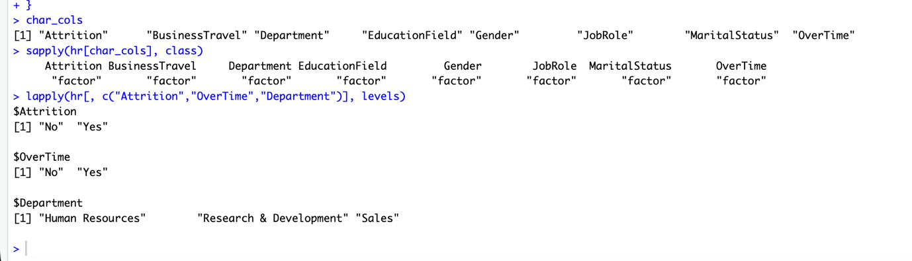
Code description of task15: The as.factor() function is applied to all character columns.
Title of the task16: Selected Variables Table
Description of the task16: This task documents the main variables used in the analysis and their roles.
Code for task16
analysis_vars <- data.frame(
Variable = c("Attrition","Age","Gender","Department","JobRole","OverTime",
"MonthlyIncome","DailyRate","DistanceFromHome","TotalWorkingYears",
"YearsAtCompany","JobLevel","JobSatisfaction","EnvironmentSatisfaction",
"WorkLifeBalance","YearsSinceLastPromotion","TrainingTimesLastYear"),
Role = c("Target","Demographic","Demographic","Work context","Work context","Workload",
"Compensation","Compensation","Commute","Experience",
"Tenure","Seniority","Satisfaction","Satisfaction",
"Satisfaction","Career growth","Training"),
stringsAsFactors = FALSE
)

analysis_vars

Sample output of your code for task16
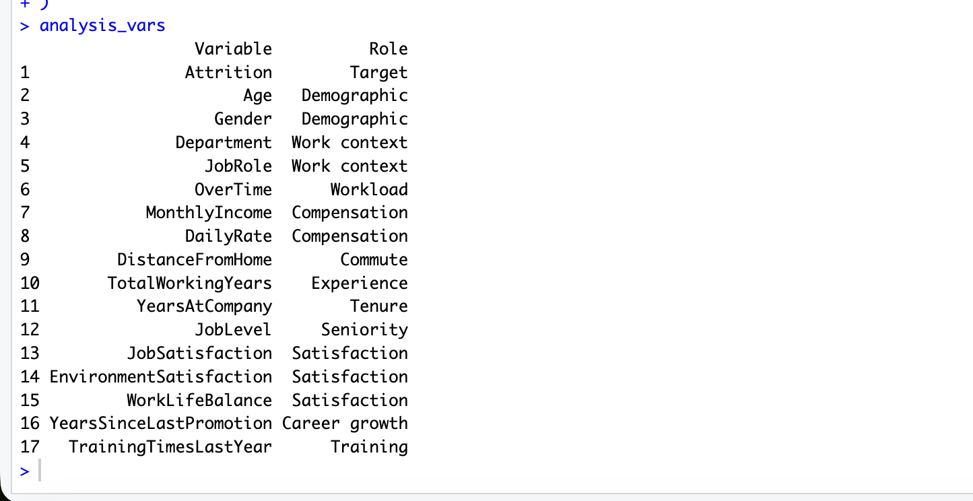
Code description of task16: A data.frame() is created to organize the chosen analysis variables.
Title of the task17: Categorical to Numeric Conversion
Description of the task17: This task creates numeric versions of selected categorical variables for numerical analysis.
Code for task17
hr$AttritionNum <- ifelse(hr$Attrition == "Yes", 1, 0)
hr$OverTimeNum <- ifelse(hr$OverTime == "Yes", 1, 0)

head(hr[, c("Attrition","AttritionNum","OverTime","OverTimeNum")])
table(hr$AttritionNum)
Sample output of your code for task17
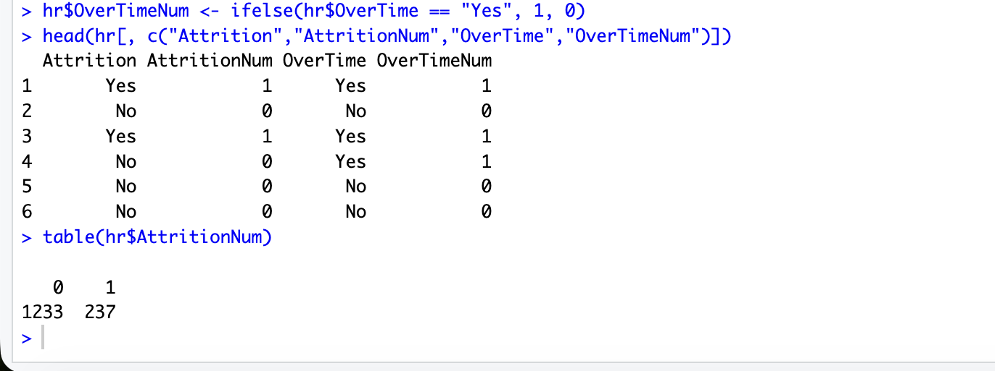
Code description of task17: The ifelse() function converts Yes/No categories into 1/0 form.

Title of the task18: Invalid Data Detection (Negative Values + Valid Range Checks)
Description of the task18: This task checks for negative values in numeric columns and verifies valid ranges for selected ordinal variables.
Code for task18
num_cols2 <- names(hr)[sapply(hr, is.numeric)]

neg_tbl <- sapply(hr[num_cols2], function(x) sum(x < 0, na.rm = TRUE))
neg_tbl[neg_tbl > 0]
sum(neg_tbl)

range_rules <- list(
Education = c(1,5),
EnvironmentSatisfaction = c(1,4),
JobSatisfaction = c(1,4),
WorkLifeBalance = c(1,4),
RelationshipSatisfaction = c(1,4),
JobInvolvement = c(1,4),
PerformanceRating = c(1,4),
StockOptionLevel = c(0,3)
)

range_check <- data.frame(
Variable = names(range_rules),
MinAllowed = sapply(range_rules, function(v) v[1]),
MaxAllowed = sapply(range_rules, function(v) v[2]),
InvalidCount = sapply(names(range_rules), function(v) {
sum(hr[[v]] < range_rules[[v]][1] | hr[[v]] > range_rules[[v]][2], na.rm = TRUE)
}),
stringsAsFactors = FALSE
)

range_check
Sample output of your code for task18
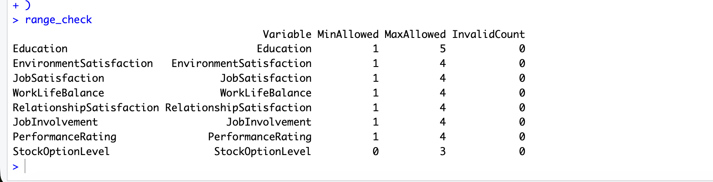
Code description of task18: Logical conditions are used to identify invalid values and count them.

Title of the task19: Filtering Example (OverTime = Yes and Age > 40)
Description of the task19: Create a subset to analyze a specific employee group and preview it.
Code for task19
subset_ot_age <- subset(hr, OverTime == "Yes" & Age > 40)
nrow(subset_ot_age)
head(subset_ot_age[, c("Age","Attrition","Department","JobRole","MonthlyIncome","OverTime")])
Sample output of your code for task19
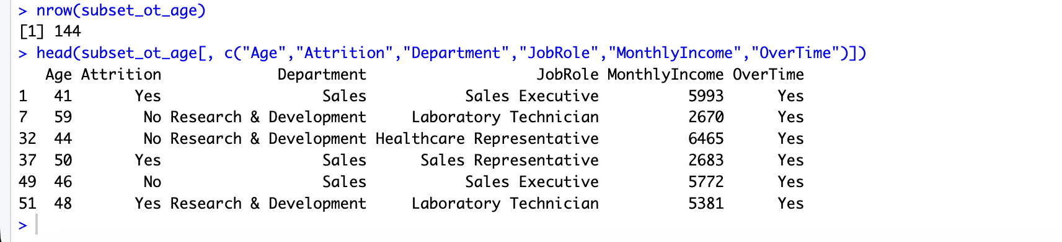
Code description of task19: subset() filters rows based on logical conditions.

Title of the task20: Filtering Example (Department = Sales) and Attrition Rate
Description of the task20: Filter Sales employees and compute attrition distribution within Sales.
Code for task20
sales_df <- subset(hr, Department == "Sales")
sales_tab <- table(sales_df$Attrition)
sales_tab
round(prop.table(sales_tab) * 100, 2)
Sample output of your code for task20
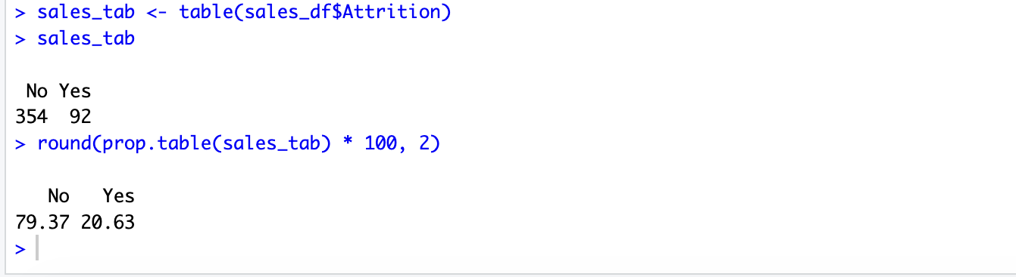
Code description of task20: Uses class proportions to compare attrition within a subpopulation.

Title of the task21: Outlier Detection Using IQR Rule
Description of the task21: Compute Q1, Q3, IQR bounds and outlier counts for selected numeric variables using the 1.5×IQR rule.
Code for task21
iqr_info <- function(x) {
q1 <- quantile(x, 0.25, na.rm = TRUE)
q3 <- quantile(x, 0.75, na.rm = TRUE)
iqr <- q3 - q1
lower <- q1 - 1.5 * iqr
upper <- q3 + 1.5 * iqr
out <- sum(x < lower | x > upper, na.rm = TRUE)
c(Q1 = q1, Q3 = q3, IQR = iqr, Lower = lower, Upper = upper, Outliers = out)
}

out_vars <- c("MonthlyIncome","TotalWorkingYears")
outlier_table <- t(sapply(hr[out_vars], iqr_info))
round(outlier_table, 2)
Sample output of your code for task21
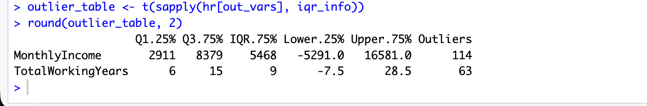
Code description of task21: Quartiles and IQR are calculated, and values beyond the IQR bounds are counted as outliers.

Title of the task22: Outlier Handling by Winsorization (Capping)
Description of the task22: Cap values below/above IQR bounds instead of deleting them (winsorization).

Code for task22
cap_iqr <- function(x) {
q1 <- quantile(x, 0.25, na.rm = TRUE)
q3 <- quantile(x, 0.75, na.rm = TRUE)
iqr <- q3 - q1
lower <- q1 - 1.5 * iqr
upper <- q3 + 1.5 * iqr
x2 <- x
x2[x2 < lower] <- lower
x2[x2 > upper] <- upper
list(Capped = x2, Lower = lower, Upper = upper, Changed = sum(x2 != x, na.rm = TRUE))
}

income_cap <- cap_iqr(hr$MonthlyIncome)
hr$MonthlyIncome_capped <- income_cap$Capped

twy_cap <- cap_iqr(hr$TotalWorkingYears)
hr$TotalWorkingYears_capped <- twy_cap$Capped

c(Lower = income_cap$Lower, Upper = income_cap$Upper, Changed = income_cap$Changed)
summary(hr$MonthlyIncome)
summary(hr$MonthlyIncome_capped)

c(Lower = twy_cap$Lower, Upper = twy_cap$Upper, Changed = twy_cap$Changed)
summary(hr$TotalWorkingYears)
summary(hr$TotalWorkingYears_capped)
Sample output of your code for task22
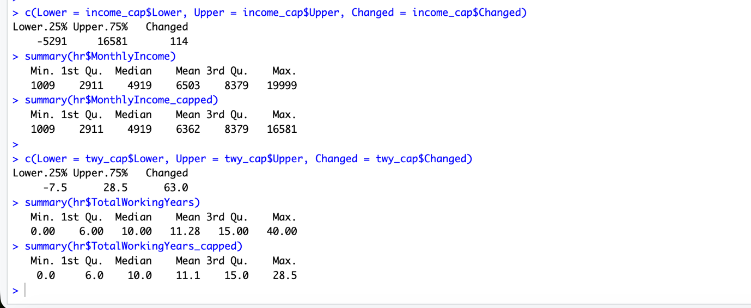
Code description of task22: Winsorization reduces extreme influence while preserving all rows.

Title of the task23: Boxplot Before vs After Outlier Treatment
Description of the task23: This task visually compares the selected variable before and after outlier treatment.

Code for task23
par(mfrow = c(1,2))
boxplot(hr$MonthlyIncome, main = "MonthlyIncome Original", ylab = "Monthly Income")
boxplot(hr$MonthlyIncome_capped, main = "MonthlyIncome Capped", ylab = "Monthly Income")
par(mfrow = c(1,1))

Sample output of your code for task23
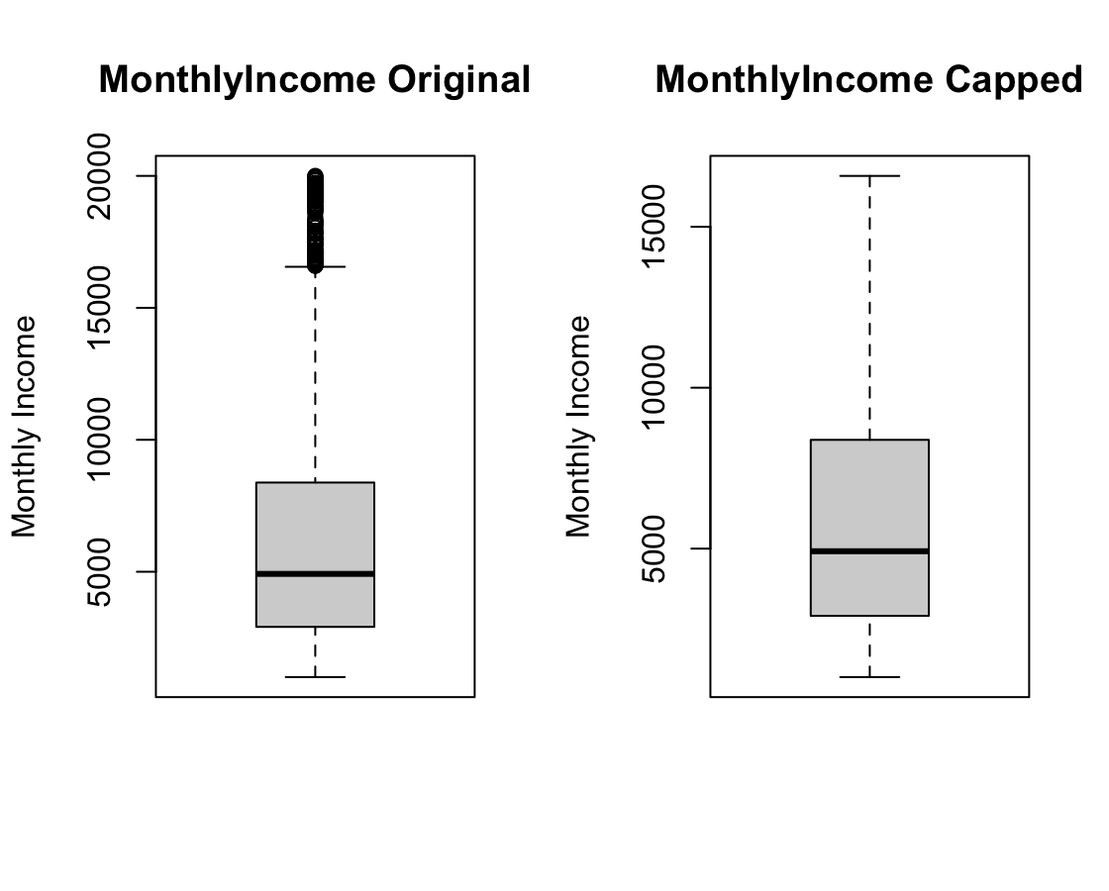
Code description of task23: Two boxplots are displayed side by side using par(mfrow=...).

Title of the task24: Min-Max Normalization
Description of the task24: Normalize continuous variables to the [0,1] range using min-max scaling.
Code for task24
minmax <- function(x) {
(x - min(x, na.rm = TRUE)) / (max(x, na.rm = TRUE) - min(x, na.rm = TRUE))
}
hr$MonthlyIncome_norm <- minmax(hr$MonthlyIncome_capped)
hr$DistanceFromHome_norm <- minmax(hr$DistanceFromHome)

head(hr[, c("MonthlyIncome_capped","MonthlyIncome_norm","DistanceFromHome","DistanceFromHome_norm")])
summary(hr$MonthlyIncome_norm)
Sample output of your code for task24
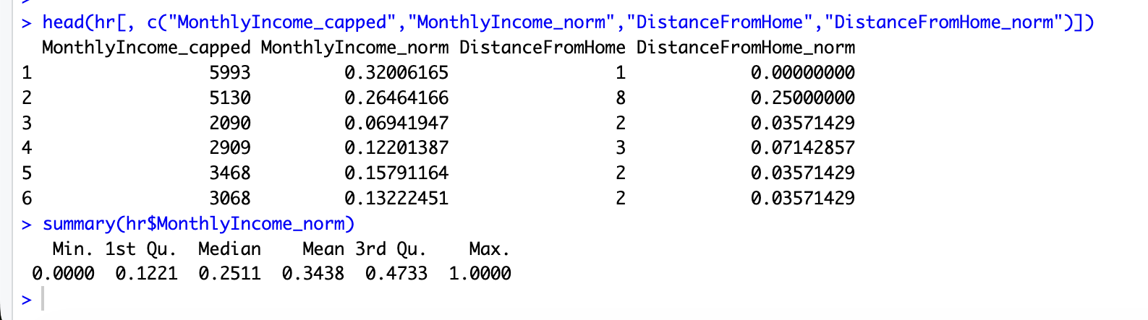
Code description of task24: Scaling prevents large-scale attributes from dominating comparisons.

Title of the task25: Numeric to Categorical Conversion
Description of the task25: Convert numeric fields into categories (AgeGroup, IncomeGroup) for grouped analysis.
Code for task25
hr$AgeGroup <- cut(
hr$Age,
breaks = c(17,29,39,49,60),
labels = c("18-29","30-39","40-49","50-60"),
include.lowest = TRUE
)

hr$IncomeGroup <- cut(
hr$MonthlyIncome_capped,
breaks = quantile(hr$MonthlyIncome_capped, probs = c(0,0.33,0.66,1), na.rm = TRUE),
labels = c("Low","Medium","High"),
include.lowest = TRUE
)

table(hr$AgeGroup)
table(hr$IncomeGroup)
table(hr$AgeGroup, hr$Attrition)
Sample output of your code for task25
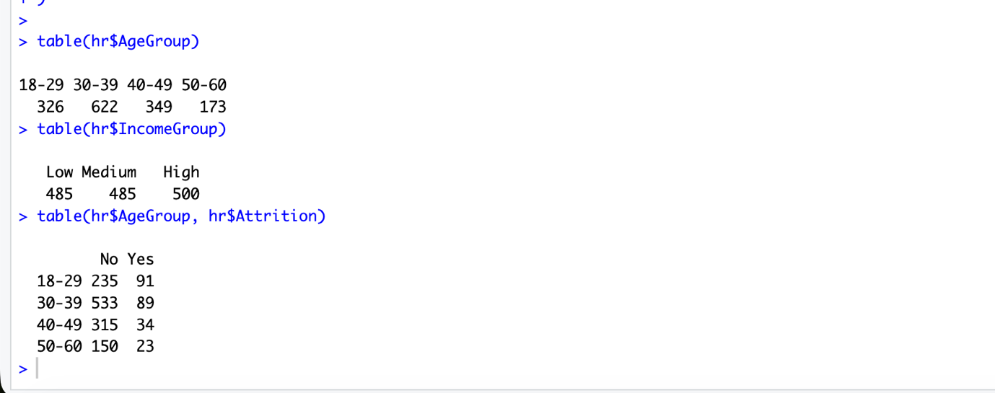
Code description of task25: cut() bins continuous data into interpretable categories.

Title of the task26: Descriptive Statistics by Class (Attrition) for Age
Description of the task26: Compute mean, median, SD, variance, IQR, min, max, range for Age by Attrition.
Code for task26
calc_stats <- function(x) {
c(
Mean = mean(x, na.rm = TRUE),
Median = median(x, na.rm = TRUE),
SD = sd(x, na.rm = TRUE),
Variance = var(x, na.rm = TRUE),
IQR = IQR(x, na.rm = TRUE),
Min = min(x, na.rm = TRUE),
Max = max(x, na.rm = TRUE),
Range = max(x, na.rm = TRUE) - min(x, na.rm = TRUE)
)
}

age_by_attr <- t(sapply(split(hr$Age, hr$Attrition), calc_stats))
round(age_by_attr, 2)
Sample output of your code for task26
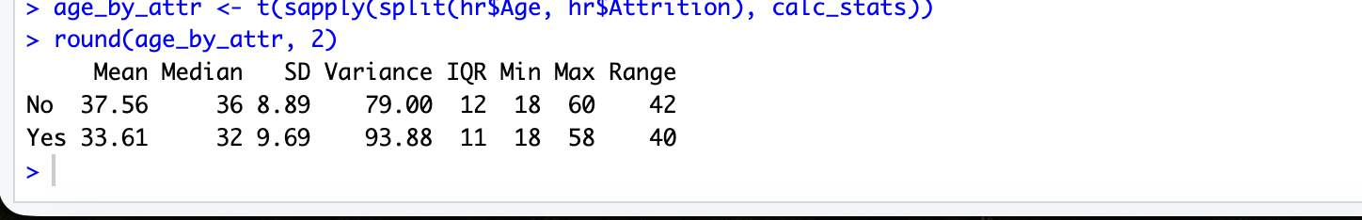
Code description of task26: split() separates values by class; sapply() computes stats per class.

Title of the task27: Descriptive Statistics by Class (Attrition) for Monthly Income
Description of the task27: Compute the same statistics for MonthlyIncome (capped) by Attrition.

Code for task27
income_by_attr <- t(sapply(split(hr$MonthlyIncome_capped, hr$Attrition), calc_stats))
round(income_by_attr, 2)
Sample output of your code for task27
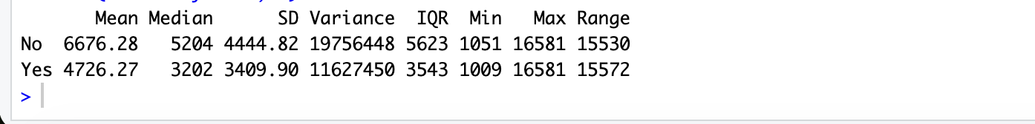
Code description of task27: Same method as Task 26, applied to income.

Title of the task28: Mean Comparison (Required) — Monthly Income Across Attrition
Description of the task28: Compare average MonthlyIncome between Attrition groups using aggregate().

Code for task28
mean_income <- aggregate(MonthlyIncome_capped ~ Attrition, data = hr, FUN = mean)
mean_income
Sample output of your code for task28
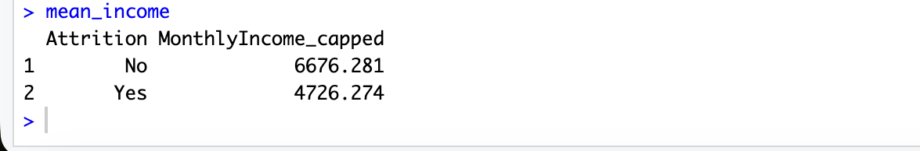
Code description of task28: aggregate() computes summary statistics by category.

Title of the task29: Mean Comparison — Total Working Years Across OverTime
Description of the task29: Compare mean TotalWorkingYears between OverTime categories (Yes/No).
Code for task29
aggregate(TotalWorkingYears ~ OverTime, data = hr, FUN = mean)
Sample output of your code for task29
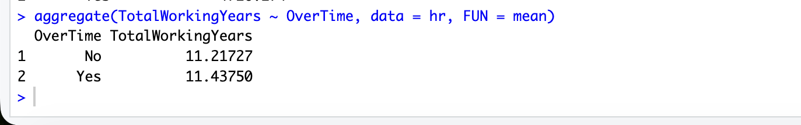
Code description of task29: Another category-based mean comparison using aggregate().

Title of the task30: Variability Comparison (Required) — Total Working Years Across Attrition
Description of the task30: This task calculates the variability measures (Range, IQR, Variance, and Standard Deviation) of TotalWorkingYears for different Attrition groups.

Code for task30
spread_twy <- aggregate(
TotalWorkingYears_capped ~ Attrition,
data = hr,
FUN = function(x) c(
Range = max(x) - min(x),
IQR = IQR(x),
Variance = var(x),
SD = sd(x)
)
)

spread_twy_df <- data.frame(
Attrition = spread_twy$Attrition,
spread_twy$TotalWorkingYears_capped
)

names(spread_twy_df) <- c("Attrition","Range","IQR","Variance","SD")

spread_twy_df[, -1] <- round(spread_twy_df[, -1], 2)

spread_twy_df
Sample output of your code for task30
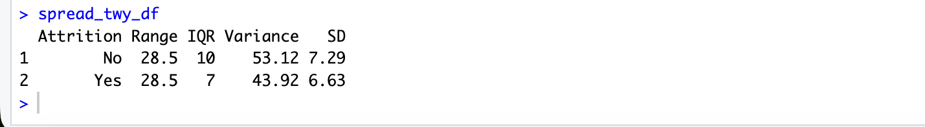
Code description of task30: The aggregate() function is used to compute variability measures for each Attrition category. The round() function is applied only to numeric columns to format the output.

Title of the task31: Variability Across Multiple Levels — Monthly Income by Department
Description of the task31: This task calculates the variability measures (Range, IQR, Variance, and Standard Deviation) of MonthlyIncome across different departments.

Code for task31
spread_income_dept <- aggregate(
MonthlyIncome_capped ~ Department,
data = hr,
FUN = function(x) c(
Range = max(x) - min(x),
IQR = IQR(x),
Variance = var(x),
SD = sd(x)
)
)

spread_income_df <- data.frame(
Department = spread_income_dept$Department,
spread_income_dept$MonthlyIncome_capped
)

names(spread_income_df) <- c("Department","Range","IQR","Variance","SD")

spread_income_df[, -1] <- round(spread_income_df[, -1], 2)

spread_income_df
Sample output of your code for task31
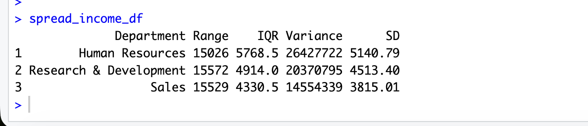
Code description of task31: The aggregate() function is used to compute variability measures for each department. The round() function is applied only to numeric columns to avoid errors from categorical variables.

Title of the task32: Correlation Matrix for Selected Numeric Variables
Description of the task32: Compute correlations among selected numeric variables and print the matrix.
Code for task32
cor_vars <- c("Age","MonthlyIncome_capped","TotalWorkingYears_capped",
"DistanceFromHome","YearsAtCompany","JobLevel","PercentSalaryHike")
cor_mat <- cor(hr[, cor_vars])
round(cor_mat, 3)

Sample output of your code for task32
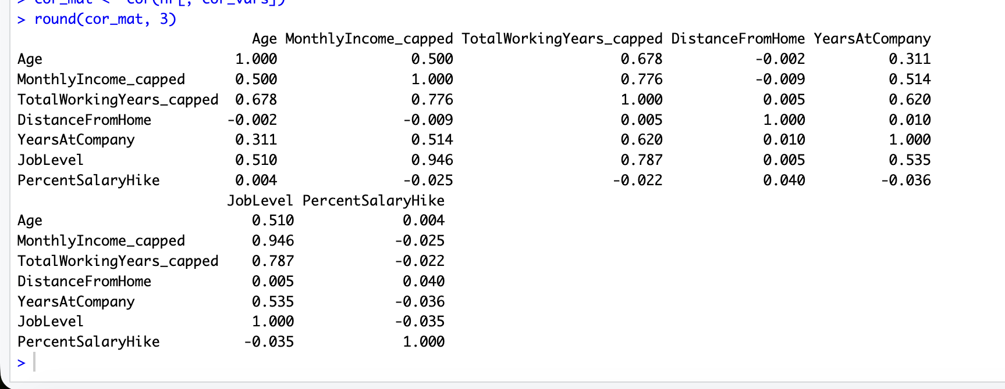
Code description of task32: cor() measures linear relationships among numeric columns.

Title of the task33: Welch Two-Sample t-test (Income vs Attrition)
Description of the task33: Test whether mean income differs between Attrition groups; include as an extra analysis.
Code for task33
t.test(MonthlyIncome_capped ~ Attrition, data = hr)
Sample output of your code for task33
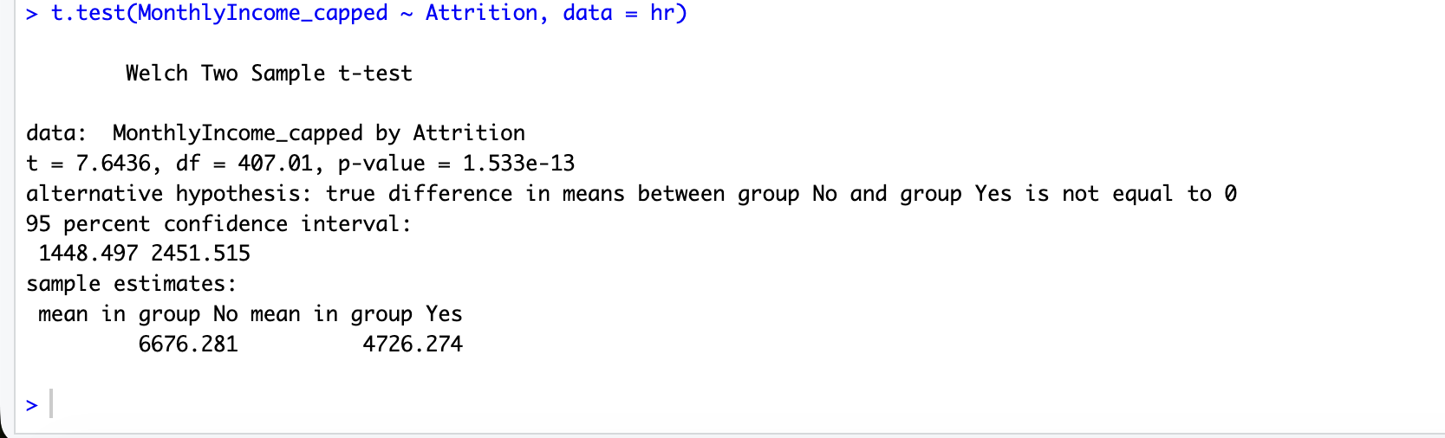
Code description of task33: t.test() performs a two-sample test; treat results as statistical evidence, while noting it does not prove causation.

Title of the task34: Histograms (Age and Monthly Income)
Description of the task34: Plot distributions for two important numeric variables.

Code for task34
par(mfrow = c(1,2))
hist(hr$Age, breaks = 15, main = "Histogram of Age", xlab = "Age")
hist(hr$MonthlyIncome_capped, breaks = 20, main = "Histogram of Monthly Income", xlab = "Monthly Income")
par(mfrow = c(1,1))

Sample output of your code for task34
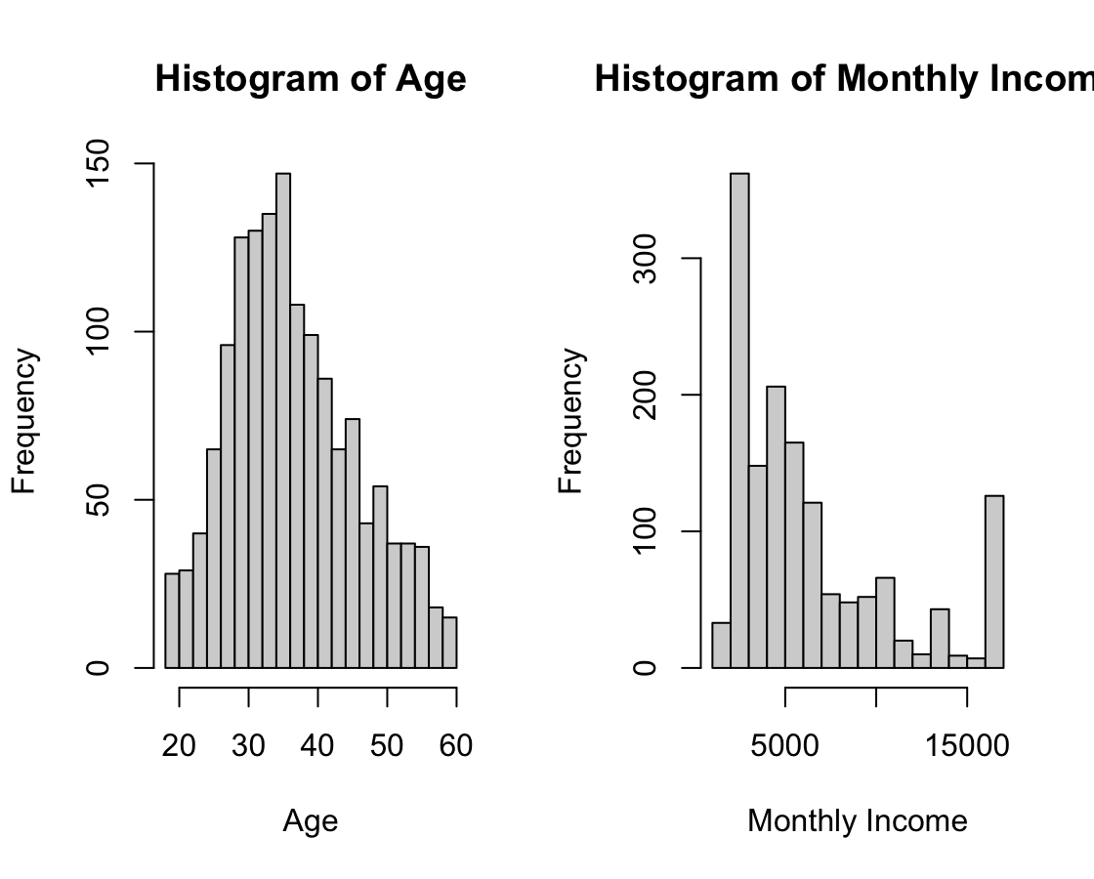
Code description of task34: Histograms summarize distribution shapes and frequency.

Title of the task35: Bar Charts (Attrition, Gender, Department)
Description of the task35: Visualize categorical distributions with bar charts.

Code for task35
par(mfrow = c(1,3))
barplot(table(hr$Attrition), main = "Attrition Counts", ylab = "Count")
barplot(table(hr$Gender), main = "Gender Counts", ylab = "Count")
barplot(table(hr$Department), main = "Department Counts", ylab = "Count", las = 2)
par(mfrow = c(1,1))
Sample output of your code for task35
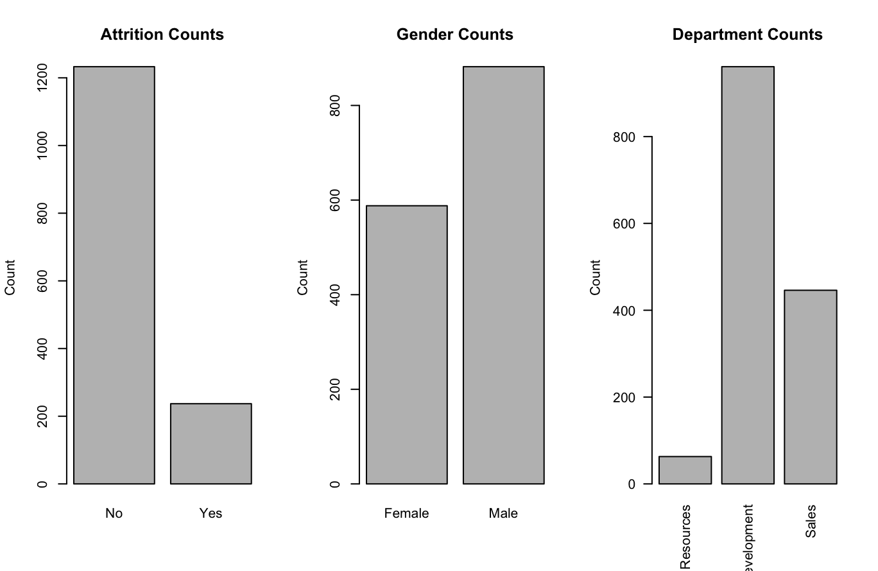
Code description of task35: barplot() visualizes category counts

Title of the task36: Attrition by OverTime (Cross-tab + Grouped Barplot)
Description of the task36: Compare Attrition counts across OverTime categories.

Code for task36
ot_tab <- table(hr$OverTime, hr$Attrition)
ot_tab
barplot(t(ot_tab), beside = TRUE, legend.text = TRUE,
main = "Attrition by OverTime", xlab = "OverTime", ylab = "Count")

Sample output of your code for task36
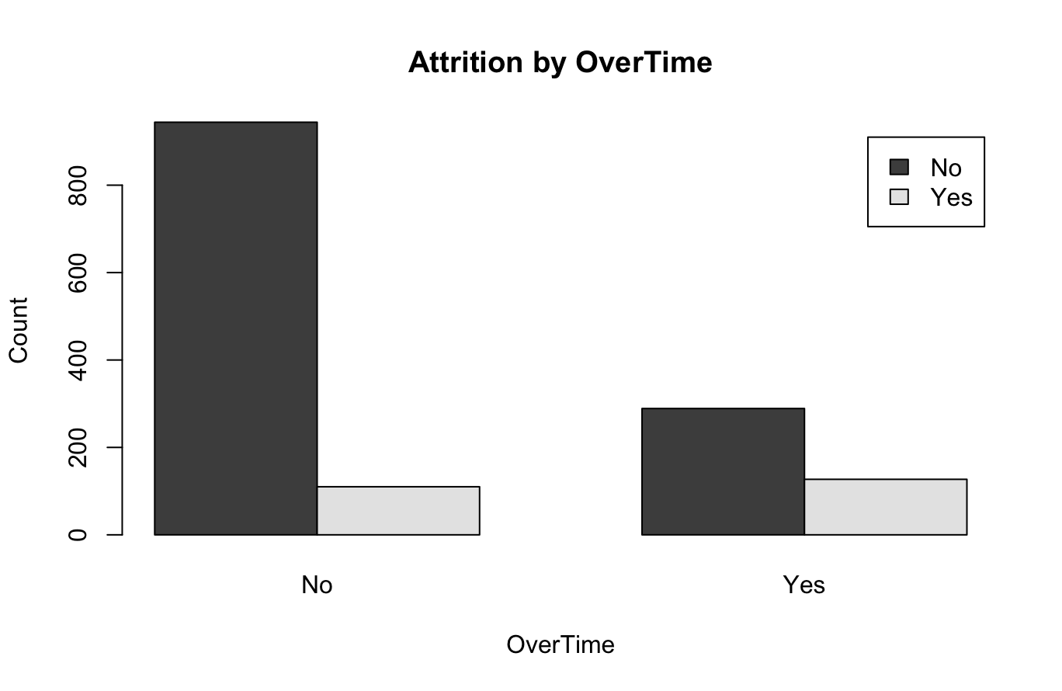
Code description of task36: table() creates a contingency table; barplot() displays it visually.

Title of the task37: Boxplot by Class + Scatter Plot
Description of the task37: Visualize income differences by Attrition and relationship between Age and Income.

Code for task37
par(mfrow = c(1,2))
boxplot(MonthlyIncome_capped ~ Attrition, data = hr,
main = "Monthly Income by Attrition",
xlab = "Attrition", ylab = "Monthly Income")

plot(hr$Age, hr$MonthlyIncome_capped, pch = 19,
col = ifelse(hr$Attrition == "Yes", 2, 4),
main = "Age vs Monthly Income",
xlab = "Age", ylab = "Monthly Income")

legend("topleft", legend = c("No","Yes"), col = c(4,2), pch = 19)
par(mfrow = c(1,1))
Sample output of your code for task37
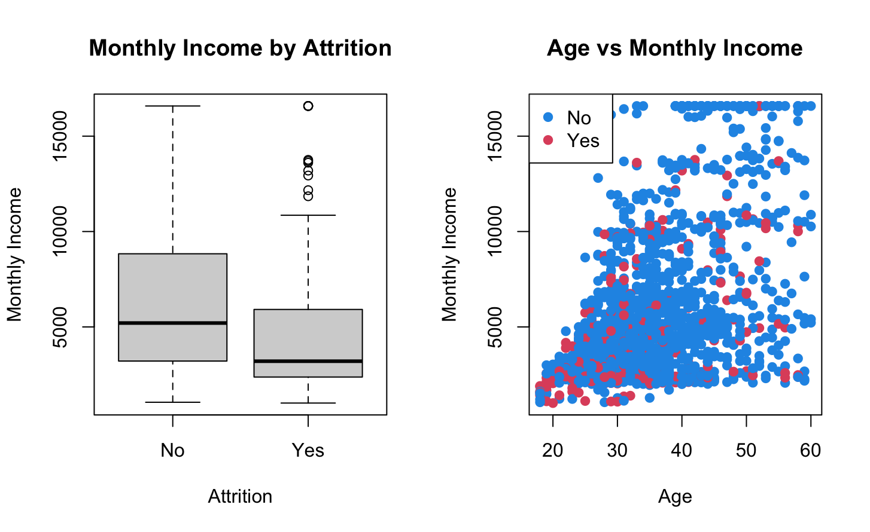
Code description of task37: Boxplot compares distributions by category; scatter shows relationship and class separation.

Title of the task38: Correlation Heatmap (Selected Variables)
Description of the task38: Visualize the correlation matrix in heatmap form.

Code for task38
heatmap(cor_mat, symm = TRUE, margins = c(15,15))
title("Correlation Heatmap")

Sample output of your code for task38
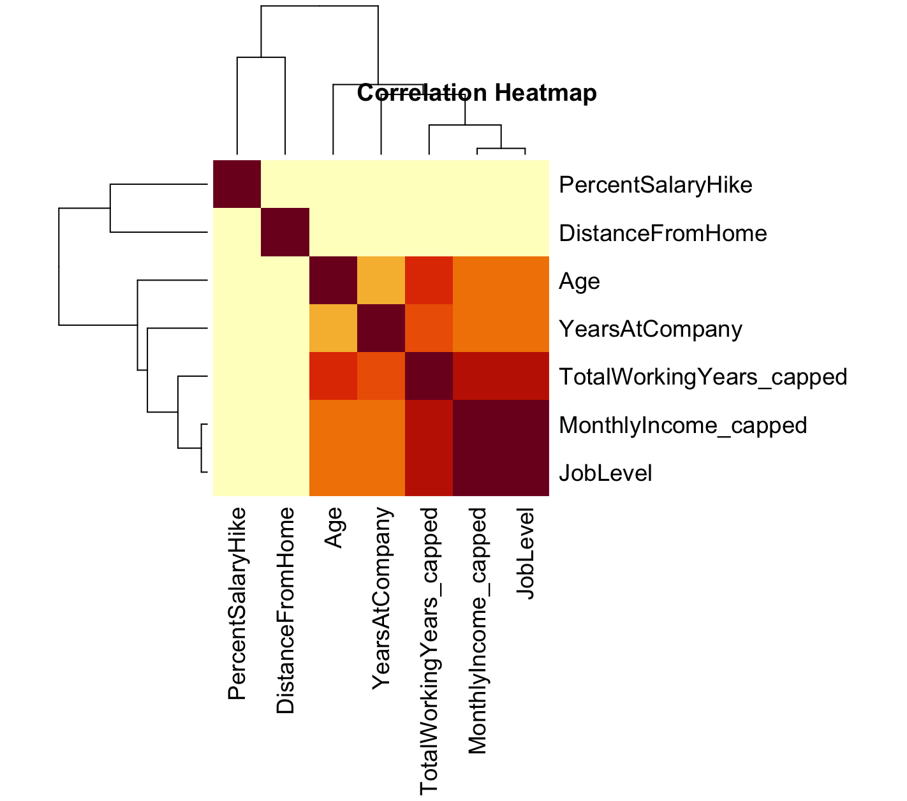
Code description of task38: heatmap() produces a color-based correlation visualization.
Title of the task39: Stratified Train-Test Split (70%/30%)
Description of the task39: Split dataset into training and testing sets while preserving Attrition ratio.

Code for task39
set.seed(42)
train_idx <- unlist(tapply(1:nrow(hr), hr$Attrition, function(idx) {
sample(idx, size = round(0.7 * length(idx)))
}))
train <- hr[train_idx, ]
test <- hr[-train_idx, ]

c(TrainRows = nrow(train), TestRows = nrow(test))
table(train$Attrition)
table(test$Attrition)
Sample output of your code for task39
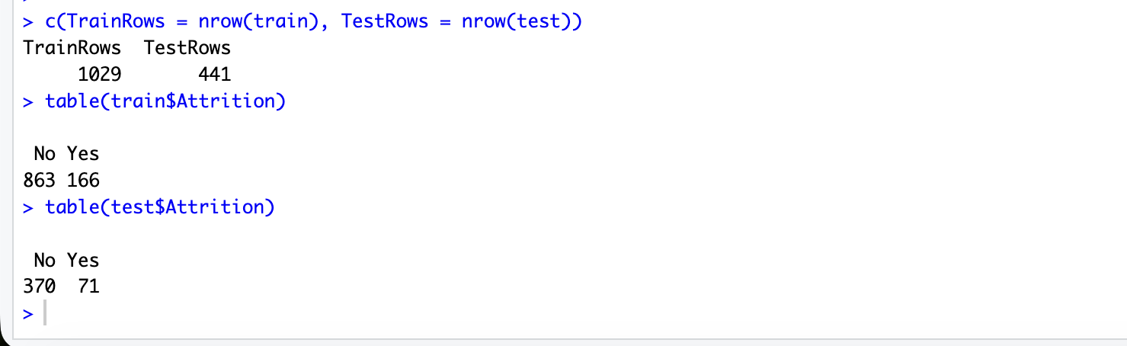
Code description of task39: The tapply() function is used to group indices by Attrition class, and sample() selects 70% of data from each class. This ensures balanced class distribution in both training and testing sets.

Title of the task40: Class Imbalance Handling (Simple Oversampling for Training Set)
Description of the task40: This task balances the training dataset by applying oversampling to the minority class (Attrition = Yes). This ensures equal representation of both classes.

Code for task40
majority_train <- train[train$Attrition == "No", ]
minority_train <- train[train$Attrition == "Yes", ]
set.seed(42)
minority_over <- minority_train[sample(1:nrow(minority_train), nrow(majority_train), replace = TRUE), ]
train_balanced <- rbind(majority_train, minority_over)
table(train_balanced$Attrition)
nrow(train_balanced)

Sample output of your code for task40
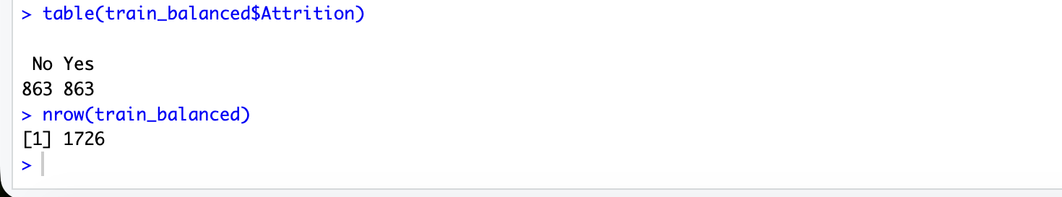
Code description of task40: The minority class is randomly sampled with replacement using the sample() function until it matches the size of the majority class. The datasets are then combined using rbind().

Project Code

hr_raw <- read.csv("WA_Fn-UseC_-HR-Employee-Attrition.csv", stringsAsFactors = FALSE)
head(hr_raw[, c("Age","Attrition","Department","JobRole","MonthlyIncome","OverTime")])

dim(hr_raw)
names(hr_raw)
str(hr_raw)

numeric_cols <- names(hr_raw)[sapply(hr_raw, is.numeric)]
categorical_cols <- names(hr_raw)[sapply(hr_raw, is.character)]

length(numeric_cols)
length(categorical_cols)

numeric_cols
categorical_cols

ds_summary <- data.frame(
Dataset = "IBM HR Analytics Employee Attrition",
Rows = nrow(hr_raw),
Columns = ncol(hr_raw),
Numeric_Columns = length(numeric_cols),
Categorical_Columns = length(categorical_cols),
Target = "Attrition (Yes/No)",
stringsAsFactors = FALSE
)
ds_summary

attr_table <- table(hr_raw$Attrition)
attr_percent <- round(prop.table(attr_table) * 100, 2)
attr_table
attr_percent

summary(hr_raw[, c("Age","MonthlyIncome","TotalWorkingYears","DistanceFromHome")])

na_col <- colSums(is.na(hr_raw))
na_col
sum(na_col)

hr_step <- hr_raw
for (col in categorical_cols) {
hr_step[[col]][trimws(hr_step[[col]]) == ""] <- NA
}
na_col2 <- colSums(is.na(hr_step))
na_col2
sum(na_col2)

get_mode <- function(x) {
ux <- unique(x[!is.na(x)])
ux[which.max(tabulate(match(x, ux)))]
}

hr_imputed <- hr_step
na_before <- colSums(is.na(hr_imputed))

for (col in numeric_cols) {
hr_imputed[[col]][is.na(hr_imputed[[col]])] <- median(hr_imputed[[col]], na.rm = TRUE)
}

for (col in categorical_cols) {
hr_imputed[[col]][is.na(hr_imputed[[col]])] <- get_mode(hr_imputed[[col]])
}

na_before
na_after <- colSums(is.na(hr_imputed))
na_after

remove_tbl <- data.frame(
Column = c("EmployeeCount","EmployeeNumber","Over18","StandardHours"),
Reason = c("Constant column","Identifier-like column","Constant column","Constant column"),
UniqueValues = c(
length(unique(hr_imputed$EmployeeCount)),
length(unique(hr_imputed$EmployeeNumber)),
length(unique(hr_imputed$Over18)),
length(unique(hr_imputed$StandardHours))
),
stringsAsFactors = FALSE
)
remove_tbl

remove_cols <- c("EmployeeCount","EmployeeNumber","Over18","StandardHours")
hr <- hr_imputed[, !(names(hr_imputed) %in% remove_cols)]
dim(hr)
setdiff(remove_cols, names(hr))

dup_before <- sum(duplicated(hr))
rows_before <- nrow(hr)
hr <- hr[!duplicated(hr), ]
rows_after <- nrow(hr)
dup_before
c(Before = rows_before, After = rows_after)

char_cols <- names(hr)[sapply(hr, is.character)]
for (col in char_cols) {
hr[[col]] <- as.factor(hr[[col]])
}
char_cols
sapply(hr[char_cols], class)
lapply(hr[, c("Attrition","OverTime","Department")], levels)

analysis_vars <- data.frame(
Variable = c("Attrition","Age","Gender","Department","JobRole","OverTime",
"MonthlyIncome","DailyRate","DistanceFromHome","TotalWorkingYears",
"YearsAtCompany","JobLevel","JobSatisfaction","EnvironmentSatisfaction",
"WorkLifeBalance","YearsSinceLastPromotion","TrainingTimesLastYear"),
Role = c("Target","Demographic","Demographic","Work context","Work context","Workload",
"Compensation","Compensation","Commute","Experience",
"Tenure","Seniority","Satisfaction","Satisfaction",
"Satisfaction","Career growth","Training"),
stringsAsFactors = FALSE
)
analysis_vars

hr$AttritionNum <- ifelse(hr$Attrition == "Yes", 1, 0)
hr$OverTimeNum <- ifelse(hr$OverTime == "Yes", 1, 0)
head(hr[, c("Attrition","AttritionNum","OverTime","OverTimeNum")])
table(hr$AttritionNum)

num_cols2 <- names(hr)[sapply(hr, is.numeric)]
neg_tbl <- sapply(hr[num_cols2], function(x) sum(x < 0, na.rm = TRUE))
neg_tbl[neg_tbl > 0]
sum(neg_tbl)

range_rules <- list(
Education = c(1,5),
EnvironmentSatisfaction = c(1,4),
JobSatisfaction = c(1,4),
WorkLifeBalance = c(1,4),
RelationshipSatisfaction = c(1,4),
JobInvolvement = c(1,4),
PerformanceRating = c(1,4),
StockOptionLevel = c(0,3)
)

range_check <- data.frame(
Variable = names(range_rules),
MinAllowed = sapply(range_rules, function(v) v[1]),
MaxAllowed = sapply(range_rules, function(v) v[2]),
InvalidCount = sapply(names(range_rules), function(v) {
sum(hr[[v]] < range_rules[[v]][1] | hr[[v]] > range_rules[[v]][2], na.rm = TRUE)
}),
stringsAsFactors = FALSE
)
range_check

subset_ot_age <- subset(hr, OverTime == "Yes" & Age > 40)
nrow(subset_ot_age)
head(subset_ot_age[, c("Age","Attrition","Department","JobRole","MonthlyIncome","OverTime")])

sales_df <- subset(hr, Department == "Sales")
sales_tab <- table(sales_df$Attrition)
sales_tab
round(prop.table(sales_tab) * 100, 2)

iqr_info <- function(x) {
q1 <- quantile(x, 0.25, na.rm = TRUE)
q3 <- quantile(x, 0.75, na.rm = TRUE)
iqr <- q3 - q1
lower <- q1 - 1.5 * iqr
upper <- q3 + 1.5 * iqr
out <- sum(x < lower | x > upper, na.rm = TRUE)
c(Q1 = q1, Q3 = q3, IQR = iqr, Lower = lower, Upper = upper, Outliers = out)
}

out_vars <- c("MonthlyIncome","TotalWorkingYears")
outlier_table <- t(sapply(hr[out_vars], iqr_info))
round(outlier_table, 2)

cap_iqr <- function(x) {
q1 <- quantile(x, 0.25, na.rm = TRUE)
q3 <- quantile(x, 0.75, na.rm = TRUE)
iqr <- q3 - q1
lower <- q1 - 1.5 * iqr
upper <- q3 + 1.5 * iqr
x2 <- x
x2[x2 < lower] <- lower
x2[x2 > upper] <- upper
list(Capped = x2, Lower = lower, Upper = upper, Changed = sum(x2 != x, na.rm = TRUE))
}

income_cap <- cap_iqr(hr$MonthlyIncome)
hr$MonthlyIncome_capped <- income_cap$Capped

twy_cap <- cap_iqr(hr$TotalWorkingYears)
hr$TotalWorkingYears_capped <- twy_cap$Capped

c(Lower = income_cap$Lower, Upper = income_cap$Upper, Changed = income_cap$Changed)
summary(hr$MonthlyIncome)
summary(hr$MonthlyIncome_capped)

c(Lower = twy_cap$Lower, Upper = twy_cap$Upper, Changed = twy_cap$Changed)
summary(hr$TotalWorkingYears)
summary(hr$TotalWorkingYears_capped)

par(mfrow = c(1,2))
boxplot(hr$MonthlyIncome, main = "MonthlyIncome Original", ylab = "Monthly Income")
boxplot(hr$MonthlyIncome_capped, main = "MonthlyIncome Capped", ylab = "Monthly Income")
par(mfrow = c(1,1))

minmax <- function(x) {
(x - min(x, na.rm = TRUE)) / (max(x, na.rm = TRUE) - min(x, na.rm = TRUE))
}

hr$MonthlyIncome_norm <- minmax(hr$MonthlyIncome_capped)
hr$DistanceFromHome_norm <- minmax(hr$DistanceFromHome)

head(hr[, c("MonthlyIncome_capped","MonthlyIncome_norm","DistanceFromHome","DistanceFromHome_norm")])
summary(hr$MonthlyIncome_norm)

hr$AgeGroup <- cut(
hr$Age,
breaks = c(17,29,39,49,60),
labels = c("18-29","30-39","40-49","50-60"),
include.lowest = TRUE
)

hr$IncomeGroup <- cut(
hr$MonthlyIncome_capped,
breaks = quantile(hr$MonthlyIncome_capped, probs = c(0,0.33,0.66,1), na.rm = TRUE),
labels = c("Low","Medium","High"),
include.lowest = TRUE
)

table(hr$AgeGroup)
table(hr$IncomeGroup)
table(hr$AgeGroup, hr$Attrition)

calc_stats <- function(x) {
c(
Mean = mean(x, na.rm = TRUE),
Median = median(x, na.rm = TRUE),
SD = sd(x, na.rm = TRUE),
Variance = var(x, na.rm = TRUE),
IQR = IQR(x, na.rm = TRUE),
Min = min(x, na.rm = TRUE),
Max = max(x, na.rm = TRUE),
Range = max(x, na.rm = TRUE) - min(x, na.rm = TRUE)
)
}

age_by_attr <- t(sapply(split(hr$Age, hr$Attrition), calc_stats))
round(age_by_attr, 2)

income_by_attr <- t(sapply(split(hr$MonthlyIncome_capped, hr$Attrition), calc_stats))
round(income_by_attr, 2)

mean_income <- aggregate(MonthlyIncome_capped ~ Attrition, data = hr, FUN = mean)
mean_income

aggregate(TotalWorkingYears ~ OverTime, data = hr, FUN = mean)

spread_twy <- aggregate(
TotalWorkingYears_capped ~ Attrition,
data = hr,
FUN = function(x) c(
Range = max(x) - min(x),
IQR = IQR(x),
Variance = var(x),
SD = sd(x)
)
)

spread_twy_df <- data.frame(
Attrition = spread_twy$Attrition,
spread_twy$TotalWorkingYears_capped
)

names(spread_twy_df) <- c("Attrition","Range","IQR","Variance","SD")

spread_twy_df[, -1] <- round(spread_twy_df[, -1], 2)

spread_twy_df

spread_income_dept <- aggregate(
MonthlyIncome_capped ~ Department,
data = hr,
FUN = function(x) c(
Range = max(x) - min(x),
IQR = IQR(x),
Variance = var(x),
SD = sd(x)
)
)

spread_income_df <- data.frame(
Department = spread_income_dept$Department,
spread_income_dept$MonthlyIncome_capped
)

names(spread_income_df) <- c("Department","Range","IQR","Variance","SD")

spread_income_df[, -1] <- round(spread_income_df[, -1], 2)

spread_income_df

cor_vars <- c("Age","MonthlyIncome_capped","TotalWorkingYears_capped",
"DistanceFromHome","YearsAtCompany","JobLevel","PercentSalaryHike")
cor_mat <- cor(hr[, cor_vars])
round(cor_mat, 3)

t.test(MonthlyIncome_capped ~ Attrition, data = hr)

par(mfrow = c(1,2))
hist(hr$Age, breaks = 15, main = "Histogram of Age", xlab = "Age")
hist(hr$MonthlyIncome_capped, breaks = 20, main = "Histogram of Monthly Income", xlab = "Monthly Income")
par(mfrow = c(1,1))

par(mfrow = c(1,3))
barplot(table(hr$Attrition), main = "Attrition Counts", ylab = "Count")
barplot(table(hr$Gender), main = "Gender Counts", ylab = "Count")
barplot(table(hr$Department), main = "Department Counts", ylab = "Count", las = 2)
par(mfrow = c(1,1))

ot_tab <- table(hr$OverTime, hr$Attrition)
ot_tab
barplot(t(ot_tab), beside = TRUE, legend.text = TRUE,
main = "Attrition by OverTime", xlab = "OverTime", ylab = "Count")

par(mfrow = c(1,2))
boxplot(MonthlyIncome_capped ~ Attrition, data = hr,
main = "Monthly Income by Attrition",
xlab = "Attrition", ylab = "Monthly Income")

plot(hr$Age, hr$MonthlyIncome_capped, pch = 19,
col = ifelse(hr$Attrition == "Yes", 2, 4),
main = "Age vs Monthly Income",
xlab = "Age", ylab = "Monthly Income")

legend("topleft", legend = c("No","Yes"), col = c(4,2), pch = 19)
par(mfrow = c(1,1))

heatmap(cor_mat, symm = TRUE, margins = c(15,15))
title("Correlation Heatmap")

set.seed(42)
train_idx <- unlist(tapply(1:nrow(hr), hr$Attrition, function(idx) {
sample(idx, size = round(0.7 * length(idx)))
}))

train <- hr[train_idx, ]
test <- hr[-train_idx, ]

c(TrainRows = nrow(train), TestRows = nrow(test))
table(train$Attrition)
table(test$Attrition)

majority_train <- train[train$Attrition == "No", ]
minority_train <- train[train$Attrition == "Yes", ]

set.seed(42)
minority_over <- minority_train[sample(1:nrow(minority_train), nrow(majority_train), replace = TRUE), ]
train_balanced <- rbind(majority_train, minority_over)

table(train_balanced$Attrition)
nrow(train_balanced)

