PL/SQL

SET-7

1. Write a Pl/SQL program to Q *Hellow world

SQL> SET SERVEROUTPUT ON;

SQL> DECLARE

2 message varchar2(20):='Hello World!';

3 BEGIN

4 dbms_output.put_line(message);

5 END;

6 /

Hello World!

PL/SQL procedure successfully completed.

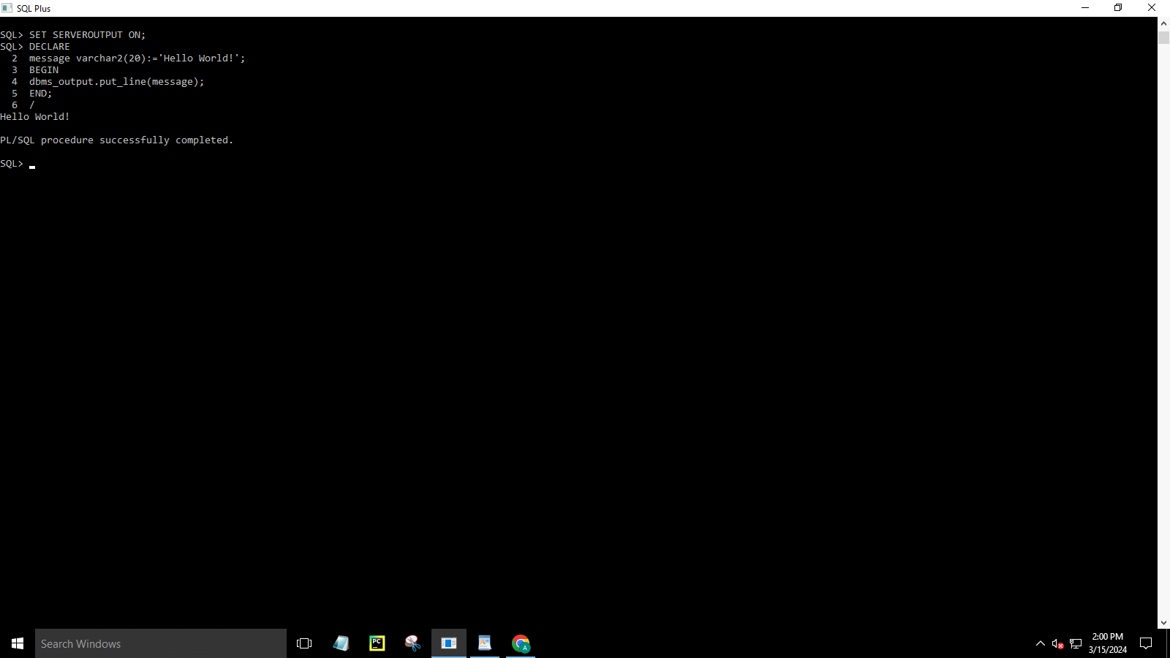

2. Write a PL/SQL block to find the maximum number from the given three

numbers.

SQL> DECLARE

2 a number;

3 b number;

4 c number;

5 BEGIN

6 a:=&a;

7 b:=&b;

8 c:=&c;

9 if(a>b and a>c)then

10 dbms_output.put_line('a is maximum'||a);

11 elsif(b>a and b>c)then

12 dbms_output.put_line('b is maximum'||b);

13 else

14 dbms_output.put_line('c is maximum'||c);

15 end if;

16 end;

17 /

Enter value for a: 4

old 6: a:=&a;

new 6: a:=4;

Enter value for b: 2

old 7: b:=&b;

new 7: b:=2;

Enter value for c: 5

old 8: c:=&c;

new 8: c:=5;

c is maximum5

PL/SQL procedure successfully completed.

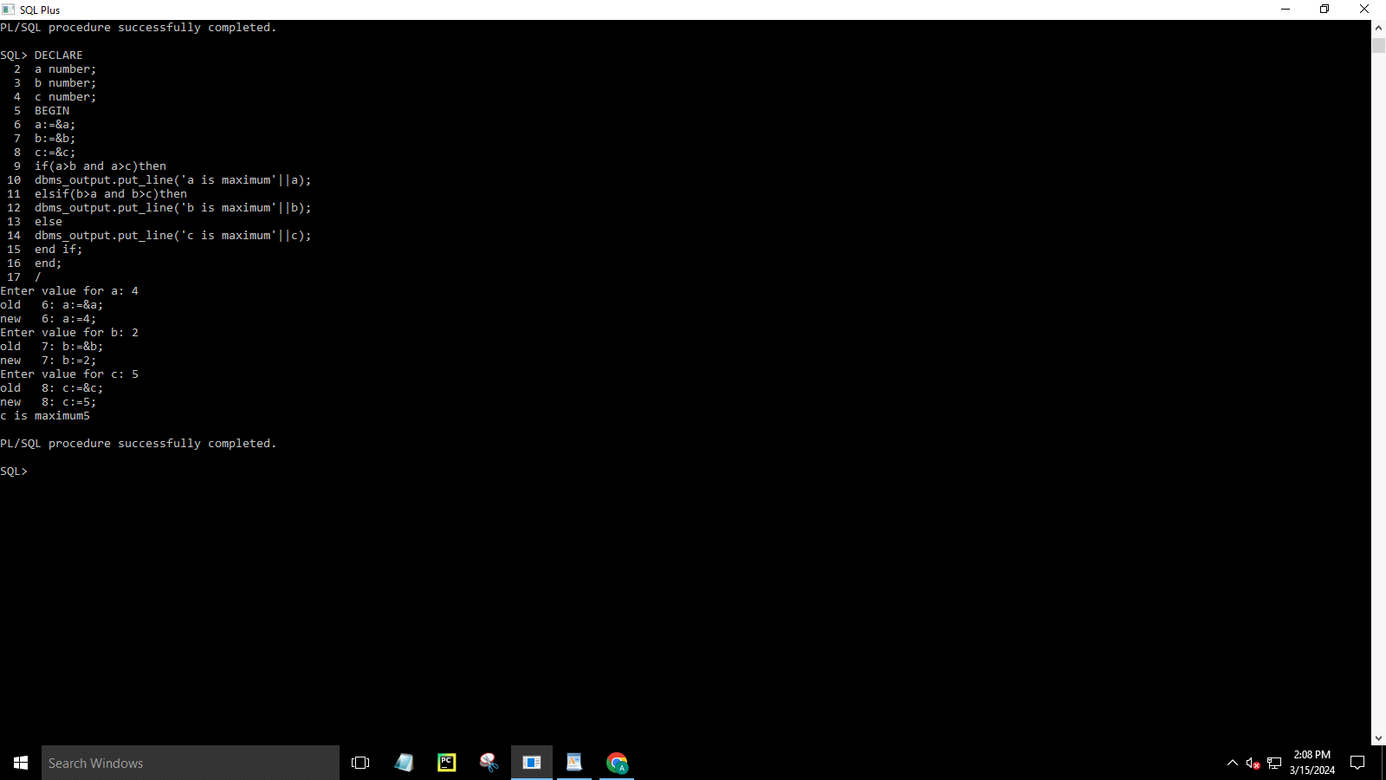

3.Write a Pl/SQL program to print integers from 1 to 10 by using PL/SQL FOR

loop

SQL> DECLARE

2 n_times NUMBER:=10;

3 BEGIN

4 FOR n_i IN 1..n_times LOOP

5 dbms_output.put_line(n_i);

6 END LOOP;

7 END;

8 /

1

2

3

4

5

6

7

8

9

10

PL/SQL procedure successfully completed

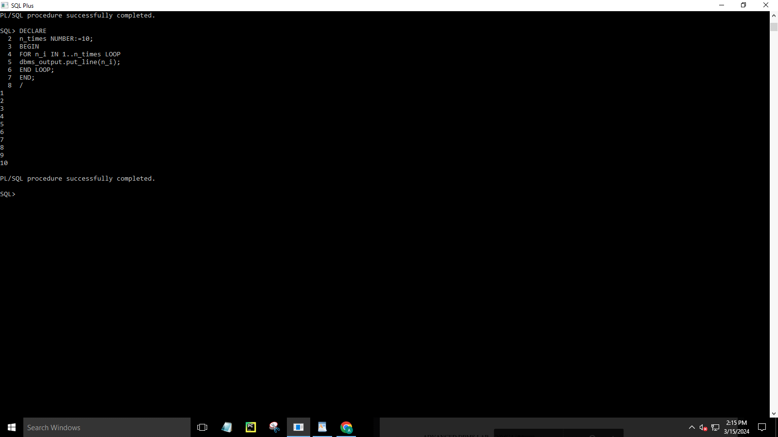

.

4. Write a program to accept a number and find the sum of the digits .

SQL> declare

2 n number(5):=&n;

3 s number:=0;

4 r number(2):=0;

5 begin

6 while n!=0

7 loop

8 r:=mod(n,10);

9 s:=s+r;

10 n:=trunc(n/10);

11 end loop;

12 dbms_output.put_line('sum of digits of given numbers is '||s);

13 end;

14 /

Enter value for n: 234

old 2: n number(5):=&n;

new 2: n number(5):=234;

sum of digits of given numbers is 9

PL/SQL procedure successfully completed.

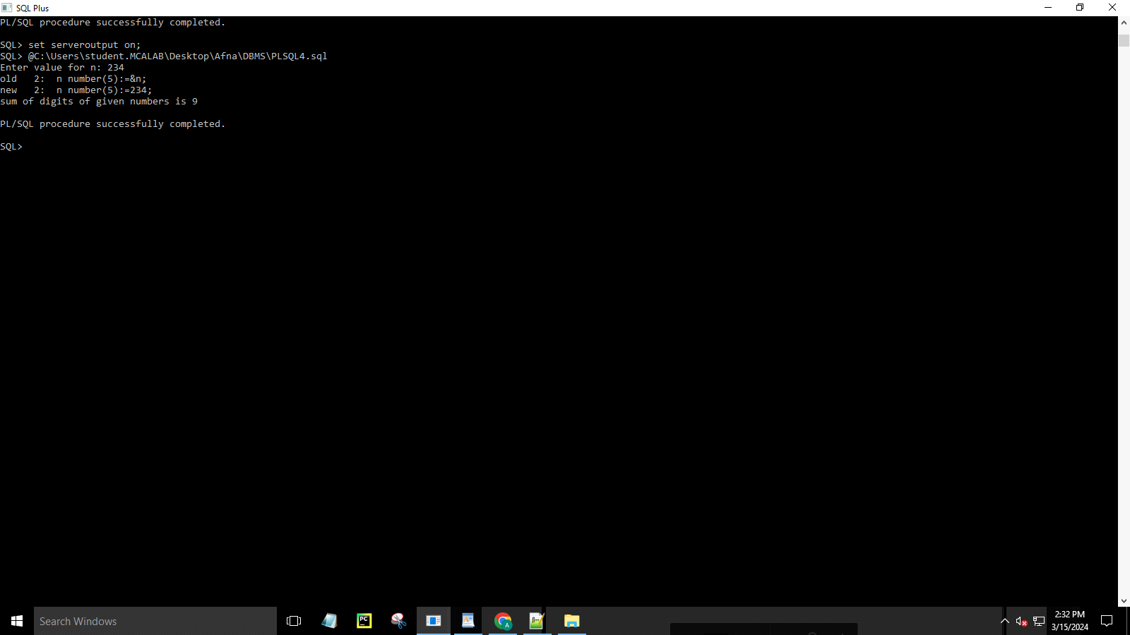

5. Find the greatest number of inputs from the console.

SQL> declare

2 a number(2) :=&value_of_a;

3 b number(2) :=&value_of_b;

4 Begin

5 if a<b then

6 dbms_output.put_line(' Smaller Value is '||a);

7 elsif a>b then

8 dbms_output.put_line(' Smaller Value is '||b);

9 else

10 dbms_output.put_line(' Both no. are equal ');

11 end if;

12 END;

13 /

SQL> set serveroutput on;

SQL> C:\Users\student.MCALAB\Desktop\Afna\DBMS\plsql5.sql

SP2-0023: String not found.

SQL> set serveroutput on;

SQL> @C:\Users\student.MCALAB\Desktop\Afna\DBMS\plsql5.sql

Enter value for value_of_a: 12

old 2: a number(2):=&value_of_a;

new 2: a number(2):=12;

Enter value for value_of_b: 33

old 3: b number(2):=&value_of_b;

new 3: b number(2):=33;

Smaller Value is12

PL/SQL procedure successfully completed.

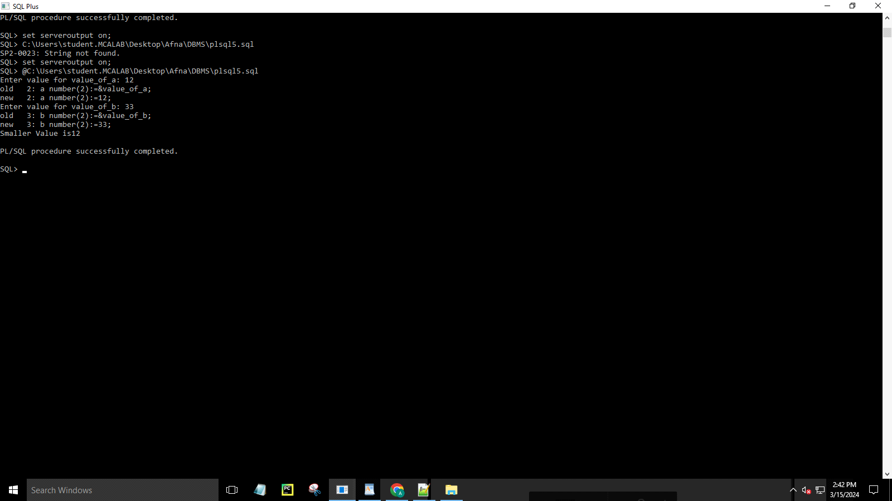

6. Reading the values from EMployee table.

SQL> CREATE TABLE emply(ssn NUMBER(2),fname VARCHAR(20),job VARCHAR(20),salary NUMBER(38));

Table created.

SQL> INSERT INTO emply VALUES(&ssn,'&fname','&job',&salary);

Enter value for ssn: 1

Enter value for fname: afna

Enter value for job: manager

Enter value for salary: 75000

old 1: INSERT INTO emply VALUES(&ssn,'&fname','&job',&salary)

new 1: INSERT INTO emply VALUES(1,'afna','manager',75000)

1 row created.

SQL> INSERT INTO emply VALUES(&ssn,'&fname','&job',&salary);

Enter value for ssn: 2

Enter value for fname: aditya

Enter value for job: clerk

Enter value for salary: 30000

old 1: INSERT INTO emply VALUES(&ssn,'&fname','&job',&salary)

new 1: INSERT INTO emply VALUES(2,'aditya','clerk',30000)

1 row created.

SQL> INSERT INTO emply VALUES(&ssn,'&fname','&job',&salary);

Enter value for ssn: 3

Enter value for fname: ajay

Enter value for job: teacher

Enter value for salary: 50000

old 1: INSERT INTO emply VALUES(&ssn,'&fname','&job',&salary)

new 1: INSERT INTO emply VALUES(3,'ajay','teacher',50000)

1 row created.

SQL> 4

SP2-0226: Invalid line number

SQL> INSERT INTO emply VALUES(&ssn,'&fname','&job',&salary);

Enter value for ssn: 4

Enter value for fname: ananthan

Enter value for job: clerk

Enter value for salary: 30000

old 1: INSERT INTO emply VALUES(&ssn,'&fname','&job',&salary)

new 1: INSERT INTO emply VALUES(4,'ananthan','clerk',30000)

1 row created.

SQL> select * from emply;

SSN FNAME JOB SALARY

---------- -------------------- -------------------- ----------

1 afna manager 75000

2 aditya clerk 30000

3 ajay teacher 50000

4 ananthan clerk 30000

Declare

v_name emply.fname%type;

v_job emply.job%type;

v_sal emply.salary%type;

Begin

select fname,job,salary

into v_name, v_job, v_sal

from emply

where ssn =2;

dbms_output.put_line('fname'||' '||'job'||' '||'salary');

dbms_output.put_line(v_name||' '||v_job||' '||v_sal);

End;

/

SQL> set serveroutput on;

SQL> @C:\Users\student.MCALAB\Desktop\Afna\DBMS\plsql6.sql

fname job salary

aditya clerk 30000

PL/SQL procedure successfully completed.

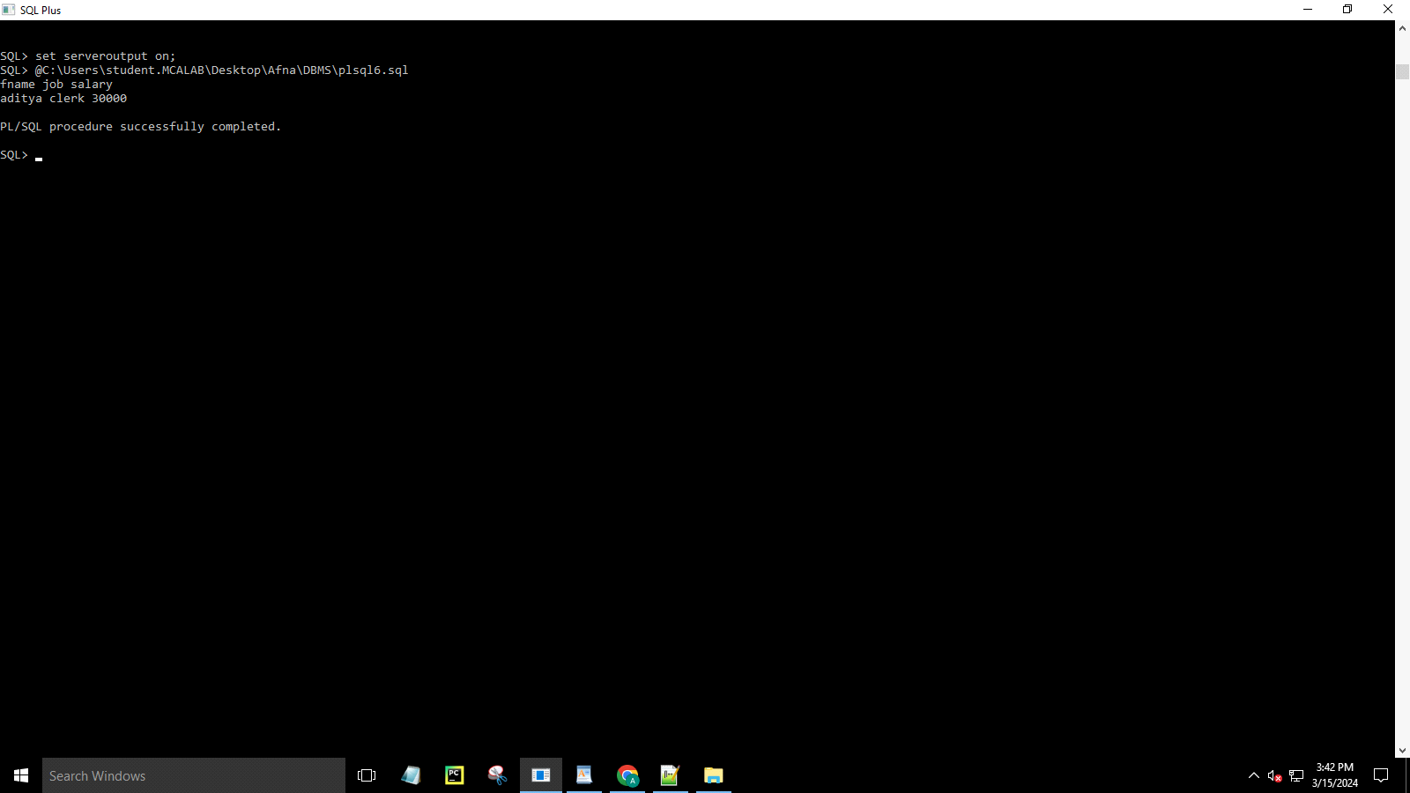

SET-9

PL/SQL Cursor , Triggor

SQL> create table stud_file(sid number,name varchar(20),m1 number,m2 number);

Table created.

SQL> insert into stud_file values(&sid,'&name',&m1,&m2);

Enter value for sid: 1

Enter value for name: anu

Enter value for m1: 40

Enter value for m2: 45

old 1: insert into stud_file values(&sid,'&name',&m1,&m2)

new 1: insert into stud_file values(1,'anu',40,45)

1 row created.

SQL> insert into stud_file values(&sid,'&name',&m1,&m2);

Enter value for sid: 2

Enter value for name: binu

Enter value for m1: 48

Enter value for m2: 45

old 1: insert into stud_file values(&sid,'&name',&m1,&m2)

new 1: insert into stud_file values(2,'binu',48,45)

1 row created.

SQL> insert into stud_file values(&sid,'&name',&m1,&m2);

Enter value for sid: 3

Enter value for name: cini

Enter value for m1: 30

Enter value for m2: 45

old 1: insert into stud_file values(&sid,'&name',&m1,&m2)

new 1: insert into stud_file values(3,'cini',30,45)

1 row created.

SQL> insert into stud_file values(&sid,'&name',&m1,&m2);

Enter value for sid: 4

Enter value for name: dini

Enter value for m1: 30

Enter value for m2: 25

old 1: insert into stud_file values(&sid,'&name',&m1,&m2)

new 1: insert into stud_file values(4,'dini',30,25)

1 row created.

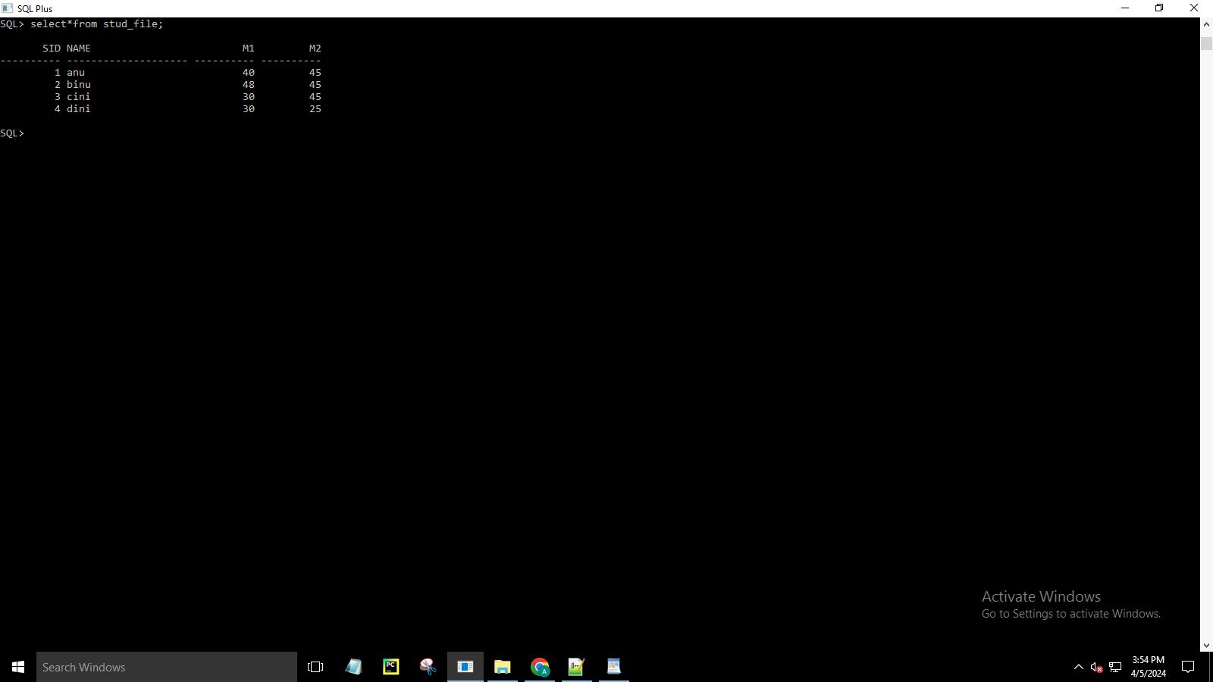

declare

id constant number :=1;

sname stud_file.name%type;

mark1 stud_file.m1%type;

mark2 stud_file.m2%type;

total number:=0;

begin

select name,m1,m2 into sname,mark1,mark2 from stud_file where sid=id;

total:=mark1+mark2;

dbms_output.put_line('Total marks of student '||sname||' with id '||id||' is:

'||total);

end;

/

SQL> set serveroutput on;

SQL> @C:\Users\student.MCALAB\Desktop\Afna\DBMS\set9.1.sql

Total marks of student anu with id 1 is:

85

PL/SQL procedure successfully completed.

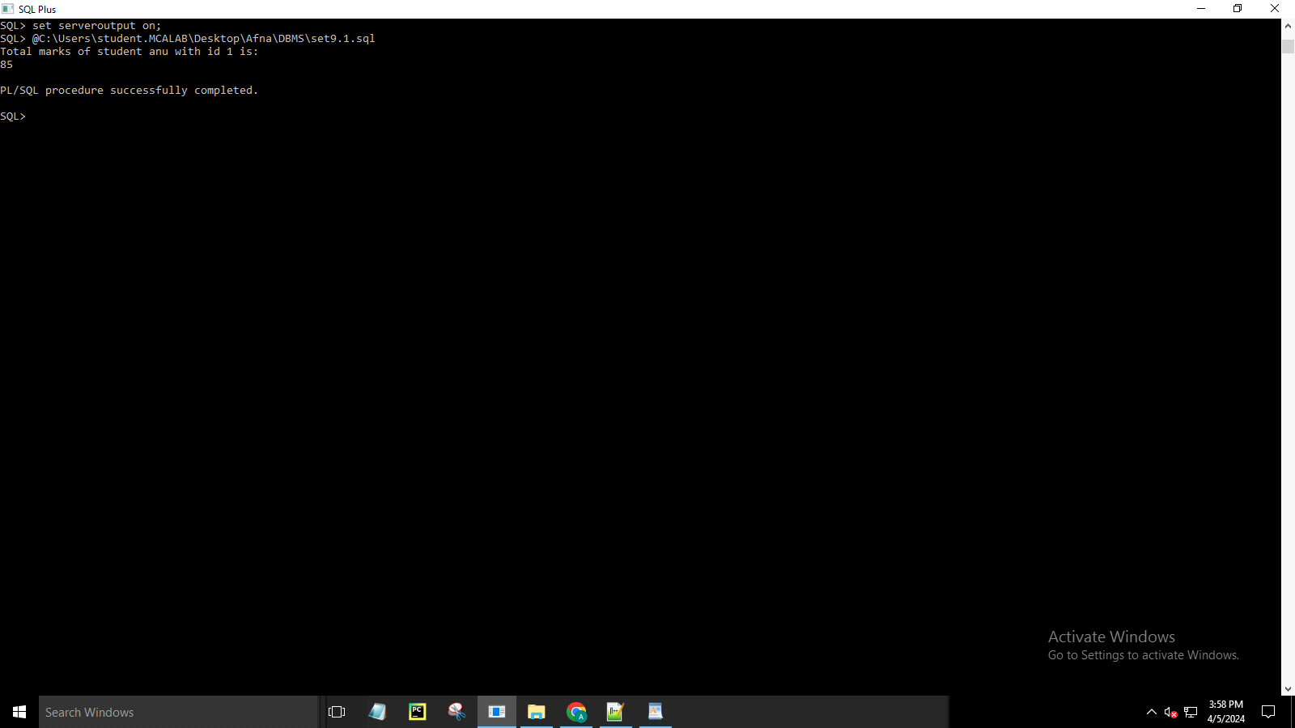

MONGODB

Please enter a MongoDB connection string (Default: mongodb://localhost/):

Current Mongosh Log ID: 6618edaebc29c95c1d9f9909

Connecting to: mongodb://127.0.0.1:27017/?directConnection=true&serverSelectionTimeoutMS=2000&appName=mongosh+2.2.2

Using MongoDB: 7.0.7

Using Mongosh: 2.2.2

mongosh 2.2.3 is available for download: <https://www.mongodb.com/try/download/shell>

For mongosh info see: <https://docs.mongodb.com/mongodb-shell/>

------

The server generated these startup warnings when booting

2024-04-08T13:26:47.946+05:30: Access control is not enabled for the database. Read and write access to data and configuration is unrestricted

------

Warning: Found ~/.mongorc.js, but not ~/.mongoshrc.js. ~/.mongorc.js will not be loaded.

You may want to copy or rename ~/.mongorc.js to ~/.mongoshrc.js.

test> use emplyee

switched to db emplyee

emplyee> db.emplyee.insertMany([{name:"afna",street:"vazhamattom",city:"erattupetta",department:"mca"}])

{

acknowledged: true,

insertedIds: { '0': ObjectId('6618f0dcbc29c95c1d9f990a') }

}

emplyee> db.emplyee.insertMany([{name:"aditya",street:"kuruppanthara",city:"kottayam",department:"mca"}])

{

acknowledged: true,

insertedIds: { '0': ObjectId('6618f12ebc29c95c1d9f990b') }

}

emplyee> db.emplyee.insertMany([{name:"ajay",street:"elanji",city:"eranakulam",department:"mca"}])

{

acknowledged: true,

insertedIds: { '0': ObjectId('6618f1cebc29c95c1d9f990c') }

}

emplyee> db.emplyee.insertMany([{name:"abin",street:"elanji",city:"eranakulam",department:"mca"}])

{

acknowledged: true,

insertedIds: { '0': ObjectId('6618f23bbc29c95c1d9f990d') }

}

emplyee> db.emplyee.insertMany([{name:"abhirami",street:"poovarani",city:"kottayam",department:"mca"}])

{

acknowledged: true,

insertedIds: { '0': ObjectId('6618f2b2bc29c95c1d9f990e') }

}

emplyee> db.emplyee.insertMany([{name:"ananthan",street:"paiga",city:"kottayam",department:"mca"}])

{

acknowledged: true,

insertedIds: { '0': ObjectId('6618f2ddbc29c95c1d9f990f') }

}

emplyee> db.emplyee.find()

[

{

_id: ObjectId('6618f0dcbc29c95c1d9f990a'),

name: 'afna',

street: 'vazhamattom',

city: 'erattupetta',

department: 'mca'

},

{

_id: ObjectId('6618f12ebc29c95c1d9f990b'),

name: 'aditya',

street: 'kuruppanthara',

city: 'kottayam',

department: 'mca'

},

{

_id: ObjectId('6618f1cebc29c95c1d9f990c'),

name: 'ajay',

street: 'elanji',

city: 'eranakulam',

department: 'mca'

},

{

_id: ObjectId('6618f23bbc29c95c1d9f990d'),

name: 'abin',

street: 'elanji',

city: 'eranakulam',

department: 'mca'

},

{

_id: ObjectId('6618f2b2bc29c95c1d9f990e'),

name: 'abhirami',

street: 'poovarani',

city: 'kottayam',

department: 'mca'

},

{

_id: ObjectId('6618f2ddbc29c95c1d9f990f'),

name: 'ananthan',

street: 'paiga',

city: 'kottayam',

department: 'mca'

}

]

emplyee> db.emplyee.updateMany({},{$set:{salary:10000}})

{

acknowledged: true,

insertedId: null,

matchedCount: 6,

modifiedCount: 6,

upsertedCount: 0

}

emplyee> db.emplyee.updateMany({name:"ananthan"},{$set:{salary:15000}})

{

acknowledged: true,

insertedId: null,

matchedCount: 1,

modifiedCount: 1,

upsertedCount: 0

}

emplyee> db.emplyee.updateMany({name:"afna"},{$set:{salary:25000}})

{

acknowledged: true,

insertedId: null,

matchedCount: 1,

modifiedCount: 1,

upsertedCount: 0

}

emplyee> db.emplyee.updateMany({name:"ajay"},{$set:{salary:20000}})

{

acknowledged: true,

insertedId: null,

matchedCount: 1,

modifiedCount: 1,

upsertedCount: 0

}

emplyee> db.emplyee.updateMany({name:"aditya"},{$set:{salary:30000}})

{

acknowledged: true,

insertedId: null,

matchedCount: 1,

modifiedCount: 1,

upsertedCount: 0

}

emplyee> db.emplyee.updateMany({name:"abin"},{$set:{salary:32000}})

{

acknowledged: true,

insertedId: null,

matchedCount: 1,

modifiedCount: 1,

upsertedCount: 0

}

emplyee>

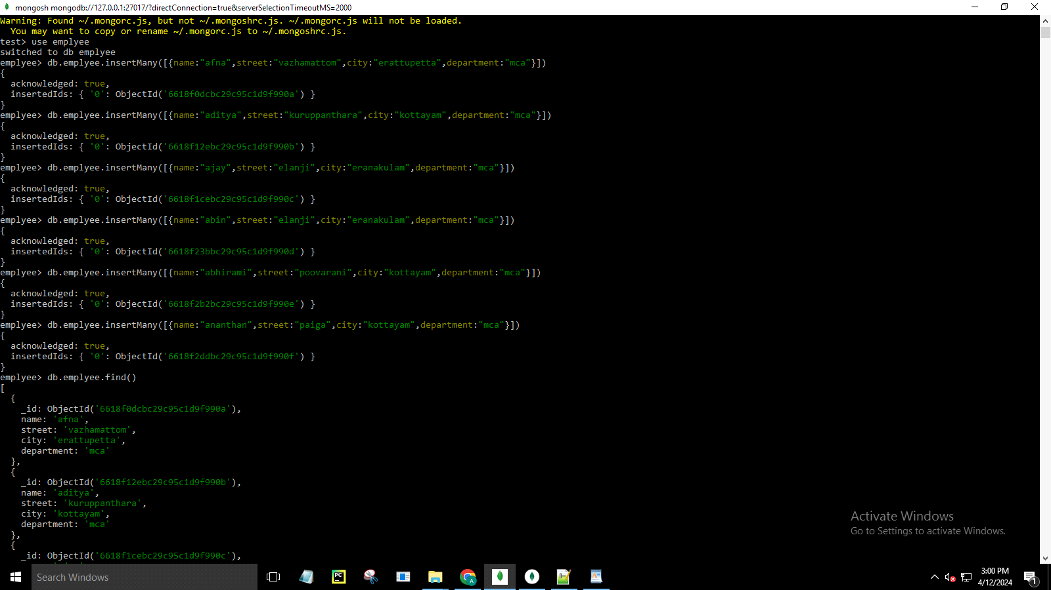

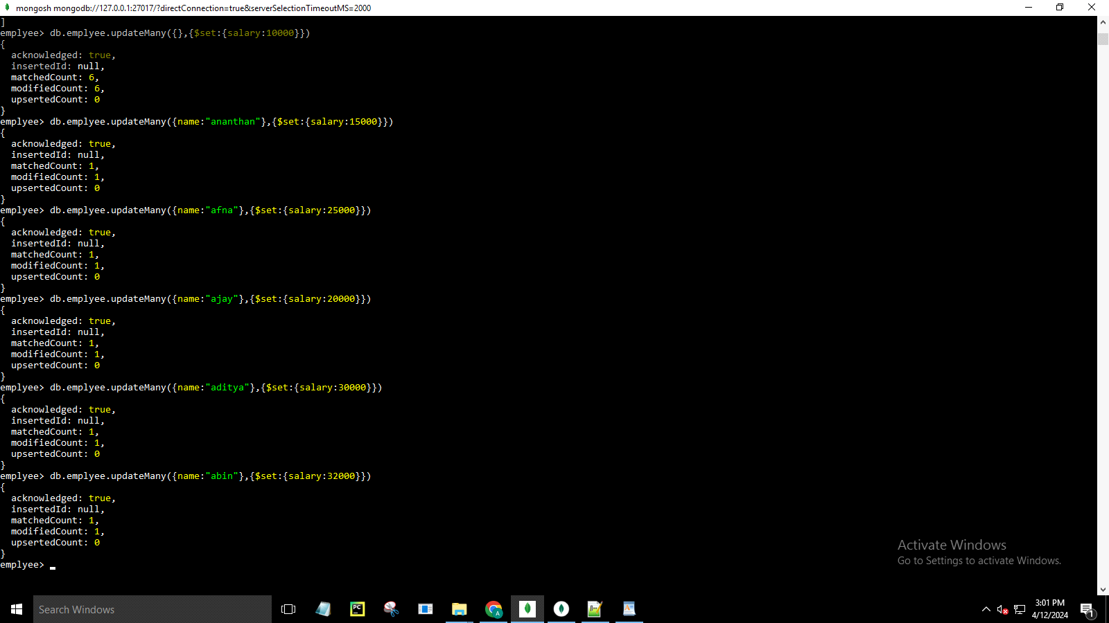

test> use emplyee

switched to db emplyee

emplyee> db.emplyee.deleteMany({salary:10000})

{ acknowledged: true, deletedCount: 1 }

emplyee> db.emplyee.find()

[

{

_id: ObjectId('6618f0dcbc29c95c1d9f990a'),

name: 'afna',

street: 'vazhamattom',

city: 'erattupetta',

department: 'mca',

salary: 25000

},

{

_id: ObjectId('6618f12ebc29c95c1d9f990b'),

name: 'aditya',

street: 'kuruppanthara',

city: 'kottayam',

department: 'mca',

salary: 30000

},

{

_id: ObjectId('6618f1cebc29c95c1d9f990c'),

name: 'ajay',

street: 'elanji',

city: 'eranakulam',

department: 'mca',

salary: 20000

},

{

_id: ObjectId('6618f23bbc29c95c1d9f990d'),

name: 'abin',

street: 'elanji',

city: 'eranakulam',

department: 'mca',

salary: 32000

},

{

_id: ObjectId('6618f2ddbc29c95c1d9f990f'),

name: 'ananthan',

street: 'paiga',

city: 'kottayam',

department: 'mca',

salary: 15000

}

]

emplyee> db.emplyee.find().sort({salary:-1})

[

{

_id: ObjectId('6618f23bbc29c95c1d9f990d'),

name: 'abin',

street: 'elanji',

city: 'eranakulam',

department: 'mca',

salary: 32000

},

{

_id: ObjectId('6618f12ebc29c95c1d9f990b'),

name: 'aditya',

street: 'kuruppanthara',

city: 'kottayam',

department: 'mca',

salary: 30000

},

{

_id: ObjectId('6618f0dcbc29c95c1d9f990a'),

name: 'afna',

street: 'vazhamattom',

city: 'erattupetta',

department: 'mca',

salary: 25000

},

{

_id: ObjectId('6618f1cebc29c95c1d9f990c'),

name: 'ajay',

street: 'elanji',

city: 'eranakulam',

department: 'mca',

salary: 20000

},

{

_id: ObjectId('6618f2ddbc29c95c1d9f990f'),

name: 'ananthan',

street: 'paiga',

city: 'kottayam',

department: 'mca',

salary: 15000

}

]

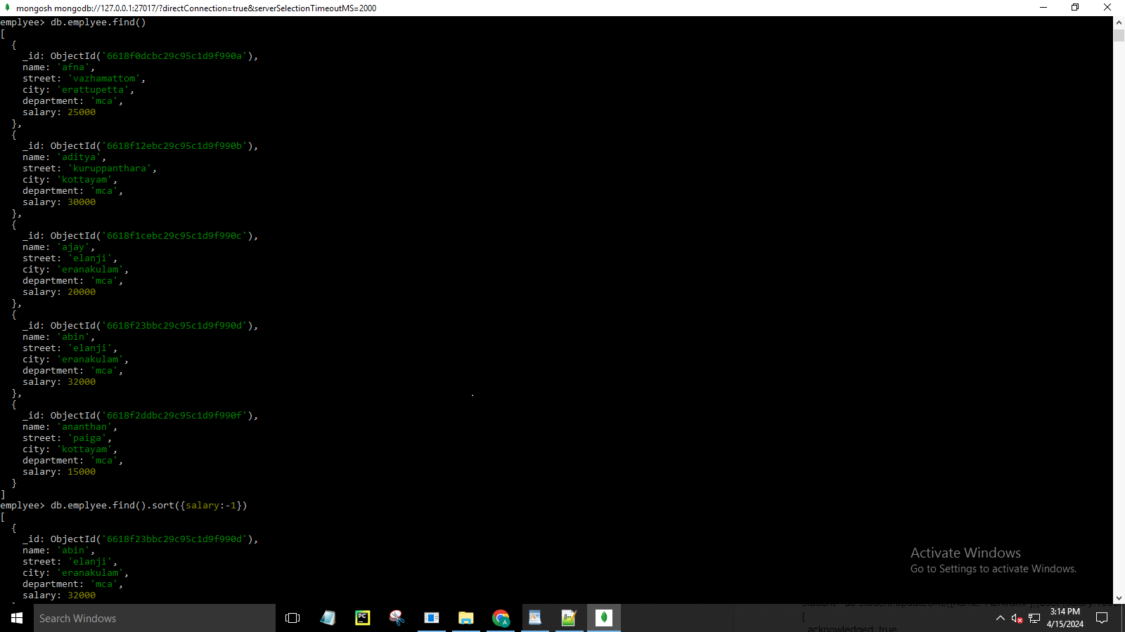

emplyee> db.student.find().sort({salary:-1}).limit(1)

emplyee> db.emplyee.find().sort({salary:-1}).limit(1)

[

{

_id: ObjectId('6618f23bbc29c95c1d9f990d'),

name: 'abin',

street: 'elanji',

city: 'eranakulam',

department: 'mca',

salary: 32000

}

]

emplyee>

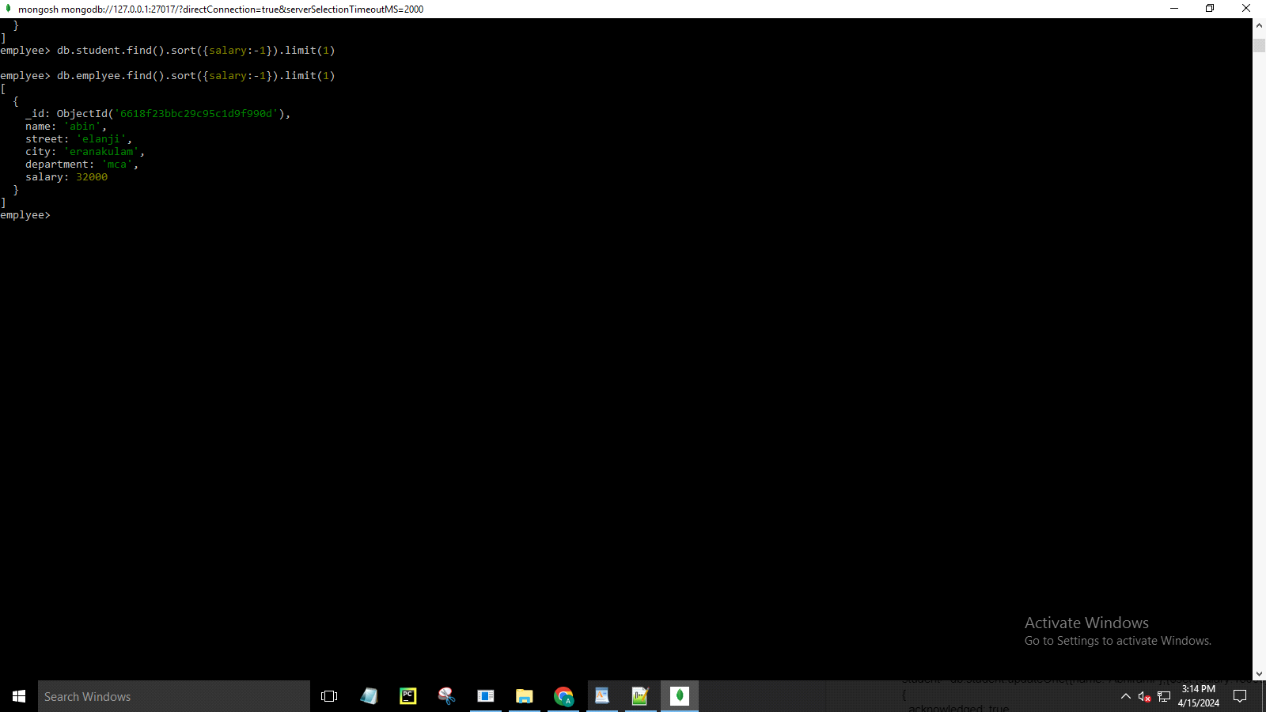

emplyee> db.emplyee.countDocuments()

5

emplyee>



emplyee> db.emplyee.find({},{name:1,salary:1})

[

{

_id: ObjectId('6618f0dcbc29c95c1d9f990a'),

name: 'afna',

salary: 25000

},

{

_id: ObjectId('6618f12ebc29c95c1d9f990b'),

name: 'aditya',

salary: 30000

},

{

_id: ObjectId('6618f1cebc29c95c1d9f990c'),

name: 'ajay',

salary: 20000

},

{

_id: ObjectId('6618f23bbc29c95c1d9f990d'),

name: 'abin',

salary: 32000

},

{

_id: ObjectId('6618f2ddbc29c95c1d9f990f'),

name: 'ananthan',

salary: 15000

}

]

emplyee> db.emplyee.find({},{_id:0,name:1,salary:1})

[

{ name: 'afna', salary: 25000 },

{ name: 'aditya', salary: 30000 },

{ name: 'ajay', salary: 20000 },

{ name: 'abin', salary: 32000 },

{ name: 'ananthan', salary: 15000 }

]

emplyee>

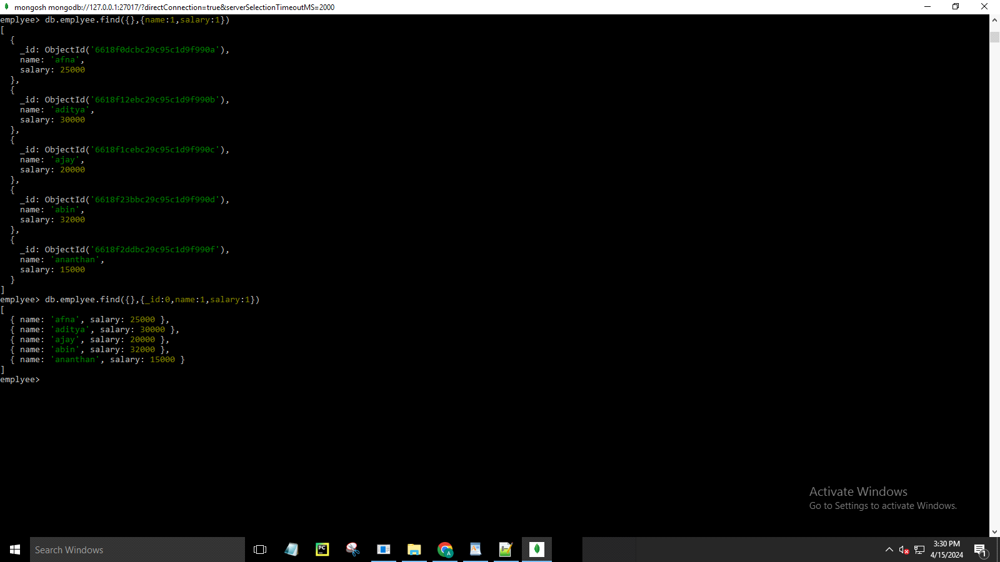

emplyee> db.emplyee.aggregate([{$group:{_id:0,total:{$sum:"$salary"}}}])

[ { _id: 0, total: 122000 } ]

emplyee> db.emplyee.find({name:'afna'},{salary:1})

[ { _id: ObjectId('6618f0dcbc29c95c1d9f990a'), salary: 25000 } ]

emplyee>

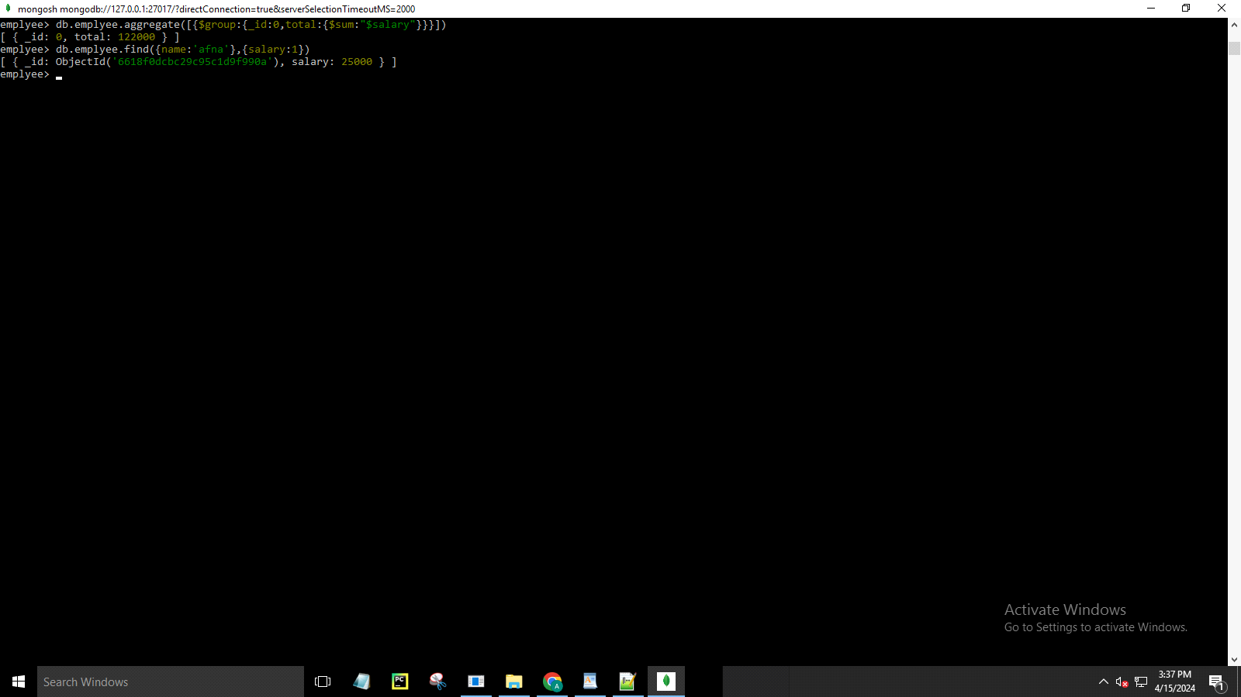

emplyee> use afna

switched to db afna

afna> db.createCollection('student');

{ ok: 1 }

afna> db.student.insert({'Rno':'1','Name':'Piyush','Class':'TE COMP'});

DeprecationWarning: Collection.insert() is deprecated. Use insertOne, insertMany, or bulkWrite.

{

acknowledged: true,

insertedIds: { '0': ObjectId('661cfebd6a775495479f990a') }

}

afna> db.student.insert({'Rno':'2','Name':'Abhi','Class':'TE COMP'});

{

acknowledged: true,

insertedIds: { '0': ObjectId('661cff026a775495479f990b') }

}

afna> db.student.insert({'Rno':'3','Name':'Ashley','Class':'TE COMP'});

{

acknowledged: true,

insertedIds: { '0': ObjectId('661cff216a775495479f990c') }

}

afna> db.student.insert({'Rno':'4','Name':'Hitesh','Class':'TE COMP'});

{

acknowledged: true,

insertedIds: { '0': ObjectId('661cff496a775495479f990d') }

}

afna> db.student.insert({'Rno':'5','Name':'Pratik','Class':'TE COMP'});

{

acknowledged: true,

insertedIds: { '0': ObjectId('661cff716a775495479f990e') }

}

afna> db.student.insert({'Rno':'6','Name':'Pratik','Class':'TE COMP'});

{

acknowledged: true,

insertedIds: { '0': ObjectId('661cff7b6a775495479f990f') }

}

afna> db.student.find();

[

{

_id: ObjectId('661cfebd6a775495479f990a'),

Rno: '1',

Name: 'Piyush',

Class: 'TE COMP'

},

{

_id: ObjectId('661cff026a775495479f990b'),

Rno: '2',

Name: 'Abhi',

Class: 'TE COMP'

},

{

_id: ObjectId('661cff216a775495479f990c'),

Rno: '3',

Name: 'Ashley',

Class: 'TE COMP'

},

{

_id: ObjectId('661cff496a775495479f990d'),

Rno: '4',

Name: 'Hitesh',

Class: 'TE COMP'

},

{

_id: ObjectId('661cff716a775495479f990e'),

Rno: '5',

Name: 'Pratik',

Class: 'TE COMP'

},

{

_id: ObjectId('661cff7b6a775495479f990f'),

Rno: '6',

Name: 'Pratik',

Class: 'TE COMP'

}

]

afna>

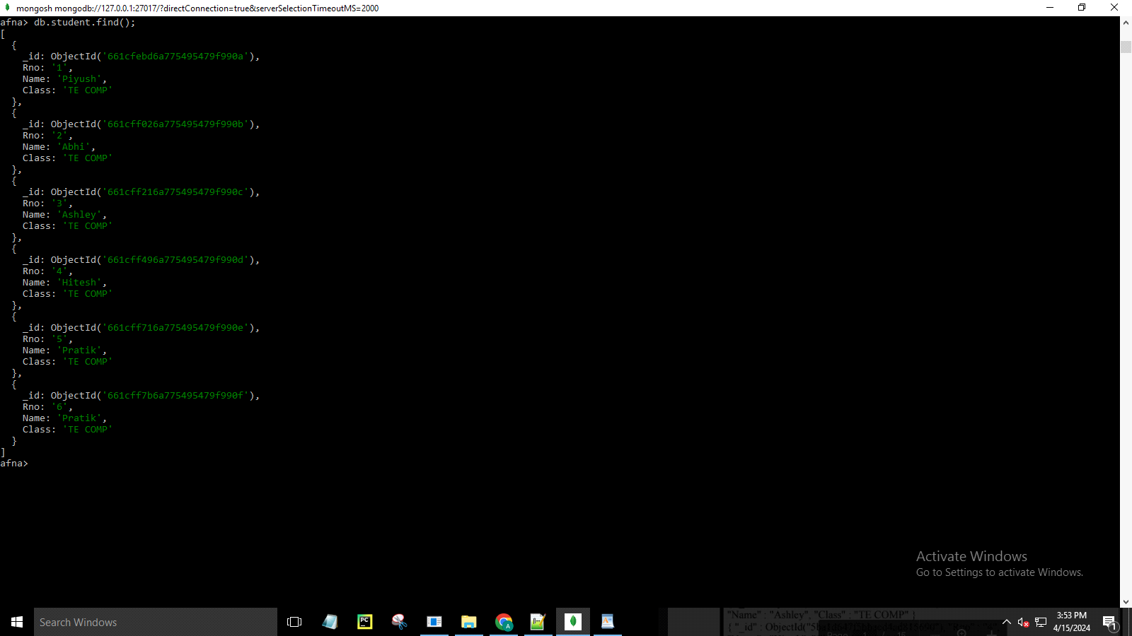

afna> db.student.update({'Name':'Hitesh'},{$set:{'Name':'Henry'}});

{

acknowledged: true,

insertedId: null,

matchedCount: 1,

modifiedCount: 1,

upsertedCount: 0

}

afna> db.student.find()

[

{

_id: ObjectId('661cfebd6a775495479f990a'),

Rno: '1',

Name: 'Piyush',

Class: 'TE COMP'

},

{

_id: ObjectId('661cff026a775495479f990b'),

Rno: '2',

Name: 'Abhi',

Class: 'TE COMP'

},

{

_id: ObjectId('661cff216a775495479f990c'),

Rno: '3',

Name: 'Ashley',

Class: 'TE COMP'

},

{

_id: ObjectId('661cff496a775495479f990d'),

Rno: '4',

Name: 'Henry',

Class: 'TE COMP'

},

{

_id: ObjectId('661cff716a775495479f990e'),

Rno: '5',

Name: 'Pratik',

Class: 'TE COMP'

},

{

_id: ObjectId('661cff7b6a775495479f990f'),

Rno: '6',

Name: 'Pratik',

Class: 'TE COMP'

}

]

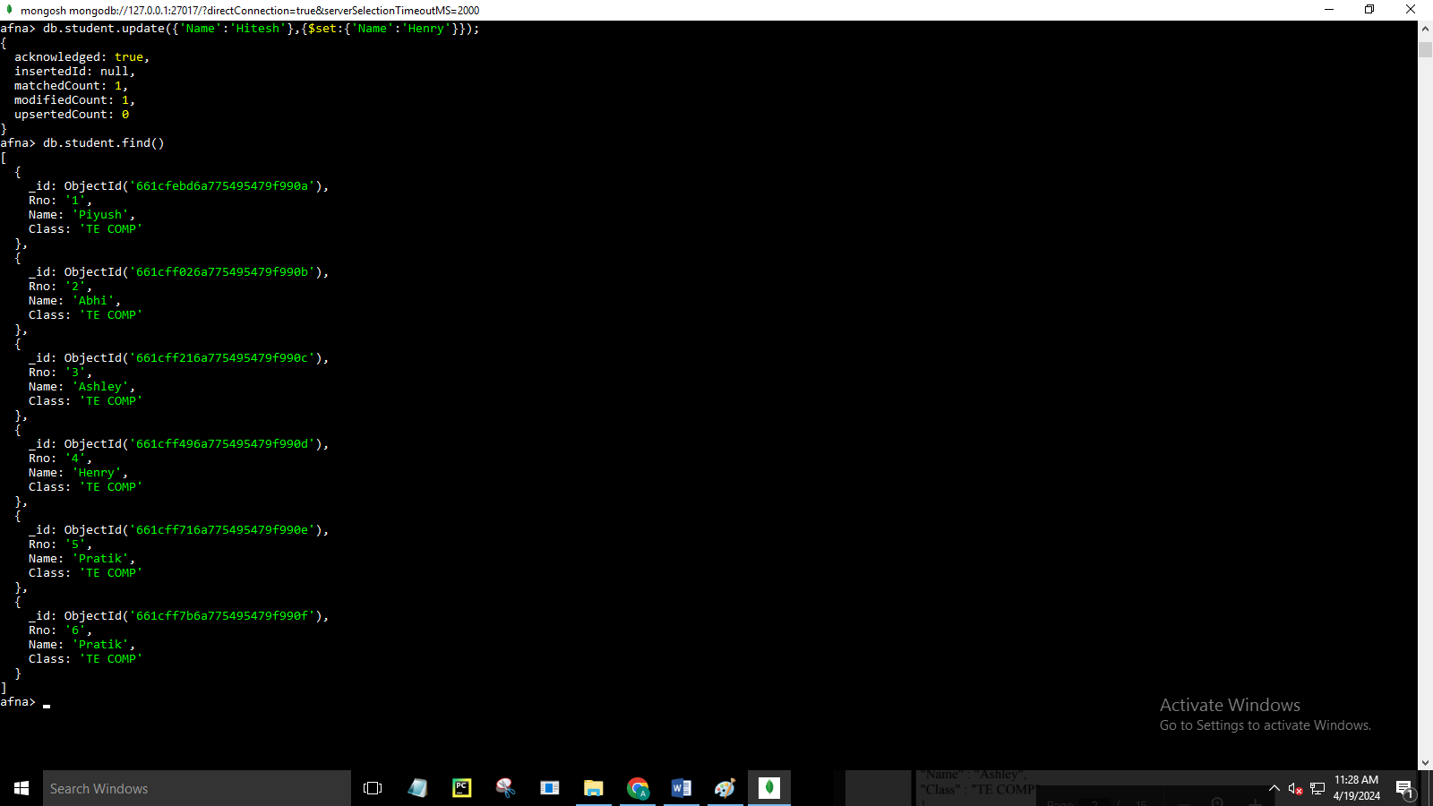

afna> db.student.remove({'Rno':'1'});

{ acknowledged: true, deletedCount: 1 }

afna> db.student.find()

[

{

_id: ObjectId('661cff026a775495479f990b'),

Rno: '2',

Name: 'Abhi',

Class: 'TE COMP'

},

{

_id: ObjectId('661cff216a775495479f990c'),

Rno: '3',

Name: 'Ashley',

Class: 'TE COMP'

},

{

_id: ObjectId('661cff496a775495479f990d'),

Rno: '4',

Name: 'Henry',

Class: 'TE COMP'

},

{

_id: ObjectId('661cff716a775495479f990e'),

Rno: '5',

Name: 'Pratik',

Class: 'TE COMP'

},

{

_id: ObjectId('661cff7b6a775495479f990f'),

Rno: '6',

Name: 'Pratik',

Class: 'TE COMP'

}

]

afna>

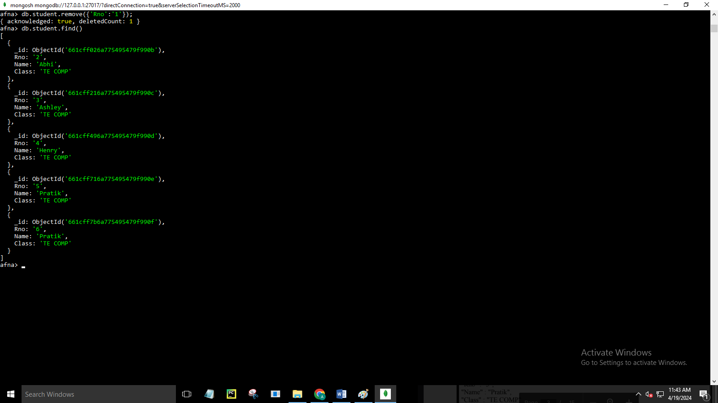

afna> db.student.find({$and:[{"Name":"Abhi"},{"Rno":"2"}]});

[

{

_id: ObjectId('661cff026a775495479f990b'),

Rno: '2',

Name: 'Abhi',

Class: 'TE COMP'

}

]

