CarSharing Report with SQL Queries

Name: Akinmade Afolayan Desire

Project: SIWES Data Analysis Project

Date: 04/26/2026

1. Introduction
The objective of this project is to analyze and understand how key environmental factors—such as weather conditions, temperature, and humidity—influence customer demand for car-sharing services across different seasons. By leveraging historical data from 2017, this analysis aims to uncover patterns and trends that can support data-driven decision-making, particularly in optimizing operations, improving customer targeting, and enhancing overall service efficiency.

2. Data Preparation (Google Sheets)
- Handling missing values: Missing values in temperature and temp_feel were filled by the mean values of the respective columns. No other columns recorded missing values.
- Creation of temp_category: temp_category was created by segmenting the temp_feel values into cold, mild and hot based on their values.
- Creation of temp_code: temp_code was created by concatenating temp, temp_feel and temp_category values
- Weather coding: weather code was created by label encoding the values in the weather column
- Time feature extraction: New columns were created to get extract the necessary values from the timestamp into them like the hour, weekday name and month name.

3. Database Design
- Database name: carsharing
- Tables created: CarSharing_df, weather, temperature, time
- Relationships:
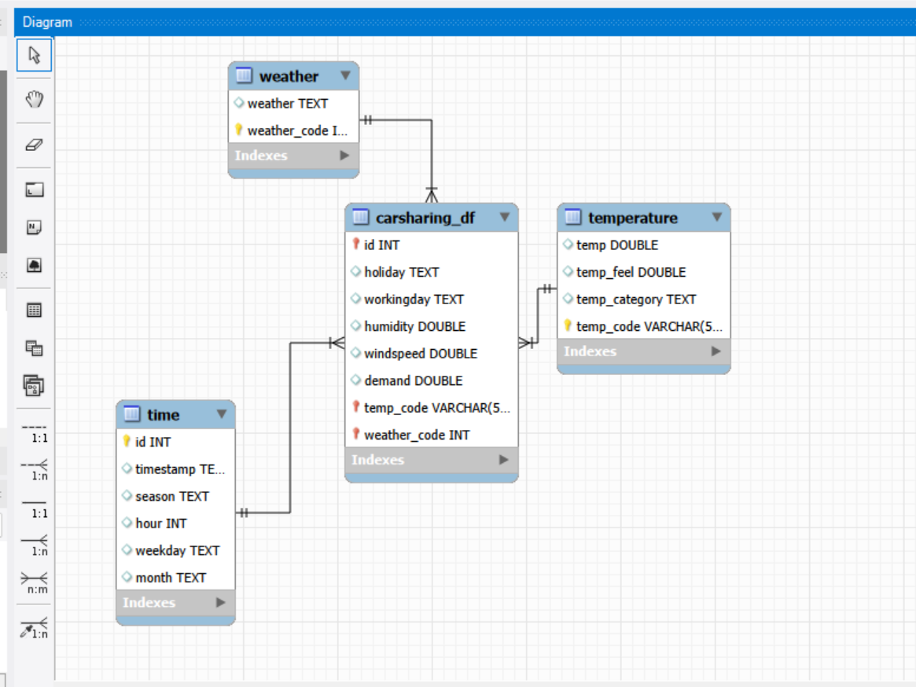

4. SQL Analysis & Results

(a) Highest Demand in 2017
SQL Query:
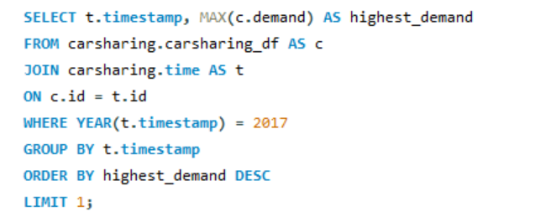
Result:
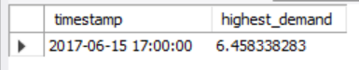
Interpretation: Peak demand in 2017 was recorded at 5:00 PM on June 15th, highlighting late afternoon hours as a key demand driver. This pattern suggests strong alignment with commuter behavior, indicating an opportunity for the company to prioritize fleet availability and dynamic pricing strategies during these high-demand periods.

(b) Highest and Lowest Average Demand by Time Features
SQL Query:
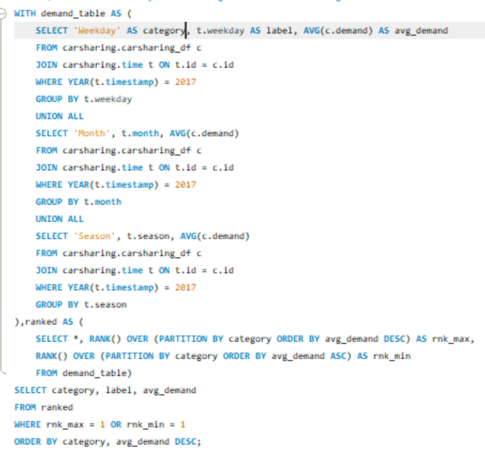
Result Table:
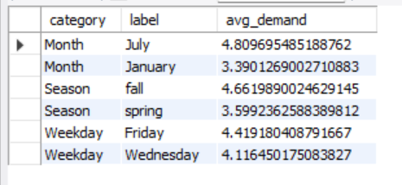
Interpretation: The analysis shows that Friday, the Fall season, and the month of July recorded the highest average demand, while Wednesday, Spring, and January had the lowest. This suggests that demand is generally higher towards the end of the week and during mid-to-late year periods, likely due to increased travel and social activities. In contrast, lower demand during midweek and early in the year presents an opportunity to introduce promotions or incentives to boost usage during these periods.

(c) Hourly Demand for Selected Weekday(s)
SQL Query:
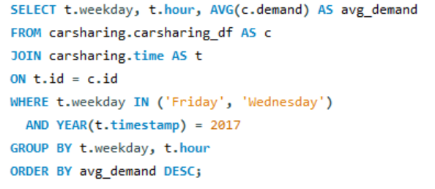
Result Table:
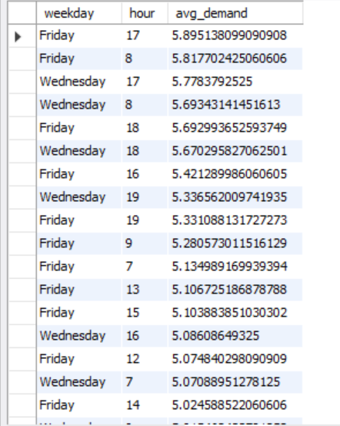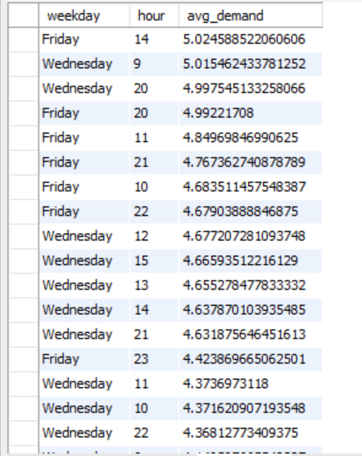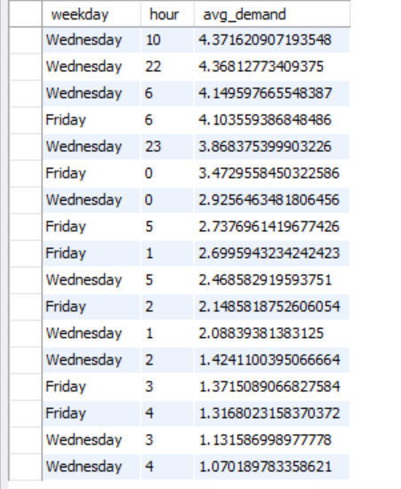
Interpretation: The table presents the variation in average demand across different hours for the selected weekdays—Friday and Wednesday—which recorded the highest and lowest average demand respectively. The results highlight how demand fluctuates throughout the day, providing insight into peak and off-peak hours within both high-demand and low-demand days, which can support more effective scheduling and resource allocation.

(d) Weather Analysis for 2017
1. Temperature Category Distribution (Cold/Mild/Hot):
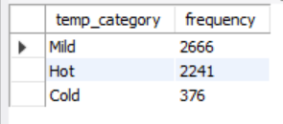
2. Most Prevalent Weather Condition: Mild
3. Wind Speed Analysis Table:
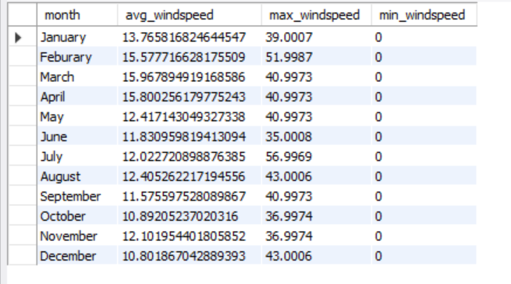
4. Humidity Analysis Table:
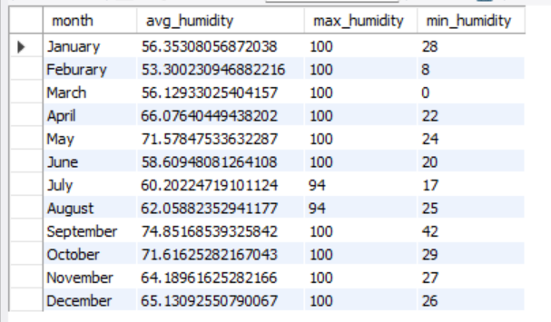
5. Average Demand by Temperature Category:
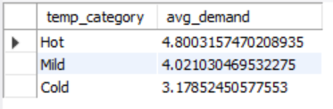

(e) Weather Analysis for Month with Highest Average Demand

1. Temperature Category Distribution (Cold/Mild/Hot):
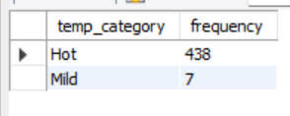
2. Most Prevalent Weather Condition: Hot
3. Wind Speed Analysis Table:
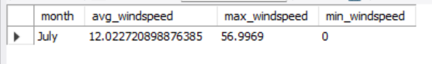
4. Humidity Analysis Table:
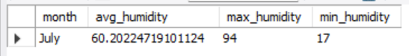
5. Average Demand by Temperature Category:
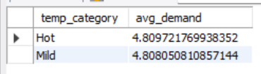

5. Conclusion
The analysis indicates that customer demand is generally higher under cooler and more favorable weather conditions, as reflected in the relationship between temperature and demand levels. Additionally, demand tends to peak during specific hours of the day—particularly in the morning and evening—likely aligning with commuting patterns. Seasonal trends further reinforce this pattern, with higher demand observed during periods characterized by more moderate weather conditions. These insights suggest that both environmental factors and time-of-day play a significant role in shaping customer demand, and can be leveraged to improve operational planning and service optimization.

Link to tables: Tables

