5.1 Validation experiments under constant-temperature protocols
This subsection evaluates whether the calibrated freezing model reproduces the thermal response measured during baseline water-fill experiments at constant cold-plate temperatures. These experiments provide the validation step before the same model is used for open-loop trajectory design.
Analysis workflow
The validation data comprised five independent water-fill experiments at each constant plate setpoint: -10, -15, and -20 deg C. The experimental traces were aligned to the fill/insertion event, interpolated onto a common time base, and summarized as the mean +/- 1 SD at each embedded thermocouple. The simulated traces were taken from the `with_rho_temperature_dependent` calibrated suite, using a fill temperature of 12.5 deg C, an effective external heat-transfer coefficient of 2 W m^-2 K^-1, and probe positions of 3.0, 6.2, and 11.0 mm with a 1 mm wall inset. The 0 deg C crossing time was defined as the first downward crossing after filling and was obtained by linear interpolation between neighboring samples.
Plate setpoint | Experimental replicates | Simulation source | Tamb used in model
-10 deg C | 5 | with_rho_temperature_dependent | 9.708 deg C
-15 deg C | 5 | with_rho_temperature_dependent | 7.568 deg C
-20 deg C | 5 | with_rho_temperature_dependent | 5.750 deg C
Temperature-history agreement
The simulated thermal histories reproduce the dominant cooling behavior of the experiments across all three plate temperatures. In each case, the model captures the rapid cooling near the cold plate, the ordering of the probe responses with height, and the gradual late-stage approach toward subzero temperatures. Across the nine probe/condition comparisons, the mean MAE was 0.72 deg C and the mean RMSE was 0.91 deg C when each simulation was compared against the experimental mean over the plotted post-fill interval.
Plate | Probe | RMSE (deg C) | MAE (deg C) | Bias (deg C)
-10 deg C | 3.0 mm | 0.28 | 0.18 | -0.16
-10 deg C | 6.2 mm | 0.58 | 0.43 | -0.06
-10 deg C | 11.0 mm | 1.23 | 1.08 | -0.18
-15 deg C | 3.0 mm | 0.74 | 0.71 | +0.69
-15 deg C | 6.2 mm | 1.17 | 1.01 | +1.01
-15 deg C | 11.0 mm | 1.17 | 0.83 | -0.11
-20 deg C | 3.0 mm | 0.58 | 0.50 | +0.48
-20 deg C | 6.2 mm | 1.06 | 0.89 | +0.89
-20 deg C | 11.0 mm | 1.33 | 0.86 | +0.01
0 deg C crossing times
The agreement is strongest at the lowest probe, where the imposed plate boundary dominates the response. The simulated 3.0 mm crossing differs from the experimental mean by -1.1 s at -10 deg C, +2.2 s at -15 deg C, and +0.1 s at -20 deg C. At the 6.2 mm and 11.0 mm probes, the model generally predicts later crossings, with the largest offsets at the upper probe during the late freezing stage.
Plate | Probe | Experimental mean +/- SD (s) | Simulation (s) | Sim - exp (s)
-10 deg C | 3.0 mm | 76.8 +/- 6.1 | 75.7 | -1.1
-10 deg C | 6.2 mm | 357.2 +/- 28.8 | 345.0 | -12.2
-10 deg C | 11.0 mm | 967.4 +/- 43.6 | 1018.6 | +51.2
-15 deg C | 3.0 mm | 44.7 +/- 1.5 | 46.9 | +2.2
-15 deg C | 6.2 mm | 187.2 +/- 8.7 | 217.1 | +29.9
-15 deg C | 11.0 mm | 614.4 +/- 28.7 | 669.3 | +54.8
-20 deg C | 3.0 mm | 34.6 +/- 3.0 | 34.6 | +0.1
-20 deg C | 6.2 mm | 143.1 +/- 12.3 | 155.7 | +12.7
-20 deg C | 11.0 mm | 428.7 +/- 23.9 | 494.2 | +65.5
Interpretation
The residual mismatch has a physically consistent pattern. As distance from the plate increases, the measured response is more sensitive to processes that are not explicitly resolved in the current model, including liquid-phase natural convection, mixing immediately after filling, possible disturbances around the thermocouple junctions, and uncertainty in the effective local air boundary condition. The model should therefore be interpreted as a conduction-dominated predictive framework for trajectory design, not as a complete thermo-fluid description of the liquid phase. Within that intended use, the agreement in the near-plate response, the correct probe ordering, and the bounded upper-probe timing errors support using the model as the computational plant for the open-loop design study.
Figures
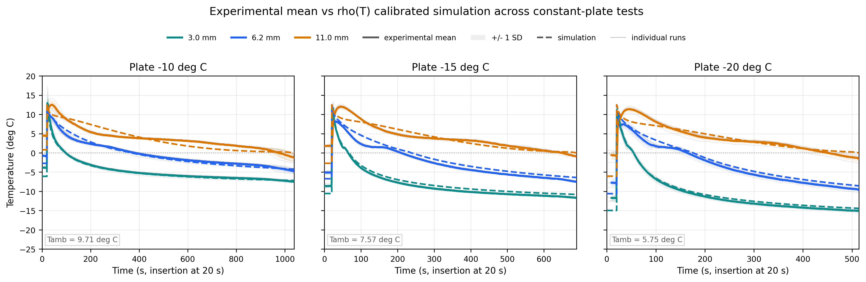
Figure 5.1-1. Experimental and simulated temperature histories for the three constant-plate validation experiments. Each panel corresponds to one plate setpoint and contains the three thermocouple heights. Thin gray traces show individual experimental runs, solid colored curves and shaded bands show the experimental mean +/- 1 SD, and dashed colored curves show the corresponding rho(T) calibrated simulation.
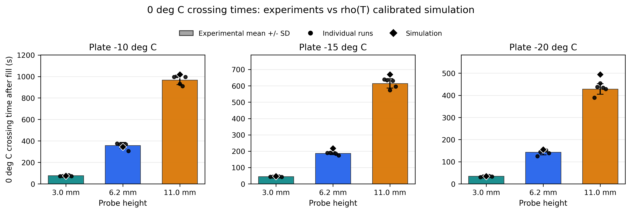
Figure 5.1-2. Comparison of experimentally inferred and simulated 0 deg C crossing times for the constant-temperature validation experiments. Bars show the mean of five experimental runs, error bars show 1 SD, black circles show individual runs, and black diamonds show the corresponding rho(T) simulation.
Generated files
Figures, READMEs, and CSV summaries are stored in `code_simulation/Article_drafts/figures/section_5_1_validation`. The crossing-time summary is stored in `section_5_1_zero_crossing_times.csv`, and the temperature-history error summary is stored in `section_5_1_temperature_history_errors.csv`.

