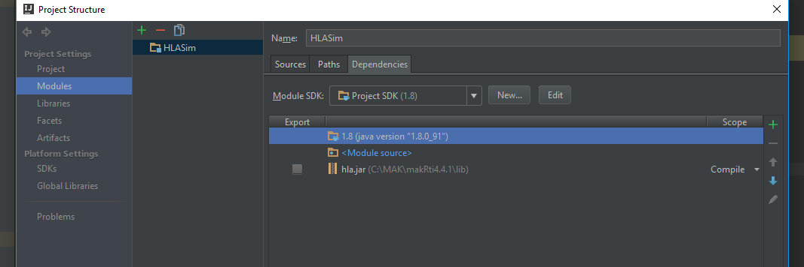

*File -> Project Structure -> Modules -> Dependencies : Add MAK_INSTALL_DIR\lib\hla.jar*

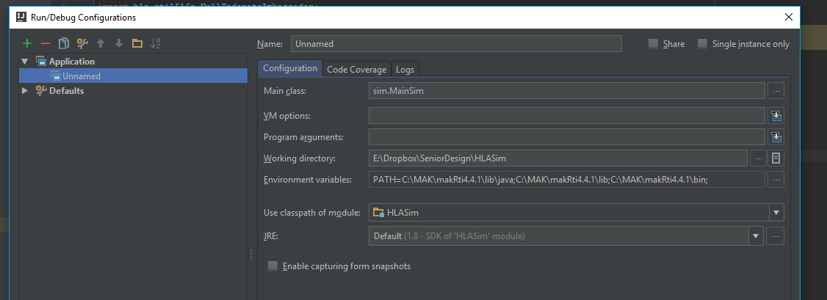

*Run -> Edit Configurations (Create a new configuration or edit an existing one) : set the Main Class to sim.MainSim and set up the PATH in environment variables. You have to set the path here regardless of your system-wide env variables. Replace MAK_INSTALL_DIR with wherever MAK is installed, PATH=MAK_INSTALL_DIR\lib\java; MAK_INSTALL_DIR\lib; MAK_INSTALL_DIR\bin;* ***NOTE: You must use full paths here, for some reason IntelliJ doesn’t like windows variables ie: %var%.***

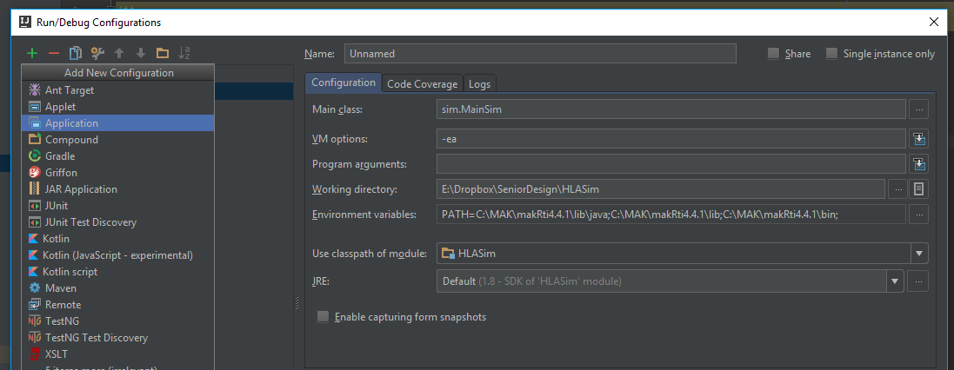

*I used a lot of assert statements, which are really convenient for ensuring things which are “mission critical” ie: the program should die if they don’t happen. Java needs the -ea parameter to be passed to the VM or it won’t execute the assert statements.*