Laboratorio 1, Tópicos en análisis datos 1

Joshua Isaac Cervantes Artavia

2023-08-22

# Carga de tablas de datos

library(MASS)  
data(survey)  
names(survey)

[1] "Sex" "Wr.Hnd" "NW.Hnd" "W.Hnd" "Fold" "Pulse" "Clap" "Exer"   
 [9] "Smoke" "Height" "M.I" "Age"

# Se hace un grafico  
pie(table(survey$Smoke))

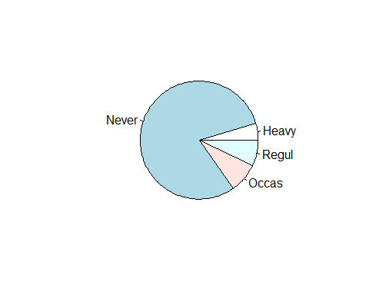

# Se cargan los datos de iris  
data(iris)  
  
  
# Se realiza un grafico de caja  
boxplot(iris$Sepal.Width)

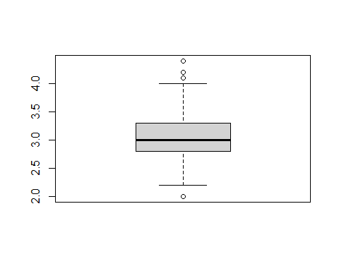

boxplot(iris$Sepal.Length, iris$Sepal.Width, iris$Petal.Length, iris$Petal.Width)

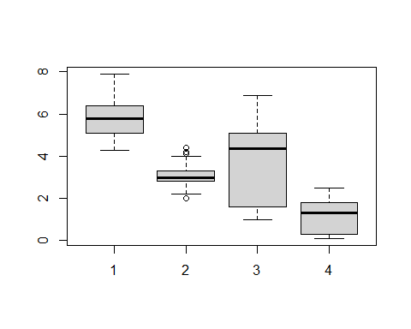

# Se ven las instrucciones de la funcion boxplot  
?boxplot

starting httpd help server ... done

# Gráficos de dispersión

Se generan dos series de datos normales:

C1 <- matrix(rnorm(200, sd = 0.5), ncol = 2)  
C2 <- matrix(rnorm(200, mean = 1, sd = 0.5), ncol = 2)  
  
# Se unen las matrices  
mat <- rbind(C1, C2)

Se grafica C1

plot(C1)

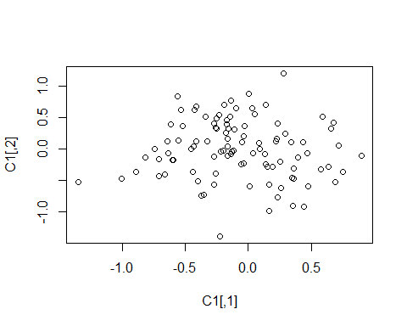

plot(C1, col = "blue")  
# Se añaden los puntos de C2  
points(C2, col = "red")

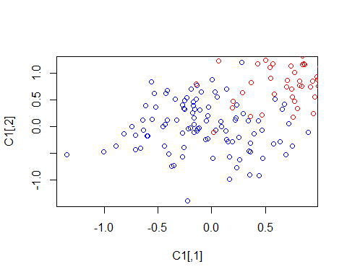

Se procede a ajustar el tamaño del gráfico

plot(C1,  
 col = "blue",  
 xlim = range(mat[, 1]),  
 ylim = range(mat[, 2]),  
 main = "Representacion de una nube de puntos",  
 xlab = "X1", ylab = "X2"  
)  
points(C2, col = "red")

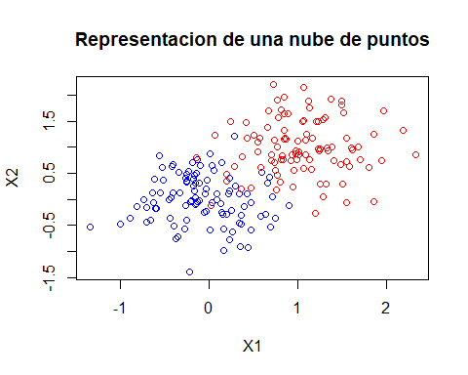

Se retoca el gráfico

plot(1,  
 xlim = range(mat[, 1]),  
 ylim = range(mat[, 2]),  
 main = "Representacion de una nube de puntos",  
 xlab = "X1", ylab = "X2",  
 bty = "l", tcl = -.25  
)  
rect(-3, -3, 3, 3, col = "cornsilk")  
points(C1, col = "blue", pch = 22, bg = "red")  
points(C2, col = "red", pch = 25, bg = "yellow")

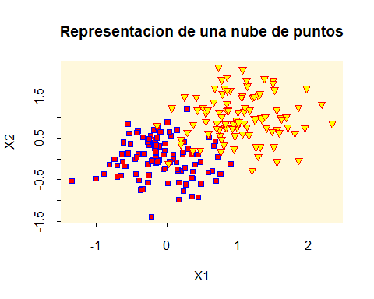

Se generan varios gráficos al mismo tiempo

plot(iris[, 1:4],  
 bg = c("red", "green3", "blue")[iris[, 5]],  
 pch = c(21, 25, 24)[iris[, 5]],  
 main = "Iris de Fisher",  
 labels =  
 c(  
 "Largo\nSepale",  
 "Ancho\nSepale",  
 "Largo\nPetale",  
 "Ancho\nPetale"  
 )  
)

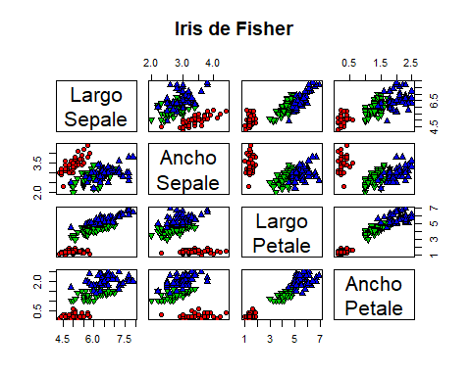

Se genera un gráfico de dispersión separando colores según sexo

plot(survey$Wr.Hnd, survey$NW.Hnd, pch = ifelse(survey$Sex == "Male", 1, 19))  
legend("topleft", inset = 0.01, c("Hombre", "Mujer"), pch = c(1, 19))

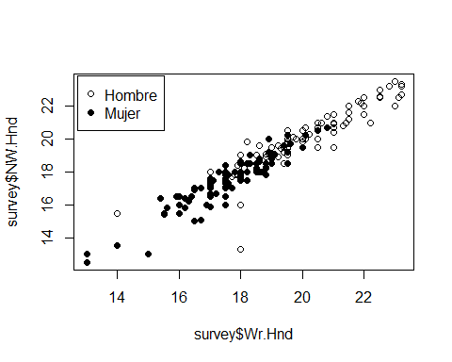

# Creación de histogramas básicos

hist(survey$Height,  
 col = grey(0.9),  
 border = grey(0.2),  
 main = paste("Talla de", nrow(survey), "estudiantes"),  
 xlab = "Talla [cm]",  
 ylab = "Número",  
 labels = TRUE,  
 las = 1,  
 ylim = c(0, 50)  
)

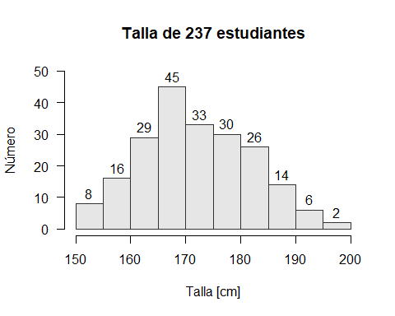

# Frecuencias relativas, incluyendo ajuste a una curva normal

hist(survey$Height,  
 col = grey(0.9), border = grey(0.2),  
 main = paste("Talla de", nrow(survey), "estudiantes"),  
 xlab = "Talla [cm]", proba = TRUE  
)  
x <- seq(  
 from = min(survey$Height, na.rm = T),  
 to = max(survey$Height, na.rm = T), length = 100  
)  
lines(x, dnorm(  
 x, mean(survey$Height, na.rm = TRUE),  
 sd(survey$Height, na.rm = TRUE)  
))  
mtext("Ajuste (dudoso) a una distribuci´on normal")

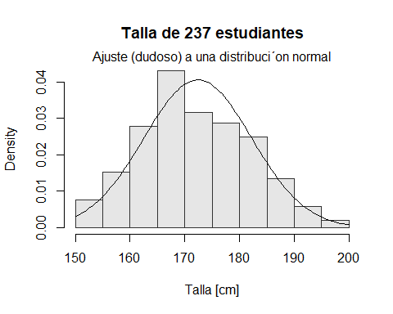

# Control del ancho de los intervalos en los hitogramas

hist(survey$Height,  
 col = grey(0.9), border = grey(0.2),  
 main = paste("Talla de", nrow(survey), "estudiantes"),  
 xlab = "Talla [cm]",  
 proba = TRUE,  
 breaks = seq(from = 150, to = 200, length = 15)  
)

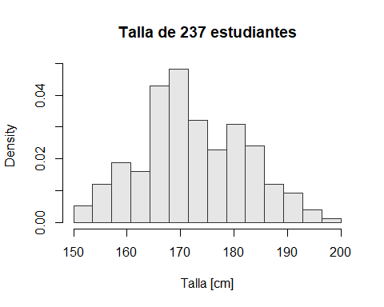

# Usando intervalosdel mismo efectivo

isohist <- function(x, nclass, ...) {  
 breaks <- quantile(x,   
 seq(from = 0,  
 to = 1,  
 length = nclass + 1),  
 na.rm = TRUE)  
 invisible(hist(x, breaks = breaks, ...))  
}  
isohist(survey$Height, 10,  
 col = grey(0.9), border = grey(0.2),  
 main = paste("Talla de", nrow(survey), "estudiantes"),  
 xlab = "Talla [cm]", proba = TRUE  
)

