PROJECT TESTING PHASE
Script-Controlled ACL – Restrict Record Access Based on Field Value
1. Testing Objective

The objective of testing is to verify that the Script-Controlled ACL correctly restricts access to Institution Details records based on the user's role and Branch value.

The testing confirms that:

EEE users can access EEE records.
EEE users cannot access non-EEE records.
Users without the required role cannot access the records.
Administrators have full access.
Read, Create, Write, and Delete permissions work according to the assigned roles.
2. Test Environment

Platform: ServiceNow

Custom Table: u_institution_details

Branches Used:

EEE
ECE
CSE

Test User: EEE User

Test Roles:

bb1 – Read EEE records
bb2 – Create EEE records
bb3 – Write EEE records
bb4 – Delete EEE records
3. Test Cases
Test Case Test Description Expected Result Status
TC01 EEE User opens an EEE record EEE record should be accessible Pass
TC02 EEE User tries to access an ECE record Access should be restricted Pass
TC03 EEE User tries to access a CSE record Access should be restricted Pass
TC04 User with bb2 creates an EEE record Record should be created successfully Pass
TC05 User with bb3 modifies an EEE record Record should be updated successfully Pass
TC06 User with bb4 deletes an EEE record Record should be deleted successfully Pass
TC07 User without the required role accesses records Access should be denied Pass
TC08 Administrator accesses the table Administrator should have full access Pass
4. Read Access Testing

The EEE User was tested with an EEE record.

Expected Result:
The EEE User should be able to read EEE records.

The user was then tested with ECE and CSE records.

Expected Result:
The EEE User should not be able to access ECE or CSE records.

Result: Passed.

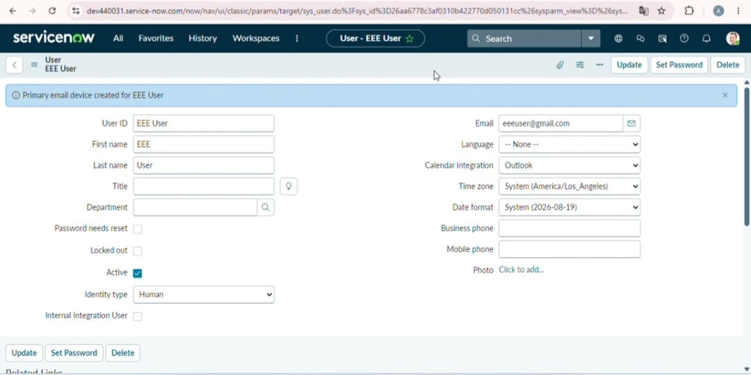

5. Create Access Testing

The user with the bb2 role was tested for creating a new Institution Details record.

Expected Result:
The user should be able to create an EEE record.

Result: Passed.

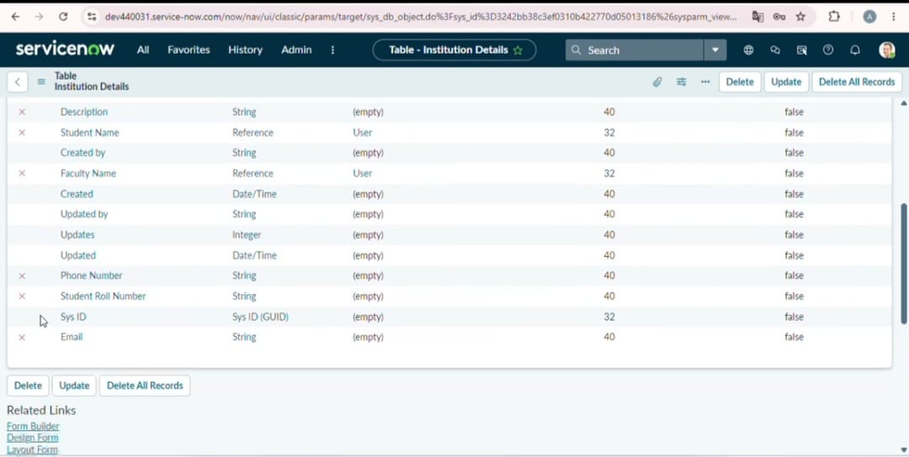

6. Write Access Testing

The user with the bb3 role was tested by modifying an existing EEE record.

Expected Result:
The user should be able to update the EEE record.

Result: Passed.

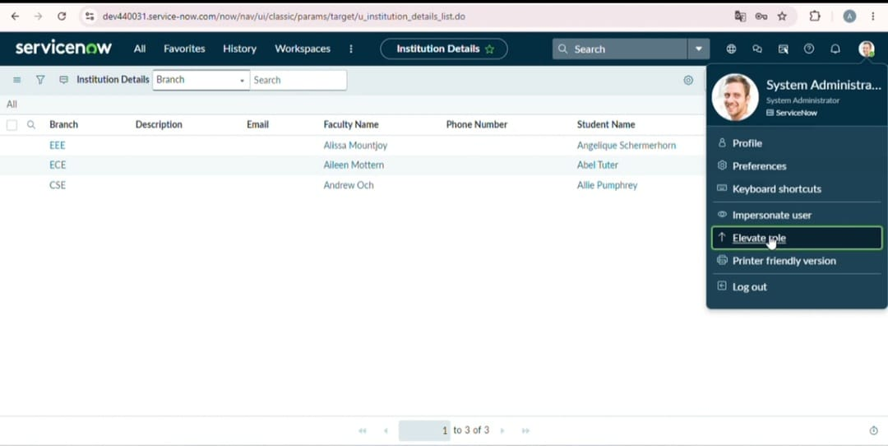

7. Delete Access Testing

The user with the bb4 role was tested by deleting an EEE record.

Expected Result:
The user should be able to delete the EEE record.

Result: Passed.

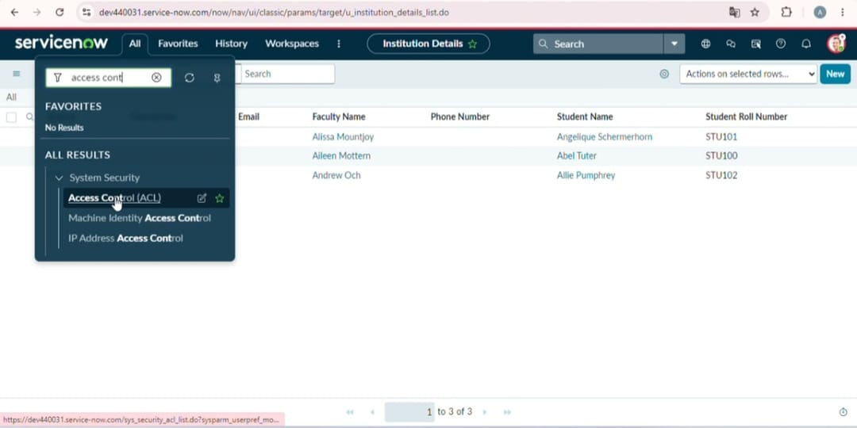

8. Unauthorized Access Testing

A user without the required ACL role was tested.

Expected Result:
The user should not be able to access or modify the restricted records.

Result: Passed.

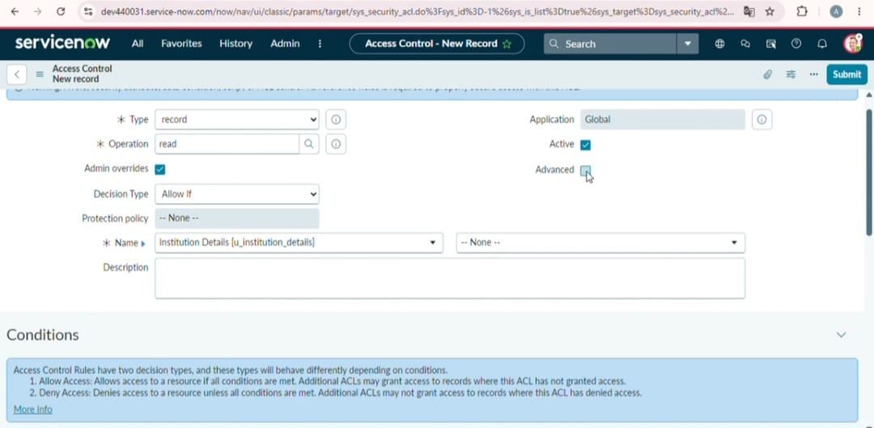

9. Administrator Testing

The administrator account was tested.

Expected Result:
The administrator should have complete access to the Institution Details table.

Result: Passed.

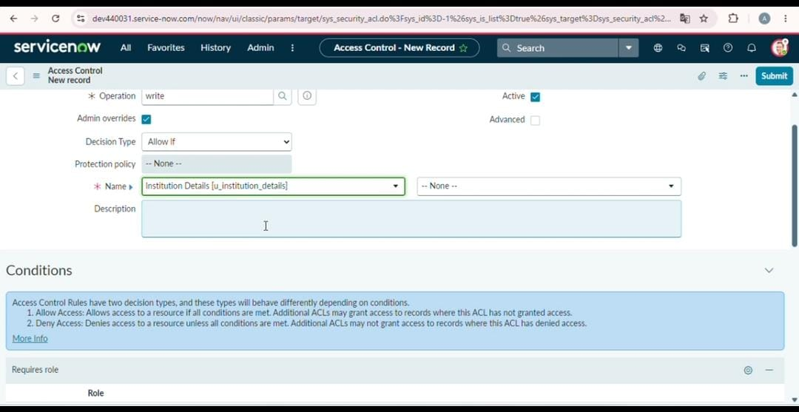

10. Testing Conclusion

All major ACL test cases were performed successfully. The Script-Controlled ACL correctly restricts Institution Details records based on the Branch value and assigned user roles.

The testing confirms that the implemented security rules provide controlled access to the Institution Details records.

