TensorFlow Sentiment Analysis Model
End-to-End Technical Documentation
Educational Feedback Classification using LLM + Bi-LSTM
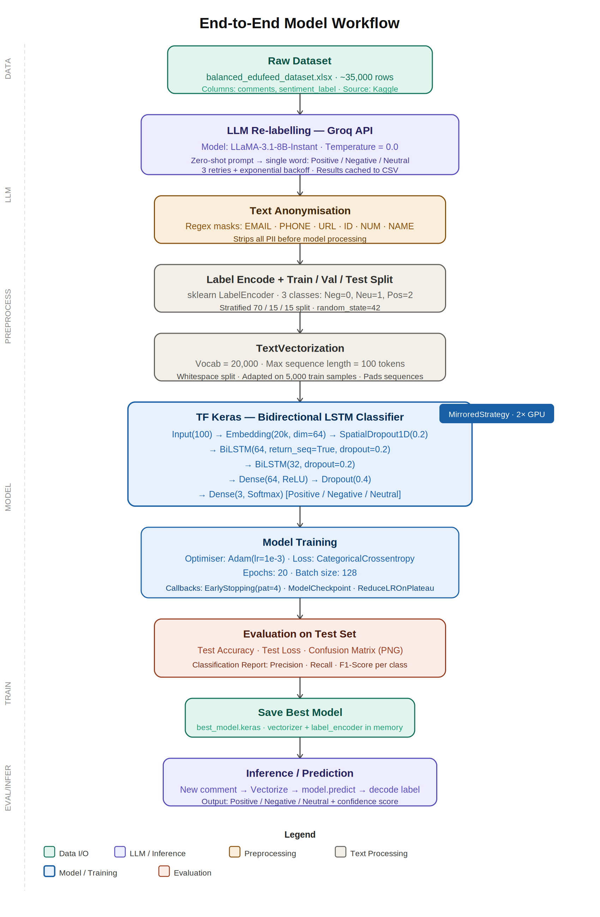
Figure 1: Complete Model Pipeline — Data Ingestion to Inference
Prepared for Internal Team Review | Kaggle Notebook | TensorFlow + Groq API

1. Project Overview
This notebook implements a complete, production-ready sentiment classification pipeline for educational feedback comments. The system uses a two-stage approach: first, a large language model (LLaMA-3.1-8B-Instant via Groq API) re-labels raw comments at scale with zero-shot prompting; second, a custom TensorFlow Keras Bidirectional LSTM model is trained on those clean labels to perform fast, local inference at deployment time.
The goal is to automatically classify any educational feedback comment into one of three sentiments — Positive, Negative, or Neutral — enabling institutions to monitor student satisfaction, flag concerns, and improve teaching quality at scale.

2. Dataset
2.1 Source
The dataset is sourced from Kaggle (sonu7676/data-for-tensorflow) as a Microsoft Excel file named balanced_edufeed_dataset.xlsx. It contains approximately 35,000 educational feedback comments collected from students. The dataset is described as 'balanced', meaning the three sentiment classes are represented roughly equally, which avoids class-imbalance issues during training.

Attribute | Details
File format | Microsoft Excel (.xlsx)
Total rows | ~35,000 feedback comments
Columns used | comments (raw text), sentiment_label (target class)
Classes | Positive, Negative, Neutral
Class balance | Balanced — roughly equal samples per class
Domain | Educational feedback from students

2.2 Why a Balanced Dataset Matters
A balanced dataset ensures the model does not develop a bias toward any single class. If 80% of samples were 'Positive', a naive model could achieve 80% accuracy by simply predicting Positive every time. Balancing forces the model to genuinely learn distinguishing patterns across all three sentiments.

3. LLM Re-labelling via Groq API
3.1 Purpose
The original dataset already contains sentiment labels, but their quality may be inconsistent or derived from simple rule-based methods. To improve label quality before training, every comment is re-classified using a state-of-the-art large language model. This process is called LLM-assisted data labelling or weak supervision.

3.2 Model Used — LLaMA-3.1-8B-Instant
LLaMA-3.1-8B-Instant is a Meta AI open-source large language model with 8 billion parameters. It is accessed through Groq Cloud, an inference platform that runs LLaMA models on custom LPU (Language Processing Unit) hardware for extremely fast response times. The 'Instant' variant is optimised for low-latency, high-throughput inference — essential when processing 35,000 comments.

Parameter | Value | Reason
Model | llama-3.1-8b-instant | Fast, high-quality, open-source LLM
Temperature | 0.0 | Deterministic output — no randomness in labelling
Max tokens | 5 | Forces single-word response; prevents verbosity
Prompt style | Zero-shot instruction | No examples needed; model infers from instruction alone
Retry logic | 3 attempts + exponential backoff | Handles transient API failures gracefully
Fallback label | Neutral | Safe default when all retries fail
Caching | Results saved to groq_labels.csv | Avoids re-calling API if notebook restarts

3.3 Prompt Design
The prompt is deliberately minimal and zero-shot. It instructs the model: 'Classify the sentiment of the following educational feedback comment. Reply with ONLY one word: Positive, Negative, or Neutral.' The comment is appended and the model completes with a single word. This approach avoids hallucination and guarantees a parseable output. A regex tokenizer then extracts the first valid label word from the response, defaulting to Neutral on ambiguity.

4. Data Preprocessing
4.1 Text Anonymisation
Before any text is tokenised or seen by the model, a regex-based anonymisation pass strips all personally identifiable information (PII). This is critical for privacy compliance and also reduces noise in the vocabulary — model IDs, phone numbers, and URLs add no sentiment signal.

PII Type | Regex Pattern Targets | Replacement Token
Email addresses | Standard email format with @ and domain | <EMAIL>
Indian phone numbers | +91 prefix or 10-digit starting 6-9 | <PHONE>
URLs | http://, https://, www. prefixes | <URL>
Alphanumeric IDs | Course codes, roll numbers (e.g. CS2023A) | <ID>
Long numeric strings | 5 or more consecutive digits | <NUM>
Proper nouns / names | Title-cased word sequences | <n>

4.2 Label Encoding
The three string class labels are converted to integers using sklearn's LabelEncoder, which applies alphabetical ordering: Negative=0, Neutral=1, Positive=2. These integer labels are then converted to one-hot vectors using keras.utils.to_categorical, which is required by the categorical crossentropy loss function.

4.3 Train / Validation / Test Split
The dataset is split into three mutually exclusive subsets using sklearn's train_test_split with stratify=y enabled. Stratification ensures each subset maintains the same class proportion as the full dataset — critical for unbiased evaluation.

Split | Proportion | Size (approx.) | Purpose
Training | 70% | ~24,500 rows | Used to update model weights during training
Validation | 15% | ~5,250 rows | Used by callbacks for early stopping and LR reduction
Test | 15% | ~5,250 rows | Held out completely; final accuracy measurement only

4.4 Text Vectorisation
Text vectorisation converts raw comment strings into fixed-length integer sequences that the model can process. The tf.keras.layers.TextVectorization layer handles this entirely within the TensorFlow computation graph, making it efficient and deployable without separate preprocessing code.

Parameter | Value | Explanation
Vocabulary size | 20,000 | Only the 20k most frequent tokens are kept
Max sequence length | 100 tokens | Sequences padded or truncated to exactly 100 tokens
Split strategy | Whitespace | Faster than character-level; adequate for English text
Vocabulary adapted on | First 5,000 train samples | Vocabulary stabilises at this size; saves compute
Output shape | (batch, 100) | Each sample becomes a vector of 100 integers

5. Model Architecture — Bidirectional LSTM
5.1 Why Bidirectional LSTM?
A standard LSTM (Long Short-Term Memory) reads a text sequence from left to right, building a hidden state that captures context. However, sentiment in a sentence often depends on words that appear after the key sentiment-bearing token — for example, 'not bad at all' requires understanding 'at all' to correctly interpret 'not bad'. A Bidirectional LSTM runs two LSTMs in parallel: one forward (left to right) and one backward (right to left). Their outputs are concatenated, giving every token access to its full context in both directions. This is particularly valuable for educational feedback which often uses complex negation and qualification.

5.2 Layer-by-Layer Breakdown
Layer | Configuration | Output Shape | Role
Input | shape=(100,) | (batch, 100) | Receives tokenised integer sequences
Embedding | vocab=20,000, dim=64 | (batch, 100, 64) | Maps each token ID to a 64-dimensional dense vector
SpatialDropout1D | rate=0.2 | (batch, 100, 64) | Drops entire feature maps — stronger regularisation than standard dropout for sequences
BiLSTM (first) | units=64, return_sequences=True, dropout=0.2 | (batch, 100, 128) | Captures contextual patterns across all 100 positions; outputs full sequence
BiLSTM (second) | units=32, dropout=0.2 | (batch, 64) | Compresses sequence into a single context vector; doubles to 64 due to bidirectionality
Dense (hidden) | units=64, activation=ReLU | (batch, 64) | Non-linear transformation to extract higher-level features
Dropout | rate=0.4 | (batch, 64) | Heavy dropout before output — prevents overfitting on training labels
Dense (output) | units=3, activation=Softmax | (batch, 3) | Outputs a probability distribution over 3 classes; argmax gives the predicted label

5.3 Multi-GPU Training with MirroredStrategy
The model is compiled and trained inside a tf.distribute.MirroredStrategy scope, which automatically distributes training across all available GPUs (2× NVIDIA T4 on the Kaggle environment). The strategy splits each batch equally across GPUs, computes gradients independently on each GPU, then aggregates them via AllReduce before updating the weights. This effectively doubles throughput without requiring any changes to model code.

6. Training Configuration
6.1 Optimiser — Adam
Adam (Adaptive Moment Estimation) is used with an initial learning rate of 1e-3. Adam combines the benefits of momentum (accelerates convergence) and RMSProp (adapts learning rate per parameter). It is the standard choice for NLP models due to its robustness to hyperparameter choices and its efficient handling of sparse gradients.

6.2 Loss Function — Categorical Crossentropy
Since this is a multi-class classification problem with one-hot encoded labels, categorical crossentropy is the appropriate loss. It measures the divergence between the predicted probability distribution (3 values summing to 1) and the true one-hot distribution. Minimising this loss pushes the model to assign high probability to the correct class.

6.3 Training Callbacks
Callback | Parameters | Behaviour
EarlyStopping | monitor=val_accuracy, patience=4, restore_best_weights=True | Stops training if validation accuracy does not improve for 4 consecutive epochs; restores the best checkpoint automatically
ModelCheckpoint | monitor=val_accuracy, save_best_only=True | Saves the model weights to best_model.keras only when validation accuracy improves — ensures the saved model is always the best seen
ReduceLROnPlateau | monitor=val_loss, factor=0.5, patience=2, min_lr=1e-6 | Halves the learning rate if validation loss plateaus for 2 epochs; prevents oscillation around a local minimum

Hyperparameter | Value
Initial learning rate | 0.001 (1e-3)
Maximum epochs | 20
Batch size | 128
GPU strategy | MirroredStrategy (2× T4)
Minimum learning rate | 1e-6

7. Model Evaluation
7.1 Metrics
After training, the best checkpoint (best_model.keras) is loaded and evaluated on the completely held-out test set. The following metrics are computed:

Metric | Description | Tool
Test Accuracy | Proportion of test comments classified correctly | keras model.evaluate
Test Loss | Categorical crossentropy on test set — lower is better | keras model.evaluate
Precision (per class) | Of all comments predicted as class X, how many actually were X | sklearn classification_report
Recall (per class) | Of all actual class X comments, how many were correctly identified | sklearn classification_report
F1-Score (per class) | Harmonic mean of Precision and Recall — balances both | sklearn classification_report
Confusion Matrix | Table showing actual vs predicted class counts across all 3 classes | sklearn + seaborn heatmap

7.2 Confusion Matrix
The confusion matrix is visualised as a seaborn heatmap with the Blues colour palette. Each cell shows the count of samples with a given actual label (rows) predicted as a given label (columns). Diagonal cells represent correct predictions; off-diagonal cells show misclassifications. The chart is saved as confusion_matrix.png for reporting.

8. Inference Pipeline
Once training is complete, the system is ready to classify new, unseen comments in real time. The full inference pipeline is:

- Load best_model.keras from disk using keras.models.load_model
- The TextVectorization layer and LabelEncoder remain in memory from training — no re-fitting required
- Pass the new raw comment string through the vectorizer to get a padded integer sequence
- Run model.predict to obtain a 3-value softmax probability vector
- Apply numpy.argmax to find the class index with highest probability
- Decode the integer index back to a string label using label_encoder.inverse_transform
- Optional: the Groq client is still available for LLM-based cross-validation of predictions

9. Technology Stack
Component | Library / Tool | Version / Detail | Role
Deep Learning | TensorFlow / Keras | TF 2.x | Model building, training, inference, GPU strategy
LLM Inference | Groq Python SDK | groq library | Access LLaMA-3.1-8B-Instant for data labelling
LLM Model | LLaMA-3.1-8B-Instant | Meta AI (via Groq) | Zero-shot sentiment classification of raw text
Data Handling | Pandas, NumPy | Standard | Excel loading, array operations, label manipulation
Text Processing | tf.keras TextVectorization | Built-in TF layer | Tokenisation, vocabulary building, sequence padding
Label Handling | sklearn LabelEncoder | scikit-learn | String-to-integer encoding and decoding
Evaluation | sklearn metrics | scikit-learn | Accuracy, precision, recall, F1, confusion matrix
Visualisation | seaborn, matplotlib | Standard | Confusion matrix heatmap, training curves
Model Persistence | Keras .keras format | Native Keras | Save and reload best model checkpoint
GPU Acceleration | tf.distribute.MirroredStrategy | Built-in TF | Distribute training across 2× T4 GPUs
Platform | Kaggle Notebooks | Cloud | 2× NVIDIA T4 GPU environment with Kaggle Secrets for API key

10. End-to-End Summary
The following sequence describes the complete execution of this notebook from start to finish:

- Step 1 — Load ~35,000 educational feedback comments from balanced_edufeed_dataset.xlsx
- Step 2 — Re-label all comments using LLaMA-3.1-8B-Instant via Groq API (zero-shot, cached to CSV)
- Step 3 — Apply regex anonymisation to strip PII: emails, phone numbers, URLs, IDs, names
- Step 4 — Encode labels (Neg=0, Neu=1, Pos=2) and split 70/15/15 with stratification
- Step 5 — Build TextVectorization layer (vocab=20k, max_len=100) adapted on training data
- Step 6 — Construct Bidirectional LSTM model: Embedding → SpatialDropout → 2× BiLSTM → Dense → Softmax
- Step 7 — Compile with Adam(1e-3) and categorical crossentropy; train on 2× GPU with 3 callbacks
- Step 8 — Evaluate best checkpoint on test set: accuracy, F1 per class, confusion matrix heatmap
- Step 9 — Save best_model.keras for deployment; vectorizer and encoder persist in memory
- Step 10 — Inference: new comment → vectorize → predict → decode → Positive / Negative / Neutral

— End of Document —

