***BAHRIA UNIVERSITY KARACHI CAMPUS***

**DATA STRUCTURES & ALGORITHM LAB (CSL-221)**

**PROJECT REPORT**

**FALL - 2022**

**VENDING MACHINE**

**GROUP MEMBERS**

Syed Arham Ali (02-134212-006) (BSCS-3A)

Afrah Imran (02-134212-009) (BSCS-3A)

Fatima Muhammad (02-134212-080) (BSCS-3A)

SUBMITTED ON

Thursday 19th January 2023

TO

SABA IMTIAZ



**Table of Contents**

* + 1. Abstract Pg # 3
    2. Introduction Pg #3
    3. Working/ Data Structures Used Pg #4
    4. Output Screenshots Pg #5
    5. Conclusion Pg #5

1. **ABSTRACT:**

Imagine, paying and placing an order in a food outlet only to wait for an extra twenty to thirty minutes to get the ordered products. How tiring. This is the current situation in different food outlets and shops. What if we could save time by 75% to 83% and get an order in five minutes or less?Vending Machine as we all know is a machine which can vend different selling products such as snacks, beverages, lottery tickets, and etc. Which is more like an automated process with no requirement of man handling which we normally see in fast moving cities because of fast paced life.

1. **INTRODUCTION:**

Now-a-days vending machines are becoming very popular in western countries because of their ease, less wastage of time and effort, availability near doorstep and variety of products. The Purpose of the Project is to build a Vending Machine in C++ using appropriate data structures. The program will prompt the users to enter in their selection, it will also prompt the users to make a selection of choice they want to purchase from the vending machine. The Objective is to Provide the users with multiples items such as food and drinks within affordable price range effectively and conveniently, The user will Insert the currency in the vending machine and can proceed to purchase the items they require, at the end of the program the user will be returned the change if any left along with the items they purchased. It is vital to save time and reduce human energy.

1. **WORKING/DATA STRUCTURES USED:**

We applied Linked List & Stacks (LIFO), when the product is out of stock we will add new product using Linked List, LIFO and Stacks to refill the Vending Machine.

* If the selection is sold out, state that the choice you selected is not available.
* If the customer does not place enough currency, state that the currency is not enough to purchase this item
* Once the choice is selected, state the cost of the choice and display the output of the choice within the vending machine.
* Program will also keep track of the inventory of all products sold as well as not sold within the vending machine.

**DATA STRUCTURES USED:**

* Stack Implemented through Linked list:

Several Stacks of the products are linked using linked list so that user than buy whatever product they wish purchase.

We used stacks since in vending machine LIFO pattern is implemented, vendor stacks the products into a vending machine, the first product they stack is moved to the back of the stack and is bought in the last and the last product they stack in bought first, similarly Stacks also implements LIFO pattern.

Linked List was used to connect all the products in the vending machine making it easier for the vendor to stack the products and for the user to choose between any products to purchase.

**Functions Used:**

* + Pop: Used to delete a product out the stacks when a user purchases a particular item.
  + Push: Used by the vendor to Insert Items into the product stacks.
  + Display: To display the remaining products in the vending machine.
  + Search; Search a particular product in the vending machine.

1. 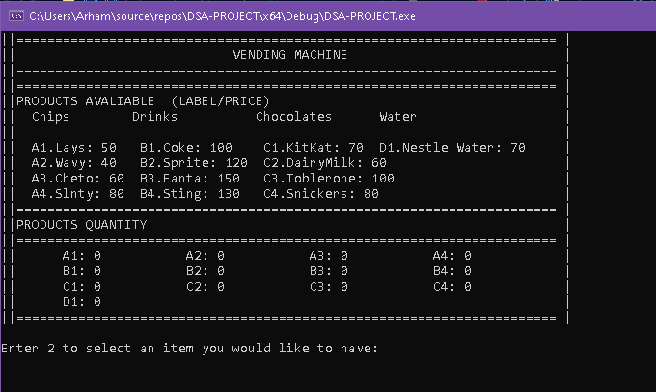**OUTPUT SCREENSHOTS:**
2. **CONCLUSION:**

In conclusions our project is a success, our vending machine is successfully able to accept payment from users and serve them conveniently, It also returns the change to the user if there’s any left or promote the user to add more money to make more purchases if they want to, Vending machine also successfully enables the vendor to stack items when the need arises. It keep track of the inventory, with every purchase the inventory is updated.