Secure Chat System Report
Name: Afrah Syed
Roll Number: 22i1008
Assignment: Information Security – Assignment 2

1. Introduction
This report documents the design and implementation of a Secure Chat System achieving Confidentiality, Integrity, Authenticity, and Non‑Repudiation (CIANR). Screenshots will be added where indicated.

2. PKI Setup and Certificate Validation
I implemented a self‑built Certificate Authority (CA) and generated X.509 certificates for client and server.
Both client and server exchange certificates during the CONTROL PLANE and validate:
- CA signature chain
- CN/hostname
- Expiry and validity period

3. Registration and Login
User credentials are encrypted using AES‑128 under a temporary DH‑derived key. The server stores salted SHA‑256 hashes only.

4. Session Key Establishment (DH)
After authentication, a Diffie‑Hellman exchange establishes a unique session key.

5. Encrypted Messaging & Integrity
Each message is encrypted with AES‑128 (ECB + PKCS#7) and digitally signed using RSA.
Replay defense = sequence numbers.
Tampering defense = signature verification.
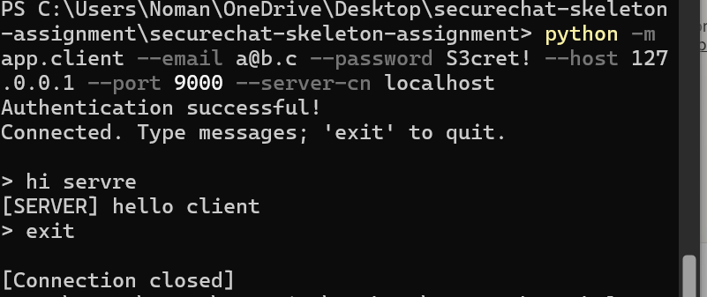
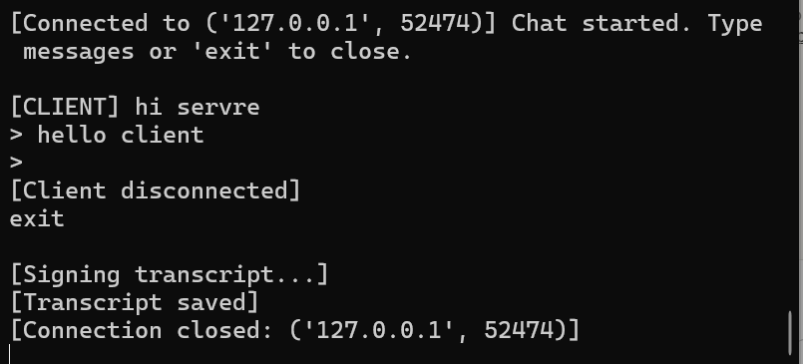

6. Non‑Repudiation (Transcripts & Receipt)
An append‑only transcript logs: seqno | timestamp | ct | sig | peer fingerprint.
At teardown, both sides sign transcript hash.
