**MVP**

Three plots have been produced, the first plot is the regression fit which shows the results predicted by the model (the line) against the actual results (the dots), we can clearly see that the model produces good results when X is 10 or less, the second plot is the residual plot, which shows the distance between actual values and predicted values, and similar to the previous plot, it illustrates good results when X is 10 or less, the third plot is the Q – Q plot which compares the theoretical quantiles of a distribution with the quantiles of the dataset, and shows whether or not the data has a normal distribution, as the graph illustrates, values between -5 and 5 in the dataset quantiles produce the closest results to the theoretical quantiles, and the data does not follow a normal distribution but rather a uniform one.

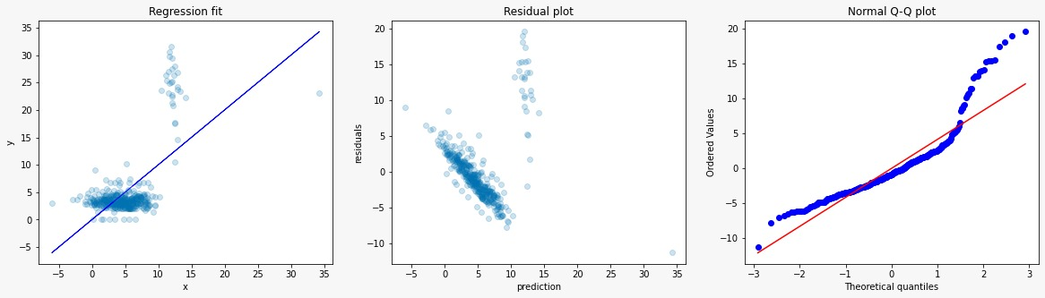

Group members:

Afrah Almotairi

Tamader Abo Alhassan

Moneera Alfulaij