PENETRATION TESTING REPORT
FOOTPRINTING & NETWORK SCANNING PHASES
W2-PM-FINAL | CYBERSECURITY | NETWORKWALKS
Pentester Name  (Cybersecurity Professional) | Ifrah Mohamed
Program/Batch | B084-Networkwalks
Date | 11 Nov 2026
Modules completed | W2-PM3 (Maltego tool)  W2-PM5 (Zenmap Scanning)
Client/Target | 1. Networkwalks (secured written permission already)  2. My own local LAN Network
Permission secured from client? | Yes
Phases covered | Phase 1: Reconnaissance & Footprinting  Phase 2: Scanning & Network Discovery  Phase 3: Report Writing

1. Liability Disclaimer
I performed these activities only on systems and devices for which I had secured written permission or that I personally own. This material is intended for educational and research purposes only. It must not be used to break the law. The instructor, the authors, and Networkwalks are not responsible for any misuse of this knowledge. Every action taken using this information is the user's own responsibility. Misuse may result in criminal charges, significant fines, loss of employment, and a permanent record. In most countries, unauthorized access is a crime, even when no damage is caused.

2. Introduction
This report covers footprinting of the networkwalks.com domain using Maltego on Kali Linux (W2-PM3) and scanning of my own local network using Zenmap (W2-PM5). One module focuses on the footprinting phase, while the other focuses on the scanning phase. Together, they demonstrate how an attacker may move from gathering publicly available information to identifying live hosts on a network. This report documents the Week 2 activities of my ongoing internship program at Networkwalks.
Both the footprinting and scanning activities were performed in Kali Linux. The evidence section documents the steps followed, the results observed, and supporting screenshots. The findings are also considered from a security perspective to explain why they may matter to an organization.

3. Tools Used
The table below lists the tools used in this report and describes their purposes.

TOOLS | PURPOSE
Kali Linux | Operating system environment used to run the footprinting and network-scanning tools.
Maltego | Used to perform domain footprinting and identify publicly available information associated with networkwalks.com.
Zenmap (Nmap GUI) | Used to perform a ping scan of the local LAN, identify live hosts, and view the network topology.

4. Activities Performed
4.1 Footprinting & Reconnaissance
I used Maltego on Kali Linux to conduct footprinting against the networkwalks.com domain. The objective was to identify publicly available information associated with the domain. After configuring Maltego and creating a Domain entity for networkwalks.com, I ran the available email-related transform. The transform returned info@networkwalks.com. This finding shows how publicly available contact information may be collected during the reconnaissance phase. The practical steps and screenshots are presented in Section 8.1.
I performed reconnaissance against the networkwalks.com domain using Maltego.
4.2 Network Scanning with Zenmap
I used Zenmap to perform a Ping Scan of my own local LAN. The scan identified two live hosts, with the IP addresses 10.0.0.1 and 10.0.0.2. I also recorded the MAC addresses displayed by the scan and reviewed the network topology in Zenmap. The topology graphic was exported as a PDF. This activity demonstrated how network discovery can help identify active devices and provide a visual overview of a network. The practical steps and screenshots are presented in Section 8.2.
5. Risk Analysis & Impact
The exercises demonstrated how information collected during footprinting and network scanning may be useful during security reconnaissance. The following points describe potential risks associated with the observations; they are not confirmed vulnerabilities.
5.1 Publicly Available Contact Information
The discovery of info@networkwalks.com shows that an organizational email address was returned by the email-related Maltego transform. Publicly available contact information may be misused in phishing or social-engineering attempts. The discovery alone does not demonstrate that the mailbox is vulnerable or compromised.
5.2 Network Discovery Information
The Zenmap scan identified two live hosts on my own local LAN and displayed their IP and MAC addresses. Such information can help someone understand which devices are active on a network. If obtained by an unauthorized person, it could support further reconnaissance. The ping scan did not establish that any ports were open, that services were exposed, or that a device was vulnerable.
5.3 Network Topology Visibility
The topology view provided a visual representation of the hosts discovered by the scan. Network diagrams can reveal useful structural information, so access to internal network maps should be limited to authorized personnel.
6. Recommendations
Based on the observations from these exercises, the following measures may help reduce the potential risks associated with information exposure and network discovery.
6.1 Email and Phishing Protection
Provide regular security-awareness training, encourage employees to report suspicious messages, and use appropriate email authentication and filtering controls, including SPF, DKIM, and DMARC where applicable.
6.2 Network Access and Device Management
Maintain an inventory of authorized devices, restrict network access to approved users and devices, and use network segmentation where appropriate. Review firewall rules and investigate unfamiliar devices or unexpected changes in the network.
6.3 Monitoring and Maintenance
Keep operating systems and network devices updated, monitor network activity for unusual behavior, and conduct regular security assessments within an approved scope. Review publicly available organizational information periodically and take appropriate steps to reduce unnecessary exposure.
7. Conclusion
This Week 2 project provided practical experience with two important activities in penetration testing: footprinting and network scanning. Using Maltego, I performed reconnaissance against networkwalks.com and identified an associated email address returned by an email-related transform. Using Zenmap, I scanned my own local LAN, identified two live hosts, recorded their IP and MAC addresses, and reviewed the network topology. These activities helped me understand how publicly available information and network-discovery results can contribute to the reconnaissance process. They also reinforced the importance of protecting organizational information, maintaining visibility over network devices, and conducting security assessments responsibly and only with proper authorization.

8. Evidence Collected
8.1 Maltego tool
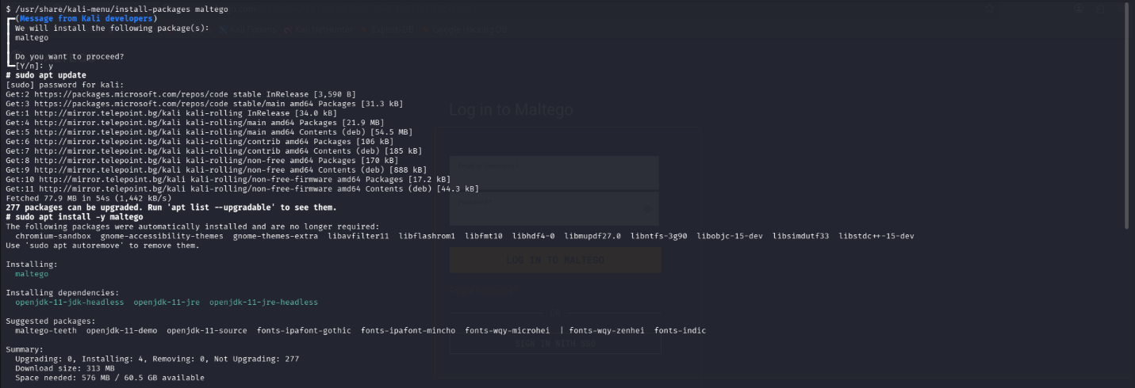
First, I searched for Maltego, opened the Maltego installer, and confirmed the installation through the command-line interface (CLI).


Second, I completed the registration form to obtain my free Maltego ID.
Finally, I completed the tool configuration and installation. Maltego was then ready to run transforms.
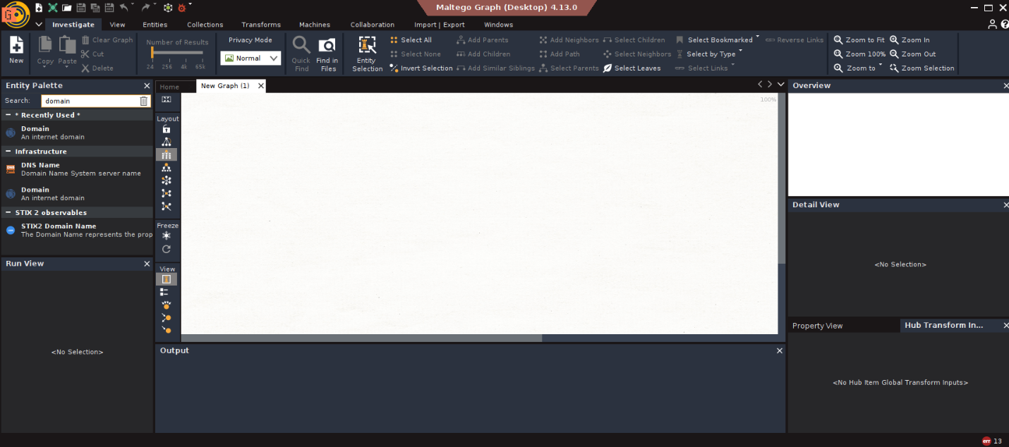

I searched for the Domain entity and dragged it onto the graph.
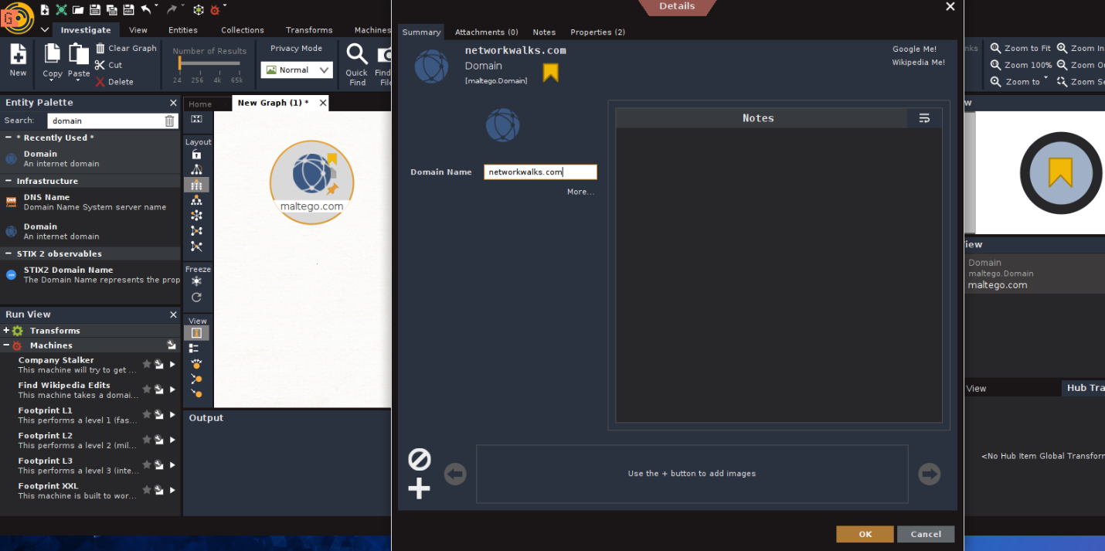

I double-clicked the entity, changed its name to networkwalks.com, and clicked OK.

I right-clicked the entity, filtered the available transforms for email-related options, and ran the selected transform.
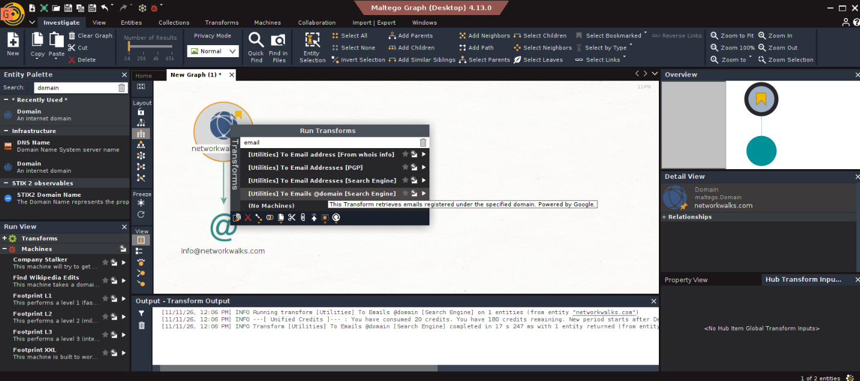

The transform returned the following email address associated with networkwalks.com: info@networkwalks.com.
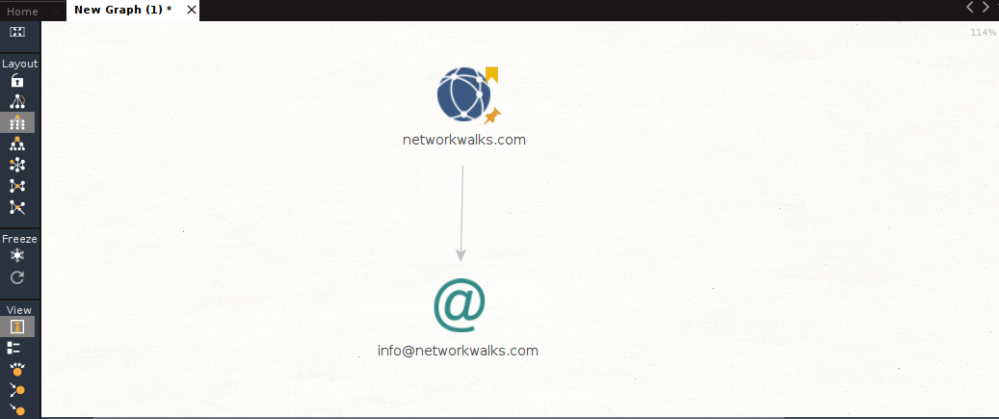

8.2 Zenmap Tool
I opened the terminal and ran the ifconfig command to identify my PC's local IP address and local LAN subnet.

8.2 Zenmap Tool
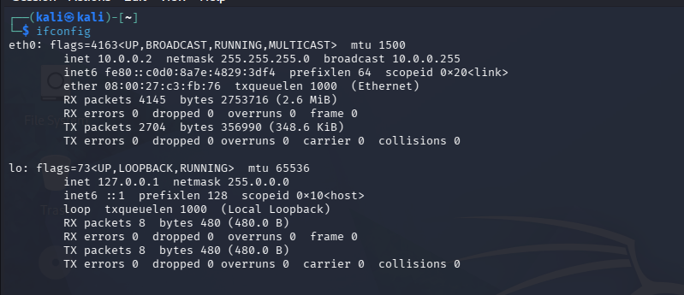
I opened the terminal and run ifconfig command to find my PC’s local IP ADDRESS & my local LAN subnet.

To identify live hosts on my IP subnet, I opened Zenmap, entered the local LAN subnet, and selected Ping Scan.
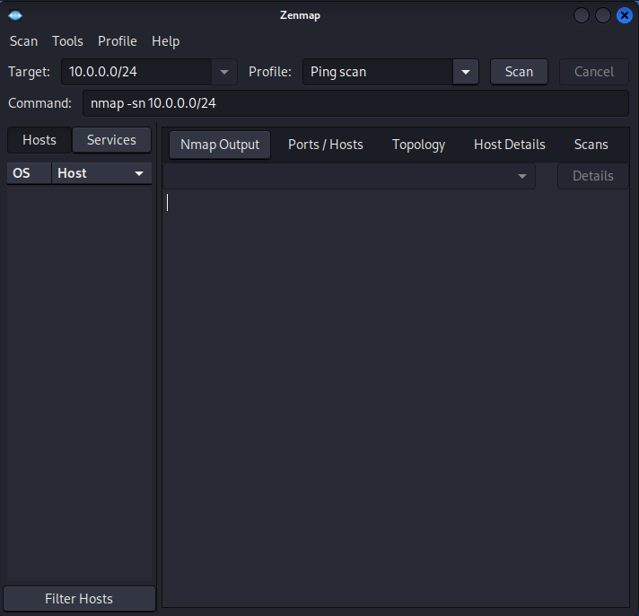

The scan identified two live hosts, including my own PC.
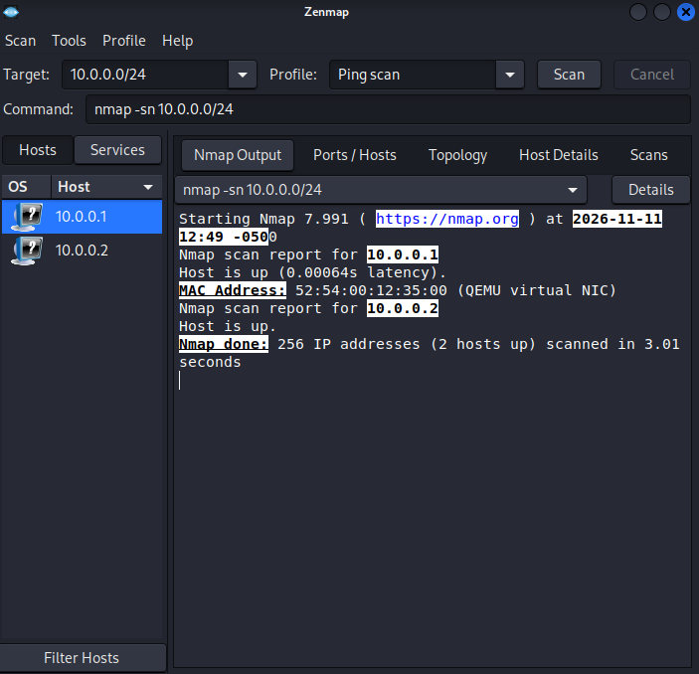

The IP addresses of the live hosts are:
- 10.0.0.1
- 10.0.0.2

The MAC addresses of the live hosts are:
- 0A-00-27-00-00-14
- 52:54:00:12:35:00
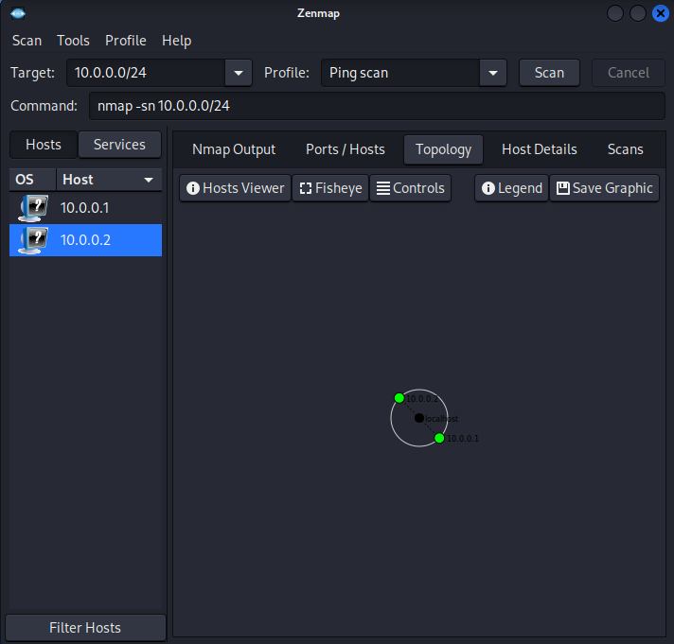
To display the network topology, I clicked the Topology tab.

I enabled the legend and reviewed the information it displayed.
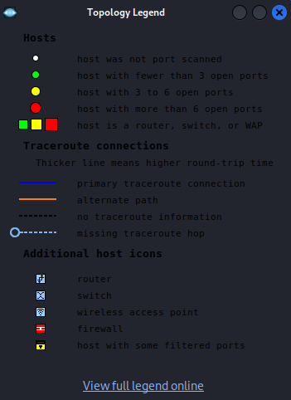

Finally, I clicked Save Graphic and selected PDF from the available file formats.
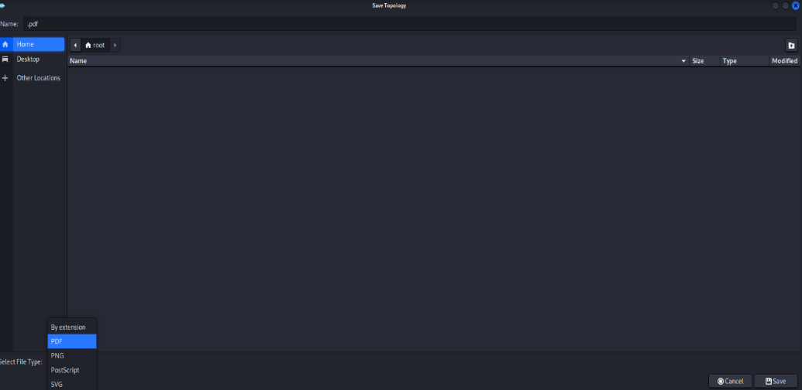

The PDF was then saved to the Desktop.


