**ECG Based Info Lock**

**__ Idea 4 __**

**SC_42**

|  |  |
| --- | --- |
| **ID** | **Name** |
| 20191700118 | أفرايم عزت اديب شكرالله |
| 2021170283 | عبدالرحمن أحمد أبو الحجاج |
| 2021170603 | هاجر ياسر محمد |

**Project Overview**

The ECG-Based Info Lock project explores biometric security mechanisms by leveraging unique physiological signals, specifically electrocardiograms (ECG). The core objective is to develop a reliable system capable of identifying individuals using their ECG data, processed through a comprehensive pipeline of signal filtering, feature extraction, and machine learning classification.

This project utilizes real-world ECG data from multiple subjects and employs advanced signal processing techniques and machine learning models to build an accurate, secure, and scalable biometric authentication system.

**Data Preparation**

The dataset comprises ECG signals collected from five distinct patients.

1. **Bandpass Filtering**

A third-order Butterworth bandpass filter with a lowcut frequency of 1.0 Hz and a high cut frequency of 40.0 Hz is applied to the raw ECG signals. This helps in removing noise and baseline wander.

1. **R-Peak Detection**

R-peaks are detected in the filtered ECG signal . The detection considers a minimum distance of 0.6 seconds between peaks and a height threshold based on the mean of the filtered signal.

1. **Segmentation**

ECG segments of 0.6 seconds are extracted around each detected R-peak. Segments that fall out of bounds are discarded.

**|** The total number of segments loaded for analysis is 1447.

**Feature Extraction**

Features are extracted in three primary categories for each ECG segment:

**Fiducial Features**

These features are derived based on the known physiological landmarks of the ECG waveform—primarily the P, R, and T points:

* R-peak amplitude
* PR segment amplitude
* RT interval
* PT slope

**Time-Domain Features:**

* Mean of the segment
* Standard deviation of the segment
* Skewness of the segment
* Kurtosis of the segment
* Root Mean Square (RMS) of the segment

**Frequency-Domain Features:**

These are derived from the Fast Fourier Transform (FFT) magnitude of the segment and include power in specific frequency bands:

* Low frequencies (1-10 Hz)
* Mid frequencies (10-50 Hz)
* High frequencies (50-150 Hz)

In addition to these base features, two distinct feature sets are created by combining them with transform-based features:

* **Discrete Cosine Transform (DCT) Features:**

The first 20 coefficients of the Discrete Cosine Transform (DCT) are extracted from each segment. These are then concatenated with the base features, resulting in a total of 32 features.

* **Discrete Wavelet Transform (DWT) Features:**

The Discrete Wavelet Transform (DWT) is applied using the 'db4' wavelet at level 4. For each coefficient set obtained from the DWT, the mean of the absolute coefficients, standard deviation, maximum absolute value, sum of squares, and root mean square are calculated. These wavelet features are then extended and concatenated with the base features, also resulting in a total of 37 features.

**Classification**

A **Support Vector Machine (SVM)** classifier is used for both feature sets. To optimize the SVM's performance, GridSearchCV is employed for hyperparameter tuning with a 3-fold cross-validation (cv=3) and an accuracy scoring metric.

The parameters explored for the SVM classifier include:

* C: Regularization parameter, with values [0.1, 1, 10].
* gamma: Kernel coefficient, with values ['scale', 0.01, 0.001].
* kernel: The kernel type, set to 'rbf' (Radial Basis Function).

The best parameters found by GridSearchCV for each model are:

* **DCT-SVM** ~> C=1, gamma=0.001, kernel='rbf'
* **Wavelet-SVM** ~> C=10, gamma=0.001, kernel='rbf'

The dataset was split into training and testing sets

* 80% training, 20% test
* random_state = 42 for reproducibility.
* Stratified splitting was used to maintain the proportion of classes.

**Results**

|  |  |  |
| --- | --- | --- |
| **Model** | **DCT** | **Wavelet** |
| SVM | 0.9966 | 0.9862 |
| RF | 1.0000 | 1.0000 |
| GB | 0.9966 | 0.9966 |

DCT-Based SVM Model

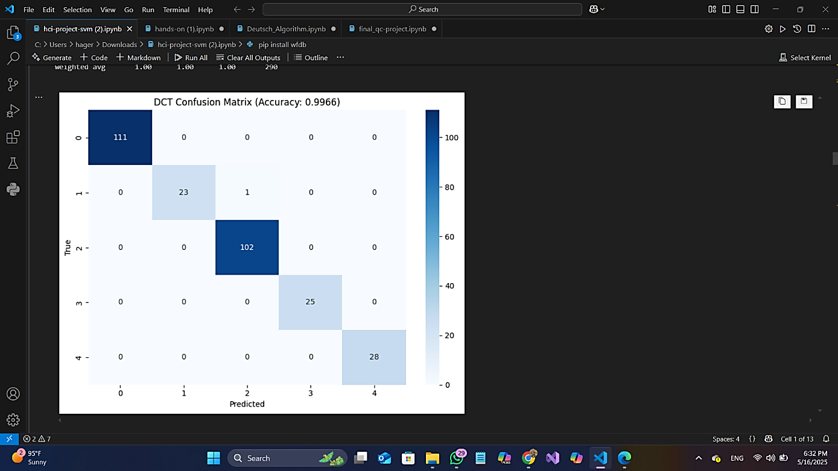

Wavelet-Based SVM Model

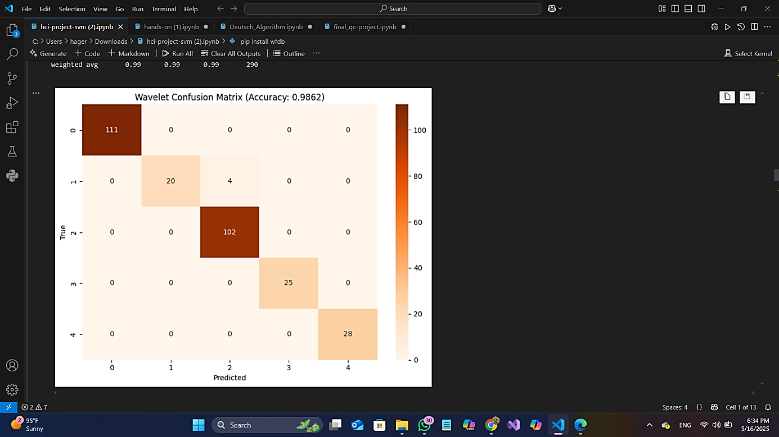

**UI Screenshots**

These screenshots showcase the step-by-step user interaction within the **ECG-Based Info Lock** application. From uploading biometric ECG files to unlocking protected data, the interface is designed to be intuitive, secure, and responsive. Key screens include the welcome screen prompting for file upload, the system file picker for selecting ECG biometric files, and the unlock confirmation screen, all crafted with a sleek and minimal UI for optimal user experience.

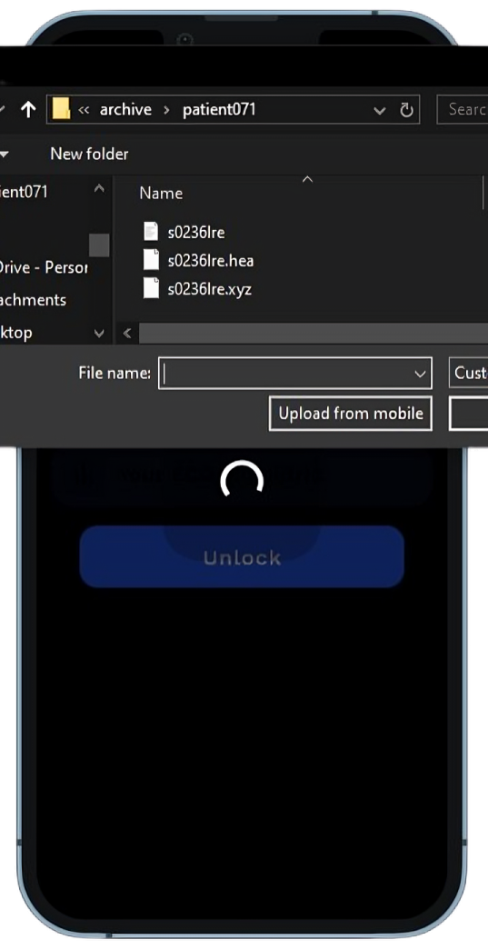

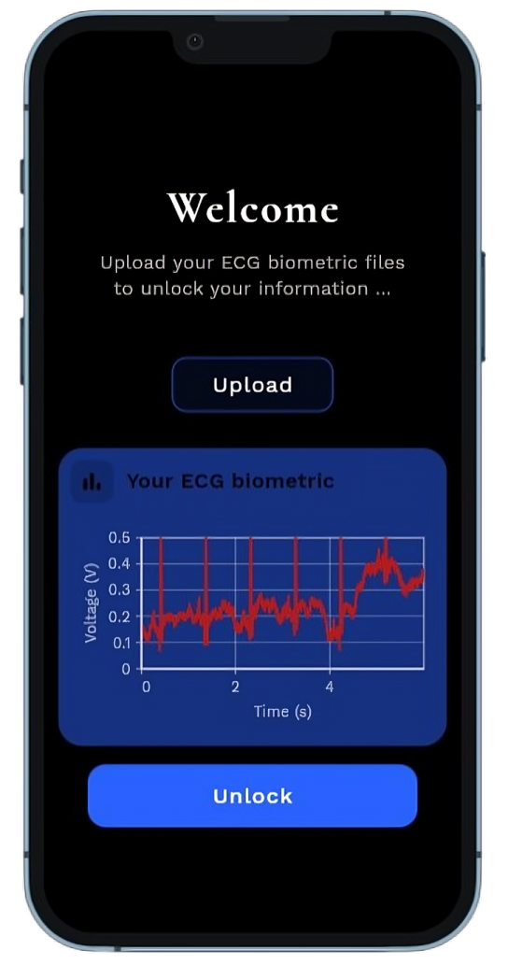

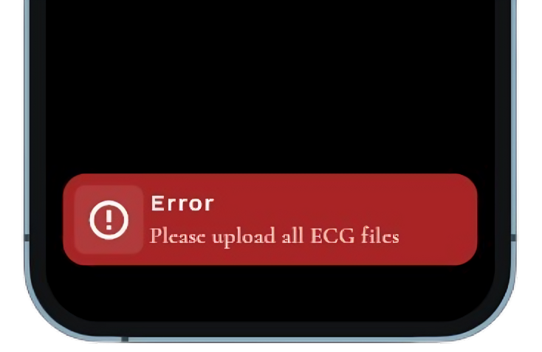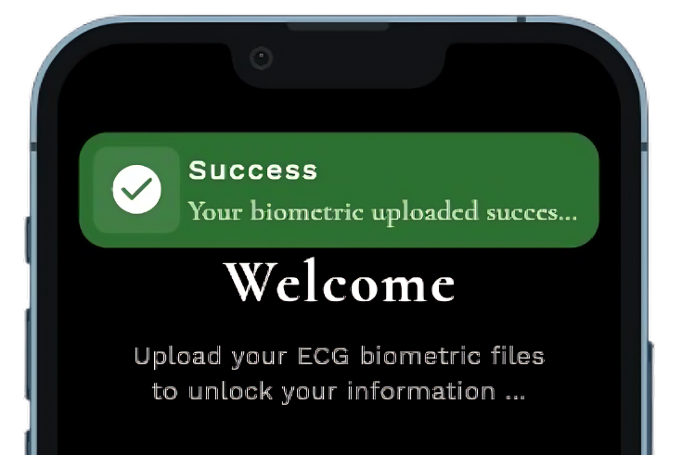

**Conclusion**

The ECG-Based Info Lock system demonstrates high accuracy in user identification using physiological signals. The use of both statistical and transform-based features, combined with optimized machine learning models, provides a secure, efficient, and scalable biometric authentication framework.

This solution lays a foundation for further integration into real-time mobile and embedded applications where privacy and identity security are critical.